Supplementary Information 1
A registered genome-wide analysis identifies robust, context-dependent transcriptional responses of lychee to Peronophythora litchii
Eric Zhuang
NYU Langone Health, New York, New York, USA

Contents
Figures S1–S3, machine-readable Tables S1–S18, all figure source data, the registered protocol and amendment log, analysis code, workflows, configurations, tests, metadata, and environment specifications are available exclusively in the version-specific Zenodo record at https://zenodo.org/records/22436625. Their table and figure captions are listed below.

Supplementary table captions
The following captions correspond to the machine-readable TSV files archived in the Zenodo record.
- Table S1. Biological-unit registry.
- Table S2. Per-library quality control.
- Table S3. Genome-wide discovery statistics.
- Table S4. Robustness file manifest.
- Table S5. All external frozen tests.
- Table S6. Pathway and signature tests.
- Table S7. Conditional differential-transcript-usage results.
- Table S8. Candidate annotation and orthology evidence.
- Table S9. Small-RNA reference-gate outcome.
- Table S10. Motif-background tests and sensitivity results.
- Table S11. Accession-aware evidence registry.
- Table S12. Scripts, environments, and command inventory.
- Table S13. Protocol amendment and deviation log.
- Table S14. Legacy within-cultivar audit.
- Table S15. Controlled promoter-motif background comparison.
- Table S16a. Reconstructed dataset-search queries.
- Table S16b. Dataset eligibility decisions.
- Table S17. Exact software versions.
- Table S18. Power-simulation minimum detectable effects.

Supplementary figure captions
- Figure S1: Replicate-level normalized counts for the two cross-context-supported genes, twelve Tier B genes, and two legacy highlights.
- Figure S2: Parametric detection probability for cultivar-by-infection effects under genome-wide discovery and candidate-family external adjustment.
- Figure S3: Exploratory PRJNA1090613 signed-signature estimate, shown separately because cohort metadata did not support its inclusion in the confirmatory evaluation.
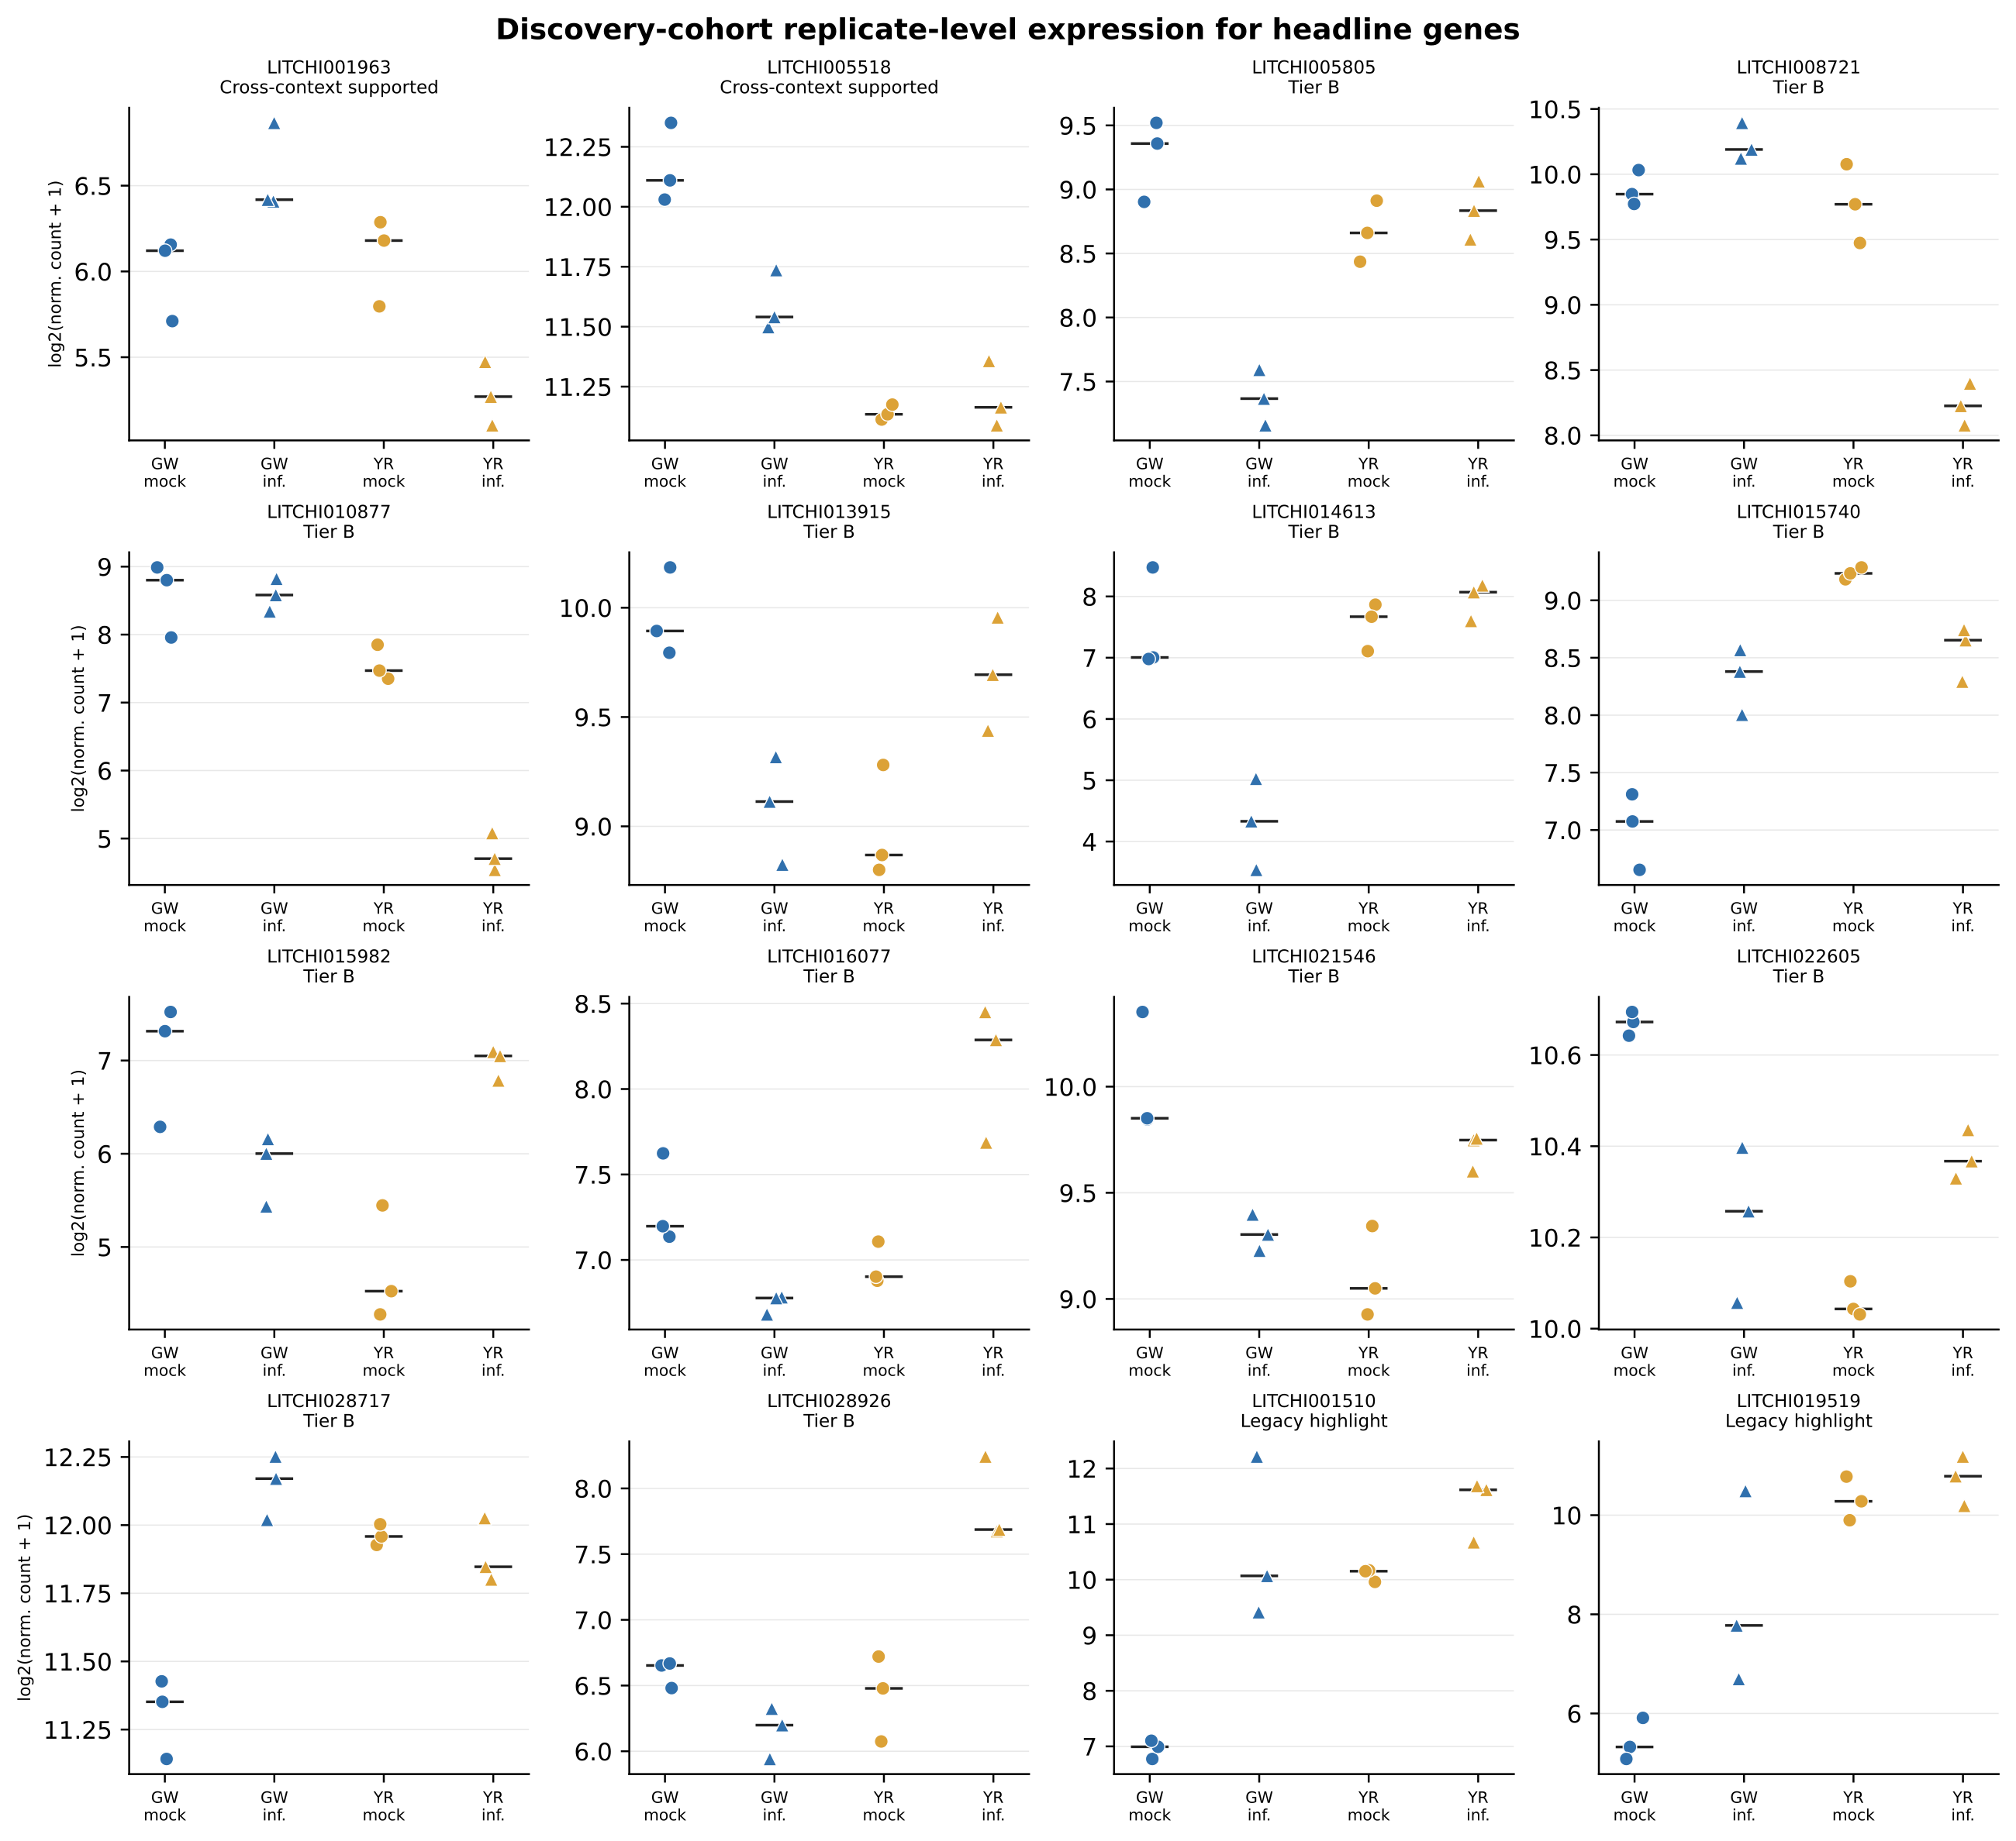
Figure S1. Replicate-level normalized counts for the two cross-context-supported genes, twelve Tier B genes, and two legacy highlights. Points are individual deposited libraries; bars show cultivar-treatment medians.
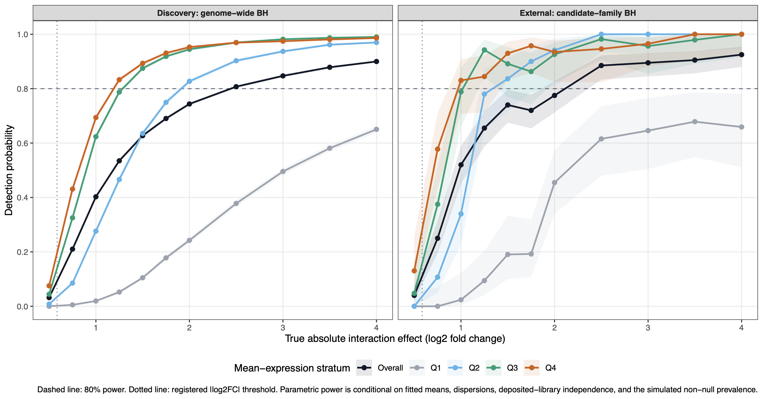
Figure S2. Parametric detection probability for cultivar-by-infection effects under genome-wide discovery and candidate-family external adjustment. Curves show the overall result and mean-expression quartiles; the dashed line marks 80% power.
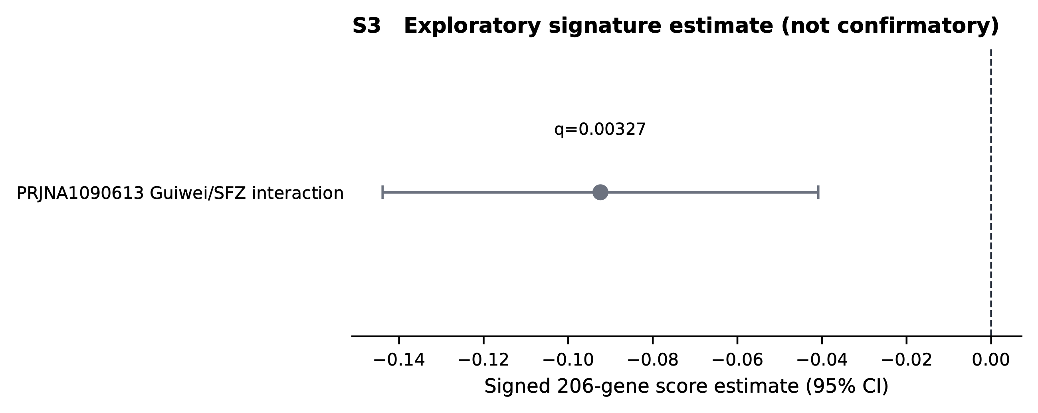
Figure S3. Exploratory PRJNA1090613 signed-signature estimate, shown separately because cohort metadata did not support its inclusion in the confirmatory evaluation.

