Supplementary Information 1
A registered genome-wide analysis identifies robust, context-dependent transcriptional responses of lychee to Peronophythora litchii
Eric Zhuang
NYU Langone Health, New York, New York, USA

Contents
This file contains Figures S1–S3 and their captions. Supplementary Data 2, supplied as Discover_Plants_Data_and_Code.zip, contains machine-readable Tables S1–S18, all figure source data, the registered protocol and amendment log, analysis code, workflows, configurations, tests, metadata, and environment specifications. The complete archive is also permanently available at https://doi.org/10.5281/zenodo.22436625.
- Figure S1: Replicate-level normalized counts for the two cross-context-supported genes, twelve Tier B genes, and two legacy highlights.
- Figure S2: Parametric detection probability for cultivar-by-infection effects under genome-wide discovery and candidate-family external adjustment.
- Figure S3: Exploratory PRJNA1090613 signed-signature estimate, shown separately because cohort metadata did not support its inclusion in the confirmatory evaluation.
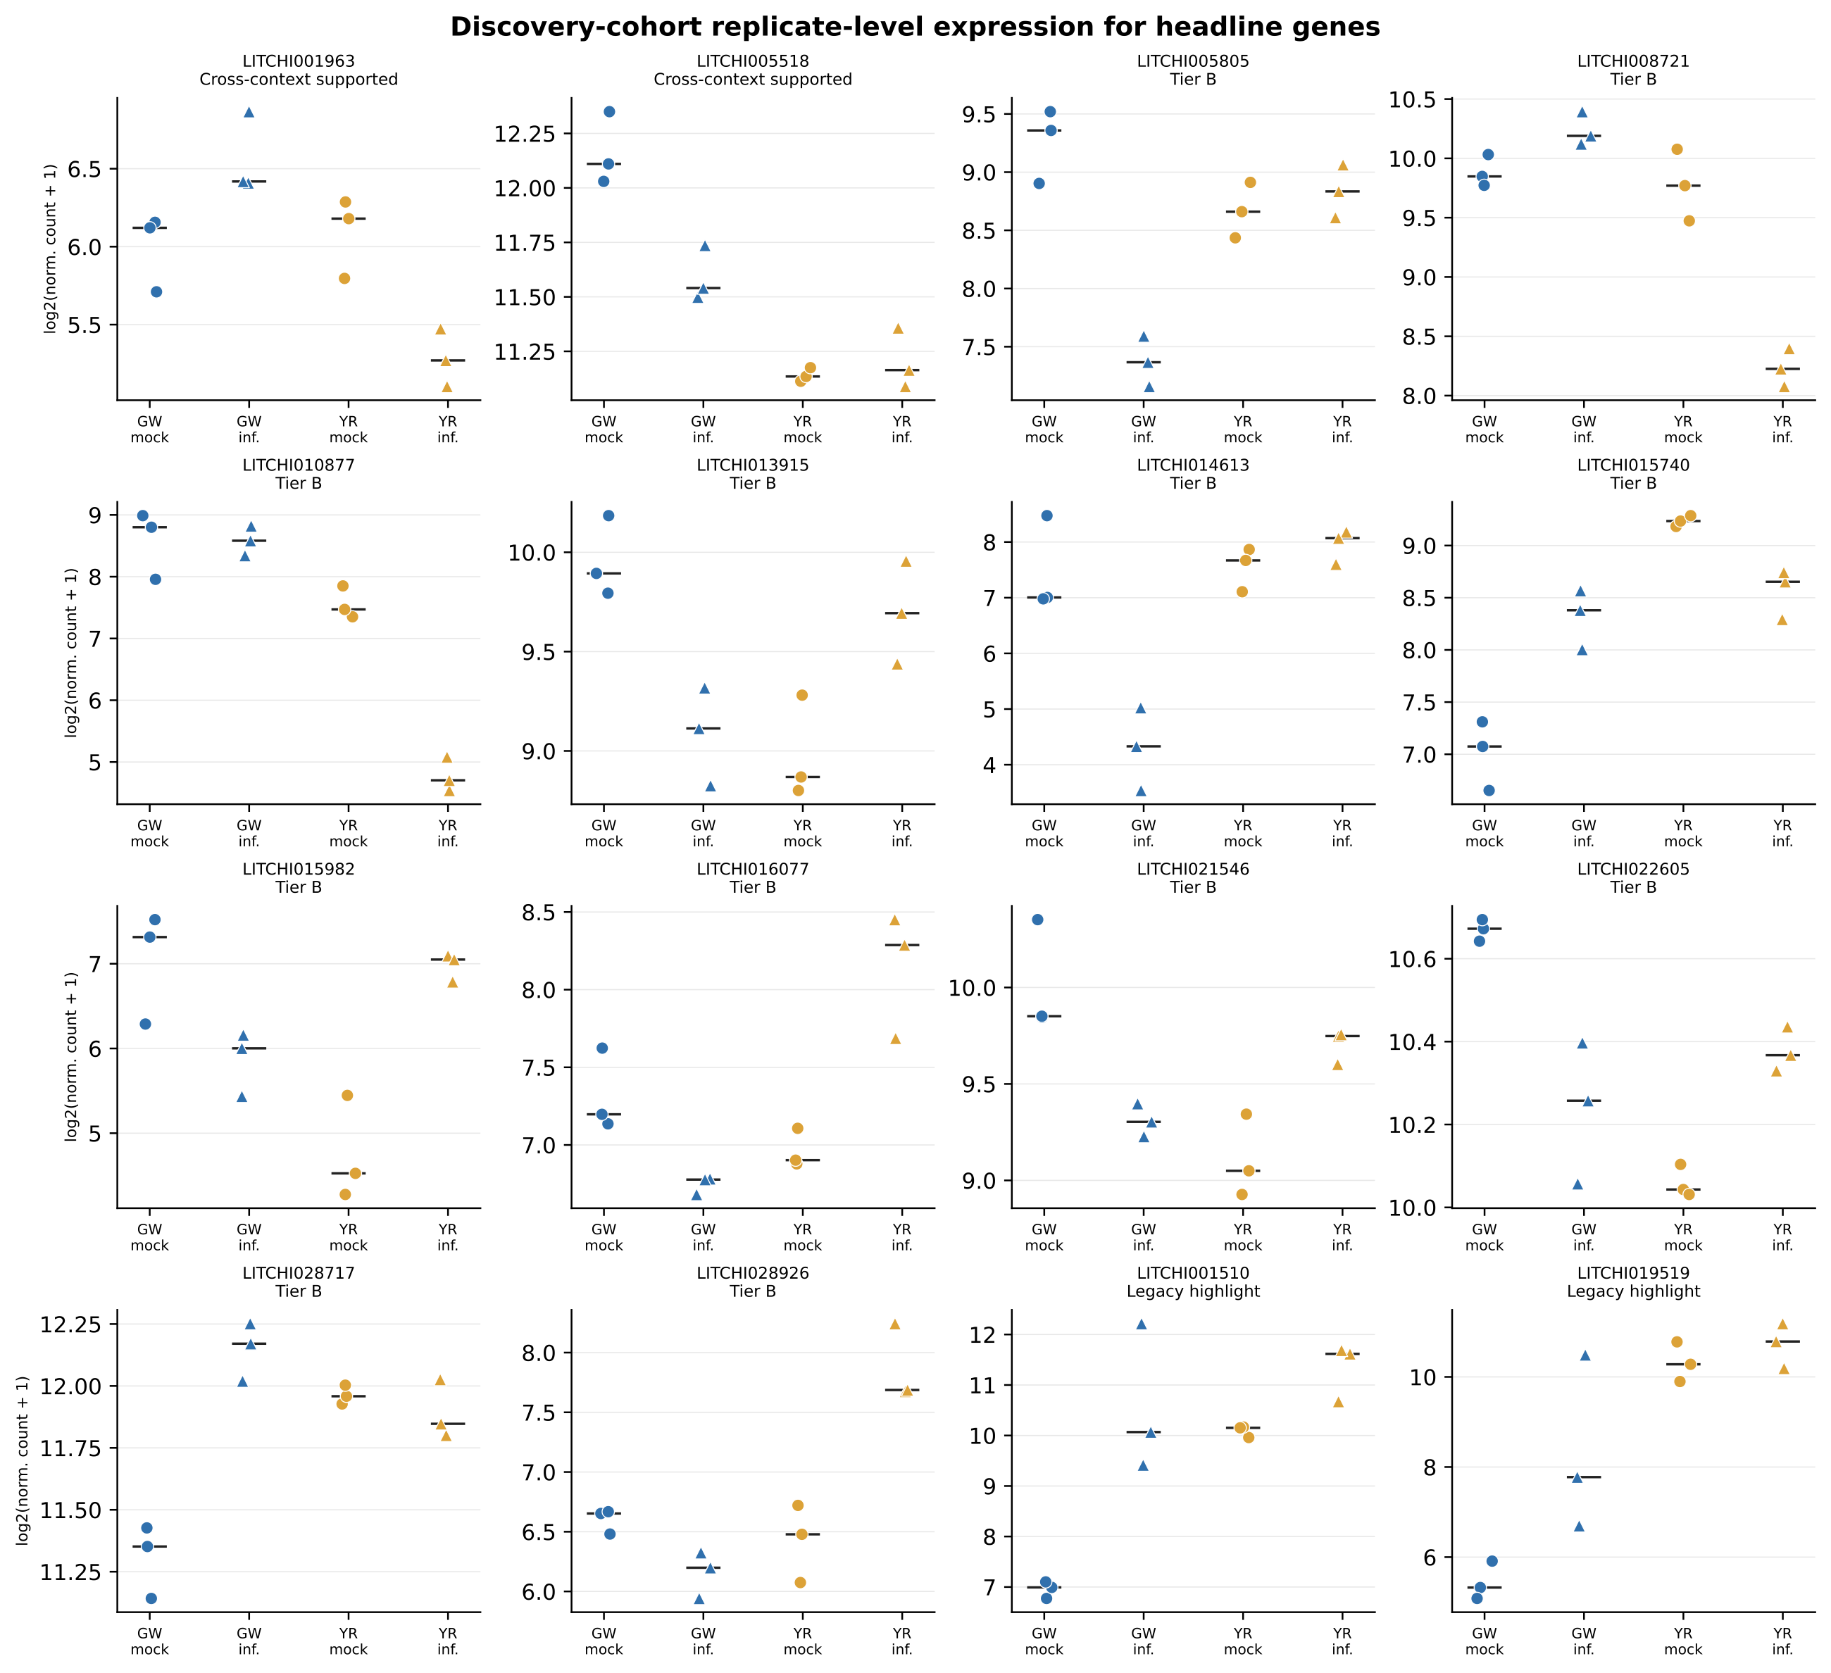
Figure S1. Replicate-level normalized counts for the two cross-context-supported genes, twelve Tier B genes, and two legacy highlights. Points are individual deposited libraries; bars show cultivar-treatment medians.
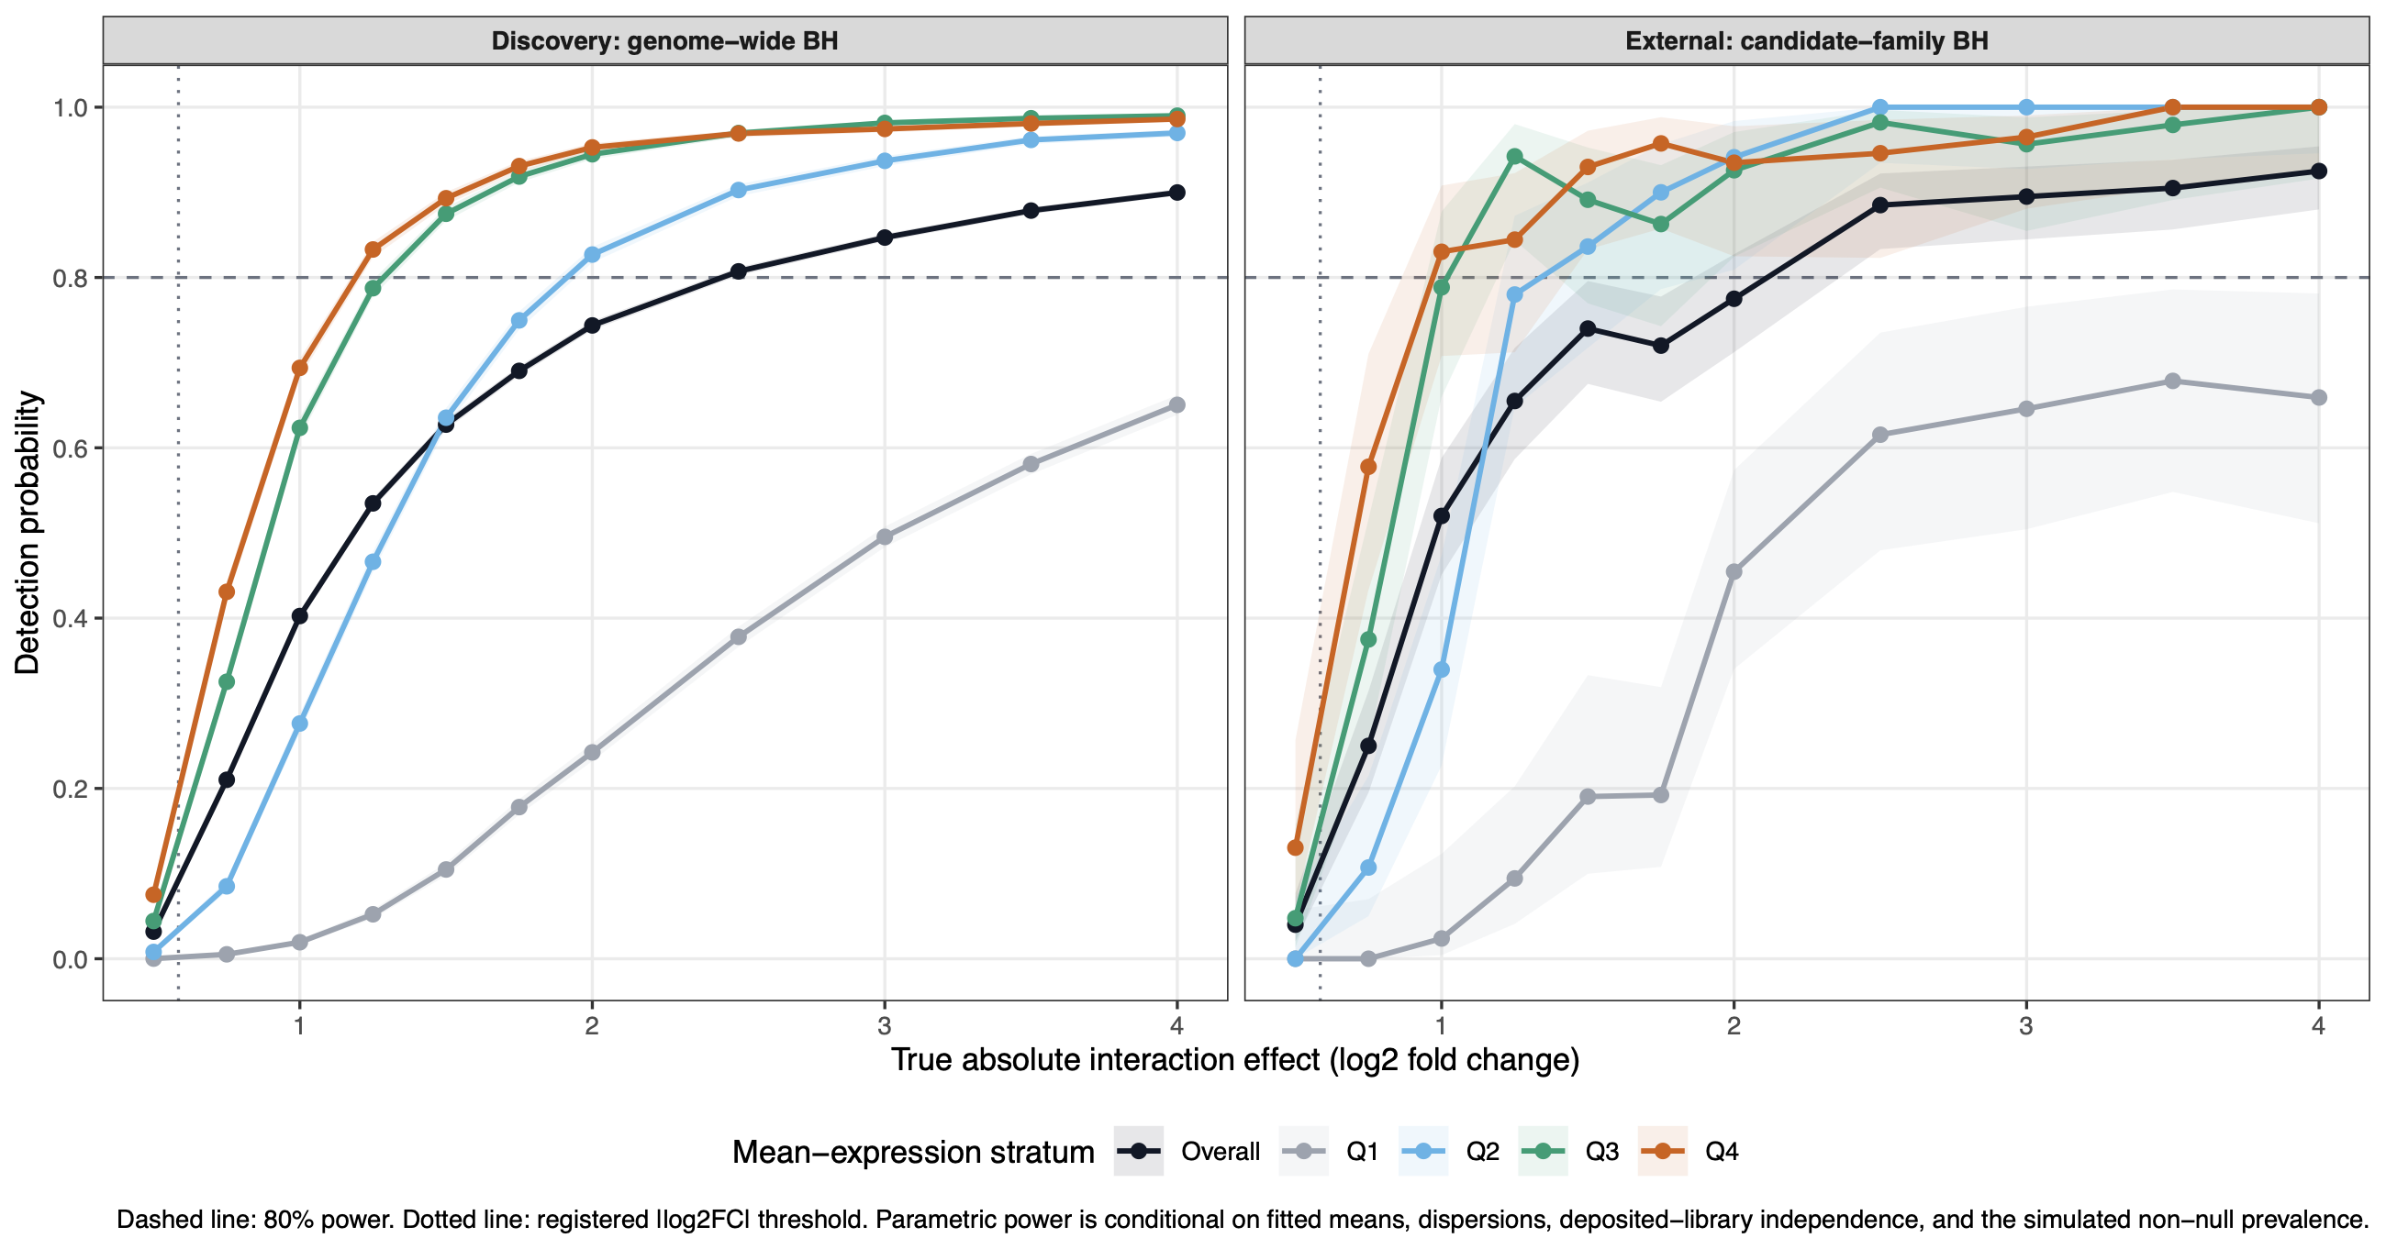
Figure S2. Parametric detection probability for cultivar-by-infection effects under genome-wide discovery and candidate-family external adjustment. Curves show the overall result and mean-expression quartiles; the dashed line marks 80% power.
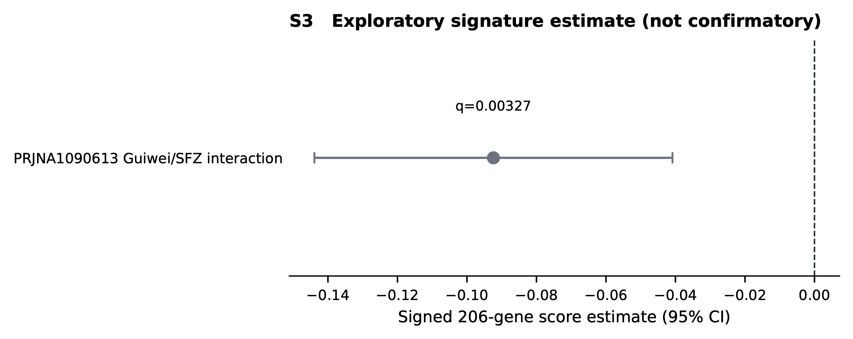
Figure S3. Exploratory PRJNA1090613 signed-signature estimate, shown separately because cohort metadata did not support its inclusion in the confirmatory evaluation.

