**Which points have been accomplished?**

**Part 1 COMPLETED**

* README.docx was created.
* ErifeoluwaJamgbadi(C18387973).zip was used for file folder name.

**Part 2 COMPLETED**

* A server using Express.js that loads the file “data.json” and save it in an object called colours was created.
* The server updates the changes in the data.json file so it inputs all the insert colours from the user.
* Implemented the routing and middleware to properly attend to the following requests from external petitions. Created the code for creating an API able to respond to the following queries:

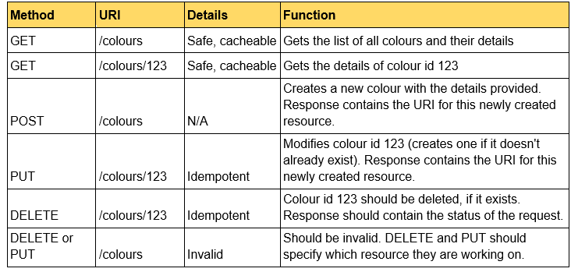

Is all the method working? Most is working, there is a problem with delete and put though, but the code is there, but not fully functional.

**Part 3 MAJORITY COMPLETED**

* A website called Index.html was created.
* Some tests are functioning.
* When the users type a wrong address, a message is sent indicating that an error has been made and displays a link to access the main page.

**Part 4**

* Attempted cookies for background colour, but not fully functioning

**How to execute your code or if there is something that has to be considered**

* Node express –save – download in cmd terminal.
* Download npm install -g [npm@8.7.0](mailto:npm@8.7.0) in terminal.
* Download npm install --save cookie-parser in terminal.
* Download npm install --save express-session in terminal.
* In terminal run node Express.js. This will load the file for the index.html.
* Put this in the browser: <http://localhost:8080/index.html> .
* Can click on the different functionalities, but because it’s not all in one page, so go back after the display of the functionality is shown *e.g show colour - > it goes to show the colours on a different page, after view -> click the back button to go back*
* If want to click MODIFY BUTTON, click 4 times the first click and then from then on whenever without refresh click 2 for action to disappear. (I think the listener was slow)
* Check the data.json after finishing all operations and the input from the new colour created can be seen in the file at the bottom of the page.