Safe Serialization under Mutually Suspicion
by Mark S. Miller
submitted to Professor Scott Smith for credit as independent study

Abstract
XXX To be written

Introduction
XXX To be written

Many Uses for Serialization
- Transcending Space: Distributed Object Protocols
- Transcending Time: Persistence
- Transcending Change: Upgrade
Kinds of Upgrade:
  - Upgrade for prototyping (live upgrade)
  - Upgrade for release (when unserializing)
  - Upgrade / Downgrade for comm coexistence
(when unserializing / serializing)
- State separation / communication / integration
- Open formats; unanticipated tools [XXX Prescod]

Security vs. Serialization?
Object-capability model of object-oriented security
Objects vs. Data
Conventional serialization “violates” the object model’s encapsulation, and thereby violates object-capability security. Repairing the security issue is really repairing serialization to be consistent with the object model of computation.
Encapsulation vs. Representation
It’s not just information anymore -- manipulating authority and identity

Many Plausible Serialization Policies
XXX List range of policies
Need mechanism / policy separation

Three Sides of Serialization
In this section, we first give an overview of conventional object serialization and unserialization -- conventionally ignorant of security -- before proceeding to explain E’s novel contributions to secure serialization. Throughout, we use Java’s Object Serialization Streams (JOSS) to illustrate the conventional issues because:
- of its widespread familiarity and mature documentation,
- it represents the needed conventional issues well -- especially schema evolution, and
- it’s used to build the current implementation of the serialization system described by this paper in the way that its use as an example would imply.
But unlike conventional object serialization systems, JOSS itself was designed with security in mind. However, its security assumptions and ours are mostly disjoint, so we have ignored, both in the paper and in the implementation, those aspects of JOSS designed to support security. For purposes of this paper, JOSS should be considered a representative of a conventional non-secure serialization system.
We assume that serialization is performed by a serializer, and that unserializing is performed by an unserializer. A serializer is a function-like object that’s applied to a subgraph of live objects to produce a string of bits somehow “representing” that subgraph -- in a form suitable for interpretation by compatible unserializers. An unserializer is approximately the inverse function-like object -- when applied to the string of bits produced by a compatible serializer, it instantiates a live graph of objects that in some meaningful sense is a replica or heir to the original graph.

A Picture of Conventional Object Serialization
The figure below illustrates the conventional issues delimiting a subgraph to be serialized. In theory, a subgraph could be defined by enumerating an arbitrary subset of the nodes of the overall object reference graph -- such as [C, D, H]. These nodes + the arcs among them would then form the subgraph itself -- the middle of our diagram. Practically, one tells a serializer about a subgraph by designating certain objects as starting points, or roots, for traversal. The serializer then transitively traverses, in the forward direction, all those references traversable by this serializer, in order to identify the overall reachable subgraph to be serialized. For example, in the above diagram, A might use her reference to C to ask the serializer to serialize the subgraph reachable from C. The reference from A to C would then be an incoming root reference. The reference from B to H is also an incoming reference but not a root -- the serializer proceeds without taking it into account, and no trace of its existence appears in the resulting bit string.
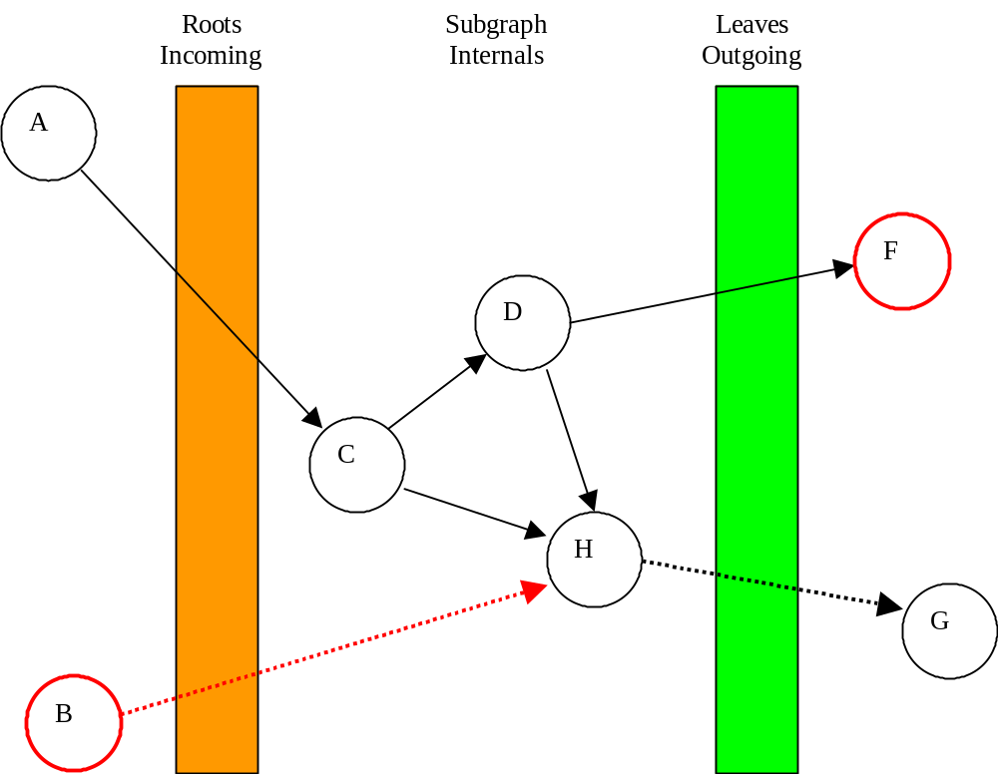Each reference the serializer encounters but doesn’t traverse is a leaf of this subgraph. For example, let’s say our serializer is built on JOSS, and that H is holding its reference to G in a transient instance variable. Although G might be essential for the operation of H, JOSS will traverse this transient/leaf reference to G, and so will not serialize these G. Transient instance variables are simply absent from the resulting bit string -- exactly as if they hadn’t been present in the original object state. On unserialization, transient instance variables are initialized to null, so an unserialized H can usually at least tell that its G is missing.
The roots, the subgraph itself, and the leaves, are the three sides of serialization. There’s a section below on the security issues specific to each side.

Customization Hooks for Expressing Policy
Continuing our example using JOSS, let’s say F is an instance of a class that doesn’t implement Serializable. Because the serializer does not or cannot access F’s state, we say that F is opaque to this serializer. Whereas the reference from H to G is a leaf based on information about the reference (the transient declaration in H), the reference from D to F is a leaf based on information about F. By default, when JOSS encounters an opaque object, it throws an exception causing the serialization as a whole to fail. But JOSS enables a serializer to specify other policies. These other policies usually take the form of serializing some other object in lieu of F, FRep, which JOSS refers to as the replacement of F. FRep is produced by the serializer according to its own policy and for its own use. The serializer generally produces FRep in collaboration with F, but this is its choice. Serialization then proceeds as if D had been pointing at FRep rather than F, producing exactly the bit string that would have been produced were this the case.
By using replacement to express policy, the serializer can no longer be said to be saving a simple representation of the original live graph, but rather a representation of its transformation of the live graph. By using resolution, the unserializer likewise can express its policy by transforming the represented graph during the process of producing a new live graph.
Again using JOSS as an example, each individual serialized object may itself be unserialized “naively” -- by instantiating the named class with the given state. For example, FRep might be momentarily unserialized as FR, pointing at the unserialized form of FRep’s state. But FR may not itself be plugged directly into the resulting object graph -- when D is again given life, it may never see FR. The unserializer may instead specify another object, FRes, as FR’s resolution, in which case the newly instantiated D is initialized to point at FRes instead. The unserializer typically calculates FRes in collaboration with FR, and therefore, indirectly, in collaboration with the original serializer collaborating with the original F.
The secure serialization techniques presented below are indeed implemented primarily by patterns of replacing and resolving.

Schema Evolution
The art of persistence is to preserve state amid change
and to enable change amid state.
--with apologies to Alfred North Whitehead
An object is an encapsulated bundle of state and behavior. All serialization systems do their best to save and restore state. What about behavior? For some purposes the right thing to do may be to serialize and unserialize the representation of behavior -- the code -- along with the state. But such purposes are not JOSS’s purposes. Once object state lasts longer than product release cycles, one will typically want to unserialize old state in order to instantiate newer versions of their original classes. This is the object-analog in the small of using the newer version of a word processor on documents created by the old.
The bit string JOSS produces as the representation of an object is a bundle of the object’s encoded state, as discussed above, and the name of its behavior. (In the idealization of JOSS we use in this paper, we ignore JOSS’s “serialVersionUID” and instead assume that the fully qualified class name is used as the saved behavior name.) A Java ClassLoader maps fully qualified names to classes, faulting them in from .class files if need be. An unserializer uses a given ClassLoader, to find the class to use to instantiate old objects.
Of course, the version of the class found by this ClassLoader may assume different state than the version of the class from which the state was originally saved. The needed representation conversion -- into state that’s a valid instance of the new class -- is known as schema evolution. JOSS provides elaborate means by which the programmers writing the old class and those writing the new class can coordinate, without undue effort, in order to give the new class a reasonable chance at successfully converting old state into a valid, and reasonably meaning preserving, instance of itself. There is much research on more ambitious systems of schema evolution [XXX refs], but for our purposes, the evolution mechanisms provided by JOSS are adequate.

Security within the Subgraph: Encapsulation vs. Representation
XXX Resolving the tension with rights amplification
What is transparent to a given serializer?
Loader as natural unit of representation reflection

Security at the Leaves: Reclaiming Old Authorities
With all these hooks for expressing policy by transformation, how can the unserializer succeed at producing a new live subgraph that works? Not all the state that enabled the original subgraph to work was saved, so where’s the new state to come from?
- Restoring
- Replacing / Resolving
- Reconstructing
- Reconnecting

The Gordian Scalpel: Extracting a Subgraph for Transplant

Lambda Abstraction by “Removing Details” [Kahn]

Comity
Comity […] the courtesy by which nations recognize within their own territory […]the rights and privileges acquired by […] citizens in their own land […].
--Webster’s Revised Unabridged Dictionary

Chain of Custody
Chain of Custody. An unbroken trail of acceptability that ensures
the physical security of samples, data and records.
--American Society for Quality Control, ANSI/ASQC E4-1993

The Gordian Suture: Transplanting a Subgraph into a Live Host
Immortality is easy. Comity is hard.
--with apologies to Edward Kean

Reconnection as Lambda Application

Limited Willingness to Extend Comity

Extending Virtualized Comity

Limited Ability to Extend Comity

Persistence and Magic Powers
XXX Ideally, all authority derives from diminishing the authorities provided by magic powers.
Magic powers as suture sub-tables

Example: Capabilities to Access Named Files
XXX chroot and virtual comity
Portability by using multiple “roots”.

Schema Evolution as Comity for Code [Shapiro]
The behavior loader is effectively a magic power sub-table mapping fqn-graph-parameter-names to its desired version of the named behavior. Evolution happens by applying the old data to the new code? Weird.
An appealing generalization, but not reflected in the current mechanisms.

Security at the Roots: Reclaiming Old Identities

What is Object Identity?

Rights to invoke, be, compare

Secure Distributed Objects:
Islands of Partitioned Capabilities, Hooked Together by a Sea of Password Capabilities

CapTP’s Encoding of a Capability

Knowledge is Power

The Logic of Telling Secrets

SturdyRefs: Guarding the Boundary between the Worlds
SturdyRefs are data + a capability to a LocatorUnum, which provides it the power to turn bits into a capability. The LocatorUnum is normally not serialized, but rather replaced by a GraphParam(“LocatorUnum”), to be resolved by the unserializer into a fresh LocatorUnum; provided of course that the unserializer is willing and able to extend this comity to those (such as serialized SturdyRefs) whose previous incarnation allegedly had access to the LocatorUnum of their world.

Hash Chaining Identity Rights

Immediate Reincarnation
SwissNumber := hash(SwissBase)

Example: persist-echat.e-awt
For when you’d rather rebuild it than save and restore it.

Reincarnation On-Demand
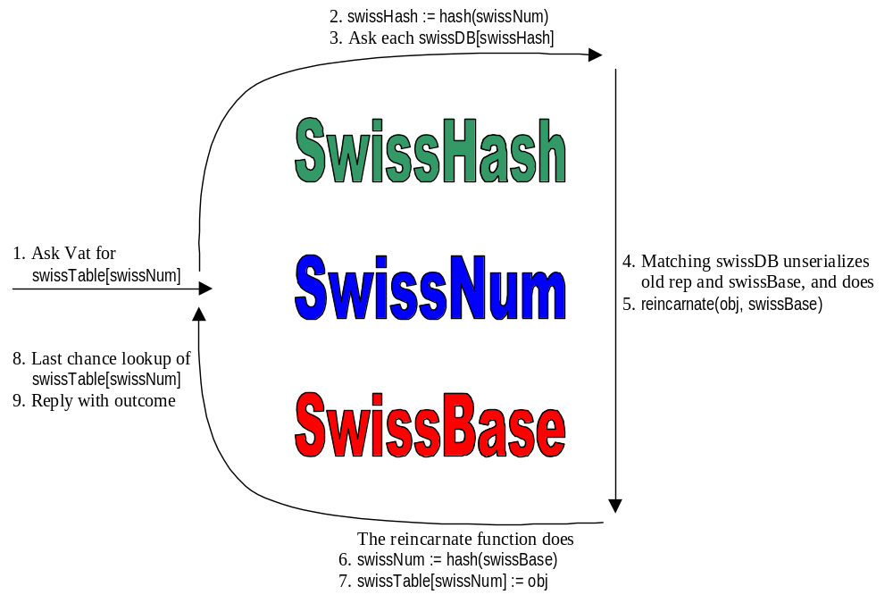XXX Unprivileged fault handlers [ref XOF]

Example: Mints with Purses
XXX Purses are naturally stored in databases. Potentially massive number of Purses, but most stay dormant for long periods.

Persistence & Upgrade

In Praise of Manual Persistence
XXX Need to separate upgrade from schema evolution below.
Computers crash too often. We wish our applications, data, and activities to last much longer. To achieve this, traditionally, programmers had to encode their application’s representations twice – once as a live in-core data structure and once as a file format or database schema to be saved to disk. This was the pain of manual persistence. Transparent orthogonal persistence was first conceived as a way to avoid this error-prone redundancy, essentially by masking the crash [KeyKOS, EROS, PJama]. A process running in such a system proceeds essentially as if no crash had happened. Such a process has an easy immortality, and the original persistence problem is solved.
However, if one uses transparent orthogonal persistence instead of manual persistence, one amplifies the difficulty of the schema evolution problem, often to a fatal extent. Manual persistence provides a source of great leverage for schema evolution, and one that’s easy to miss: By encoding their representation twice, programmers naturally bring to each encoding those concerns specific to the purpose of that encoding, often without thinking about this dichotomy explicitly.
Do you, Programmer, take this Object to be part of the persistent state of your application, to have and to hold, through maintenance and iterations, for past and future versions, as long as the application shall live?
--Arturo Bejar [StateBundles]
Normally, we view the design of the runtime representation of our application as the “real” one, and wish the persistent representation to be derived from it. But as this quote from Arturo suggests, the kind of commitment one needs to invest in persistent state isn’t appropriate for runtime data structures, and shouldn’t be. Runtime data structures are often delicate complex machines in motion, with many complex distributed consistency assumptions between the parts, designed to interact efficiently with an ongoing world of users or devices, and encoding meaning in ways that are largely undocumented. The complexity of this runtime world traditionally relies on the program itself staying constant while the process is executing.
By contrast, when programmers designs file formats for manual persistence, Arturo’s question is properly uppermost on their mind. These file formats are stable representations designed with little redundancy, few opportunities for distributed inconsistency, with little penalty for costly encode/decode logic, encoding only the essential application state that needs to survive across time, where this encoding is much more likely to be well documented. Runtime representations emphasize the operational, whereas file formats emphasize the declarative.
Once the customers of an application accumulate their own privately held persistent state from this application, such as their own private documents, then Arturo’s question becomes unavoidable. To release a new version of an application without losing old customers, one must enable those customers to revive their old state using the new version of the application – to upgrade.
If the programmers were using only transparent orthogonal persistence to give the application’s data long life, then this upgrade problem resembles maintenance on an operational (but probably suspended) machine whose workings may be largely mysterious. Worse, since the upgrades must happen in an automated way on customer data without the programmers present, it more closely resembles building an upgrade-robot that will reliably perform this maintenance on any possible state such a machine may be in. With machines of great complexity, the feasible changes will usually only be minor tweaks and adjustments, not major design changes. The difficulty of upgrade will place a severe limit on the speed with which a vendor will be able to improve their program. This kind of persistence indeed provides a process with easy immortality, but only as a living fossil.
If, on the other hand, the programmers were using manual persistence (whether through foresight, habit, or lack of an alternative), then, when they wish to release a new version, the total number of semantically significant cases in the file format should usually be small enough that they can each be thought about carefully, in order to see how to convert its meaning into the closest appropriate meaning in the application’s new version. The upgrade-robot arrives with parameterized blueprints (the new version of the program) for building a new running machine (instantiating a new running process). The file format provides the arguments needed to complete the blueprint. The old machine is scrapped and a new machine is freshly built around these arguments. Having made the greater initial investment in engineering two representations, the programmers using manual-persistence will then be able to improve their application much faster without losing their customers, perhaps overtaking the head start of the fossilizing alternative.
The best first approach to the schema evolution problem is to save smaller schema.

Persistence and E
XXX Basic E orientation, including Vats, distributed objects, live refs and SturdyRefs, and object-capability security.
XXX Assumption of per-vat persistence by E computational model.

Manual Revival as Zero-Delta Upgrade
Note that none of the above discussion assumes that transparent orthogonal persistence and largely manual persistence are exclusive options. A system may well use both: transparent orthogonal persistence to mask crashes efficiently [KeyKOS, EROS], and largely manual persistence only when upgrading. A future E-on-EROS may very well operate in this mode. In this scenario, performance need not be a goal of the largely manual system.
In the absence of support for high speed transparent orthogonal persistence, a system may very well use largely manual persistence mechanism for both purposes. Each post-crash revival is then a degenerate zero-delta upgrade: it runs through the logic motivated by upgrade each time, even when no upgrade is actually occurring. The current E, running on Java running on stock OSes, operates in this mode. Nevertheless, performance is not a goal of E’s persistence mechanisms at this time.

Mechanism / Policy Separation
Of course, by definition, anything a program does is automated, so what do we even mean by “manual” persistence? We are not arguing against automation, abstraction, and reuse. Rather the issue is whether to build an inescapable comprehensive solution vs. a toolkit of reusable tools from which one can roll one’s own solution. When one can design a single solution adequate for the needed range of uses, often one should, as the uniformity of a single comprehensive solution can bring great benefits. When one size doesn’t fit all, we should instead turn to the tradition mechanism / policy separation – the toolkit can serve as the mechanisms out of which one may build a variety of persistence systems embodying a (limited) range of policy choices.
What we mean by “manual” persistence is that the E kernel does not itself provide a primitive persistence system, but rather provides primitive tools out of which persistence systems may be fashioned. The E system as a whole does provide a default persistence system built “manually” from these tools, but this has the status of library code rather than fundamental primitives. Multiple such libraries can coexist, and the default one is in no sense special.
The tool most central to such a toolkit is a serialization / unserialization system. E currently uses Java’s serialization streams, which has a rather flexible and mature set of customization hooks for building streams embodying a wide range of serialization policies. Most of the goals of our toolkit are already achieved by Java’s serialization design, so this paper proceeds from there.

XXX punt line
Here, we wish to support a range of compromises between the explicitness and separation of concerns of manual persistence vs. the economy of expression provided by automating aspects of persistence. Why a range of compromises? Why not try to find one good compromise and just build that? Because there are too many kinds of persistence policies that plausibly need to be supported.
- What to save/restore vs. what to reconstruct vs. what to reconnect. (More on this below.)
- Where to save persistent state? Files? Databases?
- When to revive saved state? On process (vat) revival, or faulting on-demand?
- Fail-stop vs. best efforts. When problems are hit, either saving or restoring, should one give up or make due?
- What is a consistent state, and how does one obtain access such a state? Does such a state include messages in flight?
- Transactions: When is a saved state a basis for commitment? How does one abort and fall back to a previous state? As separate subsystems asynchronously snapshot, how is consistency recovered when they revive from different times?
Faced with such a variety, we use the traditional answer: mechanism / policy separation. We have built persistence support into E in two layers:
- A set of building blocks from which an application developer can (within limits) build a persistence system embodying those policies that serve their needs, including a fully manual system if desired. These mechanisms must not allow an unprivileged persistence subsystem from violating any of E’s security properties, while allowing for operation that’s reasonable for a subsystem holding a given set of authorities.
- One example persistence system, built only from these building blocks, embodying a set of policy choices that won’t be suitable for all applications, but is nevertheless designed to be widely reused.

Persistence and Mutual Suspicion

History and Acknowledgements
We thank Monica Anderson, Arturo Bejar, Danfuzz Bornstein, Tyler Close, Gordie Freedman, Michael Glenn, Norm Hardy, Ken Kahn, Chip Morningstar, Trevor Morris, Jonathan Shapiro, Scott Smith, Terry Stanley, Marc Stiegler, E-Dean Tribble for conversations and insights which have contributed to these ideas or this paper.
Electric Communities, Agorics, Combex, Johns Hopkins University, e-lang.
Sun, NeXT, Kaleida Labs, Waterken

References

The original being “The art of progress is to preserve order amid change and to preserve change amid order.” from Alfred North Whitehead in “Science and the Modern World”, Macmillan, 1925 or 1929.
The original being “Dying is easy, comedy is hard.” –Edward Kean, the comedian, on his deathbed.
This upgrade-robot issue answers the possible objection: But what about Smalltalk? Smalltalk does provide transparent orthogonal persistence, and for many Smalltalk apps this is the only form of persistence provided. Nevertheless, Smalltalk and its applications evolve quite quickly. However, Smalltalk users are programmers, and the result of upgrading persistent state may often throw one into a debugger or create other anomalies that the typical Smalltalk user can figure out how to recover from. So long as such manual intervention is occasionally required and assumed, transparent orthogonal persistence cannot compete for use in production applications.

