Overcooked

Introduction:

Overcooked is a switch game. In Overcooked **players must journey through a variety of cruel and unusual kitchens on their quest to become master chefs capable of conquering an ancient edible evil which plagues the land**. Play solo or engage in classic, chaotic couch co-op for up to four players in both co-operative and competitive challenge modes.

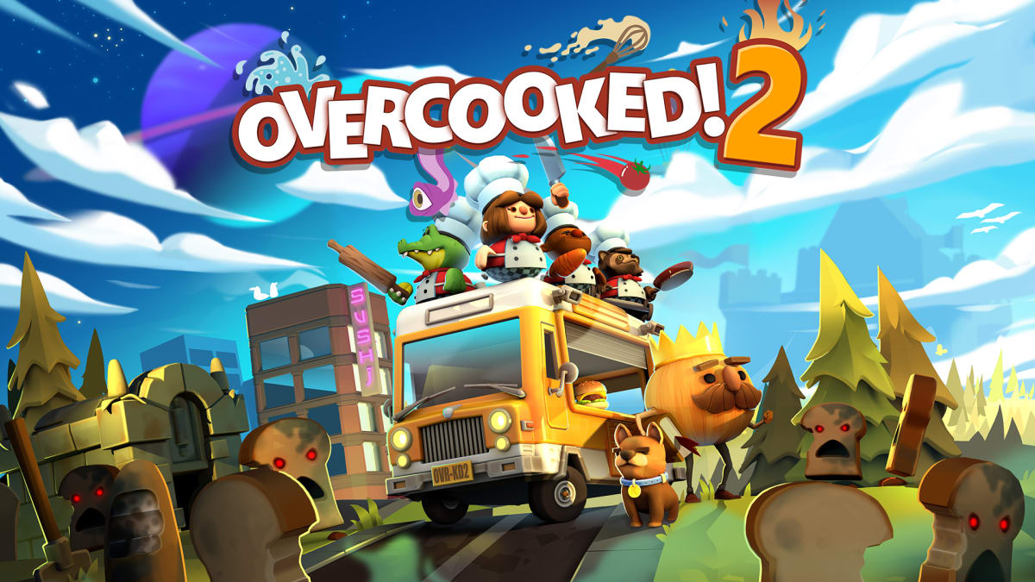

<https://www.google.com/url?sa=i&url=https%3A%2F%2Fwww.nintendo.com%2Fstore%2Fproducts%2Fovercooked-2-switch%2F&psig=AOvVaw2599LJXLpBYDTsqjKEzSm9&ust=1649988515930000&source=images&cd=vfe&ved=0CAwQjRxqFwoTCMCKlK68kvcCFQAAAAAdAAAAABAT>

The change of difficulty:

The maps would change with the rise of difficulty.

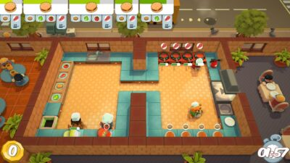

<https://www.google.com/url?sa=i&url=https%3A%2F%2Fwww.team17.com%2Fgames%2Fovercooked%2F&psig=AOvVaw2599LJXLpBYDTsqjKEzSm9&ust=1649988515930000&source=images&cd=vfe&ved=0CAwQjRxqFwoTCMCKlK68kvcCFQAAAAAdAAAAABAZ>

There would be crush that prevent players to cooperate smoothly.

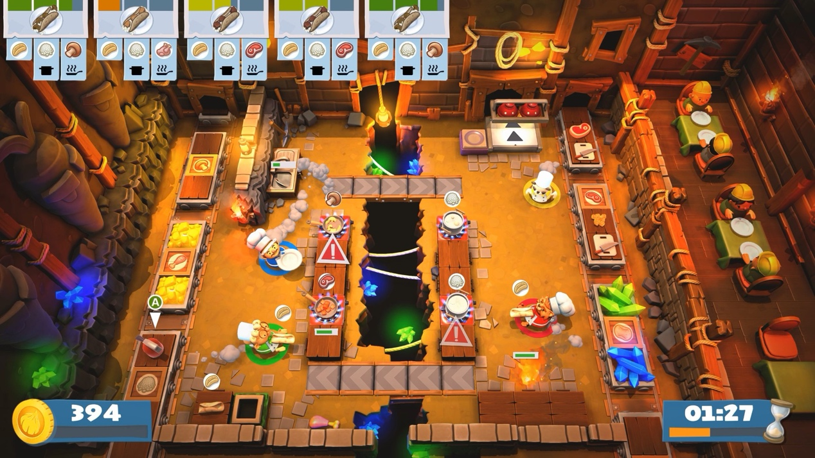

<https://www.google.com/url?sa=i&url=https%3A%2F%2Fwww.instant-gaming.com%2Fit%2F2705-comprare-overcooked-2-pc-mac-gioco-steam%2F&psig=AOvVaw2599LJXLpBYDTsqjKEzSm9&ust=1649988515930000&source=images&cd=vfe&ved=0CAwQjRxqFwoTCMCKlK68kvcCFQAAAAAdAAAAABAf>

Players will have more tasks gradually: washing dishes, sending food to the table, cooking rice, and cutting off vegetables.