Title

Nicholas L. Gjording⁺*, Erik W. Ertsgaard⁺, Iris Dimpsey, Owen Bard, and David E. Giblin

University of Washington Herbarium (WTU), Burke Museum,
Land of the sʔabəb səlš (Coast Salish) peoples,
Seattle, Washington, United States of America

Abstract
[250 words maximum, write last]

Key Words: [4-10 key words readers may search for, or that highlight aspects of story]

* Corresponding Author
Email: nicgjording@gmail.com

+ Authors contributed equally to this publication

INTRODUCTION
[Nick & Erik]

MATERIALS AND METHODS

Study Areas
[David]

Focal Taxa
[David]

Occurrence Data
Spatial records for the occurrences were generated from all herbarium collections and iNaturalist observations of each taxon. Both sources are widely used in SDM studies as they contain spatial information and indefinitely identifiable materials that form a modern picture of species’ distributions (Loarie et al., 2008; Salariato et al., 2022; Gaier and Resasco, 2023; Oke et al., 2023; MacDonald et al., 2025). The spatial precision and identification accuracy of each data source can vary, but these data are made reliable through community input, GPS technology, georeferencing efforts, and scrutinous filtering of occurrence data by study authors (Bloom et al., 2018; Gábor et al., 2023; Hart et al., 2023; White et al., 2023).
The spatial precision, or resolution, of occurrence data is affected foremost by the usage of a GPS. Most iNaturalist observations are taken with cell phone cameras that record precise location information; therefore, we filtered out any observations with higher than 30-meter uncertainty values that would most likely result from erroneous phone GPS recordings. Herbarium collections often predate GPS technologies, so collections are georeferenced according to the original collector’s site description if no coordinates are provided. These georeferenced points are triangulated manually, and an uncertainty value is chosen to represent the specificity of the collector’s site description within the surrounding landscape. Following the Spatial Analysis Georeferencing Accuracy (SAGA) protocol (Bloom et al., 2018), we omitted all collections with spatial uncertainty higher than 1,000 meters.
Central to this study is the accurate identification of the herbarium specimens and iNaturalist images used to generate current distributions for each taxon. For herbarium specimen records we first analyzed all specimen images for each taxon that are available in the Consortium of Pacific Northwest Herbaria online database (2025). Additionally, we examined all unimaged herbarium specimens held in the University of Washington Herbarium, Burke Museum (WTU) because it has the most comprehensive collection of specimens for these taxa. We found no misidentified specimens through this effort. Though we only included Research Grade iNaturalist images for the analyses (iNaturalist community, 2025), we fully examined images from each reported locality to ensure accurate identification. This resulted in the elimination of some images reported as Pedicularis rainierensis. No misidentifications were encountered for all other taxa in this study.
Occurrence points of the same species within 5 meters of each other were also removed such that duplicate surveys representing the same population do not unduly influence the SDM. The final sample size of herbarium and iNaturalist points for each species after uncertainty and accuracy filters were applied are listed in Table 1.

Environmental Data
Climate Data
[Nick]

Geology Data
For soil type, we obtained data from the USDA's STATSGO2 for Washington, paired the MUkey from the shapefile with the corresponding field in the comp.txt file, and used the pairwise clip tool to clip the soil map to our study extents, exporting the layers as shapefiles. For lithology, we downloaded the 1:500,000 surface geology map from the Washington state DNR database, added it to ArcGIS Pro, and applied unique value symbology. We then used the clip tool to intersect the map data with our study areas, adding lithology data for Rainier and Wenatchee.

Topography Data
To process elevation, we downloaded 1/3 arc-second DEMs from the USGS National Map (10m resolution), clipped them to our study area, and mosaicked them in ArcGIS Pro with a WGS 1984 projection. For slope, I used the Slope tool in Spatial Analyst with a geodesic method, calculating percent rise and setting the Z unit to meters, processing first on GPU then CPU. For aspect, I generated the Aspect raster from the slope layer using the geodesic method, using equations to create a raster that gave us Northness (-cos(aspect*PI/180), Eastness (sin(aspect*PI/180), and Northeastness (sin((aspect*PI/180)+PI/4)) on a scale of -1 to 1, with 1 being due north, east, or northeast. TPI was calculated (Topographic position index) using Focal Statistics on the 10m DEM with focal radii of 20m, 30m, 50m, 100m, 300m, and 500m, then subtracted the focal mean from the elevation using the minus raster function.

Canopy Cover Data
For percent tree canopy cover, we accessed the NLCD USA Tree Canopy data (30m resolution) for 2011-2021 through ArcGIS Pro, then clipped it to our study area.

[Table of all variables, their descriptive statistics, and their sources]

Principle Component Analysis (PCA)
[Nick]
Climate Visualization

Data Adjustment(/Reduction)

Canopy Cover Model

Species Distribution Modeling (SDM)
[Erik & Nick]

RESULTS
(Nick’s PCA figures)
(Table of Ensemble Model performance statistics)
(Erik’s current and projected SDMs)

DISCUSSION
[Nick & Erik]

CONCLUSION
[Nick & Erik]

ACKNOWLEDGEMENTS
[Tony Cavalieri and UW Herbarium financial supporters. Jon Bakker and Allie Howell for guidance on our study focus approach. Hélène Blancheteau, Henry Sheffield, and Arjun Thomas for analytical and technical assistance. [Something about ChatGPT maybe?]. [iNaturalist contributors] for their dedication to observing and identifying…]

AUTHOR CONTRIBUTIONS

DATA AVAILIBILITY STATEMENT
[Reference to data repository]. Additional supporting information may be found online in the Supporting Information section at the end of the article.

LITERATURE CITED

Bloom, T. D. S., A. Flower, and E. G. DeChaine. 2018. Why georeferencing matters: Introducing a practical protocol to prepare species occurrence records for spatial analysis. Ecology and Evolution 8: 765–777.
Gábor, L., W. Jetz, A. Zarzo-Arias, K. Winner, S. Yanco, S. Pinkert, C. J. Marsh, et al. 2023. Species distribution models affected by positional uncertainty in species occurrences can still be ecologically interpretable. Ecography 2023: e06358.
Gaier, A. G., and J. Resasco. 2023. Does adding community science observations to museum records improve distribution modeling of a rare endemic plant? Ecosphere 14: e4419.
Gentili, R., C. Baroni, C. Panigada, M. Rossini, G. Tagliabue, S. Armiraglio, S. Citterio, et al. 2020. Glacier shrinkage and slope processes create habitat at high elevation and microrefugia across treeline for alpine plants during warm stages. CATENA 193: 104626.
Hart, A. G., H. Bosley, C. Hooper, J. Perry, J. Sellors-Moore, O. Moore, and A. E. Goodenough. 2023. Assessing the accuracy of free automated plant identification applications. People and Nature 5: 929–937.
iNaturalist community. 2025. iNaturalist.
Loarie, S. R., B. E. Carter, K. Hayhoe, S. McMahon, R. Moe, C. A. Knight, and D. D. Ackerly. 2008. Climate Change and the Future of California’s Endemic Flora. PLOS ONE 3: e2502.
MacDonald, Z. G., J. Beninde, K. Matsunaga, B. Zhou, T. W. Gillespie, and H. B. Shaffer. 2025. Species distribution modeling for conservation science: new predictor layers, reproducible code, and an evaluation of California protected areas. 2025.01.23.634559.
Oke, T. A., D. Stralberg, D. G. Reid, B. A. Bennett, S. Cannings, C. Willier, J. R. Fulkerson, et al. 2023. Warming drives poleward range contractions of Beringian endemic plant species at high latitudes. Diversity and Distributions 29: 509–523.
Salariato, D. L., C. Zanotti, and F. O. Zuloaga. 2022. Assessing the impact of climate change on threatened endemic vascular plants of Argentina. Folia Geobotanica 57: 49–69.
Univeristy of Washington Herbarium (WTU). 2025. Consortium of PNW Herbaria.
Wershow, S. T., and E. G. DeChaine. 2018. Retreat to refugia: Severe habitat contraction projected for endemic alpine plants of the Olympic Peninsula. American Journal of Botany 105: 760–778.
White, E., P. S. Soltis, D. E. Soltis, and R. Guralnick. 2023. Quantifying error in occurrence data: Comparing the data quality of iNaturalist and digitized herbarium specimen data in flowering plant families of the southeastern United States. PLOS ONE 18: e0295298.

TABLES
Table 1. Focal taxa selected as endemic, or largely endemic, to Washington in either the Wenatchee Mountains area (in Chelan and Kittitas Counties) or to the Mount Rainier National Park area (in Pierce and Lewis Counties). Classification as endemic is based on herbarium specimen records dating back to the late 19th century (Univeristy of Washington Herbarium (WTU), 2025) and iNaturalist photos (iNaturalist community, 2025). All taxa are perennial, dicotyledonous Angiosperms. Pollination mode, dispersal mode, and distribution notes provided for each taxon.
 | Pollination Mode | Dispersal Mode | Distribution Notes | Number of iNaturalist observations | Number of Herbaria Collections
Taxon |  |  | Wenatchee Mountains
Androsace nivalis (Lindl.) Wendelbo (Primulaceae) | Insect | Barochory | Primary distribution in Chelan and Kittitas counties, with outlying populations in Ferry and Okanogan counties.
Chaenactis thompsonii Cronquist (Asteraceae) | Insect | Epizoochory | Restricted to Chelan and Kittitas counties.
Claytonia megarhiza (A.Gray) Parry ex S.Watson var. nivalis (English) C.L.Hitchc. (Montiaceae) | Insect | Barochory | Restricted to Chelan and Kittitas counties; if synonymized within C. megarhiza (Miller XXXX; Legler 2018), then disjunct from core distribution from northeastern OR to CA, and in the Rocky Mountains.
Lomatium cuspidatum Mathias & Constance (Apiaceae) | Insect | Barochory | Restricted to Chelan and Kittitas counties.
Oreocarya thompsonii (I.M.Johnst.) Abrams (Boraginaceae) | Insect | Barochory, Epizoochory | Restricted to Chelan and Kittitas counties.
 |  |  | Mount Rainier National Park
Castilleja cryptantha Pennell & G.N.Jones (Orobanchaceae) | Insect | Barochory | Primary distribution in Lewis and Pierce counties, with single population in adjacent Yakima County.
Pedicularis rainierensis Pennell (Orobanchaceae) | Insect | Barochory | Restricted to Lewis and Pierce counties.
Tauschia stricklandii (J.M.Coult. & Rose) Mathias & Constance (Apiaceae) | Insect | Barochory | Population core in Pierce County, with small outlying populations in Yakima County, Columbia River Gorge, and Oregon Coast Range (Lincoln County).

FIGURES
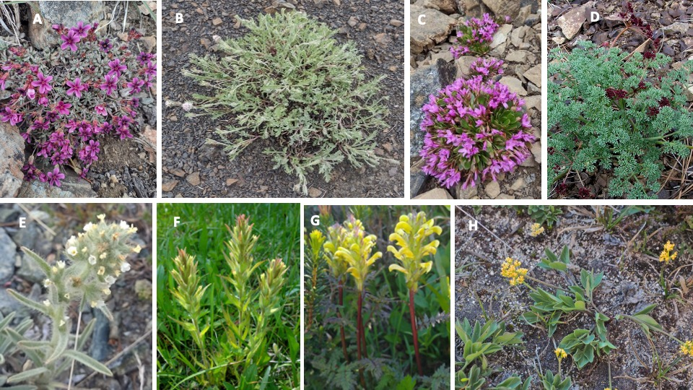

Figure 1. Taxa examined in this study. Images A-E are taxa from Wenatchee Mountains area;
images F-H are taxa from Mount Rainier National Park area. A - Androsace nivalis; B-
Chaenactis thompsonii; C - Claytonia megarhiza var. nivalis; D- Lomatium cuspidatum; E -
Oreocarya thompsonii; F - Castilleja cryptantha; G - Pedicularis rainierensis; H - Tauschia
stricklandii. Photos A, B, C, E, and G by David Giblin; photo D by Don Knoke; photo F by Ben
Legler; photo H by Gary Brill.

APPENDICES
[Figures/tables with captions]

