Men’s Health

Completion of Unit 6 enables you to:
- Describe the pathophysiology and treatment of erectile dysfunction (ED).
- Describe the endocrine components that govern testosterone deficiency.
- Discuss indications and contraindications for testosterone replacement therapy.
- Describe the pathophysiology and treatment of benign prostatic hypertrophy.
- List the causes of male infertility.
- Discuss the pathophysiology and treatment of prostatitis and Urinary Tract Infection (UTI).
- Discuss clinical practice guidelines regarding prostate health.

- Pathophysiology and treatment of erectile dysfunction
Erectile dysfunction arises from disruption of the neurovascular processes required for penile erection. Normal erection depends on coordinated parasympathetic activation, endothelial nitric oxide release, cyclic guanosine monophosphate signaling, cavernosal smooth muscle relaxation, arterial dilation, and veno-occlusive trapping of blood within the corpora cavernosa. Any pathology impairing neural input, vascular inflow, smooth muscle relaxation, or venous occlusion may produce ED.
Vasculogenic ED is the most common etiology and is strongly associated with endothelial dysfunction, atherosclerosis, hypertension, diabetes, dyslipidemia, and smoking. Reduced nitric oxide bioavailability limits smooth muscle relaxation and arterial dilation. Diabetes contributes through microvascular disease and autonomic neuropathy. Neurogenic causes include spinal cord injury, multiple sclerosis, pelvic surgery, and peripheral neuropathy. Hormonal causes involve testosterone deficiency, which reduces libido and modulates nitric oxide synthase activity. Psychogenic factors alter central initiation pathways and often coexist with organic disease. Medication effects, particularly antihypertensives, SSRIs, and antiandrogens, are also important contributors.
Treatment targets underlying mechanisms and modifiable risk factors. First-line therapy typically involves phosphodiesterase type 5 inhibitors, which enhance nitric oxide mediated vasodilation by preventing cGMP degradation. Response requires intact neural and endothelial signaling. Testosterone replacement may be considered when hypogonadism is present. Second-line therapies include intracavernosal vasoactive agents, vacuum erection devices, and intraurethral prostaglandins. Penile prosthesis implantation is reserved for refractory cases. Cardiometabolic optimization, exercise, weight management, and smoking cessation are central to long-term management.
- Endocrine components governing testosterone deficiency
Testosterone production is regulated by the hypothalamic–pituitary–gonadal axis. Gonadotropin releasing hormone from the hypothalamus stimulates pituitary secretion of luteinizing hormone, which drives Leydig cell testosterone synthesis. Follicle stimulating hormone supports spermatogenesis via Sertoli cells. Testosterone exerts negative feedback at both hypothalamic and pituitary levels.
Testosterone deficiency may be primary, secondary, or mixed. Primary hypogonadism reflects testicular failure, characterized by reduced testosterone with elevated luteinizing hormone. Causes include genetic disorders, testicular injury, chemotherapy, infection, and age related Leydig cell dysfunction. Secondary hypogonadism arises from hypothalamic or pituitary dysfunction, producing low testosterone with low or inappropriately normal gonadotropins. Contributing factors include pituitary tumors, hyperprolactinemia, systemic illness, obesity, medications, and functional suppression from chronic disease. Aging commonly produces a combined picture involving reduced Leydig cell responsiveness and altered hypothalamic signaling.
Sex hormone binding globulin strongly influences measured testosterone. Conditions increasing SHBG may mask deficiency, whereas obesity and insulin resistance often lower SHBG, affecting interpretation of total testosterone levels.
- Indications and contraindications for testosterone replacement therapy
Testosterone therapy is indicated in symptomatic men with consistently low serum testosterone confirmed by appropriate biochemical testing. Clinical features include reduced libido, fatigue, decreased muscle mass, anemia, low bone density, and sexual dysfunction. Therapy is intended to restore physiological levels and improve symptoms rather than achieve supraphysiologic concentrations.
Contraindications include known or suspected prostate cancer, male breast cancer, untreated severe obstructive sleep apnea, uncontrolled heart failure, polycythemia, and individuals actively seeking fertility. Testosterone suppresses pituitary gonadotropins, reducing intratesticular testosterone and impairing spermatogenesis. Caution is warranted in patients with cardiovascular disease, thrombotic risk, elevated hematocrit, and significant lower urinary tract symptoms. Monitoring includes testosterone levels, hematocrit, prostate specific antigen, and clinical response.
- Pathophysiology and treatment of benign prostatic hypertrophy
Benign prostatic hypertrophy results from nonmalignant proliferation of stromal and epithelial cells within the prostate, particularly the transition zone. Androgen signaling, specifically dihydrotestosterone, plays a central role in prostatic growth. Enlargement produces bladder outlet obstruction through both static and dynamic mechanisms. Static obstruction reflects increased tissue mass compressing the urethra. Dynamic obstruction arises from smooth muscle tone mediated by alpha adrenergic receptors.
Obstruction increases detrusor workload, leading to hypertrophy, decreased compliance, urgency, frequency, nocturia, weak stream, and incomplete emptying. Chronic obstruction may result in urinary retention, infections, hydronephrosis, and renal impairment.
Treatment strategies depend on symptom severity and complication risk. Alpha adrenergic antagonists reduce smooth muscle tone and improve flow. Five alpha reductase inhibitors decrease conversion of testosterone to dihydrotestosterone, reducing prostate volume over time. Combination therapy is common in moderate to severe disease. Phosphodiesterase type 5 inhibitors may provide adjunctive benefit. Surgical interventions are considered for refractory symptoms or complications.
- Causes of male infertility
Male infertility results from abnormalities in sperm production, function, or delivery. Etiologies include primary testicular failure, genetic disorders, varicocele, hormonal dysregulation, obstruction of the reproductive tract, infection, systemic illness, medications, environmental exposures, and lifestyle factors. Endocrine causes involve disruption of the hypothalamic–pituitary–gonadal axis. Obstructive causes prevent sperm transport despite normal production. Varicocele impairs spermatogenesis through temperature elevation and oxidative stress. Additional contributors include erectile dysfunction, ejaculatory disorders, and immunologic factors.
Evaluation requires hormonal assessment, semen analysis, anatomical assessment, and identification of reversible factors.
- Pathophysiology and treatment of prostatitis and urinary tract infection
Prostatitis encompasses several syndromes with distinct mechanisms. Acute bacterial prostatitis results from ascending infection, typically involving gram negative organisms. Inflammation produces pelvic pain, urinary symptoms, fever, and systemic illness. Chronic bacterial prostatitis involves recurrent infection with bacterial persistence in prostatic tissue. Chronic pelvic pain syndrome involves noninfectious mechanisms including neuromuscular dysfunction, central sensitization, and inflammatory signaling.
Treatment of bacterial forms requires antibiotics with adequate prostatic penetration. Symptom management often includes alpha blockers, anti inflammatory agents, and supportive care. Nonbacterial forms emphasize multimodal pain and symptom management.
Urinary tract infections in males are less common and frequently associated with structural abnormalities, obstruction, catheterization, or prostatitis. Management requires appropriate antimicrobial therapy and evaluation for underlying causes.
- Clinical practice guidelines regarding prostate health
Contemporary prostate health strategies emphasize shared decision making, risk stratification, and avoidance of unnecessary interventions. Screening decisions consider age, life expectancy, family history, ethnicity, and patient preferences. Prostate specific antigen testing remains controversial due to risks of overdiagnosis and overtreatment. Guidelines typically support individualized screening discussions rather than universal testing.
Management of benign prostatic enlargement prioritizes symptom burden and quality of life. Cancer evaluation integrates PSA kinetics, imaging, and biopsy when indicated. Preventive strategies focus on cardiometabolic health, as vascular disease and metabolic dysfunction are strongly linked to both erectile and prostate-related conditions.

Lecture
Gross Anatomy of the Male Reproductive Tract
Note:
- Vas deferens
  - Contains artery, nerve, veing
  - Descends through injuinal canal
- Prostatic urethra
- Testes
  - Surrounded by tough connective tissue sheath
  - Comprised of seminiferous tubules
- Sperm production
  - Contributions from seminal vesicle, prostate, Cowper’s gland
Histophysiology of the Seminiferous Tubules
- Principle Cell Types
  - Spermatogonia
    - Stem cells
  - Spermatocytes, spermatids
    - Immature sperm cells
  - Sertoli cells
    - Supportive, blood-testes barrier
  - Leydig cells
    - Steroid-secreting cells

Endocrine Axes
- Note:
  - The hypothalamus releases gonadotropic releasing hormone (GnRH)
    - This induces the release of LH and FSH from the anterior pituitary gland
  - LH binds to Leydig cells between seminiferous tubules
    - Stimulates testosterone secretion
  - FSH binds to Sertoli cells in the seminiferous tubules
    - Sertoli cells form part of the blood-testes barrier and support spermatogenesis
      - They also secret: androgen binding protein, inhibin (which inhibits FSH)

Relationships Between DHEA, Testosterone, DHT
- Cholesterol, a part of the cell membrane, is transformed via a series of steps into testosterone
  - The first step is the transformation into pregnanolone
    - From there pregnanolone is used as a substrate for production of Progesterone or dehydroepiandrosterone (DHEA)
      - Following the latter, DHEA is converted into androstenedione to testosterone to DHT (dihydrotestosterone)
        - DHT is the more physiologically potent form of testosterone
      - Alternatively, testosterone is converted to estradiol by the enzyme aromatase (CYP19A1)
      - Main sites of conversion in males
        - Adipose tissue (major peripheral source, proportional to fat mass)
        - Testes (Leydig and Sertoli cells contribute locally)
        - Brain and CNS (local conversion important for neuroendocrine and behavioural effects)
        - Bone, skin, and other peripheral tissues (local paracrine/autocrine actions)
      - DHT (Testosterone) binds to androgen receptor, which is a master gene activator
        - Inside cells, testosterone is converted into dehydroepiandosterone (DHT)
        - DHT binds to the androgen receptor
        - The dht-ar complex dimerizes then binds to a reponse elent in several genes
          - This results in gene transcription that ultimately affects several pathways that regulate:
            - Growth
            - PSA
            - Cell survival
- Physical Effects of Testosterone
  - Wide ranging
    - Liver: increased cholesterol, suppression of LDL
    - Cardiovascular: inotropic effects, ECG changes
    - Vascular system: anti-atherosclerotic effects, vasorelaxation, anti-inflammatory effects
    - Renal: increased fluid retention
- Prostate Micro/Macro Anatomy
  - Macro:
    - The prostate sits inferior to the bladder, with the prostatic urethra coursing through it
    - Surrounding the urethra is a narrow periurethral glandular region
    - The central zone of the prostate gland is adjacent and inferior to the periurethral zone
    - The posterior and lateral sides of the periurethral zone are surrounded by the peripheral zone
      - The peripheral zone is the most common site of origin of prostate carcinoma
    - Anterior to the periurethral zone lie the transitional and fibromuscular zones
      - The transitional zone is the usual site of prostatic hyperplasia
  - Micro
    - Glandular tissues in prostate are lined by a double epithelial layer:
      - Inner secretory columnar/cuboidal epithelium that produces prostatic fluid
      - Outer basal cell layer providing structural support and regenerative capacity
      - The stroma contains smooth muscle, fibro blasts, and extracellular matrix that enable contractile expulsion of glandular secretions.
- Prostate Functions
  - Production of prostatic fluids:
    - Kallikreins (inc PSA), citrate, zinc, spermine
    - Prostaglandins (hence prostate)
    - Helps to capacitate mature sperm
  - Microbiome
    - Rich in proprionium sp bacteria
    - Pro inflammatory role? Also present in most prostate ca
- Prostate Histology
  - Typical acinar organization, supporting stroma
  - BPH: hyperplasia of acinar cells
  - Prostate CA: abnormal cells, dysregulated structure, immortalization
  - Prostate inflammation: inflammatory infiltration

Benign Prostatic Hyperplasia
- DHT drives prostatic hyperplasia by activating androgen receptor signaling in both epithelial and stromal cells
- Triggers paracrine stomal-epithelial interactions that favor cell proliferation, reduced apoptosis, extracellular matrix remodeling, and glandular enlargement
- Factors further favoring hyperplasia: fibroblast growth factor, keratinocyte growth factor (produced by stromal cells), insulin like growth factor (DHT enhances IGf-1 activity, IGF-1 reduces apoptosis, increases growth)
- Opposing the effects of DHT: transforming growth factor beta (TGF-B) which sends out antiproliferative signals and opposes the effects of DHT
Presentation of BPH
- Voiding issues:
  - Due to inceeased urethral resistance
    - Weak or slow stream
    - Intermittency
    - Straining to initiate or maintain voiding
    - Sensation of incomplete bladder emptying
- Storage issues:
  - Due to bladder instability and increased residual volumes caused by outlet obstruction
  - Increased daytime frequency
  - Nocturia (waking at night to void often more than 1-2 times)
  - Urgency or urge incontinence
- Other signs:
  - Post-void dribbling, terminal dribbling
  - Recurrent UTI
  - Hematuria
  - Acute urinary retention
Treatment for BPH
- Alpha blockers
  - Relax smooth muscles near prostate
    - Terazosin
    - Tamsulosin
- 5-alpha reductase inhibitors
  - Inhibits transformation testosterone to dihydrotestosterone
    - Finasteride
    - Dutasteride
- Combination therapies
Alpha blocker MOA
- Epinephrine binds to alpha 1 receptors on bladder and prostate smooth muscle
- This activated phospholipase C (PLC)
  - PLC converts phosphatidylinositol 4,5-bisphosphate (PIP2) into inositol 1,4,5 trisphosphate (IP3) and diaxylglycerol (DAG)
  - IP3 triggers release of calcium from the sarcoplasmic reticulum
  - DAG triggers release of calcium from the sarcoplasmic reticulum
  - DAG triggers entry of extracellular calcium
  - Elevated intracellular calcium triggers actin-myosin cross bridge formation and muscl contraction
- Tamsulosin competitively binds to the same alpha 1 adrenoreceptor
  - This inhibits the signaling sequence of contraction
- Reduced DHT lowers intraprostatic and androgen signalling, causing: prostate epithelial and stromal involution, decreased prostate volume, reduced androgenic growth signals
Tamsulosin Side Effects
- Generally well tolerated
- Common SE: dizziness, orthostatic hypotension due to vascular effects, rhinitis, headache, abnormal ejaculation
- Red flags: syncope, priapism
Finasteride Side Effects
- Sexual dysfunction: decreased libido, ED, decreased ejaculatory volume, orgasmic disorder
- Breast changes: gynecomastia, breast tenderness
- Less common: psychiatric: depression, anxiety, mood changes
  - Neurological: cognitive complaints such as memory problems or brian fog, headache
  - MSK: myalgia, muscle weakness, rare reports of serious muscle injury
- Potential persistent effects:
  - Post-finasteride syndrome: persistent sexual, psychological, or cognitive symptoms reported by some med after stopping finasteride, causality and incidence remain unknown
- Lab and screening effects:
  - PSA suppression: serum PSA typically falls on therapy and must be interpreted accordingly for prostate cancer screening
  - Fertility: alteration in semen parameters have been reported in some men
Prostate Cancer
- Epidemiology (Canada 2024)
  - New cases 27900
  - Prostate cancer deaths 5000
  - Screening: prostate specific antigen, digital rectal exam
- Pathophysiology:
  - Prostate carcinogenesis and progression driven by androgen receptor signalling
  - Promotes proliferation and survival
  - Tumours remain AR dependent for many years basis of randrogen-deprivation therapy
  - Genetic basis: several genetic risk factors: loss of tumour suppressors, mutations in TP53 gene, and DNA repair defects (BRCA2)
  - Prostate cancer is genetically and histologically heterogeneous
    - AR targeted therapy can produce resistant subclones
  - Stromal fibroblasts, immune cells, and extracellular matrix provide paracrine signals
    - FGF, IGF, immune cells, and extracellular matrix provide paracrine signals
    - Chronic inflammation and age-related stromal changes are contributing factors
- Prostate Cancer
  - Types:
    - Acenar adenocarcinoma
      - Most dominant type
      - Arises in pancreatic acine
    - Ductal adenocarcinoma
      - Less common, aggressive
    - Neuroendocrine/small cell
      - Rare, aggressive, often androgen-independent
  - Acini are the enlarged glandular portions of the pancreas
    - Cutibacteria often found in protate samples
      - Disease link to BPH and prostate Ca? uncertain
    - Comprised of: acinar (secretory) cells
      - Basal cells, which include stem cells
      - Ductal cells
      - Surrounding stomal cells (non-secretory)
      - Immune cells
  - Treatment
    - Localized:
      - Active surveillance (serial PSA, repeat biopsy)
      - Radical prostatectomy
      - Radiation therapy (beam or brachytherapy)
        - Focal therapies (HIFU or cryotherapy)
    - Metastatic disease:
      - Androgen-deprivation therapy
        - LHRH agonists
        - Systemic agents (docetaxel, AR pathway inhibitors such as abiraterone)
        - Targeted genomic therapies
- Prostatitis
  - SS: difficulty urinating, blood in urine or semen, painful ejaculation or BM, low back pain
  - Predisposing factors: recent UTI, obstruction, biopsy, autoimmune
  - Can be bacterial or non-bacterial
  - Acute or chronic – chronic is persistent or recurrent, bacteria easily sheltered in prostate or by biofilms
    - Etiology:
      - E. coli
      - Less common: klebsiella, Enterobacter, proteus, pseudomonas
      - Categories: 1 (acute bacterial), 2 (chronic bacterial)
  - Chronic pelvic pain syndrome:
    - Category 3. (non-bacterial)
    - More common
    - Multiple factors:
      - Anatomic, neurogenic
      - Urine reflux
      - Medication causes: anticholinergis and antimuscarinics reduce detrusor contraction and can cause urinary retention
        - First generation antihistamines and oral decongestants
        - Anticholinergic or alpha-adrenergic effects
  - Treatment:
    - Non-complicated:
      - Fluoroquinolones
      - Trimethoprim sulfamethoxazole (TMP SMX)
      - 3rd gen cephalosporins
    - Complicated:
      - Abscess: cephalosporin, amp plus gent
      - STI: cephalosporin or doxy
      - Sepsis: fluoroquinolone plus gent
- Testosterone Deficiency Syndrome
  - Due to many trophic actions of testosterone there are wide-ranging effets:
    - Psychological: mood changes, decreased cognitive function
    - Physical: hair loss, gynecomastia, muscle loss, osteoporosis, hot flashes
    - Cardiometabolic: increased BMI, visceral obesity, metabolic syndrome
    - Sexual: infertility, erectile dysfunction
  - Testosterone and aging:
    - Decrease in both free and total testosterone
      - Free testosterone can decrease 50% by age 60
    - Increase in sex hormone binding globulin
      - A compensatory response to decreased testosterone
  - Causes of testosterone deficiency:
    - Primary: decreased free testosterone, increased LH and FSH
      - Congenital: Related to testicular abnormalities: Klinefelter, FHS.LH receptor gene defects, cryptorchidsm
      - Aquired: chemotherapy, STI, hypothyroidism, testicular torsion
    - Secondary:
      - Decreased free testosterone, normal or lower LH and FSH
      - A pathology indirectly affecting the testes,
        - Congenital: prader-willi, Kallman
        - Acquired: opioid use, hyperprolactinemia, pituitary tumours, sleep deprivation
    - Mixed:
      - Decreased free testosterone, variable LH and FSH
        - Acquired: aging, cancer, HIV, glucocorticoid use, cirrhosis
- TDS diagnosis
  - Who to test: malees with unexplained symptoms of androgen deficiency
    - Reduced libido, ED, decreased spontaneous erections, low energy, loss of muscle mass or strength, increased body fat, decreased bone density, depressed mood
  - When to test:
    - Measure morning total testosterone on two separate occasians, with samples drawn fasting and ideally before 10 am
      - If total testosterone is clearly low on repeated testing this confirms biochemical deficiency
      - If borderline: measure calculated or directly measured free testosterone or assess SHBG to clarify androgen status
      - Also measure gonadotropins (LH and FSH) to distinguish primary (hypergonadotrophic) to secondary (hypogonadotropic) and check prolactin when secondary hypogonadism is suspected
      - CUA guidelines use a combination of clinical assessment and lab values rather than a single universal numeric cutoff
        - Very low repeated total testosterone indicated deficiency
        - Borderline = integration of symptoms and free testosterone measurement
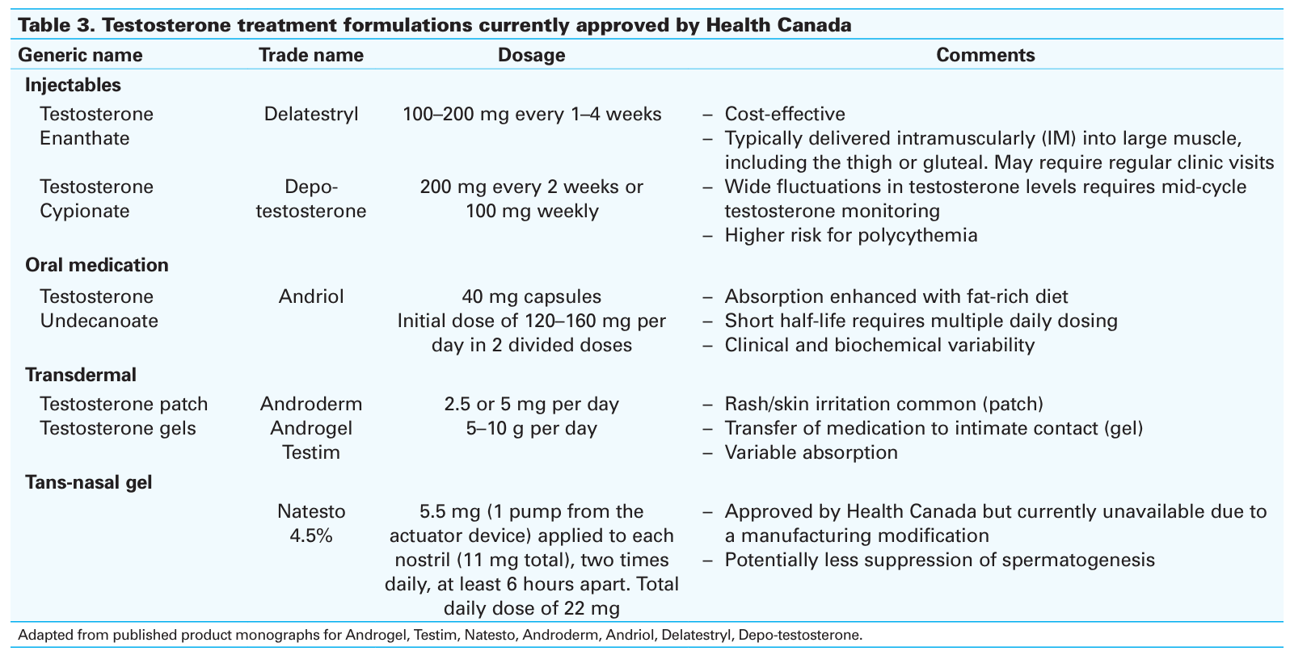
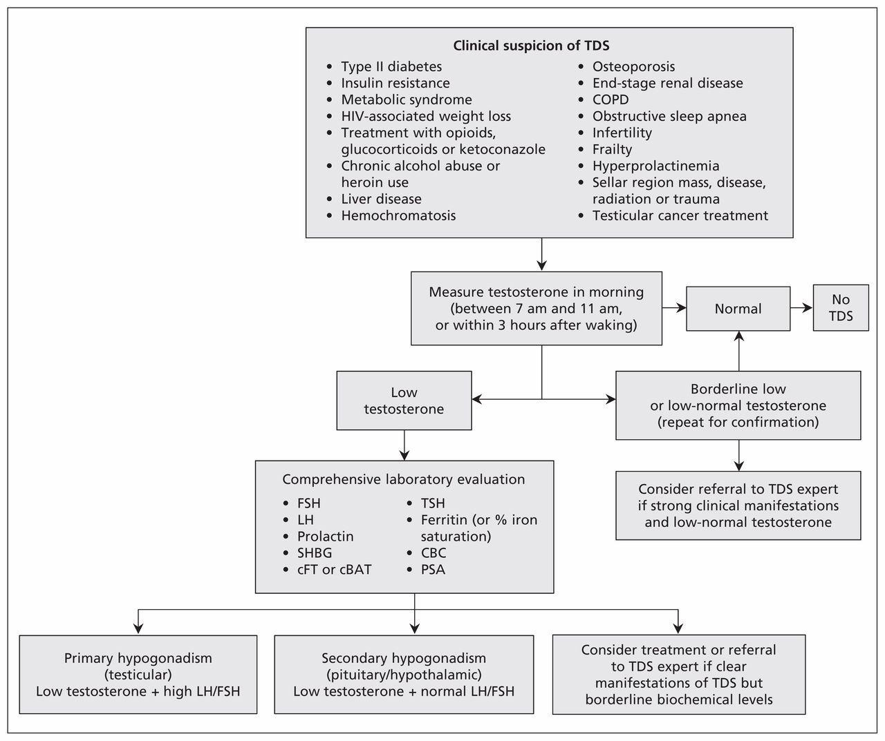
Algorithm for the diagnosis of testosterone deficiency syndrome (TDS).
- While this guideline was first published some time ago, it is still considered relevant
- It also highlights several medical conditions which can raise the clinical suspicion of testosterone deficeincy syndrome, including:
  - Type II diabetes and insulin resistance
  - Metabolic syndrome
  - Liver disease, etc.
- Some highlights include:
  - Measurement early in the morning
  - Lab evaluation for diagnosis of TDS
cBAT = calculated bioavailable testosterone, CBC = complete blood count, cFT = calculated free testosterone, COPD = chronic obstructive pulmonary disease, FSH = follicle-stimulating hormone, LH = luteinizing hormone, PSA = prostate-specific antigen, SHBG = sex hormone–binding globulin, TSH = thyroid-stimulating hormone.

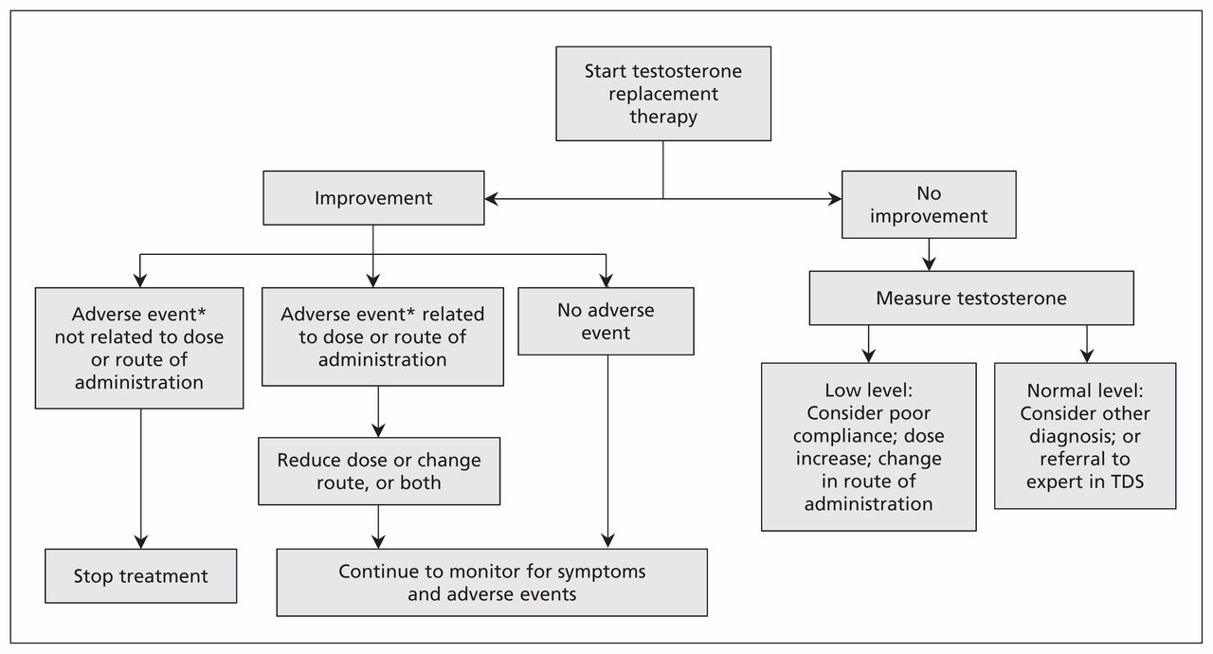
Algorithm for the treatment of testosterone deficiency syndrome (TDS)
- This algorithm highlights the clinical approach after staring testosterone replacement therapy:
  - If symptom improvement:
    - Monitor for adverse events
    - Continue to monitor for symptoms and adverse events
  - If no symptom improvement
    - Measure testosterone
      - If low level:
        - Consider poor compliance;
        - Increase dose;
        - Change route of administration
      - If normal level:
        - Consider other diagnosis or refer to expert in TDS
Risks Associated with Testosterone Therapy
- Evidence is contradictory regarding cardiovascular risks
  - Benefits vs risks
- Cardiovascular risks associated with age
  - Correlation with age
  - Risk is more severe in patients with a previous MI
- Elevated PSA levels
- Polycythemia
- For these reasons, before prescribing testosterone many cliniccians will order:
  - Hematocrit and CBC
  - PSA
  - Liver function tests
  - Cardiovascular assessment
Erectile Dysfunction
Basic Physiology of an Erection
- Complex event
  - Involves psychologic, neurologic, endocrine, vascular, and local anatomic systems
- Originates in higher cortical centers
  - conveyed to hypothalamus then to sacral parasympathetic fibres
- Inhibition of adrenergic fibres
  - results in release of nitric oxide from vascular endothelium
- Nitric oxide decreases muscle tone
  - allows arterial inflow and occlusion of venous outflow to corpora
Role of Nitric Oxide in Erectile Function
- Nerve terminals next to vascular smooth muscle release nitric oxide
  - This is a very soluble, short-lived gas
- This activate guanylate cyclase, a second messenger
  - Guanylate cyclase transforms GTP to cyclic GMP (cGMP)
- cGMP activates cGMP Kinase
  - This blocks potassium efflux and calcium influx to the muscle cell
    - This decrease intracellular calcium
      - In turn causes muscle relaxation and vascular engorgement (erection)
- cGMP is degraded by phosphodiesterase 5 (PDE5) into 5 prime GMP
- PDE5 inhibitors therefore can reduce cGMP degradation
  - This facilitates muscle relaxation and erection
Causes of Erectile Dysfunction
- Failure to initiate:
  - Psychoigenic or neurogenic
- Inflow Failure:
  - Arterial insufficiency
- Outflow issue:
  - Failure to store
  - Venous leak
Risk Factors Associated with Erectile Dysfunction (ED):
- Cardiovascular disease
  - Vascular insufficiency, endothelial dysfunction
- Diabetes
  - Microvascular disease, endothelial dysfunction
- Depression
  - Psychogenic causes, treatment-induced
- Neurologic
  - CVA, MS, PD, spinal cord injury
- Trauma
  - Pelvic nerve injury, radiation
Erectile Dysfunction Treatment Modalities
First-line management
- Lifestyle modification:
  - weight loss, smoking cessation, exercise, alcohol moderation, sleep optimization, and control of diabetes, hypertension, and dyslipidemia
- Pharmacotherapy (first choice):
  - PDE5 inhibitors (sildenafil, tadalafil, vardenafil, avanafil) tailored to onset/duration needs, comorbidities, interactions, and patient preference; titrate to maximum tolerated dose
- Address reversible contributors:
  - stop or change offending medications where possible; treat hypogonadism if diagnosed; manage depression and relationship issues with therapy.
Second-line and salvage options
- Vacuum erection devices (VED):
  - noninvasive, good option when PDE5is contraindicated or ineffective
- Intraurethral alprostadil (MUSE):
  - alternative for men who prefer to avoid injections
- Intracavernosal injection (ICI) therapy:
  - alprostadil or combination (bimix/trimix) for reliable erections; titrated under supervision; educate on technique and priapism risk
Third-line and surgical management
- Penile prosthesis implantation: inflatable or malleable implants for men with refractory ED or when other therapies are unacceptable; high satisfaction in well-selected patients
- Vascular surgery: rarely indicated; considered only in select younger men with focal arterial lesions.
PDE5 Inhibitors
Drug | T_{max} (min) | Half Life  (hours) | Food-Drug Interactions | Dose
Stendra (avanafil) | 30-45 | 5-10 | No | PRN
Viagra (sildenafil) | 60 | 3-5 | Yes (avoid high fat) | PRN
Levitra (vardenafil) | 60 | 4-5 | Yes (avoid high fat) | PRN
Cialis (tadalafil) | 120 | 17.5 | No | Daily or Weekend
PDE5 Inhibitors
- Stendra (avanafil)
  - Tmax: 30-45 min; half life: 5-10 hours); dose: taken when needed (prn)
- Viagra (sildenafil)
  - Tmax: 60 min; half life: 3-5 hours; dose: PRN
  - Avoid high fat food
- Levitra (vardenafil)
  - Tmax: 60 min; half life: 4-5 hours; dose: PRN
  - Avoid high fat foods
- Cialis (tadalafil)
  - Tmax: 120 min; half life: 17.5 hours; dose: daily or weekend
PDE-5 Side Effects
- Decreased blood pressure
- Headache
- flushing (12%-16%)
- nasal congestion (2%-4%)
- gastric reflux
- nausea (5%-7%)
- priapism (very rare)
- leg-buttock pain (vardenafil, tadalafil)
Conclusions
- As with the female reproductive system, regulation of the male reproductive system begins with the HPA axis
  - Includes GnRH, FSH, LH
  - Downstream targets are different
- We have covered a variety of disorders involving men’s health
  - BPH, ED, prostate CA, Prostatitis
- What we have not covered includes a variety systemic issues which affect males in greater proportion to than in females:
  - Gout
  - CAD and MI
  - Autism spectrum disorder, ADHD
  - Hemophilia

