Men’s Health

Completion of Unit 6 enables you to:
- Describe the pathophysiology and treatment of erectile dysfunction (ED).
- Describe the endocrine components that govern testosterone deficiency.
- Discuss indications and contraindications for testosterone replacement therapy.
- Describe the pathophysiology and treatment of benign prostatic hypertrophy.
- List the causes of male infertility.
- Discuss the pathophysiology and treatment of prostatitis and Urinary Tract Infection (UTI).
- Discuss clinical practice guidelines regarding prostate health.

Pathophysiology and treatment of erectile dysfunction
Erectile dysfunction arises from disruption of the neurovascular processes required for penile erection. Normal erection depends on coordinated parasympathetic activation, endothelial nitric oxide release, cyclic guanosine monophosphate signaling, cavernosal smooth muscle relaxation, arterial dilation, and veno-occlusive trapping of blood within the corpora cavernosa. Any pathology impairing neural input, vascular inflow, smooth muscle relaxation, or venous occlusion may produce ED.
Vasculogenic ED is the most common etiology and is strongly associated with endothelial dysfunction, atherosclerosis, hypertension, diabetes, dyslipidemia, and smoking. Reduced nitric oxide bioavailability limits smooth muscle relaxation and arterial dilation. Diabetes contributes through microvascular disease and autonomic neuropathy. Neurogenic causes include spinal cord injury, multiple sclerosis, pelvic surgery, and peripheral neuropathy. Hormonal causes involve testosterone deficiency, which reduces libido and modulates nitric oxide synthase activity. Psychogenic factors alter central initiation pathways and often coexist with organic disease. Medication effects, particularly antihypertensives, SSRIs, and antiandrogens, are also important contributors.
Treatment targets underlying mechanisms and modifiable risk factors. First-line therapy typically involves phosphodiesterase type 5 inhibitors, which enhance nitric oxide mediated vasodilation by preventing cGMP degradation. Response requires intact neural and endothelial signaling. Testosterone replacement may be considered when hypogonadism is present. Second-line therapies include intracavernosal vasoactive agents, vacuum erection devices, and intraurethral prostaglandins. Penile prosthesis implantation is reserved for refractory cases. Cardiometabolic optimization, exercise, weight management, and smoking cessation are central to long-term management.
Endocrine components governing testosterone deficiency
Testosterone production is regulated by the hypothalamic–pituitary–gonadal axis. Gonadotropin releasing hormone from the hypothalamus stimulates pituitary secretion of luteinizing hormone, which drives Leydig cell testosterone synthesis. Follicle stimulating hormone supports spermatogenesis via Sertoli cells. Testosterone exerts negative feedback at both hypothalamic and pituitary levels.
Testosterone deficiency may be primary, secondary, or mixed. Primary hypogonadism reflects testicular failure, characterized by reduced testosterone with elevated luteinizing hormone. Causes include genetic disorders, testicular injury, chemotherapy, infection, and age related Leydig cell dysfunction. Secondary hypogonadism arises from hypothalamic or pituitary dysfunction, producing low testosterone with low or inappropriately normal gonadotropins. Contributing factors include pituitary tumors, hyperprolactinemia, systemic illness, obesity, medications, and functional suppression from chronic disease. Aging commonly produces a combined picture involving reduced Leydig cell responsiveness and altered hypothalamic signaling.
Sex hormone binding globulin strongly influences measured testosterone. Conditions increasing SHBG may mask deficiency, whereas obesity and insulin resistance often lower SHBG, affecting interpretation of total testosterone levels.
ndications and contraindications for testosterone replacement therapy
Testosterone therapy is indicated in symptomatic men with consistently low serum testosterone confirmed by appropriate biochemical testing. Clinical features include reduced libido, fatigue, decreased muscle mass, anemia, low bone density, and sexual dysfunction. Therapy is intended to restore physiological levels and improve symptoms rather than achieve supraphysiologic concentrations.
Contraindications include known or suspected prostate cancer, male breast cancer, untreated severe obstructive sleep apnea, uncontrolled heart failure, polycythemia, and individuals actively seeking fertility. Testosterone suppresses pituitary gonadotropins, reducing intratesticular testosterone and impairing spermatogenesis. Caution is warranted in patients with cardiovascular disease, thrombotic risk, elevated hematocrit, and significant lower urinary tract symptoms. Monitoring includes testosterone levels, hematocrit, prostate specific antigen, and clinical response.
Pathophysiology and treatment of benign prostatic hypertrophy
Benign prostatic hypertrophy results from nonmalignant proliferation of stromal and epithelial cells within the prostate, particularly the transition zone. Androgen signaling, specifically dihydrotestosterone, plays a central role in prostatic growth. Enlargement produces bladder outlet obstruction through both static and dynamic mechanisms. Static obstruction reflects increased tissue mass compressing the urethra. Dynamic obstruction arises from smooth muscle tone mediated by alpha adrenergic receptors.
Obstruction increases detrusor workload, leading to hypertrophy, decreased compliance, urgency, frequency, nocturia, weak stream, and incomplete emptying. Chronic obstruction may result in urinary retention, infections, hydronephrosis, and renal impairment.
Treatment strategies depend on symptom severity and complication risk. Alpha adrenergic antagonists reduce smooth muscle tone and improve flow. Five alpha reductase inhibitors decrease conversion of testosterone to dihydrotestosterone, reducing prostate volume over time. Combination therapy is common in moderate to severe disease. Phosphodiesterase type 5 inhibitors may provide adjunctive benefit. Surgical interventions are considered for refractory symptoms or complications.
Causes of male infertility
Male infertility results from abnormalities in sperm production, function, or delivery. Etiologies include primary testicular failure, genetic disorders, varicocele, hormonal dysregulation, obstruction of the reproductive tract, infection, systemic illness, medications, environmental exposures, and lifestyle factors. Endocrine causes involve disruption of the hypothalamic–pituitary–gonadal axis. Obstructive causes prevent sperm transport despite normal production. Varicocele impairs spermatogenesis through temperature elevation and oxidative stress. Additional contributors include erectile dysfunction, ejaculatory disorders, and immunologic factors.
Evaluation requires hormonal assessment, semen analysis, anatomical assessment, and identification of reversible factors.
Pathophysiology and treatment of prostatitis and urinary tract infection
Prostatitis encompasses several syndromes with distinct mechanisms. Acute bacterial prostatitis results from ascending infection, typically involving gram negative organisms. Inflammation produces pelvic pain, urinary symptoms, fever, and systemic illness. Chronic bacterial prostatitis involves recurrent infection with bacterial persistence in prostatic tissue. Chronic pelvic pain syndrome involves noninfectious mechanisms including neuromuscular dysfunction, central sensitization, and inflammatory signaling.
Treatment of bacterial forms requires antibiotics with adequate prostatic penetration. Symptom management often includes alpha blockers, anti inflammatory agents, and supportive care. Nonbacterial forms emphasize multimodal pain and symptom management.
Urinary tract infections in males are less common and frequently associated with structural abnormalities, obstruction, catheterization, or prostatitis. Management requires appropriate antimicrobial therapy and evaluation for underlying causes.
Clinical practice guidelines regarding prostate health
Contemporary prostate health strategies emphasize shared decision making, risk stratification, and avoidance of unnecessary interventions. Screening decisions consider age, life expectancy, family history, ethnicity, and patient preferences. Prostate specific antigen testing remains controversial due to risks of overdiagnosis and overtreatment. Guidelines typically support individualized screening discussions rather than universal testing.
Management of benign prostatic enlargement prioritizes symptom burden and quality of life. Cancer evaluation integrates PSA kinetics, imaging, and biopsy when indicated. Preventive strategies focus on cardiometabolic health, as vascular disease and metabolic dysfunction are strongly linked to both erectile and prostate-related conditions.

Lecture
Gross Anatomy of the Male Reproductive Tract
Note:
- Vas deferens
  - Contains artery, nerve, vein
  - Descends through injuinal canal
- Prostatic urethra
- Testes
  - Surrounded by tough connective tissue sheath
  - Comprised of seminiferous tubules
  - Site of sperm production
- Sperm production
  - Contributions from seminal vesicle, prostate, Cowper’s gland
Histophysiology of the Seminiferous Tubules
- Principle Cell Types
  - Spermatogonia
    - Stem cells
  - Spermatocytes, spermatids
    - Immature sperm cells
  - Sertoli cells – somatic cell
    - Supportive, blood-testes barrier
  - Leydig cells
    - Steroid-secreting cells androgens

Endocrine Axes
- Note:
  - The hypothalamus releases gonadotropic releasing hormone (GnRH)
    - This induces the release of LH and FSH from the anterior pituitary gland
  - LH binds to Leydig cells between seminiferous tubules
    - Stimulates testosterone secretion
  - FSH binds to Sertoli cells in the seminiferous tubules
    - Sertoli cells form part of the blood-testes barrier and support spermatogenesis
      - They also secret: androgen binding protein, inhibin (which inhibits FSH by negative feedback)

Relationships Between DHEA, Testosterone, DHT
- Cholesterol, a part of the cell membrane, is transformed via a series of steps into testosterone
  - The first step is the transformation into pregnanolone
    - From there pregnanolone is used as a substrate for production of Progesterone or dehydroepiandrosterone (DHEA) (progesterone can also be a precursor to aldosterone and cortisol)
      - Following the latter, DHEA is converted into androstenedione to testosterone to DHT (dihydrotestosterone)
        - DHT is the more physiologically potent form of testosterone
      - Alternatively, testosterone is converted to estradiol by the enzyme aromatase (CYP19A1)
      - Main sites of conversion in males
        - Adipose tissue (major peripheral source, proportional to fat mass)
        - Testes (Leydig and Sertoli cells contribute locally)
        - Brain and CNS (local conversion important for neuroendocrine and behavioural effects)
        - Bone, skin, and other peripheral tissues (local paracrine/autocrine actions)
      - DHT (Testosterone) binds to androgen receptor, which is a master gene activator
        - Inside cells, testosterone is converted into dehydroepiandosterone (DHT)
        - DHT binds to the androgen receptor
        - The dht-ar complex dimerizes then binds to a response elent in several genes
          - This results in gene transcription that ultimately affects several pathways that regulate:
            - Growth
            - PSA
            - Cell survival
- Physical Effects of Testosterone
  - Wide ranging
    - Liver: increased cholesterol, suppression of LDL
    - Cardiovascular: inotropic effects, ECG changes
    - Vascular system: anti-atherosclerotic effects, vasorelaxation, anti-inflammatory effects
    - Renal: increased fluid retention
    - Increases expression of SCARB1, inscreases hepatic cholesterol deposition, suppression of LDL, inhibition of leptin
    - ECG changes: elongation of T-wave, shortening of QT interval
    - Vasoreaxation: relaxation of smooth muscles through voltage and calcium dependent potassium channels, activating endothelial nNOS, blockage of L and T type calcium channels
    - Positive inotropic effect: increased contractility of cardiomyocytes, increased velocity of ventricular contraction, delayed relaxation phase
    - Fluid retention: increased fluid retention due to higher expression of sodium/hydrogen exchanger, aquaporin 1
    - Anti-inflammatory effect: inhibits TNF-a, IL6, VAM1, induces IL10
    - Antiatheroscolerotic effect

Prostate Micro/Macro Anatomy
  - Macro:
    - The prostate sits inferior to the bladder, with the prostatic urethra coursing through it
    - Surrounding the urethra is a narrow periurethral glandular region
    - The central zone of the prostate gland is adjacent and inferior to the periurethral zone
    - The posterior and lateral sides of the periurethral zone are surrounded by the peripheral zone
      - The peripheral zone is the most common site of origin of prostate carcinoma
    - Anterior to the periurethral zone lie the transitional and fibromuscular zones
      - The transitional zone is the usual site of prostatic hyperplasia
  - Micro
    - Glandular tissues in prostate are lined by a double epithelial layer:
      - Inner secretory columnar/cuboidal epithelium that produces prostatic fluid
      - Outer basal cell layer providing structural support and regenerative capacity
      - The stroma contains smooth muscle, fibro blasts, and extracellular matrix that enable contractile expulsion of glandular secretions.
- Prostate Functions
  - Production of prostatic fluids:
    - Kallikreins (inc PSA), citrate, zinc, spermine
    - Prostaglandins (hence prostate)
    - Helps to capacitate mature sperm
  - Microbiome
    - Rich in proprionium sp bacteria cutibacterium we often find this in prostate biopsies, especially in cancers is it proinflammatory?
    - Pro inflammatory role? Also present in most prostate ca
- Prostate Histology
  - Typical acinar organization, supporting stroma
  - BPH: hyperplasia of acinar cells
  - Prostate CA: abnormal cells, dysregulated structure, immortalization
  - Prostate inflammation: inflammatory infiltration

Benign Prostatic Hyperplasia
- DHT drives prostatic hyperplasia by activating androgen receptor signaling in both epithelial and stromal cells
- Triggers paracrine stomal-epithelial interactions that favor cell proliferation, reduced apoptosis, extracellular matrix remodeling, and glandular enlargement
- Factors further favoring hyperplasia: fibroblast growth factor, keratinocyte growth factor (produced by stromal cells), insulin like growth factor (DHT enhances IGf-1 activity, IGF-1 reduces apoptosis, increases growth)
- Opposing the effects of DHT: transforming growth factor beta (TGF-B) which sends out antiproliferative signals and opposes the effects of DHT
Presentation of BPH
- A matter of balance between cell proliferation and cell death
- DHT causes cell proliferation and is favoured by FGF, KGF, IGF which lead to hyperplasia with androgens but DHT can also lead towards cell death with TGF --? Leads to normoplasia
- Voiding issues:
  - Due to increased urethral resistance
    - Weak or slow stream
    - Intermittency
    - Straining to initiate or maintain voiding
    - Sensation of incomplete bladder emptying
- Storage issues:
  - Due to bladder instability and increased residual volumes caused by outlet obstruction
  - Increased daytime frequency
  - Nocturia (waking at night to void often more than 1-2 times)
  - Urgency or urge incontinence
- Other signs:
  - Post-void dribbling, terminal dribbling
  - Recurrent UTI
  - Hematuria
  - Acute urinary retention
Treatment for BPH
- Alpha blockers – act quickly and open up the plumbing, relax smooth muscles
  - Relax smooth muscles near prostate
    - Terazosin
    - Tamsulosin
- 5-alpha reductase inhibitors – helps prevent progression of the disease
  - Inhibits transformation testosterone to dihydrotestosterone
    - Finasteride
    - Dutasteride
- Combination therapies
Alpha blocker MOA
- Epinephrine binds to alpha 1 receptor on bladder and prostate smooth muscle
- This activated phospholipase C (PLC)
- Competitive antagonistic effect on smooth muscle cells
  - PLC converts phosphatidylinositol 4,5-bisphosphate (PIP2) into inositol 1,4,5 trisphosphate (IP3- Regulates contractility) and diaxylglycerol (DAG)
  - IP3 triggers release of calcium from the sarcoplasmic reticulum
  - DAG triggers release of calcium from the sarcoplasmic reticulum
  - DAG triggers entry of extracellular calcium
  - Elevated intracellular calcium triggers actin-myosin cross bridge formation and muscle contraction
- Tamsulosin competitively binds to the same alpha 1 adrenoreceptor
  - This inhibits the signaling sequence of contraction, limits IP3, limits amount of calcium coming in limits contraction
- Reduced DHT lowers intraprostatic and androgen signalling, causing: prostate epithelial and stromal involution, decreased prostate volume, reduced androgenic growth signals
5-Alpha Reductase Inhibitors MOA
- Finasteride, dutasteride (inhibits formation of DHT)
- Blocks the enzyme 5-alpha reductase
- 5 alpha reductase converts testosterone into more portent DHT
- Reduced DHT lowers intraprostatic androgen signalling which causes: prostate epithelial and stromal involution, decreased prostate volume, reduced androgenic growth signals
Tamsulosin Side Effects
- Generally well tolerated
- Common SE: dizziness due to alpha 1 effects, orthostatic hypotension due to vascular effects, rhinitis, headache, abnormal ejaculation
- Red flags: syncope, priapism
Finasteride Side Effects
- Sexual dysfunction: decreased libido, ED, decreased ejaculatory volume, orgasmic disorder
- Breast changes: gynecomastia, breast tenderness
- Less common: psychiatric: depression, anxiety, mood changes
  - Neurological: cognitive complaints such as memory problems or brian fog, headache
  - MSK: myalgia, muscle weakness, rare reports of serious muscle injury
- Potential persistent effects:
  - Post-finasteride syndrome: persistent sexual, psychological, or cognitive symptoms reported by some med after stopping finasteride, causality and incidence remain unknown
- Lab and screening effects:
  - PSA suppression: serum PSA typically falls on therapy and must be interpreted accordingly for prostate cancer screening
  - Fertility: alteration in semen parameters have been reported in some men
Prostate Cancer
- Epidemiology (Canada 2024)
  - New cases 27900
  - Prostate cancer deaths 5000
  - Screening: prostate specific antigen, digital rectal exam
- Pathophysiology:
  - Prostate carcinogenesis and progression driven by androgen receptor signalling
  - Promotes proliferation and survival
  - Tumours remain AR dependent for many years basis of androgen-deprivation therapy
  - Genetic basis: several genetic risk factors: loss of tumour suppressors, mutations in TP53 gene, and DNA repair defects (BRCA2)
  - Prostate cancer is genetically and histologically heterogeneous
    - AR targeted therapy can produce resistant subclones
  - Stromal fibroblasts, immune cells, and extracellular matrix provide paracrine signals
    - FGF, IGF, immune cells, and extracellular matrix provide paracrine signals
    - Chronic inflammation and age-related stromal changes are contributing factors
- Prostate Cancer
  - Types:
    - Acinar adenocarcinoma
      - Most dominant type
      - Arises in pancreatic acini
    - Ductal adenocarcinoma
      - Less common, aggressive
    - Neuroendocrine/small cell
      - Rare, aggressive, often androgen-independent
  - Acini are the enlarged glandular portions of the pancreas
    - Cutibacteria often found in prostate samples
      - Disease link to BPH and prostate Ca? uncertain
    - Comprised of: acinar (secretory) cells
      - Basal cells, which include stem cells
      - Ductal cells
      - Surrounding stomal cells (non-secretory)
      - Immune cells
  - Treatment
    - Localized:
      - Active surveillance (serial PSA, repeat biopsy)
      - Radical prostatectomy
      - Radiation therapy (beam or brachytherapy)
        - Focal therapies (HIFU or cryotherapy)
    - Metastatic disease:
      - Androgen-deprivation therapy
        - LHRH agonists
        - Systemic agents (docetaxel, AR pathway inhibitors such as abiraterone)
        - Targeted genomic therapies
- Prostatitis
  - SS: difficulty urinating, blood in urine or semen, painful ejaculation or BM, low back pain
  - Predisposing factors: recent UTI, obstruction, catheterization, biopsy, autoimmune (HIV)
  - Can be bacterial or non-bacterial
  - Acute or chronic – chronic is persistent or recurrent, bacteria easily sheltered in prostate or by biofilms
    - Etiology:
      - E. coli
      - Less common: klebsiella, Enterobacter, proteus, pseudomonas
      - Categories: 1 (acute bacterial), 2 (chronic bacterial)
  - Chronic pelvic pain syndrome:
    - Category 3. (non-bacterial)
    - More common
    - Multiple factors:
      - Anatomic, neurogenic
      - Urine reflux
      - Medication causes: anticholinergis and antimuscarinics reduce detrusor contraction and can cause urinary retention
        - First generation antihistamines and oral decongestants
        - Anticholinergic or alpha-adrenergic effects
  - Treatment:
    - Non-complicated:
      - Fluoroquinolones
      - Trimethoprim sulfamethoxazole (TMP SMX)
      - 3rd gen cephalosporins
    - Complicated:
      - Abscess: cephalosporin, amp plus gent
      - STI: cephalosporin or doxy
      - Sepsis: fluoroquinolone plus gent
- Testosterone Deficiency Syndrome
  - Due to many trophic actions of testosterone there are wide-ranging effects:
    - Psychological: mood changes, decreased cognitive function
    - Physical: hair loss, gynecomastia, muscle loss, osteoporosis, hot flashes
    - Cardiometabolic: increased BMI, visceral obesity, metabolic syndrome
    - Sexual: infertility, erectile dysfunction
  - Testosterone and aging:
    - Decrease in both free and total testosterone
      - Free testosterone can decrease 50% by age 60
    - Increase in sex hormone binding globulin
      - A compensatory response to decreased testosterone – one thing we want to measure in understanding the pathogenesis of testosterone deficiency but decreased testosterone is a normal part of aging
  - Causes of testosterone deficiency:
    - Primary: decreased free testosterone, increased LH and FSH
      - Congenital: Related to testicular abnormalities: Klinefelter, FHS/LH receptor gene defects, cryptorchidism
      - Acquired: chemotherapy, STI, hypothyroidism, testicular torsion
    - Secondary:
      - Decreased free testosterone, normal or lower LH and FSH
      - A pathology indirectly affecting the testes,
        - Congenital: Prader Willi, Kallman
        - Acquired: opioid use, hyperprolactinemia, pituitary tumours, sleep deprivation
    - Mixed:
      - Decreased free testosterone, variable LH and FSH
        - Acquired: aging, cancer, HIV, glucocorticoid use, cirrhosis
- TDS diagnosis
  - Who to test: males with unexplained symptoms of androgen deficiency
    - Reduced libido, ED, decreased spontaneous erections, low energy, loss of muscle mass or strength, increased body fat, decreased bone density, depressed mood
  - When to test:
    - Measure morning total testosterone on two separate occasions, with samples drawn fasting and ideally before 10 am
      - If total testosterone is clearly low on repeated testing this confirms biochemical deficiency
      - If borderline: measure calculated or directly measured free testosterone or assess SHBG to clarify androgen status
      - Also measure gonadotropins (LH and FSH) to distinguish primary (hypergonadotropic) to secondary (hypogonadotropic) and check prolactin when secondary hypogonadism is suspected
      - CUA guidelines use a combination of clinical assessment and lab values rather than a single universal numeric cutoff
        - Very low repeated total testosterone indicated deficiency
        - Borderline = integration of symptoms and free testosterone measurement
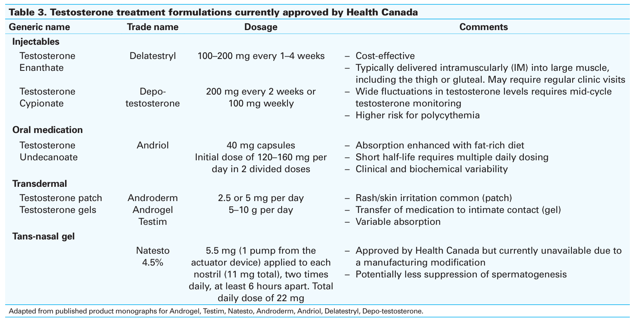
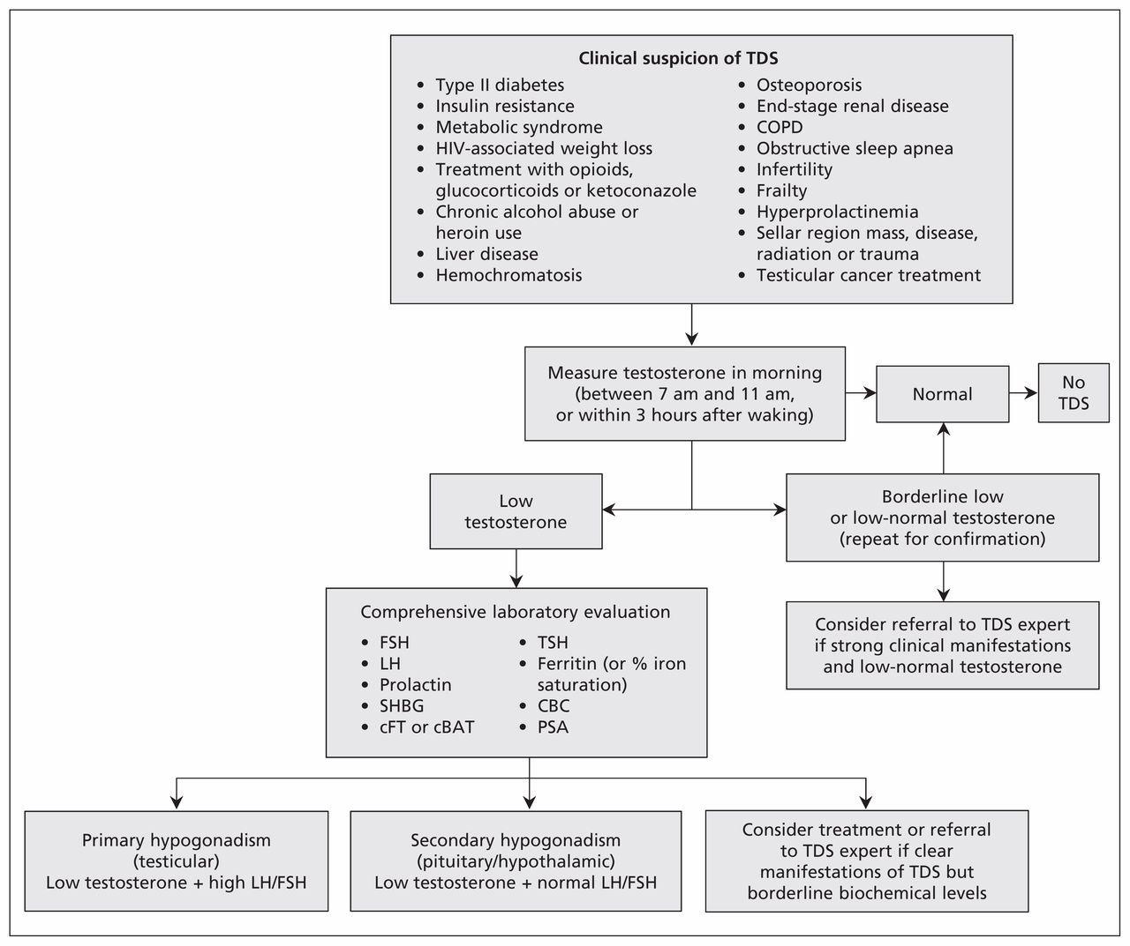
Algorithm for the diagnosis of testosterone deficiency syndrome (TDS).
- While this guideline was first published some time ago, it is still considered relevant
- It also highlights several medical conditions which can raise the clinical suspicion of testosterone deficeincy syndrome, including:
  - Type II diabetes and insulin resistance
  - Metabolic syndrome
  - Liver disease, etc.
- Some highlights include:
  - Measurement early in the morning
  - Lab evaluation for diagnosis of TDS
cBAT = calculated bioavailable testosterone, CBC = complete blood count, cFT = calculated free testosterone, COPD = chronic obstructive pulmonary disease, FSH = follicle-stimulating hormone, LH = luteinizing hormone, PSA = prostate-specific antigen, SHBG = sex hormone–binding globulin, TSH = thyroid-stimulating hormone.

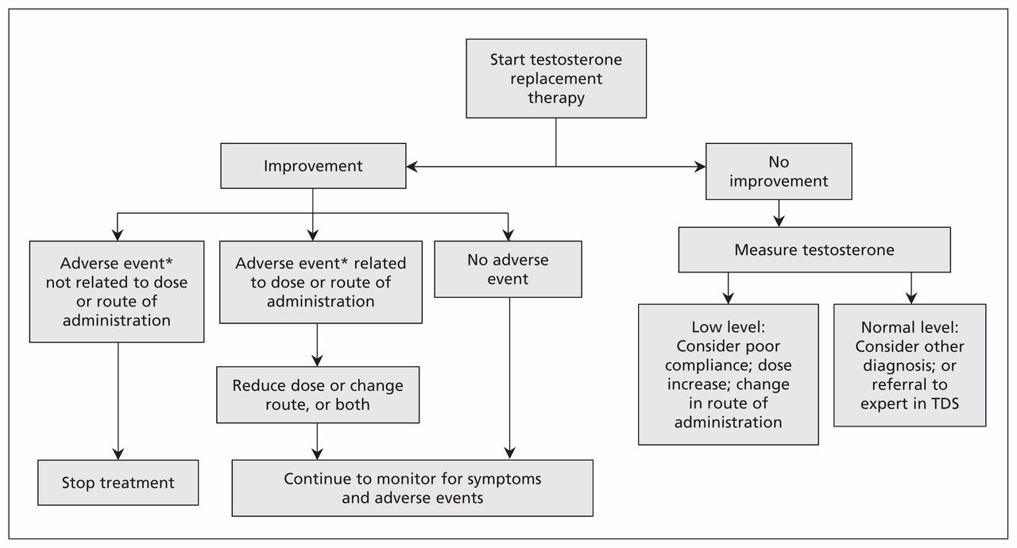
Algorithm for the treatment of testosterone deficiency syndrome (TDS)
- This algorithm highlights the clinical approach after staring testosterone replacement therapy:
  - If symptom improvement:
    - Monitor for adverse events
    - Continue to monitor for symptoms and adverse events
  - If no symptom improvement
    - Measure testosterone
      - If low level:
        - Consider poor compliance;
        - Increase dose;
        - Change route of administration
      - If normal level:
        - Consider other diagnosis or refer to expert in TDS
Risks Associated with Testosterone Therapy
- Evidence is contradictory regarding cardiovascular risks
  - Benefits vs risks
- Cardiovascular risks associated with age
  - Correlation with age
  - Risk is more severe in patients with a previous MI
- Elevated PSA levels
- Polycythemia
- For these reasons, before prescribing testosterone many cliniccians will order:
  - Hematocrit and CBC
  - PSA
  - Liver function tests
  - Cardiovascular assessment
Erectile Dysfunction
Basic Physiology of an Erection
- Complex event
  - Involves psychologic, neurologic, endocrine, vascular, and local anatomic systems
- Originates in higher cortical centers - conveyed to hypothalamus then to sacral parasympathetic fibres
- Inhibition of adrenergic fibres
  - results in release of nitric oxide from vascular endothelium
- Nitric oxide decreases muscle tone
  - allows arterial inflow and occlusion of venous outflow to corpora
Role of Nitric Oxide in Erectile Function
- Nerve terminals next to vascular smooth muscle release nitric oxide
  - This is a very soluble, short-lived gas
- This activate guanylate cyclase, a second messenger
  - Guanylate cyclase transforms GTP to cyclic GMP (cGMP)
- cGMP activates cGMP Kinase (tacks a phosphate onto something)
  - This blocks potassium efflux and calcium influx to the muscle cell
    - This decrease intracellular calcium
      - In turn causes muscle relaxation and vascular engorgement (erection)
- cGMP is degraded by phosphodiesterase 5 (PDE5) into 5 prime GMP
- PDE5 inhibitors therefore can reduce cGMP degradation
  - This facilitates muscle relaxation and erection
Causes of Erectile Dysfunction
- Failure to initiate: Psychogenic or neurogenic
- Inflow Failure: Arterial insufficiency pharmacotherapy targets this
- Outflow issue: Failure to store, venous leak
Risk Factors Associated with Erectile Dysfunction (ED):
- Cardiovascular disease: Vascular insufficiency, endothelial dysfunction
- Diabetes: Microvascular disease, endothelial dysfunction
- Depression: Psychogenic causes, treatment-induced
- Neurologic: CVA, MS, PD, spinal cord injury
- Trauma: Pelvic nerve injury, radiation
Erectile Dysfunction Treatment Modalities
First-line management
- Lifestyle modification:
  - weight loss, smoking cessation, exercise, alcohol moderation, sleep optimization, and control of diabetes, hypertension, and dyslipidemia
- Pharmacotherapy (first choice):
  - PDE5 inhibitors (sildenafil, tadalafil, vardenafil, avanafil) tailored to onset/duration needs, comorbidities, interactions, and patient preference; titrate to maximum tolerated dose
- Address reversible contributors:
  - stop or change offending medications where possible; treat hypogonadism if diagnosed; manage depression and relationship issues with therapy.
Second-line and salvage options
- Vacuum erection devices (VED):
  - noninvasive, good option when PDE5is contraindicated or ineffective
- Intraurethral alprostadil (MUSE):
  - alternative for men who prefer to avoid injections
- Intracavernosal injection (ICI) therapy:
  - alprostadil or combination (bimix/trimix) for reliable erections; titrated under supervision; educate on technique and priapism risk
Third-line and surgical management
- Penile prosthesis implantation: inflatable or malleable implants for men with refractory ED or when other therapies are unacceptable; high satisfaction in well-selected patients
- Vascular surgery: rarely indicated; considered only in select younger men with focal arterial lesions.
PDE5 Inhibitors
Drug | T_{max} (min) | Half Life  (hours) | Food-Drug Interactions | Dose
Stendra (avanafil) | 30-45 | 5-10 | No – take when needed | PRN
Viagra (sildenafil) | 60 | 3-5 | Yes (avoid high fat) | PRN
Levitra (vardenafil) | 60 | 4-5 | Yes (avoid high fat) | PRN
Cialis (tadalafil) | 120 | 17.5 | No – taken daily or weekend | Daily or Weekend
PDE5 Inhibitors
- Stendra (avanafil)
  - Tmax: 30-45 min; half life: 5-10 hours); dose: taken when needed (prn)
- Viagra (sildenafil)
  - Tmax: 60 min; half life: 3-5 hours; dose: PRN
  - Avoid high fat food
- Levitra (vardenafil)
  - Tmax: 60 min; half life: 4-5 hours; dose: PRN
  - Avoid high fat foods
- Cialis (tadalafil)
  - Tmax: 120 min; half life: 17.5 hours; dose: daily or weekend
PDE-5 Side Effects
- Decreased blood pressure
- Headache
- flushing (12%-16%)
- nasal congestion (2%-4%)
- gastric reflux
- nausea (5%-7%)
- priapism (very rare) – blood pooling for long periods of time
- leg-buttock pain (vardenafil, tadalafil)
Conclusions
- As with the female reproductive system, regulation of the male reproductive system begins with the HPA axis
  - Includes GnRH, FSH, LH
  - Downstream targets are different
- We have covered a variety of disorders involving men’s health
  - BPH, ED, prostate CA, Prostatitis
- What we have not covered includes a variety systemic issues which affect males in greater proportion to than in females:
  - Gout
  - CAD and MI
  - Autism spectrum disorder, ADHD
  - Hemophilia

Erectile Dysfunction
According to some studies, 49.4% of men over 40 had erectile dysfunction (ED). This could, in fact, be an underestimate, given the difficulty some male patients have in discussing the topic. For a practitioner to manage this issue successfully, an understanding of the mechanisms and hemodynamics of erection and tumescence is useful.
From a hemodynamic perspective, penile erection is a complex process involving mechanical, physiological, and psychological elements. It is beyond our scope here to discuss all of these, and so we restrict this discussion to the physiology of erectile failure. The penis has three columns of erectile, or cavernous tissue: two columns of corpora cavernosa, and the corpus spongiosum, which surrounds the urethra and is continuous with the glans penis. To begin, neuroendocrine signals from the brain, created by audiovisual, tactile, and/or other stimuli generate nerve action potentials along the cavernosal nerve to the erectile tissue, initiating a veno-occlusive mechanism; this also triggers increased arterial flow into the sinusoids of the cavernosal tissue, compressing venous plexes and further preventing venous outflow. As this demonstrates, there are neuroendocrine and vascular elements to an erection.
It is worth understanding some of the molecules involved in these events, because this helps clarify the roles of pharmacologic therapies useful in treating ED. Nitric oxide (NO) is a potent signaling molecule released by neurons and endothelial cells. NO activates guanylate cyclase, which converts guanosine triphosphate (GTP) to cyclic guanosine monophosphate (cGMP), an active second messenger. cGMP reduces intracellular calcium, causing smooth muscle relaxation in arterioles supplying the cavernosa, increasing arteriolar blood flow to the cavernosa, and compressing penile venous plexes. Working against this mechanism is an enzyme, phosphodiesterase E5 (PDE5), which converts cGMP to 5’GMP, an inactive form of the molecule (see Figure 6).
Figure 6:
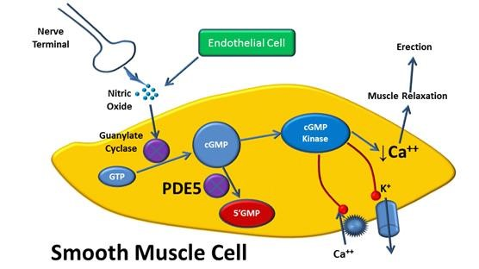Note. Effects of nitric oxide and PDE5 on vascular smooth muscle (© W. Diehl-Jones)
We can simplify our view of the pathophysiology of ED as a failure of one or more of the following (see Figure 7).
Figure 7:
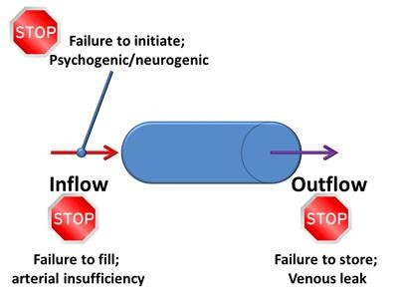Note. Vascular basis of erectile dysfunction (© W. Diehl-Jones)
The following drug classes may be used to treat ED:
- PDE-5 inhibitors (e.g., Sildenafil or Viagra)
- vasodilators (e.g., alprostadil or Caverject)
- androgens (e.g., testosterone or AndroGel)

Andropause (Testosterone Deficiency Syndrome)
The term, menopause, refers to the cessation of menstruation in women between the ages of 45–45, and which is caused by age-associated changes in gonadal steroids. In men, there are also age-related changes in the secretion of gonadal hormones, in men’s case, testosterone, and also linked to both physiological and physical changes.
Pathophysiology. At the onset of adolescence, the hypothalamus produces gonadotropin releasing hormone (GnRH) which triggers the anterior pituitary to produce luteinizing hormone (LH) and follicle stimulating hormone (FHS). In males, rather than stimulating theca and granulosa cells, FSH stimulates sertoli cells in the testes to produce androgen-binding protein (ABP), which stimulates spermatogenesis and inhibin, which inhibits FSH production; LH stimulates steroid-producing cells (leydig cells) to produce testosterone (see Figure 8).
Figure 8:
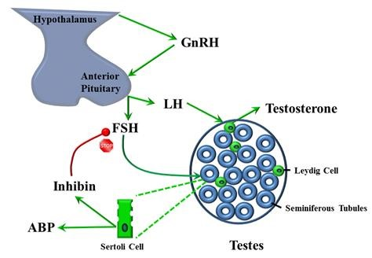Note. Hypothalamic-pituitary-testicular axis (© W. Diehl-Jones)
During aging, it appears that hypothalamic cells that produce GnRH decrease in number and can be one of the chief contributory factors in decreased levels of testosterone. Leydig cell function also declines with age, as does the secretion of weak androgens by the adrenal cortex. These declines occur most dramatically in men 60–70 years. It is important to point out that testosterone exists in both free and bound forms; only about 2% of testosterone is in the free state. One important testosterone-binding hormone is sex-hormone-binding globulin (SHBG). Levels of SBGH increase on a yearly basis by about 1.2%. Thus, while overall testosterone levels may remain relatively high in males until about 60 years of age, the amount of free testosterone steadily decreases, and is considered a better indicator of testosterone deficiency.
Other hormones associated with the andropause symptoms also decrease with age. For example, melatonin, a product of the pineal gland, decreases with aging, accounting in part for sleep disturbances in many older men. The levels of growth hormone also decline with aging, leading to a decline in muscle mass and strength, features of hypoandrogenism.
Treatment. Testosterone replacement therapy (TRT) is sometimes used for men with symptoms of andropause and low serum testosterone levels, although there are numerous contraindications. It is also important to note that administration of exogenous testosterone does not reverse the aging process in men with normal (eugonadal) serum testosterone levels, but it can be helpful in ameliorating the symptoms of andropause in men with documented low serum hormone levels. Benefits can include increased muscle mass, improved memory, fewer depressive symptoms, enhanced sex drive and immune system function, and improved serum lipid profiles. If symptoms associated with andropause are not due to low serum testosterone levels, it is important to rule out endocrine disorders.

Infertility
Male infertility contributes to approximately 30% of all infertility cases and is the sole cause of infertility in approximately 20% of all infertility cases. Broadly, there are four main causes of male infertility:
- a disorder of the hypothalamic-pituitary axis (1–2%)
- gonadal disorders (30–40%)
- sperm transport defects (10–20%)
- unknown causes (40-50%)
Defects of sperm (considered under the umbrellas of gonadal disorders and sperm transport defects) are the usual causes of infertility. There may be too few sperm; the sperm can have short life spans or the sperm can have low motility. These can typically be diagnosed though examination of ejaculate, which entails assessing the following (Rubenstein J. 2016. Medscape):
- semen volume (normal is 1.5–5 ml)
- semen quality
- sperm density (>20 million/ml)
- sperm motility (>60% with normal movement)
- sperm morphology (>60% normal)
- signs of infection (presence of white blood cells in semen)
- other (e.g., zinc, citrate levels)
In addition to defects inherent in sperm, there may be pathologies involving the male reproductive tract that impair sperm transport, such as retrograde ejaculation (where sperm are forced up through the bladder neck), and strictures or scarring that decrease the patency of the vas deferens.

Disorders of the prostate
Prostatitis. This is an inflammation or infection of the prostate gland that can be either acute or chromic. In general, the following symptoms are common:
urinary frequency or urgency
- dysuria
- Nocturia
- reduced stream and hesitancy
- perineal pain
- pain or discomfort after ejaculation
- low back pain
Note that many of these symptoms are like those of benign prostatic hypertrophy, which is always one of the differential diagnoses. In the absence of a documented infection, asymptomatic inflammatory prostatitis and chronic pelvic pain syndrome both need to be considered. Urinalysis and urine culture can be used to confirm the presence of microbes. The treatment of prostatitis depends on the pathogen(s), but general considerations include the need to select antibiotics that have a high pKa (acid dissociation constant) and increased lipid solubility, because these are better able to penetration the prostate tissue.
Benign Prostatic Hyperplasia. Benign prostatic hyperplasia (BPH) is a common noncancerous condition in which overgrowth of the glandular portion of the prostate can compress or occlude the urethra and bladder, blocking the flow of urine. This typically leads to lower urinary tract symptoms (LUTS) and hypertrophy of the bladder detrusor muscle, trabeculation, and diverticular pouches. LUTS includes urine storage symptoms (e.g., urgency, frequency, nocturia, and incontinence) and voiding symptoms such as reduced flow and feelings of incomplete emptying. By the fourth decade of life, BPH is demonstrable in 30–40% of males.
Although the pathophysiology is still not completely understood, the roles of androgens and androgen receptors in the prostate gland are well-defined, and lifetime exposure to androgens correlates with the incidence of this disease. Dihydrotestosterone, a potent androgen, is produced primarily in the prostate through the action of 5-alpha reductase. Three pharmacotherapeutic approaches are used in the treatment of BPH:
- 5-aplha reductase inhibitors such as finasteride
- alpha adrenergic blockers such tamulosin
- phosphodiesterase 5 (PDE5) inhibitors such as sildenafil
Please utilize the learning resources listed above to complete the following PBL activities and Guiding Questions, before testing your knowledge via the Self-Test Questions at the end of this unit.

Problem-Based Learning Activities
- What is the first-line therapy for ED? How does it work? Are there any potentially harmful drug–drug interactions? Any contraindications?
- What element of ED is affected by testosterone?
- Men with diabetes have a higher rate of ED. What are the mechanisms underlying ED in diabetic men?
- Which other medications other than those in the classes listed above can be used as adjunct therapies in treating ED?
- Make a list of the typical signs and symptoms of andropause.
- What (if any) Canadian clinical practice guidelines are available for treating andropause?
- What are contraindications to the use of TRT?
- Which other conditions, aside from low testosterone, need to be ruled out?
Besides aging, which other disorders may be associated with ‘Low T’?
- What are common infectious processes that can decrease male fertility?
- List environmental factors that candecrease sperm production
- What, if any, treatment protocols are available for improving male fertility?
- What are the Canadian clinical practice guidelines regarding prostate examinations?
- Can clients with BPH take more than one medication simultaneously?
- Which over-the-counter (OTC) and alternative medications are used for TDS and BPH?

Guiding Questions
- What would be your approach to a patient who reports difficulty achieving an erection? In addition to pharmacotherapy, which other factors should be considered?
- Which are the key therapies to consider in a patient with benign prostatic hypertrophy?

First line therapy for erectile dysfunction is a phosphodiesterase type 5 inhibitor. Common agents include sildenafil, tadalafil, vardenafil, and avanafil. These medications work by inhibiting the enzyme PDE5 in the corpus cavernosum. Normally nitric oxide released during sexual stimulation increases cyclic guanosine monophosphate which relaxes smooth muscle in penile arteries and increases blood flow. PDE5 breaks down cGMP. By inhibiting PDE5, these medications prolong cGMP activity and allow sustained smooth muscle relaxation and penile engorgement.
Potentially harmful drug interactions occur with nitrates such as nitroglycerin and isosorbide because the combined vasodilatory effect can produce severe hypotension and syncope. Caution is also required with alpha blockers used for BPH because additive blood pressure lowering can occur. Other interactions include strong CYP3A4 inhibitors such as ketoconazole, erythromycin, or ritonavir which can increase serum levels of PDE5 inhibitors. Contraindications include concurrent nitrate therapy, severe hypotension, recent myocardial infarction or stroke when sexual activity is not advised, unstable cardiovascular disease, and severe retinitis pigmentosa in some cases.
Testosterone primarily affects libido and sexual desire rather than the mechanical process of erection itself. Adequate testosterone supports normal nitric oxide signaling and sexual interest. Men with low testosterone often report reduced sexual desire, decreased spontaneous erections, and reduced morning erections, which indirectly contributes to erectile dysfunction.
Men with diabetes have a higher rate of erectile dysfunction because of several pathophysiologic mechanisms. Chronic hyperglycemia damages vascular endothelium and leads to impaired nitric oxide production and reduced vasodilation. Diabetic neuropathy affects autonomic and sensory nerves required for erection. Microvascular disease reduces penile blood flow. Additionally insulin resistance and obesity are associated with reduced testosterone levels which further worsens erectile function.
Other medications used as adjunct therapies for erectile dysfunction include intracavernosal injections such as alprostadil which directly causes vasodilation of penile arteries. Intraurethral alprostadil suppositories may also be used. Vacuum erection devices create negative pressure to draw blood into the penis and are often combined with a constriction ring. Testosterone replacement may be used in men with confirmed hypogonadism. Rarely surgical penile prostheses are used for severe refractory cases.
Typical signs and symptoms of andropause or testosterone deficiency syndrome include reduced libido, erectile dysfunction, decreased spontaneous erections, fatigue, reduced energy, depressed mood, decreased muscle mass, increased body fat particularly central adiposity, reduced bone density, decreased physical strength, reduced concentration, irritability, sleep disturbances, and sometimes gynecomastia. Some men also report reduced motivation and decreased sense of well being.
Canadian clinical practice guidance for testosterone deficiency generally comes from the Canadian Urological Association and the Canadian Men’s Health Foundation. These recommendations emphasize confirming symptoms plus low morning serum testosterone on two separate measurements before initiating testosterone replacement therapy. Treatment decisions should consider risks such as cardiovascular disease, prostate disease, and fertility concerns.
Contraindications to testosterone replacement therapy include known or suspected prostate cancer, male breast cancer, untreated severe obstructive sleep apnea, hematocrit above about 54 percent, uncontrolled heart failure, and men actively trying to conceive because exogenous testosterone suppresses spermatogenesis. Severe lower urinary tract symptoms from untreated prostate enlargement are also considered a relative contraindication until stabilized.
Other conditions that must be ruled out before diagnosing testosterone deficiency include thyroid disease, depression, chronic systemic illness, medication effects such as opioids or glucocorticoids, obesity related hypogonadism, sleep apnea, and pituitary disorders such as prolactinoma. Disorders associated with low testosterone include metabolic syndrome, obesity, type 2 diabetes, chronic kidney disease, chronic liver disease, HIV infection, and long term opioid therapy.
Common infectious processes that can reduce male fertility include mumps orchitis which can damage testicular tissue, sexually transmitted infections such as chlamydia and gonorrhea which can lead to epididymitis and scarring of reproductive ducts, prostatitis, and other infections of the reproductive tract. Chronic inflammation can impair sperm production and motility.
Environmental factors that can decrease sperm production include exposure to high temperatures such as frequent hot tub use or prolonged laptop heat on the groin, occupational exposure to pesticides and heavy metals, radiation exposure, cigarette smoking, excessive alcohol consumption, anabolic steroid use, recreational drugs such as marijuana or cocaine, obesity, chronic stress, and endocrine disrupting chemicals such as phthalates and bisphenol compounds.
Treatment approaches for improving male fertility depend on the underlying cause. Management may include treating infections, correcting hormonal abnormalities, stopping medications that impair fertility, weight loss and lifestyle changes, smoking cessation, and minimizing heat or toxin exposure. Medical therapies may include selective estrogen receptor modulators such as clomiphene or aromatase inhibitors in certain endocrine patterns. Assisted reproductive technologies such as intrauterine insemination or in vitro fertilization may be considered when conservative approaches fail.
Canadian clinical practice guidance regarding prostate examination emphasizes individualized screening discussions rather than universal screening. Digital rectal examination and prostate specific antigen testing may be considered in men with symptoms or those at higher risk after discussing potential benefits and harms. Routine screening in asymptomatic men requires shared decision making because evidence regarding mortality benefit remains debated.
Patients with benign prostatic hyperplasia can take more than one medication simultaneously. Combination therapy is commonly used when symptoms are moderate to severe. Alpha one blockers such as tamsulosin relax smooth muscle in the prostate and bladder neck and provide rapid symptom relief. Five alpha reductase inhibitors such as finasteride or dutasteride reduce prostate size over time by blocking conversion of testosterone to dihydrotestosterone. Using both classes together can improve symptom control and reduce progression in men with larger prostates.
Common over the counter and alternative products used for testosterone deficiency syndrome and benign prostatic hyperplasia include herbal products such as saw palmetto, beta sitosterol, pygeum africanum, and pumpkin seed extract. Evidence for effectiveness is inconsistent and generally weaker than prescription therapies. Some men also use vitamin D, zinc, or herbal testosterone boosters although these rarely correct clinically significant hypogonadism.
When approaching a patient who reports difficulty achieving an erection, begin with a comprehensive history and physical examination. Assess onset, duration, severity, relationship factors, and whether erections occur during sleep or masturbation. Review cardiovascular risk factors, diabetes, medication use, smoking, alcohol intake, and psychological stressors. Evaluate for depression, anxiety, or relationship concerns. Laboratory evaluation may include fasting glucose, lipid profile, and morning testosterone if symptoms suggest hypogonadism. Lifestyle modification such as weight loss, exercise, smoking cessation, and improved cardiovascular health should be addressed alongside pharmacologic treatment.
Key therapies to consider in benign prostatic hypertrophy include alpha one blockers to relax smooth muscle and improve urinary flow, five alpha reductase inhibitors to shrink prostate size and slow disease progression, and combination therapy in men with larger prostates or more severe symptoms. Additional options include phosphodiesterase type 5 inhibitors such as tadalafil which can improve urinary symptoms in some patients. Surgical interventions such as transurethral resection of the prostate are considered when medications fail or complications such as urinary retention or recurrent infections occur.

