Erik Marrero

5/2/2020

CS-152

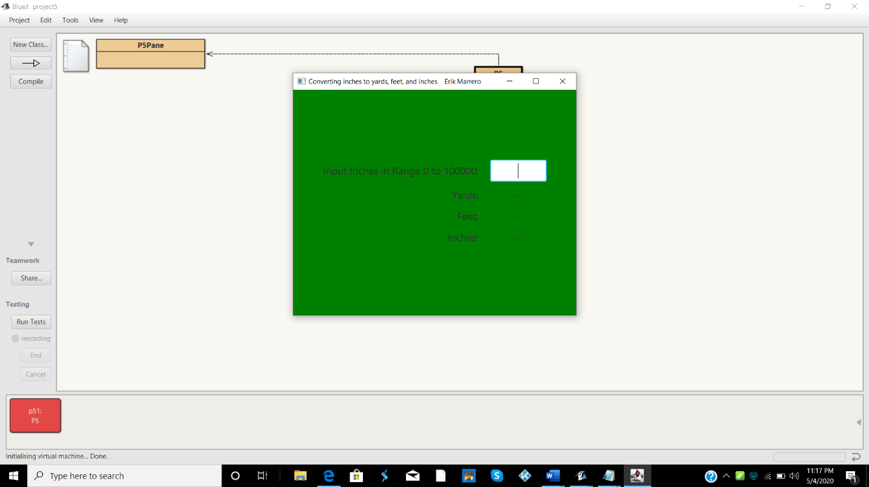

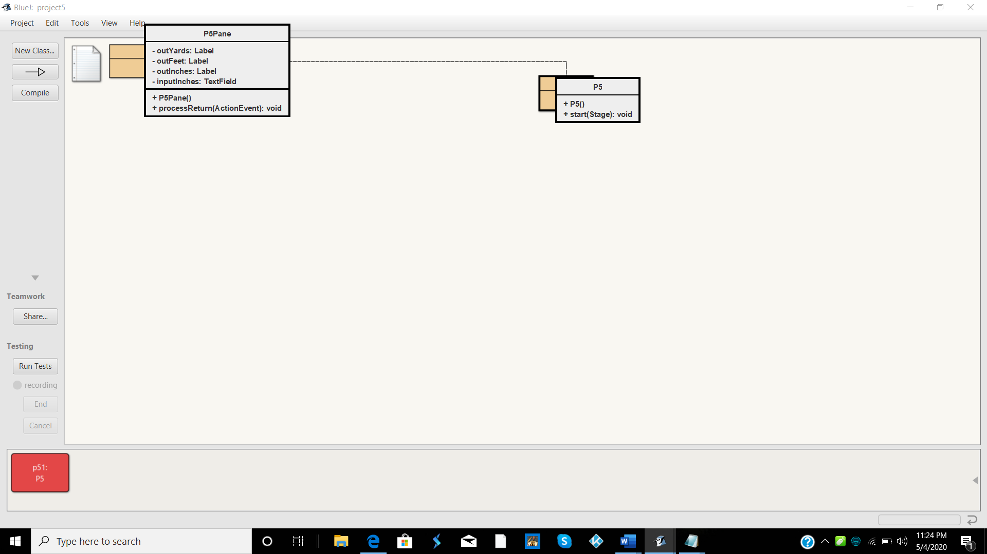 

GreedPane

-selfHAlign:gridpane

import javafx.event.ActionEvent;

import javafx.geometry.HPos;

import javafx.geometry.Pos;

import javafx.scene.control.Label;

import javafx.scene.control.TextField;

import javafx.scene.layout.GridPane;

import javafx.scene.text.Font;

public class P5Pane extends GridPane

{

private Label outYards, outFeet, outInches;

private TextField inputInches;

public P5Pane()

{

Font font = new Font(18);

Label inputLabel = new Label("Input Inches in Range 0 to 100000:");

inputLabel.setFont(font);

GridPane.setHalignment(inputLabel, HPos.RIGHT);

Label outLabelYards = new Label("Yards:");

outLabelYards.setFont(font);

GridPane.setHalignment(outLabelYards, HPos.RIGHT);

outYards = new Label("---");

outYards.setFont(font);

GridPane.setHalignment(outYards, HPos.CENTER);

Label outLabelFeet = new Label("Feet:");

outLabelFeet.setFont(font);

GridPane.setHalignment(outLabelFeet, HPos.RIGHT);

outFeet = new Label("---");

outFeet.setFont(font);

GridPane.setHalignment(outFeet, HPos.CENTER);

Label outLabelInches = new Label("Inches:");

outLabelInches.setFont(font);

GridPane.setHalignment(outLabelInches, HPos.RIGHT);

outInches = new Label("---");

outInches.setFont(font);

GridPane.setHalignment(outInches, HPos.CENTER);

inputInches = new TextField();

inputInches.setFont(font);

inputInches.setPrefWidth(100);

inputInches.setAlignment(Pos.CENTER);

inputInches.setOnAction(this::processReturn);

setAlignment(Pos.CENTER);

setHgap(20);

setVgap(10);

setStyle("-fx-background-color: Green");

add(inputLabel, 0, 0);

add(inputInches, 1, 0);

add(outLabelYards, 0, 1);

add(outYards, 1, 1);

add(outLabelFeet, 0 , 2);

add(outFeet, 1, 2);

add(outLabelInches, 0, 3);

add(outInches, 1, 3);

}

public void processReturn(ActionEvent event)

{

int inches = Integer.parseInt(inputInches.getText());

int yards = inches / 36;

outYards.setText(yards + "");

int feet = (inches % 36) / 12;

outFeet.setText(feet + "");

int inchResult = inches % 12;

outInches.setText(inchResult + "");

}

}

import javafx.application.Application;

import javafx.scene.Scene;

import javafx.stage.Stage;

public class P5 extends Application

{

public void start(Stage primaryStage)

{

Scene scene = new Scene(new P5Pane(), 500, 400);

primaryStage.setTitle("Converting inches to yards, feet, and inches"

+ " Erik Marrero");

primaryStage.setScene(scene);

primaryStage.show();

}

}