TS-2000(X) /TS-B2000
Firmware updating procedure
Updated:January 30,2005:Mickey Rossi from Original Kenwood Document

The TS-2000(X)/B2000 firmware is stored in the main CPU chip which contains a built-in flash ROM.
This manual describes the method of updating the firmware of the TS-2000(X)/B2000.

1. Requirements
1) A personal computer. (IBM PC or compatible)
2) The firmware updating program.
This program runs on Windows 95/98/ME/NT4.0/2000/XP(*1).
About 1MB of free hard disk space is needed to install this program.
At least 5MB of memory is required to run this program.
(*1) Windows are either registered trademarks or trademarks of Microsoft Corporation.
Note : When installing, running and uninstalling this program on the Microsoft Windows NT4.0/2000/ XP operating systems, you must have administrative privileges.
3) An RS-232C straight cable . Do not use a null modem adaptor, Using a gender bender is ok
(With 9-pin female connector for the TS-2000(X)/B2000 COM connector)
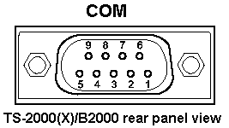
COM  Pin No. | COM Pin Name  Ref. : Computer | Function  Ref. : Transceiver | I/O  Ref. : Transceiver
1 | NC | - | -
2 | RXD | Transmit data | Output
3 | TXD | Receive data | Input
4 | NC | - | -
5 | GND | Signal ground | -
6 | NC | - | -
7 | RTS | Receive enable | Input
8 | CTS | Transmit enable | Output
9 | NC | - | -

1a. Backup TS-2000 memory and program contents:
Using Kenwood’s Memory Control Program MCP2000. Write all contents of the radio’s memory to the computer.

1b. Check firmware version:
TS-2000(X) Push and Hold (MIC and NR) then Press (Power) button

2. Firmware updating program installation
1) Execute the downloaded file (self-extracting) and extract the installation program into a designated folder.
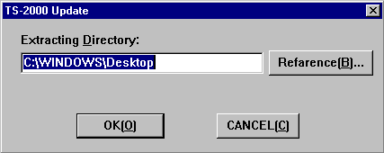
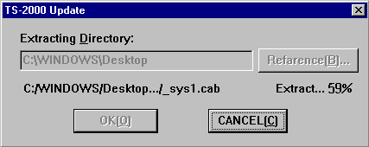
2) In the designated folder, a folder labeled "disk1" will be created.
3) Execute the "Setup.exe" file 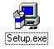within the "disk1" folder to begin installation.
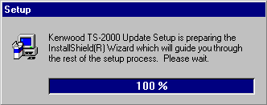
4) Once installation begins, follow the instructions that appear on the screen.
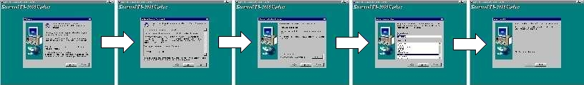

3. TS-2000(X)/B2000 baud rate setting
1) Press (Power) to turn the transceiver ON.
2) Set the communication baud rate of your TS-2000(X)/B2000 to 9600bps (Menu 56) .

4. Start TS-2000(X)/B2000 firmware updating program
1)Start the TS-2000 firmware updating program
[Start] => [Programs] => [KENWOOD] => [TS-2000 Update] => [TS-2000 Update]
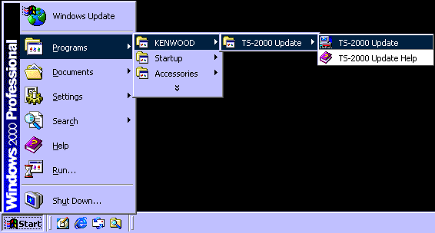
2) Select the serial port you will use. TS-2000 should be powered on and S1 in the off (Normal) position in this step.
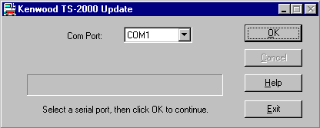
3)To start communication between the PC and the TS-2000(X)/B2000, clickOK. If you cannot connect see trouble shooting section
The following dialog box will appear. You must follow these steps exactly!
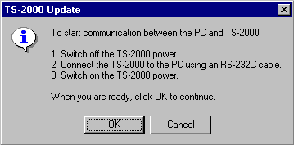

5. Transceiver recognition steps
1)Press (Power) to turn the transceiver OFF.
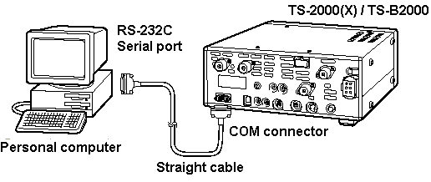
2)Connect the TS-2000(X)/B2000 to the PC using an RS-232C straight cable as shown above.
3)Press (Power) to turn the transceiver ON.
Click OK. The following dialog box will appear. You must follow these steps exactly!
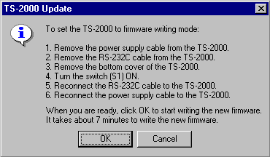
Note : This transceiver recognition step is required only in the 1st execution after installation.

6. Firmware writing procedures
1)Remove the DC power supply cable from the TS-2000(X)/B2000. (DO NOT Power off using the (Power) button)
2)Remove the RS-232C cable from the TS-2000(X)/B2000.
3)Remove the bottom cover of the TS-2000(X)/B2000.
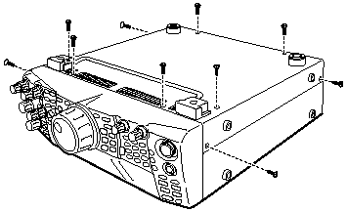
4) Turn the switch (S1) ON.
The switch is located on the PC board as shown below.
Notes:
1) | The DC power supply cable must be removed
 | before the switch (S1) is turned ON.
2) | Move the tab of the switch (S1) gently;
 | Rough handling may cause it to break.
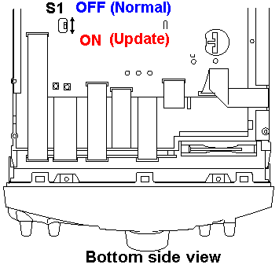
5)Reconnect the RS-232C cable to the TS-2000(X)/B2000.
6)Reconnect the DC power supply cable to the TS-2000(X)/B2000.
Note : The transceiver does not turn on any indicators, but it is ready to rewrite firmware.
Note: Front Panel Display will not illuminate but this is normal while S1 is set to on.
Do not operate (Power) switch during the firmware writing mode.
When you are ready, click OK.
The new firmware will be transferred into the main CPU flash ROM.
It takes about 7 minutes to write the new firmware.
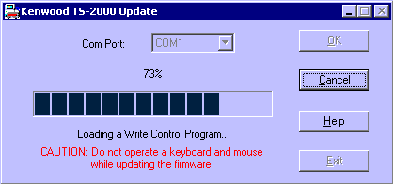
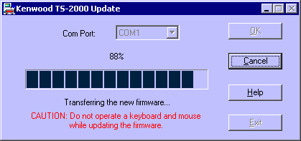
After the firmware writing step is completed, the following confirmation dialog box will appear.
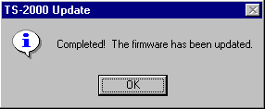
Click OK.
The following information dialog box will appear.
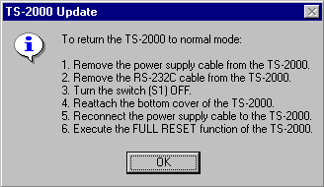
Notes:
1) Do not operate the power switch of the transceiver during the firmware writing mode.
2) Do not operate a keyboard and mouse while updating the firmware.
(Such as move the dialog box or right click a task bar while updating the firmware.
It may cause a communication error.)
3) Do not worry if the firmware writing step fails for some reason.
(e.g. RS-232C cable has a bad contact or there is an unexpected power failure)
The status of the firmware writing step is backed up on your PC.
Remove and reconnect the power supply cable.
Then repeat the firmware writing step.
4) If the firmware fails to update see “FIFO Fix” in the trouble shooting section.

7. Post Updating steps
1) Remove the power supply cable from the TS-2000(X)/B2000.
2) Remove the RS-232C cable from the TS-2000(X)/B2000.
3) Turn the switch (S1) OFF.
4) Reattach the bottom cover of the TS-2000(X)/B2000.
5) Reconnect the power supply cable to the TS-2000(X)/B2000.
6) Execute the FULL RESET function of the TS-2000(X)/B2000 as follows.

8. FULL RESET
a: TS-2000(X)
1) Press (Power) to turn the transceiver on while pressing and holding [A=B].
2) "FULL RESET PUSH A=B SW" message will appear.
3) Press [A=B] to perform the FULL RESET.
b: TS-B2000
1) Press (Power) to turn the transceiver on.
2) Press [Reset] button on the front panel to perform the FULL RESET.

9. Uninstalling the firmware updating program
Delete "Kenwood TS-2000 Update" by executing [Control Panel]-[Add/Remove Programs].

10. Check firmware version:
Push and Hold (MIC and NR) then Press (Power)

Troubleshooting:
Unable to connect to computer com 1:
Make sure S1 is off (normal), and power is applied to TS-2000.
Front panel display should be illuminated and power applied in step 4-2.
Do not use a null modem adaptor with your RS-232c cable.
You may use a gender bender on one end of the RS-232c cable.
Make sure no other program is using com 1.
If you can backup the radio using the MCP2000 program, then the cable
type and com port is correct.

The upgrade fails around 13%..20%: Try the “FIFO FIX”
goto device manager
select the communication port (com 1)
click on "restore defaults""
select advanced
enable FIFO buffers
set receive to value 8 (range is 1 to 14)
set transmit to value 4 (range 1 to 16)
click ok
click ok again

then select the communication port again (com 1)
disable it ! (right mouse button, select disable)
enable it again (right mouse button, select enable).
Retry upgrade

