Supplementary Table S1. Overall prompt designs used in Criteria2Query 3.0.
Task | Prompt
Concept extraction | Annotate clinical concepts from the given text using the following rules:  - Annotate concepts with the domains 'Demographic', 'Condition', 'Device', 'Procedure', 'Drug', 'Measurement', 'Observation', 'Visit', 'Value', and 'Temporal'. If you cannot annotate with the given domains, you can name a new one (e.g., Drug_cycle, Visit, Provider, etc.).  - Split the concepts as detail as possible. Each concept can be annotated only once with a single domain.  - Normalize clinical abbreviation and acronyms and attached behind the original abbreviation with parenthesis.  - If you find negated concepts, exclude the concept from the extraction.  - Return your response with extracted entities and under [Annotation] section.  Following is not allowed examples:  - <Measurement>eGFR <Value>triple negative</Value></Measurement>  - <Condition>Hypertension, diabetes, heart failure, and dementia</Condition>  Following is allowed examples:  - <Measurement>eGFR</Measurement> <Value>triple negative</Value>  - <Condition>hypertension</Condition>, <Condition>T2DM (Type 2 Diabetes Mellitus)</Condition>, <Condition>heart failure</Condition>, and <Condition>dementia</Condition>  - Patient <Demographic>aged<Demographic> > <Value>65 years old</Value>  - <Drug>Metformin</Drug> <Value>500 mg</Value> <Temporal>daily</Temporal>  Following is information for each domain:  - Condition is events of a Person suggesting the presence of a disease or medical condition stated as a diagnosis, a sign, or a symptom, which is either observed by a Provider or reported by the patient.  - Drugs include prescription and over-the-counter medicines, vaccines, and large-molecule biologic therapies. Radiological devices ingested or applied locally do not count as Drugs.  - Procedure is records of activities or processes ordered by, or carried out by, a healthcare provider on the patient with a diagnostic or therapeutic purpose. Lab tests are not a procedure, if something is observed with an expected resulting amount and unit then it should be a measurement.  - Devices include implantable objects (e.g. pacemakers, stents, artificial joints), medical equipment and supplies (e.g. bandages, crutches, syringes), other instruments used in medical procedures (e.g. sutures, defibrillators) and material used in clinical care (e.g. adhesives, body material, dental material, surgical material).  - Measurement contains both orders and results of such Measurements as laboratory tests, vital signs, quantitative findings from pathology reports, etc. OBSERVATION captures clinical facts about a Person obtained in the context of examination, questioning or a procedure. Any data that cannot be represented by any other domains, such as social and lifestyle facts, medical history, family history, etc. are recorded here.  - Observations differ from Measurements in that they do not require a standardized test or some other activity to generate clinical fact. Typical observations are medical history, family history, the stated need for certain treatment, social circumstances, lifestyle choices, healthcare utilization patterns, etc.  - Demographic can include factors of patient such as age, gender, race, ethnicity, education level, income, occupation, geographic location, marital status, and family size. Age term can be demographic but the specific age criteria should be annotated as value.  - Value is the numeric value or string test result of clinical concepts. Typical values can be the results of Measurements such as Lab test, vital signs, and quantitative findings from pathology reports. It can also be the dosage of drugs, the frequency of drugs, positive/negative of Gene test or lab test, the duration of drugs or numeric criteria of age, weight, height, etc.
SQL generation | Generate PostgreSQL query from the given text while following the rules:  - Target database is OMOP-CDM version 5.3.2.  - The given text consists of three sections: [initial_event], [inclusion_criteria], and [exclusion_criteria]. Sentences with HTML mark tags located under each section. [Initial_event] will be entry of cohort. However, if there is nothing under [Initial_event] section, then [Inclusion_criteria] will be [Initial_event] and all the sentences under [Inclusion_criteria] will be used for cohort entry event.  - Use Common Table Expression and add semi-colon after sql statement.  - Extract 'person_id', 'gender_concept_id', 'year_of_birth', 'month_of_birth', 'day_of_birth', and 'race_concept_id' from [PERSON] table. 'year_of_birth', 'month_of_birth', and 'day_of_birth' columns are string.  - Create temp table named [final_cohort] and insert the query result into [final_cohort].  - Patients who satisfy [Inclusion_criteria] can only be included in the cohort and exclude patients who satisfied [Exclusion_criteria].  - Sentences under each section has HTML mark tags, i.e., '<mark data-entity=\"[domain]\" concept-id=\"[concept_id]\">[token]</mark>'. Use the [concept_id] in the tag if it exists.  - Annotated concepts without [concept-id] (e.g., [value], [temporal]) are dependent to other concepts with [concept-id]. Consider the relationship between these concepts while generating the queries. For example, '<mark data-entity=\"drug\" concept-id=\"[concept_id]\">metformin</mark> is prescribed for <mark data-entity=\"temporal\"6 month</mark>' means 'temporal' should be considered in query with metformin. One exception is [demographic] which is related to [PERSON] table  - Include descendant concepts of the [concept_id]. For example, [select * from CONDITION_OCCURRENCE where condition_concept_id in (select descendant_concept_id from concept_ancestor where ancestor_concept_id = 'target_concept_id')]. The concept_id columns of CDM tables are '[domain]_concept_id'.  - Use all concepts in the given text to generate the query and use subquery for each [concept-id]. Do not query [concept-id]s together unless there is any comments defining concept relationships such as 'or', 'one of', 'any of', 'at least'.  - Consider clinician provided comments in the given text, if exists. It has information of logic, negation, relation of concepts, which is crucial generating query.  Hint: [domain] in the tag indicates the clinical domain of the concept and they are directly mapped to the OMOP-CDM tables. Left side is the [domain] in given text and right side is the name of CDM tables.  - [demographic] = [PERSON]  - [condition] = [CONDITION_OCCURRENCE]  - [drug] = [DRUG_EXPOSURE]  - [procedure] = [PROCEDURE_OCCURRENCE]  - [device] = [DEVICE_EXPOSURE]  - [observation] = [OBSERVATION]  - [measurement] = [MEASUREMENT]  - [visit] = [VISIT_OCCURRENCE]  - [death] = [DEATH]  - [cost] = [COST]  Hint: Desirable sql query will look like:  WITH initial_event AS (SELECT ...your query...), inclusion_criteria AS (SELECT ...your query...), exclusion_criteria AS (SELECT ...your query...) SELECT person_id, gender_concept_id, year_of_birth, month_of_birth, day_of_birth, race_concept_id INTO TEMP TABLE final_cohort FROM PERSON p JOIN inclusion_criteria ic ON p.person_id = ic.person_id WHERE p.person_id NOT IN (SELECT p.person_id FROM exclusion_criteria);
Reasoning | Explain logics, temporal, relation, attributes between clinical concepts from a given query with the following rules.  - The query confirms to OMOP-CDM version 5.3.2 and the concept mapping list consists of [data-entity], [concept-id], and [concept-name]. Concept-name is located behind concept-id and in front of <b><i>. Neglect the information behind <b><i> tag.  - If you find the unused concepts, then explain why they are not used in the query. One of the possible reason is the inclusion of disease hierarchy.  - Return your answer as the narrative explanation with numbers.  - Explain with [concept-name] and without [concept-id] to make answer easier to read by clinicians.  - Your answer should very clearly define the relations and logics with narrative explanation.

Supplementary Table S2. Clinical trial information used in the evaluation process.
NCT | Condition | Type | Phase | Intervention | Number of participants | Number of criteria | Number of simple criteria | Number of complex criteria | Complexity score
NCT05880693 | Hypotension | Interventional (Clinical Trial) | 1 | Drug: Dexmedetomidine  Drug: Magnesium sulfate | 56 | 9 | 8 | 1 | 0.11
NCT05719155 | Type II Diabetes Mellitus | Interventional (Clinical Trial) | 1 | Drug: CKD-379  Drug: D759+D745+D150 | 32 | 7 | 5 | 2 | 0.29
NCT05844735 | Rheumatoid Arthritis | Interventional (Clinical Trial) | 1 | Drug: SAR441566  Drug: Placebo  Drug: Ciprofloxacin | 60 | 14 | 2 | 12 | 0.86
NCT05837130 | Parkinson Disease | Interventional (Clinical Trial) | 1 | Other: Blood sample collection and an optional cerebrospinal fluid (CSF) collection  Other: Blood sample collection | 45 | 9 | 2 | 7 | 0.78
NCT05821153 | Alzheimer Disease | Interventional (Clinical Trial) | 1 | Drug: Aldesleukin | 8 | 15 | 9 | 6 | 0.40
NCT05880927 | Breast Cancer | Interventional (Clinical Trial) | 2 | Drug: Pyrotinib | 150 | 11 | 7 | 4 | 0.36
NCT05865730 | Carcinoma, Renal Cell  Carcinoma, Non-Small-Cell Lung | Interventional (Clinical Trial) | 2 | Other: Live Bacterial Product - Akkermansia muciniphila | 122 | 20 | 15 | 5 | 0.25
NCT05831670 | Colitis, Ulcerative | Interventional (Clinical Trial) | 2 | Drug: KSP-0243  Drug: Placebo | 100 | 9 | 3 | 6 | 0.67
NCT05810012 | Post-operative Pain Management  Hip Fracture Surgery | Interventional (Clinical Trial) | 2 | Drug: PENG block  Drug: FICB Block | 50 | 7 | 6 | 1 | 0.14
NCT05819281 | Irritable Bowel Syndrome | Interventional (Clinical Trial) | 2 | Dietary Supplement: Probiotic blend  Dietary Supplement: PLACEBO | 114 | 8 | 4 | 4 | 0.50
NCT05820880 | Hypertension | Interventional (Clinical Trial) | 3 | Drug: Fixed [Per/Ind/Aml]  Drug: Free [Per/Ind + Aml] | 532 | 7 | 3 | 4 | 0.57
NCT05532800 | Hyperlipidemia | Interventional (Clinical Trial) | 3 | Drug: JS002  Drug: Placebo | 255 | 12 | 4 | 8 | 0.67
NCT05521633 | NAFLD | Interventional (Clinical Trial) | 3 | Drug: Metformin and Pioglitazone | 96 | 11 | 4 | 7 | 0.64
NCT05480878 | Rheumatoid Arthritis | Interventional (Clinical Trial) | 3 | Drug: Placebo  Drug: Nitazoxanide 500Mg Oral Tablet  Drug: Escitalopram 10mg | 90 | 16 | 10 | 6 | 0.38
NCT05276336 | Allergic Rhinitis | Interventional (Clinical Trial) | 3 | Procedure: Radiofrequency turbinate reduction  Drug: Pharmacology treatment | 32 | 12 | 6 | 6 | 0.50
NCT05753280 | Chronic Hepatitis b | Interventional (Clinical Trial) | 4 | Drug: Vitamin D | 90 | 17 | 7 | 10 | 0.59
NCT05535595 | Hypertension | Interventional (Clinical Trial) | 4 | Drug: genotyping and selection of renin-angiotensin system blocker  Drug: Perindopril | 77 | 13 | 10 | 3 | 0.23
NCT05479214 | Diabetes Mellitus Pregnancy | Interventional (Clinical Trial) | 4 | Drug: Metformin  Drug: Insulin | 150 | 13 | 7 | 6 | 0.46
NCT05447507 | Orthopedic Disorder | Interventional (Clinical Trial) | 4 | Drug: Remimazolam  Drug: Dexmedetomidine | 104 | 8 | 3 | 5 | 0.63
NCT05387967 | Heart Failure, Systolic | Interventional (Clinical Trial) | 4 | Drug: Sacubitril/valsartan | 121 | 11 | 10 | 1 | 0.09

Supplementary Table S3. Macro performance metrics by OMOP categories.
OMOP categories | Precision | Recall | F1-score
Condition | 0.967 | 0.976 | 0.971
Demographic | 0.800 | 0.706 | 0.750
Device | 0.500 | 0.500 | 0.500
Drug | 0.841 | 0.841 | 0.841
Measurement | 0.982 | 0.948 | 0.965
Observation | 0.718 | 0.850 | 0.779
Procedure | 0.848 | 0.875 | 0.862
Temporal | 0.710 | 0.917 | 0.800
Value | 0.919 | 0.958 | 0.938
Visit | 0.143 | 0.667 | 0.235
Macro average | 0.743 | 0.834 | 0.764
Weighted average | 0.897 | 0.929 | 0.910

Supplementary Figure S1. Annotation entity distribution by clinical trials
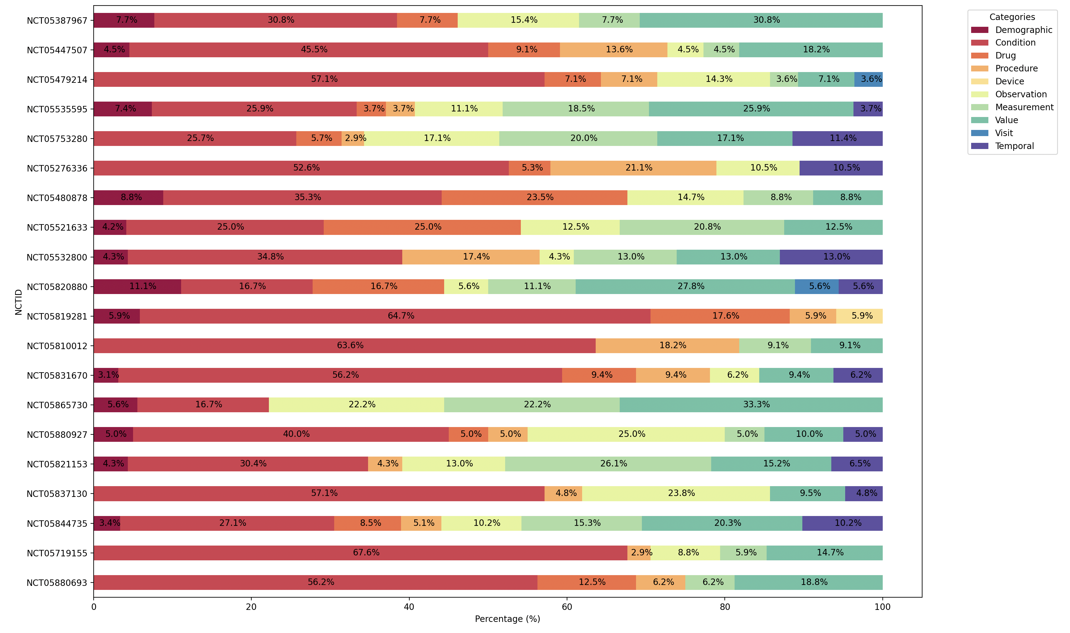
Supplementary Figure S2. Comparing the mean score and distribution between reasoning evaluation categories
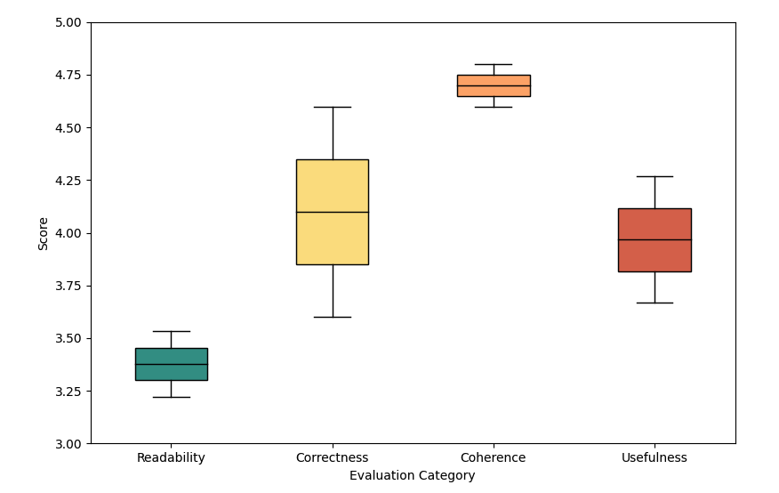
Supplementary Figure S3. Comparison of error analysis between Criteria2Query 2.0, GPT-3.5-turbo, and GPT-4
Supplementary Figure S4. Measurement-related parsing result using Criteria2Query 3.0. The eligibility criteria are the exclusion criteria of NCT05535595.
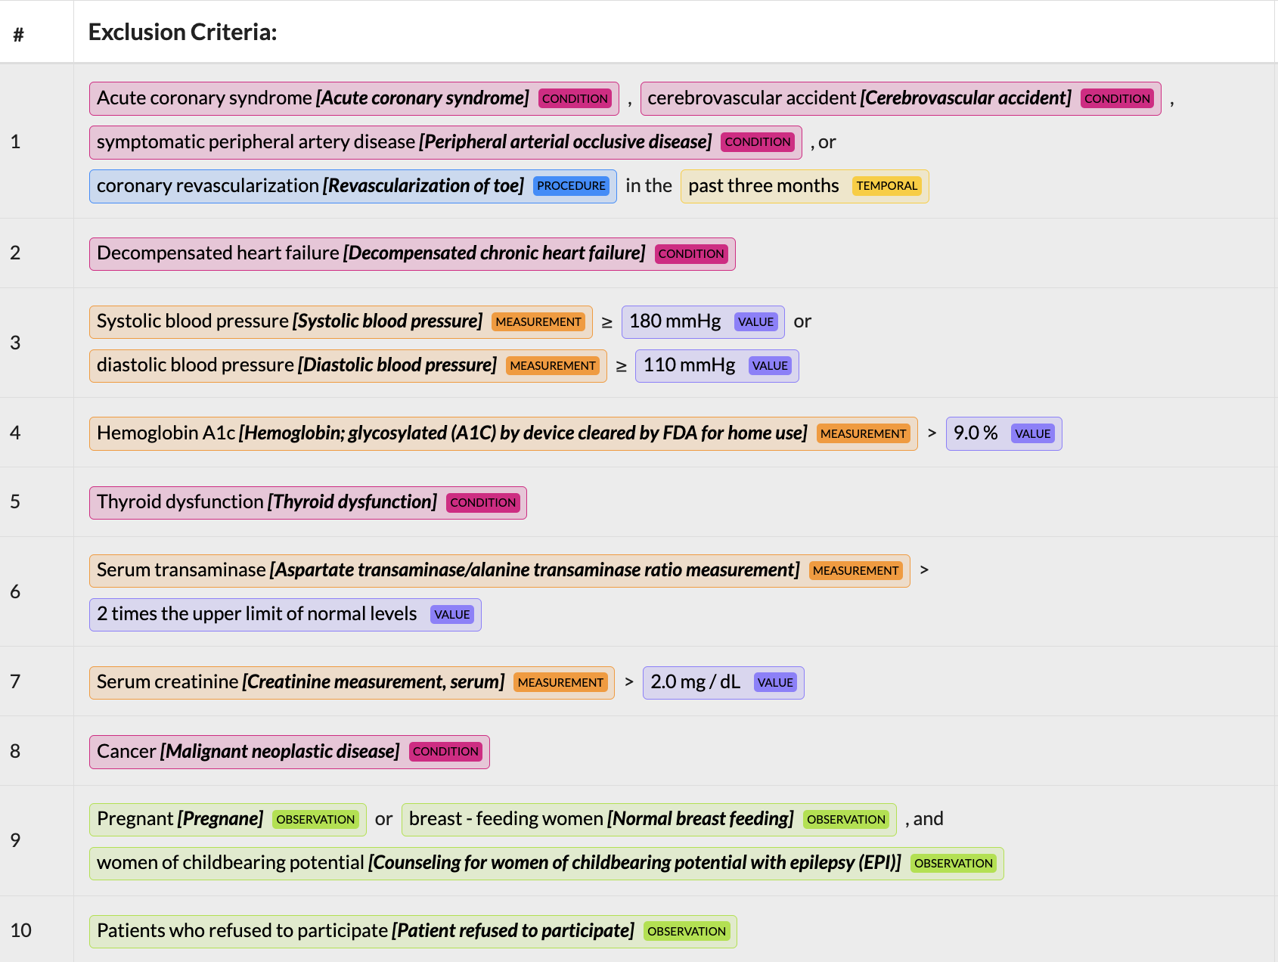

Supplementary Figure S5. Rephrasing the eligibility criteria of NCT05447507 using GPT-4 to improve concept extraction performance.
Supplementary Figure S6. Example of concept extraction by Criteria2Query 3.0. The concept and corresponding modifiers were extracted together. ChatGPT generated the examples.
