README: auction_emotions data

Erik Johnson

5/11/2018

# Data

Data comes from experiments and is available in ~/Dropbox/pkg.data/auction_emotions/. There are 8 sessions in the folder. Also include some other information here.

## Work

This is the function used to aggregate the dutch auction results.

* Need to incorporate Cary’s edits into this code. For now use the final data file (TickDataFull.csv)

## Description

Column and data description from

|  |  |  |
| --- | --- | --- |
| name | descrip | vals |
| V1 | Not sure | NA |
| tick_id | clock tick id. starts at 1 and counts up | 1,2,3,4,5,6,…,81 |
| time_floor | starting time for the tick | 11.253,…,2969.0548102 |
| time_ceil | ending time for the tick | 11.752,…,2969.0871752 |
| event | Not sure. How is this different than session? | NA,da1,da2,…,da20,da21,da22 |
| participant_id | Only unique within session. For full unique use subjects | NA, 1, 2,…,22, 23, 24 |
| esi_key | Related to session??? | NA, ESI-115-01,…,ESI-115-23, ESI-115-24 |
| ClockPrice | Price during the tick (starts at 240) | 0, 3, 6,…,234, 237, 240 |
| Ses_temps | Just like Ses_TickData but with NAs | NA, 1, 2,…,6, 7, 8 |
| Subjects | Not the same as participant. Unique to each subject | 1, 2, 3,…,170, 171, 172 |
| DANum | Dutch Auction Number(event) | 1, 2, 3,…,23, 24, 25 |
| Ses_TickData | ? | 1, 2, 3,…,6, 7, 8 |
| Group | 4 players to a group (playing against) | 1, 2, 3,…,4, 5, 6 |
| Win | 1 if ended up winning, 0 otherwise | 1,0 |
| FinalPrice | Price where auction stopped | 3, 24, 36,…,225, 228, 231 |
| Value | Value assigned to participant | 0, 8, 16,…,224, 232, 240 |
| Diff | Value-ClockPrice | -240, -237, -234,…,234, 237, 240 |
| Neutral | Emotion Score | 0, 0.001, 0.002,…,0.997, 0.998, 0.999 |
| Happy | Emotion Score | 0, 0.001, 0.002,…,0.996, 0.997, 0.998 |
| Sad | Emotion Score | 0, 0.001, 0.002,…,0.998, 0.999, 1 |
| Angry | Emotion Score | 0, 0.001, 0.002,…,0.998, 0.999, 1 |
| Surprised | Emotion Score | 0, 0.001, 0.002,…,0.998, 0.999, 1 |
| Scared | Emotion Score | 0, 0.001, 0.002,…,0.988, 0.993, 0.995 |
| Disgusted | Emotion Score | 0, 0.001, 0.002,…,0.997, 0.998, 0.999 |
| Contempt | Emotion Score | 0, 0.001, 0.002,…,0.954, 0.955, 0.957 |
| Valence | Emotion Score | -1, -0.999, -0.998,…,0.992, 0.993, 0.995 |
| Arousal | Emotion Score | 0, 0.001, 0.002,…,0.894, 0.895, 0.916 |

## Analysis

Draw some cool pictures. Try this for one individual (from the raw/source data)

## Saving 5 x 4 in image

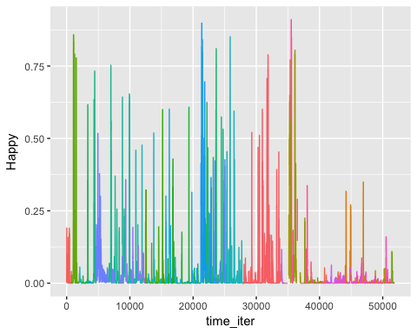

## Saving 5 x 4 in image

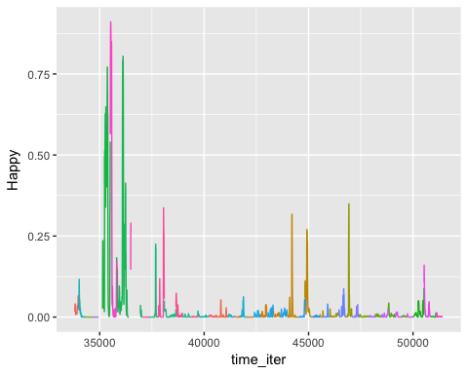

## Saving 5 x 4 in image

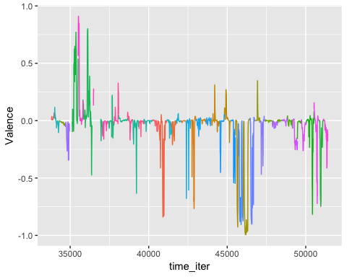

## Questions

### What is the unique key for a session?

This is defined by the session/group pair.

The session and participant id are for unique individuals.

The group membership for an individual will change within the session (to stop cartel behavior).

### Plot out raw data for an individual over all sessions (include initial value, and win/loss, etc.)

Started working on this in the One Individual Section

### What is the actual research question? Do we know? What should we explore?

1. Initial value assignment

Because subjects observe their value for the first time at the start of the auction, can we grab the average emotion for the first second of each auction to analyze how emotions are impacted by value realization. Any reaction would be somewhat visible in the timepath plots we discussed previously.

1. Emotional triggers for ending auction
2. Fatigue/Emotional trends through repeated auctions
3. Emotional responses to losing/winning auction

Can we grab the average emotion over the time between auctions, which is when people see the results. What we are thinking about here is if emotional reaction to the previous auction impacts bidding in the next auction.

1. Indvidiual heterogeneity in response
2. How are scores done? Is it intensity
3. Some go da then fp.
4. Valence

The difference between highest happiness and lowest emotional state (max of good ones - max of bad ones)

1. =
2. Pull the trigger (why)
3. Do emotions spillover? (Maybe add this into the analysis in 12.)
4. Subjects learn value at start of auction. Does this affect emotional response (value realization affect).

## Differences between dutch auctions and fp Auctions

1. Is there a difference in emotions between first price and dutch auctions (spillover effect.. does happiness differ between first price and dutch auctions)
2. Expect emotions to be changing more in a dutch auction more than first price auction. Emotions more extreme in dutch auctions, less in first price auctions. Expect to see.
3. Plot the same things for arousal (measure of intensity)

finalPayment separates da and fp auction

No Event Marker only time between instructions

infoda1 Results of da1

Values data not in the emotions file

## TODO Plots

Value, profit,

Focus on valence and arousal, both dutch and fp (4 total figures)

Two colors, portion of actual auction in one color, feedback in another

Dutch Auction: Magnitude of the win (if win, dot at end of segment that is solid if win open if loss, size for (Price) value-final price at end time (if negative red if positive black))

FP Auction: Value-Bid (same colors as before)

x-axis (should be start of auction start)

Auction line blue (lettering from grey poupon), info (Grey Popon) dijon mustard color.

Value line is green value normalized between 0 and 1

Final Price : normalized to 0 and 1, black

Create summary statistics for timepath options