Submerged leaf litter colonization alters aquatic environmental DNA removal in experimental mesocosms
AUTHOR NAMES: Erik M. Curtis*†¹, Jennifer L. Tank*¹, Elise D. Snyder¹, Pedro F.P. Brandão-Dias††², Kyle Bibby³, Arial J. Shogren⁴, Diogo Bolster³, Scott P. Egan², Gary A. Lamberti¹.
AUTHOR ADDRESS:
¹Department of Biological Sciences, University of Notre Dame, 100 Galvin Life Sciences, Notre Dame, IN 46556 USA, EMC: erik.curtis@mail.utoronto.ca, JLT: jtank@nd.edu, EDS: esnyder4@nd.edu, GAL: glambert@nd.edu
²Department of BioSciences, Rice University, 6100 Main St, Houston, TX 77005-1827 USA, PFPBD: pb21@rice.edu, SPE: spe1@rice.edu
³Department of Civil & Environmental Engineering & Earth Science, University of Notre Dame, 156 Fitzpatrick Hall of Engineering, Notre Dame, IN 46556 USA, KB: kbibby@nd.edu, DB: dbolster@nd.edu
⁴Department of Biological Sciences, The University of Alabama, Science and Engineering Complex,1325 Hackberry Ln, Tuscaloosa, AL 35401, USA, AJS: ashogren@ua.edu
Present Addresses
† Department of Ecology and Evolutionary Biology, University of Toronto, Toronto, Ontario M5S 1A1, Canada
ABSTRACT: Understanding what controls eDNA removal from the water column remains a critical challenge for interpreting eDNA results in flowing waters. Allochthonous organic matter inputs represent an important seasonal change in stream ecosystems. In smaller, headwater streams, leaf litter accumulation and decomposition modify biotic and abiotic conditions that may influence eDNA removal. We conducted experimental releases of Common Carp (Cyprinus carpio) and Steelhead Trout (Oncorhynchus mykiss) eDNA in recirculating mesocosms to explore how leaf litter density and decomposition stage might influence eDNA removal. We found that leaf density had no significant effect on eDNA removal rates, but removal rates for smaller eDNA particles (0.4 – 1.2 μm) were 74% higher in mesocosms with biofilm-colonized leaves relative to those with “fresh” leaves (Tukey HSD, p < 0.001). In contrast, we found no significant difference in removal rates between colonized and uncolonized leaves for larger eDNA particles (>1.2 μm). Overall, eDNA removal rates were higher for smaller eDNA particles, particularly in the presence of biofilm-colonized leaves, implying a biological mechanism for eDNA removal from the water column. These results suggest that seasonal leaf litter can affect the fate of eDNA particles and may assist in interpreting eDNA data in natural systems.
KEYWORDS: Environmental DNA, aquatic biofilms, aquatic biomonitoring, ddPCR, particle size distribution.

TEXT:
- Introduction
Environmental DNA (eDNA) is conceptualized as the sum of all DNA-containing particles within an environment, and its importance for biodiversity monitoring is increasingly recognized in the field of limnology (Rees et al., 2014). Declining biodiversity is a growing crisis that affects numerous habitats globally, and the field of conservation is heavily reliant on population data derived from species monitoring (Guisan and Thuiller, 2005; Magurran, 2004). In many cases, however, these data are difficult to acquire, especially at large spatial scales or in challenging habitats. Moreover, efforts may require invasive sampling and organism death (Fediajevaite et al., 2021) or have a high rate of species misidentification (Austen et al., 2016). In such situations, eDNA sampling represents an efficient and non-invasive method of monitoring the biodiversity of organisms in aquatic habitats that has the added benefit of increased sensitivity when dealing with species at low population densities (Jerde et al., 2011).
While significant attention has been placed on the study of eDNA in standing water (Barnes and Turner, 2016), less research has been conducted regarding the behavior of eDNA particles in flowing waters (i.e., rivers and streams). While eDNA can be a sensitive indicator of the presence of rare, endangered, or invasive species, eDNA technology is often unable to identify the exact location of the target organism in flowing water (Deiner and Altermatt, 2014). Several studies have shown that eDNA particles are not homogenous in nature, but rather differ in size and composition (Shogren et al., 2016) and may change over time (Brandão‐Dias et al., 2023; Zhao et al., 2021). As a result, the removal of eDNA from the water column may vary based on a complex combination of abiotic and biotic factors, including discharge (Thalinger et al., 2021), pH and temperature (Strickler et al., 2015), substrate composition (Shogren et al., 2017), and the composition of the aquatic microbial community (Barnes and Turner, 2016). Many of these controls on eDNA transport and removal also vary seasonally, especially in temperate streams (Dettinger and Diaz, 2000; Hullar et al., 2006; Polato et al., 2018). However, most eDNA research to date has primarily focused on how seasonality influences eDNA generation through changes in organismal behavior.(Buxton et al., 2017; de Souza et al., 2016) Although some studies have quantified eDNA in relation to seasonal changes in flow rates,(Curtis et al., 2021; Thalinger et al., 2021) few studies have explored how other seasonal factors such as autumn litterfall alter eDNA transport and removal.
The influence of allochthonous (i.e., external) detrital inputs and their subsequent decomposition in forested streams is well documented; decomposing leaves represent an important seasonal resource subsidy that supports stream ecosystem function through multiple pathways.(Tank et al., 2010) Leaf litter processing includes physical breakdown, as well as microbially-mediated breakdown and consumption by macroinvertebrates.(Marks, 2019) Seasonal leaf litterfall is an important source of coarse and fine particulate organic matter (CPOM and FPOM, respectively) in streams both through invertebrate shredding(Wallace et al., 1982) and breakdown by fungal decomposers.²⁴ Once in particulate form, leaf-derived POM is exported downstream or remains in depositional areas, contributing to the energy base of stream food webs.(Webster et al., 1999) Leaf decomposition also modifies the chemistry of streams. Leaves initially release their most labile dissolved organic carbon (DOC) as leachate that is quickly assimilated by microbes, and this DOC from leaf litter is a major component of dissolved organic matter (DOM) standing stock in streams.(Meyer et al., 1998) As a source of organic matter, leaves contribute to heterotrophy in streams via microbial respiration. Most detrital carbon is respired by microorganisms,(Marcarelli et al., 2011) and prior to decomposition, leaf material further influences stream ecosystems by increasing the three-dimensional complexity of the stream substrate, providing valuable surface area for biofilm colonization and microhabitat for stream organisms.
Although litterfall is a well-studied phenomenon in streams, the influence of the autumn pulse of leaves on eDNA transport has not yet been explored. The potential for leaves and their decomposition to modify eDNA removal in streams is three-fold. First, when deposited in high densities, leaf litter increases the three-dimensional complexity of the stream substrate, which has been shown previously to alter eDNA removal rates in the case of rock substrate.(Shogren et al., 2017) Second, microbial biofilms, which have also been linked to increased eDNA removal,(Shogren et al., 2018; Snyder et al., 2023) may also increase eDNA removal rates after leaf surfaces are colonized. Finally, the leaching of DOM may also stimulate eDNA removal through increased microbial activity in the water column.(Zhao et al., 2023) This confluence of enhanced physical and biological removal pathways of eDNA suggests that autumn litterfall represents an important potential driver of eDNA fate and transport in forested streams.
Using replicated experimental mesocosms, we investigated the physical and biological effects of submerged leaf litter, and associated biofilms, on the removal of aquatic eDNA. We addressed two main questions: 1) Does the addition of leaf litter lead to increased removal of eDNA through physical mechanisms, biofilm activity, or some combination of the two? 2) Does the effect of leaves on eDNA removal vary for differently-sized eDNA particles? We hypothesized that both physical removal by leaves and trapping by biofilms would increase the rate of eDNA removal, and that removal would be fastest at high leaf density and when leaves are colonized with biofilms. We also predicted that physical removal would be fastest for larger particles (>1.2 μm), as in general, larger particles have been shown to fall out of suspension more rapidly in streams,(Thomas et al., 2001) and previous eDNA studies have observed faster removal of larger particles under varying substrate conditions.(Brandão‐Dias et al., 2023; Snyder et al., 2023)
- Materials and Methods
2.1 Experimental Design
To investigate the effect of leaf litter on eDNA removal, we performed experimental eDNA releases using 24 recirculating stream mesocosms located at the Notre Dame Experimental Mesocosm Facility (EMF). The EMF mesocosms are arrayed in four rows of six fiberglass mesocosms each, linked via a motorized shaft with six individual paddlewheels that push the water in a circular path around each mesocosm, simulating the natural flow of a stream (Fig. 1A). Our experimental design included six different experimental treatments, each with four mesocosm replicates: no leachate or litter (“Control”); leaf leachate only (“DOC”); low density, uncolonized litter (“Low Leaves”); low density, colonized litter (“Low Leaves + Biofilm”); high density, uncolonized litter (“High Leaves”); and high-density, colonized litter (“High Leaves + Biofilm”). For the controls, we included only groundwater such that these mesocosms represented the removal of eDNA from degradation alone. For the leaf leachate treatments, we added 53.2 mg/L of sugar maple leaf leachate (Acer Saccharum Marshall) to each mesocosm prior to our eDNA additions. In the four treatments where we added leaf litter, we used two densities of leaves, low(51 g m⁻² ) versus high (102 g m⁻²), and two stages of biofilm colonization, colonized versus uncolonized. We randomly assigned the n=6 treatments to the n=24 mesocosms, ensuring that each of the four rows contained one replicate of each treatment.
In Fall 2021, we collected freshly-fallen sugar maple leaves, oven-dried them at 56°C for at least 48 hrs, and separated them in netted bags each containing 6 g of dry leaf mass. For the treatments with biofilm-colonized leaves, we obtained a biofilm slurry from decomposing leaves in a local stream (Juday Creek, 41°43'42.4"N, 86°15'48.3"W) by gently rinsing decaying leaf material through a 1-mm sieve into a bucket. We then added 1 L of biofilm slurry and 25 L of low-nutrient groundwater into each of the designated mesocosms before placing the treatment-specific leaf density into each mesocosm. For the “Low Leaves + Biofilm” mesocosms, we placed three netted bags (18 g) into each mesocosm, and for the “High Leaves + Biofilm” mesocosms, we used six netted bags (36 g). We allowed these leaves to colonize with natural biofilms for 18 days prior to the experimental eDNA releases. For the remaining treatment mesocosms, we only added leaves to streams 48 hrs prior to the eDNA releases. We added three netted bags (18 g) into the “Low Leaves” treatment, and six netted bags (36 g) into both the “High Leaves” and “DOC” treatments. These leaf quantities reflect 50% and 100% of the mean leaf density in forested headwater streams, respectively.(Webster et al., 1999) Then, we allowed the leaves to leach the most labile DOC into the water for 24 hours.
After DOC leaching and biofilm colonization was complete, approximately 24 hours before beginning the eDNA releases, we prepared the mesocosms for the experiments (Fig. 1A). First, we removed leaves from DOC treatments, leaving only the DOC-rich water behind. Then, we drained the water from the non-DOC mesocosms and cleaned them (rinsing with a mild vinegar solution). We also removed leaves from bags across all treatments, and secured the leaves to 15x15-cm clean, ceramic tiles (n=5 per mesocosm) using thin rubber bands (Fig. 1A). We note that DOC treatment mesocosms did not receive their leaves back, and remained leafless. For the control and DOC treatments, we also placed five empty tiles into each mesocosm. Finally, regardless of treatment, we fully covered the bottom of all mesocosms with an extra 10 smaller (7.5x7.5-cm) tiles. For treatments other than DOC, we re-filled the mesocosms with 21 L of low-nutrient groundwater, and for DOC mesocosms, we only replenished evaporated water to the same total volume. During both the colonization and preparatory period, we set mesocosms to recirculate at an average water velocity of 0.15 m s⁻¹ which remained constant for the duration of the experiment.
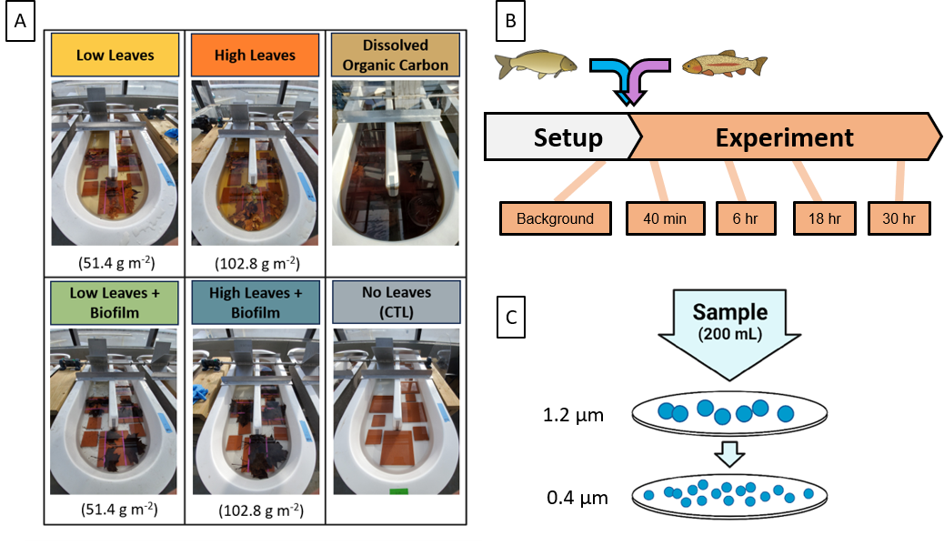
Figure 1. (A) Images of recirculating mesocosm treatments immediately before the addition of eDNA. (B) Diagram depicting experimental timeline. (C) Depiction of sequential filtration process using 1.2-μm and 0.4-μm polycarbonate membrane filters.
2.2 Experimental eDNA Releases
On the morning of the eDNA releases, we collected water from 1) a moat containing Common Carp (Cyprinus carpio) at the Potawatomi Zoo (South Bend, IN) and 2) a holding tank containing Steelhead Trout (Oncorhynchus mykiss) at the Bodine State Fish Hatchery (Mishawaka, IN), using a clean 2-L container to collect enough water to fill n=4 five-gallon buckets at each site. We promptly transported the buckets back to the laboratory and placed them in a refrigerator at 4°C. Next, we collected 200-mL water samples from each bucket of release solution to assess the concentration of the eDNA source solution. We also collected 200-mL water samples from each mesocosm to confirm the absence of Carp and Steelhead eDNA. To begin the experimental eDNA releases, we homogenized the water in buckets using aquarium mixers. Once mixed, we poured 2 L of both Carp and Steelhead eDNA solution into each of the 24 mesocosms, marking the beginning of the release. We collected 200-mL water samples from each mesocosm at 40 minutes, 6 hours, 18 hours, and 30 hours post-release (Fig. 1B). We immediately placed these water samples into an ice-filled cooler, along with a 200-mL groundwater blank until filtration. We performed a two-step sequential filtration (Fig. 1C) of each sample to independently quantify eDNA particles within given particle size classes, based on methods from Brandão-Dias et al. (2023a), (see Supporting Information).(Brandão‐Dias et al., 2023)
2.3 eDNA Extraction and Quantification
We extracted the eDNA from each water sample using the phenol:chloroform:isoamyl alcohol extraction method (see Supporting Information)(Brandão‐Dias et al., 2023; Sambrook and Russell, 2006) We quantified target eDNA concentration in each sample using the BioRad QX200 droplet digital PCR (ddPCR) platform (BioRad, Hercules, CA). We opted to use ddPCR due to the combination of high sensitivity and smaller sample volumes, as well as its proven reliability for eDNA studies.(Jerde et al., 2011) We assayed each sample using previously developed primer/probe combinations targeting the cytochrome b mitochondrial gene for our two target species (Table S1, see Supporting Information).(Duda et al., 2021; Takahara et al., 2012) We determined the limit of detection (LOD) using the approach described in Klymus et al. (2020),(Klymus et al., 2020) which we determined to be 3.8 gene copies per well for the Carp assay and 3.2 gene copies per well for the Steelhead assay.
We also quantified the eDNA particle size distribution for all eDNA source water used in the experiment (Fig. S1, see Supporting Information). We determined that the particle size distribution did not differ among the four buckets of Carp release solution (Chi-square, p=0.073). However, PSD differed among the four buckets of Steelhead release solution (Chi-square, p<0.001), but we accounted for the potential differences in PSD in our study design; within a given treatment, each of the four replicate mesocosms was spiked with release solution from a different bucket, so that any variation in the initial concentration of eDNA would be distributed across experimental units. We also accounted for this difference with the inclusion of the random-intercept component in our mixed-effects linear model for eDNA removal.
2.4 Environmental Data
We also measured relevant physicochemical variables prior to, and during, the eDNA release. We collected filtered water samples for nitrate (NO₃⁻-N), ammonia (NH₄⁺-N), soluble reactive phosphorus (SRP), and DOC concentrations at the beginning and end of the release period. We also recorded mesocosm water volume, water column turbidity, temperature, and pH for each mesocosm for each time point. We measured water velocity at 40 minutes and at 30 hours. To assess the metabolic activity within the mesocosms during the experiment, we performed metabolism incubations of mesocosm water and leaves in both light and dark conditions using standard methods (see Supporting Information).(Hall and Hotchkiss, 2017)
2.5 Statistical Analyses
We assessed the rate of eDNA removal using a hierarchical (mixed-effects) linear model. We performed all analyses in R version 4.3.2(R Core Team, 2023) using the “lme4” package(Bates et al., 2015) for model fitting and the “emmeans” package(Lenth, 2023) for statistical analyses. We included a random intercept and slope component for each mesocosm to address any differences in the amount of eDNA spiked into each mesocosm, as well as the lack of independence between measurements derived from sampling the same mesocosm across time (repeated-measures approach). As a first-order linear process, we modeled the natural logarithm of the quantity of eDNA as scaling linearly in time with the slope given by the interaction of the three factors dictated by our experimental design; leaf litter quantity and composition (Treatment), eDNA particle size class (Size), and target organism (Target). The resulting model notation for the “lme4” package is the following:
$$ln\left(\left[Gene Copies\right]\right) \sim Time :Treatment*Size*Target+(1+Time | Mesocosm)$$
We assessed model fit by examining the Response vs. Predicted graph and Q-Q plot using the package “ggResidPanel.”(Goode and Rey, 2019) We extracted eDNA removal rates according to our three factors from the fitted model using the “emtrends” function (“emmmeans” package) applied across time, and performed pairwise comparisons of these estimates using a Tukey HSD post-hoc test. We used Beta family linear models using the R package “betareg”(Cribari-Neto and Zeileis, 2010) using the formula proportion ~ Time:Treatment to observe if the proportion of 1.2-μm eDNA was increasing or decreasing, generating separate models for Carp and Steelhead. We used ANOVAs and post-hoc comparisons with Tukey HSD tests to compare environmental conditions between treatment groups and we checked for correlations between eDNA removal and environmental conditions using the “rcorr” function from R package “Hmisc”.(Harrell Jr, 2023)
- Results
3.1 Experimental eDNA Release
We observed a measurable decrease in eDNA concentration in 23 of 24 experimental mesocosms during the experiment. For one DOC replicate (DOC Mesocosm 3), we were unable to accurately assess eDNA concentration, and therefore we excluded this mesocosm replicate from all analyses. We also measured an eDNA concentration of 0 gene copies mL⁻¹ for the 1.2-μm filter at initial time point for one mesocosm (Low Leaves Mesocosm 3), which we attributed to an error during DNA extraction, and so we also excluded this replicate from further analysis. Occasionally, we observed eDNA concentrations of 0 or concentrations below the LOD for the ddPCR assay, typically later in the study period. These measurements were excluded from further analysis to ensure accuracy when quantifying the removal rates. We note that at 40 minutes, we observed higher concentrations of Steelhead eDNA relative to Carp eDNA, consistent with the relationship between the two release solutions (Fig. S1, see Supporting Information).
Overall, the decrease in eDNA concentration in the 23 mesocosms was consistent with first-order removal (Fig. 3A, 3B). The eDNA particle size distribution at 40 minutes roughly approximated the PSD for the source solution, with the 1.2-μm size accounting for >50% of the total eDNA for most mesocosms (Fig. 2, Inset panels). Because the removal rate was different between particle sizes (p <0.001, Table S3, see Supporting Information), we also observed that the relative proportion of components changed over time in mesocosms (Fig. 2, Inset panels). The proportion of 1.2-μm Carp eDNA decreased significantly over time for all but the DOC treatment (beta linear regression, p < 0.03). The proportion of 1.2-μm Steelhead eDNA increased significantly over time for all but the Low Leaves treatment (beta linear regression, p < 0.03).

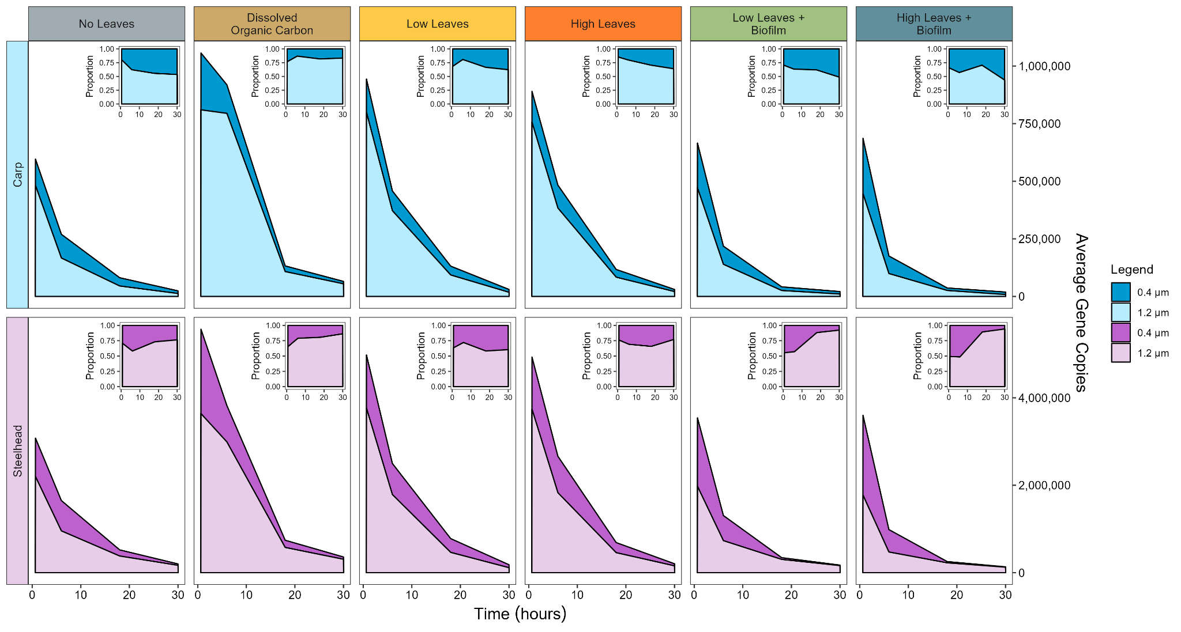
Figure 2. Stacked area plot representing average Carp (Top row) and Steelhead (Bottom row) eDNA quantities for the six treatments. Inset plots represent the proportion of eDNA for each particle size.
3.2 Model Fit and Removal Estimates
To account for the hierarchical nature of our experiment with repeated observations within mesocosms, we analyzed removal using a mixed-effects linear model. We observed a robust fit in our response vs. predicted graph with low heteroscedasticity of variance and a roughly Gaussian distribution for the residuals for the n=340 observations, consistent with the assumptions of linear models (Fig. S2, see Supporting Information). Notably, the model fit indicated a strongly significant interaction between the three experimental factors in our experiment (Treatment, Particle Size, and Target Organism), indicating that trends in removal in the experiment were dictated by combinations of these three factors (Fig. 3, Table S3, see Supporting Information).
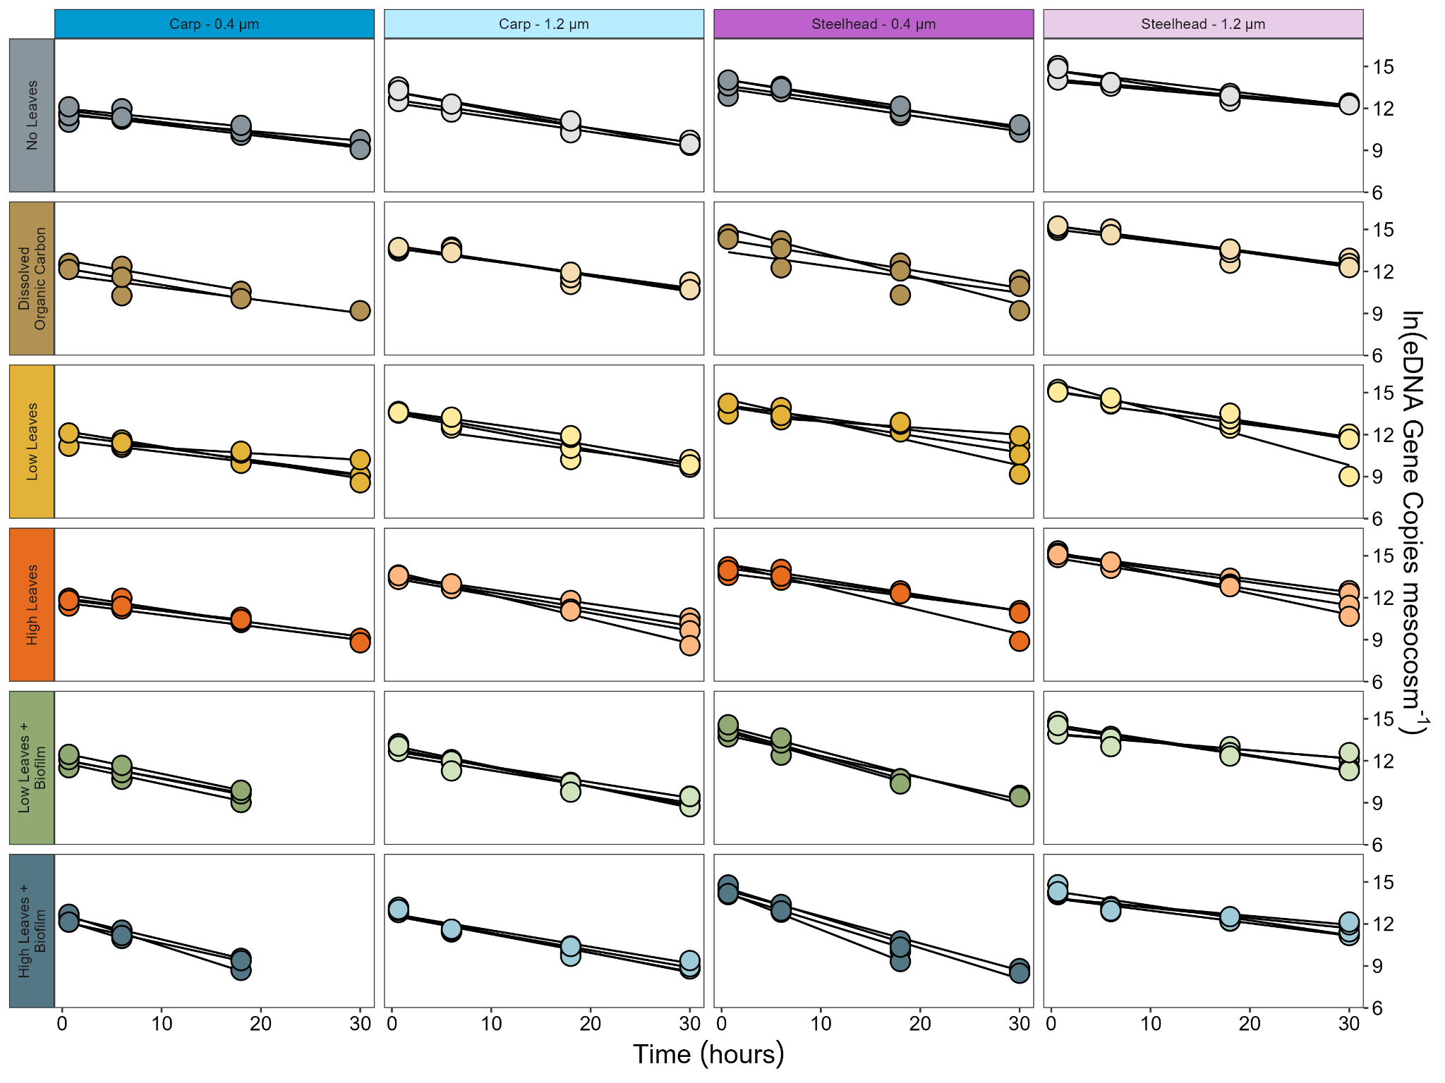
Figure 3. Removal of Carp (left) and Steelhead (right) eDNA within each mesocosm for both 1.2-μm (lighter) and 0.4-μm (darker) particle sizes.
Mesocosms with high-density biofilm-colonized leaves had significantly faster eDNA removal rates relative to the four non-biofilm treatments (k=3.75⁻¹ vs. Other treatments, k<2.72 d⁻¹; Tukey HSD, p<0.01 for all comparisons, Fig. 4A). We observed the same effect at the 0.4-μm size class for both densities (High Leaves+Biofilm, k=4.27 d⁻¹; Low Leaves+Biofilm, k=3.75 d⁻¹ vs. Other treatments, k<2.70 d⁻¹; Tukey HSD, p<0.01 for all comparisons, Fig. 4B). However, for the 1.2-μm size class, mesocosms with biofilm-colonized leaves had comparable removal rates to the control (High Leaves+Biofilm, k=3.24 d⁻¹; Low Leaves+Biofilm, k=3.04 d⁻¹ vs. No Leaves, k=2.74 d⁻¹, Tukey HSD, p>0.36 for both comparisons, Fig. 4B), indicating that the association with biofilm colonization and faster eDNA removal was best attributed to smaller eDNA particles. DOC was associated with a significant decrease in removal rate only for the 1.2-μm particle size (k=1.59 d⁻¹ vs. k=2.77 d⁻¹, Tukey HSD, p<0.001, Fig. 4B).
Across all treatments, we observed faster removal for the 0.4-μm particle size relative to the 1.2-μm particle size (k=3.04 d⁻¹ vs. k=2.60 d⁻¹, Tukey HSD, p<0.001). In particular, this effect was significant for the high-density biofilm treatment (k=4.27 d⁻¹ vs. k=3.24 d⁻¹, Tukey HSD, p<0.001), the low-density biofilm treatment (k=3.75 d⁻¹ vs. k=3.04 d⁻¹, Tukey HSD, p<0.01), and the DOC treatment (k=2.60 d⁻¹ vs. k=1.60 d⁻¹, Tukey HSD, p<0.001).
Although total eDNA removal rates did not differ significantly between species (2.80 d⁻¹ vs. 2.83 d⁻¹, Tukey HSD, p=0.83), for Steelhead eDNA specifically we observed significantly faster removal at the smaller (0.4 μm) particle size relative to the larger (1.2 μm) particle size (k=3.38 d⁻¹ vs. k=2.28 d⁻¹, Tukey HSD, p<0.001). In comparison, removal rates for Carp were comparable between small and large eDNA sizes (k=2.70 d⁻¹ vs. k=2.91 d⁻¹, Tukey HSD, p=0.67). This difference may relate to the differences in the initial eDNA concentration for each species, with the starting concentration for Steelhead exceeding that for Carp (Fig. S1, see Supporting Information). This effect is visible when examining estimates of eDNA removal for each combination of treatment, particle size, and target organism (Fig. 4C).

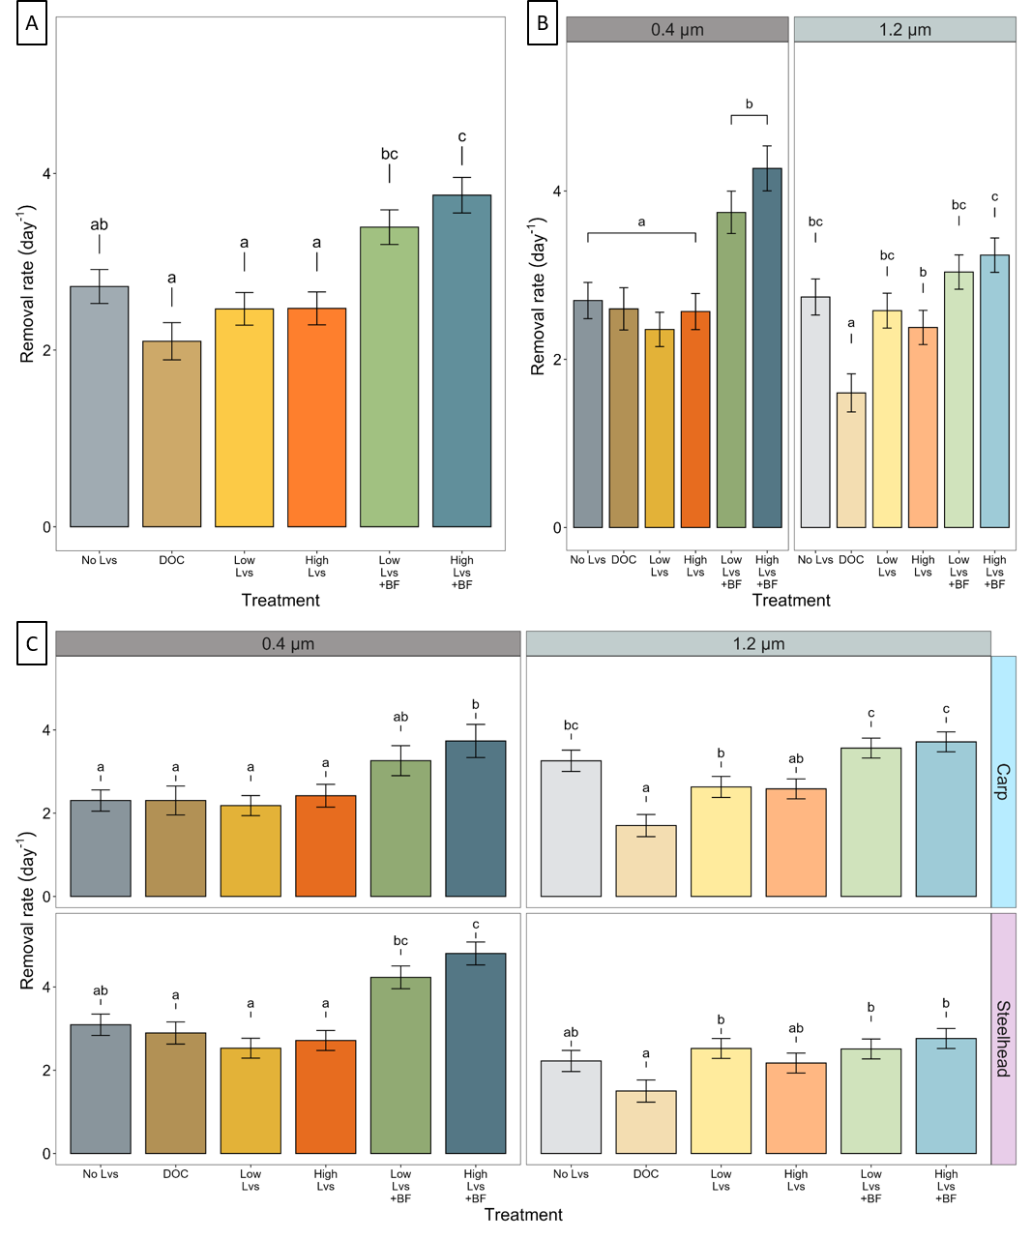
Figure 4. Removal rate (k) estimates + standard error from the mixed-effects model based on (A) Treatment alone, (B) Treatment and particle size alone, and (C) Treatment, particle size, and target organism. Letters denote pairwise comparisons within each panel (Tukey HSD) with different letters indicating a significant difference (p<0.05).
3.4 Environmental Variables
Average turbidity, DOC concentration, ammonium concentration (NH₄⁺-N), and SRP concentration were higher for the DOC treatment relative to the remaining treatments, and average nitrate concentrations (NO₃⁻-N) were elevated for the High Biofilm treatment relative to control (Tukey HSD, p<0.01 for all comparisons, Table S4, see Supporting Information). Respiration was significantly higher within the water column for the DOC treatment (Tukey HSD, p=0.01, Fig. S5A), but respiration rates of leaf biota did not differ by treatment (ANOVA, p=0.06, Fig. S5B). Environmental conditions in the mesocosms were not significantly correlated with eDNA removal (k, in d⁻¹), excluding nitrate concentration (NO₃—N, in μg N L⁻¹), which had a negative correlation of -0.33 (Pearson correlation, p=0.001).

- Discussion
4.1 eDNA Removal Dynamics varied with leaf litter quality
We hypothesized that leaf litter would impact eDNA removal through both physical and biological mechanisms. Surprisingly, we found that both densities (51 and 102 g m⁻²) of uncolonized leaves did not influence eDNA removal rates compared to the control; rather, the presence or absence of biofilm, regardless of density, was the overall control on the rate of eDNA removal (Fig. 4). The lack of a density effect was unexpected, given that eDNA particles are known to be trapped and retained in substrate.(Barnes and Turner, 2016; Jerde et al., 2016; Snyder et al., 2023) This result may have occurred because the leaves in our study were distributed across the bottom of the recirculating mesocosms after we secured them to tiles, which prevented the natural accumulation of leaves into leaf packs and debris dams. In headwater streams, leaves accumulate into larger packs that often modify the flow,(Tabacchi et al., 2000) and the gradual accumulation of leaf litter in autumn has been linked to elevated transient storage and slower water velocities.(Argerich et al., 2008) The experimental constraints imposed by our mesocosms potentially limited the physical effect of bare leaves on removal relative to the potential three-dimensional effect in natural systems. Moreover, the pore spaces created by the distributed leaves may have been too large and lacked physical complexity compared to the small rocks that were shown to increase eDNA removal in previous studies.(Jerde et al., 2016; Snyder et al., 2023)
Although we did not observe an effect of uncolonized leaves on the removal of eDNA, we did see an increase in eDNA removal with the addition of both the low and high density of biofilm-colonized leaves (Fig 4A). Potential mechanisms driving this increase in removal rates include the physical properties of biofilms that trap more eDNA particles,(Roche et al., 2017) along with the biological removal of eDNA by the microbial consortium on leaves. Previous studies on eDNA removal have found that microbial communities can increase removal through hydrolysis via extracellular and membrane-bound nucleases;(Lance et al., 2017; Strickler et al., 2015) however, these observations were limited to planktonic microbes in standing water. To our knowledge, no studies have sought to confirm this mechanism of removal through examination of metabolic activity and enzymatic activity in concert with eDNA degradation. In our study, metabolic activity alone, estimated using the microbial respiration assay, did not explain variation in eDNA removal rates, and biofilm-colonized leaves did not exhibit higher respiration rates compared to the other treatments (Fig. S5, see Supporting Information). In fact, respiration in the water column was highest for the DOC treatment (Fig. S5, see Supporting Information) which had lower eDNA removal relative to control (Fig. 4A, 4C). Therefore, elevated eDNA removal rates for the two biofilm treatments might be better explained by the polysaccharide matrix trapping eDNA particles through chemical or physical means. Recent work has indicated that natural biofilms can trap and preserve eDNA, acting as passive samplers of eDNA in marine environments,(Rivera et al., 2023) and extracellular DNA is a well-known component of the biofilm polysaccharide matrix.(Whitchurch et al., 2002) Further, in previous experiments within the same mesocosms, Brandão-Dias et al. (Under Review)(Brandão-Dias P.F.P. et al., n.d.) have found that biofilm preferentially uptakes long eDNA molecules, again pointing to its potential use as a structural component in biofilm matrix. Future studies that seek to investigate the accumulation rates of eDNA within the biofilm could draw valuable conclusions about the ecology of eDNA under biotic conditions in streams.
The eDNA removal rates documented in our study were comparable to rates observed in previous studies. In the control treatment, eDNA removal was higher (k=2.74 d⁻¹) compared to similar control conditions implemented by Snyder et al. 2023 (k=1.1 d⁻¹),(Snyder et al., 2023) which may be due to the addition of the bare ceramic tiles in our study. In contrast, Snyder et al. (2023) showed higher eDNA removal rates for biofilm-colonized rock substrate (k=10.2 d⁻¹) relative to the biofilm-colonized leaves used in this study (High Leaves+Biofilm, k=3.42 d⁻¹; Low Leaves+Biofilm, k=3.75 d⁻¹). In addition, removal rates for uncolonized substrate and uncolonized leaves were more similar (Uncolonized Substrate, k=2.0 d⁻¹ vs. Low Leaves, k=2.47 d⁻¹; High Leaves, k=2.41 d⁻¹). In general, the effect of biofilm-colonization on eDNA removal was more pronounced for rock substrate (Snyder et al. 2023) than for the leaf litter we studied. This substrate-specific biofilm effect may reflect differences in biofilm constituents, and therefore the structure and function of the biofilms. While the primary stages of leaf colonization are dominated by aquatic hyphomycetes (Fungi Imperfecti),(Marks, 2019; Suberkropp and Klug, 1980) biofilm assemblages on rocks (the epilithon) tend to be composed of algae and bacteria.(Barry J. F. Biggs, 1996) Leaf biofilms also tend to have higher endocellulase activity relative to epilithic assemblages, indicating significant differences in enzymatic activity and functional roles between the two biofilm communities.(Tank and Winterbourn, 1996) Therefore, differences in the biofilm structure might modify the passive “stickiness” of the polysaccharide matrix, or in case of active removal, different biofilm-building organisms may use different amounts of eDNA to build their biofilm matrix. Overall, biofilm effects on eDNA may relate to differences in the production and dispersal of enzymes that could contribute to eDNA degradation, but this process deserves further study.
Although we measured an increase in eDNA removal with the addition of biofilm-colonized leaves, crucial differences that would occur in natural streams could alter this effect. In particular, the decomposition and conditioning process applied to the leaves in this study only represented the microbial effects of decomposition, as the leaves were isolated from the normal macroinvertebrate communities present in streams. For example, in headwater streams treated with insecticide, both the breakdown rate of leaves and FPOM concentrations were significantly reduced.(Wallace et al., 1982) Likewise, excluding shredding invertebrates from the decomposition process with fine-netted bags resulted in higher species richness of aquatic hyphomycetes on the surfaces of oak and larch litter relative to litter in coarsely-netted bags.(Bärlocher, 1980) The exclusion of macroinvertebrates in our study may have impacted eDNA removal by altering the quantity and composition of the leaf biofilms and the state of particulate matter in the water column. Since fine particles suspended in the water column alter eDNA removal rates,(Brandão-Dias et al., 2023) it is possible that the effect of leaf litter on eDNA removal occurs indirectly over longer time scales by increase in stream FPOM, which later stimulates heterotrophic activity, and , consequently, eDNA removal. Given the short time span of our study, this potential long-term effect of leaf litter in streams is understated.
4.2 Differences in particle size distribution moderate the effect of biofilm
We observed that, on average, the smaller eDNA particle size (0.4 μm) was removed faster than the larger particle size (1.2 μm), and that the biofilm effect on removal was particularly strong for the 0.4-μm particle size. This result contrasts with previous research in the same mesocosms where smaller and intermediate particles (0.2 μm and 1.0 μm, respectively) were removed at similar rates in mesocosms with biofilm-colonized rocks (Snyder et al. 2023).(Snyder et al., 2023) Differences in the amount of each substrate applied to each mesocosm may have influenced these contrasting trends. For our high-density leaf treatments, we added 0.462 m² of leaves to each mesocosm on average, while a mesocosm filled with pea gravel, such as those used in Brandão-Dias et al. (2023b),(Brandão-Dias et al., 2023) had a substrate surface area of ~3X higher at 1.27 m². Their study also found that the addition of pea-gravel substrate was more strongly associated with the removal of larger (10 μm) eDNA particles relative to smaller and intermediate sizes (0.2 and 1.0 μm). Not only was the physical contribution of leaves to mesocosm surface area lower relative to pea gravel, this result indicated that eDNA at the filter sizes used here (0.4 and 1.2μm) might also be less influenced by physical trapping via substrate interactions. Brandão-Dias et al. (2023b) also observed that removal of the 0.2 and 1.0-μm particle sizes was more strongly associated with biotic mechanisms, similar to the 0.4-μm particle size here.
In combination, the results of this study indicate that the removal of eDNA at smaller sizes tends to be elevated in the presence of biofilms. However, since we have not yet sought to identify the composition of eDNA for these sizes, our explanation for this result may rely on the environmental context. In particular, the lack of a relationship between microbial respiration and eDNA removal in this study indicates that enzymatic activity might play a less important role in eDNA removal in flowing water. Instead, a higher efficiency of sorption to biofilms mediated by differences in charge or chemical components for smaller eDNA particles, coupled with increased physical trapping due to differences in mass or shape of the eDNA particle, might be a more parsimonious explanation for enhanced eDNA removal by microbially colonized leaves.
4.3 Conclusions
To our knowledge, no previous laboratory or field study has examined the interaction between leaf litter decomposition and eDNA removal. Integrating this important aspect of seasonality into the broader understanding of controls on eDNA transport and removal provides critical insight into the use of eDNA-based species detection, and will improve eDNA monitoring and interpretation when sampling forested streams and rivers. In this study, we found that eDNA removal from the water column increased in the presence of biofilm-colonized leaves, particularly for smaller eDNA particles, but that removal rates were not influenced by leaf quantity at the two levels tested here. We also observed that eDNA particle size influenced removal rates based on the interaction between the target organism (Carp vs. Steelhead) and particle size. Our study highlights the importance of understanding the environmental context, both physical and biological, when applying eDNA to assess biodiversity or survey for target organisms. To improve eDNA as a management tool, more work is needed to understand the components of particle size distribution, which will help us to better understand the complexities of eDNA removal across the vast gradient of environmental conditions present within the waters we seek to manage with eDNA.

ASSOCIATED CONTENT
Supporting Information.
Additional Figures and Tables: Scatterplots of PSD over time, model summary table and diagnostic plots, examination of model fits, visualization of initial eDNA concentration of source solution, eDNA Assay Primers/Probes, raw and modelled eDNA removal rates, environmental data (PDF)
RMarkdown Synopsis: complete reproduction of all analyses performed for this study; summary outputs of all statistical tests, code to generate each of the included figures (PDF)
AUTHOR INFORMATION
Corresponding Authors
*† Erik Curtis – Department of Biological Sciences, University of Notre Dame, Notre Dame, Indiana 46556, United States; Email: erik.curtis@mail.utoronto.ca
* Jennifer Tank – Department of Biological Sciences, University of Notre Dame, Notre Dame, Indiana 46556, Unites States; Email: jtank@nd.edu
Present Addresses
† Department of Ecology and Evolutionary Biology, University of Toronto, Toronto, Ontario M5S 1A1, Canada
†† University of Washington, School of Marine and Environmental Affairs, Seattle, Washington, USA
Author Contributions
J.L.T., D.B., A.J.S., G.A.L., K.B., and S.P.E. conceptualized the work; J.L.T., E.D.S., D.B., P.F.P.B.-D., and S.P.E. designed the experiment; E.M.C, P.F.P.B.-D. and E.D.S. performed the experiment; E.M.C. processed eDNA samples; E.M.C., E.D.S., P.F.P.B.-D., J.L.T analyzed experimental data; all authors discussed findings; E.M.C. wrote first manuscript draft; and all authors contributed to manuscript editing.
Notes
The authors declare no competing financial interest.
ACKNOWLEDGMENTS
We would like to thank Emma Thrift-Cahall, Ursula Mahl, Mitchell Liddick, Kayle Lauck, and Emma Pierce for their assistance in collecting and filtering water samples during the experiment. We also extend our gratitude to Brett Peters for constructing and managing the mesocosms at the EMF, and to Dave Meuninck from Bodine State Hatchery and Amanda Brunson-Cruz from the Potawatomi Zoo for access to water from their facilities for target eDNA. This study was supported through funding from the U.S. Department of Defense (DoD) Strategic Environmental Research and Development Program (SERDP, Project RC19-1276), and support to E.M.C. from the Glynn Family Honors Program at the University of Notre Dame as part of his undergraduate thesis.

REFERENCES
Argerich, A., Martí, E., Sabater, F., Ribot, M., Von Schiller, D., Riera, J.L., 2008. Combined effects of leaf litter inputs and a flood on nutrient retention in a Mediterranean mountain stream during fall. Limnology & Oceanography 53, 631–641. https://doi.org/10.4319/lo.2008.53.2.0631
Austen, G.E., Bindemann, M., Griffiths, R.A., Roberts, D.L., 2016. Species identification by experts and non-experts: comparing images from field guides. Sci Rep 6, 33634. https://doi.org/10.1038/srep33634
Bärlocher, F., 1980. Leaf-eating invertebrates as competitors of aquatic hyphomycetes. Oecologia 47, 303–306. https://doi.org/10.1007/BF00398521
Barnes, M.A., Turner, C.R., 2016. The ecology of environmental DNA and implications for conservation genetics. Conserv Genet 17, 1–17. https://doi.org/10.1007/s10592-015-0775-4
Barry J. F. Biggs, 1996. Patterns in Benthic Algae of Streams, in: Algal Ecology: Freshwater Benthic Ecosystems, Aquatic Ecology Series. Academic Press, San Diego, pp. 31–56.
Bates, D., Mächler, M., Bolker, B., Walker, S., 2015. Fitting Linear Mixed-Effects Models Using lme4. Journal of Statistical Software 67, 1–48. https://doi.org/10.18637/jss.v067.i01
Brandão-Dias, P.F.. P., Tank, J.L., Snyder, E.D., Mahl, U.H., Peters, B., Bolster, D., Shogren, A.J., Lamberti, G.A., Bibby, K., Egan, S.P., 2023. Suspended Materials Affect Particle Size Distribution and Removal of Environmental DNA in Flowing Waters. Environ. Sci. Technol. acs.est.3c02638. https://doi.org/10.1021/acs.est.3c02638
Brandão‐Dias, P.F.P., Hallack, D.M.C., Snyder, E.D., Tank, J.L., Bolster, D., Volponi, S., Shogren, A.J., Lamberti, G.A., Bibby, K., Egan, S.P., 2023. Particle size influences decay rates of environmental DNA in aquatic systems. Molecular Ecology Resources 1755–0998.13751. https://doi.org/10.1111/1755-0998.13751
Brandão-Dias P.F.P., Snyder E.D., Tank J.L., Mahl, U.H., Beters, B., Shogren A.J., Bolster D., Lamberti G.A., Bibby K, Egan S., n.d. Environmental DNA ecology is better associated with particle size than molecule length in recirculating streams. Under review in Environmental DNA.
Buxton, A.S., Groombridge, J.J., Zakaria, N.B., Griffiths, R.A., 2017. Seasonal variation in environmental DNA in relation to population size and environmental factors. Sci Rep 7, 46294. https://doi.org/10.1038/srep46294
Cribari-Neto, F., Zeileis, A., 2010. Beta Regression in R. Journal of Statistical Software 34, 1–24. https://doi.org/10.18637/jss.v034.i02
Curtis, A.N., Tiemann, J.S., Douglass, S.A., Davis, M.A., Larson, E.R., 2021. High stream flows dilute environmental DNA (eDNA) concentrations and reduce detectability. Diversity and Distributions 27, 1918–1931. https://doi.org/10.1111/ddi.13196
de Souza, L.S., Godwin, J.C., Renshaw, M.A., Larson, E., 2016. Environmental DNA (eDNA) Detection Probability Is Influenced by Seasonal Activity of Organisms. PLoS ONE 11, e0165273. https://doi.org/10.1371/journal.pone.0165273
Deiner, K., Altermatt, F., 2014. Transport Distance of Invertebrate Environmental DNA in a Natural River. PLoS ONE 9, e88786. https://doi.org/10.1371/journal.pone.0088786
Dettinger, M.D., Diaz, H.F., 2000. Global Characteristics of Stream Flow Seasonality and Variability. J. Hydrometeor 1, 289–310. https://doi.org/10.1175/1525-7541(2000)001<0289:GCOSFS>2.0.CO;2
Duda, J.J., Hoy, M.S., Chase, D.M., Pess, G.R., Brenkman, S.J., McHenry, M.M., Ostberg, C.O., 2021. Environmental DNA is an effective tool to track recolonizing migratory fish following large-scale dam removal. Environmental DNA 3, 121–141. https://doi.org/10.1002/edn3.134
Fediajevaite, J., Priestley, V., Arnold, R., Savolainen, V., 2021. Meta‐analysis shows that environmental DNA outperforms traditional surveys, but warrants better reporting standards. Ecol. Evol. 11, 4803–4815. https://doi.org/10.1002/ece3.7382
Goode, K., Rey, K., 2019. ggResidpanel: Panels and Interactive Versions of Diagnostic Plots using “ggplot2.”
Guisan, A., Thuiller, W., 2005. Predicting species distribution: offering more than simple habitat models. Ecology Letters 8, 993–1009. https://doi.org/10.1111/j.1461-0248.2005.00792.x
Hall, R.O., Hotchkiss, E.R., 2017. Stream Metabolism, in: Methods in Stream Ecology. Elsevier, pp. 219–233. https://doi.org/10.1016/B978-0-12-813047-6.00012-7
Harrell Jr, F.E., 2023. Hmisc: Harrell Miscellaneous.
Hullar, M.A.J., Kaplan, L.A., Stahl, D.A., 2006. Recurring Seasonal Dynamics of Microbial Communities in Stream Habitats. Appl Environ Microbiol 72, 713–722. https://doi.org/10.1128/AEM.72.1.713-722.2006
Jerde, C.L., Mahon, A.R., Chadderton, W.L., Lodge, D.M., 2011. “Sight-unseen” detection of rare aquatic species using environmental DNA: eDNA surveillance of rare aquatic species. Conservation Letters 4, 150–157. https://doi.org/10.1111/j.1755-263X.2010.00158.x
Jerde, C.L., Olds, B.P., Shogren, A.J., Andruszkiewicz, E.A., Mahon, A.R., Bolster, D., Tank, J.L., 2016. Influence of Stream Bottom Substrate on Retention and Transport of Vertebrate Environmental DNA. Environ. Sci. Technol. 50, 8770–8779. https://doi.org/10.1021/acs.est.6b01761
Klymus, K.E., Merkes, C.M., Allison, M.J., Goldberg, C.S., Helbing, C.C., Hunter, M.E., Jackson, C.A., Lance, R.F., Mangan, A.M., Monroe, E.M., Piaggio, A.J., Stokdyk, J.P., Wilson, C.C., Richter, C.A., 2020. Reporting the limits of detection and quantification for environmental DNA assays. Environmental DNA 2, 271–282. https://doi.org/10.1002/edn3.29
Lance, R., Klymus, K., Richter, C., Guan, X., Farrington, H., Carr, M., Thompson, N., Chapman, D., Baerwaldt, K., 2017. Experimental observations on the decay of environmental DNA from bighead and silver carps. MBI 8, 343–359. https://doi.org/10.3391/mbi.2017.8.3.08
Lenth, R.V., 2023. emmeans: Estimated Marginal Means, aka Least-Squares Means.
Magurran, A.E., 2004. Measuring biological diversity. Blackwell Pub, Malden, Ma.
Marcarelli, A.M., Baxter, C.V., Mineau, M.M., Hall, R.O., 2011. Quantity and quality: unifying food web and ecosystem perspectives on the role of resource subsidies in freshwaters. Ecology 92, 1215–1225. https://doi.org/10.1890/10-2240.1
Marks, J.C., 2019. Revisiting the Fates of Dead Leaves That Fall into Streams. Annu. Rev. Ecol. Evol. Syst. 50, 547–568. https://doi.org/10.1146/annurev-ecolsys-110218-024755
Meyer, J.L., Wallace, J.B., Eggert, S.L., 1998. Leaf Litter as a Source of Dissolved Organic Carbon in Streams. Ecosystems 1, 240–249. https://doi.org/10.1007/s100219900019
Polato, N.R., Gill, B.A., Shah, A.A., Gray, M.M., Casner, K.L., Barthelet, A., Messer, P.W., Simmons, M.P., Guayasamin, J.M., Encalada, A.C., Kondratieff, B.C., Flecker, A.S., Thomas, S.A., Ghalambor, C.K., Poff, N.L., Funk, W.C., Zamudio, K.R., 2018. Narrow thermal tolerance and low dispersal drive higher speciation in tropical mountains. Proc. Natl. Acad. Sci. U.S.A. 115, 12471–12476. https://doi.org/10.1073/pnas.1809326115
R Core Team, 2023. R: A Language and Environment for Statistical Computing.
Rees, H.C., Maddison, B.C., Middleditch, D.J., Patmore, J.R.M., Gough, K.C., 2014. REVIEW: The detection of aquatic animal species using environmental DNA – a review of eDNA as a survey tool in ecology. Journal of Applied Ecology 51, 1450–1459. https://doi.org/10.1111/1365-2664.12306
Rivera, S.F., Vasselon, V., Bouchez, A., Rimet, F., 2023. eDNA metabarcoding from aquatic biofilms allows studying spatial and temporal fluctuations of fish communities from Lake Geneva. Environmental DNA edn3.413. https://doi.org/10.1002/edn3.413
Roche, K.R., Drummond, J.D., Boano, F., Packman, A.I., Battin, T.J., Hunter, W.R., 2017. Benthic biofilm controls on fine particle dynamics in streams. Water Resources Research 53, 222–236. https://doi.org/10.1002/2016WR019041
Sambrook, J., Russell, D.W., 2006. Purification of Nucleic Acids by Extraction with Phenol:Chloroform. Cold Spring Harb Protoc 2006, pdb.prot4455. https://doi.org/10.1101/pdb.prot4455
Shogren, A.J., Tank, J.L., Andruszkiewicz, E., Olds, B., Mahon, A.R., Jerde, C.L., Bolster, D., 2017. Controls on eDNA movement in streams: Transport, Retention, and Resuspension. Sci Rep 7, 5065. https://doi.org/10.1038/s41598-017-05223-1
Shogren, A.J., Tank, J.L., Andruszkiewicz, E.A., Olds, B., Jerde, C., Bolster, D., 2016. Modelling the transport of environmental DNA through a porous substrate using continuous flow-through column experiments. J. R. Soc. Interface. 13, 20160290. https://doi.org/10.1098/rsif.2016.0290
Shogren, A.J., Tank, J.L., Egan, S.P., August, O., Rosi, E.J., Hanrahan, B.R., Renshaw, M.A., Gantz, C.A., Bolster, D., 2018. Water Flow and Biofilm Cover Influence Environmental DNA Detection in Recirculating Streams. Environ. Sci. Technol. 52, 8530–8537. https://doi.org/10.1021/acs.est.8b01822
Snyder, E.D., Tank, J.L., Brandão-Dias, P.F.P., Bibby, K., Shogren, A.J., Bivins, A.W., Peters, B., Curtis, E.M., Bolster, D., Egan, S.P., Lamberti, G.A., 2023. Environmental DNA (eDNA) removal rates in streams differ by particle size under varying substrate and light conditions. Science of The Total Environment 903, 166469. https://doi.org/10.1016/j.scitotenv.2023.166469
Strickler, K.M., Fremier, A.K., Goldberg, C.S., 2015. Quantifying effects of UV-B, temperature, and pH on eDNA degradation in aquatic microcosms. Biological Conservation 183, 85–92. https://doi.org/10.1016/j.biocon.2014.11.038
Suberkropp, K., Klug, M.J., 1980. The maceration of deciduous leaf litter by aquatic hyphomycetes. Can. J. Bot. 58, 1025–1031. https://doi.org/10.1139/b80-126
Tabacchi, E., Lambs, L., Guilloy, H., Planty-Tabacchi, A.-M., Muller, E., Décamps, H., 2000. Impacts of riparian vegetation on hydrological processes. Hydrol. Process. 14, 2959–2976. https://doi.org/10.1002/1099-1085(200011/12)14:16/17<2959::AID-HYP129>3.0.CO;2-B
Takahara, T., Minamoto, T., Yamanaka, H., Doi, H., Kawabata, Z., 2012. Estimation of Fish Biomass Using Environmental DNA. PLoS ONE 7, e35868. https://doi.org/10.1371/journal.pone.0035868
Tank, J.L., Rosi-Marshall, E.J., Griffiths, N.A., Entrekin, S.A., Stephen, M.L., 2010. A review of allochthonous organic matter dynamics and metabolism in streams. Journal of the North American Benthological Society 29, 118–146. https://doi.org/10.1899/08-170.1
Tank, J.L., Winterbourn, M.J., 1996. Microbial activity and invertebrate colonisation of wood in a New Zealand forest stream. New Zealand Journal of Marine and Freshwater Research 30, 271–280. https://doi.org/10.1080/00288330.1996.9516714
Thalinger, B., Kirschner, D., Pütz, Y., Moritz, C., Schwarzenberger, R., Wanzenböck, J., Traugott, M., 2021. Lateral and longitudinal fish environmental DNA distribution in dynamic riverine habitats. Environmental DNA 3, 305–318. https://doi.org/10.1002/edn3.171
Thomas, S.A., Newbold, J.D., Monaghan, M.T., Minshall, G.W., Georgian, T., Cushing, C.E., 2001. The influence of particle size on seston deposition in streams. Limnology & Oceanography 46, 1415–1424. https://doi.org/10.4319/lo.2001.46.6.1415
Wallace, J.B., Webster, J.R., Cuffney, T.F., 1982. Stream detritus dynamics: Regulation by invertebrate consumers. Oecologia 53, 197–200. https://doi.org/10.1007/BF00545663
Webster, J.R., Benfield, E.F., Ehrman, T.P., Schaeffer, M.A., Tank, J.L., Hutchens, J.J., D’Angelo, D.J., 1999. What happens to allochthonous material that falls into streams? A synthesis of new and published information from Coweeta. Freshwater Biology 41, 687–705. https://doi.org/10.1046/j.1365-2427.1999.00409.x
Whitchurch, C.B., Tolker-Nielsen, T., Ragas, P.C., Mattick, J.S., 2002. Extracellular DNA Required for Bacterial Biofilm Formation. Science 295, 1487–1487. https://doi.org/10.1126/science.295.5559.1487
Zhao, B., Van Bodegom, P.M., Trimbos, K., 2021. The particle size distribution of environmental DNA varies with species and degradation. Science of The Total Environment 797, 149175. https://doi.org/10.1016/j.scitotenv.2021.149175
Zhao, B., Van Bodegom, P.M., Trimbos, K.B., 2023. Bacterial abundance and pH associate with eDNA degradation in water from various aquatic ecosystems in a laboratory setting. Front. Environ. Sci. 11, 1025105. https://doi.org/10.3389/fenvs.2023.1025105

For Table of Contents Only

