To test clone the project from this link or download as a zip.

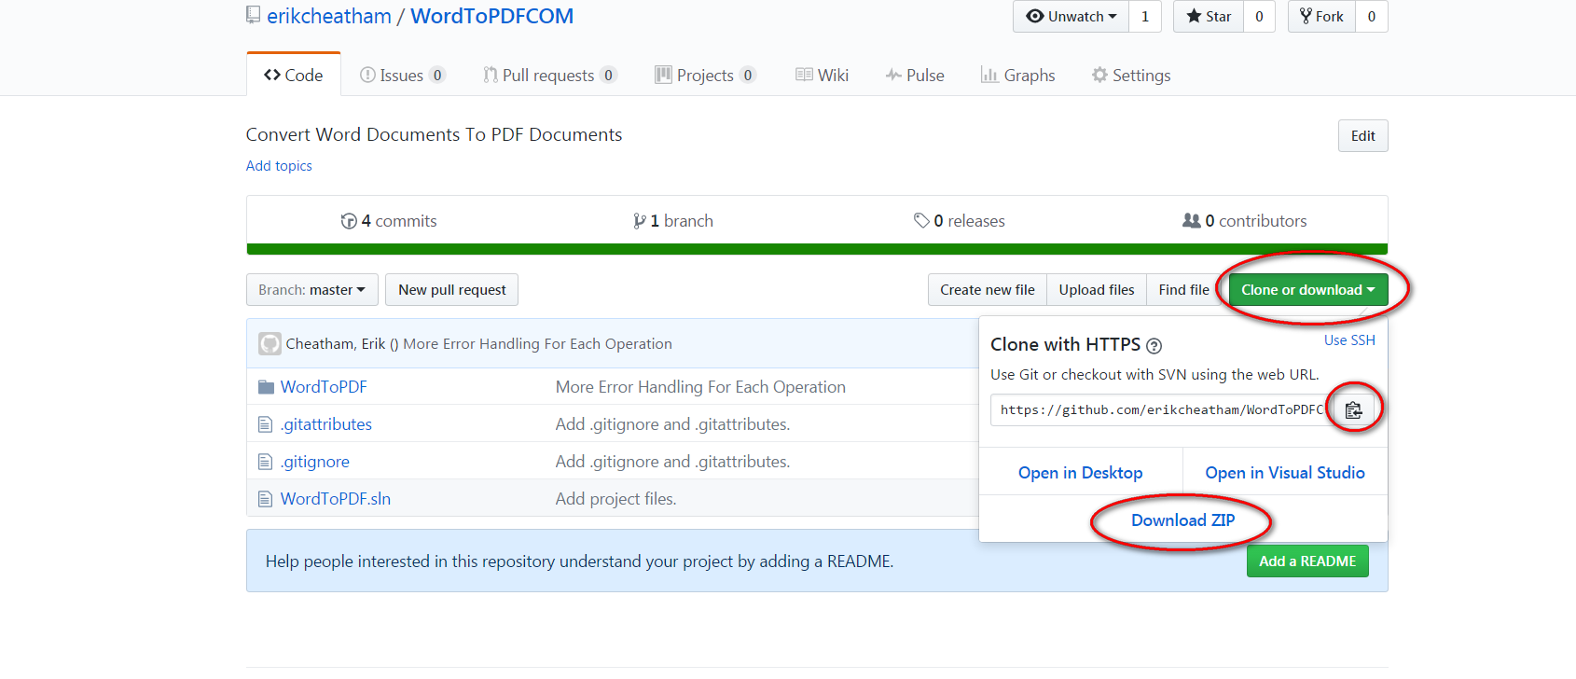

Opening the solution **(If you don’t have visual studio jump to the next page!)**

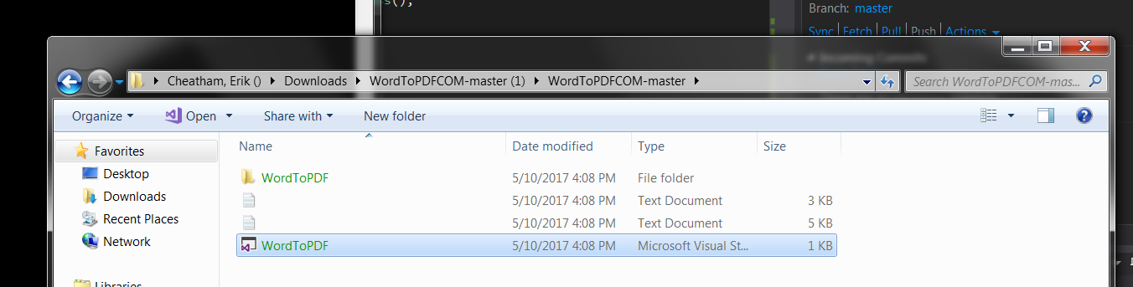

And running the program

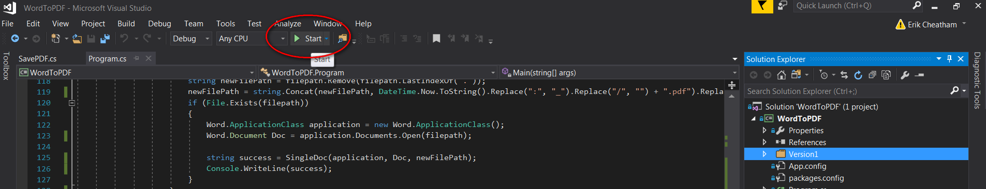

Or navigate to the project you can dive into the Version1 folder

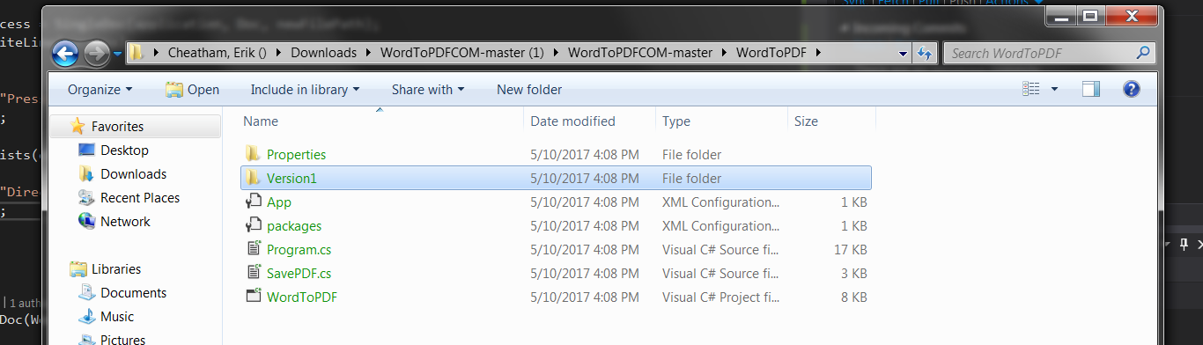

And you can run the program directly here

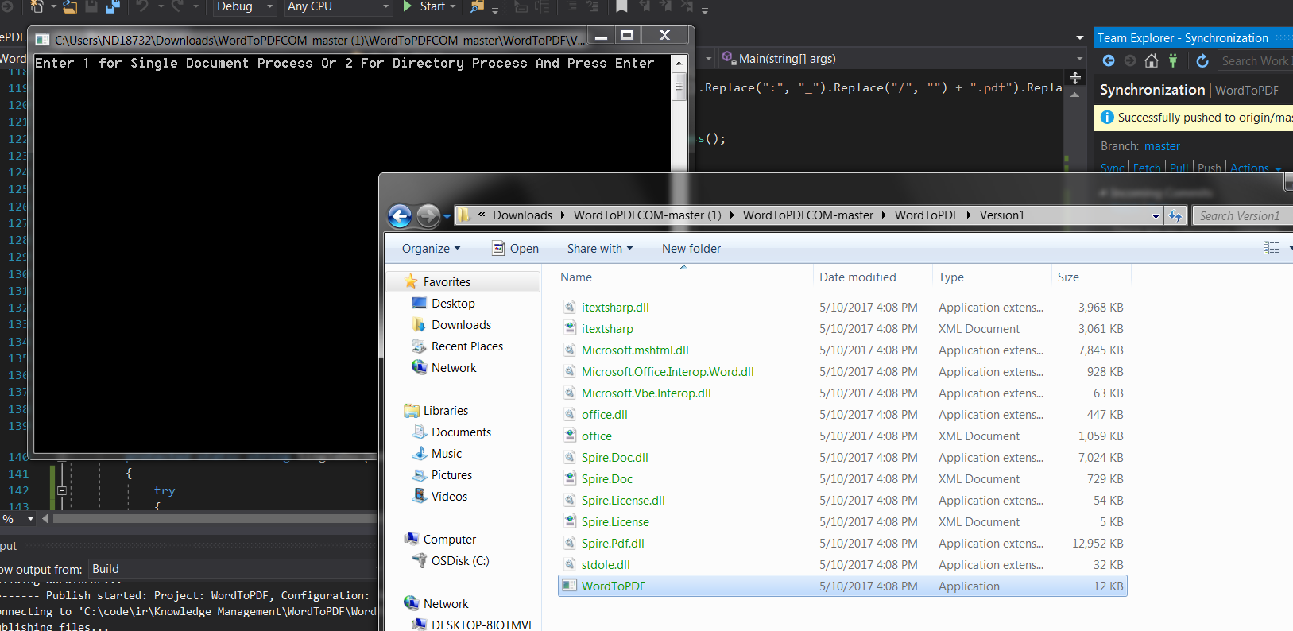

You can type 1 and press enter to drag and drop a single file onto the black screen or type 2 and drag and drop a whole folder to process onto the black screen