* Save both scripts (test_script_Yuri_fMRI.m and preprocessing1stlevel_FT.m) in the same folder. Add this folder to the path in Matlab (set path in editor, or addpath command)
* In **preprocessing1stlevel_FT.m (replace FT with NBack or Odorn for the other two tasks):**

1. If you are using a windows computer, change all forward slashes (‘/’) to backward slashes (‘\’) by clicking on the find function in the Matlab editor window and replacing ‘/’ with ‘\’. Mac or linux users do not need to change anything.
2. **Line 3**: change the filepath to the path to the folder where the PHIME MRI data is stored on your computer. We assume in the rest of the script that this folders has the following general structure (where 1,2 and 3 are the subject folders, note that the script will work fine if these subject folders have different names):

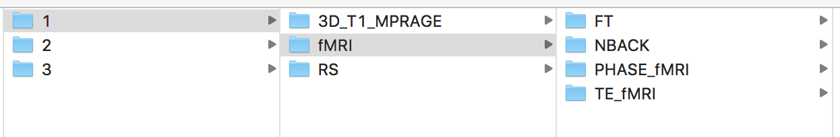

1. **Line 6**: change this path to the path where the SPM MNI template is stored on your computer (you only have to change the part before ‘spm12/ tpm/TPM.nii’).
2. **Line 34 and 61**: This line specifies that all subjects within the folder defined in line 3 will be analyzed. If you want to select only a subset of subjects, you can replace the command with, e.g., *for h = 1:10* (to only include the first 10 subjects, in alphabetical order of their folder names) or *for h = 1, 5, 10:20* (to include the 1st, 5th, and 10th though 20th subjects, inalphabetical order of their folder names)*.*

* Run the **preprocessing1stlevel_FT.m** script by going to “Editor” and clicking on the green arrow.