Synaptic State Simulator
Kürti Erik Dominik IMSNS1
Why this as a project choice?
I chose this subject and design for various reasons. First of all I am very interested in neuroscience and computational neuroscience. I figured it would be a fitting project idea and due to me enjoying the topic very much it would be also very fun to complete it. It aims to provide more information regarding neurotransmitters and certain substances that affect these neurotransmitters, while also providing a simple fun little visualized explanation for it on a cartoony human skull and also providing the basic benefits and negatives of the selected substance.
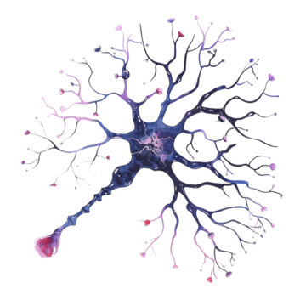

- Project overview and UI Architecture:
As I have said before the Synaptic State Simulator is a computational neuro-analysis tool designed to visualize the effects of various substances on neural firing patterns, while also having a fun little simplified aspect to it. The project aims to provide a bridge between complex neurobiology and interactive digital media in a simplified matter.
Aesthetic: The interface is rather dark themed, using a neon blueish colour
Typography: A custom “GTA” style font (pricedown) that I took inspiration from the GTA franchise and I also find that font very appealing is integrated via the @font-face rule to provide a nice, high tech feel most likely also familiarity to many people.
Neon Glows: CSS box-shadow and text-shadow are used to create a glowing “neon” effect.
The site features a sticky menu designed with a flexbox allowing users to navigate between the four html files.
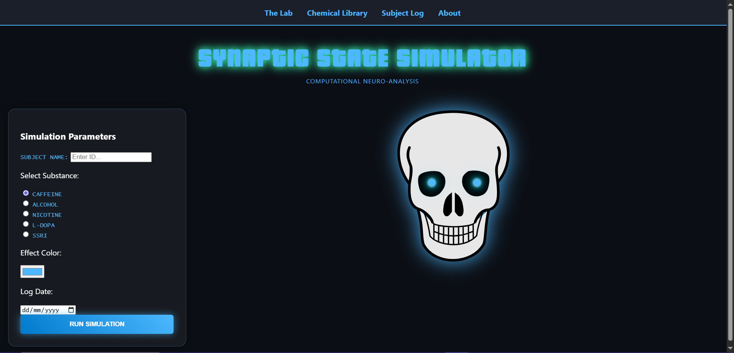
- HTML Infrastructure
Core components:
The application is built using standard semantic HTML elements including div, span, p and hierarchical headings. A central cartoony skull image serves as the focal point for all visual simulations.
The chemical library html page utilizes a complex HTML table to store neurochemical data.
Information is categorized using numbered lists for classifications (excitatory, inhibitory etc) and bulleted lists for specific substance effects.
The “Simulation parameters” panel includes a diverse array of form inputs:
- Text inputs: Single-line fields for subject Ids.
- Radio buttons: Used for the substance selection.
- Colour picker: A simple personalized colour picker to see the big flash of the simulation in a specific colour that the user might want to see.
- Date selector: Used for timestamping simulations.
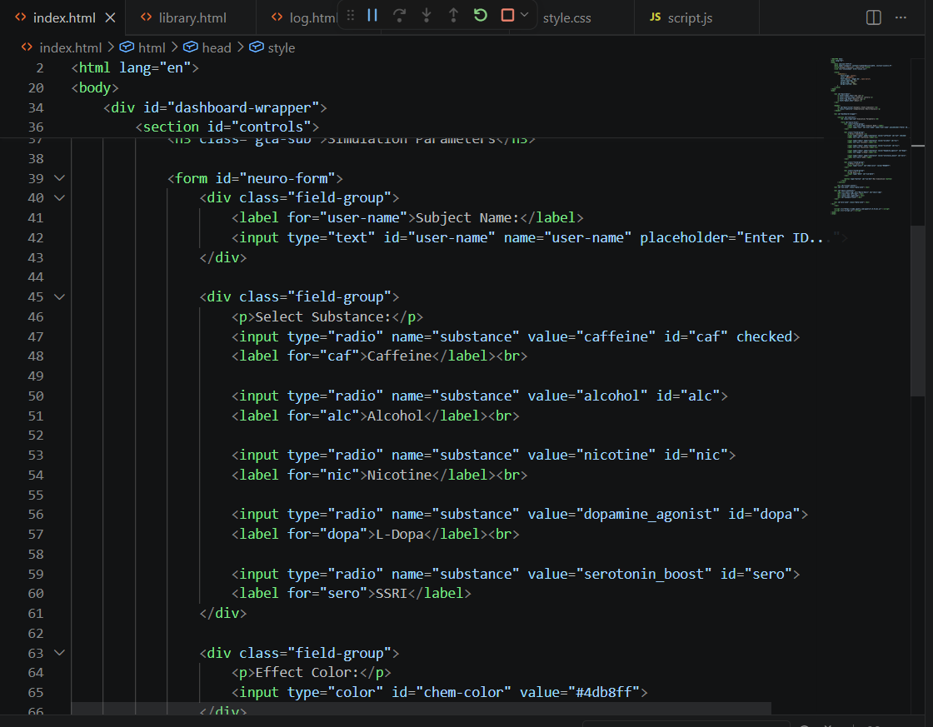

- CSS and Layout Logic
The project utilizes a hybrid CSS approach:
- External stylesheet: Contains the main neuroscience theme and global layout rules.
- Internal <style> tags, used for page specific subtitle formatting.
- Inline style attributes: Applied for specific flex-basis overrides and unique section widths.
Identifier and class based styling:
ID selectors: Unique elements like #main-title and #skull-container receive specific positioning and animation rules.
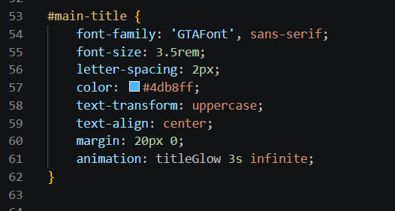
Class Selectors: Repeated elements such as .neuron-fire and .data-zone, use classes to ensure visual consistency across the project.
The visual-center uses Flexbox to create a three-pane layout. The skull image remains fixed in the center while two dynamic data zones (#con-zone and #pro-zone) flank it to display information and real time analysis results after the user uses a simulation of a substance to show the benefits and negatives of the selected substance.
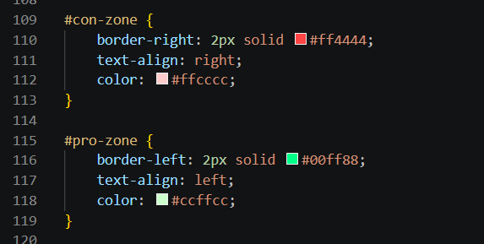
- JavaScript and jQuery mechanics
Dynamic DOM manipulation
A cornerstone of the project is the creation of new elements.
- Neural bursts: When the simulation is ran, the script dynamically creates div elements with the .neuron-fire class.
- Performance: These elements are automatically removed from the DOM using setTimeout after their animation completes.
The script demonstrates mastery of jQuery selectors:
- By Tag: Modifying the body background colour during a simulation flash.
- By Name: Selecting the active substance via input[name=”substance”]: checked
- By ID: Triggering the simulation logic through the #run-btn click event.
Behavioral logic
A switch statement processes the substance the user selected to assign unique values for the burstIntensity, prosText and consText. This allows the “Alcohol” simulation to appear slow and green for example while the “Nicotine” simulation appears fast and red adhering to their neurological truth presenting a visual helper to how they function on the brain simplified.
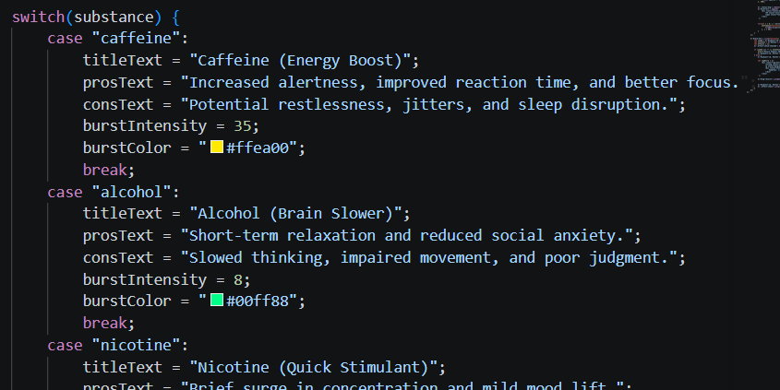
- Validation and logging
To ensure integrity the system implements form checking.
If the “Subject name” field is empty, the script prevents the simulation from running and triggers an alert.
The script applies a red frame (.error-border) to the invalid input field as a visual feedback.
The subject log page demonstrates advanced data handling methods:
- Multi-line input: A textarea allows for the user to write detailed clinical observations.
- Checkboxes: Users can select multiple physiological responses simultaneously.
- Dynamic logging: Upon clicking “Log Observation” the script captures these inputs and modifies the existing page by prepending a new log entry card to the history list.
The “About” page details the project and lists some sources for neuroscience and computational neuroscience, the sources for those being also here:
https://www.psychologytoday.com/us/basics/neuroscience
https://www.cnsorg.org/computational-neuroscience
Project requirement checklist:
Requirement Implementation in my project
Minimum 4 HTML files | Index.html, library.html, log.html, about.html
Table formatting | The #chem-table in the chemical library
Numbered and bulleted lists | Classifications and substance effects in library.html
Colour and date selectors | Integrated into the main lab control panel
Menu design | Sticky navigation bar with hover effects
Background colour | Deep blue with active simulation flashes

Of course this project is a severely simplified version of the complexities of neuroscience and computational neuroscience but it could be always improved and expanded with more buttons more information regarding the neurotransmitters or more brain regions or more detailed explanation and visually with more detailed feedback of how these work and function fully.

