**PlateWellsTransfer User Manual**

A Java swing application for compound and plate operations. The compound data is stored in the Compounds.xml file and plate data is stored on the Plates.xml file. The application allows users to add register compounds, create new plates, view existing plates, add compounds to plate wells, and transfer the contents of a plate well to existing plate well locations.

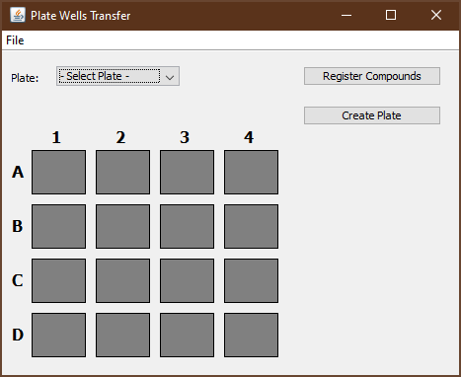

1. **Register new compounds**

To register new compounds click the “Register Compounds” button on the main form. This displays the Register Compounds form. When the form loads all existing compounds are displayed in the Compound List. The list is initially empty since there are no compounds in the Compounds.xml file.

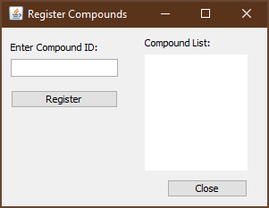

Enter a Compound ID and click the “Register” button. The Compounds List will then show the new Compound ID. It will also be automatically saved to the Compounds.xml file.

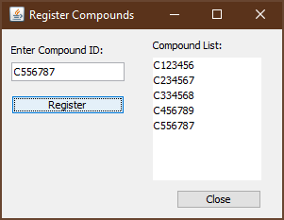

1. **Create a new plate**

Click the “Create Plate” button to show the Create Plate form.

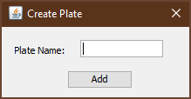

Enter the plate name and click add. This will add the plate to the Plates.xml file.

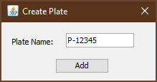

After the form closes the new plate is displayed on the main form.

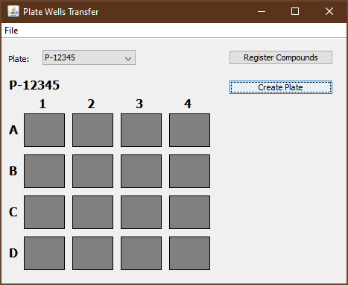

1. **View an existing plate**

Select a plate from the dropdown plate list.

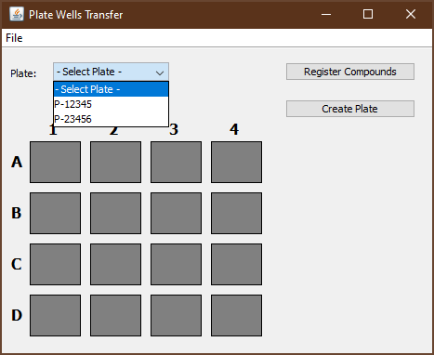

The plate will then be loaded. The plate below is currently empty. Users need to double left click on a well to add a compound (see step 4 below).

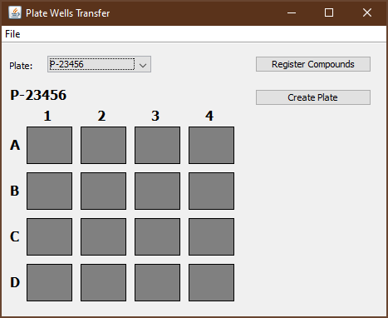

1. **Add a compound to a specified well**

A plate must be selected to add a compound to a well location. Double left click the desired well to display the Add Compound form.

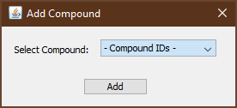

Select a compound from the dropdown and click the “Add’ button.

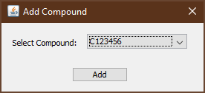

Then selected compound will then be displayed in the specified well location.

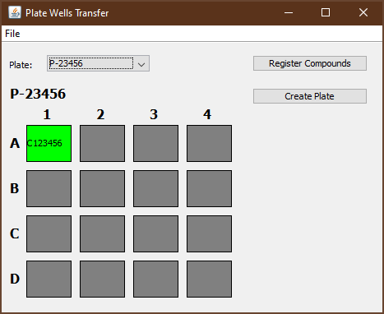

Users will need to click each well location to populate the plate.

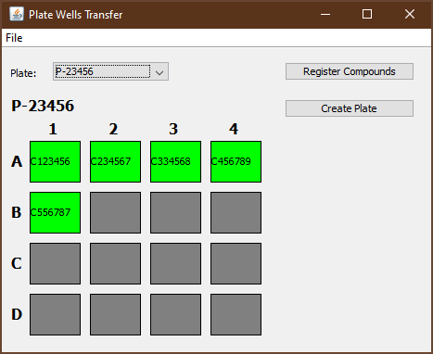

1. **Transfer a compound from a specified plate well location to existing plate wells**

To transfer a compound to other plate well locations first right click on a populated well. Below is an example of right clicking the well location B2 in plate P-23456 (see above).

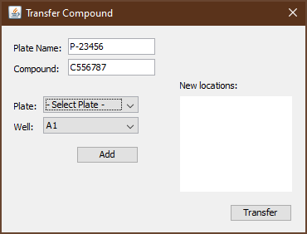

Select a plate and well location then the “Add” button. This will add the new location to the list box.

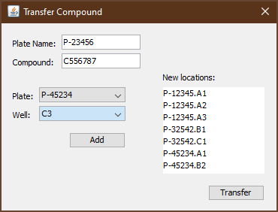

Click the “Transfer” button to create the plate well records in the Plates.xml file.

Select the plates specified to verify that the compounds were added correctly.

