  - QUALITY ASSURANCE / PLAYTEST

BEAT THE HOUSE
  - Consolidated Playtest Bug Report
  - Current source candidate and packaged-artifact verification

34  CONFIRMED DEFECTS | 7  CRITICAL | 6  SPECIALIST TESTERS | 18 / 11  ROOMS / GAMES

Field | Value
Test date | 20 September 2026
Source identity | HEAD 4384378a00d2e81e259aa28ae01ffbbc7cf21fd5 plus pre-existing uncommitted worktree changes
Runtime | Godot 4.6 stable (89cea1439), Windows 10 (19045), i9-9900K, 64 GB RAM, RTX 4070 Ti
Published metadata | 0.5.1; repository notes identify active main-line work as unreleased 0.6
Change policy | Diagnostic only. No gameplay, source, content, or data defect was fixed.
Confidence rule | Player-facing bugs required production-path evidence and repeatability; harness-only failures were excluded.

Prepared for engineering triage. Internal QA evidence paths are repository-relative.

Executive summary
This six-specialist campaign confirmed 34 distinct actionable defects after root-cause validation and deduplication. The set contains 7 Critical, 17 High, 9 Medium, and 1 Low findings. The dominant risk is not game-rule correctness or frame time; it is interaction authority and accessibility. Multiple visible controls claim the same hit area, several route controls overlap, and one scenario audit explicitly suppresses the evidence that should catch those collisions.
No current performance regression was confirmed: all eleven games completed functional contracts, all ten sampled resolve paths stayed within budget, and active Coin Pusher/Slot paths remained inside the player-frame budget. Actual SaveService disk restores also preserved dynamic-scenario queues and continuation state; the earlier apparent save-data-loss cluster was a harness shortcut and is excluded.
Priority | Triage focus | Why it matters
1 | Restore trustworthy collision auditing (UIE-021) | The current scenario audit returns false zeroes in rooms with shipped developer placements, hiding blocking route/action collisions.
2 | Separate route and wagering authority (UIE-010/012/013/017/019/020) | Core navigation or action controls share pointer space; the selected outcome can depend on z/order.
3 | Repair keyboard/touch accessibility (A11Y-001/003/004) | Keyboard-only travel is blocked and advertised large-target settings do not reach dynamic gameplay actions.
4 | Validate checked-in placements | Exact developer coordinates bypass collision recovery and account for a large cluster of repeatable room conflicts.
5 | Re-layout Bar Dice and tutorial focus | Fixed geometry obscures table tells; wrong-order tutorial input points at the object while the required action disappears.
6 | Bind release artifacts to one source identity | The tested packages claim Version 0.5.1 while representing different untraceable development snapshots.

Release recommendation
Do not treat the current candidate as interaction-complete. At minimum, fix and regression-test the false-clean audit, overlapping route controls, keyboard-inaccessible world map, and accessibility-setting regressions before release qualification. Game-rule and performance baselines are strong enough to support focused remediation rather than a broad gameplay rewrite.

Severity model
Level | Definition used in this report | Count
Critical | Blocks or ambiguously reroutes a core progression/action path, or disables the safety audit intended to catch it. | 7
High | Materially impairs interaction, accessibility, or readability on a repeatable production path. | 17
Medium | Recoverable but confusing, undersized, truncated, or inconsistent behavior with clear player impact. | 9
Low | Limited presentation defect with low functional risk. | 1

Test identity, method, and coverage
The candidate was tested in its existing dirty worktree because those changes were already present when the assignment began. The campaign preserved them and produced only reports and temporary evidence. Runtime-heavy Godot work was serialized to avoid the repository's documented cross-gate interference; static analysis and evidence review proceeded in parallel.
Area | Coverage executed | Outcome
Environment/UI | Fresh deterministic captures of all 18 archetypes; direct interaction-rect intersections computed separately from 8 px spacing warnings; current-date Bar scenario frames reviewed. | 16 base-room and 4 scenario hitbox conflicts; 6 additional UI defects.
Games | All 11 modules; 4 functional shards / 10 checks; 48 resolve samples per applicable game; active Coin Pusher and Slot paths. | Functional and current performance gates passed; two Bar Dice layout defects.
Tutorial/progression | Both tutorial routes; 56 lesson-boundary save/load checkpoints; 100-seed stuck sweep; 1,622 guardrail transitions; 28 systems checks. | One recoverable wrong-order tutorial defect.
Persistence/chaos | Two seeds × two disk generations; scenario queue, travel, travel lock, closing, event, challenge, and terminal state. | No product persistence defect; raw-JSON harness failures excluded.
Accessibility/input | Twice-run production-class probes for focus, modal cancel, small-screen sizing, dynamic UI scaling, and reduced motion. | Five defects reproduced identically.
Packages | Windows distribution start twice, archive integrity, native plugin parity, two 64-scenario sweeps, and Web artifact smoke. | Runtime passed; two release-identity/custody defects confirmed.

Validation standard
- A visible symptom had to reproduce at least twice or be deterministic across the entire generated sample.
- The report distinguishes direct interaction-rectangle intersections from spacing-only footprint warnings.
- Root causes were traced to checked-in data, runtime layout/selection code, or shared UI policy with exact source references.
- Harness failures were challenged against the actual player path. SaveService/RunSaveCodec evidence overruled a raw-JSON false positive.
- No defect was fixed; proposed options are for a later implementation pass.

Root-cause clusters
Cluster | Affected findings | Engineering implication
Exact placement bypass | UIE-002–008, 014, 016, 017 | Checked-in developer coordinates are treated as exact and skip recovery; promotion needs direct-hit validation.
Exhausted placement accepted | UIE-001, 009, 011, 015 | When no candidate fits, the colliding rectangle is stored with no placement error.
Duplicate route slots | UIE-010, 012, 013, 020 | Independent route categories can author the same doorway coordinate; route authority needs consolidation.
Audit suppression | UIE-018–021 | Developer-placement rooms bypass scenario/base collision accounting, producing false clean reports.
Fixed surface geometry | UIE-022-A/B | Bar Dice panels, patrons, and dealer widgets are drawn from unrelated fixed-coordinate systems.
Text/asset constraints | UIE-023–025 | Hard width caps, destructive prefix fitting, and clipped raster title art reduce legibility.
Tutorial dependency/focus ordering | GP-01 | Focus is cleared using the first dependent lesson rather than the final active lesson after out-of-order progress.
Accessibility policy fragmentation | A11Y-001–005 | Focusable controls, target sizing, dynamic scaling, modal cancel, and reduced motion are implemented inconsistently.
Release provenance | PKG-001/002 | Versioning, staging, and an immutable cross-platform manifest must tie every upload artifact to one source/build identity.

Consolidated bug index
Report ID | Source ID | Severity | Area | Summary
BTH-001 | UIE-001 | High | Environment layout | Bar ticket redeemer and slot share hit authority
BTH-002 | UIE-002 | High | Environment layout | Corner Store Odds Notebook and Trunk overlap
BTH-003 | UIE-003 | High | Environment layout | Corner Store Late Shift Discount and merchant overlap
BTH-004 | UIE-004 | Medium | Environment layout | Corner Store Late Shift Discount and Cashier Tip overlap
BTH-005 | UIE-005 | High | Environment layout | Corner Store merchant and Cashier Tip overlap
BTH-006 | UIE-006 | High | Environment layout | Gas Station Pull Tabs and Scratch Tickets overlap
BTH-007 | UIE-007 | High | Environment layout | Gas Station drink and numbers book overlap
BTH-008 | UIE-008 | Medium | Environment layout | Gas Station Parking Lot Tip and Side Door overlap
BTH-009 | UIE-009 | Medium | Environment layout | Grand Casino slot bank controls overlap
BTH-010 | UIE-010 | Critical | Environment layout | Grand Casino Back Room route overlaps Blackjack
BTH-011 | UIE-011 | High | Environment layout | Grand Casino Craps overlaps ticket redeemer
BTH-012 | UIE-012 | Critical | Environment layout | Grand Casino Cage Main Floor and Leave routes overlap
BTH-013 | UIE-013 | Critical | Environment layout | Grand Casino High-Limit Cage and Leave routes almost completely overlap
BTH-014 | UIE-014 | High | Environment layout | House Storage Spot and Trunk overlap
BTH-015 | UIE-015 | Medium | Environment layout | Jazz Club Cello Round and ticket redeemer overlap
BTH-016 | UIE-016 | High | Environment layout | Motel Parking Lot Tip and Malik Stone overlap
BTH-017 | UIE-017 | Critical | Scenario layout | Bar Rowdy Regular and Bar Dice overlap under Dead Tuesday
BTH-018 | UIE-018 | High | Scenario layout | Coin Pusher and Dead Tuesday Patron Zone overlap
BTH-019 | UIE-019 | Critical | Scenario layout | Pull Tabs and Dead Tuesday task control overlap
BTH-020 | UIE-020 | Critical | Scenario layout | Leave and Dead Tuesday Safe Exit overlap
BTH-021 | UIE-021 | Critical | Scenario layout | Scenario layout audit falsely reports a clean room
BTH-022 | UIE-022-A | High | Game surface UI | Bar Dice Rail Cups panels obscure the left patron rail
BTH-023 | UIE-022-B | High | Game surface UI | Bar Dice dealer-status widgets cover Iris, the right-center patron
BTH-024 | UIE-023 | Medium | Text / presentation | Object labels silently truncate without ellipsis
BTH-025 | UIE-024 | Medium | Text / presentation | Grand Casino High-Limit title plate asset is clipped
BTH-026 | UIE-025 | Low | Text / presentation | Corner Store resolved label still covers another actionable object
BTH-027 | GP-01 | Medium | Tutorial / progression | Wrong-order Corner Store tutorial loses the actionable Buy target
BTH-028 | A11Y-001 | High | Accessibility / input | World-map destinations cannot be selected by keyboard
BTH-029 | A11Y-002 | Medium | Accessibility / input | Escape does not close the Settings modal
BTH-030 | A11Y-003 | High | Accessibility / input | Small-screen environment action targets are only 34 px high
BTH-031 | A11Y-004 | High | Accessibility / input | Rebuilt gameplay actions lose large-text and small-screen sizing
BTH-032 | A11Y-005 | Medium | Accessibility / input | TalkDock attention motion still runs with Reduce Motion enabled
BTH-033 | PKG-001 | High | Release packaging | Unreleased 0.6 packages identify themselves as published Version 0.5.1 and carry no embedded source identity
BTH-034 | PKG-002 | High | Release packaging | The Windows upload ZIP, loose itch executable, current Windows folder, and Web folder are different unbound build snapshots

Representative visual evidence
These production and deterministic-capture frames illustrate the recurring failure modes. Exact pair geometry and source traces appear in the detailed findings.
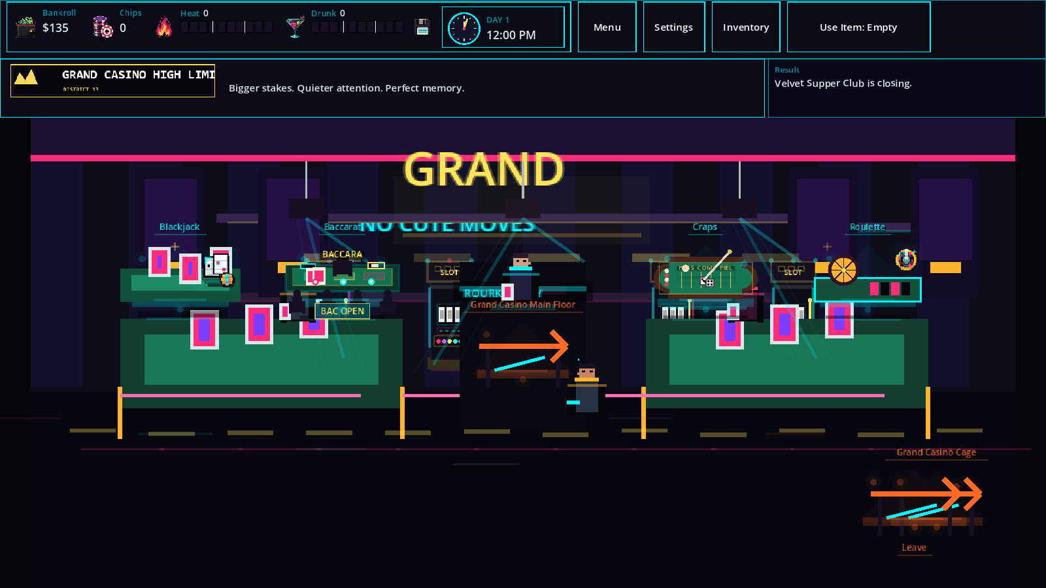
Figure 1 — Grand Casino High-Limit: two route arrows share the right-side doorway, while the title raster ends at “LIMI”.
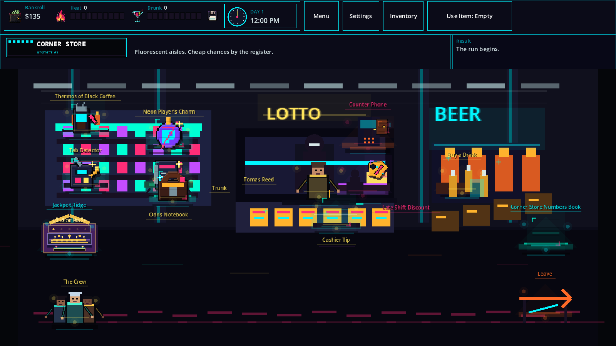
Figure 2 — Corner Store: exact promoted placements stack items and cashier/event controls in the same visual and interactive regions.
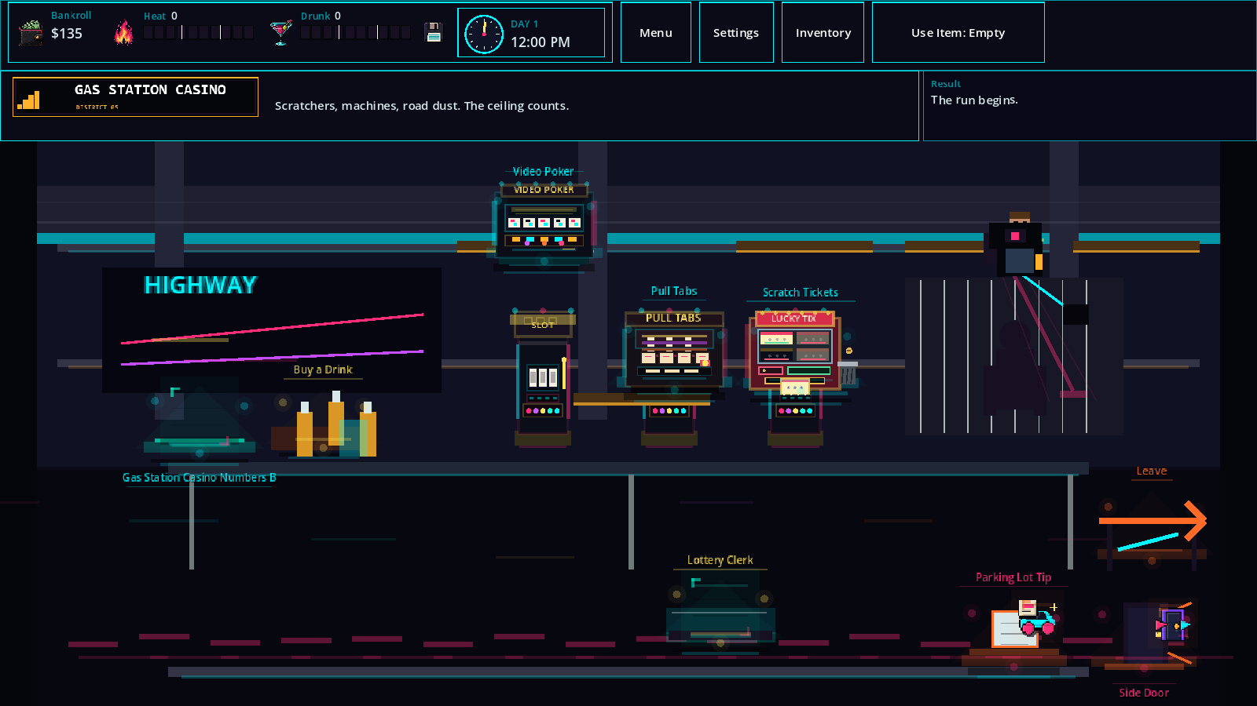
Figure 3 — Gas Station Casino: Pull Tabs/Scratch Tickets and the Parking Lot Tip/Side Door controls intersect.
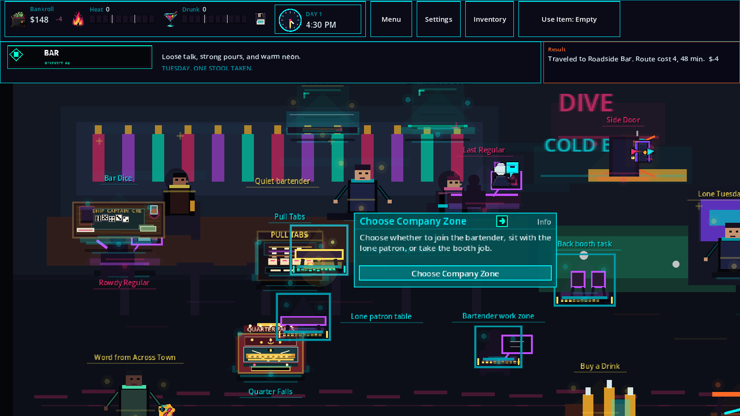
Figure 4 — Bar Dead Tuesday: active scenario stations overlap base games, patrons, and exit authority while the audit reports zero collisions.
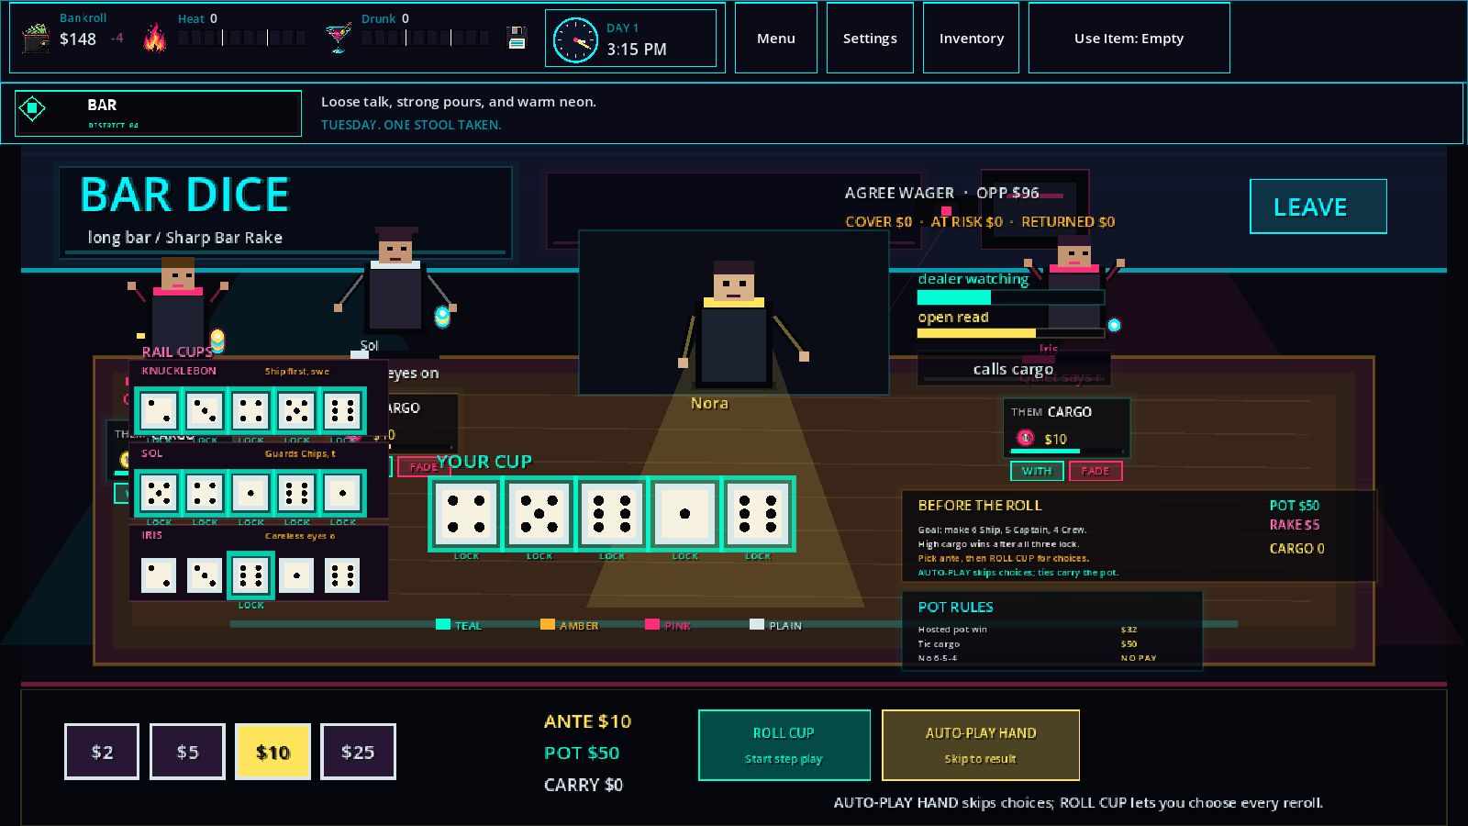
Figure 5 — Bar Dice: Rail Cups panels obscure left patrons and dealer-status widgets overprint the right-center patron.

Detailed confirmed findings

Environment layout

BTH-001 / UIE-001 — Bar ticket redeemer and slot share hit authority
Severity: High | Confidence: High | Status: Confirmed
- Severity: High
- Room/evidence: bar.png; game_hook:pull_tabs:ticket_redeemer ↔ game:slot
- Direct intersection: 2,436 px²
- Root cause: Bar authored slots are dense (data/environments/placement_surfaces.json:41). The ticket redeemer is automatically moved but the non-manual recovery path accepts the colliding selection after no supported alternative succeeds (environment_instance.gd:715-736).
- Fix options: add a valid nonoverlapping behind-counter candidate; move one authored slot; or make unresolved collision a placement error instead of silently accepting it.

BTH-002 / UIE-002 — Corner Store Odds Notebook and Trunk overlap
Severity: High | Confidence: High | Status: Confirmed
- Severity: High
- Evidence: corner_store.png; item:odds_notebook ↔ item:trunk
- Direct intersection: 3,360 px²
- Root cause: the shipped category override for item_spots:1 places an item at [189,144] (developer_placement_overrides.json:87); manual placement bypasses collision recovery and lands on the trunk.
- Fix options: move the notebook/trunk; validate checked-in overrides; reject promotion of overlapping developer placements.

BTH-003 / UIE-003 — Corner Store Late Shift Discount and merchant overlap
Severity: High | Confidence: High | Status: Confirmed
- Severity: High
- Evidence: corner_store.png; event:late_shift_discount ↔ shopkeeper:merchant
- Direct intersection: 2,304 px²
- Root cause: event_spots:1 and the merchant have conflicting checked-in developer coordinates (developer_placement_overrides.json:75, 113), and manual coordinates bypass recovery.
- Fix options: separate the event and cashier counter person; reserve the merchant footprint; gate project overrides with direct-hit validation.

BTH-004 / UIE-004 — Corner Store Late Shift Discount and Cashier Tip overlap
Severity: Medium | Confidence: High | Status: Confirmed
- Severity: Medium
- Evidence: corner_store.png; event:late_shift_discount ↔ service:cashier_tip
- Direct intersection: 228 px²
- Root cause: the exact event override is accepted without testing later/generated service authority (environment_instance.gd:703-715).
- Fix options: move the event; create a dedicated late-shift service slot; rerun collision packing after all manual and generated entries are assembled.

BTH-005 / UIE-005 — Corner Store merchant and Cashier Tip overlap
Severity: High | Confidence: High | Status: Confirmed
- Severity: High
- Evidence: corner_store.png; shopkeeper:merchant ↔ service:cashier_tip
- Direct intersection: 525 px²
- Root cause: the merchant's checked-in exact override (developer_placement_overrides.json:113) does not reserve space against the generated service.
- Fix options: merge Cashier Tip into the merchant action panel; move its prop; or enforce a project-override collision gate.

BTH-006 / UIE-006 — Gas Station Pull Tabs and Scratch Tickets overlap
Severity: High | Confidence: High | Status: Confirmed
- Severity: High
- Evidence: gas_station_casino.png; game:pull_tabs ↔ game:scratch_tickets
- Direct intersection: 994 px²
- Root cause: checked-in exact positions [430,126] and [526,127] are closer than the two 110×72 game controls can support (developer_placement_overrides.json:161-168).
- Fix options: increase horizontal separation; reduce only the art footprint while preserving 44-pixel minimum targets; fail override promotion on intersection.

BTH-007 / UIE-007 — Gas Station drink and numbers book overlap
Severity: High | Confidence: High | Status: Confirmed
- Severity: High
- Evidence: gas_station_casino.png; service:house_drink ↔ numbers:book
- Direct intersection: 378 px²
- Root cause: checked-in exact positions [170,186] and [71,183] bypass collision recovery (developer_placement_overrides.json:173-180).
- Fix options: move either counter service; combine them into a shared clerk surface; validate direct hit rectangles before shipping.

BTH-008 / UIE-008 — Gas Station Parking Lot Tip and Side Door overlap
Severity: Medium | Confidence: High | Status: Confirmed
- Severity: Medium
- Evidence: gas_station_casino.png; event:parking_lot_tip ↔ event:side_door
- Direct intersection: 63 px²
- Root cause: category overrides for successive event slots are placed at [693,344] and [792,345] (developer_placement_overrides.json:127-134); category overrides take precedence over object overrides at environment_instance.gd:699-705.
- Fix options: move the side door to its dedicated doorway slot; treat doors as reserved; prevent category overrides from silently superseding a safer object-specific coordinate.

BTH-009 / UIE-009 — Grand Casino slot bank controls overlap
Severity: Medium | Confidence: High | Status: Confirmed
- Severity: Medium
- Evidence: grand_casino.png; game:slot ↔ game:slot:2
- Direct intersection: 144 px²
- Root cause: authored slot coordinates are only 126 pixels apart (placement_surfaces.json:381-383) while support correction produces 110-pixel controls plus intended spacing; the fallback path stores a collision without an error.
- Fix options: widen the bank spacing; render one bank control for multiple cabinets; surface exhausted placement as a generation error.

BTH-010 / UIE-010 — Grand Casino Back Room route overlaps Blackjack
Severity: Critical | Confidence: High | Status: Confirmed
- Severity: Critical
- Evidence: grand_casino.png; travel:grand_casino_back_room ↔ game:blackjack
- Direct intersection: 128 px²
- Impact: a navigation control and a wagering game claim the same pointer area.
- Root cause: route [0,176] and blackjack [120,176] are adjacent authored slots (placement_surfaces.json:385-387); support correction and final sizes still intersect, but the resolver records no placement error.
- Fix options: reserve a route rail; move blackjack; make route/game intersections fatal in content validation.

BTH-011 / UIE-011 — Grand Casino Craps overlaps ticket redeemer
Severity: High | Confidence: High | Status: Confirmed
- Severity: High
- Evidence: grand_casino.png; game:craps ↔ game_hook:pull_tabs:ticket_redeemer
- Direct intersection: 170 px²
- Root cause: dense authored positions (placement_surfaces.json:385-386) exhaust available compatible surfaces and the unresolved collision is stored as valid.
- Fix options: relocate redeemer to a cashier/fixture zone; add another supported floor surface; report/fail exhausted collision placement.

BTH-012 / UIE-012 — Grand Casino Cage Main Floor and Leave routes overlap
Severity: Critical | Confidence: High | Status: Confirmed
- Severity: Critical
- Evidence: grand_casino_cage.png; travel:grand_casino ↔ travel:leave
- Direct intersection: 1,044 px²
- Root cause: Cage authors the local casino door and generic travel spot at the same [824,350] coordinate (archetypes.json:4378-4389).
- Fix options: remove redundant Leave in this subroom; give each route a unique slot; display a single route selector when destinations share a doorway.

BTH-013 / UIE-013 — Grand Casino High-Limit Cage and Leave routes almost completely overlap
Severity: Critical | Confidence: High | Status: Confirmed
- Severity: Critical
- Evidence: grand_casino_high_limit.png; travel:grand_casino_cage ↔ travel:leave
- Direct intersection: 5,824 px²
- Impact: the two orange arrows are drawn nearly on top of one another, making mouse authority and destination legibility unreliable.
- Root cause: High-Limit room authors casino_door_spots[1] and travel_spots[0] both at [808,350] (archetypes.json:3978-3993).
- Fix options: remove redundant Leave; split door positions; render a single doorway with explicit destination choices.

BTH-014 / UIE-014 — House Storage Spot and Trunk overlap
Severity: High | Confidence: High | Status: Confirmed
- Severity: High
- Evidence: house.png; home_storage:place ↔ home_container:trunk_01
- Direct intersection: 810 px²
- Root cause: exact project overrides [320,293] and [231,297] conflict (developer_placement_overrides.json:219-230) and manual placements bypass collision recovery.
- Fix options: move the controls; represent Storage Spot as a panel action on the trunk; validate project overrides.

BTH-015 / UIE-015 — Jazz Club Cello Round and ticket redeemer overlap
Severity: Medium | Confidence: High | Status: Confirmed
- Severity: Medium
- Evidence: jazz_club.png; service:jazz_cello_round ↔ game_hook:pull_tabs:ticket_redeemer
- Direct intersection: 252 px²
- Root cause: dense authored service/wall placements (placement_surfaces.json:131-132) leave no valid alternative; the automatic path silently accepts a collision (environment_instance.gd:715-736).
- Fix options: move the redeemer to the bar; add a dedicated supported wall slot; fail unresolved placement.

BTH-016 / UIE-016 — Motel Parking Lot Tip and Malik Stone overlap
Severity: High | Confidence: High | Status: Confirmed
- Severity: High
- Evidence: motel.png; event:parking_lot_tip ↔ lender:motel_friend
- Direct intersection: 936 px²
- Root cause: exact project overrides [33,345] and [115,357] conflict (developer_placement_overrides.json:235-254) and bypass recovery.
- Fix options: move lender/tip; sequence one through dialogue instead of separate floor props; validate promoted overrides.

Scenario layout

BTH-017 / UIE-017 — Bar Rowdy Regular and Bar Dice overlap under Dead Tuesday
Severity: Critical | Confidence: High | Status: Confirmed
- Severity: Critical
- Evidence: .tmp/agent_playtest_24h_ui/0016.png; event:rowdy_regular ↔ game:bar_dice
- Direct intersection: 3,920 px²
- Root cause: checked-in developer override moves Bar Dice to [65,146], while the base Rowdy Regular remains at [77,178] (developer_placement_overrides.json Bar section; placement_surfaces.json:41). Project developer placement is accepted as authoritative.
- Fix options: move Bar Dice back to a machine zone; reserve its footprint against base events; reject intersecting project overrides.

BTH-018 / UIE-018 — Coin Pusher and Dead Tuesday Patron Zone overlap
Severity: High | Confidence: High | Status: Confirmed
- Severity: High
- Evidence: 0016.png; game:coin_pusher ↔ scenario::bar_dead_tuesday_patron_zone
- Direct intersection: 1,152 px²
- Root cause: scenario slot bar_dead_tuesday_patron_zone:[300,266] conflicts with active base controls (placement_surfaces.json:42); Bar's developer-placement status suppresses normal scenario collision enforcement.
- Fix options: provide a scenario fallback slot; reserve all current base hitboxes during scenario layout; never suppress scenario/base validation for project overrides.

BTH-019 / UIE-019 — Pull Tabs and Dead Tuesday task control overlap
Severity: Critical | Confidence: High | Status: Confirmed
- Severity: Critical
- Evidence: 0016.png; game:pull_tabs ↔ scenario::bar_dead_tuesday_task_0
- Direct intersection: 2,916 px²
- Root cause: the scenario task is authored at [316,188] while Pull Tabs occupies the same central band (placement_surfaces.json:41-42); developer-room suppression allows the collision.
- Fix options: place the task in a dedicated wall slot; relocate base machine while scenario is active; enforce scenario/base interaction disjointness.

BTH-020 / UIE-020 — Leave and Dead Tuesday Safe Exit overlap
Severity: Critical | Confidence: High | Status: Confirmed
- Severity: Critical
- Evidence: 0016.png/0017.png; travel:leave ↔ scenario::bar_dead_tuesday_safe_exit
- Direct intersection: 94 px²
- Root cause: both controls target the right exit rail, and checked-in Bar route overrides make the whole room developer-placed. The scenario resolver therefore skips the ambiguous route check.
- Fix options: reuse one exit authority instead of drawing two; offset the scenario marker; keep route-vs-route intersections fatal even in developer placement mode.

BTH-021 / UIE-021 — Scenario layout audit falsely reports a clean room
Severity: Critical | Confidence: High | Status: Confirmed
- Severity: Critical
- Frequency: 100% in the captured Bar Dead Tuesday state
- Evidence: 0016.result.json reports room_canvas.object_layout.overlap_count=9, while scenario_layout_audit.normal_overlap_count=0, small_screen_overlap_count=0, collision_adjustment_count=0, and valid=true.
- Root cause: _overlap_count returns zero for the entire room when any developer placement exists (scenario_layout_resolver.gd:1620-1643). Related validation loops also skip developer-placed targets/rooms (824-847). Checked-in project overrides therefore disable safety gates in ordinary production content, not merely an editor preview.
- Fix options: distinguish temporary user freeform edits from shipped project data; always calculate and report overlaps even if nonfatal; make route and actionable control collisions nonwaivable.

Game surface UI

BTH-022 / UIE-022-A — Bar Dice Rail Cups panels obscure the left patron rail
Severity: High | Confidence: High | Status: Confirmed
Severity: Major / P2 Frequency: 2/2 consecutive production frames Area: Bar Dice, in-game table readability Evidence: .tmp/agent_playtest_24h_ui/0013.png, .tmp/agent_playtest_24h_ui/0014.png
Reproduction
1. Enter a Bar Dice table with the normal four-patron production layout.
2. Advance to a hand in which opponent cup rows are visible.
3. Inspect the left rail around the first patron and the Rail Cups panel stack.
Expected: Opponent dice, patron identity, body-language tell, and character art each occupy readable, non-overlapping regions.
Actual: The Rail Cups stack is painted across the left patron rail. Patron names/tells are clipped or hidden behind the three opaque dice panels, and parts of the character presentation are visually disconnected from their labels.
Measured geometry: The first opponent panel is Rect2(68, 136, 164, 48). Patron 0's declared safe region is Rect2(44, 30, 142, 158). Their intersection is 118 × 48 = 5,664 design-space pixels. The next two opponent rows continue down the same x-range, so the obstruction persists through the remaining left-side identity/tell rows.
Root cause: scripts/games/bar_dice.gd:70-80 hard-codes opponent row origins at x=76 while placing the first patron at x=94. _draw_opponent_dice_rows() constructs 164×48 panels beginning eight pixels left of those origins (scripts/games/bar_dice.gd:3191-3208). Patron safe rectangles are independently derived as 142×158 regions around the hard-coded patron positions (scripts/games/bar_dice.gd:3495-3500). No layout solver or collision check relates these two systems. Draw order makes the defect destructive: patrons are drawn first and dice rows later (scripts/games/bar_dice.gd:552-565), so the opaque row panels cover the patron content.
Why existing tests missed it: scripts/tests/foundation/check_table_games.gd:7444-7467 validates text_panel_rects against patron_safe_rects and patron-safe rectangles against each other. Rail Cups rectangles are not exported into either tested collection.
Fix options (for a later implementation agent):
- Move opponent rows to a dedicated rail lane that does not intersect any patron safe rectangle.
- Shift the left patron positions right/up and reserve the full Rail Cups stack before seating patrons.
- Preferably expose opponent-panel rectangles as layout metadata and add a general pairwise collision assertion against patron safe rectangles. This prevents the same failure from returning when row count or scaling changes.

BTH-023 / UIE-022-B — Bar Dice dealer-status widgets cover Iris, the right-center patron
Severity: High | Confidence: High | Status: Confirmed
Severity: Major / P2 Frequency: 2/2 consecutive production frames Area: Bar Dice, attention/tell readability Evidence: .tmp/agent_playtest_24h_ui/0013.png, .tmp/agent_playtest_24h_ui/0014.png
Reproduction
1. Enter the same Bar Dice production table.
2. Observe the dealer attention meter, danger/gaze meter, and calls cargo/read-window panel at center-right.
3. Compare those widgets with Iris's sprite, name, and tell.
Expected: Dealer attention information and the neighboring patron presentation are simultaneously legible.
Actual: The fixed dealer widgets run through Iris's sprite and text. In both observed frames, meter captions and Iris's name/tell are layered into one unreadable block.
Measured geometry: Iris uses patron position (660, 70), giving declared safe region Rect2(610, 16, 142, 158). The shared dealer renderer places widgets at Rect2(566, 92, 118, 9), Rect2(566, 116, 118, 6), and Rect2(566, 130, 122, 22). Those three intersections occupy 666, 444, and 1,716 design-space pixels respectively, or 2,826 pixels total inside Iris's safe region.
Root cause: Bar Dice uses the shared fixed-coordinate draw_dealer_station() without adapting its right-side widget lane to Bar Dice's custom patrons. The station always writes its meters/panel from x=566 through x=688 (scripts/games/table_game_visuals.gd:139-178), while Bar Dice fixes the third patron around x=660 (scripts/games/bar_dice.gd:75-80). As with UIE-022-A, these rectangles are absent from the collision metadata used by the test.
Fix options (for a later implementation agent):
- Supply Bar Dice-specific status-widget bounds that fit inside the central dealer station.
- Move Iris to a genuinely free right rail position and recompute patron safe rectangles from the final layout.
- Make the shared dealer renderer return/export its occupied rectangles, then validate them against each game's patron-safe regions.

Text / presentation

BTH-024 / UIE-023 — Object labels silently truncate without ellipsis
Severity: Medium | Confidence: High | Status: Confirmed
- Severity: Medium
- Evidence: fresh gas_station_casino.png shows Gas Station Casino Numbers B; current-date 0017.png shows Bar Dead Tu. The full identities remain different from the visible labels.
- Expected: long labels wrap, scale, or show an ellipsis/tooltip so the truncation is perceptible.
- Actual: trailing characters disappear, creating ambiguous names.
- Root cause: object label width is hard-capped at 126 pixels (pixel_scene_canvas.gd:92, 5059-5068). _fit_draw_text removes one trailing character at a time until the text fits and returns the bare prefix with no ellipsis (3878-3896); _draw_object_label renders it directly (5336-5352).
- Fix options: reserve ellipsis width; expose full tooltip/accessibility text; allow a two-line label for long route/source names.

BTH-025 / UIE-024 — Grand Casino High-Limit title plate asset is clipped
Severity: Medium | Confidence: High | Status: Confirmed
- Severity: Medium
- Frequency: 100%
- Evidence: fresh grand_casino_high_limit.png and source asset assets/art/ui/environment_titles/grand_casino_high_limit.png both end at GRAND CASINO HIGH LIMI.
- Root cause: the bitmap itself contains clipped text. EnvironmentHeader uses title art by default (scripts/ui/environment_header.gd:28-37) and the High-Limit config does not opt into text mode (data/ui/environment_ui.json). The texture widget preserves aspect rather than generating accessible visible text (environment_header.gd:87-101).
- Fix options: regenerate the asset with adequate right padding; use title_mode:text for long titles; add asset-content bounds visual QA.

BTH-026 / UIE-025 — Corner Store resolved label still covers another actionable object
Severity: Low | Confidence: High | Status: Confirmed
- Severity: Low
- Evidence: fresh report: corner_store.canvas_object_layout.label_layout.resolved_object_overlap_count=1; the resolved label for event:late_shift_discount intersects service:cashier_tip by 15 px².
- Root cause: the label resolver removes label-label collisions but cannot fully satisfy the crowded manual object layout; it accepts one label-object collision. The underlying checked-in placements already overlap.
- Fix options: resolve the object positions first; permit another label row; hide labels until focus when density exceeds the layout budget.

Tutorial / progression

BTH-027 / GP-01 — Wrong-order Corner Store tutorial loses the actionable Buy target
Severity: Medium | Confidence: High | Status: Confirmed
Severity: P2 / Medium Frequency: 2/2 dedicated regressions plus one instrumented reproduction Player impact: confusing progression friction and apparent tutorial stall; recoverable only by manually reselecting Coffee Affected flow: first-night tutorial, Corner Store, Coffee/Pencil ordering

Reproduction
1. Start the first-night tutorial and travel to the Corner Store.
2. Inspect Coffee as directed.
3. Inspect and buy the Pencil before buying Coffee.
4. Return focus to Coffee and allow already-satisfied intermediate lessons to advance.
5. Observe the final “buy remaining Coffee” lesson.

Expected
Coffee remains selected and the coach ring targets the Coffee Buy action. The player can immediately perform the required action.

Actual
The Coffee selection is cleared. The selected-info/action panel is hidden and its action rect is Rect2(0, 0, 0, 0). The coach falls back to the shelf-object rectangle instead of the Buy action. Instrumented state at failure:
- Coffee offer exists and is affordable ($8; bankroll $66).
- Shelf object is enabled and advertises buy_item.
- selected_info.visible == false.
- The highlighted rect is the Coffee shelf object (117.58,253.84 120.56x72.33), not the action control.
The run is not permanently dead: clicking/re-focusing the object can recover it. However, the prescribed action is unavailable at the moment the tutorial says to take it, and the visual instruction points to the wrong control.

Root cause
FoundationMain._resume_after_completed_tutorial_action() clears stale focus before it resolves the final active lesson (scripts/ui/foundation_main.gd:16381-16392). _clear_stale_focus_before_dependent_tutorial_target() examines only the first directly authored dependent and returns (16395-16411). It does not skip dependents that the player already satisfied out of order, nor compare the selected object with the eventual active lesson.
Once selection is cleared, PixelSceneCanvas only exposes the action rectangle for the selected object (scripts/ui/pixel_scene_canvas.gd:4839-4845). The tutorial target resolver then falls back to the shelf object (scripts/ui/foundation_main.gd:15003-15006). The lesson graph is therefore advanced correctly, but focus state and coach geometry are resolved against different lessons.

Fix options
1. Resolve/refresh the final active lesson first, then clear selection only if that lesson truly targets a different object.
2. When walking dependencies, skip already-complete or currently ineligible lessons before making the focus decision.
3. As a defensive UI measure, when an action-target lesson activates for the same object, restore that object's selection before resolving the action rect.
4. Keep the wrong-order regression as a required tutorial gate and assert that both selected_info.visible and the buy_item action rect are non-empty.

Evidence
- .tmp/playtest_2026-09-20/gameplay_progression/tutorial_visible/tutorial_corner_shop_order_check.*
- .tmp/playtest_2026-09-20/gameplay_progression/tutorial_repros/tutorial_corner_shop_order_check.*
- .tmp/playtest_2026-09-20/gameplay_progression/diagnostics/corner.stdout.log
- Regression route: scripts/tests/tutorial_corner_shop_order_check.gd:65-104

Accessibility / input

BTH-028 / A11Y-001 — World-map destinations cannot be selected by keyboard
Severity: High | Confidence: High | Status: Confirmed
- Severity: High
- Frequency: 100%; reproduced in both probe runs and all generated map-node buttons use the same constructor
- Affected input: keyboard, switch input mapped through focus navigation, and assistive technology that depends on focusable controls
- Reproduction:
1. Open the world map without using a pointer after it appears.
2. Attempt to Tab to a destination or use directional navigation to select one.
3. Observe that destination nodes never receive focus; only a prior control or ordinary overlay button can participate in focus traversal.
- Expected: every revealed destination has a focusable, named target; focus enters the map on open; directional or Tab navigation can select a destination and then reach Travel.
- Actual: the destination hit targets have focus_mode=FOCUS_NONE (0) and empty button text. The only label is a pointer tooltip. The controller contains pointer callbacks but no keyboard node-selection route.
- Evidence: world_map_nodes[0] records focus_mode:0, text:"", tooltip:"Stop A", and visible:true. The same result was produced twice.
- Root cause:
- _hit_button creates a flat, empty Button and explicitly assigns Control.FOCUS_NONE (scripts/ui/world_map_overlay_controller.gd:717-731).
- Node labels are stored only in tooltip_text (world_map_overlay_controller.gd:527-554, 557-581).
- Opening the overlay clears room selection and shows the map but does not place focus inside it (scripts/ui/foundation_main.gd:3785-3804).
- The map’s Close button is a local variable, preventing the controller from using it as a deterministic entry focus (foundation_main.gd:10007-10009).
- Impact: map travel is a core progression boundary. A keyboard-only player cannot complete it without a pointer.
- Fix options:
1. Make revealed node buttons focusable, assign accessibility_name/visible text from the node label, and implement roving spatial focus between map nodes.
2. Store the Close button and move focus to the nearest revealed node or Close when the overlay opens; restore prior focus when it closes.
3. Add a keyboard-accessible destination list synchronized with the visual map if spatial navigation is undesirable.
4. Add an automated contract that selects and confirms a destination using only key events.

BTH-029 / A11Y-002 — Escape does not close the Settings modal
Severity: Medium | Confidence: High | Status: Confirmed
- Severity: Medium
- Frequency: 2/2 direct reproductions
- Reproduction:
1. Open Settings.
2. Press Escape.
3. Repeat after closing/reopening Settings.
- Expected: Escape cancels or closes the modal and returns focus to the control that opened it.
- Actual: Settings remains visible and emits no back_requested signal. The probe recorded visible_after_escape:true and back_signal_count:0 in both iterations.
- Root cause:
- SettingsMenu._input handles Tab trapping only and contains no ui_cancel branch (scripts/ui/settings_menu.gd:178-196).
- The application-level input router only handles web-audio gestures and TalkDock hotkeys (scripts/ui/foundation_main.gd:778-784); it does not route modal cancel.
- The existing focus-return implementation runs only after some other path hides Settings (settings_menu.gd:204-219).
- Impact: mouse users have a Back button, but keyboard users lose the standard modal cancel path and must traverse the entire Settings focus loop to reach Back.
- Fix options:
1. Add ui_cancel handling to SettingsMenu that emits back_requested and marks the event handled.
2. Prefer a central modal-cancel router with explicit priority so Escape closes only the topmost dismissible overlay.
3. Add two tests: Escape after opening from the main menu and Escape after opening from the run menu, both asserting focus restoration.

BTH-030 / A11Y-003 — Small-screen environment action targets are only 34 px high
Severity: High | Confidence: High | Status: Confirmed
- Severity: High on touch devices; Medium elsewhere
- Frequency: 100%; identical in both probe runs
- Reproduction:
1. Enable “Play on small screen.”
2. Focus an environment object with a primary or inline detail action.
3. Measure the action hit rectangle.
- Expected: interactive controls meet the project’s 52 px small-screen target policy and never fall below the project’s 44 px native minimum.
- Actual: both primary and inline action heights are 34 px. The evidence records primary:34, inline:34, minimum_native:44, and small_screen_control_target:52.
- Root cause:
- The small-screen policy hard-codes ENVIRONMENT_ACTION_HEIGHT and ENVIRONMENT_INLINE_ACTION_HEIGHT to 34 (scripts/ui/small_screen_policy.gd:14-15) even though the same policy defines CONTROL_TOUCH_TARGET_HEIGHT=52 (small_screen_policy.gd:10).
- PixelSceneCanvas returns those 34 px constants when small-screen mode is active (scripts/ui/pixel_scene_canvas.gd:3982-3987) and uses them for drawn action rectangles (pixel_scene_canvas.gd:4071-4082, 4436-4443).
- Impact: the preference promises larger controls and tap areas, but these gameplay-critical actions remain 18 px smaller than that promise and 10 px smaller than the standard minimum.
- Fix options:
1. Set both small-screen action heights to at least 52 px and recompute detail-card height/placement.
2. If visual rows must remain compact, retain the visual 34 px row but expand each nonoverlapping hit rectangle to 52 px.
3. Add a layout audit that enumerates every clickable rect, not only native Buttons, under small-screen mode.

BTH-031 / A11Y-004 — Rebuilt gameplay actions lose large-text and small-screen sizing
Severity: High | Confidence: High | Status: Confirmed
- Severity: High
- Frequency: 2/2 direct reproductions; the helper has 51 call sites
- Reproduction:
1. Enable Large text, UI Scale 130%, and Play on small screen, then apply.
2. Trigger a gameplay refresh that rebuilds an environment/event/numbers action card.
3. Inspect the newly created action buttons.
- Expected: dynamically created controls inherit the active accessibility font scale and the 52 px small-screen minimum.
- Actual: new card buttons are created at the unscaled defaults: 13 px font and 44 px height. Both probe iterations reported font_size:13, height:44, and expected_small_screen_height:52.
- Root cause:
- Applying settings transforms the existing tree first, then rerenders gameplay snapshots (scripts/ui/foundation_main.gd:16259-16268).
- Rerendered cards call _add_card_button, which directly delegates to FoundationWidgets.add_card_button without applying the host’s active accessibility transform (foundation_main.gd:19936-19937).
- The shared helper always authors 44 px / 13 px defaults (scripts/ui/foundation_widgets.gd:37-54, 77-83).
- The host’s accessible _button path does apply current small-screen sizing (foundation_main.gd:20760-20764), but the dynamic card helper bypasses it.
- Impact: settings screens pass their target-size checks while core gameplay actions silently revert after refresh, creating inconsistent text and touch sizes precisely where the player acts.
- Fix options:
1. Route dynamic action construction through the host’s accessibility-aware _button helper.
2. Apply _apply_accessibility_to_node to every newly created subtree before it becomes interactive.
3. Reorder settings application so rerender completes before the recursive transform, while still making future dynamic creation accessibility-aware.
4. Extend tests to apply settings, rebuild an environment card and an event popup, then assert effective font and target sizes.

BTH-032 / A11Y-005 — TalkDock attention motion still runs with Reduce Motion enabled
Severity: Medium | Confidence: High | Status: Confirmed
- Severity: Medium
- Frequency: 2/2 direct reproductions
- Reproduction:
1. Enable Reduce Motion.
2. Present a new TalkDock entry.
3. Inspect the dock panel and portrait immediately after the entry changes.
- Expected: the entry appears in its settled state with no fade or scale tween.
- Actual: the panel starts at alpha 0.88, the portrait starts at scale 1.04, and an attention tween is created. Repeating the presentation created a second tween while reduce_motion:true remained active.
- Root cause:
- Every new TalkDock entry unconditionally calls _play_attention_animation (scripts/ui/talk_dock.gd:324-343).
- set_reduce_motion completes the typewriter and updates the portrait idle-animation policy, but does not cancel/normalize attention tweens (talk_dock.gd:535-541).
- _play_attention_animation has no reduced-motion guard and always applies alpha/scale offsets plus 0.12/0.18-second tweens (talk_dock.gd:1307-1319).
- CoachOverlay implements the missing pattern correctly by returning early when reduced motion is active (scripts/ui/coach_overlay.gd:971-978), confirming the intended policy.
- Impact: recurring dialogue produces motion despite an explicit user preference intended to suppress it.
- Fix options:
1. Return early from _play_attention_animation when reduce_motion is true after normalizing panel alpha and portrait scale.
2. When Reduce Motion is enabled mid-animation, kill active attention tweens and settle both controls immediately.
3. Add a test that presents two consecutive entries with Reduce Motion enabled and asserts no valid tween and settled transforms.

Release packaging

BTH-033 / PKG-001 — Unreleased 0.6 packages identify themselves as published Version 0.5.1 and carry no embedded source identity
Severity: High | Confidence: High | Status: Confirmed
- Classification: packaging/release identity; do not count as a current-source gameplay bug.
- Severity: High / release blocker. If any tested local artifact is handed to a player or uploaded, its visible and operating-system identity collides with an immutable public release while its content is materially newer and different.
- Frequency: 100% on all three inspected Windows executables and the tested Web start menu.
- Reproduction:
1. Inspect the Windows file/product version of builds/windows/BeatTheHouse.exe, the EXE inside the Windows upload ZIP, or the loose itch EXE. Each reports 0.5.1.
2. Open builds/web/index.html through the production-compatible local server. The lower-right start-menu copy visibly says Version 0.5.1.
3. Compare hashes and sizes with docs/plans/0.5.1_release_checklist.md; neither local upload ZIP matches the immutable published 0.5.1 artifact.
4. Search the packages for a commit/tree/candidate manifest. No artifact-owned commit identity is present; performance telemetry accepts a caller-provided bth_perf_source_commit, so it cannot independently prove which source was exported.
- Player/operator impact:
- Bug reports and saves cannot be reliably attributed to a source boundary.
- A local 0.6 playtest build can be mistaken for the published 0.5.1 release in screenshots, Windows Properties, or an upload channel.
- Support cannot distinguish the three different Windows binaries because all share the same product/version identity.
- Root cause:
- project.godot:19 holds config/version="0.5.1" for the unreleased development line.
- export_presets.cfg:26-27 stamps the Windows file and product versions as 0.5.1.
- scripts/ui/foundation_main.gd:17384-17389 renders that project setting directly as the player-visible version.
- tools/export_itch.ps1:46-52,194 reads the same value, and its packaging phase records a console hash but does not place a source/version manifest inside the artifact.
- The README says the retained 0.5.1 stamp is intentional until release06_1; the defect arises because runnable/exported 0.6 artifacts exist without an equally visible development identity or a packaging guard.
- Fix options (not implemented):
1. Stamp playtest exports as 0.6.0-dev+<short-commit> and display that identity in the menu while preserving the published release tag.
2. Embed a machine-readable manifest containing version, commit, tree, dirty-state digest, engine hash, export-preset hash, platform, and native-library hash; make telemetry read it rather than trusting a caller string.
3. Refuse packaging/upload when the version equals an immutable published tag but the exact source tree and artifact hashes do not match that tag's release record.

BTH-034 / PKG-002 — The Windows upload ZIP, loose itch executable, current Windows folder, and Web folder are different unbound build snapshots
Severity: High | Confidence: High | Status: Confirmed
- Classification: package custody/platform skew; do not count as a current-source gameplay bug.
- Severity: High / release blocker for distribution, Medium for internal playtesting.
- Frequency: 100% of integrity comparisons.
- Reproduction:
1. Extract builds/itch/BeatTheHouse-windows.zip and hash its executable.
2. Hash builds/windows/BeatTheHouse.exe and builds/itch/BeatTheHouse.exe.
3. Observe three different sizes and SHA-256 values, even though all claim Version 0.5.1.
4. The Web PCK is dated 2026-09-17 while the current Windows executable is dated 2026-09-19. Eighteen commits have commit timestamps after the Web PCK and seven after the current Windows EXE. Because no embedded manifest exists, the exact included boundary cannot be proven.
5. The archive's native Coin Pusher DLL does match the current Windows DLL, demonstrating that a matching dependency does not establish a matching game payload.
- Player/operator impact:
- Uploading BeatTheHouse-windows.zip would not distribute the executable that was just smoke-tested from builds/windows.
- Web and Windows test notes may describe different code, including fixes committed between their timestamps (tutorial flow, frozen Pinball/Coin Pusher sessions, travel recovery, casino interactions, Blackjack settlement, scenario-save recovery, and later performance work).
- A pass on one platform cannot qualify the other artifact.
- Root cause:
- builds/ is ignored at .gitignore:19, so multiple opaque products persist outside source control and custody review.
- tools/export_itch.ps1:252-258 archives the current output directory but does not require an artifact manifest, compare the resulting archive payload back to a named candidate, or quarantine older loose executables.
- Exporting Windows and Web is independent; no common-candidate assertion binds the two directories and ZIPs as a release pair.
- Fix options (not implemented):
1. Export both platforms into a new versioned staging directory keyed by commit/tree, then package only from that immutable staging root.
2. Generate and verify a cross-platform manifest; require the same candidate commit/tree in both products and compare every archived file hash with the staged directory before upload.
3. Remove loose ambiguous executables from the upload directory and name internal artifacts with version, platform, and short commit. Keep only one candidate set at a time or quarantine superseded builds.

False positives, exclusions, and passed risk areas

Persistence false positive rescinded
The broad fuzz harness initially appeared to drop pending dynamic-scenario facts and mutate restores. Independent production-path validation proved the opposite. The harness sent RunState.to_dict() through raw JSON directly into RunState.from_dict(), bypassing RunSaveCodec's exact-integer wrapper. Actual SaveService disk tests preserved queue sizes 2 → 2 → 2 in two seeds across two generations, with byte-identical loaded snapshots and successful post-restore travel. This is a test-maintenance finding, not a player bug.
Relevant production path: scripts/core/save_service.gd:328–371 and scripts/core/run_save_codec.gd:204–216, 274–290, 392–409. Evidence: .tmp/playtest_2026-09-20/persistence_chaos/persistence_probe.json.
Excluded signal | Reason excluded
Nine base-room footprint warnings | They violate the desired 8 px spacing margin but their actual interaction rectangles do not intersect.
Five additional Bar scenario footprint warnings | Visually crowded but no direct hitbox intersection; retained as diagnostics only.
Talk popup / closing-time failures | Fixtures call FoundationMain before the staged UI reaches the production ready boundary.
Dialogue effect failures | Fixture event IDs do not match the host-authorized queued event ID; production correctly rejects them.
Motel → Jazz Club continuation | Fuzz selector omits the production availability filter and chooses an unavailable destination.
Bar Dice pseudo-midstep restore | The fixture discards the local ui_state that defines the controlled-roll midstep.
Suite wall-time overrun | All four shards passed; dedicated frame/resolve probes were green. Classified as test-runner telemetry.
Old Blackjack/Baccarat/Roulette spikes | Did not reproduce on the current candidate; current measurements are within budget.

Verified passes
Risk area | Result
All 11 game modules | Functional contracts passed; no rule/authority/stuck-state defect confirmed.
Performance | Ten resolve paths passed 48-sample budgets; active frame observations remained within the 16.6 ms low-end budget.
Tutorial stability | Both routes complete; 100-seed stuck sweep 0 failures; 56 save-boundary and 1,622 guardrail transitions passed.
Persistence | Actual disk save generations preserve scenario queue, travel, travel lock, closing, triggered event, and terminal state.
Environment loading | All 18 archetypes rendered; no room failed to load.
Windows package startup | Fresh-profile start and tutorial entry passed twice with zero content validation errors.
Archive integrity | Web zip matches current distributable entries; Windows archive extracts and native solver DLL matches.

Evidence index and handoff
Evidence set | Path
UI/environment specialist report | reports/playtest_2026-09-20/ui_environment.md
Gameplay/progression specialist report | reports/playtest_2026-09-20/gameplay_progression.md
Games/performance specialist report | reports/playtest_2026-09-20/games_performance.md
Persistence/chaos specialist report | reports/playtest_2026-09-20/persistence_chaos.md
Accessibility/input specialist report | reports/playtest_2026-09-20/accessibility_input.md
Packaged-platform specialist report | reports/playtest_2026-09-20/packaged_platform.md
Fresh 18-room layout data | .tmp/playtest_2026-09-20/ui_environment/fresh_layout/layout_report.json
Current performance data | .tmp/playtest_2026-09-20/games_performance/performance_current.json
Accessibility observations | .tmp/playtest_2026-09-20/accessibility_input/accessibility_probe.json
Production SaveService observations | .tmp/playtest_2026-09-20/persistence_chaos/persistence_probe.json

Recommended ownership
- Environment/layout owner: UIE-001–021 and UIE-025, starting with the false-clean audit and route authority.
- Table-game UI owner: UIE-022-A/B, with occupied-rectangle contracts for patrons, dealer widgets, and opponent rows.
- UI/art owner: UIE-023/024 and title/label readability tests.
- Tutorial owner: GP-01 and the out-of-order lesson focus regression.
- Accessibility owner: A11Y-001–005, preferably as one cross-surface policy pass with keyboard-only regression coverage.
- Release owner: PKG-001/002 version identity, immutable staging, and cross-platform artifact custody.
End of report. No product fixes were made during this assignment.

