<table>

<tr> 🡪 Sirve para delimitar las filas de la tabla. Contiene otros elementos <th> o <td>.

<th> 🡪 es la cabecera de la columna.

<td> 🡪 es la entrada de columna normal.

Primero table, después tr, después th y después mas tr con td

<table>

<tr>

<th>Month</th>

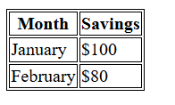 <th>Savings</th>

</tr>

<tr>

<td>January</td>

<td>$100</td>

</tr>

<tr>

<td>February</td>

<td>$80</td>

</tr>

</table>

<ul> 🡪 determina una lista sin orden

<ol> 🡪 determina una lista con orden numérico

<li> 🡪 es para que salgan puntos en cada línea

<ol>

<li value="100">Coffee</li>

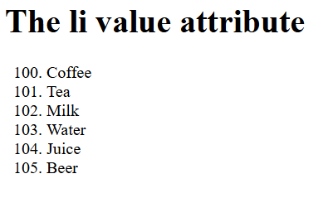 <li>Tea</li>

<li>Milk</li>

<li>Water</li>

<li>Juice</li>

<li>Beer</li>

</ol>

Display flex

**flex-direction**

**flex-direction : row-reverse;**

* row (default): left to right in ltr; right to left in rtl
* row-reverse: right to left in ltr; left to right in rtl
* column: same as row but top to bottom
* column-reverse: same as row-reverse but bottom to top

#### flex-grow

#### flex-grow: 4;

#### Hace crecer al item del contenedor si es necesario.

#### flex-wrap

#### flex-wrap : wrap;

* nowrap (default): all flex items will be on one line
* wrap: flex items will wrap onto multiple lines, from top to bottom.
* wrap-reverse: flex items will wrap onto multiple lines from bottom to top.

#### justify-content

* flex-start (default): items are packed toward the start of the flex-direction.
* flex-end: items are packed toward the end of the flex-direction.
* start: items are packed toward the start of the writing-mode direction.
* end: items are packed toward the end of the writing-mode direction.
* left: items are packed toward left edge of the container, unless that doesn’t make sense with the flex-direction, then it behaves like start.
* right: items are packed toward right edge of the container, unless that doesn’t make sense with the flex-direction, then it behaves like end.
* center: items are centered along the line
* space-between: items are evenly distributed in the line; first item is on the start line, last item on the end line
* space-around: items are evenly distributed in the line with equal space around them.
* space-evenly: items are distributed so that the spacing between any two items (and the space to the edges) is equal.

#### 

#### align-items

* flex-start / start / self-start: items are placed at the start of the cross axis. The difference between these is subtle, and is about respecting the flex-direction rules or the writing-mode rules.
* flex-end / end / self-end: items are placed at the end of the cross axis. The difference again is subtle and is about respecting flex-direction rules vs. writing-mode rules.
* center: items are centered in the cross-axis
* baseline: items are aligned such as their baselines align

#### 