Question 1

Estimate the volume of a sphere of unit radius in 6 dimensions using a “hit-or-miss" Monte Carlo method.

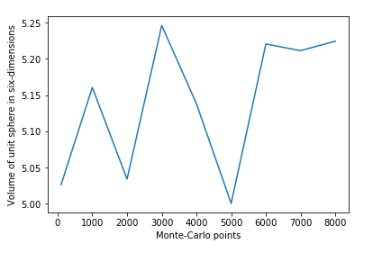

Python code Lab10Q1.py has been attached.