System layout：

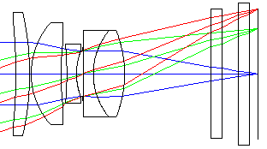

Lens parameters：

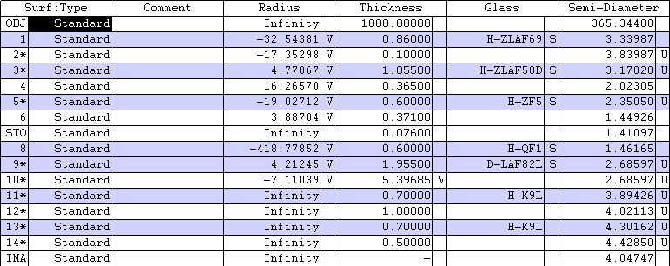

MTF:

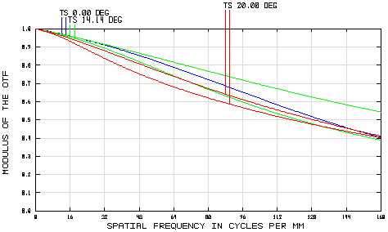

Field curvature/Distortion： Spherical Aberration (three wavelengths)：

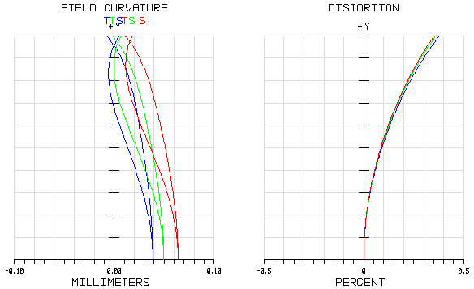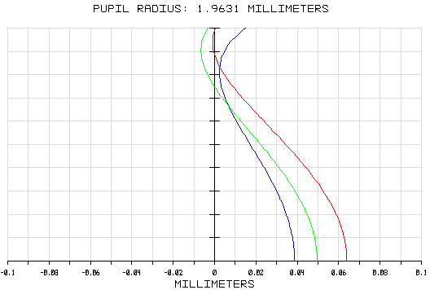

Lateral chromatic aberration： Spot diagrams：

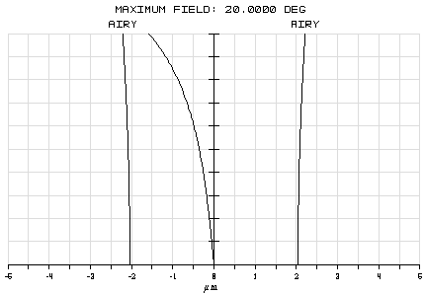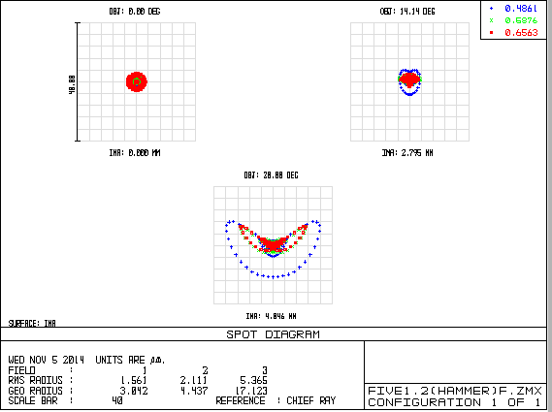

Overall:

|  |  |
| --- | --- |
|  | In this design |
| EFFL(mm) | 10.9936 |
| MTF（lowest） | 0.389 (0.707 field, sagittal) |
| Total length (mm)（to imaging plane） | 15.07885 |
| Largest distortion | 0.3523% |
| Largest radius in spot diagram | 5.365μm |
| # of individual lenses | 5 |
| Relative illuminance at full field of view | 80.6% |
|  |  |