Question2

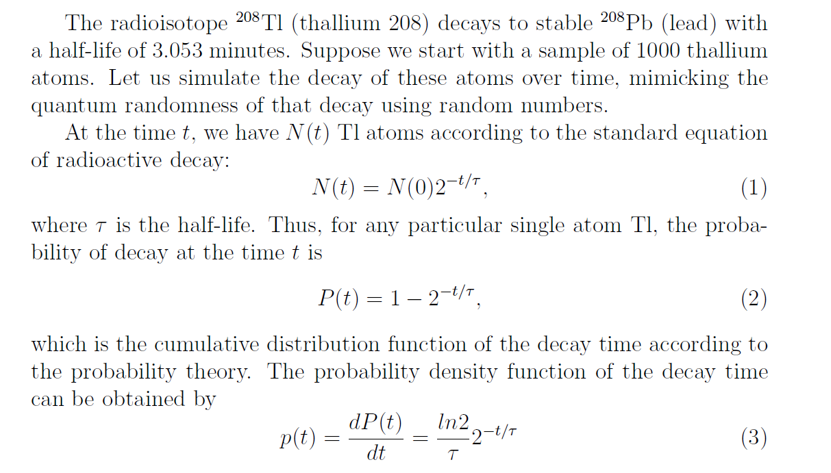

Let x = P(t)

We have

$$x=1-2^{-t/τ}$$

$$x∈[0,1]$$

Then

$$t= {-τlog}_{2}(1-x)$$

By generating a pseudorandom number of x, we can generate a pseudorandom number of t using the above equation.

The python code Lab10Q2.py has been attached.

