2026
Timeseries tool database & api
March edition. With demo
database. Contains export/import samples using Python. (ver 1.9.8.4)
Erik Soeberg
rsb@ssb.no
11/01/2026
Harmonize Structured TimeSeries

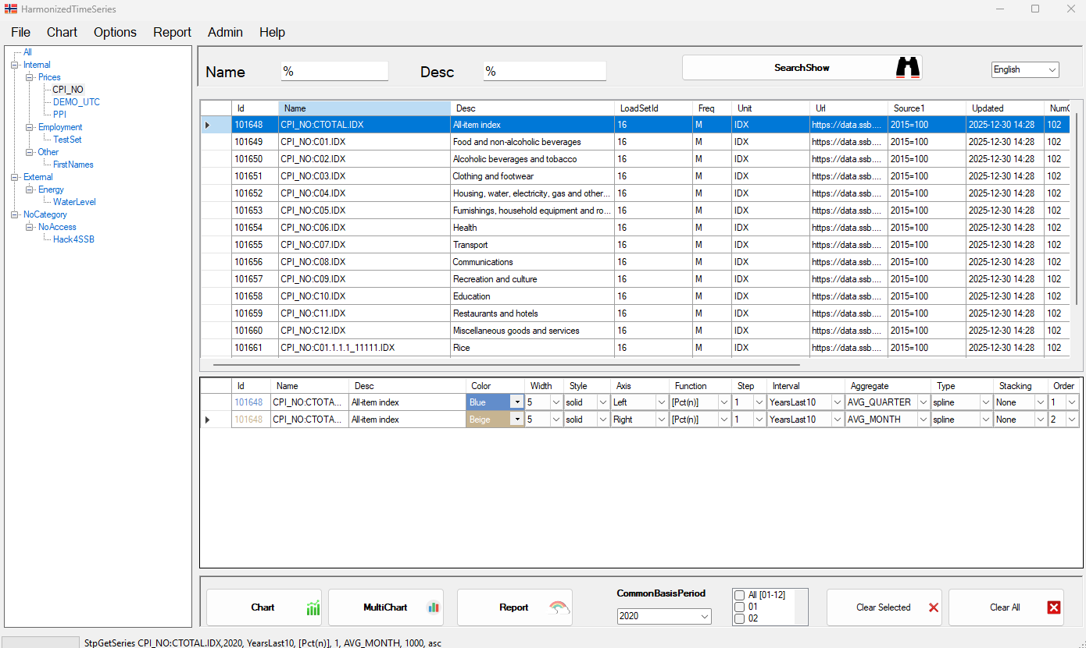

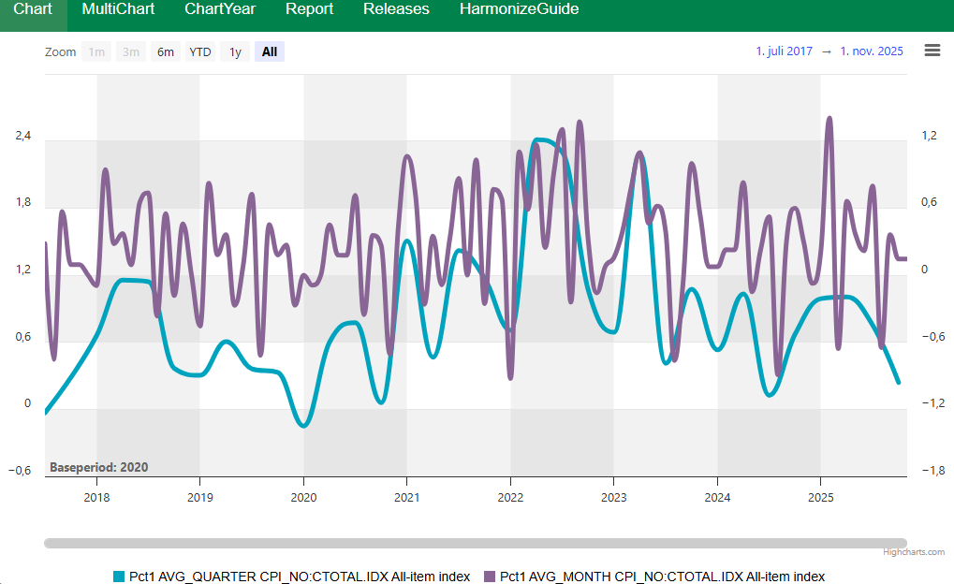

Harmonize User and Installation Guide 2026

Summary

Harmonize is designed to make time series data accessible to users without programming skills, while also helping management and analysts save time. The system stores time series in a generic, flexible format, allowing easy comparison of datasets with different frequencies. The system is based on MS SQL-Server database. The system also allows users to access the database-procedures (api) using tools like Python and R. By using the Harmonize application, the time series is easily available for many users, having different access, for comparison, with different functions, aggregates and the use of common base year.
Examples:
- Chart a quarterly index with a monthly index seamlessly.
- Adding a weekly, monthly, quarterly and annual series correctly; - Charts can use a common base year or base period, even if datasets have different base years (e.g., 2015=100 vs 2020=100).
Charts are zoomable and scrollable because all data uses datetime formats. You can apply aggregations like avg_quarter or avg_year, and functions such as diff_n, pct_1, pct_2, … pct_n (where n is the lag).
Harmonize can be run via the C# application for windows, using Highcharts to make modern charts. The Html scripts can be modified to use your colors / fonts and css information, you can also replace higcharts.com with other similar open source javascript charting tools, which are not recommended.
Harmonize can save and retrieve chart selections, for reuse with fresh data later. The dynamic intervals will make sure current year is the current year. However static intervals may be applied if users always want a chart to be with observation in 2025, always.

Contents

Harmonize User and Installation Guide 2026 1
Summary 1
Installation Guide 3
Step 1 — Application Installation 3
Step 2 — Database Connection Configuration 8
Step 3 — Using the Application 9
Step 4 — Template for the Chart & Report options 11
Common base year 14
Application tricks & techniques 15
Menus and Languages 18
Data management 19
Timezones and day light saving 20
Error messages: 22
Notes and Best Practices 25
Python 26
Import Update Upsert 26
Export data using python. 28
Utilities 29
Harmonize SQLAddin 31
Install Harmonize SQLAddin 31
Getting Started with SQLAddin 32
Uploading from Excel / PutSerie 32
GetSerie parameters and functions 32
Recommended Workflow & Checklist 34
Admin tool 36
Appendix – create database user script 37

Installation Guide

Step 1 — Application Installation
Requirements: Google Chrome or any modern browser.

- Download files, unzip the files in a folder C:\Harmonize\app\, and Start Harmonize.exe (with a flag) 
The Harmonize system will initially access a Demo database, with read access to some demo data. When you want to use Harmonize with your own custom data you need your own MSSQL database that only you and your company can access.
- Alternatively, the more professional alternative, however this required admin rights: Run Setup.exe to copy files to your chosen folder. This requires you to download the Setup..
  - Default location:
C:\Harmonize\App\

- Main Files installed: (in addition there are some python samples to import & export)

Harmonize.exe Main application
Harmonize.css Styling for templates
Harmonize.bak Database backup, to be restored in your mssql environment.
Chart.html Single chart template
MultiChart.html multi-chart template
YearChart.html Yearly overlay chart template, using current year intervals
Report.html Report template for direct reporting
Release.html Release notes
connection.txt Sample database connection (username/password)
Menues.txt Menu labels (multi-language support)
ffi.py generic py script that can import csv files to datasets in the sql
FFItestfile.csv Sample dummy csv file, to be imported by the ffi.py program
cpi.py Sample reading CPI from statbank Norway json-stat format
ppi.py Sample reading ppi-index from statbank in Norway
GetCurvetoPython.py Gets series from the database and chart it

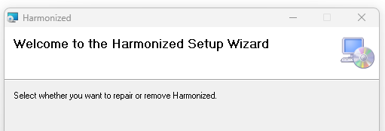

The application can be installed to a shared folder (read access) for multiple users, together with the database connection.txt and the html templates. If usernames and passwords are hardcoded in connection.txt, all files need to be placed at each user personal home drive. The best set up is to us a shared folder, using a trusted database connection.txt not containing any passwords,
During setup, extract files to a temp folder, then run setup.exe. Use default settings, the application will install into C:\Harmonize\App – If later you install Excel Harmonize addin, the XlsAddin will require Harmonize to be installed default to share connection details in connection.txt. This will ensure both applications access the same database if Having more databases. The python samples will by default also use same connection.txt details to connect.
Personal data, temporary datafile will be stored by default at C:\Harmonize\Chart, can be changed in connection.txt, but must be a folder that is private for each user.
You may initially try to double click at the file Releases.html, and verify it opens in Chrome or Edge. If your html-files is defined to open in ie. notepad or any other non-browser application, this needs to be changed, so a browser like Chrome or Edge automatically opens html files. When Harmonize application creates charts, they will open in your default browser and read the freshest MyData.js available in your personal C:\Harmonize\Chart folder. To set default browser use Windows+i
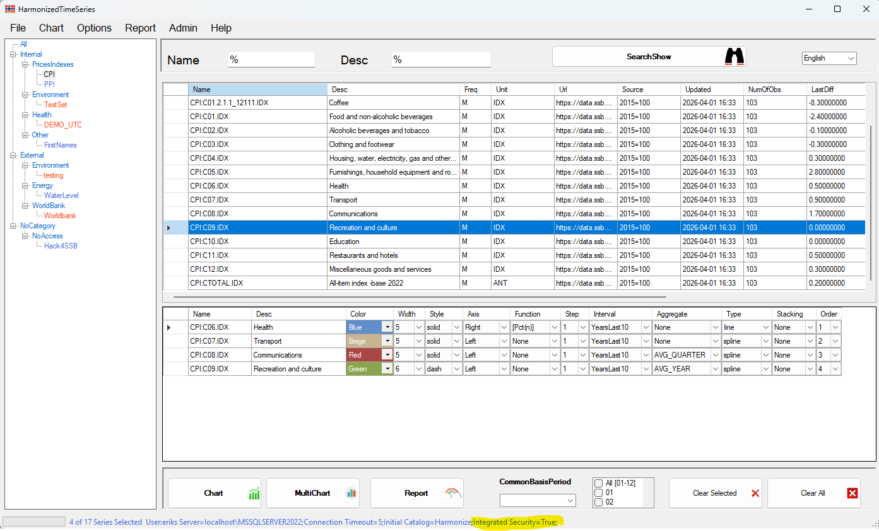
When the application is launched, the connection string is shown in the bottom form. In the example above it’s used a trusted connection, to user that only has public access to the Harmonize sql database.
By double clicking (selection) one or more series, they will jump to the bottom grid in the application, where you can select interval, function, aggregation, base-year, and chart style. When you have one or more series in the bottom grid, the Chart buttons will be enabled. Inside the charts, you can see the charts as a report, However, you can also report data directly from the application, from Report Menu in the top application bar.
The application lists all datasets accessible to the user.
Datasets with write permissions are highlighted in orange.
For these datasets, a right-click menu provides options to:
- Delete a series from the dataset
- Upload data to the selected dataset

To utilize Harmonize, you need a Microsoft SQL Server database that you / your company controls with your data series that you populate from internal and external sources.
- Install SQL Server on your machine or server.
  - You may use SQL Server Express if a full version is not available.
- Restore the Harmonize database backup harmonize.bak with the system. Logg in using an administrator like sa, use master, and restore the database file. You can call the MSSQL -database Harmonize, but other names can be used.
- Verify that you can connect to the database using SQL Server Management Studio (SSMS).
  - Ensure that the user credentials or trusted connection are working.
  - Harmonize is default installed with a trusted connection in connection.txt
- Note the database name and connection details; you will need them when configuring connection.txt. See the sample connection details strings in bottom of connection.txt. Try to use an integrated / trusted connection, making connection details safer and more secure. The first line only, in the connection.txt holds the connection details. Line #2 is the name of the directory where the users temporary data for charting and reporting is stored. Line #3 are the languages in your Menue.txt file that will be selectable in the application. Line# is the default Language, a 0 is the first language: English. Line #5 is the maximum number of rows returned for one series, This is typically only important for time series of high frequency such as hourly, minutely or secondly.

- Database Users: By design the system is to be used by api, via python/R or the C# visual studio Harmonixe.exe application. The users do not need other than public access to the database, and it should be enough to run all import and extract procedures no matter if you are using python or R or Harmonize.exe
- By doing this, we ensure no bad queries are executed, and the system will perform fast and smoothly, and metadata will be updated according to design ( ie updated date)

Step 2 — Database Connection Configuration

- Edit connection.txt. The first line must be connection string to your SQL Server database with a trusted connection not requiring database username and password. If using a trusted connection, all users can use the Harmonize files from the same shared folder. This is the best and safest set-up, and it will be simpler to upgrade to later versions. The file must be named connection.txt. Personal user ids and passwords are also OK, but then the application need to installed locally for each user.
- Choose where local chart data will be stored (MyData.js). Default folder is: C:/Harmonized/Charts/ - if this is changed this path needs to be changed in the 3 html files: Chart, MultiChart, and YearChart, and Report.html. Initially let the directory and files be unchanged until you have Harmonize up and running.
- Recommendation: use connection mode as shown in connection.txt for trusted connections.

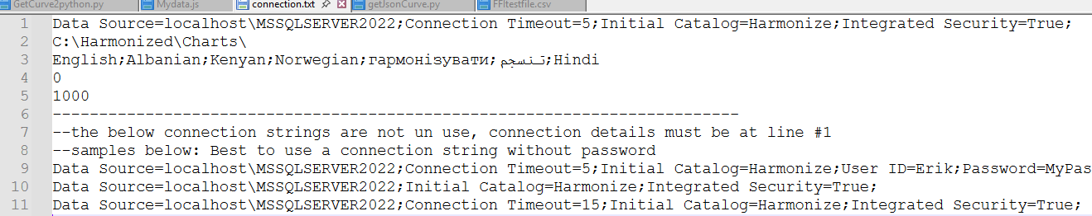

Step 3 — Using the Application

- Run Harmonize.exe, a shortcut should be available on your desktop.
- Verify that the application, list a tree with datasets:
- Test Help, Release from top menu to verify that the application can open your default browser, and display the data. If this does not work It will not work to show charts either.

- Generate charts & Reports using:
  - Chart, MultiChart, YearChart is under the Chartmenue
  - User Report button for quick horizontal & vertical reports
  - Report Tables also available from the inside the Charts
- Charts are rendered in the default browser (Chrome recommended but Harmonize uses your default browser. You need to have a browser as a default application to open html files.)
- Modify templates as needed: (not needed but possible to customize)
  - Change fonts, colors, legends, tooltips
  - Can modify Harmonize.css so it fits your standards.
  - Use Highcharts or another compatible library

- The C# application overwrites MyData.js each time charts are generated. Copy it elsewhere if you need to preserve data. If so, you may need to copy one of the templates Chart.html to point to your local files. You may create your own html templates. It’s also possible to change and customize all the html files.

- Important: YearChart template: only use intervals containing data up to one year (e.g., CurrentYear-1, CurrentYear-2) More Intervals can be added into the database.

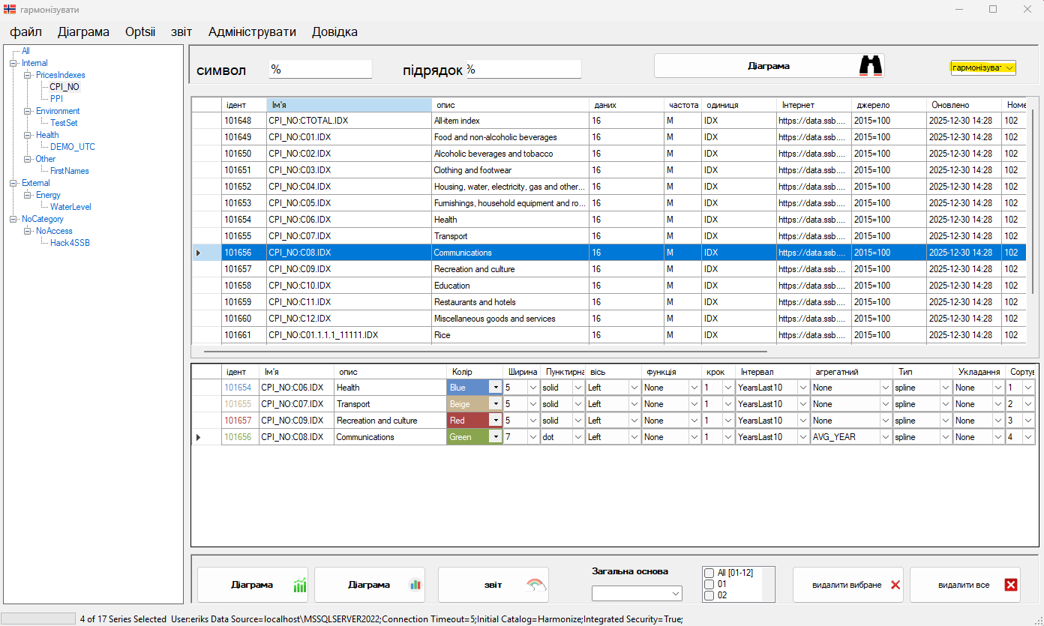

Step 4 — Template for the Chart & Report options

Chart.html (Template for n series in 1 container)
The main template takes all your selected series and chart them in one container. To compare more series, you may choose various functions and aggregations, as well as common base year functionality. Series may be stored in different datasets, and you may use different chart styles such as line, spline, area & column. Charts are zoomable.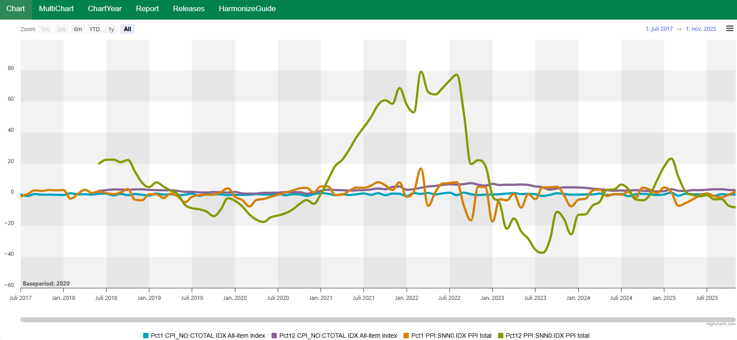

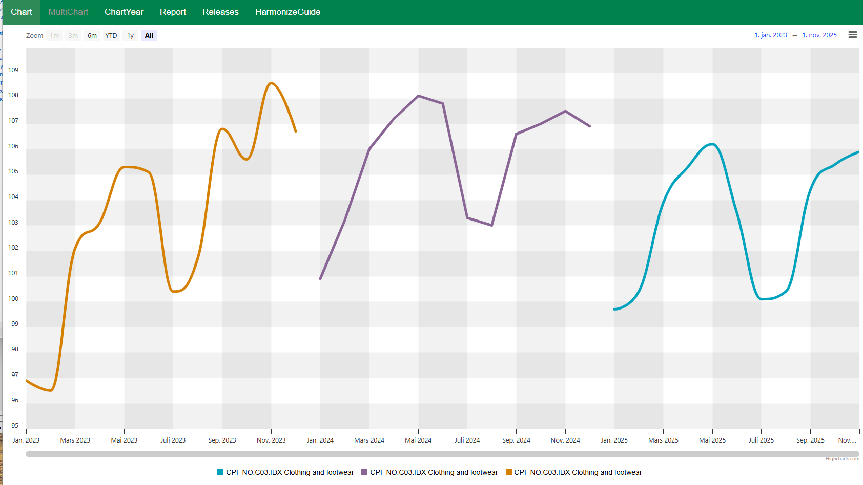

MultiChart.html (Template for n charts in separate containers)

MultiChart, will chart n series in n containers, you will see approximately 3 charts on each page, scroll down if more charts are available. The n charts are independent and not synchronized based on the x-axis.
Currently there are no print or view data as table for this template, this can easily be added in the MultiChart.html

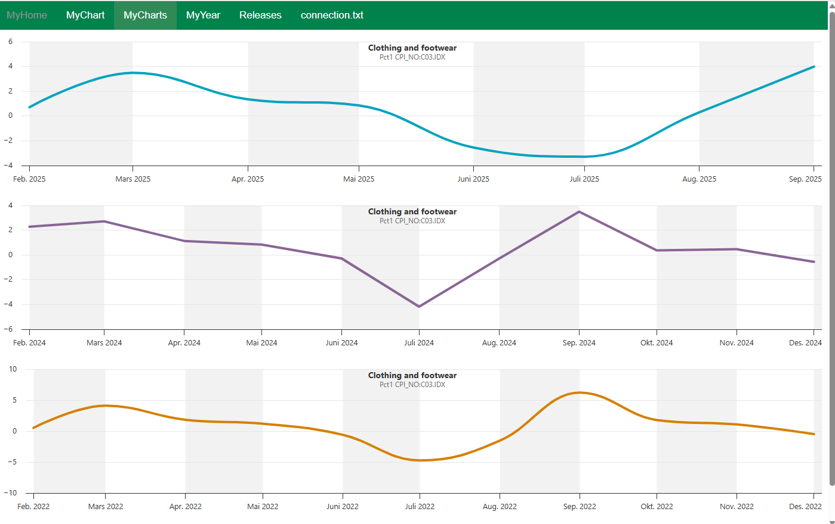

YearChart.html – overlay ( all Series need to use intervals containing one year)

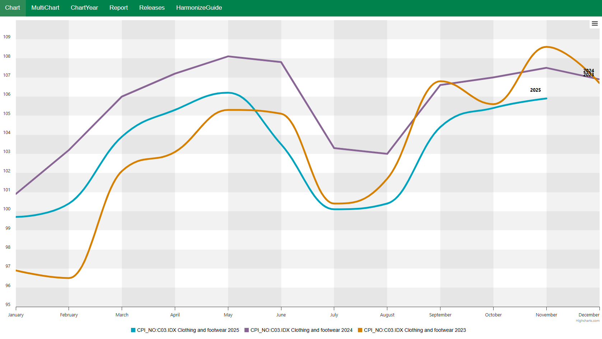

The ChartYear template is only usable when used as above and correct intervals are used. A yearly label is shown in labels and legends to more easily differ among the different years.
All charts can be viewed as a table, or saved as csv, se the small hamburger menu located in the top right corner in your charts.
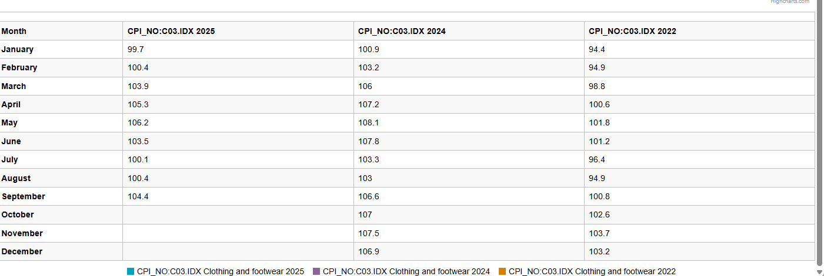

Common base year

When common base period is used, this will be printed in your charts, be aware common base year can be combined with function and aggregates. The year selected as the common year need to have data observation(s). The sample below compared CPI and PPI, 2 indexes that have different base year, now using common base year 2022 = 100.
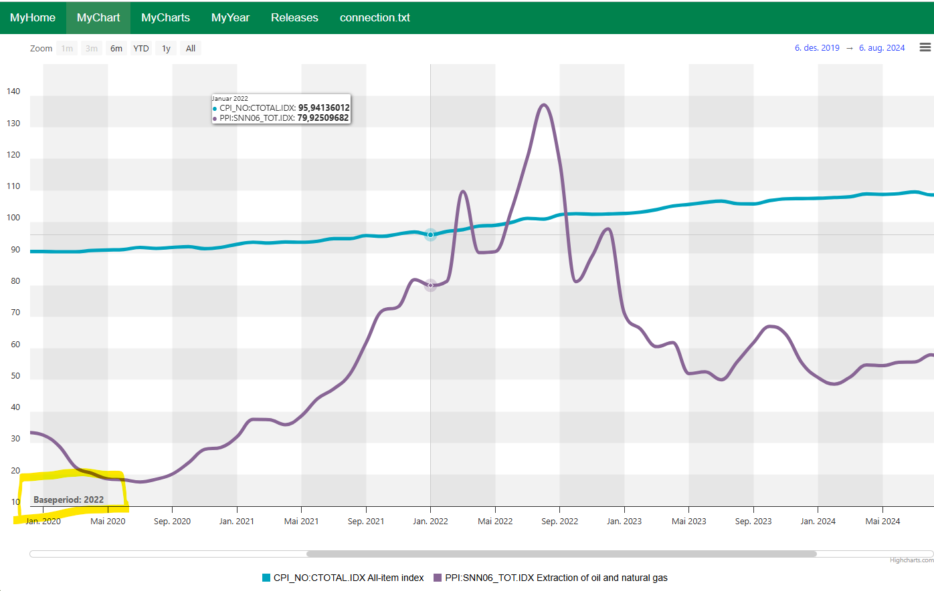

Application tricks & techniques

- When searching for series you can hold shift key down and select several series in one go. The series will then move to the selected area, and the Chart /Report options will be enabled.
- In the selected area, you can right click, and apply interval, function etc to all series
- The order column is used for sorting; by clicking on the column headers, you may sort on any column, or you can specify an order number to sort on.
- Hidden under the File menu, you can save your chart selection, with intervals, functions and all the information in the selected area. Save the selection.csv on your computer to recreate the chart with fresh data, at later point in time.
- Be aware of changes in the series names or change of access to the data since you saved your definition may cause some issues.
- # of Decimals and date formats can be selected under the Options menu.
- Shortcuts, Harmonize standard shortcuts are Alt+C => Chart, Alt+M => Multichart, Alt+R => Report to execute a Charts /Report. The application will always extract the newest data from the database before displaying it.

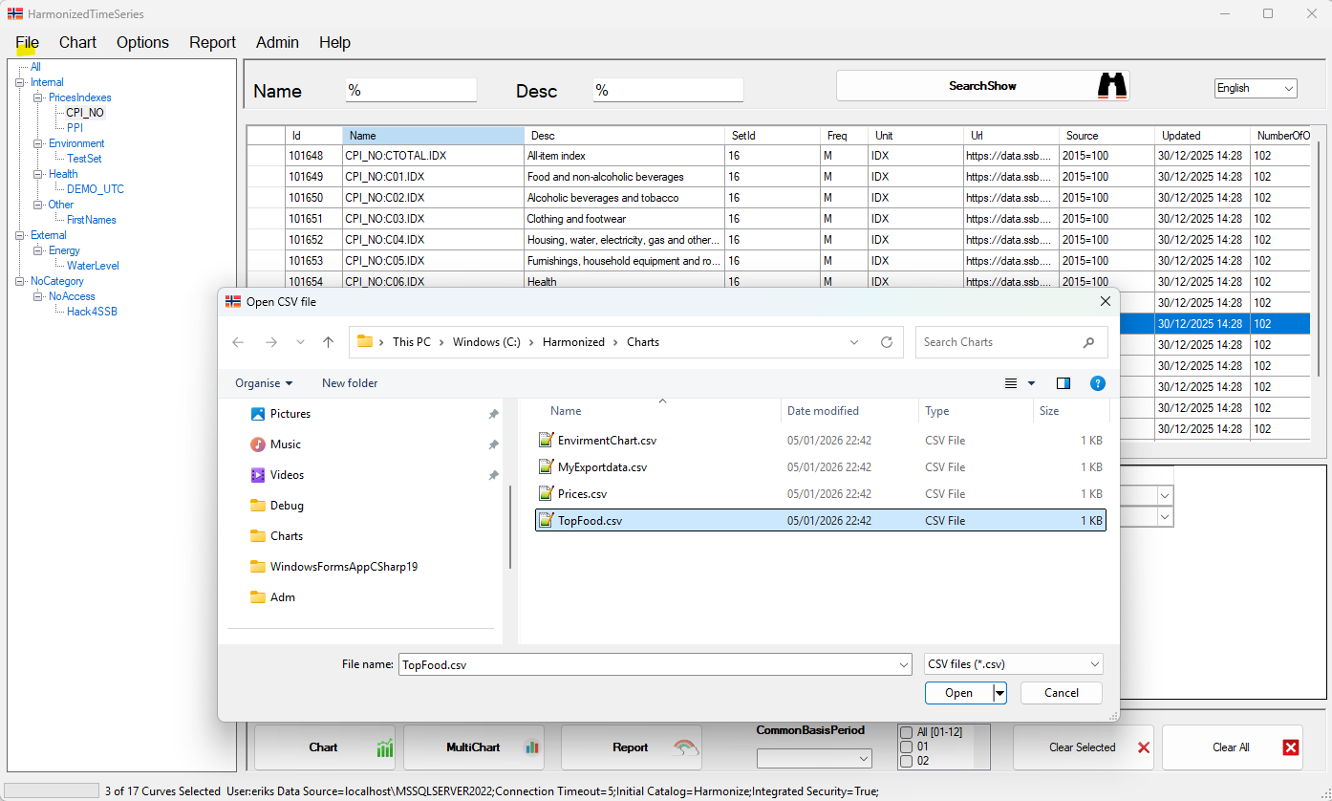

Sorting and Ordering

In the top DataGrid you may sort the series in the dataset on all columns, observe that the column Last Diff sort the dataset, based on which curves had the most / least change according to the previous observation.

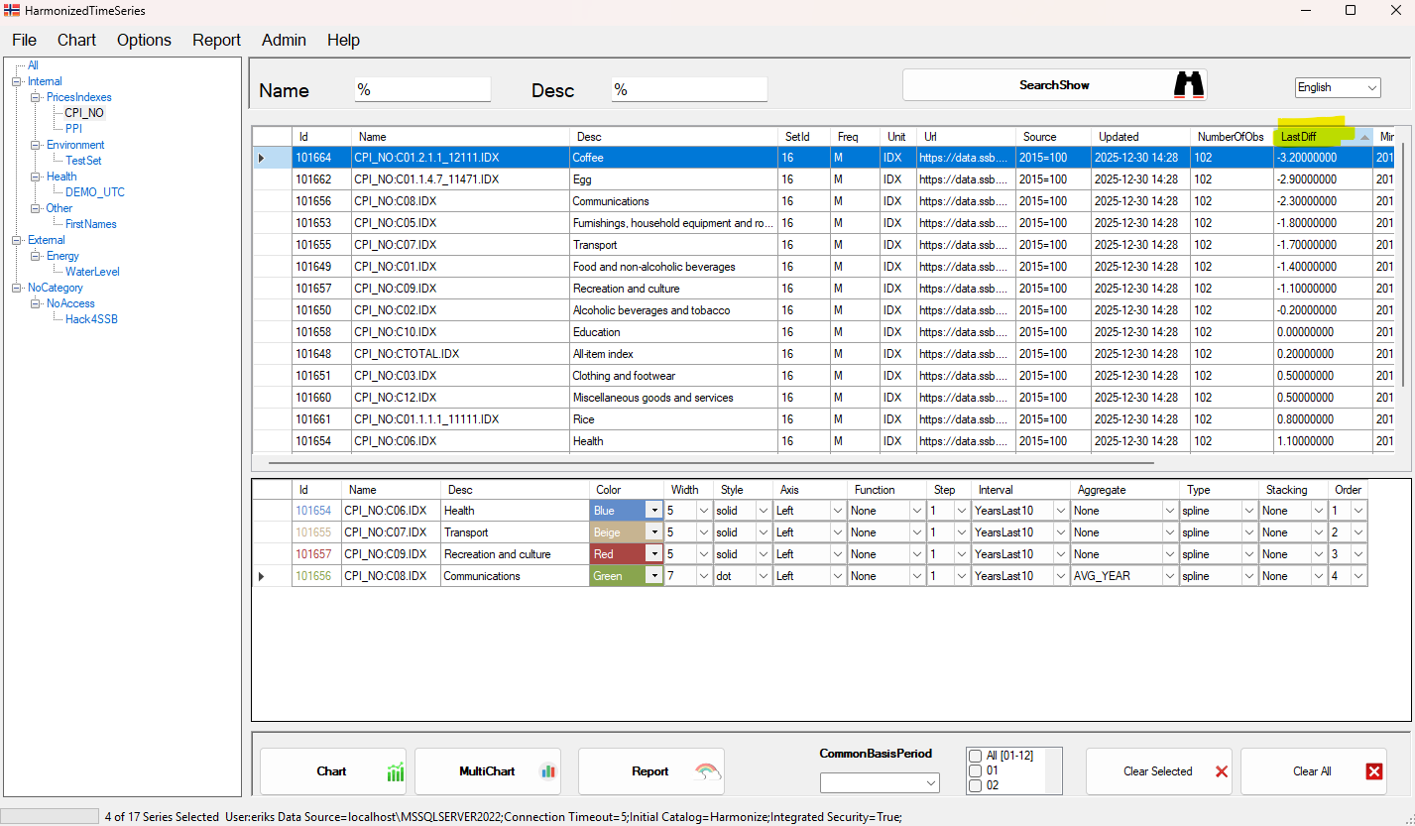

When viewing as table, clicking at Header you easily find max and min point for the series. (This is why the Date is not sorted: but the max value is September 2025.

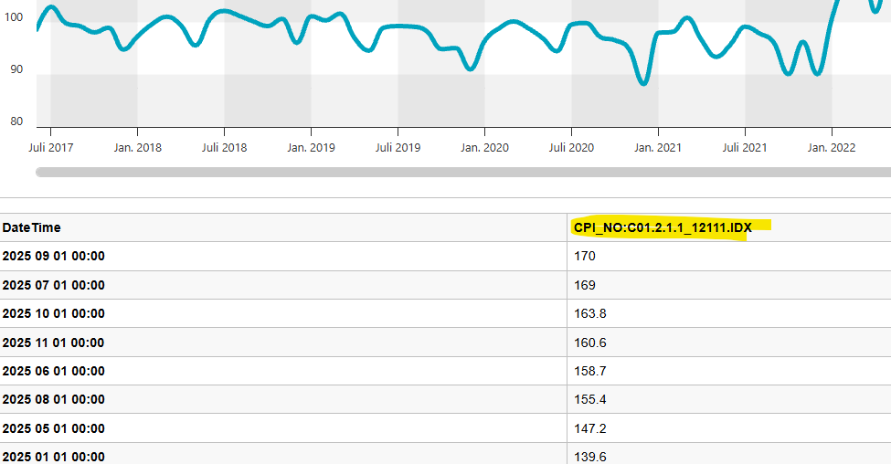
Min point:
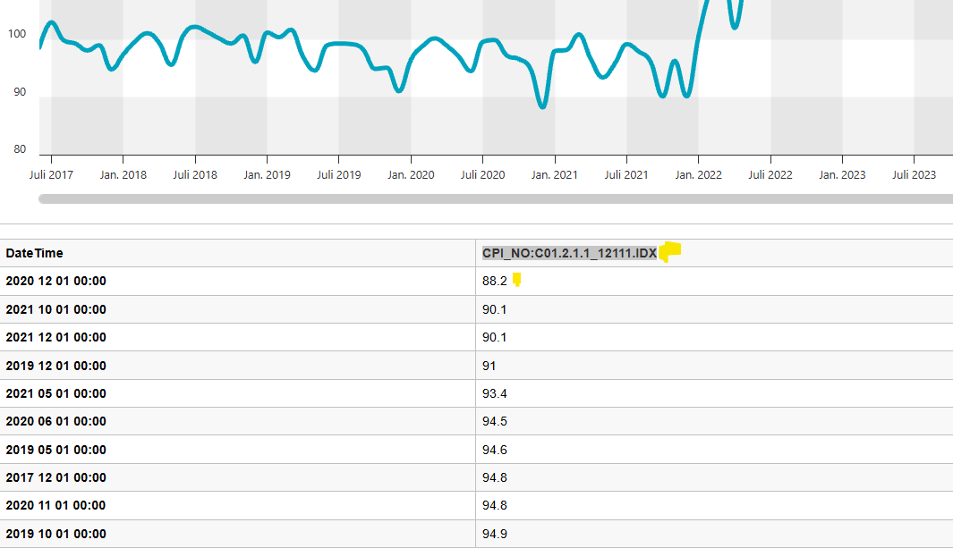

Menus and Languages

- Edit Menues.csv for custom language labels.
- Do not remove lines or change the order in Menues.csv. Backup the original file before editing.

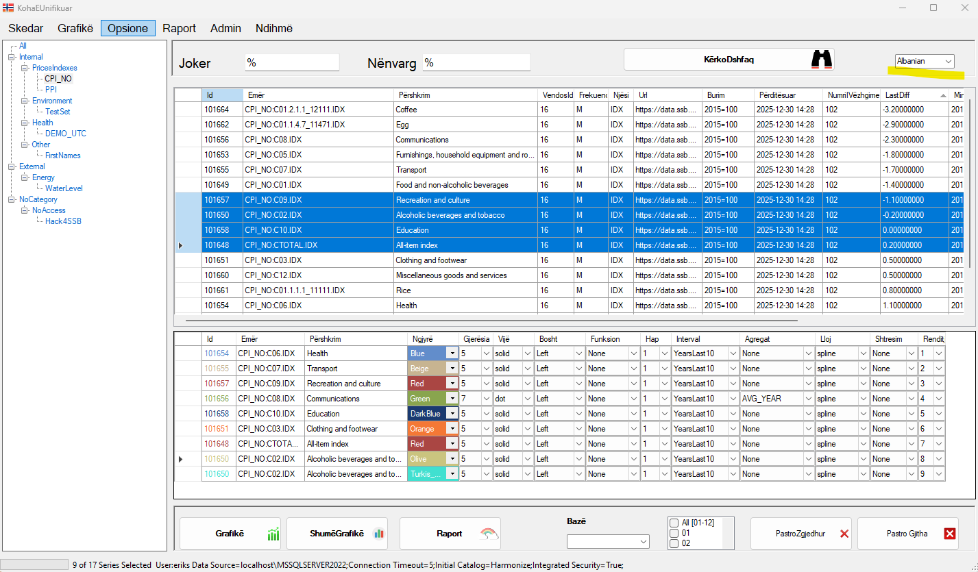

Data management

- Harmonize calls SQL stored procedures to generate MyData.js.
- Sample Python scripts are included for importing or updating data.
- Units are standardized via Unit IDs, editable in the Admin form or directly in the database.

- Interval may be added to the View inside the database, sql logic. The procedures using the intervals will query data that is GE start_date and LT end_date

- Additional datasets should be defined from admin, they can also be put in a tree, which is displayed leftmost inside the application.

- Utility procedures are included for deleting data and creating new datasets.

- The time series may be stored in many different tables; the data tables need to be in the same format and contain a column value_date in date or datetime. Choose date if you do not have hourly data.

Timezones and day light saving

When having higher frequencies such as hourly, and need to manage summer and wintertime, the system can handle this. Data needs to be stored in UTC and in the Loadset table, the dataset needs to be configured to be displayed in a different time zone than UTC. Be aware that time zones are more complicated than just visualizing the data. When you do aggregation, the system converts time zone, before applying functions and aggregations such as average day.
Ie hourly spot prices will have 25 observations (hours) when shifting to wintertime, but only 23 hours (see next page) when shifting from winter to summertime.
The chart below displays 2 observations on the hour 02:00, because the CET clock is set back by one hour once a year.

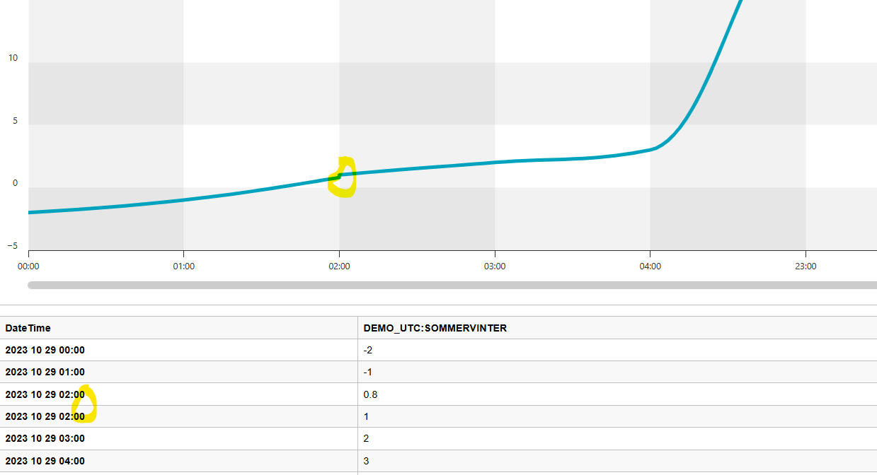
In the dataset configuration the dataset above is stored in UTC, but the series from this dataset is displayed in Central European time.

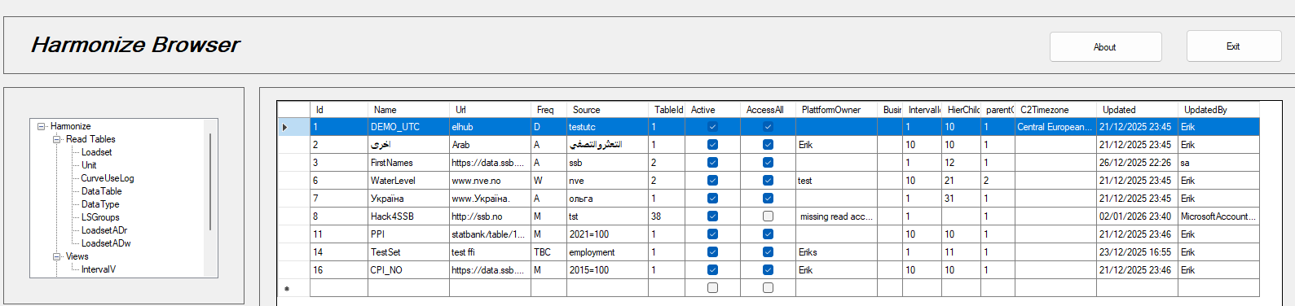

When having hourly data, the report information may be confusing as the standard report template use a date format year month day, but this can easily be changed to contain hours and or minutes or seconds as well.
Below, observe the gap x-axis when chart/reporting an hourly series in the winter to summer shift.
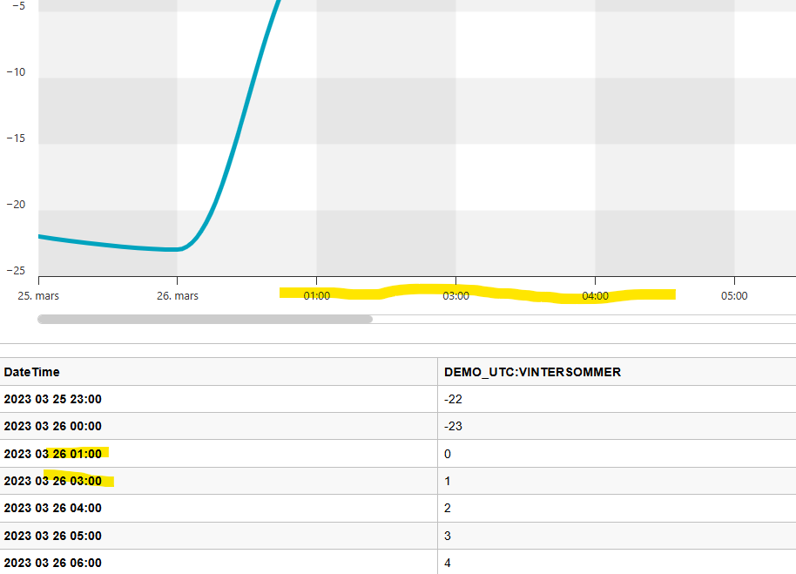

Error messages:

- Cannot connect to server, verify username and password, or the trusted connection, if possible, try with sql management studio for better error messages, or login with an admin user to see if password has expired.

- When installing / reinstalling, it may be the installer is not able to remove previous installation, then settings, App – Uninstall Harmonize ‘manually’

- Cannot update /”upsert” data into the database. This is problem related to database access. When running the application with sa (sysadmin) you do not necessarily have write access to the database. The access-all flag in the loadset table indicates whether all users have read access to the dataset. If/ When not all users should have access, the table called LoadsetADr, configure which users have access to which loadset = dataset.

- The table LoadsetADw will indicate which users have write access to the datasets. Be aware that logging into the database with trusted connection using mssql management, may not be the same username as when logged in via trusted connection using Python. When using python your trusted user is typically the username printed with the cmd windows- command whoami. Users who need write access to the datasets must be defined in the table LoadsetADw. To shortcut the installation and get started process, all users typically have write access to the database. The write access functionality is defined in the database function IsAccessw. The content of the table LoadsetADw shown below gives you the idea.

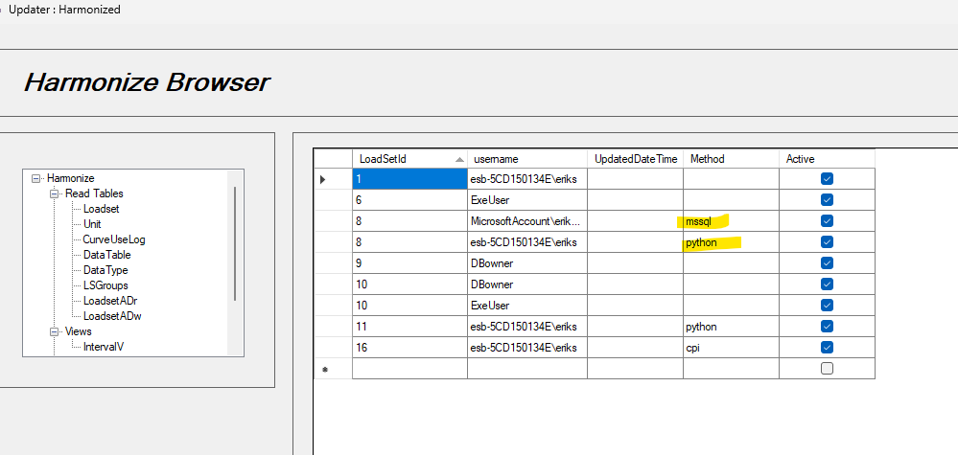

- No Access or no rows/data in selected intervals. Make sure you have data in the selected interval. If your interval is the year 4 years ago, and there is no data, you will get this warning. Here you must change the interval, also be aware of the metadata indicating the start and last observation, also be aware charting a series with one only observation, the chart may look empty because it’s only one point. This error may also occur if you have selected a common base year or a function that requires data in a interval, that does not exist or is empty.

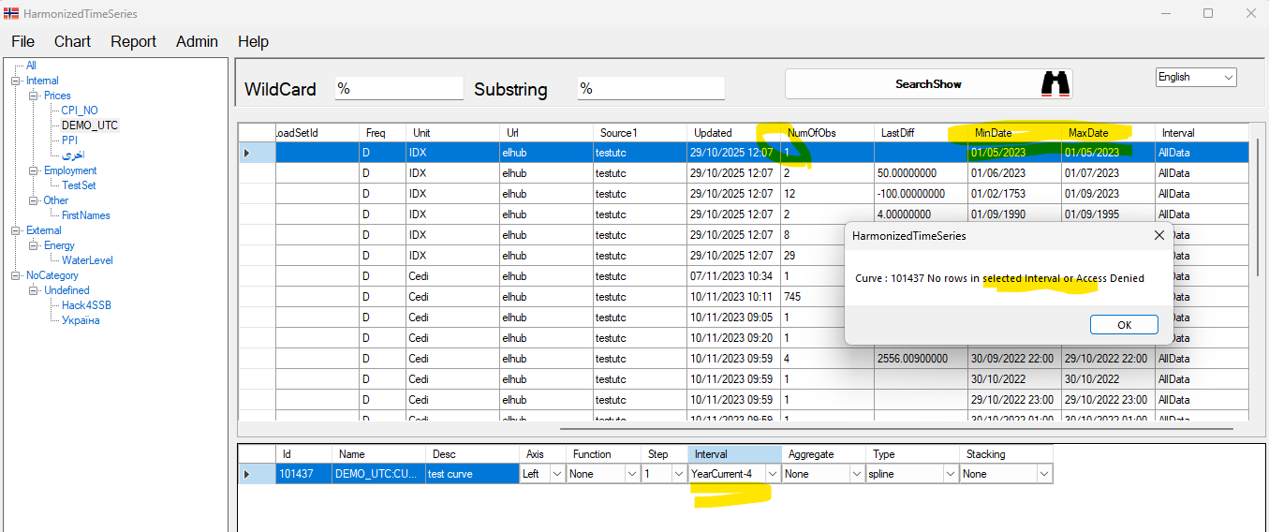

- If setup is already installed, you will need to use windows add/remove applications and remove the Harmonize software. Then run the setup.exe again.

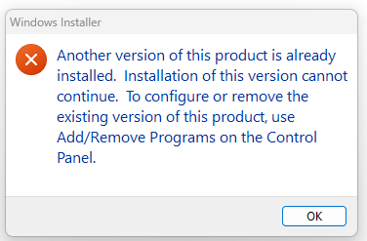

Windows + I, and Apps will take you to Installed Apps
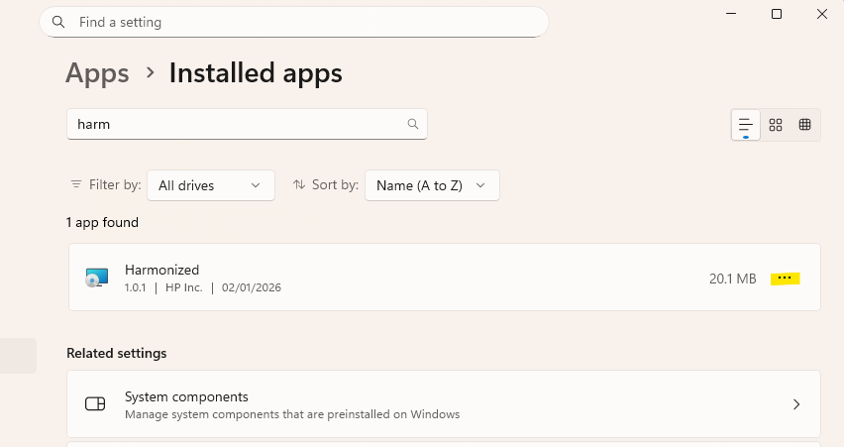

Notes and Best Practices

- MyData.js is overwritten with each chart update.
- Logic and computation mainly occur inside the database.

- Use a trusted connection to sql if possible

- C# application Harmonize is lightweight:

  - Calls stored procedures in the MSSQL database with parameters
  - Updates MyData.js for charts, the same MyData.js used for all templates, enabling you to just simply change template chart-multichart-report from the browser.

- Use python or R to modify and update data, use stored procedures that control the access rules

The application works without internet connection, but you must have access to a MSSql server to extract new data from a Harmonize database model.

Python

Import Update Upsert
A generic ffi.py flat file interface, comes with the system to provide generic upload of datafiles in a standard csv format, where comma is the separator. Commas my be included in text such as description or documentation but will need to be double quoted.
Typically, one dataset, will have same frequencies and date format, but there are no built-in restrictions for this. Data should be loaded in UTC time zone, where time zone conversions will apply.
Same and similar upsert - functionality is available on right – click nodes in the tree. This does not require python, but a similar csv file.

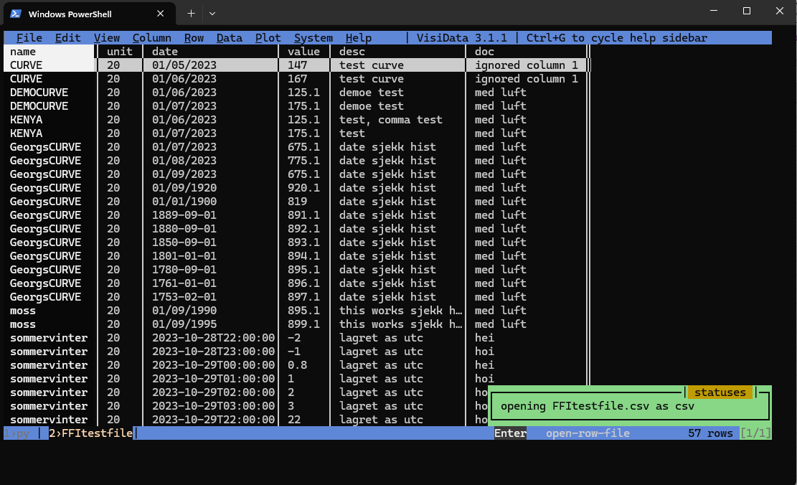

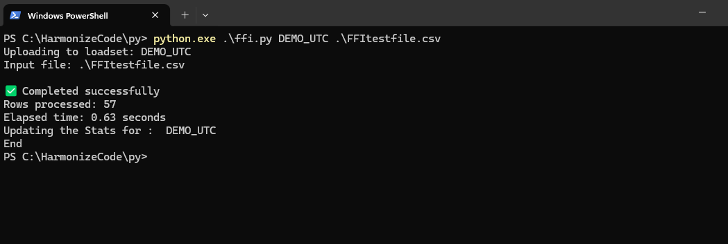

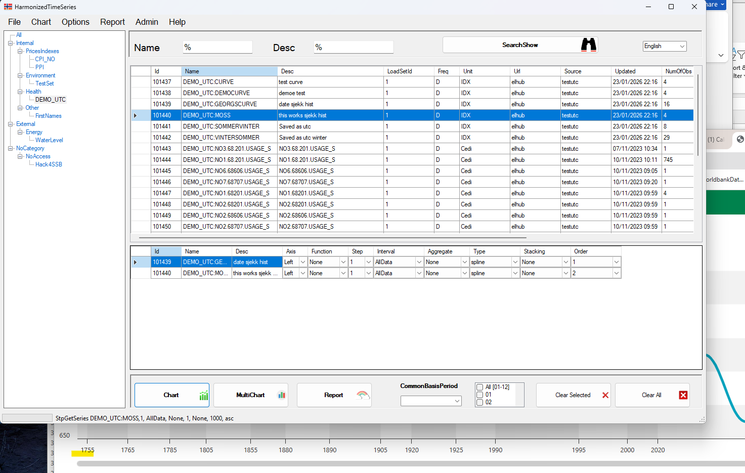
After the file has been loaded into Harmonize. The system is using the name of the dataset as prefix, making it possible to have more versions of the dataset in the system, and compare them.

Note timeseries from year 1735 will cope with the x-axis and timeline. Other systems of struggle with extreme history like this.

Export data using python.

Sample script to export data comes with the system. The procedure to get data is the exact same procedure as the Harmonize.exe application is using and will ensure same result, if used with the same parameters, such as interval function etc.

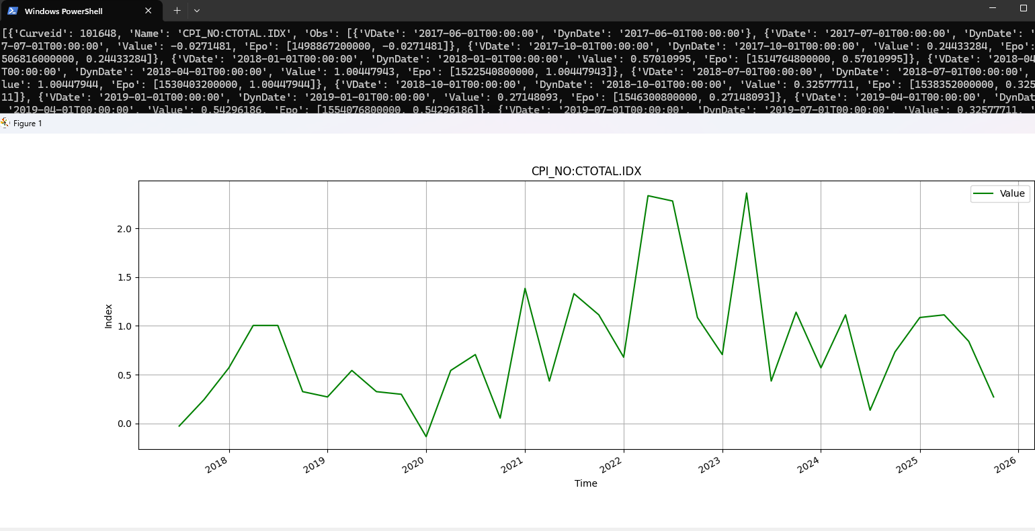
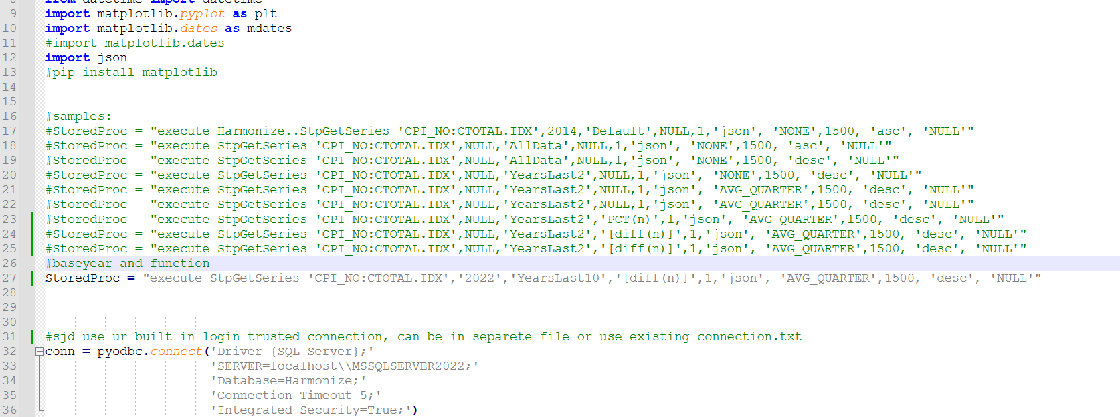

Sample calls from python, using different parameters.

Utilities
To insert delete or update data, it’s strongly recommended to use the Utility procedures in harmonize. This will ensure correct updating of automatic metadata, and use of existing write access mechanisms.
The procedures to upsert and delete data is available inside the database, as stored procedures. See also the python sample scripts to update the database correctly. In a timeseries database data observations must be stored with date or datetime, implying that storing information with a “date format” 2020M12 is not possible, but a proper date format like 2025-12-01 must be used. By storing the information in a correct manner, it then will be easier to compare information that may be stored in formats such as 2025, 2025M12 and 2025W52, making it impossible to compare without converting to date format.

- DELETE_DATA
exec UTILS_Delete_Loadset 'DELETE_DATA', 7, 'NameofDatasetToBeDeleted'

The DELETE_DATA option deletes all datapoints on all series on a dataset. The series names/ curvenames and the configuration of loadset will remain.

- DELETE_SERIES
exec UTILS_Delete_Loadset 'DELETE_SERIES ',7, 'NameDatasetToBeDeleted'
The DELETE_SERIES option deletes all datapoints on all series on a dataset as well as the names/ curvenames. However, the configuration of loadset will remain. This option is the best to use, when creation a loadset, but you find out you are not happy with the name of your series.

- DELETE_ALL
exec UTILS_Delete_Loadset 'DELETE_ALL ',7, 'NameDatasetToBeDeleted'
The DELETE_SERIES option deletes all datapoints on all series on a dataset as well as the names/ curvenames AND configuration of loadset. Be Careful. You need both the Loadset_ID and LoadsetName as argument when executing Util_Delete_loadset.

- CREATE LOADSET
Creates a new loadset. This is typically just done once initially when creating a loadset. To rename or change the information on a loadset sql management server application is the recommended tool. However, to change information on a loadset users need to have permissions. A user who creates a loadset will by default also have permission to change this loadset.

- PUTTIME
Update or Inserts date to existing series or create new series if not already exists. The procedure will check id there already exist an observation, update the value if the value is different from existing valie. If no observation for the given serie+date(time) exists, a new record is inserted.

- UPDATE STATISTICS
Procedure to update number of observations, date of the first and last observations, updated time etc. The statistics is shown in the main window in the application.

Harmonize SQLAddin

The Harmonize SQLAddin provides get and put data functionality. The Excel SQLAddin requires Excel and a successful installation of Harmonize in C:\Harmonize\App as the connection.txt must exist in this folder.

Install Harmonize SQLAddin

Administrator rights are required to install the add-in. To install:
- Extract the installation files to a temporary directory
- Run setup.exe
After installation, the Harmonize ribbon will appear when you start Excel.

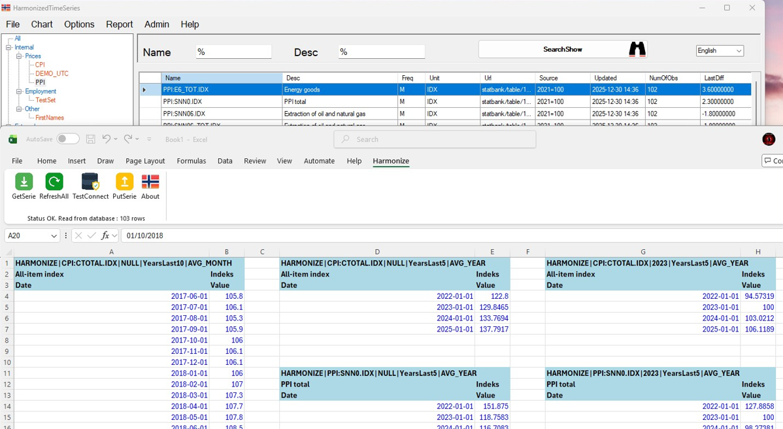

Getting Started with SQLAddin

- Select the top-left cell in your worksheet
- Click GetSerie
A sample query will be inserted. This query works if you have access to the CPI dataset. You can copy and modify it as needed.
- Refresh → updates all query in the worksheet
- GetSerie → updates only the active cell

Uploading from Excel / PutSerie

The PutSerie function allows you to upload data to a dataset.
- You must have write access to the dataset
- You can also update:
  - Description
  - UnitName (must be a valid UnitName defined in the database)

GetSerie parameters and functions

The Harmonize GetSeries function uses the following arguments:
- Dataset and series name
Format: dataset:seriesname
- Base year
- Interval
Must be a valid interval defined in the Harmonize database (customizable)
- Aggregation
Available options include:
  - AVG_MONTH
  - AVG_QUARTER
  - SUM_MONTH
  - AVG_YEAR
These correspond to the same interval options available in the application dropdown.
💡 Notes
- Ensure dataset names, intervals, and unit names match those defined in the Harmonize database
- Upload operations will fail if permissions are insufficient

Recommended Workflow & Checklist

- Set up the SQL Server database
- Install Harmonize (Setup.exe)
- Configure database connection details in: connection.txt
- Run application and generate charts verify, Multichart.html, and the Report.html

- All html files can be improved or customized, feel free.

- Possible to add extra languages

- Use sample python script to create your own to import your data for shared analytics

- The database by default let all users have access to all datasets by Access all flag in the loadset table, ( user access can be set by defining users and dataset, in the access tables LoadsetADr and LoadsetADw)

- Logging can be configured.
- If you do NOT have access to a dataset, the dataset will be listed in the tree, but no series will be listed when searching
- Be aware that wildcard and text search start searching from your position in the tree, if All is selected you will search all databases, if Prices group is selected you will search the databases in the Prices group.

- Search by wildcard for names and/or descriptions using standard sql LIKE syntax. 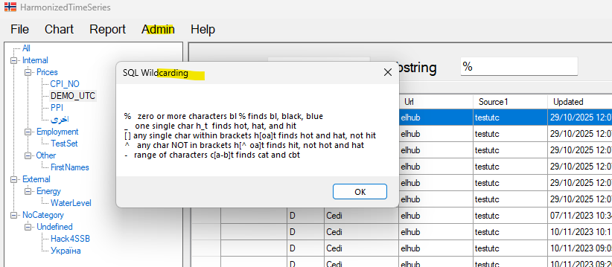

- Functions coming with the system are Mave(n), Diff(n) and Pct(n), it’s obviously possible to create and add your own customized functions, if the functions are in the same style and use the same parameters, returning the same format. Additional Functions can be placed in the database and will be available in the drop down inside the application.

- Similar, additional intervals can also be defined in the database, and all intervals defined will be selectable in the application. Make sure to use a default interval that is user friendly for most people, this is not necessarily All data

Admin tool

Admin is a browser for users to see some of the tables, and some of the tables can in theory be updated from here, but it’s mainly a tool for viewing data such as units, access, intervals and more. The form should come up like this:

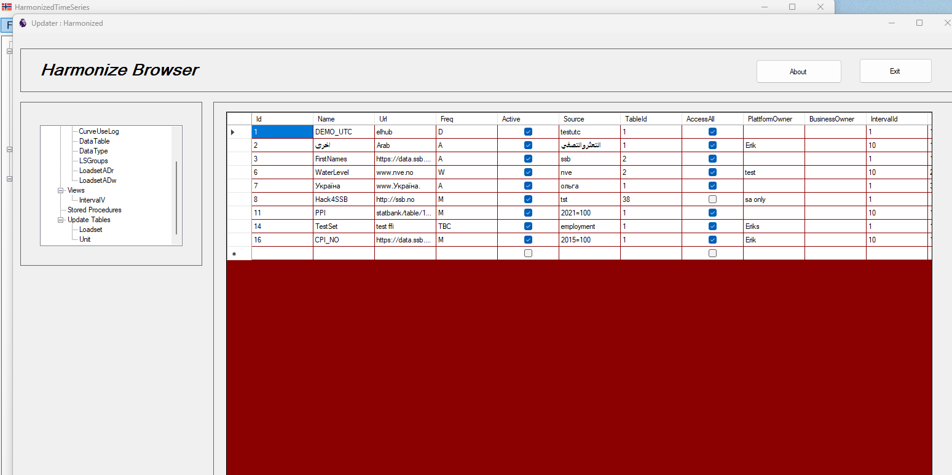

When you open the loadset table in Update mode – it will display in a red color mode. Depending on constraints on the various tables it is possible to do updates, but to update tables from sql management server will always be even better.

The advantage of the form is the use of sql procedures, making it possible for users to see data without select permissions.

Appendix – create database user script

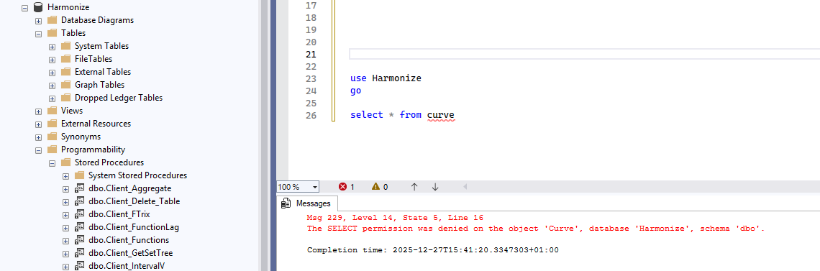

By design users cannot make pure selections like this, data tables may be huge, therefore only correct queries are recommended.

Create user script on the following page, need to be an administrator sa to execute

USE master;
GO

IF EXISTS (SELECT 1 FROM sys.server_principals WHERE name = 'demo')
BEGIN
DROP LOGIN demo;
END
GO

CREATE LOGIN demo
WITH PASSWORD = 'YourStrongPass***…',
CHECK_POLICY = ON,
CHECK_EXPIRATION = OFF,
DEFAULT_DATABASE = master;
GO
USE Harmonize;
GO
-- IMPORTANT after restore
ALTER AUTHORIZATION ON DATABASE::Harmonize TO sa;
GO
DROP USER IF EXISTS demo;
GO
CREATE USER demo FOR LOGIN demo;
GO
GRANT CONNECT TO demo;
GRANT EXECUTE TO demo;
GO
USE master;
GO

ALTER LOGIN demo WITH DEFAULT_DATABASE = Harmonize;
GO

