|

Scrummer Mobile

The mobile addition to the scrummer application

Index

Introduction 2

Kerntaak 1 3

1.1 Stel de informatie behoefte vast 3

5-6-2016 – First meeting with the group working on the web application 3

7-4-2016 – Our first meeting with Sander, our client for the project 4

14-4-2016 – Our second meeting with Sander 5

26-5-2016 – Our Third meeting with Sander 6

Make an inventory of the wishes and needs of the client 7

Collect data and information for the design of the application 7

Analyse the wishes and needs of the client to create a fitting design 8

Search for ways to improve on the wishes and ideas of the client and fit them in the design 8

1.2 Our plan of action 10

Our activities 10

Planning 11

1.3 Mock-ups 12

The wishes of our client for the design 12

Colours 12

Functional design, our mock-ups 13

Profile 15

The profile widget 16

1.4 The technical design 17

What are we going to build? 17

What programming language are we going to use? 17

The workflow 17

Database 18

Style definition 20

Whitespace 20

Typography 20

Feature list 21

Login 21

# Introduction

For a project in our education we are currently working on a Scrumboard Application. The name of the application is going to be Scrummer Space. The goal of the project is to create an application that makes it possible to digitally work with the scrum method in future projects. In the application you will be able to work on a project with a group, and for these projects it will create a digital scrumboard. Once you registered for the application you will receive your own profile and you will be able to join or create a project.

There are currently two groups which are working on this project and creating the application. The first group is working on the actual application which should include all of the features noted above. This is the application which will be used on a computer. There is also going to be a part of gamification built in the application. Once you finish certain task you receive experience points. Once you collect enough experience points you will level up. Each profile will have its own level. By leveling up or completing certain objectives you will receive trophies or perks. Some of these perks will give you certain privileges, like leaving class 5 minutes early. These are all still ideas so we’re not certain yet if the perk system will work like we have it in mind.

The first group has already been working on the project for a few weeks and they started programming the API and designing the application. They are still discussing the design and how the final application should be though, so production hasn’t really been started yet. Tom, Davy and Erik, the second group, are going to work on a mobile application for the project. We are starting a few weeks later than the other group, but we will join them from now on and can work with what they have already built.

The mobile application of Scrummer Space doesn’t need the digital scrumboard, since the screen of a mobile phone is way too small to show all this information. Instead we are going to build an application which will make it possible to see you profile, trophies and perks. It will also be possible to see the current projects you’re working om and we are going to make some kind of notification system. We’re not completely sure how we are going to implement this feature. In the end both applications, the pc one and the mobile one, should work as one and the mobile application should be a good addition to the normal web application.

# Core task 1

## Collect the required information

### 5-6-2016 – First meeting with the group working on the web application

In our first meeting with the other group we discussed what was really needed for the mobile application. Since this was the first meeting with the other group, we also discussed their ideas on the web application and they showed us what they had so far.

The application they’re going to build, is an application which makes it possible to work with a digital scrum board. In this application you will be able to create projects, and each project will have its own board and team of students working on it.

There will also be a bit of gamification build in the application. When you finish certain tasks or a project itself you will earn experience and with this experience you can level up. You will also earn trophies or perks while working in the application and some of these can give you privileges which you can later use in class.

The other group showed us their mock-ups and everything they had so far. They also started working on the API and even some front end developing. Since they are still working out how they are really going to make everything and are still working on their mock-ups, the final design is not ready yet.

We discussed what kind of features they’d like to see build in the mobile application. The application should start with a login / register screen and after the user is logged in the default panel of the mobile application will open. The most important feature of the mobile application is that you can see your profile. Since their profile panel in the web application is very mobile friendly, we are probably going the same one they used and this is going to be the first screen you’ll be redirected to once you login in the application.

They we’re not really sure what other additions and features they’d like to see in the mobile application yet, because they are still working on their own design for their web application. One thing they’d like to see in the application is a notification system.

After some discussing we decided we are also going to add the leader boards (which is a ranking of all users of the application) and we’re going to make it so you can see the projects that you’re currently working on, or that you’ve worked on in the past.

We planned a meeting for later this week to discuss what more we should add, but for now we could make a small start to the project.

### 7-4-2016 – Our first meeting with Sander, our client for the project

In this meeting we discussed the needs of the mobile application with our client and teacher, Sander. Since the meeting in the beginning of the week we started discussing ideas for the application but the most important thing is what our client wants of course.

We told Sander about the things we discussed with the other project group and found out that most features we discussed with the other group weren’t required for our mobile application. Sander told us that the most important features of the application were going the be the trophies / perks, which you can use by selecting them in the application, the notification system, which gives you a notification once a task on the scrum board gets verified and the profile page, which should contain all the information of the person who is logged in. These will be the main features we’re going to be focussing on. Every other feature is optional.

Since we also wanted to have a login and maybe a register system of our mobile, we discussed about how we could implement this into our mobile application. Since the web application is going to work with sessions, this would be really difficult for us to implement into the mobile application. That’s why we decided to use a plugin called Oauth, which makes it work like, for example, Facebook does on different sites than Facebook itself. Once the user starts the mobile application it’s going to be redirected to the web application to log in. After that the web application sends a token to the mobile application which logs the user in.

We also discussed our ideas for the design with Sander. Once you are logged in to the application you will be directed to the notification menu, where you can see which tasks need to be verified. Above the tasks we are going to show a widget with some information of the user. We will work with tabs which you can swipe through. Next to the notification you will have the perk tab and next to that will be the profile tab.

We are not really sure if this is going to be our final design yet, but from now on we can go start working on our mock-ups. That will also be the task of the next week.

### 14-4-2016 – Our second meeting with Sander

By the time we had this meeting, we had our first mock-ups ready. Everyone in the group made its own mock-ups and we found out that we all mostly had the same idea in our head for the design. We worked out all the features discussed in the previous meeting. In this meeting we were going to show our mock-ups to Sander to discuss our design.

We started with the landing page of the application: the notification tab. As soon as we showed it to Sander he started to think about what else we should be adding. What we really missed was a true purpose for the mobile application. That’s why we wanted to expand our notification tab.

Sander came with the idea to split it into multiple tabs. These are going to be urgent, checked and verification needed. I’ll go into detail in these tabs below.

**Urgent**

We will list all cards of the user which have to be finished in 7 days. These will be the so called deadline cards and since you want to know which cards need your attention, we’re going to add this tab. It will also be possible to move cards by swiping them. This way they can be moved from:

To-do -> Doing -> Verify

**Checked**

This will show all cards which you previously put in verify and are now verified by the user who needed to check the card. If it’s verified as good you can move the card to done by swiping to the right and if it’s verified as bad you can move it back to doing by swiping it to the left.

**Verification needed**

This will show all the cards that need your verification. It will not be possible to verify them in the mobile application itself, but this way you know there are some cards that need your attention.

The rest of our mock-up, the perks and the profile page, were approved by Sander. Our perk page needed a little bit of work because we had the idea of the perks a little bit wrong, but the layout was fine.

Since the other project group made some big changes to their mock-ups, like using a different pack of icons, we are going to make our new mock-ups with the ideas discussed in this meeting. We are probably going to have another meeting next week to discuss our new mock-ups.

### 26-5-2016 – Our Third meeting with Sander

After we updated our mock-ups, we went to Sander to get his opinion on them. He was in overall pleased with the designs. But we did discuss some minor details:

* When u click on a perk, a pop-up window will show up to show u the information about this perk. How much it costs to use, what it does and more information.
* There are 3 different tiers of perks. Tier 1 can be achieved by getting a minimal of 200 points in the specific perk set. Tier 2 can be achieved by getting a minimal of 500 points. And tier 3 can be achieved by getting a minimal of 950 points.
* The first 3 of the 5 achievements are for discounts. The discount of the achievement is on every other perk permanently.
* If a different school doesn’t support a certain perk. Then this perk will be de-activated. The perk will still be available to get. But when u click on it to check the info, a warning will show up saying: “This perk is not supported by your current school.”
* We’ve heard that it isn’t possible to change the colour of the numbers depending on the background in the mobile version. So we need to find something on that.
* The “Verification needed” tab has been renamed to “Attention”. In this tab the user sees what cards he needs to verify. If the user swipes the card, a context menu will appear to fix any mistakes he made.
* The amount of points that the card gives you will be shown after u verified it.

### Make an inventory of the wishes and needs of the client

Over the period of a month we had four meetings with our client, Sander. In these meetings we made sure that we got all the information we needed for starting up the project and that we are going to build exactly what our client wants.

Since our application is going to be an addition to the web application another project group is making, we also had to discuss our ideas and designs with them. Our client wants the designs to correspond with each other so we had to make sure we also planned a meeting with them regularly since it’s possible they’re also going to change their design.

In the first meetings we mostly discussed how we were going to design the application and what the main features would be. Our client wasn’t sure about the features himself yet in the beginning, but through the weeks we had the same ideas for the application and we made sure that our ideas corresponded with his.

In the later meetings we all made different mock-ups and designs to discuss with our client. Our client was very satisfied with the design we had in mind, but we were still discussing the main features. We also agreed on this in our latest meeting.

All our meetings are documented above.

### Collect data and information for the design of the application

Our client wants us to create a mobile application that is a worthy addition to the web application. We have to equate our design with the design of the web application so we decided to use the same colours for example. We will use the mock-ups of the web application to create our design for the mobile application.

He also wants to have several features of the web application build in to the mobile application. It should be possible to move cards from to do -> doing -> verify -> done in the application and some cards should also be moved the other way around, so back from verify to doing.

The perk system is also really important for the mobile application, since you might want to use the perks before you enter the class room. This system should be one of the main focus points of the application and work easy and responsive.

It should also be possible to see all your cards that are verified, so you can see they are approved or disapproved even when you’re not making use of the web application. It should also be possible to see the reason why they are approved or disapproved. Also you should be able to see which cards need to be verified by you. Our client doesn’t think it’s necessary to be able to verify them in the mobile application, but you should be able to see which cards need your attention so you can start up the web application.

Our client also wants the user to be able to see their experience and level in different skills and powers in all the tabs of the application. We are going to build a small plugin for this that will be placed on the top. We are going to design this according to the web application.

The last part of the web application that should be implemented in the mobile application is the profile page. This is the page where you will be able to see as who you are logged in, and all your levels and experience for certain skills.

### Analyse the wishes and needs of the client to create a fitting design

On the basis of all the things discussed in the meetings we could start setting up our design. The styling of the design has to correspond with the web application, so we decided to use the same colours for the most part. Their main colour is white with a lot of different colours for, for example, the cards and the different kind of power points and experience points. We are also going to use the same card design they use.

When you start up the application you will be redirected to the login screen of the application. Once you login to the application you enter the core of the application. We decided to split the core of the application in three different tabs. You will be able to swipe through these tabs, like you should be able to in a mobile application. These tabs will be split into:

* Notifications
* Perks
* Profile

The notifications tab will also be separated into different tabs. Our client wants to have a page where you can see all cards sorted on deadline. In this page you should also be able to move the cards from to-do -> doing and from doing -> verify.

The second tab in the notification page is going to contain all your cards that are verified and approved or disapproved by the person who was selected to do this. If the card is approved you should be able to move it from verify -> done. If the card is disapproved you should be able to move the card back from verify -> doing.

The third tab is going to contain all the cards that need your verification. You can only see the cards in this tab and you won’t be able to do anything with them. To verify them you have to start up the web application.

On top of all the tabs we will build a widget that will show the current user, its level, its power points and its class. This plugin will always be shown on top of the page since it contains useful information.

### Search for ways to improve on the wishes and ideas of the client and fit them in the design

Since designing a mobile application is different than designing a web application we had to make some changes in the design and we started thinking about how we could improve how certain features would work.

We discussed about the design with our client and told him that the colour that the web application uses, mostly white, doesn’t really work very well in a mobile application. We decided to keep the white that the web application has, but add some more dark grey and make a lot of use of the different main colours of the application. Our client agreed with this and we could start with setting up our designs.

We also came up with some ideas for the feature that will move the cards from to-do -> doing and all the other ways around. We decided to make it so that you can slide a card to the right to move it to the next part of the scrum board. If you want to move it back from verify -> doing you will be able to slide the card to the left.

We also found out that the login system the web application uses wouldn’t really work for our own mobile application, since they work with sessions. After discussing with the other project group we decided to work with a system called Oauth. This system makes it so a user has to login through the web application (either by Facebook, Google or Scrummer account) and once the user is logged in the web application gives a token to our mobile application to verify the user.

## 1.2 Our plan of action

### Our activities

For this project we are going to start with having meetings each week so we know exactly what is necessary for the application. After the first meeting we are going to set up our first mock-ups to further discuss our design and to make sure we are building exactly what Sander wants us to build.

We have to set up a planning for the project and everyone has to set up its own timesheet so we know exactly how many hours everyone is working on certain parts of the project.

We are also going to plan meetings with the other project group. Since they are making the backend of the application and our styling in the design has to be mostly the same as theirs, this will be necessary.

After Sander approves of our mock-ups and we’re sure we know exactly what we are going to make, we can start building our technical design and writing out all of our features. These will be activities where everyone of the project is going to take part in.

Once we make sure everything is approved and ready we can move on to the next phase of the project.

We will implement the application when we are done with programming. This means that we will not only put it “live”, but we will also extensively test it. After the implementation is successful, it is close to done. The only thing left is to manage it when something goes wrong.

#### Scrum method

We are going to work in our project with the scrum method. This is the same method as the method we are developing the Scrummer Space application for. The application is going to make it easier to work with this method.

We have our own scrum board and every week is going to be a sprint of the application. Everyone gets a task at the beginning of the spring and by the end of the week (or sprint) this task has to be done. Each week we will discuss what everyone did and made and we will combine what everyone has made into our develop environment.

The first weeks the sprints will mostly be split up in creating the documentation and the mock-ups. Once we start developing and programming everyone will be focussing on a certain feature of the application.

#### Realisation

Our design and mock-ups will be made in Axure Pro 8. This program will make it easy for us to create a functional design. In this design you will be able to see how each feature of the application works.

We are going to build the application with visual studio. This program has a component for mobile development which we are going to use. We are planning to make the application in HTML5 and JavaScript and after we finished it we are going to wrap it up into a mobile application.

The other project group is developing the core of the application, which is going to be in Python with the framework Django. This core is going to be the backend which we will also use for out mobile application.

#### Requirements

Everyone has to set up their own test environment which we will go in deeper later in the documentation. We are going to work with GitHub to share our code and publish each new change to our develop environment.

#### Role distribution

Since Tom has the most experience in programming, he is going to be the lead programmer. The backend of the application will be provided by the other project group, so most of it is going to be front end developing. Erik is also going to focus on programming and writing the documentation. Davy will also pick up some programming, but since he is still learning JavaScript he will mostly be focussing on the design and the documentation.

#### Costs

|  |  |  |  |
| --- | --- | --- | --- |
|  | Hour | Week | Month |
| Tom | 44€ | 1408€ | 5632€ |
| Erik | 40€ | 1280€ | 5120€ |
| Davy | 40€ | 1280€ | 5120€ |

### Planning

The planning is located in a different excel file. This file describes on what activities we are going to work on, the starting and end date of that certain activity, the amount of progress made in that certain activity, the amount of hours a person has worked on it and how hours there where planned. The file is called: Planning General.

## 1.3 Mock-ups

### The wishes of our client for the design

After we discussed our design in the meetings and we knew what the main features of the application would be we started making our mock-ups for the application. We will show them below and give some explanation to the corresponding images. We tried to keep our design in line with the web application so we mostly used the same styling. Below you will also see some explanation of the colours we use in the mock-ups and which we are going to use in our application.

We made sure we added everything our client wanted to see in the application to the mock-ups. Because the web application’s main colour was white we had to make some changes. If we went for all white in the mobile application it wouldn’t look very good. Our client agreed with this so we added some dark grey as you can see in our functional design below.

The features that are mentioned in the previous chapter are the features that we are going to be the only features we are going to build in the application. We are not going to expand on this since we won’t have enough time for this and if we do this we will go out of our clients budget. Our client agreed with this.

### Colours

**General**

* #00CC99 - Primary
* #F2F2F2 - Grey Light
* #666666 - Grey Dark
* #555555 to #666666 – Gradient grey

**Tags**

* #6699FF - Docs
* #999999 - Data
* #9900FF - Coding
* #FF9900 - Design
* #00CC99 – Analysis, primary

**Cards**

* #F2F2F2 – To-do
* #E9F0FF - Doing
* #F0DBFF - Verify
* #DBFFF6 - Done!

### Functional design, our mock-ups

#### The login page

The login page speaks mostly for itself. The page has got a button which will redirect you to the login page of the web application. In the web application you can login through your Facebook, Google or Scrummer account and after that you will be redirected to the mobile application.

We kept the login screen as simple as possible, just like the web application. We chose to keep the design as close as possible to the design of the web application.

#### Notifications

##### Urgent

This is our mock-up for the urgent page of our notification tab. This tab is going to contain all the cards that you’re currently working on, sorted by date they should be finished. It is going to be possible to slide them from to-do -> doing and from doing -> verify.

We decided to round the cards bottom borders so it fits more in the design. We also made the cards more compact compared to the web application since this is going to be used on mobile devices.

In the top right corner we will show the deadline of the card. All cards have a different colour corresponding to what kind of card it is (to-do or doing).

In the bottom left corner you can see what kind of card it is.

##### Verified

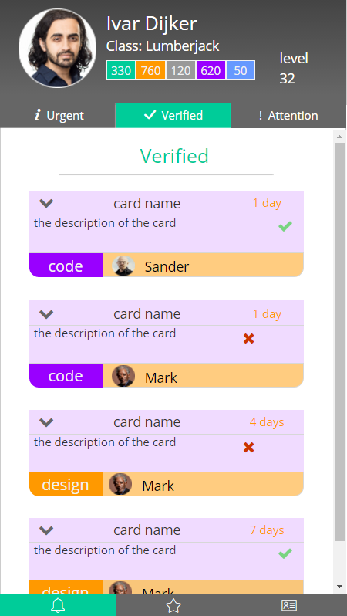

This is our mock-up for the verified page of the notifications tab. This page will show all your cards that are verified by someone else.

With the arrow in the top left corner you will be able to expand the card. Once you expand it you can see the explanation of why it is approved or disapproved.

If your card is approved you will be able to slide it to the right. Once you slide it to the right the card will be moved from verified -> done. If the card is disapproved you can slide it to the left to move it back to doing.

The name in the orange bar shows who checked your card. In the bottom left corner you can see what kind of card it is.

##### Attention

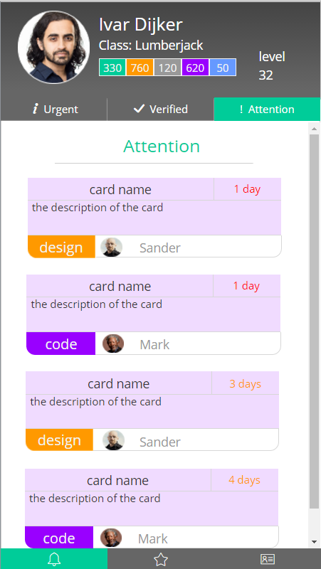

This is our mock-up for the attention page of the notifications tab. This page will show all the cards that need your verification. The name on the bottom of the card is the person who wants you to check his or her card.

It will not be possible to approve or disapprove the card in the application. In this application you can only see which cards need to be verified by you. To approve or disapprove of the cards you need to open up the web application.

In the bottom left corner you can see what kind of card it is.

#### Perks / trophies

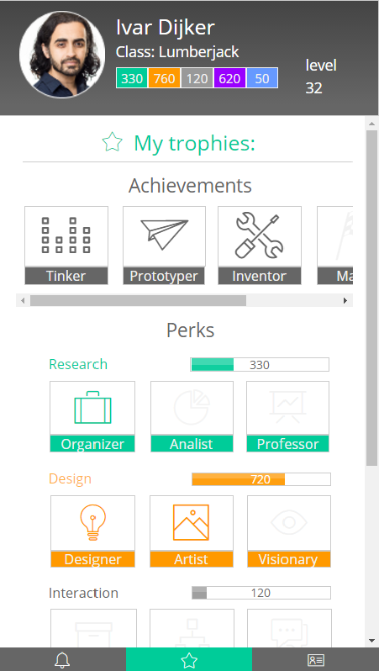

This is our mock-up for the perks / trophies page of our application. On this page you will be able to see your trophies / perks and activate them.

We will put the achievements above. These are permanent. The other perks are not and they cost points to use. The points for each skill will be shown in the top right of every perk.

The perks with the coloured icons are unlocked and can be used, and the perks with the greyed out icons cannot be used.

You can activate the perks by pressing them.

Each perk gives some benefits and we still have to decide how we are going to show which perks are activated.

### Profile

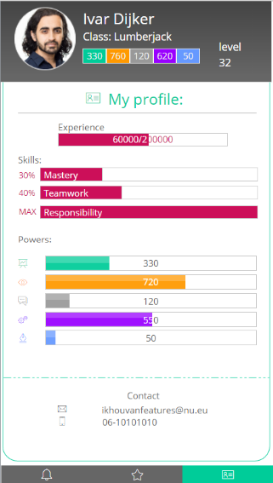

This page will show the profile of the user who is currently logged in. You can see all your experience for each skills and powers in this tab.

We tried to keep the design for this page the same as the web application.

You can also see a person’s contact information on the bottom of the screen.

### The profile widget

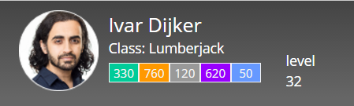  
Because our client wanted to have some user information available on all the pages in the application we decided to create a profile widget which will be shown in all the tabs. This profile widget is going to contain some basic information which will be shown on top of the page.

The widget contains the following information of the profile that’s logged in:

* Name
* Class
* Power points
* Level

This widget was also one of the reasons why we went with dark grey as a colour for the application. The background colour of the widget is a gradient colour from dark grey to slightly lighter grey. If we would have had this widget in white it just wouldn’t fit right and the design would look kind of empty. Our client agreed with this and was very satisfied with our design for this widget.

## 1.4 The technical design

### What are we going to build?

We are going to build a mobile application as an addition to the Scrummer / Scrum board application another group in our class is making. The web application is going to be called Scrummer Space. Our version of the application is going to be called Scrummer Space Mobile.

The web application makes it possible to work with the scrum method in projects all with a digital scrum board. Each user which is going to make use of the application gets a profile, which has certain information and statistics, like a level. You can level up those statistics and your level and unlock certain perks or trophies you can later use in the application.

These perks or trophies will be an important part of the application. These will be unlocked like achievements and some of them can be used to get certain privileges, like arriving at school 5 minutes late without the teachers noticing this.

Each user can take part in a project, or create a project themselves. Each project will have its own scrum board on which the project group can work. In each project you can create user stories. Each user story will have its own scrum board, split in: to-do, doing, verify and done. Once you’re done with your task and you want to move it to verify, it needs to be verified by the person you select. Each team is split up in a scum master (the project leader) and the rest of the team.

We are going to build a mobile application which is going to be an addition to the application noted above. The mobile application isn’t going to contain all of the features of the web application. We’re only going to include some of its core features.

One of the important things of the application is going to be the verify section of the scrum board. In the mobile application you should get notifications of the cards that you have to verify. The perk system is also going to be one of the important features, since you might want to activate one of these perks before you get into class. The last core feature is going to be the profile page, since a user should be able to see all of its information.

### What programming language are we going to use?

To realize our idea we are going to make use of HTML, CSS and JavaScript. The backend of the application will be programmed in Python and will be provided by the other project group that is working on the web application.

Since our mobile application is almost completely front end programming and designing we decided to stick with HTML, CSS and JavaScript.

### The workflow

Once you start the application you will begin at the login page. We decided to work with Oauth 2.0, which lets you log in through the regular web application. After you login through the web application you will be redirected and logged in to the mobile application. The web application gives a token which will be verified by the mobile application.

Once you’re logged in you will start at the main screen of the dashboard, which will be the notification menu. In this menu you will see all the cards that need your verification. On top of the page will be a widget which shows some of your profile information and your level and experience.

We are going to work with tabs, which you can swipe through. When you swipe to the left you will be taken to the perks / trophies page. On this page you can unlock new perks / trophies and see which perks / trophies you already have unlocked. It’s also possible to activate these perks / trophies on this page, so you can make use of some of its privileges. This page will also have the widget with the profile information on top of the page.

When you swipe to left again, to the third tab of the screen, you will arrive at the profile page. On this page you will be able to see all your information, like your name, level, class, experience, powers and contact information.

We also discussed some features which we might add if we have time left. In case we do, we might add a menu button which lets you edit your profile page or the settings of the application and we also might be adding the leader boards. For now this is it, since we probably won’t have enough time to do more and we might go out of our clients budget if we do.

So the core features of the application will be:

* Login screen (through the web application with Oauth 2.0)
  + Login will be possible through Facebook, Google or the application itself
* The main dashboard which includes the following tabs:
  + Notification page with profile widget on the top
    - The urgent page
    - The checked page
    - The attention page
  + Perks / Trophies page with profile widget on the top
  + The profile page which includes all the user information

### Database

Our application is going to make use of the same database as the web application. Since the database for the web application will be created by the other project group, we don’t have to work on this part of the project ourselves. The database they have at the moment is completed and checked by one of our teaches. In case things will change in the database the other project group lets us know.

On the next page we will show the different tables in the database with their fields:

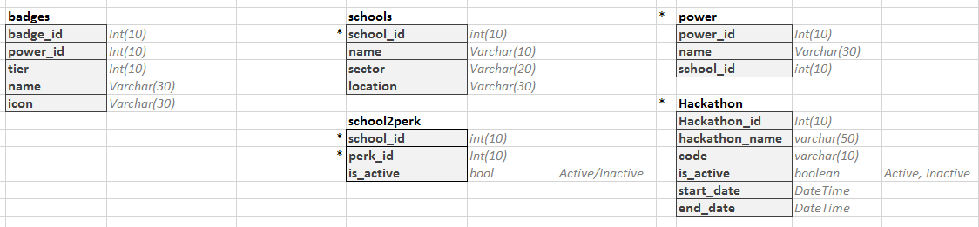

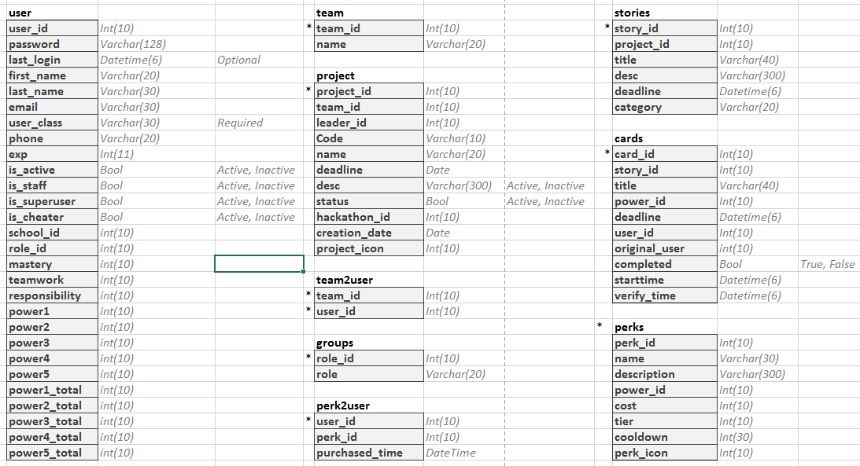

#### The relations in the database

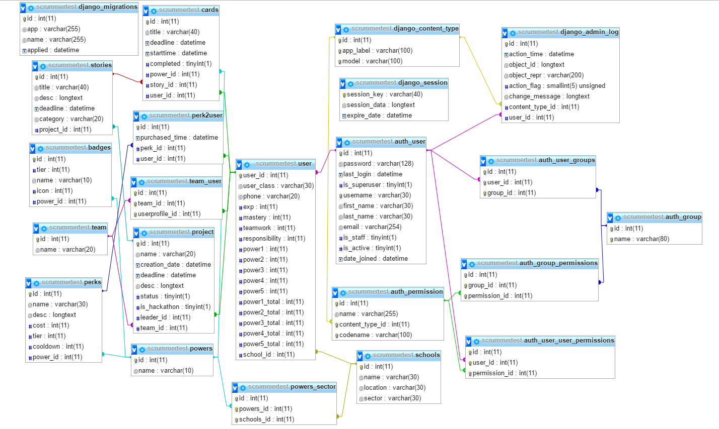  
  
Since it’s not our normalization and the other group is still working on their documentations, the relations are a bit of a mess. We will make sure we will document this better in the next phase of the project.

## 1.5 Set up the development environment

### Describe the right materials and resources that we need

All of us will work on our own computer. We will use “Visual Studio” to program the code for the application. Working in such languages as ‘JavaScript, CSS and HTML. To test our application we have a live server, this server can be tested on and edited to our liking.

The database we need to get information will be set up by the other development team. From that database we can get all the data. We will also link our phones to Visual Studio, this makes it easier to test our application. GitHub is used to share and/or merge our files.

### Install, configure and manage the right software

All of us already have Visual Studio on our computers. GitHub was also already setup because we used it in our last project. The server is setup but not used yet. The same goes for the database. The only thing necessary is connecting our phones, but that isn’t that difficult. Some have done it before with other programs.

### Takes into account the feasibility and future changes of the development environment

One thing to take into account is that certain libraries will have updates that are not backwards compatible. Cordova (formerly PhoneGap) is a risk because it still is being developed. However, this risk is declining every day as the library matures.

Another problem might be the API that our app relies on. If this API ever changes, our app might nog function properly. Therefore it is important to build the app in such a manner, that those changes can be quickly implemented.

The other products such as Visual Studio or GitHub are all stable and matured. There are no sudden changes expected in the near future.

### Keep track of the situation, development environment and results

Like explained before, We have most of the programs set-up. The only thing we need to do is connect our phones to Visual Studio. That will be done as soon as we start programming.

### Check in regularly with the client for the progress and results

We checked multiple times with the client to see if what we did was correct. Until so far the client has been pleased with our work. He agrees with the programs and methods that we use. In the beginning we discussed with the team and client what the best method would be. What language we should use and what program. This came to a quick conclusion and so we would be using our current options.