TRACK A — IMPLEMENTATION GUIDE
Module A1: System Architecture & Prerequisites
Audience: Graduate / future builders | Estimated time: 3–4 hours reading + setup
Cal Poly SLO · Industrial & Manufacturing Engineering · Digital Twin Project

Overview
This module is the entry point for anyone building or extending the Human-in-the-Loop Intelligent Digital Twin developed at Cal Poly SLO. It documents what the system is, what prior knowledge is required, and what depth of understanding each component produces. This is the empirical answer to the gap identified by González-Pérez & Ramírez-Montoya (2022): no prior retrofit DT project documented its prerequisite structure, time investment, or understanding depth.

Learning objectives
- Describe the full HitL DT system architecture from sensor to operator interface
- Identify prerequisite knowledge domains and their correct sequencing
- Estimate realistic time investment per system component
- Distinguish deep, moderate, and surface-level understanding for each domain
- Navigate the repository structure and locate relevant codebases

System Architecture
The HitL Intelligent Digital Twin is composed of five interconnected subsystems. Understanding the boundary between each subsystem and how data crosses those boundaries is more important than deep expertise in any single area at the outset.

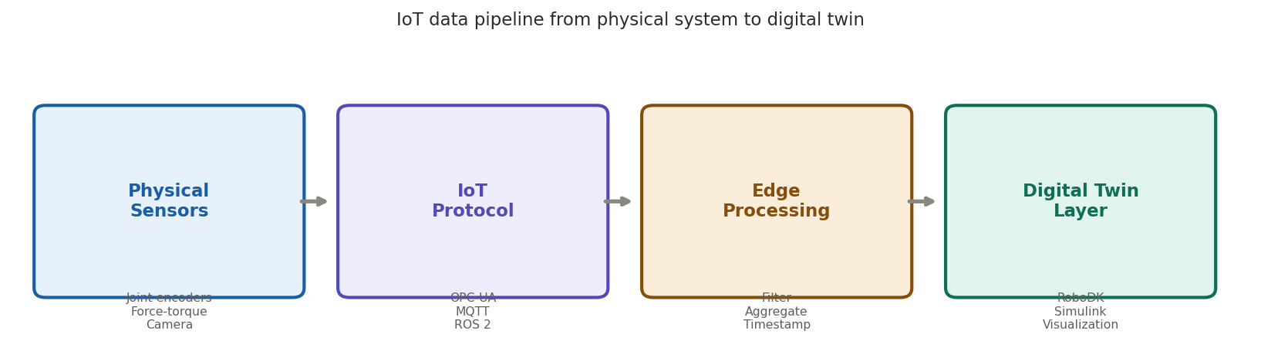
Figure 1. IoT data pipeline from physical system to digital twin (Lee et al., 2015)

Subsystem 1: Physical robot (HC10 + YRC1000)
The Yaskawa HC10 is a six-DOF collaborative robot controlled by the YRC1000 controller. State data (joint angles, end-effector pose, gripper state) is exported via Ethernet. The most critical thing to understand is what is NOT exposed by default: force-torque data requires additional hardware, and high-frequency joint state streaming requires controller-side configuration. Know the black-box boundaries before building around them.

Subsystem 2: Vision pipeline (camera + OpenCV)
A camera mounted above the workspace captures the assembly area. OpenCV performs HSV color extraction and K-means clustering to classify objects. The output is a continuous confidence score between 0 and 1 derived from the centroid distance of the classification cluster. This score is the central data stream that drives the HitL architecture.

Subsystem 3: Confidence engine & threshold logic
The confidence engine compares the score to a calibrated threshold (currently 0.607). Above threshold: the robot acts autonomously. Below threshold: the robot pauses and routes the decision to an operator. The threshold is a design parameter that should be re-calibrated if lighting or part geometry changes.

Subsystem 4: RoboDK digital twin
RoboDK maintains a real-time kinematic model of the HC10. State updates from the YRC1000 are pushed to the RoboDK API, which updates the virtual robot joint configuration. Path plans created in RoboDK are executed on the physical robot.

Subsystem 5: Human interface (GUI / LLM)
When confidence falls below threshold, the operator interface displays the camera view with the candidate object highlighted, the confidence score, and the system best guess. Responses via GUI or LLM are timestamped and logged for analysis.

Prerequisite Knowledge Map
The table below is the empirical prerequisite map that González-Pérez & Ramírez-Montoya (2022) identified as missing from every prior DT education study. Update this table as the system evolves.

Knowledge domain | Seq. | Est. hrs | Understanding depth achieved
Python + ROS 2 basics | 1st | 8 h | Deep — required to debug every downstream component
RoboDK API & kinematics | 2nd | 12 h | Deep — model accuracy determines DT fidelity
YRC1000 Ethernet interface | 3rd | 15 h | Moderate — protocol understood; controller internals opaque
OpenCV & color segmentation | 4th | 10 h | Deep — pipeline fully transparent and customizable
GMM confidence modeling | 5th | 8 h | Moderate — concepts applied; not derived from first principles
HitL logic & threshold design | 6th | 6 h | Deep — core contribution; must be owned fully
Sync & integration testing | 7th | 14 h | Moderate — functional understanding; edge cases remain

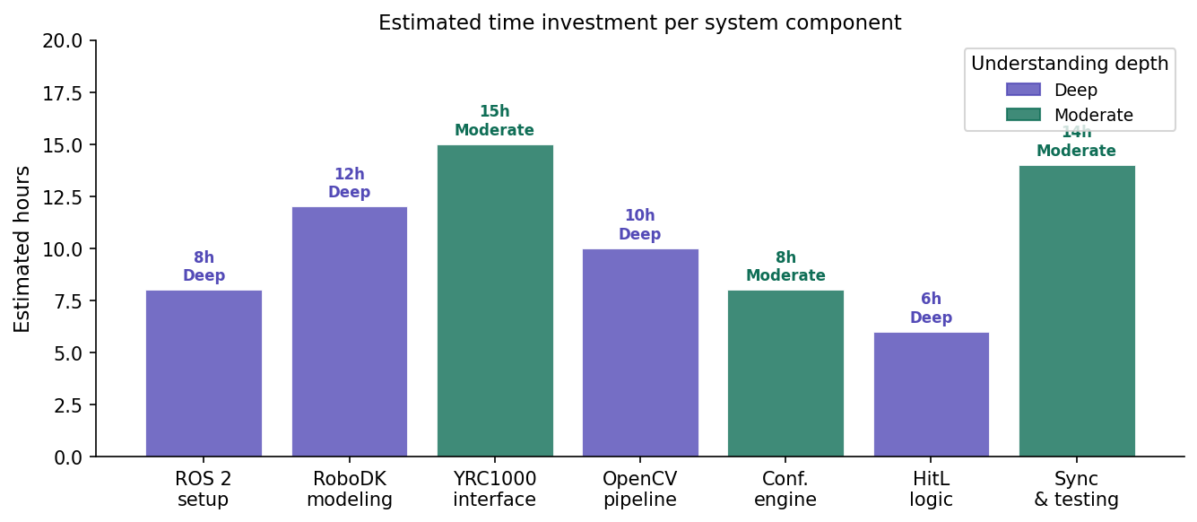
Figure 2. Estimated time investment per component with understanding depth achieved

Repository Structure
- /physical — HC10 control scripts, YRC1000 configuration, ROS 2 launch files
- /vision — OpenCV pipeline, K-means and GMM scripts, confidence calibration notebooks
- /digital_twin — RoboDK model, API interface, state synchronization loop
- /modules — Educational module documents (Track A and Track B), assessment instruments

Assessment Questions
Reflect before proceeding to Module A2
- Draw the data flow from the physical robot to the RoboDK visualization. What data crosses each boundary, and at what rate?
- The YRC1000 interface took approximately 15 hours to understand. What specific aspects contributed most?
- The confidence threshold is set at 0.607. What information would you need to argue for raising or lowering this value?
- Which prerequisite domains do you have deep understanding of already? Which will require the most preparation?

References: González-Pérez & Ramírez-Montoya (2022); Lee et al. (2015); Fuller et al. (2020); Eriksson et al. (2022)

