TRACK A — IMPLEMENTATION GUIDE
Module A2: Building & Synchronizing the Digital Twin
Audience: Graduate / future builders | Estimated time: 12–15 hours hands-on build
Cal Poly SLO · Industrial & Manufacturing Engineering · Digital Twin Project

Overview
This module walks through building the RoboDK digital twin and synchronizing it with the physical HC10 in real time. It addresses Eriksson et al. (2022) Gap 2: that retrofit DT education is valid but has never been documented with enough granularity for replication. This module is that documentation.

Learning objectives
- Build a functional HC10 kinematic model in RoboDK with accurate joint limits and geometry
- Establish a real-time state synchronization loop between the YRC1000 and RoboDK API
- Implement the ROS 2 data pipeline from joint state topics to the DT state layer
- Characterize the synchronization latency of the completed system
- Document the three most common failure modes and their resolutions

System Synchronization Architecture
The synchronization architecture defines how state data flows from the physical HC10 to the RoboDK virtual model. Every component in the chain below must function reliably before integration testing can begin.

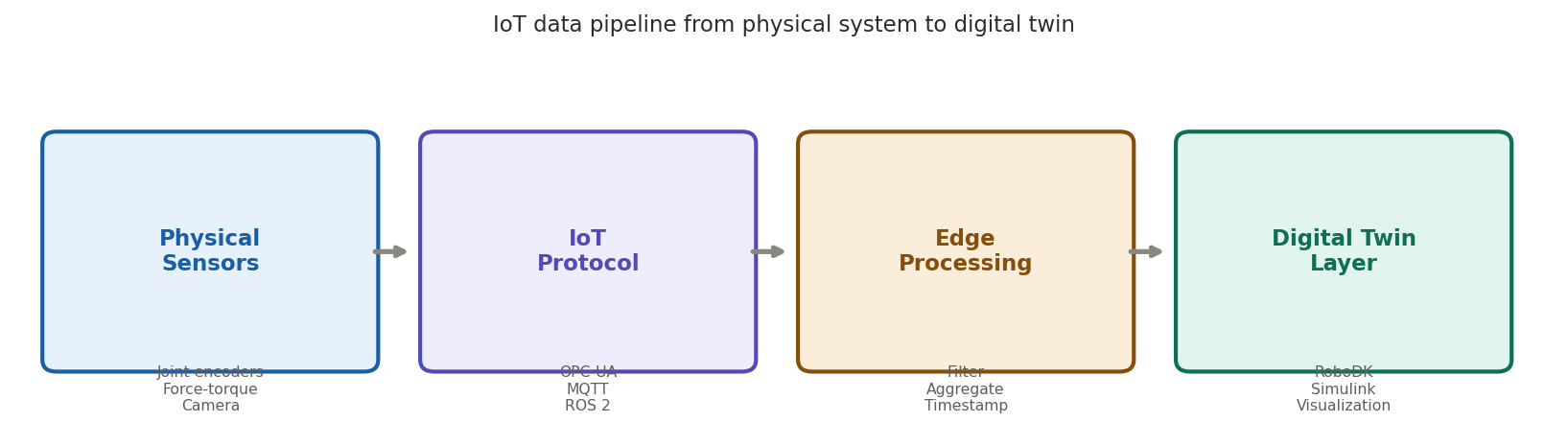
Figure 1. Data pipeline from physical robot to digital twin — each stage must be independently validated (Lee et al., 2015)

Part 1: RoboDK Model Construction

Step 1 — Load the HC10 from the RoboDK library
File → Open Online Library → search "HC10". Drag into your station. Verify joint limits against the HC10 datasheet — the community model may have inaccuracies in the wrist joints. Correct these before proceeding.

Step 2 — Define the workspace reference frame
Create a reference frame at the physical robot base. Measure the offset between the robot base and camera mounting point — this is critical for the vision pipeline to correctly localize objects. Any error here propagates through every downstream operation.

Step 3 — Configure the TCP (Tool Center Point)
Mount the gripper in RoboDK and define the TCP offset accurately. For the current gripper, the TCP is at the centroid of the jaw contact surface. Verify by jogging the physical robot to a known position and comparing the DT display.

Step 4 — Verify kinematic accuracy
Run tools/verify_kinematics.py to command five known poses and compare DT-predicted TCP position against measured physical position. Target: < 3 mm error. Document your calibration error — this is your fidelity baseline.

Part 2: State Synchronization Loop

Architecture
The sync loop is a ROS 2 node that subscribes to /joint_states published by the HC10 driver. On each received message it calls the RoboDK API to update the virtual robot joint configuration. Target rate: 20 Hz. The DT moves in lock-step with the physical robot.

Implementation steps
- Install motoman_ros2 driver and verify /joint_states publishes at target frequency
- Create sync_node.py in /digital_twin/src/ using the repository template
- Test at slow robot speeds first — verify DT tracks physical motion with no visible lag
- Stress-test at maximum joint velocity — document dropped frames or lag spikes
- Log achieved synchronization latency as your fidelity metric (target: < 50 ms end-to-end)

Common failure modes (documented from build experience)
- Joint state timestamps drift if robot controller and compute node clocks are unsynchronized — use chrony or PTP on both systems
- RoboDK API calls block the sync loop when the DT renders complex scenes — reduce rendering quality during high-frequency sync
- The HC10 driver drops connections after extended idle — add a reconnect handler with exponential backoff
- Joint angle unit mismatch (radians vs degrees) between ROS driver and RoboDK API is a silent failure — verify with a single-joint motion first

Part 3: The Digital Twin Fidelity Spectrum
Not all digital twins achieve the same level of synchronization. Understanding where your system sits on this spectrum is important for setting realistic expectations and communicating its capabilities to instructors and future students.

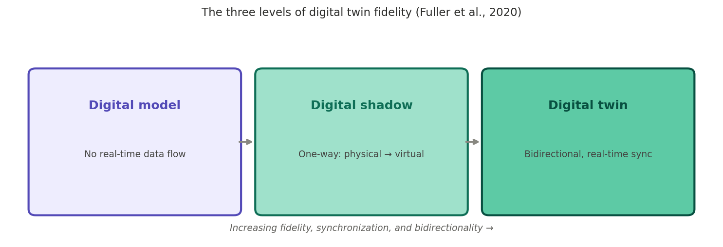
Figure 2. The three fidelity levels of digital twins — this system targets the full bidirectional twin (Fuller et al., 2020)

A key validation question: does your system enable path planning in the virtual environment and execution on the physical robot? If yes, you have achieved true DT bidirectionality. If path commands only flow one way (physical → virtual), you have built a digital shadow, not a twin. The distinction matters for the Track B modules that depend on planning and feedback.

Part 4: Validation Protocol
- Static accuracy: 5 known joint configurations — DT matches physical to within 3 mm TCP error
- Dynamic accuracy: continuous path at 30% max speed — DT maintains visual synchronization
- Latency: measured end-to-end sync delay < 50 ms at 20 Hz
- Recovery: simulate network interruption — DT reconnects within 5 seconds
- Long-duration: 30-minute continuous operation — no memory leaks or performance degradation

Retrofit Build Log (Gap 2 documentation)
Task | Time | Primary time driver
HC10 RoboDK model & joint limit verification | 4 h | Inaccuracies in community model; manual correction required
Reference frame calibration | 3 h | Physical measurement precision; iterative correction
ROS 2 driver installation & clock sync | 5 h | motoman_ros2 build dependencies; chrony configuration
Sync loop implementation | 4 h | API blocking issue; rendering quality adjustment
Validation protocol execution | 3 h | Latency source identification; recovery testing

Assessment Questions
Reflect before proceeding to Module A3
- Your sync loop achieves 18 Hz instead of 20 Hz. Is this acceptable? What would you change to reach 20 Hz?
- The DT shows accurate TCP position but joint angles look wrong. What does this tell you about the calibration issue?
- A colleague suggests skipping the 30-minute long-duration test. What argument do you make for including it?
- Document your own calibration error. How does it compare to the 3 mm target? What was the source of your largest error?

References: Eriksson et al. (2022); Quigley et al. (2009); Koenig & Howard (2004); Rasheed et al. (2020); Fuller et al. (2020)

