TRACK A — IMPLEMENTATION GUIDE
Module A3: Vision Pipeline, Confidence Calibration & HitL Logic
Audience: Graduate / future builders | Estimated time: 10–14 hours build + calibration
Cal Poly SLO · Industrial & Manufacturing Engineering · Digital Twin Project

Overview
This module covers the OpenCV vision pipeline, GMM-based confidence scoring, threshold calibration, and the HitL state machine. This is the core technical contribution and directly closes Hazrat et al. (2023) Gap 3: implementing uncertainty-aware human intervention as a designed architectural feature rather than an afterthought.

Learning objectives
- Implement HSV color extraction and K-means clustering for object classification
- Build and calibrate a GMM-based confidence scoring model
- Calibrate the confidence threshold using empirical performance data
- Implement the HitL state machine routing below-threshold decisions to operators
- Log operator responses and connect them to the robot execution pipeline

Part 1: Vision Pipeline

Stage 1 — HSV color extraction
Convert camera frames from BGR to HSV. HSV separates hue (color identity) from value (brightness), making classification more robust to lighting variation. Define HSV ranges for each object category under your specific lab lighting — generic values from tutorials will not work reliably.

Stage 2 — K-means classification
Apply K-means with k equal to the number of object categories. Confidence score formula: conf = 1 − (d_min / d_max), where d_min is the distance to the nearest centroid and d_max is the maximum inter-centroid distance. This normalizes confidence to [0, 1].

Stage 3 — GMM refinement
K-means produces hard boundaries. A Gaussian Mixture Model trained on labeled observations produces soft probabilistic boundaries better suited to visually similar objects. Train with at least 50 labeled examples per category under your lab lighting.

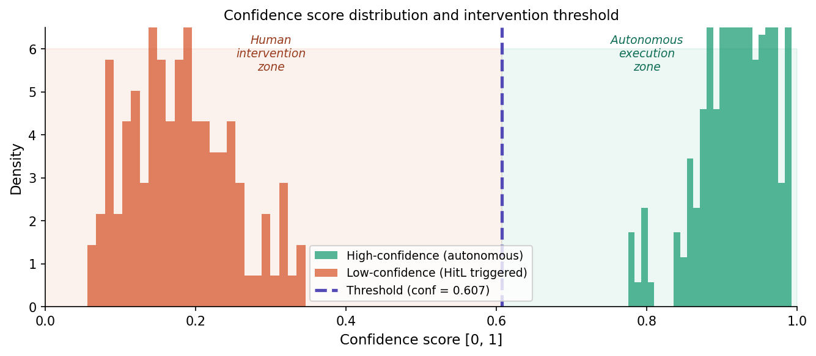
Figure 1. Confidence score distributions for autonomous and HitL-triggered classifications

Part 2: Threshold Calibration Protocol
- Collect 200 classification events — record confidence score and ground-truth outcome for each
- Plot confidence score vs. accuracy rate — identify the inflection where accuracy drops below your acceptable error rate (recommend 95%)
- Set the threshold at this inflection — currently 0.607 for this pick-and-place task
- Validate with 50 additional events: measure (a) human intervention rate, (b) autonomous accuracy rate, (c) overall accuracy
- Document the calibration dataset — recalibrate if lighting or part geometry changes

Part 3: HitL State Machine
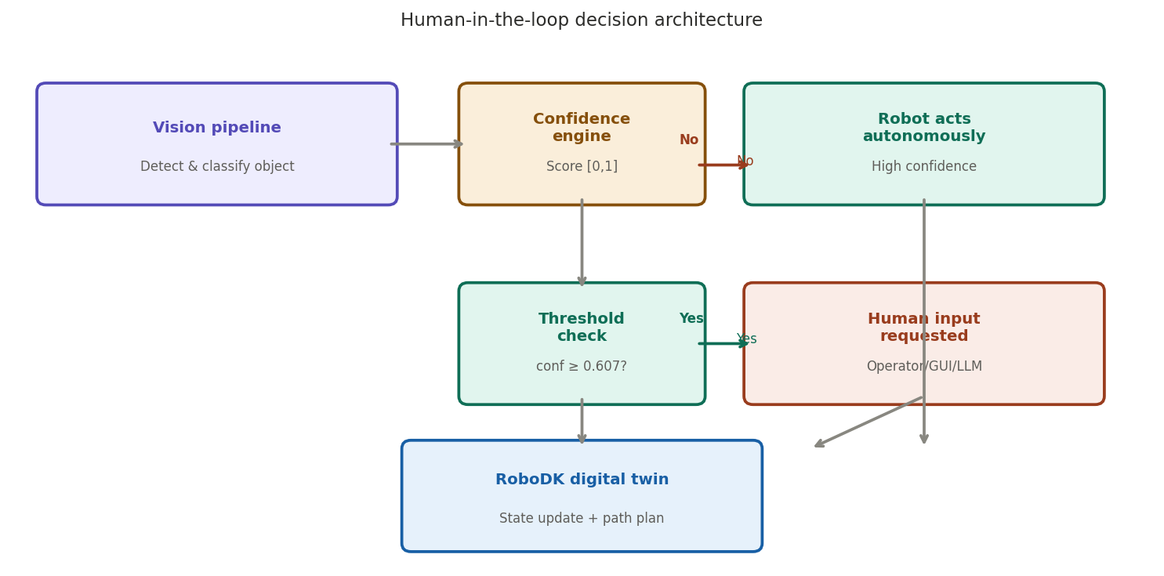
Figure 2. Human-in-the-loop decision architecture showing confidence-gated routing

Three states: AUTONOMOUS (confidence above threshold, robot acts), PENDING_HUMAN (confidence below threshold, robot pauses, operator prompted), EXECUTING_CORRECTION (human input received, robot acts on corrected classification). Implemented in Simulink Stateflow but can equally be a ROS 2 action server.

Operator interface requirements
- Current camera frame with classification candidate highlighted
- Confidence score and which threshold was breached
- System best guess for the classification
- Confirm / override / mark unclear options
- Timestamp and log every response to the interventions database

Intervention log schema
- timestamp — Unix timestamp of the intervention event
- confidence_score — score at time of trigger
- system_guess — autonomous system best classification
- human_response — operator-provided classification
- agreement — boolean: did human agree with system guess?
- cycle_time_delta — additional time added by human review

What the log enables
- Compute human intervention rate: interventions / total classifications
- Compute autonomous accuracy at the threshold boundary (how often system_guess was right near 0.607)
- Analyze agreement rate: high agreement = threshold may be too conservative; low = correctly placed
- Build a retraining dataset for the GMM using human-corrected labels — the system improves over time

Assessment Questions
Reflect before handing off to Track B users
- Your calibration finds the threshold should be 0.72 rather than 0.607. What does this tell you about your lighting conditions?
- After 500 interventions, human agreement with the system guess is 92%. What does this tell you about performance near the threshold?
- A future user wants to add a fourth object category. Which steps must they repeat, and in what order?
- Describe one improvement to the log schema that would make the Track B analysis modules more informative for students.

References: Hazrat et al. (2023); Jasim & Plapper (2014); Lenz et al. (2015); Broad et al. (2017); Amershi et al. (2014)

