TRACK B — STUDENT LEARNING MODULES
Module B1: Understanding the Digital Twin
Audience: Any IE or MfgE student — no lab access required | Estimated time: 75 minutes
Cal Poly SLO · Industrial & Manufacturing Engineering · Digital Twin Project

Introduction
"Digital twin" is used to describe everything from a 3D rendering to a sophisticated real-time system. This module gives you a precise vocabulary and a way to evaluate whether any given system actually qualifies. By the end, you will be able to look at the lab system and explain exactly what makes it a true digital twin.

Learning objectives
- Distinguish between digital models, digital shadows, and true digital twins
- Explain the physical–digital synchronization relationship and why it matters for this lab
- Place the system in the context of Industry 4.0 and Industry 5.0
- Read and interpret live telemetry output from the digital twin interface
- Articulate why the human-in-the-loop design is an Industry 5.0, not Industry 4.0, feature

Background: The Three Fidelity Levels
Fuller et al. (2020) provide the most useful precise definition by distinguishing three levels based on data flow:

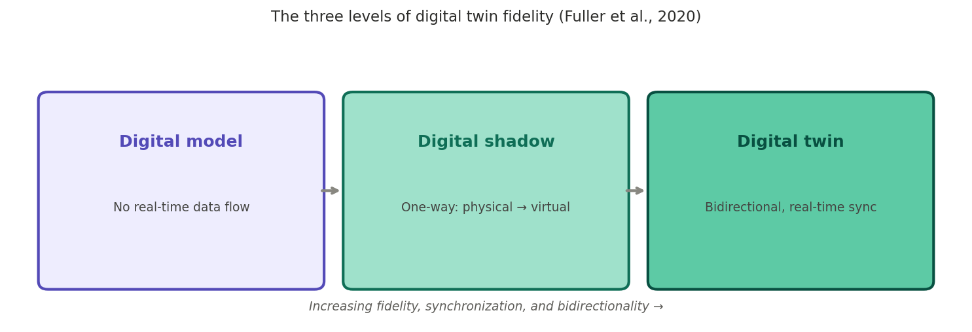
Figure 1. The three fidelity levels of digital twins (Fuller et al., 2020)

Digital model: A virtual replica with no real-time connection to the physical system. A CAD file of the robot is a digital model. Changes to the physical system are not reflected.
Digital shadow: The physical system streams data to the virtual model one-way. You can observe the physical system through the virtual one but cannot use the virtual to drive the physical.
True digital twin: Bidirectional, real-time synchronization. The physical system updates the virtual model; the virtual model can generate commands back. Planning in the virtual environment and executing physically is only possible with a true DT.

The lab system is a true digital twin. Joint states from the HC10 update the RoboDK model in real time. Path plans from RoboDK are pushed to the YRC1000 for physical execution. The bidirectional connection is what makes the HitL design possible.

Industry 4.0 and Industry 5.0 Context
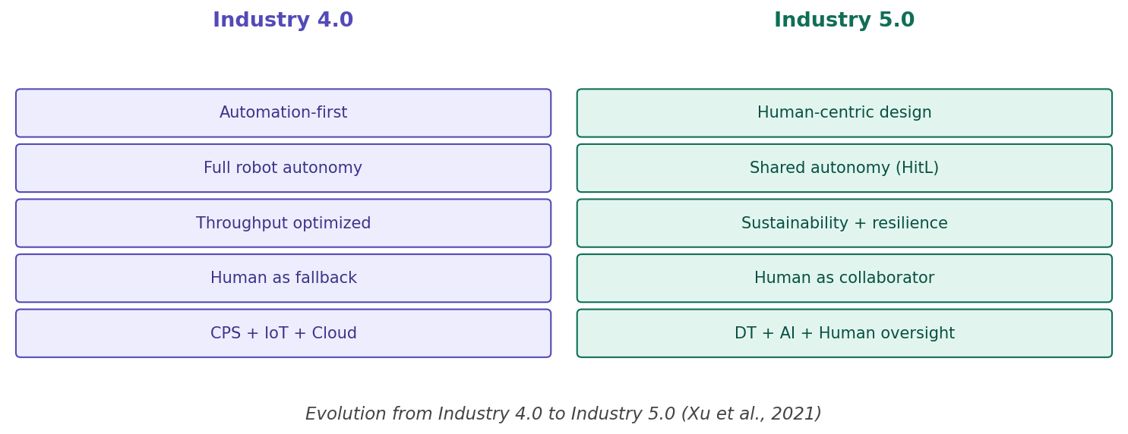
Figure 2. Key distinctions between Industry 4.0 and Industry 5.0 (Xu et al., 2021)

Industry 4.0 built the infrastructure that makes digital twins possible: IoT sensors, cloud computing, real-time data pipelines. But it treated human operators primarily as fallbacks for system failures. The digital twin you will use embodies Industry 5.0 thinking: human judgment is a routine, valued contribution, not an emergency override. When vision confidence falls below 0.607, the system asks a human for help — not because it has failed, but because that is the right architecture for handling uncertainty.

Lab Activity: Navigating the Interface

Step 1 — Identify the four information panels
Find: (1) the 3D RoboDK view of the virtual robot in real time; (2) the camera feed from the physical workspace; (3) the telemetry panel showing joint angles, TCP position, and gripper state; (4) the confidence gauge.

Step 2 — Observe and record three classification events
Run | Conf. score | Object classified | Autonomous or HitL? | Outcome correct?
1
2
3

Step 3 — Assess synchronization fidelity
While the robot moves, compare the 3D DT view and the physical robot. Note any lag, joints that differ, or motion in one not reflected in the other. This is your empirical measure of synchronization fidelity.

Discussion Questions
For small group or written reflection
- What would be different if this system were only a digital shadow? Give a concrete example of something you could no longer do.
- Zehrung (Purdue) described his DT vision as someone "sitting on a beach 3,000 miles away, able to see exactly what every machine is doing." What would need to be added to the lab system to realize this?
- Which specific feature makes this system Industry 5.0 rather than Industry 4.0? Could you remove it and still call it a digital twin?
- Name one thing the DT can tell you that you could not learn from watching the physical robot alone. Why does the virtual layer add that information?

References: Fuller et al. (2020); Grieves & Vickers (2017); Xu et al. (2021); Breque et al. (2021)

