TRACK B — STUDENT LEARNING MODULES
Module B2: Vision, Uncertainty & Confidence Scoring
Audience: IE / MfgE students — lab access required | Estimated time: 90 minutes
Cal Poly SLO · Industrial & Manufacturing Engineering · Digital Twin Project

Introduction
Automated systems often fail not because they encounter something unmanageable, but because they do not know they cannot manage it. A robot that misclassifies an object with wrong certainty causes more damage than one that pauses to ask. This module builds your understanding of how the vision system quantifies its own uncertainty.

Learning objectives
- Explain how HSV color extraction and K-means clustering produce a classification
- Interpret a confidence score and explain what drives it higher or lower
- Identify the physical conditions that push confidence below the intervention threshold
- Predict, before running a trial, whether a scenario will trigger human intervention
- Explain the tradeoff between setting the threshold higher vs. lower

How the Vision System Works

Stage 1: HSV color extraction
Each pixel is converted from RGB to HSV. HSV separates color identity (hue) from lighting effects (value), making classification more robust to ambient light variation. Significant lighting changes — a shadow, a different lamp — can shift an object's HSV values outside its trained range. This is the most common cause of sudden confidence degradation.

Stage 2: K-means classification
Each detected object is characterized by its average HSV values and shape geometry. K-means assigns it to the nearest cluster centroid. Confidence score: 1 minus the normalized distance from the observation to its nearest centroid. An observation on a centroid scores 1.0; one equidistant between two centroids scores near 0.5.

Stage 3: Threshold comparison
The confidence score is compared to the calibrated threshold (0.607). Above: robot proceeds autonomously. Below: system pauses and routes to an operator. The threshold was calibrated empirically for this specific task and objects.

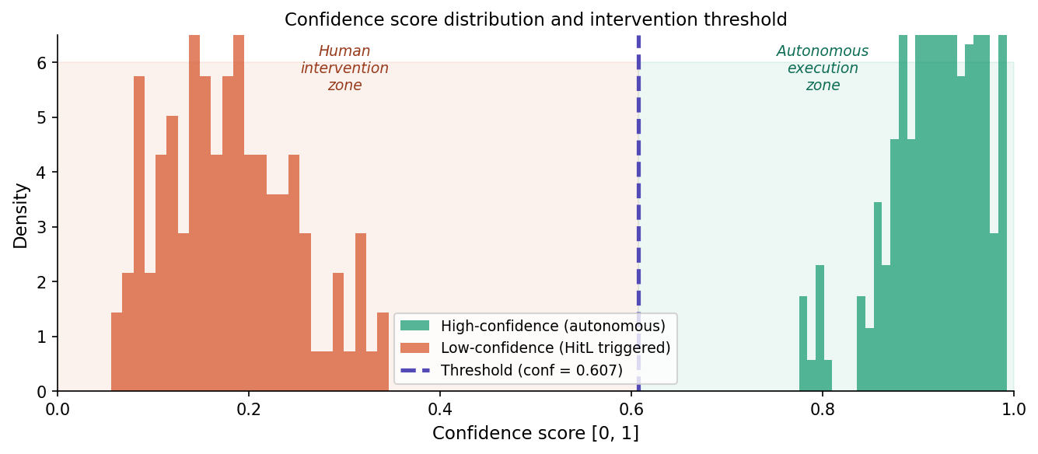
Figure 1. Confidence score distributions showing the intervention zone and autonomous execution zone

Lab Activity: Inducing and Observing Low Confidence

Pre-lab prediction (complete before the lab)
Condition | Your prediction | Reasoning
Normal conditions (baseline)
Object partially occluded
Shadow cast across workspace
Two objects of similar color
Object rotated 90° from training

Lab observations (complete during lab)
Condition | Conf. score | Prediction correct? | Notes on camera view
Baseline
Occlusion
Shadow
Similar color
Rotated 90°

Threshold Tradeoff Analysis
Threshold raised to 0.80  - More human interventions: every borderline case is reviewed  - Higher autonomous accuracy rate  - Longer cycle times overall  - Use when cost of errors is high (e.g., surgical assembly) | Threshold lowered to 0.40  - Fewer interventions: more autonomous decisions  - Lower autonomous accuracy rate  - Faster cycle times overall  - Use when cost of delay exceeds cost of occasional errors

Discussion Questions
For small group or written reflection
- You ran the occlusion condition and confidence dropped to 0.31. Should you raise or lower the threshold? Explain why neither direction is automatically correct.
- The system correctly classified an object with a confidence score of 0.42. A student argues the threshold is too high. How do you respond?
- In Zehrung's DT vision, operators observe from 3,000 miles away. What challenges does remote monitoring create for confidence management not present in the lab?
- Name one application where you would set the threshold much higher than 0.607 and one much lower. Justify both.

References: Lenz et al. (2015); Jasim & Plapper (2014); Collet et al. (2011); Rasheed et al. (2020)

