TRACK B — STUDENT LEARNING MODULES
Module B3: Human-in-the-Loop Decision Making
Audience: IE / MfgE students — lab access required | Estimated time: 90–120 minutes (CORE MODULE)
Cal Poly SLO · Industrial & Manufacturing Engineering · Digital Twin Project
This is the core module. The competency practiced here — knowing when to trust automation and intervening appropriately — is the central Industry 5.0 skill identified as absent from DT education by Hazrat et al. (2023).

Introduction
You are about to become part of the robot's decision-making architecture. When vision confidence drops below 0.607, the robot stops and asks for your input. Your response directly controls what happens next. This is not a simulation — it is the actual system. Your decisions will be logged, and you will analyze them afterward.

Learning objectives
- Respond accurately and consistently to confidence-triggered intervention requests
- Compare your decision accuracy to the autonomous system at the same confidence levels
- Identify the types of cases where human judgment adds the most value
- Explain shared autonomy and where it applies in Industry 5.0 manufacturing
- Articulate what the logged data from your interventions could be used for beyond this exercise

Background: Shared Autonomy
Shared autonomy is the formal term for systems where control is dynamically split between a human and an autonomous agent based on context. Dragan & Srinivasa (2013) formalize this as a policy-blending framework: autonomous policy and human policy are combined, with the human's weight increasing as confidence decreases. In this lab the blending is a hard threshold — a deliberate simplification that makes the human role unambiguous and the data easy to analyze.
Broad et al. (2017) showed that systems can learn from human corrections: the more interventions are logged, the better the autonomous system can model what a human would do, requesting intervention less often over time. Your corrections today are training data for a future version of this system.

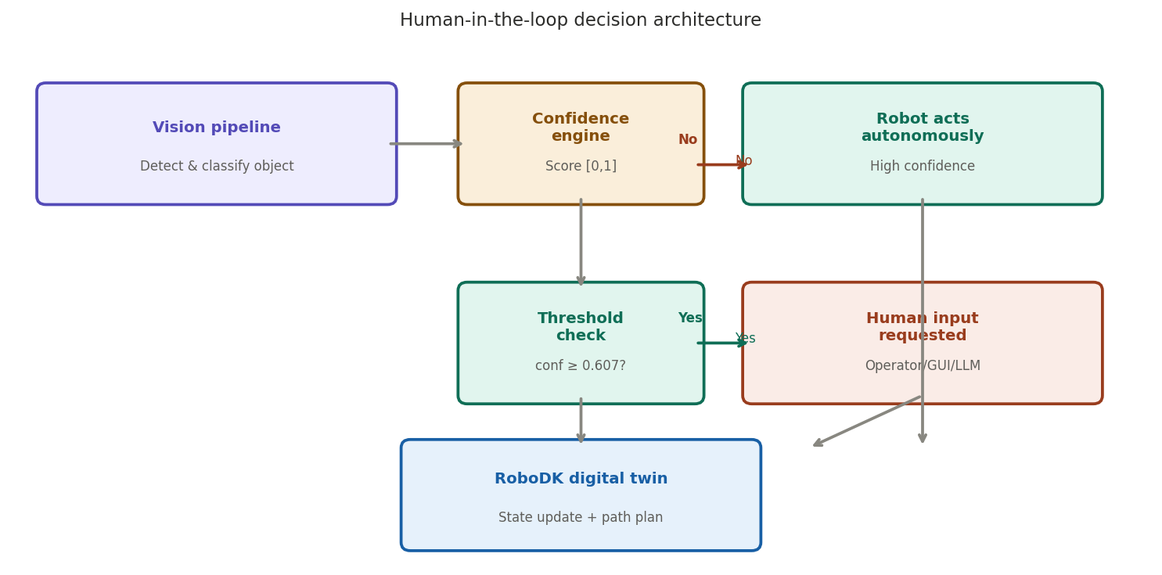
Figure 1. HitL decision architecture — you are in the "Human Input" box

Part 1: Baseline Human Performance (20 trials)

What you will see when an intervention is triggered
- The robot arm stops mid-operation — expected and intended
- The operator panel displays the camera view with the object highlighted
- The confidence score is shown (below 0.607) along with the system's best guess
- You may confirm, override, or mark as unclear
- A timer records your response time

# | Conf. | System guess | Your response | Agree? | Time (s)
1
2
3
4
5
6
7
8
9
10
11
12
13
14
15
16
17
18
19
20

Part 2: Degraded Conditions (10 trials)
Condition introduced: _____________________________________________

# | Conf. | System guess | Your response | Agree? | Time (s)
1
2
3
4
5
6
7
8
9
10

Post-Lab Analysis
- Accuracy rate Part 1 (%): ____
- Accuracy rate Part 2 (%): ____
- Agreement rate with system guess (%): ____
- Average response time Part 1 (s): ____
- Average response time Part 2 (s): ____

The autonomous system's accuracy at confidence levels below 0.607 is approximately 61% — it is wrong more than one time in three. Your task is to beat that number.

Questions for your post-lab writeup
- What was your accuracy rate in Part 1? Did you outperform the autonomous system's 61% at that confidence level?
- Did accuracy or response time change between Part 1 and Part 2? What does this reveal about human vs. machine performance under uncertainty?
- In which cases did you disagree with the system's guess? What did you see in the camera view that the confidence score did not capture?
- Broad et al. (2017) argue logged human corrections can train the autonomous system to improve. Based on your interventions, what would the system need to learn?
- At what production volume would you start questioning whether HitL review remains economically justified?

References: Hazrat et al. (2023); Dragan & Srinivasa (2013); Broad et al. (2017); Amershi et al. (2014); Villani et al. (2018)

