TRACK B — STUDENT LEARNING MODULES
Module B4: Scenario Analysis & System Evaluation
Audience: IE / MfgE students — lab + data analysis | Estimated time: 2 hours lab + 1 hour analysis
Cal Poly SLO · Industrial & Manufacturing Engineering · Digital Twin Project

Introduction
This is the capstone module. You will design and run your own production scenario, measure system performance, and make a reasoned argument about whether the HitL architecture improved outcomes relative to fully autonomous operation. You choose the scenario, you define the metrics, you draw the conclusions.

Learning objectives
- Design a production scenario with defined start conditions and measurable success criteria
- Run parallel autonomous and HitL trials and collect comparable performance data
- Calculate and interpret key metrics: classification accuracy, intervention rate, and cycle time
- Construct a reasoned argument for or against HitL deployment in your specific scenario
- Connect your findings to the broader retrofit vs. build-from-scratch vs. platform-based DT debate

The System You Are Evaluating
Before designing your scenario, review the two core components your experiment will stress-test: the confidence-gated HitL architecture and the threshold that controls when humans are asked to intervene.

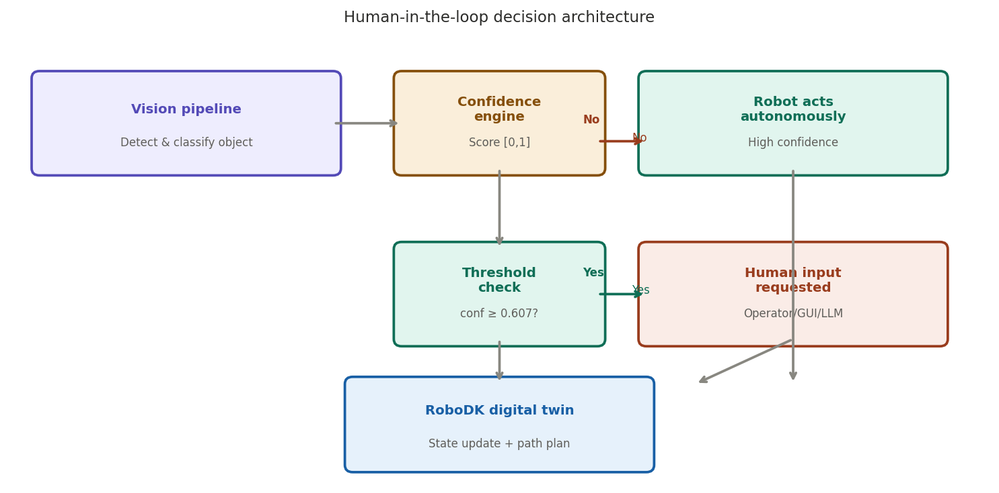
Figure 1. The HitL decision architecture your scenario will test — autonomous vs. human-routed paths

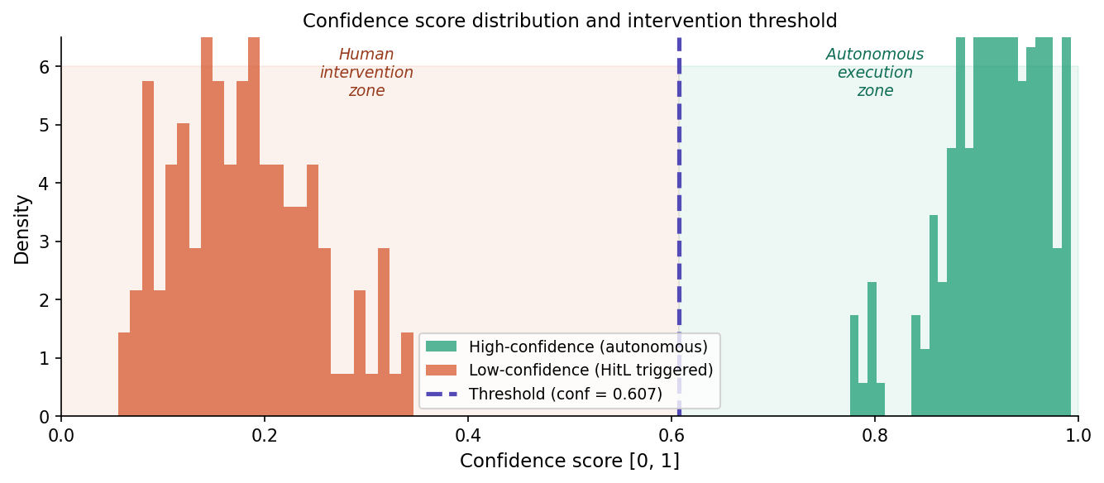
Figure 2. Confidence score distribution — your scenario design should push the system into the intervention zone to generate meaningful data

Part 1: Scenario Design
Before running any trials, define your scenario in writing. This forces you to commit to measurable success criteria before you see the data.
Complete this section before your lab session
- Scenario name: _______________________________________________
- Object types used: ___________________________________________
- Special conditions introduced (occlusion, lighting, similar objects, etc.): ___________
- Number of trials — autonomous: ___ HitL: ___
- Primary metric I will use to compare performance: ________________
- My hypothesis (which condition will perform better, and why): _________

Scenario types from the expert interviews
Type A: Routine throughput  - Baseline conditions; no special challenges  - Measure: accuracy and cycle time at steady state  - Question: Is HitL cost justified when the system works well?  - Source: Javadi (Northeastern) — normal manufacturing operation | Type B: Degraded conditions  - Introduce a deliberate disruption (shadow, similar object, occlusion)  - Measure: accuracy drop vs. HitL compensation amount  - Question: At what severity does HitL pay off?  - Source: Zehrung (Purdue) — vision failures in production

Type C — Rush order / curve ball: Mid-run, introduce a new object type the system has not seen. Measure: how the system responds, what the human does, whether the run completes successfully. Source: Zehrung — "What if we get a hot order that has to be done tomorrow?"

Part 2: Data Collection

Autonomous run (15 trials)
Trial | Conf. score | Correct? | Cycle time (s) | Notes
1
2
3
4
5
6
7
8
9
10
11
12
13
14
15

HitL run (15 trials)
Trial | Conf. | Intervened? | Correct? | Cycle time (s) | Notes
1
2
3
4
5
6
7
8
9
10
11
12
13
14
15

Part 3: Comparison Table
Metric | Autonomous (your result) | HitL (your result)
Classification accuracy (%)
Human intervention rate (%)
Average cycle time (s)
Total run time (s)
Errors requiring correction

Part 4: Final Argument (300 words)
"In your scenario, did the HitL architecture improve system performance? Under what conditions would you deploy it in a real factory, and at what production volume would you remove it?"

________________________________________________________________________________________
________________________________________________________________________________________
________________________________________________________________________________________
________________________________________________________________________________________
________________________________________________________________________________________
________________________________________________________________________________________
________________________________________________________________________________________
________________________________________________________________________________________
________________________________________________________________________________________
________________________________________________________________________________________
________________________________________________________________________________________
________________________________________________________________________________________
________________________________________________________________________________________
________________________________________________________________________________________

Connecting your findings to the literature
- Hazrat et al. (2023): Does your data support their argument that human-centric decision-making is a critical workforce competency?
- Eriksson et al. (2022): How does your experience using a retrofit DT compare to build-from-scratch approaches documented in the literature?
- Condron (Purdue, expert interview): He said students need to make dissimilar systems work together. Did that challenge appear in your scenario?
- Zehrung (Purdue, expert interview): He described the DT as letting someone "be on the floor" remotely. Did your scenario feel like that, or did physical proximity still matter?

References: Hazrat et al. (2023); Eriksson et al. (2022); González-Pérez & Ramírez-Montoya (2022); García et al. (2022); Broad et al. (2017)

