Kalah

Scrum Master: Erik Kirkegaard

Backlogs:

Task | Person
AI | Erik
GUI | James
Client-Server interface for Remote Play | James/other people
Game manager | Bishop

Task | Est. Hours Sprint 1
AI | Erik
GUI | James
Client-Server interface for Remote Play | James/other people
Game manager | Bishop

Date | AI | GUI | Client-Server Interface | Game Manager | Total Remaining
10/26 | 60 | 40 | 45 | 55 | 200
10/27 | 38 | 38 | 41 | 53 | 170
10/28 | 36 | 35 | 39 | 50 | 160
10/29 | 34 | 32 | 37 | 48 | 151
10/30 | 34 | 30 | 35 | 47 | 146
10/31 | 34 | 31 | 32 | 45 | 142
11/1 | 34 | 29 | 30 | 43 | 136
11/2 | 30 | 28 | 25 | 42 | 125
11/3 | 25 | 25 | 22 | 40 | 112
11/4 | 22 | 24 | 22 | 39 | 107
11/5 | 20 | 24 | 22 | 38 | 104
11/6 | 19 | 24 | 20 | 35 | 98
11/7 | 18 | 24 | 19 | 32 | 93
11/8 | 17 | 20 | 19 | 30 | 86
11/9 | 16 | 19 | 18 | 28 | 81
11/10 | 15 | 20 | 15 | 25 | 75
11/11 | 12 | 20 | 15 | 20 | 67
11/12 | 10 | 15 | 12 | 19 | 56
11/13 | 9 | 12 | 12 | 19 | 52
11/14 | 8 | 12 | 10 | 19 | 49
11/15 | 7 | 13 | 9 | 15 | 44
11/16 | 6 | 8 | 8 | 10 | 32
11/17 | 5 | 6 | 5 | 8 | 24
11/18 | 2 | 2 | 3 | 6 | 13
11/19 | 1 | 1 | 1 | 1 | 4

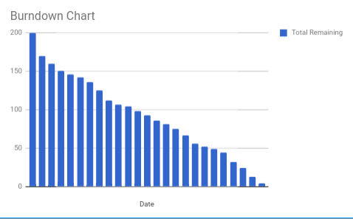
Sprint 1 Backlog
GUI:
- Placeholder GUI renders board and reacts to user clicks (does not play game at this point – placeholder widgets)
- Functional base game (player vs. player)
AI:
- Rudimentary AI which can play the game/react to player input (NOT fully featured)
Client-server model:
- Client-server model planned (at a high level/conceptual – not implemented as of sprint 1)
Game Manager:
- Game manager class created
- Game manager allows player vs. AI mode
- Game manager allows player vs. player mode
- Game manager has a system to model the board
- Game manager correctly sets board with seeds (locations and counts)
- Game state output to terminal
- Game manager allows typed input from user in terminal (user chooses which house to empty)

Overall Project Backlog
GUI:
- GUI renders game state and allows user to enter move by clicking on a slot
- GUI renders individual seeds and animates their movement
- GUI displays seed count in each pit and each player’s store
- GUI indicates the current player’s turn
- GUI includes title/game-over screen and settings dialogue
Game manager:
- Game manager class created
- Game manager allows player vs. AI mode
- Game manager allows player vs. player mode
- Game manager has a system to model the board
- Game manager correctly sets board with seeds (locations and counts)
- Game state output to terminal
- Game manager allows typed input from user in terminal (user chooses which house to empty)
- Game manager allows user to pick whether player or AI goes first (or select at random)
- Game manager tracks valid/invalid moves (does not allow invalid moves)
- Game manager implements correct moving of seeds based on input
- Game manager implements the correct seed stealing rules
- Game manager tracks total moves played by each player
- Game manager may enforce a max move count (optional)
- Game manager tracks if win condition is met
- Game manager allows whole game to be reset
- Game manager keeps track of player(s) wins (and AI wins if playing AI)
Client-server model:
- Client-server model supports remote play between players/AI
AI:
- AI features fully-implemented minimax tree (plans ahead several moves)
- AI has variable difficulty settings
- AI does not always choose optimal move (degree of randomness – dependent on difficulty setting)

