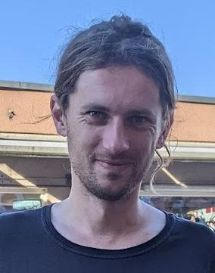
Erik Vaněk
Born September 30th, 1989, Zlín, Czech republic
Address Bayerova 34, 602 00, Brno, Czech republic
Phone +420 608 409 497
Email vanek.erik@gmail.com
Website www.erikvanek.com

“Looking for a new challenge after trying to reshape the urban farming industry since 2018 at infarm. After helping to scale a team of 8 to 60 and then back to 12 I look forward to a more predictable work environment. I bring skills from different areas like software, design and product management. Interested in shifting economies into a more regenerative future.”

Work experience

Infarm GmbH (May 2018 – February 2023)

Team lead, Software engineer, designer
- Helping to scale a team of 8 members to 60,
- Hiring, establishing a team culture, mentoring, kicking off new team rituals,
- Contributing as a domain team leader, engineer and a solution designer,
- Reference Sam Ellenby.

Snapshot GmbH (July 2016 – February 2018)

Software engineer, designer
- Development of an instant messaging app for hospitality industry,
- Promotion and adoption of human-centered design techniques,
- Daily cooperation with product team, key stakeholders and users,
- Reference Radek Matěj.

Adacta Group (June 2015 – June 2016)

Software engineer
- Insurance platform development,
- Helping to grow Czech subsidiary from 2 to 8 employees,
- Hiring, mentoring, establishing relationships with core team in Slovenia,
- Reference Benjamin Levstek.

FNZ (July 2013 – March 2015)

Automation engineer
- Development of tools for automating mundane tasks,
- Pioneering agile project management within the company,
- Guiding users of developed tools to leverage their full potential,
- Reference Ondřej Homola.

Přístupnější stát (Accessible state in translation) (2015 – 2017)

Co-founder, designer

- Co-founded an NGO focused on digitization of municipalities,
- The main aim was to help cities and small government organizations to improve their digital for their consumers,
- Reference Tomáš Arnot.

Education

Masters
- Information science and service design Masaryk University, Brno 2015 – 2017,
- including Erasmus exchange at Høgskolen i Oslo og Akershus in Norway.

Bachelors
- Computer graphics and digital image processing Masaryk University, Brno 2009 – 2013.

Others
- volunteering for Práh, Czechitas, ADRA or Vesna
- co-curating a Gallery of Architecture
- member of Sonda festival crew and part of Trychtýř collective

Hobbies
Sports, design, food and fermentation, sustainability, electronic music

