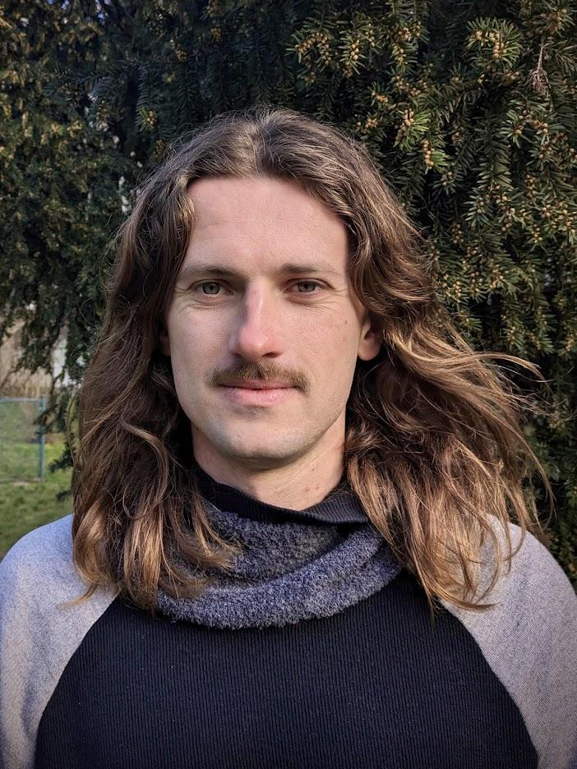
Erik Vaněk
Phone +420 608 409 497
Email vanek.erik@gmail.com
Website www.erikvanek.com

“As a service designer working for the Ministry of Social Affairs and a non-profit organization Sovia, I focus on developing tailored services that address complex social challenges. My role involves a nuanced understanding of policy and community needs, enabling me to design solutions that are both innovative and effective.”

Work experience

Sousedské dětské skupiny (April 2023 - now)

Service designer, Ministry of Labour and Social Affairs
- Designing a new community childcare service for children up to 6 years old
- Co-creation with non-designers, group facilitation, stakeholder and target group interviews, prototyping, helping to break organization silos
- Advocating concepts like human-centered design or agile project management
- Reference Roman Hřebecký.

Mám rozsudek a co dál? (July 2023 - June 2024)

Service designer, Sovia
- Creating a service to assist individuals awaiting their prison sentences
- In-depth interviews, running workshops and focus groups, conducting peer groups, prototyping and stakeholder mapping
- Fostering a healthy remote-first environment to support efficient collaboration
- Reference Lenka Kuti.

Infarm GmbH (May 2018 – February 2023)

Team lead, software engineer, designer
- Scaling a team of 8 to 60 members,
- Establishing a team culture, mentoring, hiring, implementing new team rituals,
- Contributing as a domain team leader, engineer and a solution designer,
- Reference Sam Ellenby.

Snapshot GmbH (July 2016 – February 2018)

Software engineer, designer
- Development of an instant messaging app for hospitality industry,
- Promotion and adoption of human-centered design tools and methods,
- Daily cooperation with product team, key stakeholders and users,
- Reference Radek Matěj.

Adacta Group (June 2015 – June 2016)

Software engineer
- Insurance platform development,
- Helping to grow Czech subsidiary from 2 to 8 employees,
- Hiring, mentoring, establishing relationships with core team in Slovenia,
- Reference Benjamin Levstek.

FNZ (July 2013 – March 2015)

Automation engineer
- Development of tools for automating mundane tasks,
- Pioneering agile project management within the company,
- Guiding users of developed tools to leverage their full potential,
- Reference Ondřej Homola.

Přístupnější stát (Accessible state in translation) (2015 – 2017)

Co-founder, designer
- Co-founded an NGO focused on digitization of municipalities,
- The main aim was to help cities and small government organizations to improve their digital for their consumers,
- Reference Tomáš Arnot.

Education
- Design of information services (DIS) at KISK, Brno, 2023 – 2026 (in progress)
- Information science and service design Masaryk University, Brno 2015 – 2017,
  - including Erasmus exchange at Høgskolen i Oslo og Akershus in Norway.
- Computer graphics, Masaryk University, Brno 2009 – 2013.

Volunteering and passion projects
- Volunteering for Práh, Czechitas, ADRA or Vesna (2021 – 2022)
  - Investing some of my energy in meaningful projects. Helping out at community centers or visiting clients with mental health conditions.
- Co-curating a Gallery of Architecture (2022 – 2023)
  - Curating a gallery program for 2023. Organizing gallery processes, communication with exhibitors, stakeholders or visitors, fundraising, PR.
- Member of Sonda festival crew and part of Trychtýř collective (2022 – now)
  - Event and stage management and artists assistance during Sonda festival, workshop facilitation
- DIY aeroponic systems
  - I have designed and built various soilless agriculture systems in the past. My biggest interest lies in high pressure aeroponics.

Hobbies
- Sports, design, food and fermentation, sustainability, contemporary electronic music.

