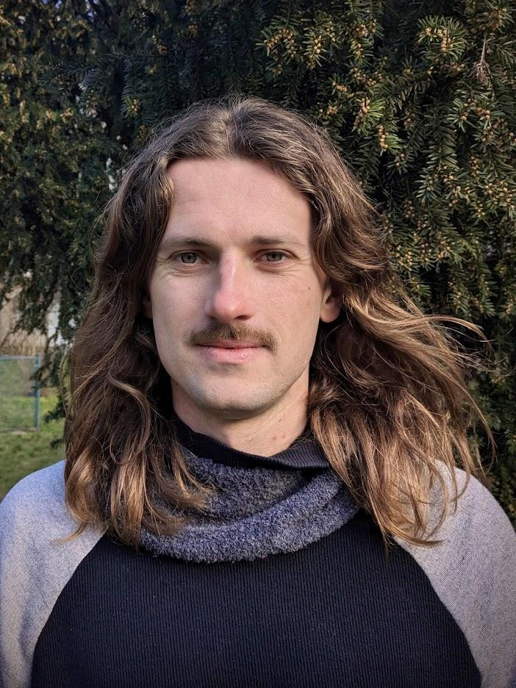
Erik Vaněk
Phone +420 608 409 497
Email vanek.erik@gmail.com
Website www.erikvanek.com

“I'm looking for a new challenge after helping to reshape the urban farming industry since 2018. Looking forward to a more predictable work environment after scaling an 8-person team to 60 and then back down to 12. I have experience in a variety of areas, including software, design, and product management. Interested in shifting economies into a more regenerative and fair future for everyone.”

Work experience

Infarm GmbH (May 2018 – February 2023)

Team lead, Software engineer, designer
- Scaling a team of 8 to 60 members,
- Establishing a team culture, mentoring, hiring, implementing new team rituals,
- Contributing as a domain team leader, engineer and a solution designer,
- Reference Sam Ellenby.

Snapshot GmbH (July 2016 – February 2018)

Software engineer, designer
- Development of an instant messaging app for hospitality industry,
- Promotion and adoption of human-centered design tools and methods,
- Daily cooperation with product team, key stakeholders and users,
- Reference Radek Matěj.

Adacta Group (June 2015 – June 2016)

Software engineer
- Insurance platform development,
- Helping to grow Czech subsidiary from 2 to 8 employees,
- Hiring, mentoring, establishing relationships with core team in Slovenia,
- Reference Benjamin Levstek.

FNZ (July 2013 – March 2015)

Automation engineer
- Development of tools for automating mundane tasks,
- Pioneering agile project management within the company,
- Guiding users of developed tools to leverage their full potential,
- Reference Ondřej Homola.

Přístupnější stát (Accessible state in translation) (2015 – 2017)

Co-founder, designer

- Co-founded an NGO focused on digitization of municipalities,
- The main aim was to help cities and small government organizations to improve their digital for their consumers,
- Reference Tomáš Arnot.

Education

Masters
- Information science and service design Masaryk University, Brno 2015 – 2017,
- including Erasmus exchange at Høgskolen i Oslo og Akershus in Norway.

Bachelors
- Computer graphics and digital image processing Masaryk University, Brno 2009 – 2013.

Volunteering and passion projects
- Volunteering for Práh, Czechitas, ADRA or Vesna
  - Investing some of my energy in projects that are meaningful to me. Helping out at community centers to provide better service to war refugees or visiting clients with mental health issues.
- Co-curating a Gallery of Architecture
  - Curating a gallery program for 2023. Organizing gallery processes, communication with exhibitors, stakeholders or visitors. Help with fundraising.
- Member of Sonda festival crew and part of Trychtýř collective
  - Contribution to a multifaceted artistic collective Trychtýř by imaginative workshop facilitation and further collaboration especially during ideation phases. Stage manager role during Sonda festival.
- DIY aeroponic systems
  - I have designed and built various soilless agriculture systems in the past. My biggest interest lies in high pressure aeroponics.

Hobbies
- Sports, design, food and fermentation, sustainability, contemporary music.

