


Title | QuoteXS Bean Documentation (0000.doc)
Version | 0.1 (draft)
Author | S.H.P. Janszen <bas@marketxs.com>
Distribution | -

1 Introduction 3
2 QuoteXS module description 4
3 The QuoteXS classes 5
1.1 How to access the QuoteXS beans? 6
4 Servlet example 7
5 The Quote class (Interface) 8
1.1 Quote’s Methods 8
1.2 Registration, Agreements and log in issues for real-time quotes. 10
6 The QuoteData, ShortQuote and DetailedQuote class 12
7 The Profile class (Interface) 13
1.1 Updating a user in the database – Example 14
8 The ProfileData class 15
9 The Lookup class 16
1.2 Lookup’s Methods 17
1.3 The integer bitmask for getTickerBySymbol and getTickerByName 18
1.4 Lookup, and TickerData Example 18
1.5 The TickerData class 19
1.6 The MarketData class 19
1.7 Object hierarchy for the Quote related data classes 20
10 Complete servlet sample code 21
11 Glossary 22

Introduction

This document describes the QuoteXS module and its objects. It gives an overview of the classes that are available to the developer as well as some sample code.

QuoteXS module description

MarketXS’ QuoteXS module provides in quote information about public companies. The bean gives a detailed overview of the most relevant financial information.

Latest quote
Time of last transaction
Volume latest transaction
Tick trend
Bid price (volume)
Asked price (volume)
Net price change (and %)
Highest and lowest quotation of the day
Highest and lowest annual price
Volume of the day
Average trading volume
Opening price
Closing price for previous day
Market

In addition, QuoteXS offers the following functionality to the application developer.

• Symbol lookup: search functionality for symbols and tickers.

• Authorization (real-time quotes only): An end-user has to be authorized before he can receive real-time quote information. The QuoteXS bean supports registration, authentication and authorization of end-users. There is no authorization required delayed quote information.

In combination with other MarketXS modules, the QuoteXS bean functionality can be expanded with the following:

• Portfolio management: Add a share with a single-click to an end-user’s portfolio (in combination with PortfolioXS).
• Financials: Get financial information about a company with a single-click (in combination with FinancialXS).

The QuoteXS classes

The QuoteXS modules have several classes that make our data available to you. They can roughly be divided into three main types of classes.

- Classes that give you access to quote information:
QuoteHome; home interface
Quote; manages the data QuoteData objects
QuoteData and its subclasses ShortQuote, DetailedQuote; contains the actual delayed/real-time quote information

- Classes that give you access to user information:
ProfileHome; home interface
Profile; manages ProfileData data objects
ProfileData; contains user information

- Utility classes that make life easier:
LookupHome,
Lookup,
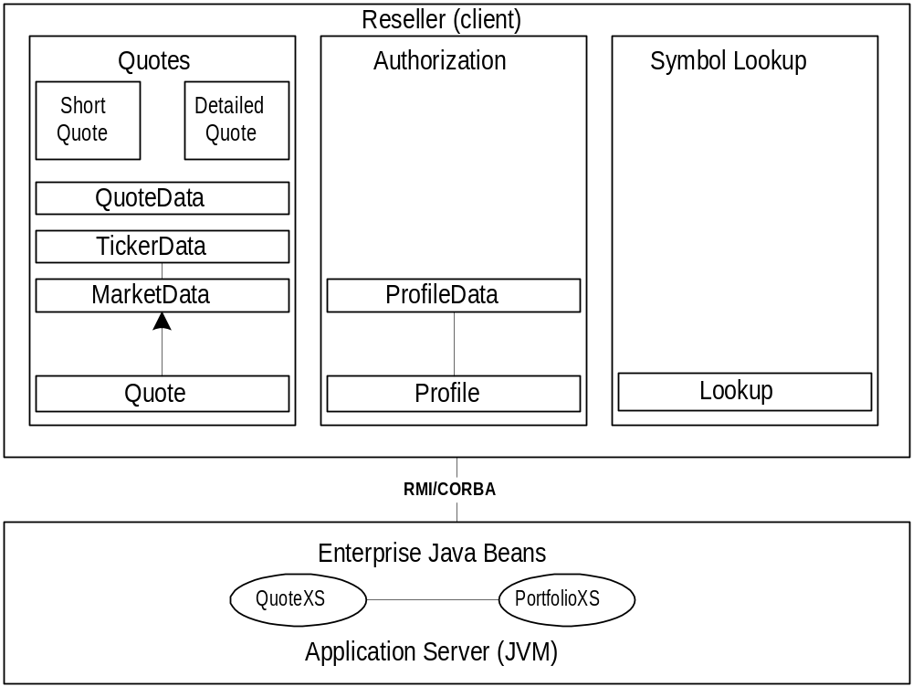TickerData

How to access the QuoteXS beans?

Typically, our beans our accessed through servlets written in the Java programming language. If you need assistance in writing servlets you may find more information about them on http://java.sun.com/products/servlet/.

Using our JAR files that we provided you with, your servlets will connect to our EJBs. This is done via Java RMI (Remote Method Invocation). Your servlet must connect to the JNDI service and do a JNDI lookup of our bean and then create an instance of the Quote bean object. Your servlet can then use this instance to retrieve information about tickers through the object’s accessor methods.

(Note: In case you are not using a java-client to connect to the EJBs on our server, our application server does support CORBA too. However, at this point in time this has not been tested)

In short, the following process should followed

- Create a framework for java servlet
- Log in to the Weblogic application server
- Do a JNDI lookup of the bean you want to use (e.g. com.marketxs.quote.Quote) and get a reference to the home interface
- Create a reference to the bean using the home interface’s create() method
- Create an instance to the data object (e.g. a QuoteData object)
- Use the object accessor methods to retrieve data from the bean

This is roughly process that should be followed. In the following chapters example code is given as well as a description of the classes that will help you in building your financial application.

Servlet example

This documentation assumes you’re using a servlet to connect to the MarketXS beans. This chapter describes how the servlet may connect to the accessor methods as implemented in the QuoteXS bean. The Quote Bean provides access to all quote data, real time and or delayed. In order to access the methods that the bean provides for, you must first create the servlet itself. The standard 1.2 JDK from Sun Microsystems may be used for this.

You can download Sun’s JDK from Sun’s Java website (http://www.javasoft.com). You must make a class that extends the HttpServer class. You will need to import the Java Servlet class files (http://java.sun.com/products/servlet/download.html). As your servlet will connect to EJBs via Java’s RMI to the MarketXS application server you will also need the Enterprise Java Bean class files (http://java.sun.com/products/ejb/docs.html) as well as the JNDI and RMI class files.

(Note: your JDK may or may already have the JNDI classes. If not, you may download them at http://java.sun.com/products/jndi/)

With these classes in your $CLASSPATH (Servlet classes, EJB classes and the JNDI classes) you are almost ready to code your first servlet. You need to install the MarketXS package with the stubs for the beans. You should have received a JAR file from MarketXS, which contains this package. Have your $CLASSPATH point to our jar file and import the following in your servlet:

// required for the servlet
import java.io.*;
import javax.servlet.*;
import javax.servlet.http.*;

// required for EJ Beans, RMI remote objects and JNDI lookups.
import javax.ejb.*;
import java.rmi.*;
import javax.naming.*;
import java.util.*;

// The MarketXS.com package for the RMI stubs for the QuoteXS objects
import com.marketxs.quote.*;

Now you have all the necessary components to build a connection to our QuoteXS bean and use its method to retrieve quote information. The first thing you should be doing in your servlet is log on the application server using your company’s username and password. In order to do that you need to set up the context for the connection by setting some environment properties. Creating an instance of he javax.naming.InitialContext (which implements the javax.naming.Context interface) and setting some properties by passing it a hash does this for you. You should set the following four properties.

Property name | Description | Example
INITIAL_CONTEXT_FACTORY | Weblogic Application Server | “weblogic.jndi.WLInitialcontextFactory”
PROVIDER_URL | The URL to the application server (protocol://machine:port” | “t3://some.machine.com:6001”
SECURITY_PRINICIPALS | Username for the application server | “foo”
SECURITY_CREDENTIALS | Password for the application server | “bar”

You can see how these properties are set in the sample code for the servlet provided in this document in the Appendix.

Once you have set these properties and the instance of the InitialContext object has been created you are logged on to the WebLogic application server. The second step is then to lookup the bindings for the QuoteHome object. This is achieved by calling the lookup method of the Context object we now have a reference to. This method should be supplied with a string, which represents the path to the Quote bean (“com.marketxs.quote.Quote”) on our application server. The method returns an object that should be type casted to an object of type QuoteHome. Now that we have a QuoteHome object we are ready to create a reference to a Quote object using the QuoteHome’s create() method. Once we have this object we have access to data objects via getQuote() and getQuoteCollection() method. These objects contain the actual financial data. The following chapters describe the Quote class and the data classes in more detail.

The Quote class (Interface)

Quote’s Methods

The Quote class methods are getQuote() for single quotes and getQuoteCollection() for retrieving multiple quotes. Both methods return delayed data, unless a user profile object is supplied. You can specify which objects type you want to be returned by the Quote object by making an instance of the required object and supply it to the Quote object’s getQuote() method or getQuoteCollection() method, along with the tickerId and a possible ProfileData object for real-time quotes.

The Quote object provides access to the data objects mentioned in the QuoteData chapter. The way these objects are retrieved is to supply the Quote object with

- A single tickerId for the getQuote method, or a Collection of tickerIds for the getQuoteCollection method
- The desired data object to return (QuotaData, ShortQuote, DetailedQuote)
- A ProfileData object (optional, for real-time quotes)

Basically, there are 2 types of methods., each with 2 variants.

- Methods that return delayed quote data (no user profile is supplied)
- getQuote(long tickerId, QuoteData quotedata) (returns a single quote)
- getQuoteCollection(Collection tickerIdCollection, QuoteData quotedata) (returns multiple quotes)

- Methods that return real-time data (a user profile is supplied as an instance of a ProfileData class)
- getQuote(long tickerId, QuoteData quotedata, ProfileData profiledata) (will return a single quote)
- getQuoteCollection(Collection tickerIdCollection, QuoteData quotedata, ProfileData profiledata) (returns multiple quotes)

As you can see the difference between the delayed and real-time quote getQuote and getQuoteCollection method is whether a user profile is supplied as well. The reason for this is that we need to check the user his username and password. This is a requirement by the stock exchanges for real-time quotes. All access to real-time quotes must be logged us.

As you can see, the Quote object is passed a QuotaData object or one of its subclasses, depending on which fields you need for this quote. For QuoteData and its subclasses, see the next chapter.

Example of retrieving the latest quote for a specific tickerId (delayed)

…
try
{
long tickerId = 57575;
Context ctx = getInitialContext();
QuoteHome qh = (QuoteHome)ctx.lookup("com.marketxs.quote.Quote");

Quote quote = qh.create();
ShortQuote shortquote = quote.getQuote(tickerId, new ShortQuote());

out.println("Last quote for tickerId "+tickerId+" = "+shortquote.getLast());
}
catch (NamingException e){out.println("Ooops: NamingException occured!");}
catch (CreateException e){out.println("Ooops: CreateException occured!");}

…

Registration, Agreements and log in issues for real-time quotes.

This chapter describes the procedure that should be followed to log in end-users. MarketXS needs control this process, as this is a requirement by the stock exchanges. The reason for this is 3 fold:

- We need to check the end-user’s password with the one stored in our database.
- We need to log the number of real-time quotes the end-user has accessed.
- We need to check whether the end-user has agreed with the stock exchange terms & conditions

By following the procedure described below you meet the criteria and requirements as set by the stock exchanges. These requirements entail that MarketXS does the end-user authorization and logging of all access to real-time quotes. Also, end-users that want access to real-time quotes will have to agree with the term and conditions (agreements) as set by the stock exchanges. In addition, this procedure avoids the need for having two separate login processes: one at the customer’s site and one at MarketXS.

There are three main aspects to the procedure.

- The registration of the end-user
- The login of an end-user
- Accessing real-time quotes (acceptation of the stock exchange the end-user agreement)

Ad1)

The registration process of and end-user can be done through API calls from a servlet or any other JVM enabled application. Our beans will receive the data objects and store the user’s profile in our database. This is only required for end-users who want to access real-time quotes.

Ad2)

The login process of an end-user that wants to access real-time quotes has to be done through a servlet that resides on the MarketXS webserver. As a requirement by the stock exchanges we need to verify the username and password of the end-user and log any accesses to real-time quotes. To achieve this the login process has to be done by MarketXS. We have implemented a login servlet to take care of the login process. Hence, it’s not done through API calls.

The MarketXS servlet should receive a username and password combination as parameters through the HTTP protocol.
The obvious way to do this is to have the login form at the reseller submit our servlet and pass it the required parameters. These are, as mentioned before, a username and password as well as a URL that our servlet that redirects the end-user to. In this way login process is done by MarketXS in a transparent way to the end-user.

Our servlet runs our checks (verify password, agreements) and registers the log in of the end-user in the database. All parameters that are supplied to the login servlet are returned to the script that you want us to redirect to. This includes the username and password as well as any other additional parameters. In this way you can run your own check and do any additional processing with the supplied parameters. This process does not necessarily has to be done is this particular order. Obviously, you could do your own end-user processing and the call our servlet.

Example (minimum) HTML for the login form

<FORM METHOD="post" ACTION="http://login.marketxs.com/servlets/login">
<INPUT TYPE="hidden" VALUE"redirect-url">
<INPUT TYPE="userid"><BR>
<INPUT TYPE="pwd"><BR>
<INPUT TYPE=”submit” VALUE=”Log in”>
</FORM>

NOTE: The URL in the HTML example is subject to change. As we are dealing here with sending user information across a public network (i.e. Internet) the preferred method of transport would be an encrypted SSL (Secure Socket Layer) session. Therefore, the URL may change.

Ad3)

When the end-user want to access real-time quotes, our beans check whether he agreed with the conditions as written down in the end-user agreement. In order to agree with these conditions, the end-user has to read the agreement, select a couple of radio buttons to indicate that he agrees with the se conditions, and then submit the form. The form resides on the MarketXS webserver. The end-user needs to fill in a form for every stock exchange he wants to access the real-time quotes from. Hence, the end-user may have to fill in multiple form. However, not all stock exchanges require the end-user to fill in such an agreement form. However, the end-user has to agree with the conditions before he gets access to the quotes in real-time by submitting the form on our webserver. Only then when can update his profile in our database and register that he has agreed with the conditions and grant him access.

Submitting our agreement form can be done at several moments. These are merely recommendations.

- At the time of registration;
- When trying to access his first real-time quote for a specific exchange;
- A combination of the two (preferred)

Note: as the end-user agreement forms resides on our webserver and the layout is dictated by the stock exchanges this implies limitations to the flexibility regarding to the design. To mimimize this effect, one could opt for putting the agreement in a javascript popup window.

The QuoteData, ShortQuote and DetailedQuote class

The Quote object getQuote and getQuoteCollection return a QuoteData object or one of its subclasses. These data objects contain information about the requested tickerId or symbol. The following data objects and their fields are available at present:

Data Object Type | Data Fields | Accessor Method | Description
QuoteData | TickerId | public long getTickerId(l) | Unique key
 | CurrencyId | public long getCurrencyId() | Currency
 | Symbol | public String getSymbol() | The ticker symbol
 | MarketId | public long getMarketId() | Stock Exchange (SE)
 | MarketAbbrev | public String getMarketAbbrev() | Abbreviation for SE
 | MarketName | public String getMarketName() | Full name for SE
 | Name | public String getName() | Name of the fund
ShortQuote  (extends QuoteData) | All of QuoteData’s fields, plus the following:
 | Last | public Double getLast() | Latest trading price
 | CumVol | public Long getCumVol() | Cumulative Volume
 | Change | public Long getChange() | Price compared to previous day close
DetailedQuote | All of ShortQuote’s fields,  plus the following:
(extends ShortQuote) | Bid |  | Bidding price
 | Ask | public Double getAsk() | Asking price
 | High | public Double getHigh() | Highest trading price of the day
 | Low | public Double getLow() | Lowest trading price of the day
 | Open | public Double getOpen() | Opening price of today
 | Yclose | public Double getyClose() | Previous closing trading price
 | Updatetime | public String getUpdateTime() | Last trading time
 | Delaymins | public Integer getDelayMins() | The delay (lag) in minutes

To see a servlet example, see the Quote class’ chapter.

The Profile class (Interface)

The Profile class is used to communicate with the ProfileData class, which holds user information. Profile manages ProfileData data objects. A ProfileData object is a required parameter to supply the Quote objects with to get access to real-time quotes. At present, this option is only available in combination with our PortfolioXS product.

Using the profile class one has access to the following functionality:

Functionality | Method
See if user is logged in | public boolean isLoggedIn(ProfileData pd, boolean updateTimestamp)
Retrieve a user’s profile | public ProfileData getProfile(String loginname)
Add a new user to the reseller database | public add(ProfileData pd)
Update an existing user in the reseller database | public update(ProfileData pd)
Delete an existing user from the reseller database | public delete(ProfileData pd)
Check if a user exists in the reseller database | public boolean exists(ProfileData pd)
Retrieve restrictions about the number of quotes per interval | public Hashtable getQuoteRestrictions(ProfileData pc)
Get the name of the reseller of this user | public String getReseller()

Updating a user in the database – Example

Example of updating a user in the database (assuming you have done the required imports)

// First we connect to the JNDI service and log in to the application server.

Hashtable hash = new HashTable();
try
{
hash.put(Context.INITIAL_CONTEXT_FACTORY,”weblogic.jndi.WLInitialContextfactory”);
hash.put(Context.PROVIDER_URL,”t3://jndi.foobar.com:7001”);
hash.put(SECURITY_PRINCIPALS,”username”);
hash.put(SECURITY_CREDENTIALS.”password”);
}
catch(NamingException e) {}

Context ctx = new InitialContext(hash);

// Now we’re ready to look up the bean’s home Interface, get a reference ph to it and use that to retrieve
// a reference to a Profile object. The Profile object can then be used to get a user’s profile (ProfileData) with
// its getProfile() method. The ProfileData object holds all the user information,which can be changed and
// updated in the database.

try
{
ProfileHome ph = (ProfileHome)ctx.lookup(“com.marketxs.profile.Profile”);
Profile profileManager = ph.create();
ProfileData userProfile = profileManager.getProfile(“jdoe”);

if (userProfile.isOwner(userProfile))
{
userProfile.setLastname(“Doe”);
profileManager.update(userProfile);
}
else
{
System.out.println(“You do not own this profile.”);
}
}
catch(RemoteException e){System.out.println("RemoteException oocured");}
catch(NoSuchUserException e) {System.out.println(“NoSuchUserException occured);
catch(CreateException e) {System.out.println("CreateException occured");}

The ProfileData class

The ProfileData class is the class that actually holds the user’s information. It represents a user in the MarketXS database. Registered users in our database are allowed to retrieve real-time quotes. Anonymous users only have access to delayed quotes. When a user of your website wants to access real-time quote, you will have to supply the Quote objects with a ProfileData object, containing the user’s information.

Data Object Type | Data Fields | Accessor Method | Description
ProfileData | profileid | public long getProfileId() | Unique key
 | Owner | public boolean isOwner(Secure secure) | Check is if the user owns this profile object
 | loginname | public String getLoginname() | Get the user’s login name
 |  | public void setLoginname(String loginname) | Set the user’s login name
 | password | public String getPassword() | Get the user’s password
 |  | public void setPassword(String Password) | Set the user’s password
 | firstname | public String getFirstname() | Get the user’s first name
 |  | public void getFirstname(String firstname) | Set the user’s first name
 | lastname | public String getLastname() | Get the user’s last name
 |  | public void getLastname(String lastname) | Set the user’s last name
 | title | public String getTitle() | Get the user’s title
 |  | public void setTitle(String title) | Set the user’s title
 | birthday | public Date getBirthday() | Get the user’s birthday
 |  | public void setBirthday(String title) | Set the user’s birthday
 | Addressline1 | public String getAddressstreet1() | Get the user’s 1st address line
 |  | public void setAddressstreet1(String address1) | Set the user’s 1st address line
 | Addressline2 | public String getAddressstreet2() | Get the user’s 2nd address line
 |  | public void setAddressstreet2(String address2) | Set the user’s 2nd address line
 | City | public String getCity() | Get the user’s city
 |  | public void setCity(String city) | Set the user’s city
 | State | public int getStateId() | Get the user’s state
 |  | public void setStateId(int stateId) | Set the user’s state
 | Zipcode | public String getZipcode() | Get the user’s zipcode
 |  | public void setZipcode(String zipcode) | Set the user’s zipcode
 | Country | public int getCountryId() | Get the user’s country
 |  | public void setCountryId(int countryId) | Set the user’s country
 | Email | public String getEmail() | Get the user’s email address
 |  | public void setEmail(String email) | Set the user’s email address
 | Phone | public String getPhone() | Get the user’s phone number
 |  | public void getPhone(String phone) | Set the user’s phone number
 | SMS | public String getSms() | Get the user’s SMS mobile phone
 |  | public void getSms(String sms) | Set the user’s SMS mobile phone
 | FirstLogin | public Date getFirstlogin() | Get creation date of this profile
 | LastLogin | public Date getLastlogin() | The date this profile was last used (last login date)
 |  | public void setLastlogin(Date lastlogin) | Specifies the date this profile was last accessed.
 | Gender | public String getGender() | Get the user’s gender
 |  | public void setGender(String gender) | Set the user’s gender
 | QuoteCount | public int getQuotecount() | Get the number of quotes accessed so far for this session.
 |  | public void setQuotecount(int quotecount) | Sets the user’s maximum allowed quotes per interval

The Lookup class

The Lookup class is a class that is used to lookup tickerIds. A tickerId is the internal key we use to uniquely identify anything that has a quote. All of our objects that query our database require the tickerId as a parameter. For example, the Quote class is passed a tickerId to construct and return a QuoteData object that is filled with information about this tickerId (quote).

To find the tickerId for a quote we provide you with a class that returns the tickerId(s) based on either the given stock symbol or the company name. If the company is listed on one stock exchange, a Collection is returned containing a single element. If the company is listed on more than one stock exchange, the returned Collection is filled with tickerIds for every stock exchange the company is listed on. If no listings are found for this company, the class throws an exception (LookupException).

Lookup’s Methods

Object | Method | Input | Returns | Example
Lookup | public Collection getTickersBySymbol(String symbol, int type) | Symbol string, representing the stock symbol. May be mixed upper and lower case.  A bitmask integer indicating which fields to return (see table) | A collection of tickerIds if the given symbol was found | “ORCL”  5
 | public Collection getTickersByName(String company, int type) | A string that represents the name of a company. Must be at least 3 characters. No percentage characters are allowed. The string is used to search our company database for a substring.  A bitmask integer indicating which fields to return (see table) | A Collection with tickerid(s) for the given company name. The Collection will hold multiple tickerIds if the company is listen on more than one stock exchange. The Collection is empty when no company was found with that name. | “Oracle"  5
 | public TickerData getTickerByTickerId(long tickerId) | A tickerId (long) representing a stock, option, index (anyhting that has a value). | A TickerData (see chapter “The TickerData class”) object for the given tickerid | 57575
 | public Collection getMarkets() | Retrieve all markets as MarketData objects bundled in a Collection | A Collection of MarketData (see chapter “the MarketData class”) objects
 | public MarketData getMarketByMarketId(long marketId) | A MarketId(long) which represent the market. Available marketIds may be obtained by invoking the getmarkets() method. | A MarketData objects holding information about the specified market (marketId, market abbreviation market name  ) | 123
 | public Collection getConstituentsByIndexId(long indexId) | An indexId (long) representing the index’s unique id. | A collection of TickerData objects which represents the constituents of the given index(indexId)

The integer bitmask for getTickerBySymbol and getTickerByName

Return tickerId for | Binary  Value | Decimal  Value
Stocks | 000001 | 1
Indices | 000010 | 2
Options | 000100 | 4
Warrants | 001000 | 8
Bonds | 010000 | 16
Miscellaneous | 100000 | 32

For example, if you would like to retrieve the tickerIds for the stocks and options of given symbol, the integer value passed to the method should be 5 (000001 + 000100 = 000101 -> 5).

Lookup, and TickerData Example

The following shows how to use the Lookup class’ getTickersBySymbol method look. It uses the TickerData class and MarketData class ‘ method to retrieve information about the given symbol. A ShortQuote is returned by the getQuote() method, which is one of the subclasses.
….

long tickerId;
String symbol;

res.setContentType("text/html");
out = res.getWriter();

// retrieve te symbol from the HTTP request, use AAB as the default if none is supplied.
symbol = req.getParameter("symbol") == null ? "AAB" : new String(req.getParameter("symbol"));

try
{
Context ctx = getInitialContext();
LookupHome slh =(LookupHome)ctx.lookup("com.marketxs.quote.Lookup");
Lookup sl = slh.create();

QuoteHome qh = (QuoteHome)ctx.lookup("com.marketxs.quote.Quote");
Quote q = qh.create();

Vector tickerVector = new Vector(sl.getTickersBySymbol(symbol, 1));
Enumeration tics = tickerVector.elements();

while (tics.hasMoreElements())
{
TickerData tic = (TickerData) tics.nextElement();
tickerId = tic.getTickerId();
ShortQuote sq = (ShortQuote) q.getQuote(tickerId, new ShortQuote());
out.println("Last quote for tickerId "+tickerId+" = "+sq.getLast()+" ("+sq.getName()+" "+sq.getMarketName()+")<BR>");
}
}
catch (NamingException e){out.println("NamingException occured!");}
catch (CreateException e){out.println("CreateException occured!");}
catch (LookupException e) {out.println("LookupException occured!");}
catch (QuoteException e) {out.println("QuoteException occured!");}

…….

The TickerData class

The TickerData class is a class that gives access to information about tickers. A ticker could be anything that holds a value in the database (e.g. a quote, an index). The TickerDataclass is sort of a helper class that holds information that is access very often. These are:

- The tickerId of this ticker (e.g. 57575). A tickerId is the key to uniquely identify a ticker.
- The ticker’s symbol that corresponds to this tickerId (e.g. ORCL for an Oracle ticker)
- The name of the fund.

TickerData is a subclass of the MarketData class. Therefore, instances of the TickerData class do not only hold information about the ticker, but also about the market. The Quote object returns TickerData and collections of TickerData objects.

For the MarketData class, see the next chapter.

The MarketData class

The MarketData class is a class that gives access to information about stock exchanges (markets). It holds the marketId, market abbreviation and market name. The MarketData class is the root class for its subclasses: TickerData, QuoteData, ShortQuote andDetailedQuote.

Object hierarchy for the Quote related data classes
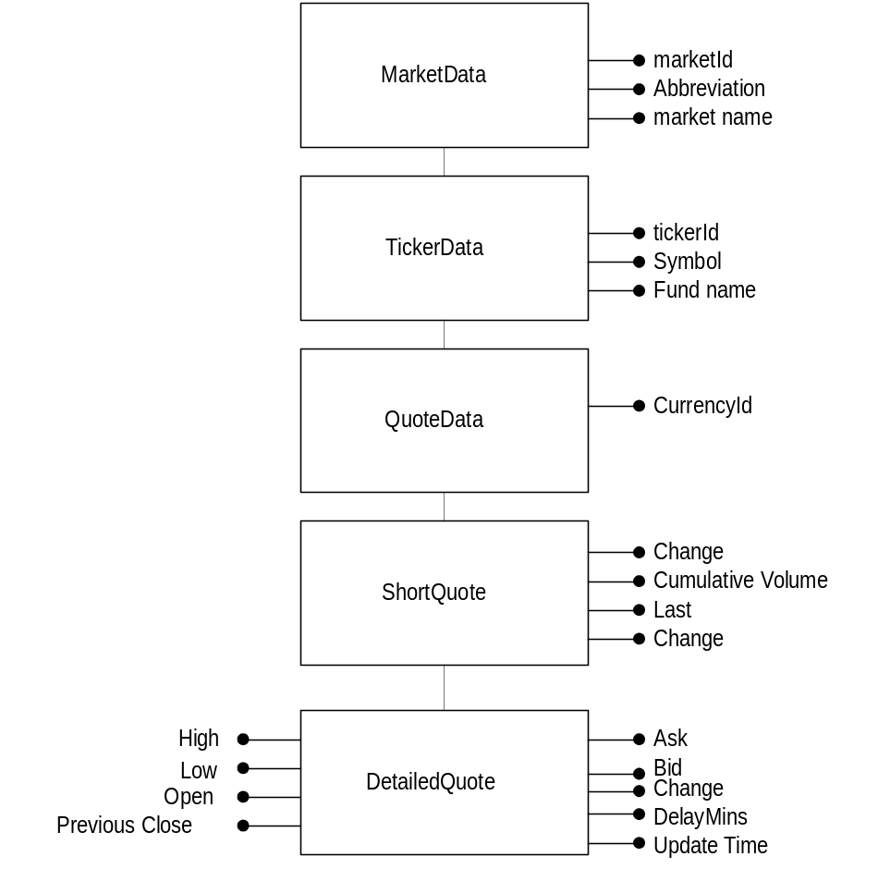

Complete servlet sample code
The following code implements a servlet that takes one parameter, a tickerId and retrieves the last quote for that tickerid.
import java.io.*;
Required for the servlet
import javax.servlet.*;
import javax.servlet.http.*;

import javax.ejb.*;
Required for EJB, RMI and JNDI.
import javax.naming.*;
import java.rmi.*;

import java.util.*;
Required for the stubs
import com.marketxs.quote.*;

public class basjServlet extends HttpServlet
{
public void service(HttpServletRequest req, HttpServletResponse res) throws ServletException, IOException
{
PrintWriter out;
long tickerId;
Double last;
String mask = "1";
Quote q;

res.setContentType("text/html");
out = res.getWriter();
tickerId=req.getParameter("tickerid") == null ? 57257 : new Long(req.getParameter("tickerid")).longValue();

try
Connect to the application server
Look up the QuoteXS EJB in the Naming Directory
Create a Quote object
Create a QuoteData object
{
Context ctx = getInitialContext();
QuoteHome qh = (QuoteHome)ctx.lookup("com.marketxs.quote.Quote");
q = qh.create();
QuoteData qd = getQuote(q, tickerId, mask);

out.println("Last quote for tickerId "+tickerId+" = "+qd.getLast());
}
catch (NamingException e){out.println("Ooops: NamingException occured!");}
catch (CreateException e){out.println("Ooops: CreateException occured!");}

} // service

public Context getInitialContext() throws NamingException
{
Define the username, password and specify the URL where the servlet may find the application server.
String user = "foo";
String password = "bar";
String url = "t3://path.to.appserver.com:7001";

Set context properties to log on to the application server
Hashtable hash = new Hashtable();
hash.put(Context.INITIAL_CONTEXT_FACTORY, "weblogic.jndi.WLInitialContextFactory");
hash.put(Context.PROVIDER_URL, url);
hash.put(Context.SECURITY_PRINCIPAL, user);
hash.put(Context.SECURITY_CREDENTIALS, password);

return new InitialContext(hash);
}

}
public QuoteData getQuote(Quote q, long tickerId, String mask)
{
QuoteData quoteData = new QuoteData();
try
{
quoteData = q.getQuote(tickerId, mask);
}
catch(RemoteException e){}
catch(QuoteException e) {}
return quoteData;
}
} // basjServlet

Glossary

API – Application’s Programmers Interface.
An API (application program interface) is the specific method prescribed by a computer operating system or by another application program by which a programmer writing an application program can make requests of the operating system or another application.

HTML - HyperText Markup Language
HTML is the lingua franca for publishing hypertext on the World Wide Web. It is a non-proprietary format based upon SGML, and can be created and processed by a wide range of tools, from simple plain text editors - you type it in from scratch- to sophisticated WYSIWYG authoring tools. HTML uses tags such as <h1> and </h1> to structure text into headings, paragraphs, lists, hypertext links etc.

SMS - Short Message Service
SMS is a service for sending messages of up to 160 characters to mobile phones that use Global System for Mobile (GSM) communication. GSM and SMS service is primarily available in Europe.

WAP - Wireless Application Protocol
The WAP is a specification for a set of communication protocols to standardize the way that wireless devices, such as cellular telephones and radio transceivers, can be used for Internet access, including e-mail, the World Wide Web, newsgroups, and so on. While Internet access has been possible in the past, different manufacturers have used different technologies. In the future, devices and service systems that use WAP will be able to inter-operate.

JNDI - Java Naming and Directory Interface
The Java Naming and Directory InterfaceTM is a standard extension to the JavaTM platform, providing Java technology-enabled applications with a unified interface to multiple naming and directory services in the enterprise. As part of the Java Enterprise API set, JNDI enables seamless connectivity to heterogeneous enterprise naming and directory services

JDK - Java Development Kit
The JavaTM Development Kit (JDKTM) contains the software and tools that developers need to compile, debug, and run applets and applications written using the Java programming language. The JDK software and documentation is free per the license agreement

EJB - Enterprise Java Beans
Enterprise JavaBeans technology is a scalable, distributed and cross-platform architecture that lets developers tap into and utilize enterprise-class services. The technology allows developers to write business logic to the JavaTM platform and easily integrate and leverage their existing enterprise investments.

JAR - Java ARchive
JAR stands for Java ARchive. It's a file format based on the popular ZIP file format and is used for aggregating many files into one. Although JAR can be used as a general archiving tool, the primary motivation for its development was so that Java applets and their requisite components (.class files, images and sounds) can be downloaded to a browser in a single HTTP transaction, rather than opening a new connection for each piece.

Servlet
Servlets are pieces of JavaTM source code that add functionality to a web server in a manner similar to the way applets add functionality to a browser. Servlets are designed to support a request/response computing model that is commonly used in web servers. In a request/response model, a client sends a request message to a server and the server responds by sending back a reply message.

ORB - Object Request Broker
In CORBA, an Object Request Broker is the programming that acts as a "broker" between a client request for a service from a distributed object or component and the completion of that request. Having ORB support in a network means that a client program can request a service without having to understand where the server is in a distributed network or exactly what the interface to the server program looks like. Components can find out about each other and exchange interface information as they are running.

OS - Operating System
An operating system (sometimes abbreviated as "OS") is the program that, after being initially loaded into the computer by a bootstrap program, manages all the other programs in a computer. The other programs are called applications. The applications make use of the operating system by making requests for services through a defined application program interface (API). In addition, users can interact directly with the operating system through an interface such as a command language.

JVM - Java Virtual Machine
The Java Virtual Machine is the cornerstone of Sun's Java programming language. It is the component of the Java technology responsible for Java's cross-platform delivery, the small size of its compiled code, and Java's ability to protect users from malicious programs. The Java Virtual Machine is an abstract computing machine. Like a real computing machine, it has an instruction set and uses various memory areas. It is reasonably common to implement a programming language using a virtual machine; the best-known virtual machine may be the P-Code machine of UCSD Pascal.

CORBA - Common Object Request Broker Architecture
CORBA is the acronym for Common Object Request Broker Architecture. It is an open, vendor-independent architecture and infrastructure that computer applications use to work together over networks. Using the standard protocol IIOP, a CORBA-based program from any vendor, on almost any computer, operating system, programming language, and network, can inter-operate with a CORBA-based program from the same or another vendor, on almost any other computer, operating system, programming language, and network.

DNS - Domain Name Service
A network service used to map domain names (e.g. marketxs.com) into IP addresses and vice versa.

IP address
In the most widely installed level of the Internet Protocol (IP) today, an IP address is a 32-bit number that identifies each sender or receiver of information that is sent in packets across the Internet. When you request an HTML page or send e-mail, the Internet Protocol part of TCP/IP includes your IP address in the message. It will send the message to the IP address that is obtained by looking up the domain name in the URL you requested or in the e-mail address you're sending a note to. At the other end, the recipient can see the IP address of the Web page requestor or the e-mail sender and can respond by sending another message using the IP address it received.

RMI – Remote Method Invocation
RMI (Remote Method Invocation) is a way that a programmer, using the Java programming language and development environment, can write object-oriented programs in which objects on different computers can interact in a distributed network. RMI is the Java version of what is generally known as a remote procedure call (RPC), but with the ability to pass one or more objects along with the request. The object can include information that will change the service that is performed in the remote computer.
s

