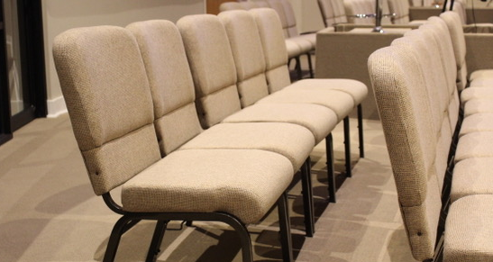  Don’t use your valuable cash reserves to acquire the equipment your Church needs. Build a line of credit for your Church while taking up to 60 months to pay. Good faith is all that’s needed!  Call us to ensure that you can reserve the total amount that you need.  We hope you’re excited to learn about this opportunity. By calling us today and taking advantage of this offer, your church can have the equipment needed to continue your good work!  Your Church Might Already Be Approved for a 50K Equipment Loan.  Your Church can choose any equipment it needs. You can take any amount; $3,000, $10,000, $25,000 or $50,000.  [your company] will Process Your Church Loan in 24/48 Hours! |  | 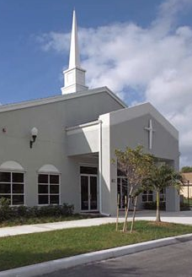  CHURCH EQUIPMENT FINANCE PROGRAM  We can finance any type of equipment for your church!
  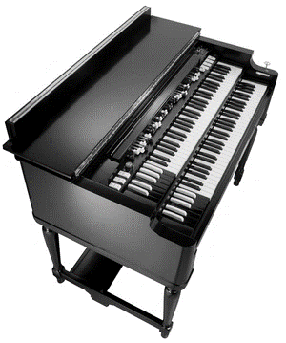
  Here are some common types of equipment we finance:
  Don’t see what you need? Let us know! Whatever your needs, [your company] can help.
  - Audio Visual Equipment
  - Church Furniture & Furnishings
  - Kitchen Equipment
  - Musical Instruments
  - Church Signs
  - Day Care Equipment
  - Heating & Air Conditioning
  - Office Equipment
  - Church Maintenance Equipment
  
  yourwebsite.com
  123.456.7890
  email@address.com
 | Church Questionnaire  Church Name: _____________________  _________________________________  Address: _________________________  City: _____________________________  State: ________Zip: ________________  Church Phone # ___________________  Fax #____________________________  Age of Church: ____________________  Denomination: ____________________  Denomination Address: _____________  _________________________________  Senior Reverend: __________________  With Church Since: ________________  Phone # __________________________  Guarantor Name: __________________  Home Address: ____________________  City: ___________State: ____Zip: _____  Social Security #___________________  Membership 2011: _________________  Membership 2012: _________________ | Equipment Information  Equipment Description: _____________  _________________________________  Price: ____________________________  Anticipated Delivery Date: ___________  Proposed Term of Financing:  ______36 Months  ______48 Months  ______60 Months  BANK REFERENCES  Name of Bank: ___________________  Phone #_________________________  Account # _______________________  Mortgage Holder or Landlord Name:  _____________________________  Account # ____________________  Phone # ______________________  Contact: ______________________  The church represents and warrants that all credit and financial information submitted to Global Financial Services is true and correct and Global may obtain any information necessary pertaining to this questionnaire.  Signature: _________________  Date: _____________________
PROGRAM HIGHLIGHTS:
- Start-Up, Newer, or Established Churches
- Approval withing 24-48 Hours
- 95% Approval Rate

As a special promotion, we will approve any church that meets our criteria!
Ready for the next step? Simply complete this brief questionnaire and email it to us at email@address.com or call 123.456.7890 for fax instructions.

