  If you accept credit cards in your business, you may be eligible for up to $250k!  A simple example of how much you can borrow:  - You collect your credit card monthly processing statements for the last 6 months, it totals $540,000.  - Divide this number by 6 = $90,000  - You can get 80-120% of that amount or $72,000 to $108,000. |  |   Up to 500K for any use in under 5 days!  EASY PAY CASH ADVANCE
  A partial list of the many services that we provide:
  - Business Acquisition Financing
  - Church Financing
  - Commercial Bridge Loans
  - Construction Equipment Financing
  - Debt Restructuring
  - Easy Pay Cash Advance
  - Equipment Leasing
  - Real Estate Financing
  - SBA Loans
  - Security-Based Lending
  - Unsecured Business Loans & Lines of Credit
  We can provide almost any type of financing a business owner needs!
  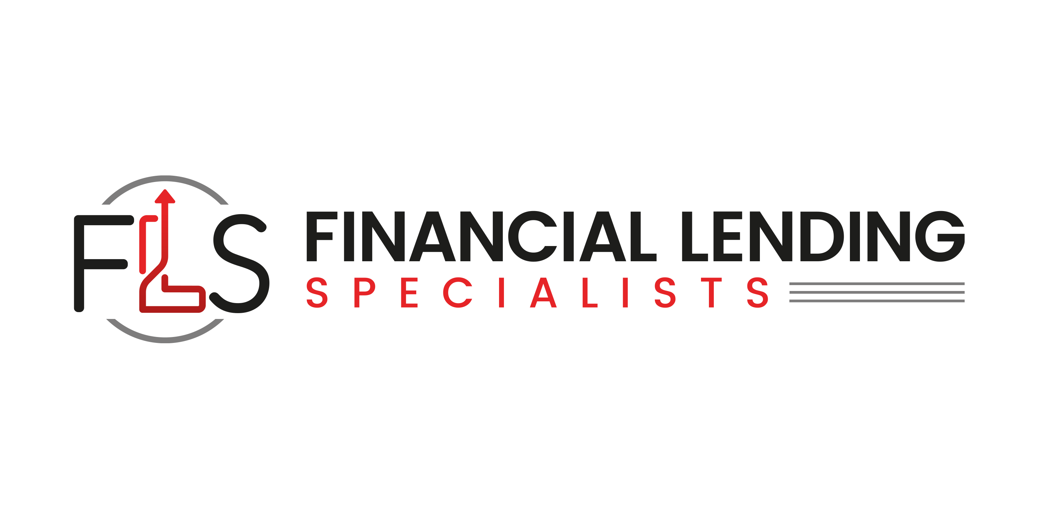
  financiallendingspecialists.com
  323-285-3721
  info@financiallendingspecialists.com
  Often a company is approved for a loan through its bank or financial institution, but the loan does not close for 4-6 months. During that time, we can provide a short-term bridge loan, which will be paid back when the senior loan closes, so your short-term financial needs can be met.
Unsecured Loans & Lines of Credit |  | We specialize in providing you with the necessary capital to fund any company you wish to acquire. We can also provide the equity necessary, should there be a cash shortfall between the financing and the cash you are putting into the transaction by leveraging the available assets of the company.



Poor Credit: No Problem
Late Payment: No Problem
Bank Turndowns: No Problem

Easy Pay Cash Advance Financing

We are proud to announce the easiest and most beneficial ways to get quick cash for your business!

We can lend you an amount equal to your total monthly sales with up to two years repay. If you take credit cards in your business, check out our easy pay cash advance program.

No hassle, quick, & easy cash for any use in under 7 days!

- You can purchase needed equipment
- Hire more employees
- No tax returns
- Approval in 48 hours
- No financials
- Advertising/Marketing
- No personal guarantees
- No hassle quick & easy cash up to
- $250,000 for any use in under 5 days
- Amount equal to your total monthly sales and up to two years to repay
For More Information

Visit Us Online
Financiallendingspecialists.com

