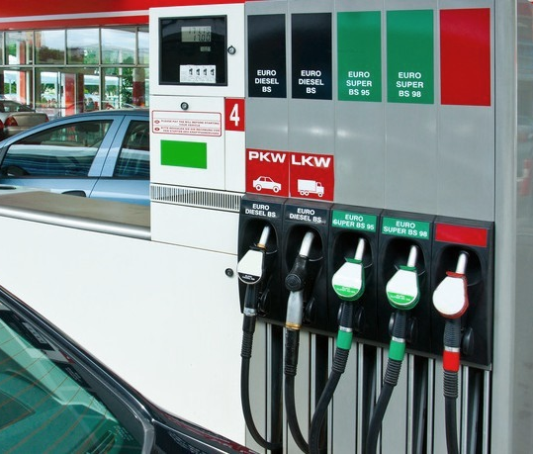  SBA Loan Program  We have been designated as a Preferred Financial Services Company by SBA lenders to have loans processed more quickly and efficiently than many others.  There are several advantages to an SBA loan:  - Longer Terms  - Very Low Rates  - No Balloon Payments  - Full 25 Year Payout  Who is eligible for an SBA loan?  Most for-profit small businesses are eligible for an SBA guaranteed loan:  - Manufacturers  - Wholesale Services  - Retail Services  - Independent Businesses  - Franchise Businesses |  | 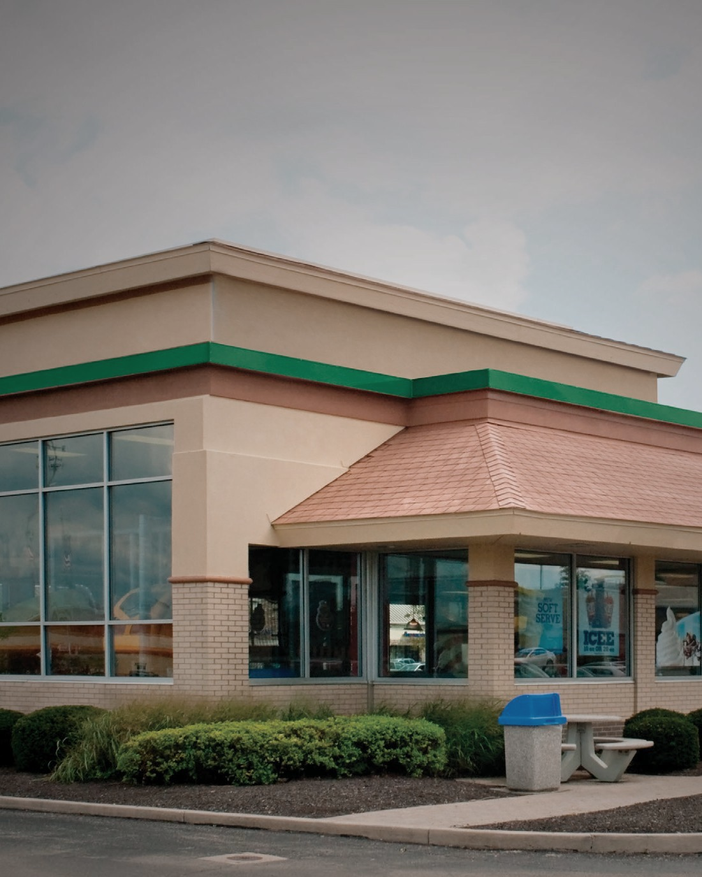  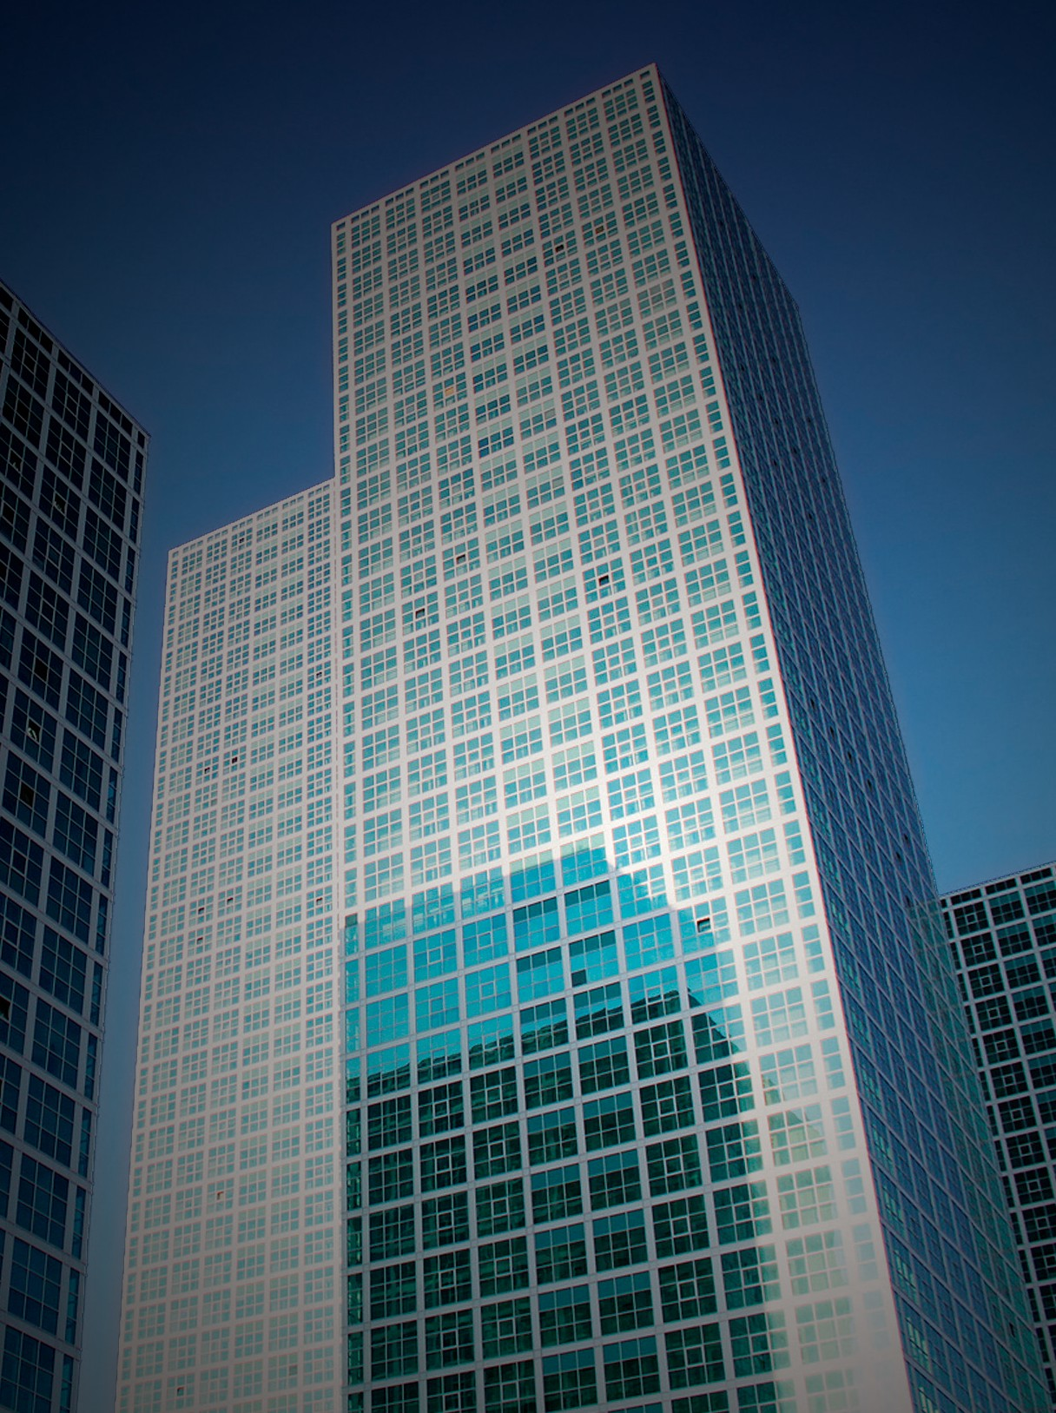  SBA LOAN PROGRAM  Get your SBA Loan approved in 30 days or less!  SBA Loans Ranging From $150K to $12M
  A partial list of the many services that we provide:
  - Business Acquisition Financing
  - Church Financing
  - Commercial Bridge Loans
  - Construction Equipment Financing
  - Debt Restructuring
  - Easy Pay Cash Advance
  - Equipment Leasing
  - Real Estate Financing
  - SBA Loans
  - Security-Based Lending
  - Unsecured Business Loans & Lines of Credit
  We can provide almost any type of financing a business owner needs!
  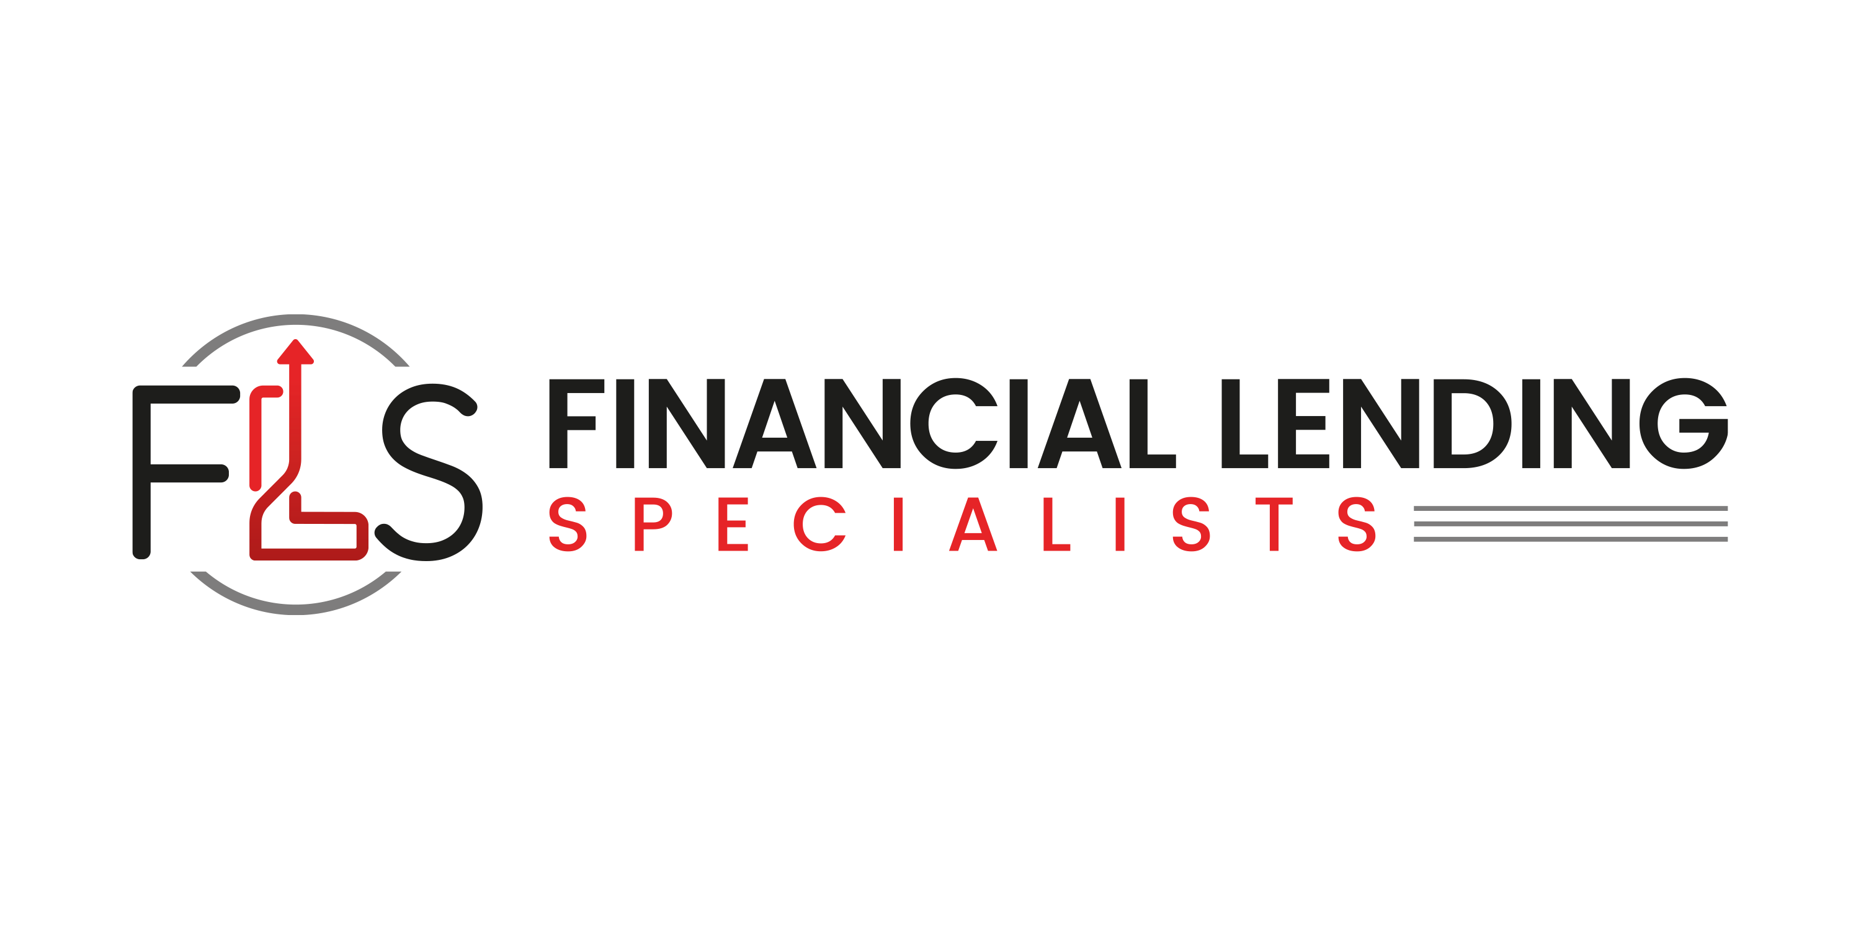
  Financiallendingspecialists.com
  323-285-3721
  info@financiallendingspecialists.com
 | - Machinery, Equipment, Furniture or Fixtures  - Business acquisition  - Working capital (offered in conjunction with some of the above)  - Start-ups, Franchises, Motels, Restaurants, Gas Stations and C-Stores  Other Credit Considerations  - Business must have adequate historic cash flow to cover the proposed debt.  - Business debt to net worth must meet industry averages.  - Borrowers must be actively involved in the day-to-day operation of the business.  - Satisfactory personal credit histories are required for all principles and guarantors.  - No bankruptcies or felony arrests |   For More Information  Visit Us Online  financiallendingspecialists.com

Loan Qualification

- Retail and service businesses with sales (3-year average) not exceeding $6 million to $20 million, depending on the industry.

- Wholesale businesses with employees up to 100 regardless of sales volume

- Manufacturers with employees up to 500 depending on the industry, regardless of sales volume

SBA 7(a) Loan Size $15M to $12M

Use of Proceeds Include:
- Commercial Real Estate (Purchases, Construction, or Refinance)
- Leasehold Improvements
- Business Expansions

