User Manual
Group 17
ETSF01
Richard Berntsson Svensson

Tommy Ivarsson, ada09tiv
Oscar Olsson, ada09ool
Jonas Klauber, ada09jkl
Fredrik Pettersson, ada09fpe
Erik Westrup, ada09ewe
Simon Thörnqvist, ada09st1

How to build and run the application
The application can be run in two ways, do either 1 or 2 to compile and run:

1.

$cd etsf01_project/
$ant
$./estimator.sh [<data filename>]
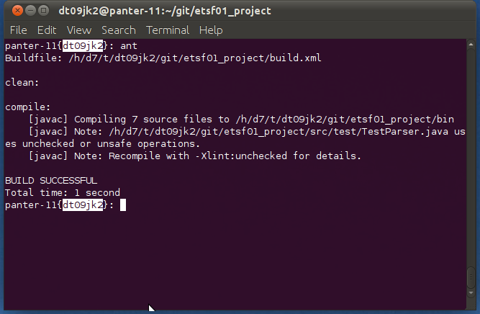
Figure 1: Building the application

The estimator.sh command will present an interactive interface where you will answer questions about you project and set a threshold to calculate simularity, the questions are listed below.

Question | Explaination | Errors if bad input
“choose a number:" | Enter values for all parameters needed. | Bad number, try again.
"LOC, enter number:" | Enter the number of LOC in your project | N/A
"ACT_EFFORT, enter number:" | Enter the Act effort of your project | N/A
"Threshold, enter number(0-100):" | Type the threshold to be to be used to calculate the simularity | N/A

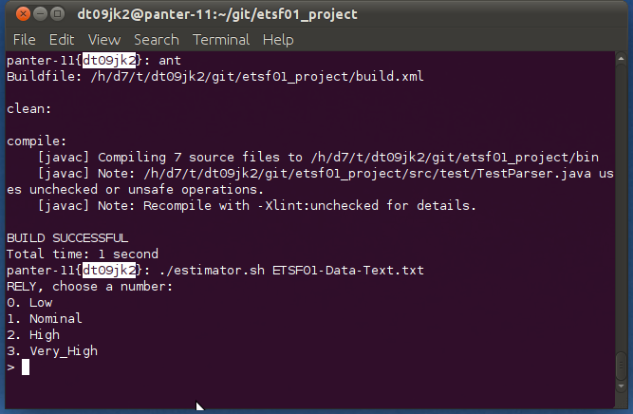Figure 2: Enter characteristics for the project to be evaluated
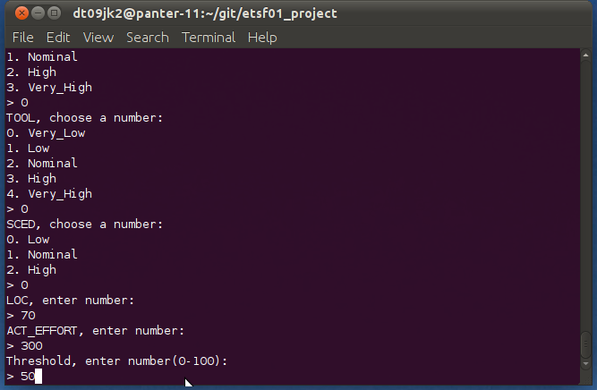
Figure 3: Enter Lines of code, Act effort and threshold
2.
The application can also be run with the following commands

$cd etsf01_project/
$ant
$./config.sh | ./estimator.sh [<data filename>]

This is a static configuration from the script config.sh that will be fed to the program, hence you will not have to enter numbers into the program. However you can edit the values in the script config.sh yourself. How to alter these values are commented in the script.

The application will return the following if executed correctly

Attributes choosen by the user:
"User attribute is: <attributes> "

How many similiar projects found:
"Found <Number of> similar project(s). ");

If no projects are within the given threshold provided by the user the program will print

“WARNING! No projects within given threshold”
No time estimation will be performed if this occurs

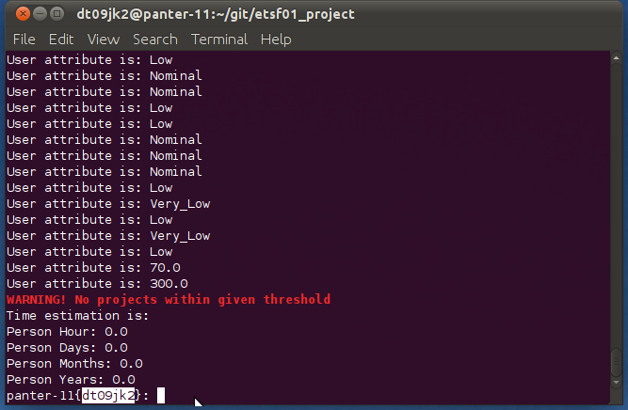
The time estimation will be printed in the following format:

"Time estimation is: "
"Person Hour: <Amount of personhours> "
"Person Days: <Amount of persondays> "
"Person Months: <Amount of personmonths>”
"Person Years: <Amount of personmonths> ”

