Revision Notes
Revision number | Dates | Revision Items
0.1 | December 22, 2015 | Initial documentation, analyze the flow how to implement registration module
0.2 | January 19, 2016 | Describe how to integrate create course properly with lecturer
0.3 | January 27, 2016 | Describe the reason behind integrating topics relation into presences table

Online Presence Web Architecture
Development Documentation

Module Registration
Need at last support following features:
- Can't register user with the same e-mail
Will notify user if another user has existing.
- Add role field to form registation
Contain two values: student, dosen.
Admin role is assumed initially registered with no option to register a new one.

Registration Field Information
Email, name, role, password.
Email is used as username account.

Registration Flow
Implemented as multi pages form wizard, here we have two options. Implement as Pure HTML + Javascript, the benefit of this approach is reducing load on web server. But as starter I implement it on pure server side on Laravel with combination of view→ request → response → view (again) → (loop until the last page).
Turns out, implementing a global variable in class with the intention to retrieve it later in another form is a wrong approach as HTTP driven application is stateless (any data across request is lost). Therefore I slightly mod the approach with sessions.

Course Related Functionalities
Use case Create Course
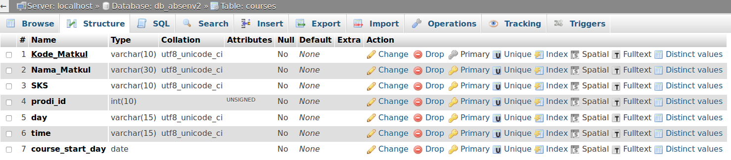
At this time, in course there are no reference to lecturer. It must be exist in order to know which course was being taught by a lecturer. Also we need to change the behavior such that when showing course, only course created by its creator is shown.

How to fill absent for student
We wanted to make the apps as seamless as possible by minimizing the user interaction with the system. Lecturer and student is needed to fill separate absent form, this approach we wanted to adopt for the developed system. However turns out, this business process drive complex coding implementation. Therefore we instead use alternate approach by make foreign key in table presences to topics.
There is another alternative, make the integration between topics and presences more loose. What was matched instead of true key of referenced table we match pertemuan_ke and kode_seksi.

