Past Simple Tense
The past simple tense is used to talk about actions that happened at a specific time in the past. You state when it happened using a time adverb.
You form the simple past of a verb by adding -ed onto the end of a regular verb but, irregular verb forms have to be learned.
To be  Statements  + | To be  Statements  - | Questions ?
I was. | I wasn't. | Was I?
He was. | He wasn't. | Was he?
She was. | She wasn't. | Was she?
It was. | It wasn't. | Was it?
You were. | You weren't. | Were you?
We were. | We weren't. | Were we?
They were. | They weren't. | Were they?

Regular Verb (to work) Statements  + | Regular Verb (to work) Statements  - | Questions | Short answer  + | Short answer  -
I worked. | I didn't work. | Did I work? | Yes, I did. | No, I didn't.
He worked. | He didn't work. | Did he work? | Yes, he did. | No, he didn't.
She worked. | She didn't work. | Did she work? | Yes, she did. | No, she didn't.
It worked. | It didn't work. | Did it work? | Yes, it did. | No, it didn't.
You worked. | You didn't work. | Did you work? | Yes you did. | No, you didn't.
We worked. | We didn't work. | Did we work? | Yes we did. | No, we didn't.
They worked. | They didn't work. | Did they work? | Yes they did. | No, they didn't.

Simple Past Timeline

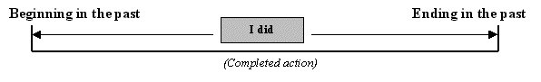
For example:
"Last year I took my exams."
"I got married in 1992."
It can be used to describe events that happened over a period of time in the past but not now.
For example:
"I lived in South Africa for two years."
The simple past tense is also used to talk about habitual or repeated actions that took place in the past.
For example:
"When I was a child we always went to the seaside on bank holidays."

