The Present Continuous Tense
When we talk about events that are actually happening now, we use the present continuous tense.
Statements  + | Statements  - | Questions | Short answer  + | Short answer  -
I'm working. | I'm not working. | Am I working? | Yes, I am. | No, I'm not.
He's working. | He isn't working. | Is he working? | Yes, he is. | No, he isn't.
She's working. | She isn't working. | Is she working? | Yes, she is. | No, she isn't.
It's working. | It isn't working. | Is it working? | Yes, it is. | No, it isn't.
You're working. | You aren'tt working. | Are you working? | Yes you are. | No, you aren't.
We're working. | We aren't working. | Are we working? | Yes we are. | No, we aren't.
They're working. | They aren't working. | Are they working? | Yes they are. | No, they aren't.

Present Continuous Timeline

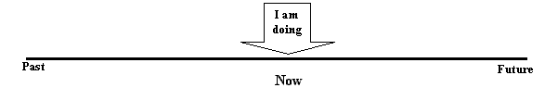
For example:
Q) "What are you doing?" A) "I'm building a website."
We also use the present continuous tense to talk about things that are happening around now but are temporary.
For example:
Q) "What are you doing these days?" A) "Unfortunately I'm working a lot."
It is also used to describe trends or situations that are happening but may be temporary.
For example:
"Nowadays more and more people are shopping on the Internet."
...and habitual actions (usually negative).
For example:
"He's always cleaning his car."
The present continuous tense can also be used to discuss future events:
Note:-
The present continuous is usually used with doing verbs (verbs of action) not with verbs of state. The following verbs are not used in the continuous form:-
Conditions: belong, cost, need, own, seem
Feelings: like, love, hate, want, wish
Beliefs: believe, feel, know, mean, remember, think, understand

