Past Continuous Tense
We use the past continuous tense to describe a past action over a period of time.

Past Continuous Timeline

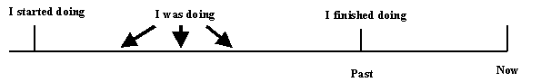
For example:
Q) "What were they doing yesterday?" A) "They were working all day."
It can be used to describe what someone was doing at a particular point in time.
For example:
Q) "What were you doing at 7.30 last night?" A) "I was watching television."
The past continuous can also be used to show that an activity frequently took place over a period of time.
Q) "What did you do on holiday?" A) "I went skiing a lot."
Often the past continuous is mixed with the past simple to show what was happening when something happened. The past continuous refers to the longer event and the simple past to the event that interrupted it.
For example:
"I was driving to work when I crashed my car."
or
As I was driving to work, I crashed my car."

