Present Perfect Continuous Tense

The present perfect continuous tense is often used (with FOR or SINCE) to describe how long something has been happening up to now.

Present Perfect Continuous Timeline
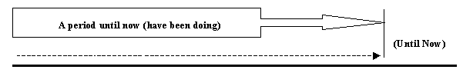
For example:-
Q) How long have you been studying English?"
A) I've been studying English for four years."
Note - You can just say "For four years."
Q) How long have you been living in Germany?
A) I've been living here since 1998.
Note - You can just say "Since 1998".
The present perfect continuous is also used to refer to an event that may or may not be finished when it's effect can be seen now.
For example:-
Look! It's been snowing.
Note - It's not necessarily snowing now but you can see the effect (the snow on the ground).
You should also use the present perfect continuous when talking about how long you have been doing your current job or working on unfinished projects:-
For example:-
I have been working at BT for three years.
We have been exporting to China since 1999.
!Note: We use FOR to talk about a period of time, and we use SINCE to talk about a point in time

