**How to use RQDA**

**How to open RQDA**

Type library(RQDA). This will run the necessary packages in R Studio using the command line.

Then type RQDA(). This will open the GUI for RQDA.

**How to start a new project**

*Click on ‘New Project’* in the Project menu. Type a name for the project and then select the desired folder to save the file to. *Click ok.*  I have used the name Digital Humanities Parental School Choice and Preferred Learning Environments.rqda

I have learned that having spaces in file names can be a problem but it hasn’t caused issues in this case, as far as I am aware.

**Input**

**How to import a file**

*Click import* and then *change to all files* in

stead of txt files in the bottom right hand corner of the screen. Select the interview transcript file from the directory that it has been saved in and *click ok*.

I completed this function each time I wanted to import one of my interviews into RQDA.

**How to assign code categories to the data**

*Click on Code Categories* and then *select Add*. Enter a new code category by typing a category for your code. For example, reason for choice of school. Then *click ok*.

**How to assign a code to the code category**

The easiest way to do this is under the code categories menu. *Rick click on the selected category code category* and *select add new code to selected category*. You can then type a code name. For example ‘School environment’.

The alternative way is to add the code name under the codes menu. *Click on codes tab* and then *select ‘add’*. Enter new code, for example ‘Teacher effectiveness’ and then *click ok*. This will just add the code to the list of codes. To assign the code to a category, go into the code categories menu and *highlight the desired code category*. *Click ‘add to’* and then selected the desired code from the list and *click ok*.

**How to assign a case**

This option allows you to add information relating to the interview, such as a recording number or time.

*Select the ‘Cases’ tab*. *Click on ‘Add”.* Type case name and then *select ok*.

**How to assign an attribute**

You can add an attribute to describe a particular case. For example, whether the chosen school was a public, catholic or independent school.

*Select the ‘Attributes’ tab*. *Click ‘Add’* and then enter attribute name and *click ok*.

I didn’t need to use cases or attributes for my data, however I did experiment with those fields.

**How to assign codes to the data**

In the files menu, *double click on the desired interview* (this will open the interview transcript in a new window). Then *click on the code categories menu*. *Click on the desired code from the menu. Highlight the text* that corresponds with the chosen code and then *click mark*. When you do this a ‘Fail to write to database’ message may come up, however if you *click on the codes menu* and *select the code* that you just used and then *click on ‘coding’*, the text that was marked will be shown.

This can also be tested by closing the interview transcript and then when you re-open in again by *double clicking on the interview* under the files menu, you will then notice that the marked text has been highlighted and given a code name. If you *right click* on the interview transcript and then *select ‘codings of selected file’*, this will give you a complete list of all the codes that have been assigned to a particular interview transcript.

**How to remove a code from the list**

In the ‘Code categories’ menu, *highlight the code category* and then *highlight the code* that you want to delete from that category. Then *click ‘Drop From’* and *click ok*.

**How to rename a code from the list**

In the ‘Code Categories’ menu, highlight the code that needs to be renamed. Right click on the code and select Rename Selected Code. Enter new code name and then click ok. If you have previously assigned this code to your data, the new name will come up next to the data that was previously highlighted. For example, when I changed ‘Small class size’ to ‘intimate’ when I was coding interview 2, I then noticed under the codings list that it had also been changed for interview 1 from ‘Small class size ‘ to ‘Intimate’ under the category of preferred learning environment.

**Output**

**How to plot selected code categories**

In the ‘code categories’ menu, *highlight* the selected category and then *right click*. *Select ‘plot selected code categories’.* This will produce a graph plotting the various codes within a code category.

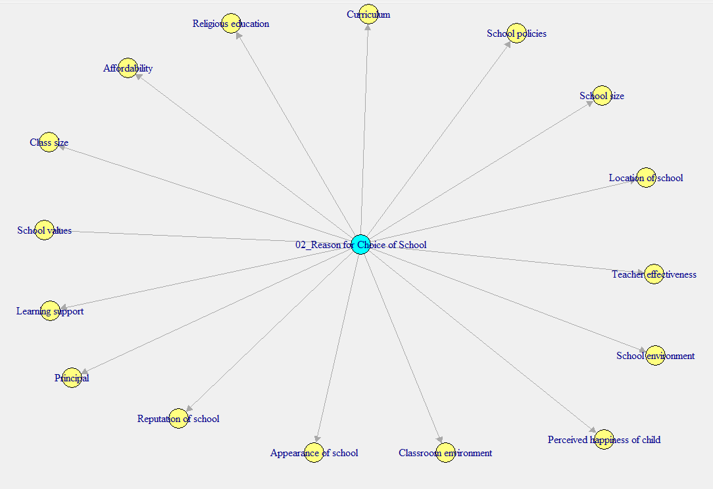

**How to search for a key word**

To perform a word search from within an interview transcript, *click on the interview transcript file* within the file menu, *right click* on the desired interview and select *‘search for a word’*.

The word will then be highlighted in the interview transcript.

**How to export codings as HTML**

Under the codes menu, *right click on the code* and select *‘Export codings as HTML’*. *Type a name* for the file and then *select the folder* that it will be saved in and *click ok*. Then *select the codes* to be exported. *To select all codes, press control A*. Otherwise *highlight the desired codes holding down the control button*. Then *click ok*. The file will then be saved in the directory as HTML.

I used this function to create a file that contains a list of all of my codes. I can then click on the code that I would like search for and then it shows a list of all of the instances in the interview transcripts of those codes. This output is very useful for when I am analysing my data and when deciding on which quotes I will use in my research report.

**How to run files by codes**

Using the command line, type

filesByCodes()

files_by_codes<-filesByCodes()

write.csv(files_by_codes,"Files by Codes.csv")

This process generates a report that sorts each interview file by the assigned codes.

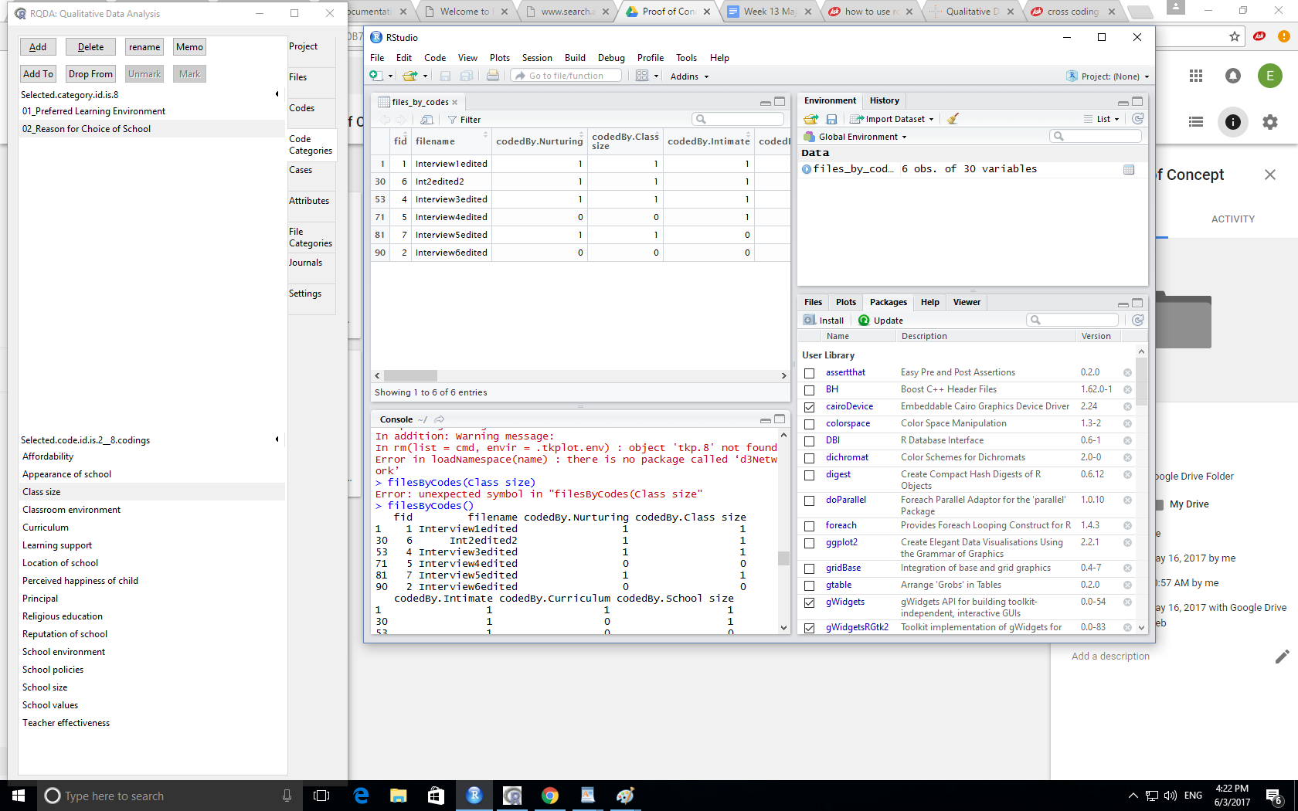

The main results from my data is that the parents in the study have a preference for learning environments that are nurturing, engaging and intimate. School size and class size were important factors when parents selected a primary school for their child. Other reasons such as the location of the school, the school environment, religious education and perceived happiness of child were also important factors influencing parental school choice. The research shows that parents are concerned about finding ‘the best fit’ for their child when choosing a school and that finding ‘the right learning environment’ is very important to parents.