Cequeau Development Guide

Contents

Purpose 2

Software Requirements 2

C++ Compiler 2

Folder Structure 2

Compilation 3

Compilation in Matlab 3

Compilation in Octave 4

Compilation of Cequeau Interpolation 4

Usage 5

Logging to .log file 5

Debugging 6

Testing Matlab and Octave 8

# Purpose

This guide provides instructions for setting up the development environment for Cequeau.

# Software Requirements

The following section outlines the software and tools necessary to develop and compile Cequeau. Cequeau can be compiled using both Matlab and Octave.

## C++ Compiler

A C++ compiler that supports **at least C++14**.

### Matlab

Matlab supports both GCC (MinGW) and MSVC, with different supported compiler versions for each release. The supported compilers can be found [**here**](https://www.mathworks.com/support/requirements/previous-releases.html), within the compilers section.

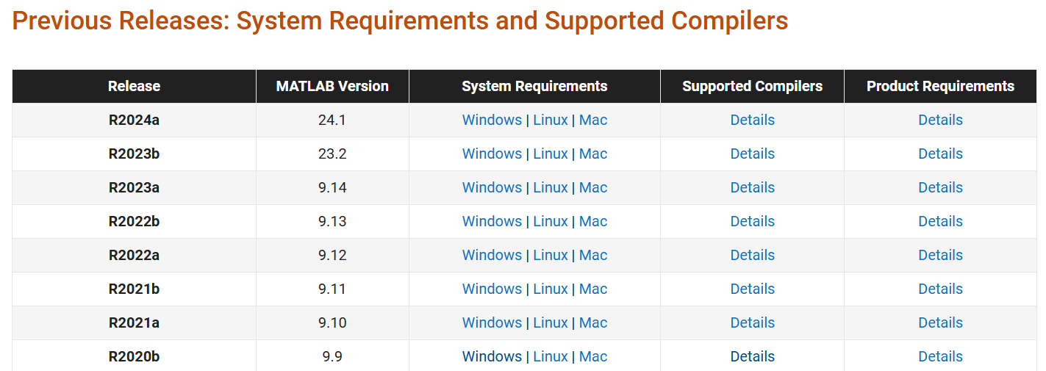

#### MSVC (Microsoft Visual C++)

MSVC is installed by installing Visual Studio with the “**Desktop development with C++**” option enabled. The required Microsoft Visual Studio version will depend on the Matlab version and its supported compilers. For example, when using Matlab R2020b, which supports up to Microsoft Visual C++ 2019, it requires Visual Studio 2019.

#### GCC (MinGW)

MinGW-w64 is a GCC toolchain for the Windows platform. It can be installed by following [Mathwork's guide](https://www.mathworks.com/matlabcentral/fileexchange/52848-matlab-support-for-mingw-w64-c-c-fortran-compiler).

### Octave

Cequeau v5.0.0 was developed using Octave 9.4, and MinGW 13. A newer version of octave and compiler will also satisfy the requirements and compile the code.

The latest version of MinGW-w64 can be installed through MSYS2.

# Folder Structure

cequeau/

src/

tests/

docs/

mex/

The src/ folder contains all header and source files for the C++ mex function, and also the matlab and octave compilation files.

The tests/ folder contains various folders to test functions and features.

The docs/ folder contains documentation for the development and usage of Cequeau

The mex/ the compiled mex binaries will be placed within this folder

# Compilation

### Compilation in Matlab

The Matlab script to compile the C++ mex function is cequeau/src/compileCequeauMat.m.

All relevant .cpp source files are appended to the SOURCES argument, if a new file is to be added, it should be appended in a similar manner.

To ensure consistency, the C++ version is specified within the compile arguments. As shown below, the script automatically detects the compiler and sets the flags accordingly. COMPFLAGS is used for MSVC and CXXFLAGS is used for GNU. More information about mex and the compiler flags can be found here (<https://www.mathworks.com/help/matlab/ref/mex.html>).

To enable logging to the .log file, set the **log** variable to true.

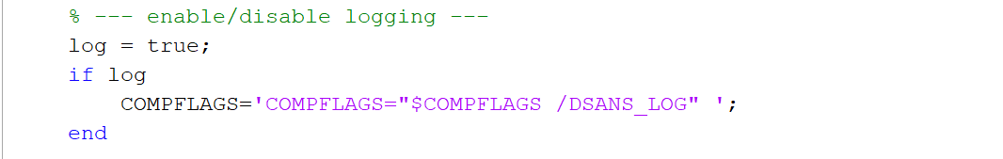

To enable debugging, the ‘-g’ flag must be set, to do so, simply set the **debug** variable to true.

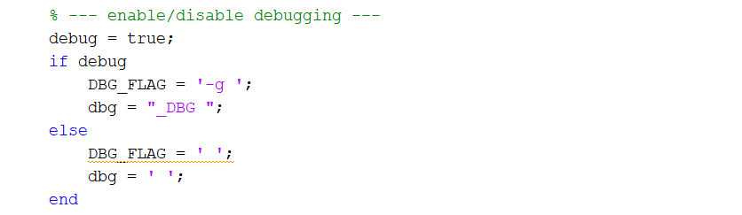

The output file is specified in the OUTFILE variable, by default the compiled mex will be placed in cequeau/mex/.

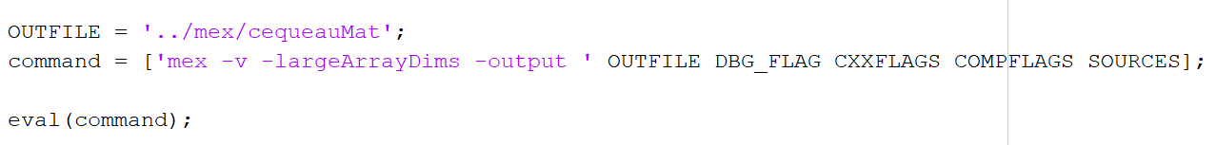

### Compilation in Octave

The compilation for octave is similar to the compilation in Matlab, with only some syntactical differences. As shown below (cequeau/src/compileCequeauOct).

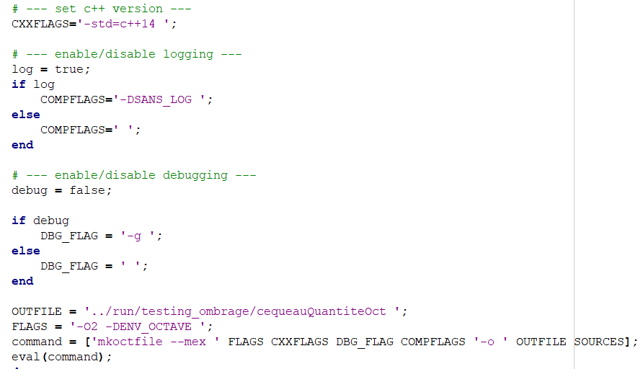

The FLAGS variable contains the custom flag ‘-DENV_OCTAVE’, which is used within the cequeau program to detect whether it is the octave version being run. This allows the ability to customize certain elements depending on the environment. For example, it is used to append Oct or Mat at the end of the log file to help the user identify the appropriate log file.

### Compilation of Cequeau Interpolation

The interpolation compilation scripts (compileInterpolationMat.m and compileInterpolationOct.m) are both similar to their respective Cequeau Quantite compilation scripts, except they are targeting the source files relevant for InterpolationMex.cpp.

# Usage

Compiling the C++ code using Matlab or Octave mex creates a mex file (.mexw64 or .mex). This file is used as a Matlab/Octave function. It takes in various inputs and the order matters, therefore if an input is optional, it is still required to provide an empty array [] within the input list. For detailed explanation about all of the inputs and outputs, please refer to ‘Intrants – Extrants v5.docx’ and for a more in depth usage guide, follow ‘Cequeau_Guide.docx’.

Here is an example usage:

[y.etatsCE, y.etatsCP, y.etatsFonte, y.etatsEvapo, y.etatsBarrage, y.pasDeTemps, y.avantAssimilationsCE, y.avantAssimilationsFonte, y.avantAssimilationsEvapo,y.etatsQualCP, y.avAssimQual] =

**cequeauQuantiteMat(**struct.execution, struct.parametres, struct.bassinVersant, struct.meteo, struct.etatsPrecedents, struct.assimilations, struct.stations**)**;

After running this function, all of the outputs will be placed in the variables provided in the left side of the function.

# Logging to .log file

A custom logger (log.h) was written to log data to a .log file during testing. This feature is useful for quick testing and ensuring expected functionality. It has various logging levels that can be used to print out the desired type of information.

enum TLogLevel {logERROR, logWARNING, logINFO, logDEBUG, logDEBUG1, logDEBUG2, logDEBUG3, logDEBUG4};

The logLevel is specified within the cequeauQuantiteMex.cpp file:  
FILELog::ReportingLevel() = logINFO; // or logWarning, logError, logDebug, etc…

# Debugging

The most convenient way to debug a mex program is using Visual Studio, by attaching the process to the running matlab instance.

1. Compile the Mex function with debug enabled

Within the appropriate script to compile, set debug to true. After compilation, there should be a .pdb file alongside the .mex file.

1. Open visual studio and continue without code

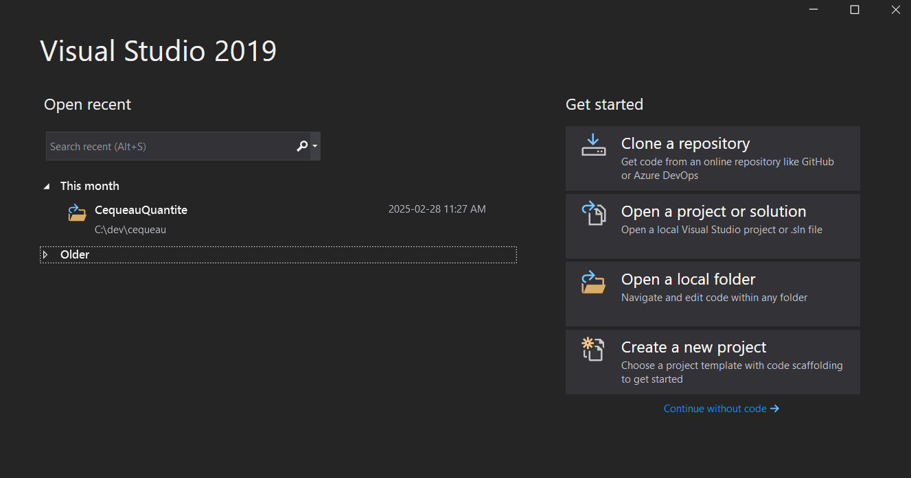

1. Click the attach button in the top toolbar

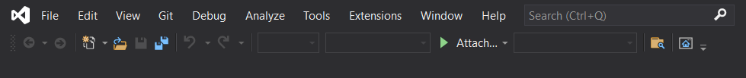

1. Find and attach to the Matlab process. You can use the filtering textbox for quick retrieval.

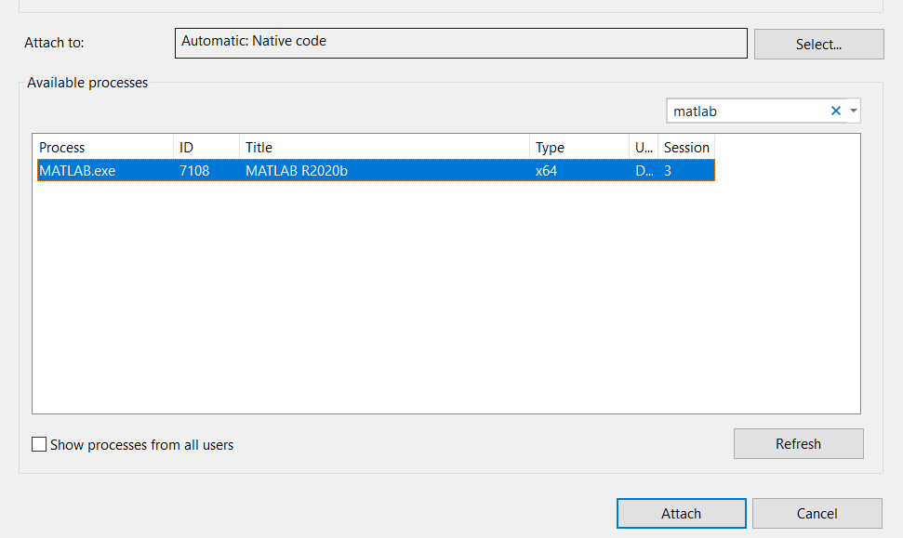

1. 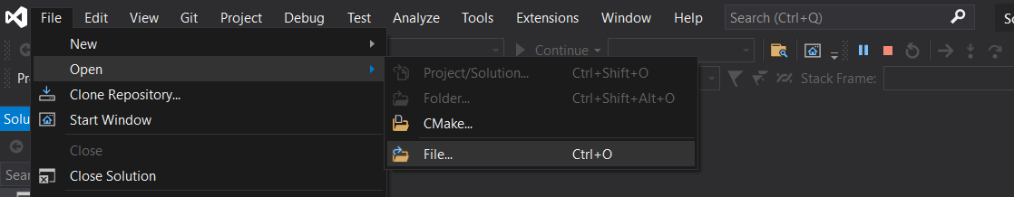Open the source file cequeauQuantiteMex.cpp. Go to File Open File, and locate the file that was compiled in the Matlab workspace.
2. Set a breakpoint at the entry point, mexFunction(). Right click on the line, breatkpoint insert breakpoint.
3. Now go back to matlab, and run the function.
4. Visual Studio should display the function blocked at the breakpoint.
5. Disable Access Violations from the exception settings from the bottom bar.

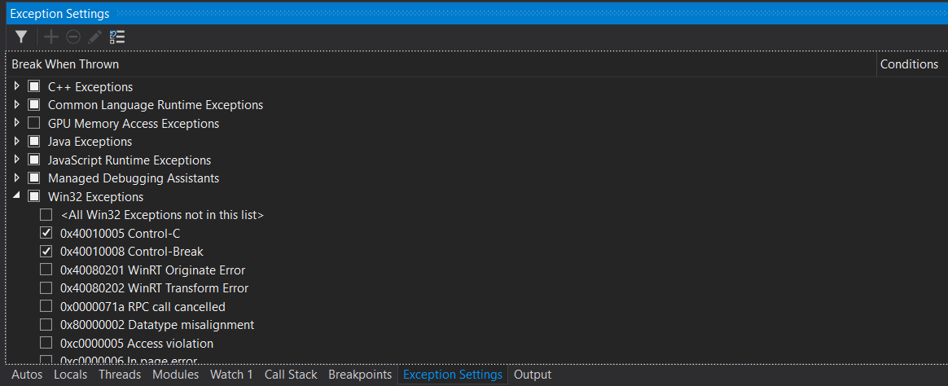

1. The program can now be debugged like any other C++ program, using “Step Into”, “Step Over”, “Continue”, etc.

# Testing Matlab and Octave

Cequeau v5.0.0 added support for Octave. To validate the octave compiled version, test run files were created to ensure the Octave version produced the same output as the Matlab version. The Matlab and Octave versions are tested with the same inputs, and the outputs are compared to ensure there are no differences.

The comparison testing is within Cequeau/tests/testing_octave/

The testing_octave/scripts/ folder contains Matlab and Octave scripts to run the program with various configurations. For example, run_mat_fonte_0_Cequeau.m tests the program with the Cequeau melting module in Matlab. The run_oct_fonte_0_Cequeau.m is the octave equivalent. Each of these files saves an output variable that is saved as .mat files within the testing_octave/outputs/ folder. The following image demonstrates an example. The outputs are saved as v7 mat files since that is the highest version supported by Octave.

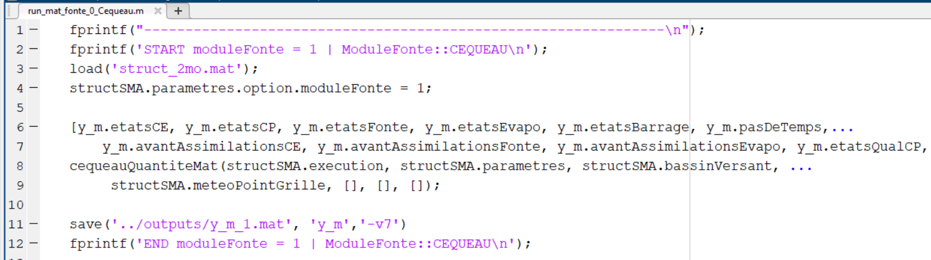

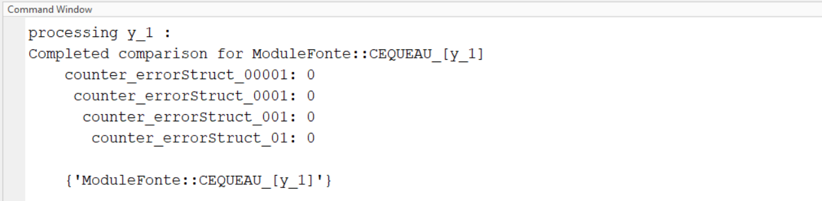Within the testing_octave/ folder, the run_mat.m and run_oct.m are used to run all of the scripts in the scripts/ folder. Once the scripts are executed and the outputs are saved, the compare.m file is used to check the comparisons for each pair of outputs. So, for example, y_m_1.mat is compared with y_o_1.mat. The script will call the compareStructs() function from compareStructs.m, which will compare each cell of the outputs using floating-point tolerance comparison. Various tolerances are used to help determine the type of issue. The counters for the number of mismatches are returned. Each counter is appended with the tolerance, so counter_errorStruct_00001 represents differences with a tolerance smaller greater than 0.00001. If there are differences, the C++ code must be modified to make sure the results match.

Causes for errors:

* If variables aren’t initialized, there will be different results between Octave and Matlab
* The usage of floats may sometime create discrepancies; therefore, it is recommended to use doubles for the additional precision.