## Octave Installations

The latest version of Octave can be downloaded from: <https://octave.org/download>

The link to download specific versions is at the bottom of the page (<https://mirror2.evolution-host.com/gnu/octave/windows/>)

Cequeau was tested with version 9.1.0 and it should work with newer versions.

## Launching and Using Octave GUI

Launch GNU Octave GUI to launch the graphical user interface application. As shown below, it is similar to Matlab. To run files, you need to navigate to the appropriate directory.

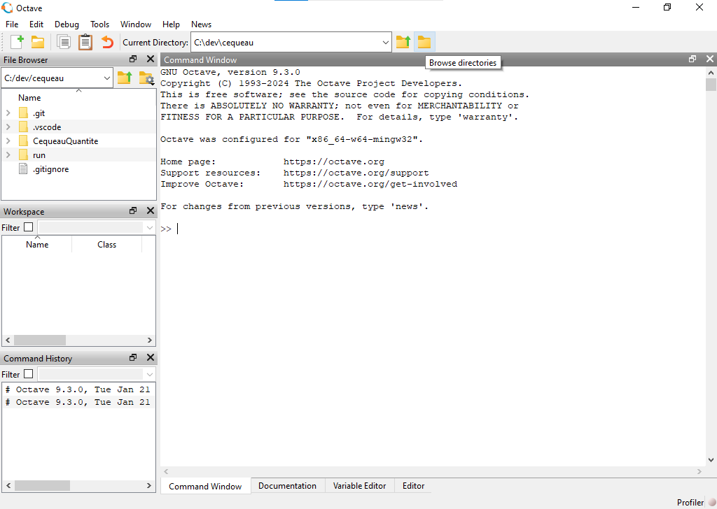

The Cequeau Mex program needs to be compiled using Octave for it to be used as a program using Octave. Cequeau/src/ contains all of the source files as well as the compilation files for both Matlab (compileCequeauMat.m) and Octave (compileCequeauOct.m).

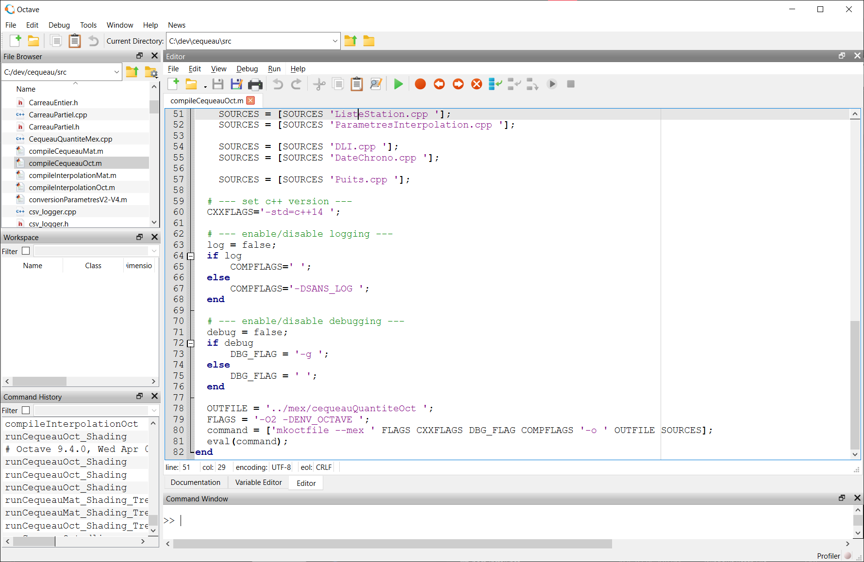

The command statement using mkoctfile is the line used to compile the octave mex program. The path “../mex/cequeauQuantiteOct” path indicates where to place the mex program and what to name it (cequeauQuantiteOct). Running the file using the green run button at the top will place cequeauQuantiteOct.mex in the mex directory within Cequeau/. This file is portable and can be placed wherever the program needs to be run.

## Octave and Matlab Compatibility

Octave syntax is mostly compatible with Matlab, therefore the files can be used with both languages. However, the cequeau program (Octave .mex or Matlab .mexw64) needs to be called from the appropriate program.

There are some features that are not fully compatible or need an Octave workaround.

### .mat files

As of version 9.3.0, Octave does not support saving in Matlab’s v7.3 binary format. If files may be used by both Matlab and Octave, it is recommended to save them as v7 using –v7 argument.

save('myfile.mat', 'myfile', '-v7')

### datetime

Octave does not support Matlab’s datetime, therefore it is recommended to use datenum instead.

In Octave, to view a date in string format, the datestr() function can be used.

When plotting, simply use datenum, and use datetick function as shown below:



For a complete overview of all timing functions: <https://wiki.octave.org/Date/Time_functions>