August 24, 15

Steven Sloman,

Editor in Chief, Cognition

Dear Dr. Sloman,

Please find enclosed a manuscript entitled “Extremely Costly Intensifiers Are Stronger Than Quite Costly Ones” for consideration as a full article in *Cognition*. My coauthor for this work is Noah Goodman (Stanford University).

It is an open question to what extent iconic, pragmatic, and other factors affect the mapping of word forms to meanings. Are meanings arbitrary or guided by form and distribution of the words themselves? In this manuscript we explore the special case of degree adverbs which modify adjectives to make them stronger (e.g. “exceedingly good paper”). In four experiments we show that there is a relationship between the length and infrequency of an intensifying degree adverb and the strength with which it intensifies the adjective it modifies. This relationship holds for both existing and novel adverbs. We describe how pragmatic inference could be responsible for such a relationship, and include as an appendix a Bayesian model of how such a pragmatic inference might occur. This work has implications for the nature of meaning, the origins of language, and how people use words. We believe it will be useful for researchers in cognitive science, psychology, linguistics, and of possible interest to the general public.

Many researchers with interests in word meaning and distribution would be qualified to review this manuscript. We suggest Terry Regier (UC Berkeley), Ted Gibson (MIT), Louise McNally (Universitat Pompeu Fabra), and Stephen Levinson (Max Planck).

Thank your for your consideration of this manuscript for publication in *Cognition*. I will be the corresponding author and will assume responsibility for informing my co-author of all progress through the review process. If you have any questions or require any clarifications about this work, please do not hesitate to contact us.

Sincerely,

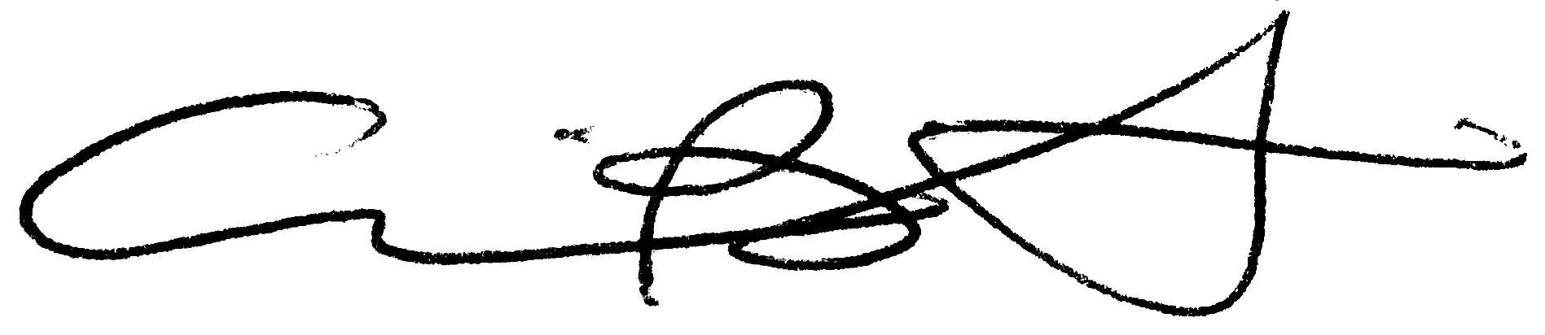

Erin Bennett

Ph.D. Candidate,

Department of Psychology,

Stanford University