Bank Management System Documentation

Adriano Demiri
Andrea Ogreni
Emanuele Berbiu
Erind Kotobelli
Erind Shabani
Joandri Domi
Joel Lluri
Kleo Miraka

Project Overview
This project involves the development of a comprehensive bank management software designed to enhance the efficiency of banking operations and improve customer experience. The product serves a wide range of users, including customers, bank staff, and administrators.
The software is intended to support critical banking processes such as account management, transaction handling and loan approvals. By integrating with existing infrastructure and providing robust security measures, the system seeks to deliver reliable banking services.

Relationships to Other Systems
The BMS integrates with the following external systems and services:

- ATM Network: Supports real-time balance inquiries and cash withdrawals through the bank’s ATM fleet. The BMS manages ATM fund allocations, maintenance scheduling, and transaction logging in sync with physical ATM devices.
- Inter-Bank Transfer Networks (SWIFT / SEPA / ACH): Facilitates secure inter-bank wire transfers and cross-border payments by interfacing with standard financial messaging networks. The BMS initiates, tracks, and reconciles all outgoing and incoming transfers through these protocols.
- Payment Processors / POS Systems: Processes debit and credit card transactions at Points-of-Sale (POS) terminals by communicating with external payment processing networks. Card issuance, spending limits, and fraud flags managed within the BMS are reflected in real time.
- SMS / Email Notification Services: Delivers real-time transaction alerts, low-balance warnings, loan payment reminders, KYC document expiry notifications, and system announcements to customers and staff via third-party SMS gateways and email service providers.
- Mobile Banking Application (iOS & Android): A customer-facing mobile application that interfaces with the BMS back-end through secure REST APIs. Supports account management, fund transfers, bill payments, QR code payments, biometric authentication, and e-statement access.
- Online Banking Web Portal: A browser-based customer self-service portal that provides the same core banking functionality as the mobile app, optimized for larger screens and standard keyboard interaction.
User Characteristics
Internal Users:
- Administrator
- Holds the highest system access level; typically an IT professional or system manager.
- Responsible for user account lifecycle, role and permission management, system health monitoring, database administration, security policy enforcement, and audit log review.
- High technical expertise; requires full access to all configuration and administrative modules.
- Bank Director
- Senior executive who uses the system for strategic oversight and high-level decision-making.
- Accesses executive dashboards, financial reports (P&L, balance sheets), branch KPIs, employee metrics, and regulatory compliance reports.
- Approves or rejects high-value loan applications and transactions that exceed defined thresholds.
- Low to moderate technical expertise; requires clear dashboards, exportable reports, and automated alerts.
- Bank Employee — Staff (Account Managers, Loan Officers, Compliance Staff)
- Back-office personnel handling complex administrative and customer service functions.
- Creates and manages customer accounts, processes loan applications, updates KYC documentation, handles complaints, and monitors flagged accounts.
- Moderate technical expertise; requires detailed account management tools, document workflows, and bulk processing capabilities.

- Bank Employee — Teller
- Front-line staff who interact directly with customers at the branch counter.
- Processes cash deposits and withdrawals, fund transfers, foreign currency exchanges, mini statements, and utility bill payments.
- Low technical expertise; requires an intuitive, fast-access transaction interface optimized for high-volume daily use.
- Facilities Manager
- Oversees all physical operations: premises, security personnel, cleaning staff, IT equipment, vehicles, and vendor contracts.
- Manages duty rosters, maintenance schedules, supply requisitions, and generates facilities reports for branch managers and the Bank Director.
- No access to customer financial data or core banking modules; system access strictly limited to facilities management modules.
External Users:
- Customer
- End-user of banking services who interacts with the system via the online banking portal or mobile application.
- Views balances and transaction history, performs fund transfers, applies for loans and cards, manages beneficiaries, and submits complaints or feedback.
- Basic computer literacy assumed; requires an intuitive, accessible interface compliant with WCAG 2.1 AA standards.
- Facilities & Support Staff (Security Guards, Cleaners, IT Technicians, Drivers, Maintenance Workers)
- Operational personnel responsible for maintaining the bank’s physical environment.
- Access is strictly limited to role-specific tools: guards log shifts and incidents; cleaners track schedules and supply requests; IT technicians manage support tickets and hardware records; drivers log trips and fuel usage; maintenance workers update repair task statuses.
- Minimal technical expertise; requires simple, task-focused screens with no exposure to financial or customer data.

Assumptions
- All internal and external users have stable internet access sufficient for real-time interaction with the BMS web portal or mobile application.
- Every user has a minimum level of digital literacy appropriate to their role (e.g., basic computer skills for customers and tellers; IT proficiency for the Administrator).
- The bank will provide and maintain secure hosting infrastructure, including firewalls, load balancers, and intrusion-detection systems, as a prerequisite for system deployment.
- Third-party integrations — including SMS gateways, email service providers, credit scoring engines, and inter-bank transfer networks — expose stable, documented APIs that remain available throughout the system’s operational lifetime.
Constraints and Dependencies
- Module Implementation Order (User Management First): The User Management module must be fully implemented and operational before any other banking functionality can be accessed. Role-based access control, authentication, and permission assignment are foundational dependencies for every other module.
- Core Module Prerequisites: The Funds Management, Audit & Reporting, and Fraud Detection modules must be implemented and active before account-related operations (deposits, withdrawals, transfers, loan processing) can be processed, as these modules enforce financial integrity and regulatory controls.
- Performance and Availability Constraints: The system must maintain a minimum uptime of 99.9% on a rolling monthly basis. At least 95% of financial transactions must complete within 2 seconds under normal load. The system must support 500 concurrent users under normal conditions and up to 1,000 during peak periods.
- Facilities Module Isolation: The Facilities Management and Facilities & Support Staff modules must be architecturally isolated from core banking modules. Personnel in these roles must have zero visibility into customer financial data, account information, or banking transaction records.

Functional Requirements
Req # | Requirement | Priority | Business Process
BS_UM_01 | The Administrator shall be able to create, modify, and delete system profiles for all user roles. | 1 | User Management
BS_UM_02 | All users shall be able to log in to the system using their registered credentials. | 1 | User Management
BS_UM_03 | The Administrator shall be able to define and manage role-based access permissions for each user level. | 1 | User Management
BS_UM_04 | The Administrator shall be able to monitor system health, schedule maintenance, and apply software updates and patches. | 1 | User Management
BS_FM_01 | The Bank Director shall be able to view fund allocations and balances across all assigned branches and ATMs. | 1 | Fund Management
BS_FM_01 | The Bank Director shall be able to view fund allocations and balances across all assigned branches and ATMs. | 1 | Fund Management
BS_FM_03 | The Bank Director shall be able to set and update interest rates, fee structures, and bank-wide financial policies. | 1 | Fund Management
BS_AM_01 | The Bank Teller shall be able to open a new bank account on behalf of a customer, subject to supervisor approval. | 1 | Account Management
BS_AM_02 | The Bank Teller shall be able to close an existing bank account upon a verified customer request. | 1 | Account Management
BS_AM_03 | The Bank Teller shall be able to modify customer account details as required. | 1 | Account Management
BS_AM_04 | The Customer shall be able to view their account details and full transaction history through the online portal. | 2 | Account Management

Req # | Requirement | Priority | Business Process
BS_AM_05 | Bank Staff shall be able to create and manage savings, current, fixed deposit, and loan accounts on behalf of customers. | 1 | Account Management
BS_AM_06 | Bank Staff shall be able to update customer KYC documentation and verify identity information. | 1 | Account Management
BS_AM_07 | The Bank Teller shall be able to verify customer identity before processing any in-branch transaction. | 2 | Account Management
BS_TM_01 | The Customer shall be able to deposit money into their bank account. | 1 | Transaction Management
BS_TM_02 | The Customer shall be able to withdraw money from their account, either at a bank branch via a Bank Teller or at an ATM using their bank card. | 1 | Transaction Management
BS_TM_03 | The Customer shall be able to transfer funds to accounts within the same bank, initiate wire transfers to external bank accounts, and configure automated recurring transfers. | 1 | Transaction Management
BS_TM_04 | The Customer shall be able to make payments using their issued debit or credit card. | 1 | Transaction Management
BS_TM_05 | Bank Staff shall be able to process bulk payment disbursements such as salary payments and utility bill settlements. | 2 | Transaction Management
BS_TM_06 | The Customer shall be able to manage and save beneficiaries for repeat fund transfers through the online banking portal or mobile app. | 2 | Transaction Management
BS_LM_01 | The Customer shall be able to submit a loan application online; Bank Staff shall review, process, and approve or reject the application. | 1 | Loan Management
BS_LM_02 | The Customer shall be able to make loan repayments through the online banking portal or at a branch. | 1 | Loan Management
Req # | Requirement | Priority | Business Process
BS_LM_03 | The Bank Director shall be able to approve or reject high-value loan applications that exceed a defined threshold. | 1 | Loan Management
BS_LM_04 | A customer with an approved loan views the amortization schedule, including monthly installments, interest, and remaining balance. The system calculates and displays the repayment plan. | 1 | Loan Management
BS_CM_01 | The Customer shall be able to apply online for a debit or credit card linked to their bank account. | 1 | Card Management
BS_CM_02 | The Customer shall be able to request a chequebook for their eligible checking account. | 1 | Card Management
BS_CM_03 | The Customer shall be able to set and modify spending limits on their issued cards. | 2 | Card Management
BS_FD_01 | Bank Staff shall be able to review flagged accounts, investigate suspicious transactions, and take appropriate corrective action. | 1 | Fraud Detection
BS_FD_02 | The Customer shall be able to report suspected fraudulent activity on their account through the online portal. | 1 | Fraud Detection
BS_FD_03 | The Bank Director shall be able to receive automated alerts for unusual account activity, fraud flags, or system anomalies. | 1 | Fraud Detection
BS_FCM_01 | The Facilities Manager shall be able to manage and approve duty rosters and shift schedules for all facilities and support staff across branches. | 2 | Facility Management
BS_FCM_02 | The Facilities Manager shall be able to assign, track, and monitor IT support tickets submitted by bank staff, including resolution times. | 2 | Facility Management

Req # | Requirement | Priority | Business Process
BS_FCM_03 | Facilities & Support Staff shall be able to log shift check-ins/check-outs, submit incident or task completion reports, and view their assigned schedules. | 2 | Facility Management
BS_FCM_04 | The Facilities Manager shall be able to schedule and track preventive maintenance for buildings, ATMs, vehicles, and equipment. | 3 | Facility Management
BS_CS_01 | The Customer shall be able to view real-time information on nearby ATMs and branches, including location, hours, and availability, through the online banking portal or mobile app. | 3 | Costumer Service
BS_CS_02 | The Customer shall be able to schedule and manage in-branch appointments through the online portal. | 3 | Costumer Service
BS_CS_03 | The Customer shall be able to submit feedback and formal complaints regarding their banking experience through the online portal. | 3 | Costumer Service
BS_CS_04 | The Customer shall be able to request official account-related documents such as statements, certificates, and reference letters. | 1 | Costumer Service
BS_CS_05 | Bank Staff shall be able to handle customer complaints and manage dispute resolution cases within the system. | 2 | Costumer Service
BS_CS_06 | Bank Staff shall be able to generate and send official account statements to customers on request or on a scheduled basis. | 2 | Costumer Service
BS_CS_07 | The Customer shall be able to receive real-time notifications and alerts for account activity, including transactions, login attempts, and payment due dates. | 2 | Costumer Service
BS_AR_01 | The Bank Director shall be able to access complete audit trails to verify compliance with banking regulations and internal policies. | 1 | Audit and Reporting

Req # | Requirement | Priority | Business Process
BS_AR_02 | The Bank Director shall be able to access customer analytics reports, including account growth, activity trends, and segmentation data. | 2 | Audit and Reporting
BS_AR_03 | The Bank Director and Bank Staff shall be able to access fraud detection analytics, including flagged transaction summaries and trend reports. | 1 | Audit and Reporting
BS_AR_04 | The Facilities Manager shall be able to generate facilities reports covering maintenance status, incidents, asset conditions, and staff attendance. | 2 | Audit and Reporting

Non-Functional Requirements
- Usability
  - The system shall provide an intuitive interface that all user levels can navigate without formal training within 30 minutes of first use.
  - The system shall display clear, descriptive error messages that guide users toward corrective action without exposing technical details
  - The system shall comply with WCAG 2.1 AA accessibility standards to ensure usability for users with disabilities

- Performance
  - At least 95% of all financial transactions shall complete processing within 2 seconds under normal operating load conditions.
  - The system shall support a minimum of 500 concurrent active users without measurable performance degradation.
  - During peak load periods the system shall sustain up to 1,000 simultaneous users without service interruption or data errors.
  - Standard account lookups and report generation queries shall return results within 1 second for datasets up to 5 million records.

- Availability
  - The system shall maintain a minimum uptime of 99.9% measured on a rolling monthly basis to ensure continuous banking operations.
  - Scheduled maintenance windows shall not exceed 4 hours per month and must be communicated to all users at least 48 hours in advance.
  - The system shall implement automatic failover to a secondary server so that service is restored within 5 minutes of a primary server failure.
  - The mean time to recovery from any unplanned outage shall not exceed 30 minutes from the point of detection.

- Security
  - All data transmitted between client devices and the server shall be encrypted using TLS 1.3 to prevent interception during communication.
  - All data stored in the database including customer records and transaction history shall be encrypted at rest using AES-256.
  - Multi-factor authentication shall be enforced for all user roles combining password credentials with a one-time password via SMS or authenticator app.
  - User sessions shall automatically expire after 10 minutes of inactivity and tokens shall be invalidated on logout to prevent session hijacking.
  - The system shall maintain a tamper-proof audit log of all user actions, financial transactions, and administrative changes including timestamps and IP addresses.

- Reliability
  - The system shall perform automated daily backups of all data to at least two geographically separated storage locations.
  - Data recovery procedures shall restore the system to a consistent operational state within 1 hour following a catastrophic failure.
  - The system shall enforce ACID transaction properties to ensure that no financial transaction is ever lost, duplicated, or left in a partial state.

- Scalability & Maintainability
  - The system architecture shall support horizontal scaling to accommodate a 300% increase in user volume without requiring a full system redesign.
  - The system shall follow a modular design so that individual components such as the loan module or reporting engine can be updated or replaced independently.
  - All system documentation including API references, deployment guides, and data schemas shall be kept current with every release.

- Compliance & Interoperability
  - The system shall comply with GDPR for customer data privacy and PCI-DSS for payment card data security across all modules handling personal or financial information.
  - Transaction records and customer data shall be retained for a minimum of 7 years in accordance with applicable banking and financial regulations.
  - The system shall expose standardized REST API endpoints to enable secure integration with third-party financial institutions and government regulatory systems

Use Cases
User Management – Andrea Ogreni

UC Name | BS_UM_01 – Create, Modify, and Delete System User Profiles
Summary | The Administrator creates, modifies, and deletes system profiles for all user roles within the Bank Management System.
Dependency | None.
Actors | Primary Actor: Administrator.
Preconditions | The Administrator is logged in to the system with full administrative privileges. The target user profile exists (for modify/delete) or the required information for the new profile is available (for create).
Description of the Main Sequence | ● Step 1: The Administrator navigates to the User Management module.  ● Step 2: The Administrator selects the action: Create, Modify, or Delete.  ● Step 3 (Create): The Administrator fills in the required fields – full name, role, contact details, and branch assignment – and submits the form.  ● Step 4: The system validates the input, generates a unique user ID and temporary password, and creates the profile.  ● Step 5: The system sends login credentials to the new user via email or SMS.  ● Step 6: The system logs the action in the audit trail with the Administrator's ID and timestamp.
Description of the Alternative Sequence | ● Step 1: The Administrator selects an existing user profile.  ● Step 2 (Modify): The Administrator updates the required fields and confirms the change. The system saves changes and logs the modification.  ● Step 3 (Delete): The Administrator selects Delete and confirms the action. The system deactivates the profile, revokes access tokens, and logs the deletion.  ● Step 4: If any required field is missing or invalid during creation/modification, the system displays an error and prompts the Administrator to correct the input.
Non functional requirements | All profile changes must be reflected in the system within 2 seconds. Deleted/deactivated profiles must have their sessions immediately invalidated. All actions must be logged in a tamper-proof audit trail.
Postconditions | The user profile has been successfully created, modified, or deleted. The audit trail contains a permanent record of the action. If created, the user receives their access credentials.
UC Name | BS_UM_01 – Create, Modify, and Delete System User Profiles

UC Name | BS_UM_02 – User Login to the System
Summary | All registered users log in to the Bank Management System using their credentials and complete multi-factor authentication to gain access.
Dependency | BS_UM_01 (User profile must exist before login is possible).
Actors | Primary Actor: Any registered user (Administrator, Bank Director, Bank Employee – Staff / Teller, Facilities Manager, Facilities & Support Staff, Customer).
Preconditions | The user has an active system profile with registered credentials. The system is online and accessible. The MFA service (SMS or authenticator app) is operational.
Description of the Main Sequence | ● Step 1: The user navigates to the system login page.  ● Step 2: The user enters their registered username and password.  ● Step 3: The system validates the credentials against the database.  ● Step 4: The system triggers the MFA step – sending a One-Time Password (OTP) via SMS or authenticator app.  ● Step 5: The user enters the OTP within the allowed time window.  ● Step 6: The system verifies the OTP and issues a secure, time-limited session token.  ● Step 7: The system redirects the user to their role-specific dashboard.  ● Step 8: The successful login event is recorded in the audit log.
Description of the Alternative Sequence | ● Step 1: If the username or password is incorrect, the system displays an error message without specifying which field is wrong.  ● Step 2: After a configurable number of consecutive failed login attempts (e.g., 5), the system temporarily locks the account and notifies the user.  ● Step 3: If the OTP expires before entry, the system offers the option to resend a new OTP.  ● Step 4: If the account is locked or deactivated, the system displays an appropriate message and prompts the user to contact the Administrator.
Non functional requirements | Login processing (credential validation and session token issuance) must complete within 2 seconds. The system must enforce brute-force protection with account lockout. Session tokens must expire after 10 minutes of inactivity. All login attempts (successful and failed) must be logged with user ID, timestamp, and IP address.
Postconditions | The user is authenticated and has an active session with access restricted to their assigned role and permissions. The login event is recorded in the audit trail.

UC Name | BS_UM_03 – Define and Manage Role-Based Access Permissions
Summary | The Administrator defines and manages the specific access permissions assigned to each user role, controlling which modules, data, and features each role can access.
Dependency | BS_UM_01 (User profiles must exist before permissions can be assigned).
Actors | Primary Actor: Administrator.
Preconditions | The Administrator is logged in with full administrative privileges. At least one user role exists within the system.
Description of the Main Sequence | ● Step 1: The Administrator navigates to the Role & Permission Management module.  ● Step 2: The Administrator selects an existing role or creates a new custom role.  ● Step 3: The Administrator reviews the list of available system modules and features.  ● Step 4: The Administrator enables or disables specific permissions for the selected role (e.g., view, create, edit, delete, approve).  ● Step 5: The Administrator saves the updated permission set.  ● Step 6: The system applies the new permissions immediately to all active users assigned to that role.  ● Step 7: The system records the permission change in the audit log with the Administrator's ID and timestamp.
Description of the Alternative Sequence | ● Step 1: If the Administrator attempts to assign permissions that conflict with regulatory compliance rules (e.g., a Teller gaining access to audit logs), the system displays a warning.  ● Step 2: The Administrator can proceed with override justification or cancel the change.  ● Step 3: If no roles exist yet, the system prompts the Administrator to create a role before assigning permissions.
Non functional requirements | Permission changes must take effect within 2 seconds for all active sessions. The system must enforce the least privilege principle – no role should receive access beyond what is explicitly defined. All permission changes must be logged in the tamper-proof audit trail.
Postconditions | The role's permissions are updated and active. All users assigned to the affected role immediately reflect the new access rights. The change is permanently recorded in the audit trail.

UC Name | BS_UM_04 – Monitor System Health, Schedule Maintenance, and Apply Updates
Summary | The Administrator monitors the health and performance of the Bank Management System, schedules maintenance windows, and applies software updates and security patches.
Dependency | None.
Actors | Primary Actor: Administrator.
Preconditions | The Administrator is logged in with full administrative privileges. The system health dashboard and monitoring tools are operational.
Description of the Main Sequence | ● Step 1: The Administrator accesses the System Health Dashboard.  ● Step 2: The Administrator reviews real-time metrics including server CPU/memory usage, database performance, network status, and application response times.  ● Step 3: The Administrator reviews any automated alerts flagged by the monitoring service.  ● Step 4: The Administrator schedules a maintenance window by specifying the date, time, and estimated duration.  ● Step 5: The system automatically sends advance notifications to all users at least 48 hours before the scheduled maintenance.  ● Step 6: During the maintenance window, the Administrator applies software updates or security patches via the patch management interface.  ● Step 7: After updates are applied, the Administrator verifies system stability through the health dashboard.  ● Step 8: The system logs all maintenance activities and patch deployments in the audit trail.
Description of the Alternative Sequence | ● Step 1: If a critical system alert is triggered, the Administrator receives an immediate notification.  ● Step 2: The Administrator investigates the issue via the health dashboard and may initiate an emergency maintenance action.  ● Step 3: If an applied patch causes a system error, the Administrator initiates a rollback procedure to restore the previous stable version.  ● Step 4: If scheduled maintenance extends beyond the planned window, additional notifications are sent to all users.
Non functional requirements | System health dashboards must refresh in real time with a maximum delay of 5 seconds. Maintenance notifications must be delivered to all users at least 48 hours in advance. Patch deployment must not exceed 4 hours of downtime per month. All maintenance actions and patch history must be logged in the audit trail.
Postconditions | System health metrics have been reviewed. Any scheduled maintenance has been communicated to users and executed. Software and security updates have been successfully applied and verified. All actions are recorded in the audit trail.

Fund Management – Andrea Ogreni
UC Name | BS_FM_01 – View Fund Allocations and Balances Across Branches and ATMs
Summary | The Bank Director views current fund allocations and cash balances across all assigned bank branches and ATMs to support financial oversight and decision-making.
Dependency | BS_UM_02 (Bank Director must be logged in). Relevant branch and ATM data must be populated in the system.
Actors | Primary Actor: Bank Director.
Preconditions | The Bank Director is authenticated and has an active session. Branch and ATM financial data is available and up to date in the system.
Description of the Main Sequence | ● Step 1: The Bank Director navigates to the Financial Overview or Branch Management module.  ● Step 2: The Bank Director selects the Fund Allocations & Balances view.  ● Step 3: The system displays a summary dashboard showing total funds allocated to each branch and ATM, current cash balances, and fund distribution breakdowns.  ● Step 4: The Bank Director can filter the view by branch, region, date, or ATM unit.  ● Step 5: The system logs the access event in the audit trail.
Description of the Alternative Sequence | ● Step 1: If data for a specific branch or ATM is unavailable or not yet updated, the system displays a 'Data Pending' indicator for that unit.  ● Step 2: If the Bank Director attempts to access a branch outside their assigned scope, the system denies access and displays an authorization message.  ● Step 3: If real-time data fails to load within the expected timeframe, the system displays the last available cached data with a timestamp and a notification.
Non functional requirements | Fund allocation data must refresh in real time or within a maximum delay of 5 seconds. The dashboard must support filtering across all branches and ATMs without performance degradation. Access to financial data must be restricted to authorized roles only, enforced by Role-Based Access Control. All data access events must be logged.
Postconditions | The Bank Director has successfully reviewed the current fund allocations and balances across all assigned branches and ATMs. The access event is recorded in the audit trail.

UC Name | BS_FM_02 – Allocate and Redistribute Funds to Financial Units
Summary | The Bank Director allocates and redistributes funds across assigned financial units (branches and ATMs) to ensure optimal cash availability and operational balance.
Dependency | BS_FM_01 (The Bank Director should review current balances before making allocation decisions). BS_UM_02 (Bank Director must be logged in).
Actors | Primary Actor: Bank Director.
Preconditions | The Bank Director is authenticated and has an active session. Current fund allocation and balance data is visible. Sufficient overall funds are available for redistribution.
Description of the Main Sequence | ● Step 1: The Bank Director navigates to the Fund Allocation module.  ● Step 2: The Bank Director reviews the current balances and identifies units requiring fund allocation or redistribution.  ● Step 3: The Bank Director selects the source unit (or central reserve) and the destination financial unit.  ● Step 4: The Bank Director enters the amount to be allocated or transferred.  ● Step 5: The system validates that the source has sufficient funds and that the amount does not exceed any defined limits.  ● Step 6: The Bank Director confirms the allocation/redistribution action.  ● Step 7: The system processes the fund movement, updates balances in real time, and generates a transaction record.  ● Step 8: The system logs the action in the audit trail with the Bank Director's ID, timestamp, and details of the fund movement.
Description of the Alternative Sequence | ● Step 1: If the source unit has insufficient funds or exceeds defined regulatory or policy limits, the system displays an error message and prevents the transaction from proceeding.
Non functional requirements | Fund allocation transactions must complete processing within 2 seconds under normal operating conditions. All fund movements must be logged as permanent, tamper-proof records. The system must enforce balance validation before processing any allocation. RBAC must ensure only the Bank Director and authorized roles can initiate fund movements.
Postconditions | Funds have been successfully allocated or redistributed to the designated financial unit. Account balances for affected units are updated in real time. A permanent transaction record and audit log entry have been created.

UC Name | BS_FM_03 – Set and Update Interest Rates, Fee Structures, and Bank-Wide Financial Policies
Summary | The Bank Director sets, reviews, and updates the bank's interest rates, fee structures, and financial policies that apply across all branches and account types.
Dependency | BS_UM_02 (Bank Director must be logged in). Existing policy and rate configurations must be present in the system.
Actors | Primary Actor: Bank Director.
Preconditions | The Bank Director is authenticated and has an active session. The Financial Policy Management module is accessible. Current rate and fee configurations are visible.
Description of the Main Sequence | - Step 1: The Bank Director navigates to the Financial Policy Management module.  - Step 2: The Bank Director selects the category to update: interest rates, fee structures, or bank-wide policies.  - Step 3: The Bank Director reviews the current configuration and enters the new values.  - Step 4: The Bank Director sets an effective date for the changes.  - Step 5: The system validates the inputs against compliance rules.  - Step 6: The Bank Director confirms and submits the changes.  - Step 7: The system applies the changes and logs the policy update in the audit trail.
Description of the Alternative Sequence | ● Step 1: If the proposed rate, fee, or policy violates compliance limits, the system blocks the update and displays a compliance warning.
Non functional requirements | Policy changes must be propagated across all affected modules within 5 seconds of confirmation. The system must enforce regulatory compliance rules for all interest rate and fee updates, blocking non-compliant entries automatically. All policy changes must be permanently logged with before and after values in the tamper-proof audit trail.
Postconditions | The updated interest rates, fee structures, and/or financial policies are active in the system from the specified effective date. All affected modules and accounts reflect the new configuration. A permanent audit record of the change including previous and new values has been created.

Account Management – Joel Lluri
UC NAME | BS_AM_01
SUMMARY | This use case describes how a Bank Teller opens a new bank account for a customer in the system, subject to supervisor approval.
DEPENDENCY | BS_UM_02 – All users shall be able to log in to the system using their registered credentials.  BS_AM_06 – Bank Staff shall be able to update customer KYC documentation and verify identity information.  BS_AM_07 – The Bank Teller shall be able to verify customer identity before processing any in-branch transaction.
ACTORS | · Primary Actor: Bank Teller  · Secondary Actor: Customer  · Supporting Actor: Supervisor
PRECONDITIONS | · The Bank Teller is logged into the system.  · The customer is present and requests account creation.  · The customer provides the required identification and KYC documents.  · The system is available and operational.
DESCRIPTION OF  MAIN SEQUENCE | · Step 1: The Bank Teller logs into the system.  · Step 2: The Bank Teller selects the option to open a new bank account.  · Step 3: The Bank Teller enters the customer’s personal and contact details.  · Step 4: The Bank Teller verifies the customer’s identity.  · Step 5: The Bank Teller uploads or records the customer’s KYC documents.  · Step 6: The Bank Teller selects the required account type.  · Step 7: The system validates the entered information.  · Step 8: The request is sent for supervisor approval.  · Step 9: The supervisor approves the request.  · Step 10: The system creates the account and generates a unique account number.  · Step 11: The system confirms successful account creation
DESCRIPTION OF ALTERNATIVE SEQUENCE | · Step 1: If the Bank Teller enters invalid login credentials, the system denies access.  · Step 2: If required customer data is missing, the system prompts the teller to complete the missing fields.  · Step 3: If identity verification fails, the account opening process is stopped.  · Step 4: If KYC documents are invalid or incomplete, the system rejects the request until corrected documents are provided.  · Step 5: If the supervisor rejects the request, the account is not created.  · Step 6: If the system validation fails, the system displays an error and the process is halted.
NON FUNCTIONAL REQ | · The system shall provide secure access through authenticated login.  · The system shall enforce role-based access control so only authorized users can open accounts.  · The system shall protect customer data using encryption and secure storage.  · The system shall maintain an audit trail of all actions performed during account creation.  · The system should process the account creation request efficiently under normal system load.
POSTCONDITION | · A new bank account is created for the customer if the main sequence is completed successfully.  · The customer’s account information and KYC data are securely stored in the system.  · A unique account number is assigned to the new account.  · The account becomes available for future banking operations.

UC NAME | BS_AM_02
SUMMARY | This use case describes how a Bank Teller closes an existing bank account upon a verified customer request.
DEPENDENCY | BS_UM_02 – All users shall be able to log in to the system using their registered credentials.  BS_AM_07 – The Bank Teller shall be able to verify customer identity before processing any in-branch transaction.
ACTORS | · Primary Actor: Bank Teller  · Secondary Actor: Customer
PRECONDITIONS | · The Bank Teller is logged into the system .  · The customer requests account closure .  · The customer’s identity is verified .  · The account exists in the system.
DESCRIPTION OF  MAIN SEQUENCE | · Step 1: The Bank Teller logs into the system  · Step 2: The Bank Teller searches for the customer account  · Step 3: The Bank Teller verifies the customer’s identity  · Step 4: The system displays account details and current balance  · Step 5: The system checks for any remaining balance or pending transactions  · Step 6: The Bank Teller confirms the account closure request  · Step 7: The system processes the account closure  · Step 8: The system updates the account status to “closed”  · Step 9: The system confirms successful closure
DESCRIPTION OF ALTERNATIVE SEQUENCE | · Step 1: If login fails, access is denied  · Step 2: If the account is not found, the system displays an error  · Step 3: If identity verification fails, the process is stopped  · Step 4: If the account has a remaining balance, the system requires withdrawal or transfer before closure  · Step 5: If there are pending transactions, the system prevents closure  · Step 6: If system validation fails, the process is halted and an error is displayed
NON FUNCTIONAL REQ | · The system shall enforce secure login and authentication  · The system shall implement role-based access control  · The system shall log all account closure activities for audit purposes  · The system shall maintain high availability and performance during operations
POSTCONDITION | · The account is marked as closed in the system  · The account can no longer be used for transactions  · All actions are recorded in audit logs

UC NAME | BS_AM_03
SUMMARY | This use case describes how a Bank Teller modifies an existing customer account’s details when changes are required.
DEPENDENCY | BS_UM_02 – All users shall be able to log in to the system using their registered credentials.  BS_AM_07 – The Bank Teller shall be able to verify customer identity before processing any in-branch transaction.
ACTORS | · Primary Actor: Bank Teller  · Secondary Actor: Customer
PRECONDITIONS | · The Bank Teller is logged into the system.  · The customer requests modification of account details.  · The customer’s identity is verified.  · The customer account exists in the system.
DESCRIPTION OF  MAIN SEQUENCE | · Step 1: The Bank Teller logs into the system.  · Step 2: The Bank Teller searches for the customer account.  · Step 3: The Bank Teller verifies the customer’s identity.  · Step 4: The system displays the current account details.  · Step 5: The Bank Teller updates the required account information.  · Step 6: The system validates the modified data.  · Step 7: The system saves the updated account details.  · Step 8: The system confirms that the modification was successful.
DESCRIPTION OF ALTERNATIVE SEQUENCE | · Step 1: If login fails, the system denies access.  · Step 2: If the account is not found, the system displays an error.  · Step 3: If identity verification fails, the modification process is stopped.  · Step 4: If the entered data is incomplete or invalid, the system rejects the changes and prompts correction.  · Step 5: If the system fails to save the changes, an error message is displayed and the account details remain unchanged.
NON FUNCTIONAL REQ | · The system shall enforce secure login and authentication.  · The system shall apply role-based access control so only authorized users can modify account details.  · The system shall protect customer information using encryption.  · The system shall maintain an audit log of all account modifications.  · The system shall process account detail updates efficiently under normal load conditions.
POSTCONDITION | · The customer account details are updated in the system.  · The updated information is securely stored.  · The modification activity is recorded in the audit logs.

UC NAME | BS_AM_04
SUMMARY | This use case describes how a Customer views their account details and full transaction history through the online portal.
DEPENDENCY | BS_UM_02 – All users shall be able to log in to the system using their registered credentials.
ACTORS | · Primary Actor: Customer
PRECONDITIONS | · The Customer is logged into the system.  · The Customer has an existing bank account.  · The online portal is available and operational.
DESCRIPTION OF  MAIN SEQUENCE | · Step 1: The Customer logs into the online banking portal.  · Step 2: The Customer selects the account to view.  · Step 3: The system displays the account details.  · Step 4: The Customer selects the option to view transaction history.  · Step 5: The system retrieves the full transaction history for the selected account.  · Step 6: The system displays the transaction history to the Customer.
DESCRIPTION OF ALTERNATIVE SEQUENCE | · Step 1: If login fails, the system denies access.  · Step 2: If transaction history cannot be retrieved, the system displays an error message.  · Step 3: If the portal is unavailable, the Customer cannot access account information.
NON FUNCTIONAL REQ | · The system shall enforce secure login and authentication.  · The system shall ensure that Customers can view only their own account information.  · The system shall protect account and transaction data using encryption.  · The system shall display account and transaction information efficiently under normal load conditions.  · The system shall maintain availability of the online portal for customer access.
POSTCONDITION | The Customer has viewed their account details and transaction history.

UC NAME | BS_AM_05
SUMMARY | This use case describes how Bank Staff create and manage different types of customer accounts, including savings, current, fixed deposit, and loan accounts
DEPENDENCY | BS_UM_02 – All users shall be able to log in to the system using their registered credentials.  BS_AM_06 – Bank Staff shall be able to update customer KYC documentation and verify identity information.
ACTORS | · Primary Actor: Bank Staff
PRECONDITIONS | · The Bank Staff is logged into the system.  · The customer exists in the system.  · The customer’s identity and KYC information are verified.  · The system is operational.
DESCRIPTION OF  MAIN SEQUENCE | · Step 1: The Bank Staff logs into the system  · Step 2: The Bank Staff selects the account management module  · Step 3: The Bank Staff searches for an existing customer or creates a new customer profile  · Step 4: The Bank Staff verifies customer identity and KYC information  · Step 5: The Bank Staff selects the type of account to create or manage  · Step 6: The Bank Staff enters or updates account details  · Step 7: The system validates the entered or modified data  · Step 8: The system saves the account information  · Step 9: The system confirms successful account creation or update
DESCRIPTION OF ALTERNATIVE SEQUENCE | · Step 1: If login fails, access is denied  · Step 2: If customer is not found, the system prompts to create a new customer profile  · Step 3: If KYC verification fails, the process is stopped  · Step 4: If required data is missing or invalid, the system rejects the input and requests correction  · Step 5: If system validation fails, the process is halted and an error is displayed
NON FUNCTIONAL REQ | · The system shall enforce secure authentication and role-based access control  · The system shall ensure data integrity and validation during account operations  · The system shall protect customer data using encryption  · The system shall log all account management actions for audit purposes  · The system shall process requests efficiently under normal load conditions
POSTCONDITION | · Customer accounts are created or updated successfully  · Account data is securely stored in the system  · All actions are recorded in audit logs

UC NAME | BS_AM_06
SUMMARY | This use case describes how Bank Staff update customer KYC documentation and verify customer identity information in the system.
DEPENDENCY | BS_UM_02 – All users shall be able to log in to the system using their registered credentials
ACTORS | · Primary Actor: Bank Staff  · Secondary Actor: Customer
PRECONDITIONS | · The Bank Staff is logged into the system.  · The customer exists in the system.  · The customer provides the required KYC or identity documents.  · The system is available and operational.
DESCRIPTION OF  MAIN SEQUENCE | · Step 1: The Bank Staff logs into the system.  · Step 2: The Bank Staff searches for the customer profile.  · Step 3: The system displays the customer’s current KYC and identity information.  · Step 4: The Bank Staff collects the updated KYC or identity documents from the customer.  · Step 5: The Bank Staff enters or uploads the updated customer information into the system.  · Step 6: The system validates the entered data and document details.  · Step 7: The system saves the updated KYC and identity information.  · Step 8: The system confirms that the update was successful.
DESCRIPTION OF ALTERNATIVE SEQUENCE | · Step 1: If login fails, the system denies access.  · Step 2: If the customer profile is not found, the system displays an error.  · Step 3: If the required KYC documents are missing or incomplete, the system rejects the update.  · Step 4: If the entered identity information is invalid, the system prompts correction.  · Step 5: If the system fails to save the updated information, an error message is displayed and the previous data remains unchanged.
NON FUNCTIONAL REQ | · The system shall enforce secure login and authentication.  · The system shall apply role-based access control so only authorized staff can update KYC information.  · The system shall protect customer identity and document data using encryption.  · The system shall maintain an audit log of all KYC updates and identity verification actions.  · The system shall validate and save updated information efficiently under normal load conditions.
POSTCONDITION | · The customer’s KYC documentation and identity information are updated in the system.  · The updated data is securely stored.  · The update activity is recorded in the audit logs.

UC NAME | BS_AM_07
SUMMARY | This use case describes how a Bank Teller verifies a customer’s identity before processing any in-branch transaction.
DEPENDENCY | BS_UM_02 – All users shall be able to log in to the system using their registered credentials
ACTORS | · Primary Actor: Bank Teller  · Secondary Actor: Customer
PRECONDITIONS | · The Bank Teller is logged into the system.  · The customer is present and requests an in-branch transaction.  · The customer provides valid identification documents.  · The system is available and operational.
DESCRIPTION OF  MAIN SEQUENCE | · Step 1: The Bank Teller logs into the system.  · Step 2: The customer presents an identification document.  · Step 3: The Bank Teller searches for the customer record in the system.  · Step 4: The Bank Teller compares the customer’s identification document with the information stored in the system.  · Step 5: The system displays the customer’s identity details for verification.  · Step 6: The Bank Teller confirms that the identity information matches.  · Step 7: The system records that identity verification was completed successfully.
DESCRIPTION OF ALTERNATIVE SEQUENCE | · Step 1: If login fails, the system denies access.  · Step 2: If the customer record is not found, the system displays an error.  · Step 3: If the identification document is missing, the verification process cannot continue.  · Step 4: If the document details do not match the system record, identity verification fails.  · Step 5: If the identification document is invalid or expired, the system rejects the verification process.
NON FUNCTIONAL REQ | · The system shall enforce secure login and authentication.  · The system shall ensure that only authorized users can access customer identity information.  · The system shall protect identity data using encryption and secure storage.  · The system shall maintain an audit log of all identity verification activities.  · The system shall support efficient retrieval of customer identity records under normal system load.
POSTCONDITION | · The customer’s identity is verified successfully if the main sequence is completed.  · The verification activity is recorded in the system.

Transaction Management – Adriano Demiri
UC Name | BS_TM_01
Summary | The Customer shall be able to deposit money into their bank account.
Dependency | BS_UM_02 (Customer must be logged in). Bank staff must verify customer identity before processing any in-branch transaction.
Actors | Primary Actor: Customer. Secondary Actor: Bank System or teller (for in-branch deposits).
Preconditions | The Customer has an active bank account. The Customer is authenticated and logged in. For in-branch deposits, a Bank Teller is available.
Description of the Main Sequence | Step 1: The Customer selects the Deposit option from the banking portal, mobile app, or requests service at the branch counter.  Step 2: The Customer specifies the deposit amount and type (cash, or electronic transfer).  Step 3: The system (or Bank Teller) validates the deposit details, including source and amount.  Step 4: The system credits the account with the deposit amount.  Step 5: The system generates a transaction reference and sends a confirmation notification to the Customer.  Step 6: The transaction is recorded in the audit trail with timestamp, amount, and actor details.
Description of the Alternative Sequence | Step 1: If the deposit amount is invalid or exceeds defined limits, the system displays an error and prompts correction.  Step 2: If the electronic transfer source is unverified, the system places the deposit on hold pending review.
Non functional requirements | Deposit transactions must be processed and reflected in the account balance within 5 seconds for cash and electronic deposits. All deposit activity must be logged in a tamper-proof audit trail.
Postconditions | The Customer’s account balance is updated to reflect the deposit. A transaction record is created. The Customer receives a confirmation notification.

UC Name | BS_TM_02
Summary | The Customer shall be able to withdraw money from their account, either at a bank branch via a Bank Teller or at an ATM using their bank card.
Dependency | BS_UM_02 (Customer must be authenticated). Bank Teller must verify customer identity for in-branch withdrawals.
Actors | Primary Actor: Customer. Secondary Actor: Bank Teller,ATM
Preconditions | The Customer has an active account with sufficient funds. The Customer is authenticated. For ATM withdrawals, the Customer’s card is valid and active.
Description of the Main Sequence | Step 1: The Customer requests a withdrawal via the ATM, banking portal, or branch counter.  Step 2: The Customer specifies the withdrawal amount.  Step 3: The system validates the requested amount against the available balance and daily withdrawal limits.  Step 4: If validation passes, the system debits the account and authorises the cash release (ATM) or instructs the Teller.  Step 5: The system generates a transaction reference and sends a confirmation notification to the Customer.  Step 6: The transaction is recorded in the audit trail.
Description of the Alternative Sequence | Step 1: If the account balance is insufficient, the system declines the request and notifies the Customer.  Step 2: If the withdrawal amount exceeds the daily limit, the system displays the limit and prompts the Customer to enter a lower amount.  Step 3: If the ATM card is expired or blocked, the ATM retains the card and notifies the Customer to contact the bank.
Non functional requirements | Withdrawal authorisation must complete within 3 seconds. The system must enforce configurable daily and per-transaction withdrawal limits. Failed withdrawal attempts must be logged with reason codes.
Postconditions | The Customer’s account is debited by the withdrawal amount. A transaction record is created. The Customer receives a confirmation notification.

UC Name | BS_TM_03
Summary | The Customer shall be able to transfer funds to accounts within the same bank, initiate wire transfers to external bank accounts, and configure automated recurring transfers.
Dependency | BS_UM_02 (Customer must be authenticated and logged in).
Actors | Primary Actor: Customer. Secondary Actor: Banking System (for inter-bank transfers).
Preconditions | The Customer has an active account with sufficient funds. The destination account details are valid. For inter-bank transfers, the external banking system (SWIFT/SEPA/ACH) is available.
Description of the Main Sequence | Step 1: The Customer navigates to the Fund Transfer module.  Step 2: The Customer selects the transfer type: internal, inter-bank, or scheduled/recurring.  Step 3: The Customer enters the destination account details, amount, and optional transfer date.  Step 4: The system validates the source balance, destination account, and transfer limits.  Step 5: The Customer confirms the transfer details.  Step 6: The system processes the transfer, debits the source account, and initiates the credit to the destination account.  Step 7: The system sends a confirmation notification and records the transaction in the audit trail.
Description of the Alternative Sequence | Step 1: If the destination account is invalid or unrecognised, the system displays an error and halts the transaction.  Step 2: If the source balance is insufficient, the system declines the transfer and notifies the Customer.  Step 3: For inter-bank transfers, if the external system is unavailable, the transaction is queued and the Customer is notified of the expected processing time.  Step 4: For scheduled transfers, if the account balance is insufficient on the due date, the system notifies the Customer and may retry based on configuration.
Non functional requirements | Internal transfers must be completed within 5 seconds. Inter-bank transfers must be initiated within 10 seconds of confirmation. Transfer limits must be enforced per account type and customer category. All transfer activity must be logged with full traceability.
Postconditions | The source account is debited and the destination account is credited (for internal transfers). Inter-bank transfer instructions are dispatched to the external system. Recurring transfer schedules are saved and activated. All transactions are recorded in the audit trail.

UC Name | BS_TM_04
Summary | The Customer shall be able to make payments using their issued debit or credit card.
Dependency | BS_UM_02. The Customer must have an active debit or credit card linked to their account.
Actors | Primary Actor: Customer. Secondary Actor: Payment/Bank System.
Preconditions | The Customer has an active debit or credit card. For debit payments, the linked account has sufficient funds. For credit payments, the Customer has available credit. The payment terminal or gateway is operational.
Description of the Main Sequence | Step 1: The Customer initiates a payment at a POS terminal or online checkout.  Step 2: The Customer provides card details (physical card swipe/tap, or online card number entry).  Step 3: The payment system sends an authorisation request to the bank.  Step 4: The system validates the card status, available balance or credit limit, and transaction limits.  Step 5: The system approves the authorisation and reserves the funds.  Step 6: The transaction is finalised, the account is debited (debit) or the credit balance is updated (credit).  Step 7: The Customer and merchant receive confirmation. The transaction is logged in the audit trail.
Description of the Alternative Sequence | Step 1: If the card is blocked or expired, the system declines the transaction and notifies the Customer.  Step 2: If funds or credit are insufficient, the transaction is declined.  Step 3: If a transaction is flagged as potentially fraudulent, the system may require additional authentication (e.g., OTP) before approving.
Non functional requirements | Payment authorisation responses must be returned within 3 seconds. The system must enforce configurable daily spending limits per card. All payment attempts (approved and declined) must be logged with merchant details, amount, timestamp, and outcome.
Postconditions | The payment is processed and the Customer’s account or credit balance is updated. A transaction record is created. The Customer and merchant receive confirmation.

UC Name | BS_TM_05
Summary | Bank Staff shall be able to process bulk payment disbursements such as salary payments and utility bill settlements.
Dependency | BS_UM_02 The customer or corporate client must have authorised the bulk payment batch.
Actors | Primary Actor: Bank Staff.
Preconditions | Bank Staff are logged in with appropriate privileges. A validated and authorised bulk payment file or instruction set is available. The source account has sufficient funds to cover all disbursements.
Description of the Main Sequence | Step 1: Bank Staff navigates to the Bulk Payment Processing module.  Step 2: Bank Staff uploads or selects the bulk payment batch (e.g., payroll file, bill payment list).  Step 3: The system validates each payment record in the batch for completeness and correctness.  Step 4: The system calculates the total disbursement amount and verifies it against the source account balance.  Step 5: Bank Staff confirms and submits the batch for processing.  Step 6: The system processes each payment in the batch, debiting the source account and crediting each recipient.  Step 7: The system generates a batch processing report and notifies Bank Staff of the outcome.  Step 8: All disbursements are recorded in the audit trail.
Description of the Alternative Sequence | Step 1: If individual payment records contain errors (invalid account numbers, missing fields), the system flags them and allows Bank Staff to correct or exclude them before resubmitting.  Step 2: If the source account balance is insufficient to cover the full batch, the system halts processing and notifies Bank Staff.  Step 3: If the external payment system is unavailable, the batch is queued and Bank Staff are notified of the delay.
Non functional requirements | Bulk payment batches must be processed within a defined service window. The system must support concurrent batch submissions without data corruption. All batch transactions must be fully traceable with individual and aggregate audit records.
Postconditions | All valid payments in the batch are disbursed. A batch processing report is available for Bank Staff review. All transactions are recorded in the audit trail. Failed or rejected records are flagged for remediation.

UC Name | BS_TM_06
Summary | The Customer shall be able to manage and save beneficiaries for repeat fund transfers through the online banking portal or mobile app.
Dependency | BS_UM_02. BS_TM_03 (Beneficiaries are used within the Fund Transfer process).
Actors | Primary Actor: Customer. Secondary Actor: None
Preconditions | The Customer has an active account and is authenticated. The Customer wishes to add, edit, or remove a saved beneficiary.
Description of the Main Sequence | Step 1: The Customer navigates to the Beneficiary Management section in the online portal or mobile app.  Step 2: The Customer selects an action: Add, Edit, or Delete a beneficiary.  Step 3 (Add): The Customer enters the beneficiary’s name, account number, bank details, and an optional nickname.  Step 4: The system validates the beneficiary account details.  Step 5: The system saves the beneficiary to the Customer’s profile.  Step 6: The Customer receives a confirmation notification. The action is recorded in the audit trail.
Description of the Alternative Sequence | Step 1: If the beneficiary account details are invalid or unrecognised, the system displays an error and prompts the Customer to correct the information.  Step 2 (Edit): The Customer selects an existing beneficiary, updates the required fields, and confirms. The system saves the changes.  Step 3 (Delete): The Customer selects a beneficiary and confirms deletion. The system removes the beneficiary from the saved list. This does not affect past transactions.  Step 4: If the Customer attempts to add a duplicate beneficiary, the system warns the Customer and requests confirmation to proceed.
Non functional requirements | Beneficiary data must be saved and immediately available for use within the Fund Transfer module. All beneficiary changes must be logged in the audit trail. Beneficiary data must be encrypted at rest.
Postconditions | The beneficiary list is updated (added, edited, or deleted). The Customer can immediately use saved beneficiaries in fund transfer transactions. All changes are recorded in the audit trail.

Loan Management – Emanuele Berbiu
UC Name | BS_LM_01
Summary | A registered customer submits a loan application; the system validates it and forwards it to bank staff for review and approval or rejection.
Dependency | None
Actors | Customer (Primary), Bank Staff, Bank System
Preconditions | Customer is registered and logged in.
Main Sequence | Step 1: Customer logs into system  Step 2: Fills loan application form  Step 3: Submits application  Step 4: System validates application  Step 5: Application is sent to Bank Staff  Step 6: Staff reviews application  Step 7: Staff approves or rejects application  Step 8: System notifies customer
Alt. Sequence | • Invalid data → System shows error  • Missing documents → Request additional info
Non-Functional Req. | Secure data handling · Fast processing time
Postconditions | Loan application is approved or rejected.

UC Name | BS_LM_02
Summary | A customer with an active loan selects a repayment method (online or branch), makes a payment, and the system updates the loan balance accordingly.
Dependency | BS_LM_01 (Depends on approved loan)
Actors | Customer (Primary), Bank Staff, Bank System
Preconditions | Customer has an active loan.
Main Sequence | Step 1: Customer selects repayment option  Step 2: Chooses online or branch  Step 3: Makes payment  Step 4: System processes payment  Step 5: Loan balance is updated  Step 6: Confirmation sent
Alt. Sequence | • Payment failure → Retry  • Incorrect amount → Show error
Non-Functional Req. | Transaction security · High availability
Postconditions | Loan balance is updated.

UC Name | BS_LM_03
Summary | When a loan application exceeds a defined threshold, it is escalated to the Bank Director for a second-level review and final approval or rejection.
Dependency | Depends on BS_LM_01
Actors | Customer (Primary), Bank Staff, Bank System
Preconditions | Loan exceeds defined threshold.
Main Sequence | Step 1: Staff reviews application  Step 2: System detects high-value loan  Step 3: Application sent to Director  Step 4: Director reviews  Step 5: Director approves or rejects  Step 6: System notifies customer
Alt. Sequence | • Missing info → Request clarification
Non-Functional Req. | Authorization control · Audit logging
Postconditions | Loan is approved or rejected by Director.

UC Name | BS_LM_04
Summary | A customer with an approved loan views the amortization schedule, including monthly installments, interest, and remaining balance. The system calculates and displays the repayment plan.
Dependency | BS_LM_01 (Depends on approved loan)
Actors | Customer (Primary), Bank System
Preconditions | Customer has an active approved loan.
Main Sequence | Step 1: Customer opens loan details  Step 2: Selects amortization schedule  Step 3: System calculates repayment plan  Step 4: System displays installments and remaining balance
Alt. Sequence | • Invalid action → Show error
Non-Functional Req. | Accurate calculations · Fast response time
Postconditions | Amortization schedule displayed.

Card Management – Emanuele Berbiu
UC Name | BS_CM_01
Summary | A customer with a valid bank account applies for a new card; bank staff reviews the request and either issues the card or rejects the application.
Dependency | BS_UM_01 (Customer account must exist)
Actors | Customer (Primary), Bank Staff, Bank System
Preconditions | Customer has a valid account.
Main Sequence | Step 1: Customer fills card application  Step 2: Submits request  Step 3: System validates  Step 4: Staff reviews  Step 5: Approve or reject  Step 6: Notify customer
Alt. Sequence | • Invalid data → Show error
Non-Functional Req. | Data security · Fast processing
Postconditions | Card issued or request rejected.

UC Name | BS_CM_02
Summary | A customer modifies the spending limit on an existing card through card settings; the system validates and saves the new limit in real time.
Dependency | BS_CM_01 (Card must exist)
Actors | Customer (Primary), Bank System
Preconditions | Customer owns a valid card.
Main Sequence | Step 1: Customer opens card settings  Step 2: Enters new limit  Step 3: System validates  Step 4: Saves changes  Step 5: Notifies customer
Alt. Sequence | • Invalid limit → Show error
Non-Functional Req. | Real-time update · Security
Postconditions | Spending limit updated.

UC Name | BS_CM_03
Summary | A customer temporarily blocks or unblocks their card through card settings; the system validates the action and updates the card status in real time.
Dependency | BS_CM_01 (Card must exist)
Actors | Customer (Primary), Bank System
Preconditions | Customer owns a valid card.
Main Sequence | Step 1: Customer opens card settings  Step 2: Selects block or unblock option  Step 3: System validates request  Step 4: Saves changes  Step 5: Notifies customer
Alt. Sequence | • Invalid action → Show error
Non-Functional Req. | Real-time update · Security
Postconditions | Card status updated (blocked or unblocked).

Fraud Detection – Joandri Domi
UC Name | BS_FD_01
Summary | Bank Staff reviews an account flagged by the fraud detection system, investigates the suspicious transactions, and applies an appropriate corrective action.
Dependency | None. Flagged accounts are generated automatically by the fraud detection engine. A fraud case submitted via BS_FD_02 may also appear in this queue, but BS_FD_01 can execute independently.
Actors | Primary: Bank Staff (Compliance / Back-Office). Secondary: System; Bank Director (if the case is escalated).
Preconditions | Bank Staff is logged in with fraud investigation access. At least one account has been flagged by the fraud detection engine or submitted via BS_FD_02.
Main Sequence | Step 1: System notifies Bank Staff of a flagged account and displays it on the Fraud Management Dashboard.  Step 2: Bank Staff selects the account and reviews its transaction history, risk score, and flag reason.  Step 3: Bank Staff determines the activity is genuinely suspicious and selects a corrective action (e.g. freeze account, block card, file SAR).  Step 4: System applies the action, records it in the audit log, and notifies the customer.  Step 5: Bank Staff records investigation notes and closes the case.
Alternative Sequence | Step 1: Bank Staff determines the flagged activity is legitimate.  Step 2: Bank Staff marks the alert as a false positive and enters a justification note.  Step 3: System clears the flag and logs the decision. No corrective action is applied.
Non-Functional Requirements | Security: All investigation actions are recorded in a tamper-proof audit log (user ID, IP address, timestamp). Access is restricted by role. Retention: Investigation records must be retained for a minimum of 7 years per BS_AR_03 reporting requirements.
Postconditions | The flagged account has been reviewed. A corrective action has been applied and logged, or the alert has been cleared as a false positive.

UC Name | BS_FD_02
Summary | A Customer reports suspected fraudulent activity on their account through the online banking portal, creating a fraud case for internal review by Bank Staff.
Dependency | None. This is a customer-initiated use case. A successful submission creates a fraud case that is subsequently handled under BS_FD_01.
Actors | Primary: Customer. Secondary: System; Bank Staff (notified to follow up via BS_FD_01).
Preconditions | Customer is logged in to the online banking portal. Customer has an active account and has identified activity they believe to be unauthorised.
Main Sequence | Step 1: Customer navigates to the Report Fraud section and selects the suspicious transaction(s) from their history.  Step 2: Customer completes the fraud report form with a description of the issue and date of discovery.  Step 3: Customer submits the report.  Step 4: System validates the form, creates a fraud case with a unique reference number, and flags the associated transactions for internal review.  Step 5: System sends a confirmation to the Customer (email/SMS) with the reference number and notifies Bank Staff via BS_FD_01.
Alternative Sequence | Step 1: Customer cannot identify a specific transaction to select.  Step 2: Customer describes the suspected fraud in the free-text description field without attaching a transaction.  Step 3: System creates the fraud case without a linked transaction and flags it for manual review by Bank Staff.
Non-Functional Requirements | Availability: The fraud reporting feature must maintain 99.9% uptime as a critical customer-facing function. Accessibility: Must comply with WCAG 2.1 AA standards. Performance: Form submission and confirmation must complete within 2 seconds.
Postconditions | A fraud case has been created with a unique reference number. The Customer has received confirmation and the case is visible to Bank Staff in the BS_FD_01 queue.

UC Name | BS_FD_03
Summary | The Bank Director receives automated real-time alerts when the system detects unusual account activity, fraud flags, or system anomalies.
Dependency | May be triggered by an escalation action within BS_FD_01 when Bank Staff escalates a high-risk case to the Bank Director. Also fires independently when the fraud detection engine crosses an alert threshold.
Actors | Primary: Bank Director. Secondary: System (Fraud Detection Engine); Bank Staff (if investigation is delegated back via BS_FD_01); Administrator (for system anomaly alerts).
Preconditions | Bank Director has a system profile with notification channels configured. The Fraud Detection Engine and Anomaly Monitor are active. An event meeting the defined alert threshold has occurred, or Bank Staff has escalated a case via BS_FD_01.
Main Sequence | Step 1: System detects an unusual pattern or threshold breach and generates an alert record (event type, severity, affected account, timestamp).  Step 2: System delivers the alert to the Bank Director via the executive dashboard and configured external channels (SMS / email).  Step 3: Bank Director reviews the alert and selects a response: mark as reviewed, delegate investigation to Bank Staff (returning to BS_FD_01), or escalate to compliance or law enforcement.  Step 4: System records the Bank Director's response in the audit trail.
Alternative Sequence | Step 1: The alert is not acknowledged by the Bank Director within the defined SLA (Service Level Agreement) window.  Step 2: System automatically escalates the alert to a designated backup executive contact.  Step 3: Backup contact receives the alert and follows the same response steps. System logs the escalation event.
Non-Functional Requirements | Performance: Alerts must be delivered within 30 seconds of event detection. Security: Dashboard access is restricted to the Bank Director and Administrator, enforced by mandatory MFA and IP whitelisting. Audit: All alert events and director responses feed into the fraud analytics accessible via BS_AR_03.
Postconditions | The Bank Director (or backup contact) has been notified and a response has been recorded in the audit trail. If delegated, a case is returned to the BS_FD_01 queue.

Facilities Management – Joandri Domi
UC Name | BS_FCM_01
Summary | The Facilities Manager creates and publishes shift schedules for all facilities and support staff across branches, ensuring full post coverage and notifying staff of their assignments.
Dependency | Depends on BS_UM_01. Staff members must have active system profiles before they can be assigned to a roster. Published rosters are a prerequisite for BS_FCM_03.
Actors | Primary: Facilities Manager. Secondary: System; Facilities & Support Staff (receive and view their assigned schedules via BS_FCM_03).
Preconditions | Facilities Manager is logged in with roster management access. Active system profiles exist for all staff members to be scheduled (created via BS_UM_01).
Main Sequence | Step 1: Facilities Manager opens the Roster Management module and selects a branch and scheduling period.  Step 2: Facilities Manager assigns staff members to shifts, specifying role, post, location, and shift times.  Step 3: Facilities Manager submits the draft roster for system validation.  Step 4: System confirms the roster is valid (no duplicate assignments, uncovered posts, or working-hours violations).  Step 5: Facilities Manager approves and publishes the roster. System notifies all assigned staff of their shifts.
Alternative Sequence | Step 1: System detects a conflict during validation (e.g. a mandatory post is uncovered or a staff member is double-booked).  Step 2: System highlights the conflicting entries and blocks publication.  Step 3: Facilities Manager resolves the conflicts and re-submits the roster for validation.  Step 4: System confirms the roster is now valid and Facilities Manager proceeds to publish.
Non-Functional Requirements | Availability: The roster module must be accessible 24/7 as shift changes can occur at any time. Performance: Saves and publications must complete within 2 seconds; staff notifications must be delivered within 2 minutes of publication.
Postconditions | The roster has been published for the selected branch and period. All assigned staff have been notified. The schedule is recorded and available to staff via BS_FCM_03.

UC Name | BS_FCM_02
Summary | The Facilities Manager reviews IT support tickets, assigns them to IT Technicians with a priority level and deadline, and tracks progress through to resolution.
Dependency | Depends on BS_FCM_03. IT support tickets are created when Facilities & Support Staff submit issue reports through their portal. The Facilities Manager cannot assign tickets that do not yet exist.
Actors | Primary: Facilities Manager. Secondary: Bank Staff (submits the ticket); IT Technician (resolves the ticket via BS_FCM_03); System.
Preconditions | Facilities Manager is logged in with IT support management access. At least one open IT support ticket exists in the system, submitted via BS_FCM_03 or by bank staff directly.
Main Sequence | Step 1: Facilities Manager opens the IT Support Ticket module and selects an unassigned ticket.  Step 2: Facilities Manager assigns the ticket to an available IT Technician and sets a resolution deadline based on priority.  Step 3: System notifies the IT Technician of the assignment.  Step 4: IT Technician resolves the issue and marks the ticket as completed with resolution notes.  Step 5: System checks if ticket was overdue. Alerts the Facilities Manager.  Step 6: Ticket is closed by system.
Alternative Sequence | Step 1: Facilities Manager determines the submitted resolution is incomplete or incorrect.  Step 2: Facilities Manager rejects the closure and adds a rejection note explaining what remains unresolved.  Step 3: System re-opens the ticket, notifies the IT Technician, and resets the resolution deadline.  Step 4: IT Technician performs the additional work and re-submits for review.
Non-Functional Requirements | Performance: Ticket status changes must be reflected on the dashboard within 5 seconds. Reporting: Resolution times per technician feed into the facilities performance reports generated via BS_AR_04. Access: IT Technicians may only view and update their own assigned tickets.
Postconditions | The ticket has been assigned, resolved, and closed. Resolution time and all activity are logged. SLA compliance data is available for BS_AR_04 reporting.

UC Name | BS_FCM_03
Summary | Facilities & Support Staff log their shift attendance and submit task completion or incident reports through the Facilities Staff Portal.
Dependency | Depends on BS_FCM_01. A shift schedule must have been published by the Facilities Manager before a staff member can check in to an assigned shift.
Actors | Primary: Facilities & Support Staff (security guard, cleaner, IT technician, driver, or maintenance worker). Secondary: Facilities Manager (reviews attendance and submitted reports); System.
Preconditions | The staff member is logged in to the Facilities Staff Portal. A shift has been assigned and published for the staff member via BS_FCM_01.
Main Sequence | Step 1: Staff member views their assigned schedule and selects Check In at the start of their shift.  Step 2: System records the check-in timestamp and marks the shift as active.  Step 3: Staff member performs their duties and submits a task completion or incident report.  Step 4: System saves the report and notifies the Facilities Manager.  Step 5: At shift end, staff member selects Check Out. System records the timestamp, marks the shift as completed, and calculates the total duration.
Alternative Sequence | Step 1: The staff member does not check out within a defined window after the scheduled shift end.  Step 2: System flags the shift as having a missing check-out and notifies the Facilities Manager.  Step 3: Facilities Manager verifies the shift end time and manually closes the shift.  Step 4: System logs the manual closure and records the discrepancy for audit purposes.
Non-Functional Requirements | Security: Staff access is strictly limited to facilities modules; no financial or customer data is accessible. Accessibility: The portal must be usable on mobile devices to support on-site logging. Performance: Check-in submissions and report saves must process within 2 seconds.
Postconditions | The shift is logged with verified check-in and check-out times. All submitted reports are saved and visible to the Facilities Manager. Attendance data is available for payroll and BS_AR_04 reporting.

Costumer Service – Kleo Miraka
UC Name | UC_BS_CS_01 – View Nearby ATMs and Branches
Summary | Customer views real-time information about nearby ATMs and bank branches.
Dependency | Requires login
Actors | Primary Actor: Customer  Secondary Actor: Location/Mapping Service
Preconditions | Customer has internet access.  Location services enabled (if using mobile app).
Description of the Main Sequence | - Step 1: Customer opens banking app  - Step 2: Navigates to “Locations” section  - Step 3: System retrieves nearby ATMs/branches  - Step 4: Displays locations, hours, and availability  - Step 5: Customer views details
Description of the Alternative Sequence | - Step 1: Location disabled → Customer enters location manually  - Step 2: No nearby results → System displays message
Non functional requirements | Real-time data updates  Fast response time
Postconditions | Customer views accurate ATM/branch information

UC Name | UC_BS_CS_02 – Manage Branch Appointments
Summary | Customer schedules and manages in-branch appointments.
Dependency | Requires login
Actors | Primary Actor: Customer  Secondary Actor: Banking System
Preconditions | Customer is logged in
Description of the Main Sequence | - Step 1: Customer selects “Appointments”  - Step 2: Chooses branch, date, and time  - Step 3: Confirms appointment  - Step 4: System saves appointment  - Step 5: Customer can view/edit/cancel appointment
Description of the Alternative Sequence | - Step 1: Selected time unavailable → Prompt new selection  - Step 2: Cancellation → System updates schedule
Non functional requirements | High availability  Confirmation notifications
Postconditions | Appointment scheduled or updated

UC Name | UC_BS_CS_03 – Submit Feedback and Complaints
Summary | Customer submits feedback or formal complaints.
Dependency | Requires login
Actors | Primary Actor: Customer  Secondary Actor: Banking System
Preconditions | Customer is logged in
Description of the Main Sequence | - Step 1: Customer selects “Feedback/Complaints”  - Step 2: Enters details of feedback/complaint  - Step 3: Submits form  - Step 4: System records and acknowledges submission
Description of the Alternative Sequence | - Step 1: Missing details → Prompt completion  - Step 2: System error → Show failure message
Non functional requirements | Data confidentiality  Reliable storage
Postconditions | Feedback/complaint recorded in system

UC Name | UC_BS_CS_04 – Request Account Documents
Summary | Customer requests official account-related documents.
Dependency | Requires login
Actors | Primary Actor: Customer  Secondary Actor: Banking System
Preconditions | Customer is logged in
Description of the Main Sequence | - Step 1: Customer selects “Request Documents”  - Step 2: Chooses document type (statement, certificate, etc.)  - Step 3: Submits request  - Step 4: System processes request  - Step 5: Document is generated and delivered
Description of the Alternative Sequence | - Step 1: Invalid request → System shows error  - Step 2: Processing delay → Notification sent later
Non functional requirements | Secure document handling  Timely processing
Postconditions | Requested document delivered to customer

UC Name | UC_BS_CS_05 – Manage Complaints and Disputes
Summary | Bank staff handle customer complaints and resolve disputes.
Dependency | Depends on UC_BS_CS_03
Actors | Primary Actor:Bank Staff  Secondary Actor: Banking System
Preconditions | Complaint exists in system.  Staff is authenticated.
Description of the Main Sequence | - Step 1: Staff logs into system  - Step 2: Views complaint list  - Step 3: Selects a complaint  - Step 4: Investigates issue  - Step 5: Updates status and resolution  - Step 6: System notifies customer
Description of the Alternative Sequence | Step 1: Insufficient information → Request more details  Step 2: Escalation required → Forward to higher authority
Non functional requirements | Audit trail for actions.  Timely resolution.
Postconditions | Complaint resolved or escalated

UC Name | UC_BS_CS_06 – Generate Account Statements
Summary | Bank Teller generate and send account statements.
Dependency | Depends on UC_BS_CS_03(when requested)  None(when is scheduled)
Actors | Primary Actor: Bank Teller  Secondary Actor: Banking System
Preconditions | Staff is logged in  Customer account exists
Description of the Main Sequence | - Step 1: Teller selects customer account  - Step 2: Chooses statement period  - Step 3: Generates statement  - Step 4: Sends to customer (email/portal)
Description of the Alternative Sequence | Step 1: Invalid date range → Prompt correction  Step 2: Delivery failure → Retry or notify staff
Non functional requirements | Accurate data generation  Secure delivery
Postconditions | Statement delivered to customer

UC Name | UC_BS_CS_07 – Receive Notifications and Alerts
Summary | Customer receives real-time alerts for account activities.
Dependency | Requires login
Actors | Primary Actor: Customer  Secondary Actor: Banking System
Preconditions | Customer account is active  Notification preferences configured
Description of the Main Sequence | - Step 1: System detects account activity (transaction, login, etc.)  - Step 2: Generates notification  - Step 3: Sends alert to customer (app/SMS/email)  - Step 4: Customer views notification
Description of the Alternative Sequence | Step 1: Notification delivery failure → Retry or fallback channel  Step 2: Disabled notifications → No alert sent
Non functional requirements | Real-time delivery.  High reliability.
Postconditions | Customer informed of account activity

Audit and Reporting – Erind Shabani
UC Name | BS_AR_01
Summary | The Bank Director accesses complete, tamper-proof audit trails within the Bank Management System to verify that all user actions, financial transactions, and administrative changes comply with banking regulations and internal policies.
Dependency | BS_UM_02 (Bank Director must be logged in). Audit trail data is generated by all system modules as a prerequisite.
Actors | Primary Actor: Bank Director.  Secondary Actor: System (Audit Log Engine).
Preconditions | The Bank Director is authenticated and has an active session.  The Bank Director's role has been granted audit trail access by the Administrator.  Audit log records exist in the system.
Description of the Main Sequence | Step 1: The Bank Director navigates to the Audit & Compliance module from the executive dashboard.  Step 2: The Bank Director applies search filters – date range, user ID, action type, module, branch, or IP address – to scope the audit query.  Step 3: The system retrieves and displays the matching audit records, each showing: user ID, timestamp, IP address, action performed, affected record, and outcome.  Step 4: The Bank Director reviews the records and drills down into individual entries to view full action details.  Step 5: The Bank Director optionally exports the audit report in PDF or CSV format for regulatory submission or internal documentation.  Step 6: The system logs the Bank Director's access to the audit trail, recording the session ID, filters used, timestamp, and IP address.
Description of the Alternative Sequence | Step 1: If the selected filter combination returns no records, the system displays a 'No matching audit records found' message and suggests broadening the search criteria.  Step 2: If the Bank Director attempts to access audit records outside their permitted scope (e.g., another director's personal access logs), the system blocks the query and displays an authorisation error.  Step 3: If the export fails due to a system error, the system displays an error notification and prompts the Bank Director to retry or contact the Administrator.  Step 4: If the audit log service is temporarily unavailable, the system displays a degraded-mode warning and provides the last cached snapshot with a clear timestamp.
Non-Functional Requirements | Security: Audit trail records must be tamper-proof and write-protected; no user — including the Administrator — may delete or silently modify a log entry.  Performance: Audit queries must return results within 3 seconds for datasets of up to 10 million records.  Retention: Audit logs must be retained for a minimum of 7 years in compliance with applicable banking and financial regulations.  Access Control: Access is restricted exclusively to the Bank Director and Administrator, enforced by RBAC with mandatory MFA on every login.  Availability: The audit log module must maintain 99.9% uptime as a critical compliance function.
Postconditions | The Bank Director has reviewed the requested audit trail records.  If exported, an official audit report has been generated and is available for download.  The Bank Director's access session and all queries are permanently recorded in the audit log.

UC Name | BS_AR_02
Summary | The Bank Director accesses customer analytics reports covering account growth trends, activity patterns, and customer segmentation data to support strategic decision-making and business planning.
Dependency | BS_UM_02 (Bank Director must be logged in). Customer account and transaction data must be available in the system.
Actors | Primary Actor: Bank Director.  Secondary Actor: System (Analytics & Reporting Engine).
Preconditions | The Bank Director is authenticated and has an active session.  The Bank Director's role has been granted access to the analytics reporting module.  Customer account and transaction data exists in the system and is up to date.
Description of the Main Sequence | Step 1: The Bank Director navigates to the Analytics & Reporting module from the executive dashboard.  Step 2: The Bank Director selects the Customer Analytics report category.  Step 3: The Bank Director configures the report parameters – date range, branch, account type, customer segment (individual, business, corporate), or customer tier (standard, premium, VIP).  Step 4: The system generates and displays the analytics report, including: new account acquisition counts, dormant account figures, account type distribution, activity trend charts, and segmentation breakdowns.  Step 5: The Bank Director reviews the report, applies additional drill-down filters where needed, and interprets the visualised data.  Step 6: The Bank Director optionally exports the report in PDF or CSV format.  Step 7: The system logs the report access event in the audit trail, including parameters used, timestamp, and the Bank Director's user ID.
Description of the Alternative Sequence | Step 1: If insufficient data exists for the selected parameters (e.g., a newly opened branch with no transaction history), the system displays a 'Insufficient data for the selected period' message and suggests alternative date ranges.  Step 2: If the analytics engine is processing a large dataset and the report takes longer than expected, the system displays a progress indicator and delivers the report asynchronously, notifying the Bank Director when it is ready.  Step 3: If the export fails, the system displays an error and allows the Bank Director to retry.  Step 4: If the Bank Director attempts to access analytics for branches outside their assigned scope, the system filters the data to only permitted locations and displays a scope notification.
Non-Functional Requirements | Performance: Standard analytics reports must generate within 5 seconds. Large cross-branch reports may be processed asynchronously with a maximum delivery time of 60 seconds.  Data Accuracy: Reports must reflect data that is no more than 5 minutes stale under normal operating conditions.  Access Control: Customer analytics data is restricted to the Bank Director role; access is enforced by RBAC and MFA.  Data Privacy: Customer analytics must be aggregated and anonymised where required by GDPR; no raw personal identifiers should be exposed in summary reports.  Audit: All report generation events, including filters applied and export actions, must be logged in the tamper-proof audit trail.
Postconditions | The Bank Director has reviewed the customer analytics report for the selected parameters.  If exported, the report file is available for download.  The report access event is permanently recorded in the audit trail.

UC Name | BS_AR_03
Summary | The Bank Director and authorised Bank Staff access fraud detection analytics reports, including summaries of flagged transactions, fraud case outcomes, alert trend data, and false-positive rates, to support oversight, pattern analysis, and strategic fraud prevention.
Dependency | BS_UM_02 (User must be authenticated). BS_FD_01 and BS_FD_03 generate the fraud investigation and alert records that populate this analytics view.
Actors | Primary Actors: Bank Director; Bank Staff (Compliance / Back-Office — with restricted access to aggregated analytics only).  Secondary Actor: System (Fraud Detection Analytics Engine).
Preconditions | The Bank Director or authorised Bank Staff is authenticated and has an active session.  The user's role has been granted access to the fraud analytics module by the Administrator.  Fraud detection records — flagged transactions, case outcomes, and alert logs — exist in the system.
Description of the Main Sequence | Step 1: The user navigates to the Fraud Detection Analytics module from their role-specific dashboard.  Step 2: The user selects a report type: Flagged Transaction Summary, Fraud Case Outcome Report, Alert Trend Analysis, or False-Positive Rate Report.  Step 3: The user configures report parameters – date range, branch, account type, alert severity, or fraud category.  Step 4: The system generates and displays the analytics report, including: total flagged transaction counts, resolved vs. open case figures, trend charts over the selected period, and breakdown by fraud category.  Step 5: The Bank Director may drill down into specific alert categories or branches for deeper analysis. Bank Staff view is limited to aggregated summaries without access to individual customer identifiers.  Step 6: The user optionally exports the report in PDF or CSV format.  Step 7: The system logs the report access event in the audit trail, including user ID, role, filters used, and timestamp.
Description of the Alternative Sequence | Step 1: If no fraud records exist for the selected parameters, the system displays a 'No fraud activity recorded for the selected criteria' message.  Step 2: If Bank Staff attempts to access individual customer-level fraud records (beyond their permitted aggregated view), the system blocks the query and displays an authorisation error.  Step 3: If the analytics engine is processing a large dataset, the system delivers the report asynchronously and notifies the user when it is ready, with a maximum wait time of 60 seconds.  Step 4: If the export fails, the system displays an error and prompts the user to retry.
Non-Functional Requirements | Access Control: The Bank Director has full access to fraud analytics including individual case details. Bank Staff access is restricted to aggregated summaries only, enforced by RBAC.  Performance: Standard fraud analytics reports must generate within 5 seconds. Complex trend analyses spanning multiple years may be processed asynchronously.  Security: Access to fraud analytics is protected by mandatory MFA. The Bank Director's access is additionally restricted by IP whitelisting per the Privileged Access Management policy.  Retention: Fraud analytics records and underlying case data must be retained for a minimum of 7 years.  Audit: All fraud analytics access events — including user, role, filters used, and export actions — are permanently logged in the tamper-proof audit trail and feed into BS_AR_01 compliance reporting.
Postconditions | The user has reviewed the fraud detection analytics report for the selected parameters.  If exported, the report file is available for download.  The report access event is permanently recorded in the audit trail.

UC Name | BS_AR_04
Summary | The Facilities Manager generates comprehensive facilities reports covering maintenance status, security incidents, asset conditions, and staff attendance across all branches, for submission to branch managers and the Bank Director.
Dependency | BS_FCM_01 (shift and attendance data), BS_FCM_02 (IT support ticket resolution data), BS_FCM_03 (check-in/check-out and incident report data), and BS_FCM_04 (maintenance task completion records) must be populated for the report to contain complete data.
Actors | Primary Actor: Facilities Manager.  Secondary Actor: System (Facilities Reporting Engine); Bank Director (report recipient).
Preconditions | The Facilities Manager is authenticated and has an active session.  The Facilities Manager's role has been granted access to the facilities reporting module.  Relevant operational data — attendance logs, maintenance records, incident reports, and asset status records — exists in the system for the selected reporting period.
Description of the Main Sequence | Step 1: The Facilities Manager navigates to the Facilities Reporting module.  Step 2: The Facilities Manager selects the report type: Maintenance Status Report, Security Incident Report, Asset Condition Report, Staff Attendance Report, or a combined Facilities Overview Report.  Step 3: The Facilities Manager configures the report parameters – branch, date range, staff category, asset type, or incident severity.  Step 4: The system compiles data from the relevant modules: maintenance task records (BS_FCM_04), shift attendance logs (BS_FCM_03), IT support ticket outcomes (BS_FCM_02), and incident reports submitted by facilities staff.  Step 5: The system generates and displays the facilities report with summaries, status indicators, and any overdue or unresolved items highlighted.  Step 6: The Facilities Manager reviews the report, adds any commentary or notes, and optionally exports it in PDF or CSV format.  Step 7: The Facilities Manager submits the finalised report to the branch manager and/or Bank Director through the internal messaging module.  Step 8: The system logs the report generation event in the audit trail, recording the Facilities Manager's user ID, report type, parameters, and timestamp.
Description of the Alternative Sequence | Step 1: If data for a specific module or branch is incomplete for the selected period (e.g., a branch has no check-out records for a shift), the system highlights the data gap with a warning indicator and generates the report with the available data, noting what is missing.  Step 2: If the selected report parameters return no records, the system displays a 'No facilities activity recorded for the selected criteria' message and prompts the Facilities Manager to adjust the filters.  Step 3: If the report generation takes longer than expected due to a large dataset, the system processes the report asynchronously and notifies the Facilities Manager when it is ready.  Step 4: If the export or report submission fails, the system displays an error and allows the Facilities Manager to retry.
Non-Functional Requirements | Performance: Standard facilities reports must generate within 5 seconds. Large multi-branch reports may be processed asynchronously with a maximum delivery time of 60 seconds.  Access Control: The Facilities Reporting module is restricted to the Facilities Manager role. The Facilities Manager has no access to customer financial data, banking transactions, or core banking modules — report scope is strictly limited to facilities and operational data.  Data Completeness: The system must surface data gaps or missing records clearly within the report rather than silently omitting them.  Retention: Facilities reports and the underlying operational records must be retained for a minimum of 5 years for compliance and asset lifecycle tracking.  Audit: All report generation events, export actions, and submissions are permanently logged with the Facilities Manager's user ID and timestamp.
Postconditions | The facilities report has been generated and reviewed by the Facilities Manager.  If exported, the report file is available for download.  If submitted, the report has been delivered to the branch manager and/or Bank Director via the internal messaging module.  The report generation event is permanently recorded in the audit trail.

Diagrams
*Every diagram you will be able to find them in the git repository with this link https://github.com/erindkotobelli12/BankManagementSystem
*The Erd Diagram and Class Diagram are too large to be put in the documentation but you can open them in in the repository with the .svg file format. If you want to see them more detailed ,you can open them at this link https://app.diagrams.net/ for the files that are with .drawio format. The files that are with the format .bpmn you can open them at this link https://bpmn.io/ .
* The Erd Diagram, Class Diagram, Use Case Diagram are made by Erind Kotobelli

Use Case
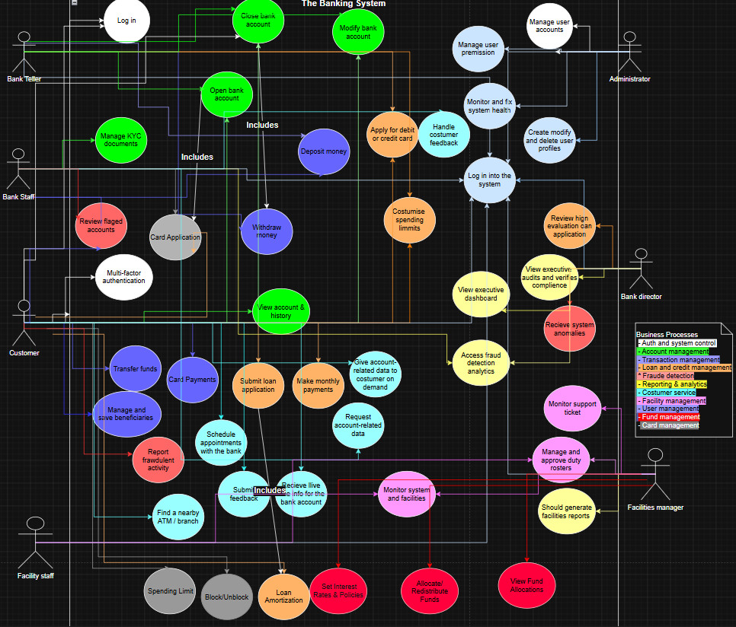

State Diagrams
Andrea Ogreni
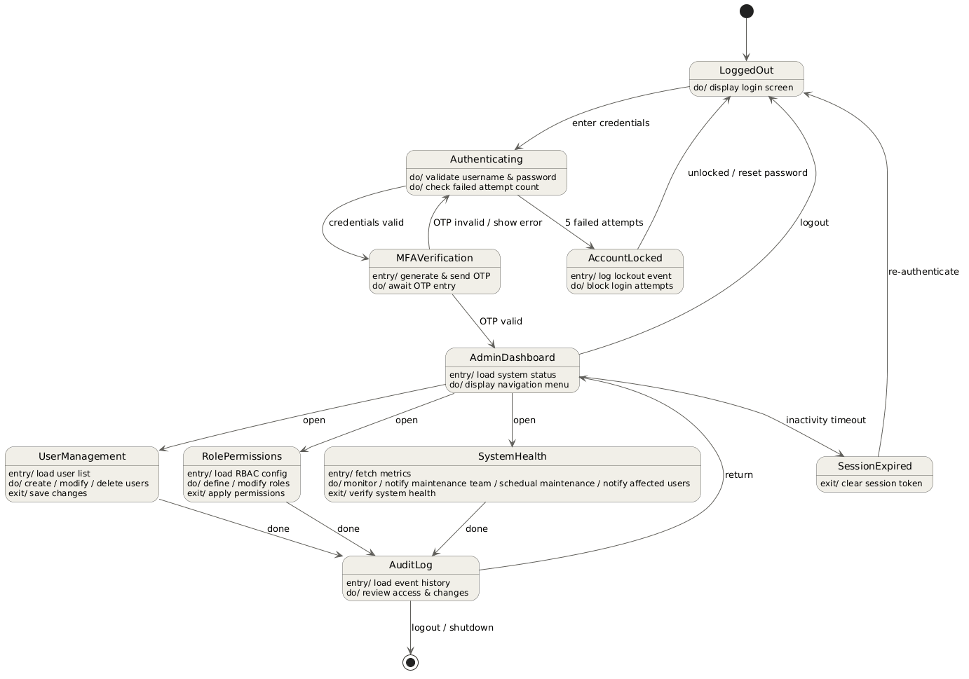

Joel Lluri
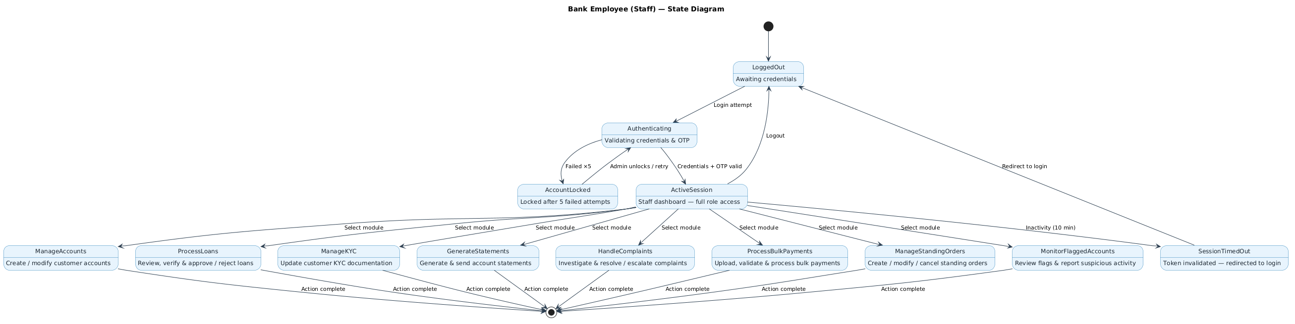

Adriano Demiri
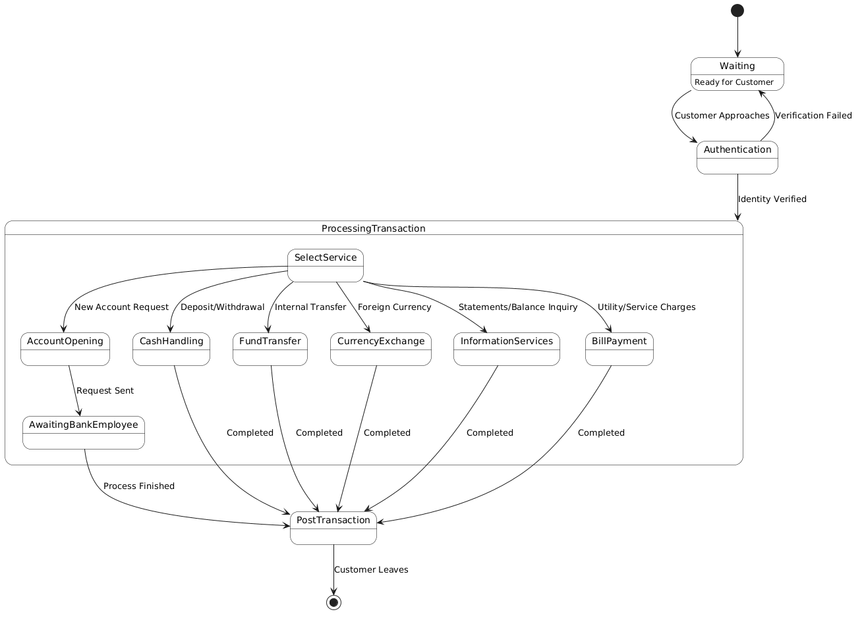

Emanuele Berbiu
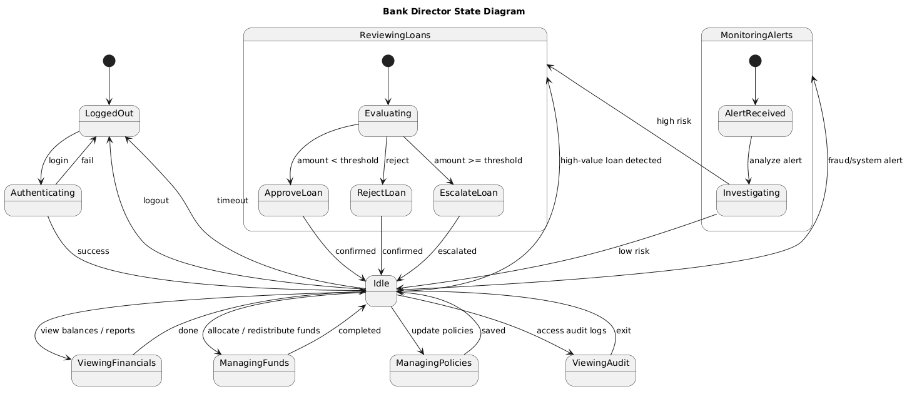

Kleo Miraka
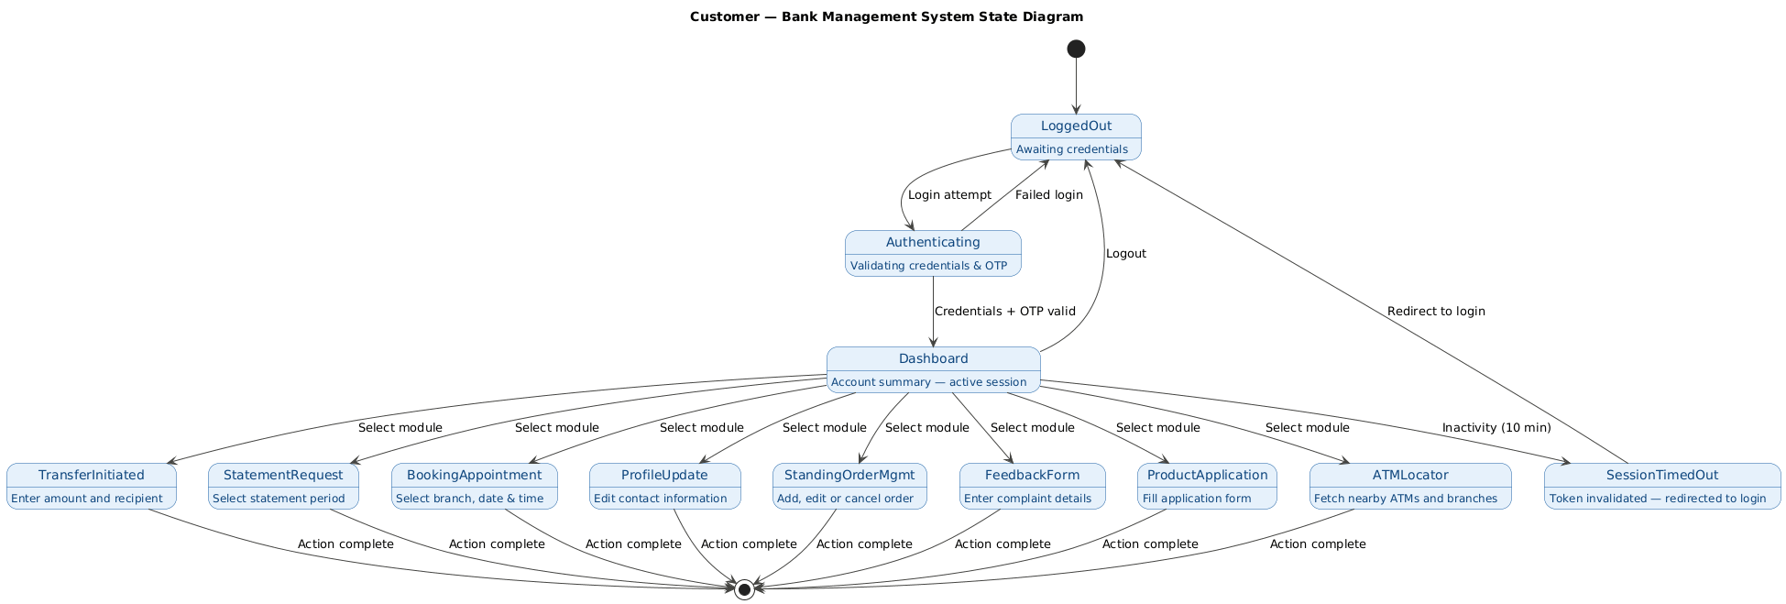

Joandri Domi
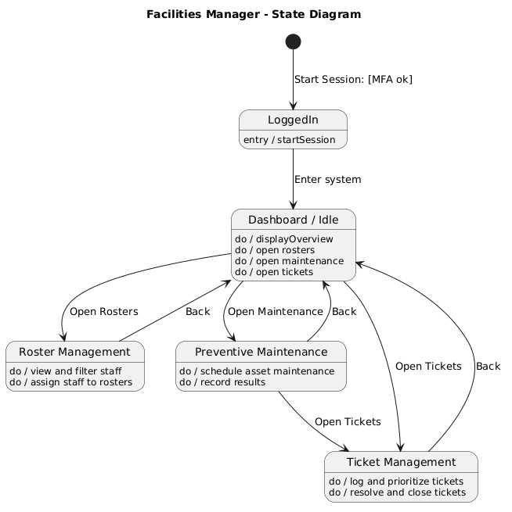

Erind Shabani
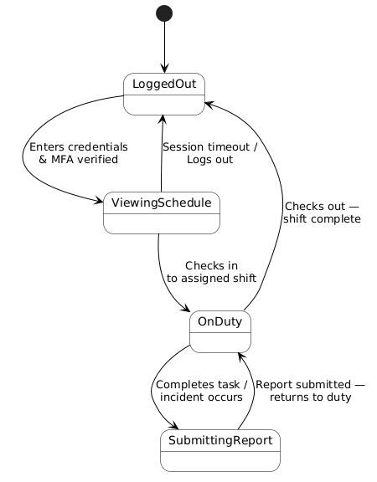

Activity Diagram
Andrea Ogreni
BS_UM_01
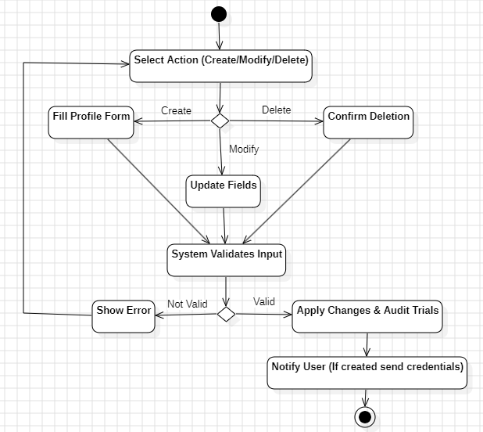

BS_UM_02
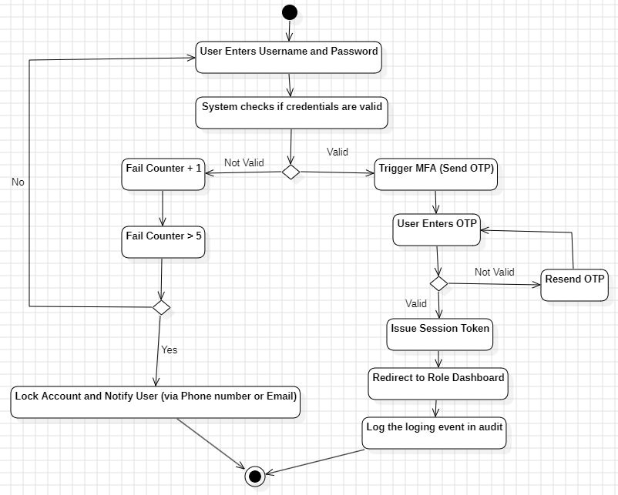

BS_UM_03
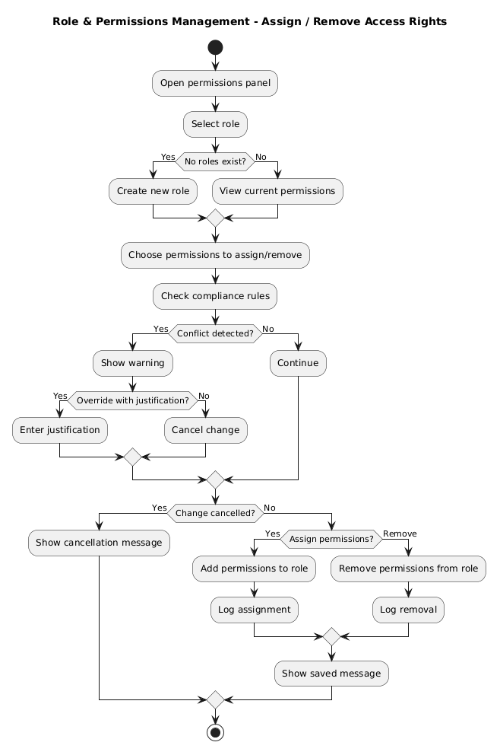

BS_UM_04
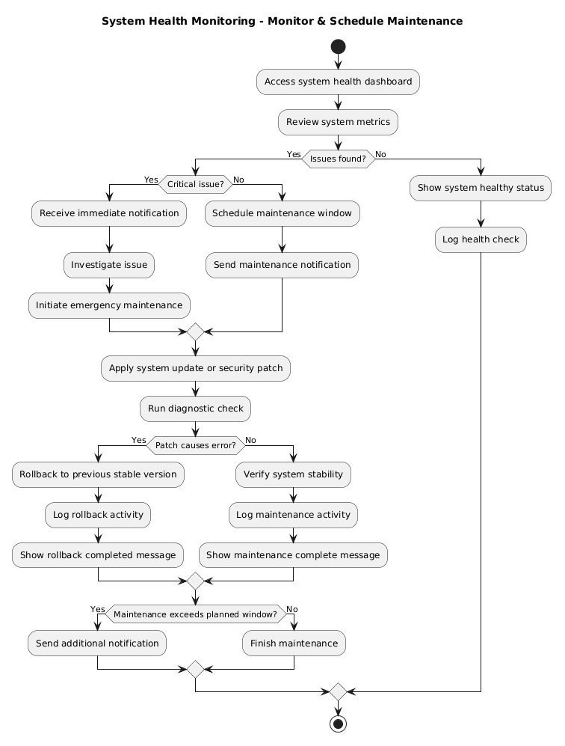
Andrea Ogreni
BS_FM_01
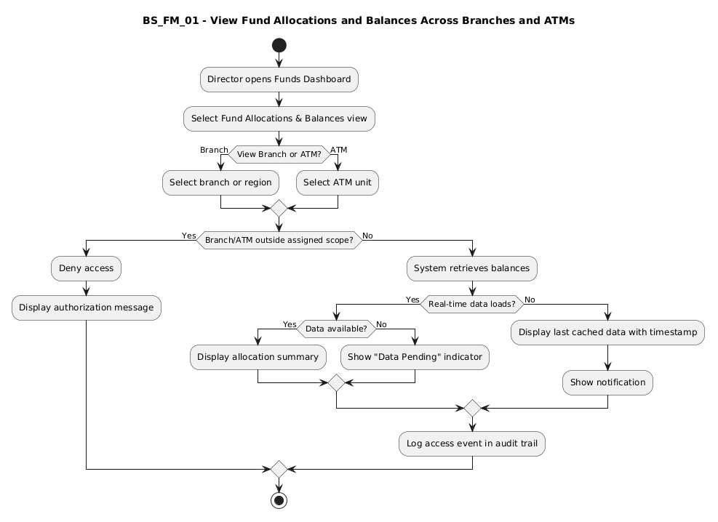

BS_FM_02
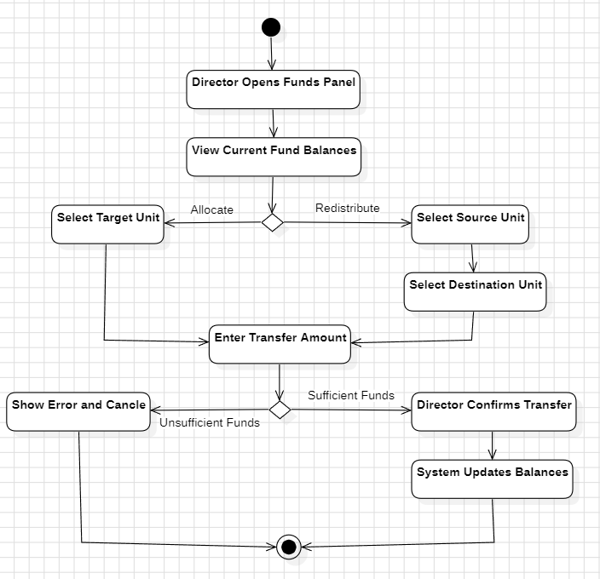

BS_FM_03
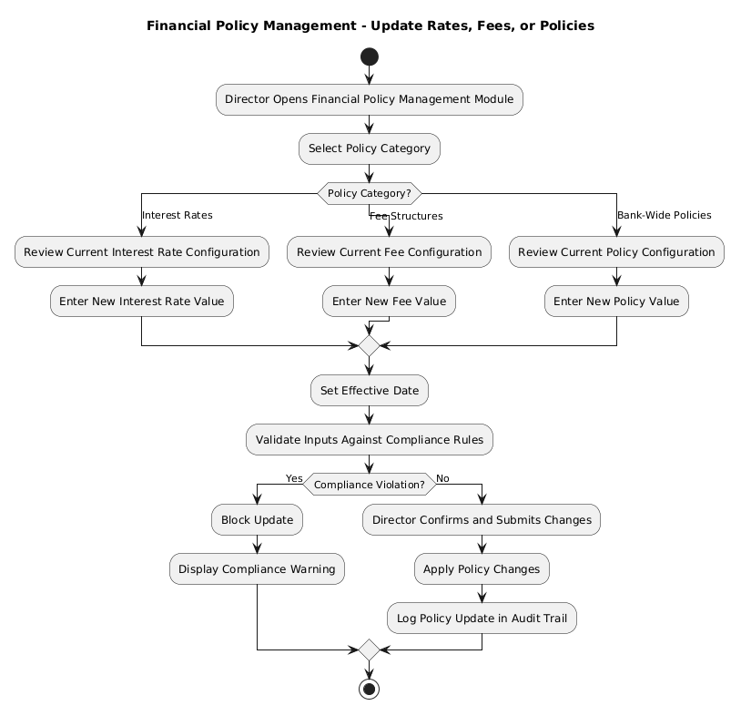

Joel Lluri
BS_AM_01
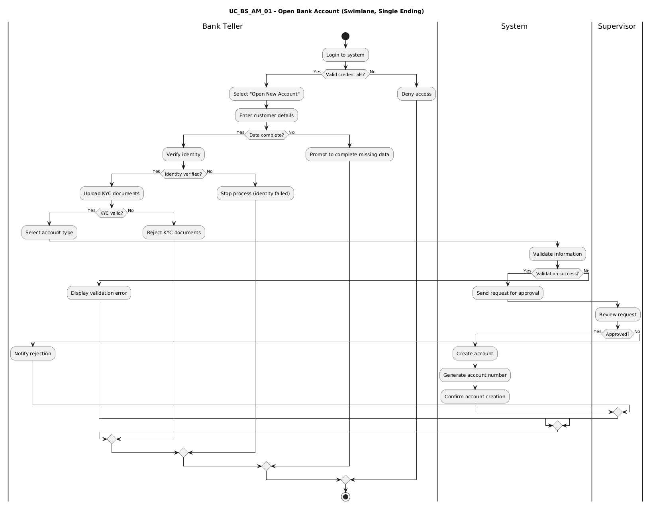

BS_AM_02
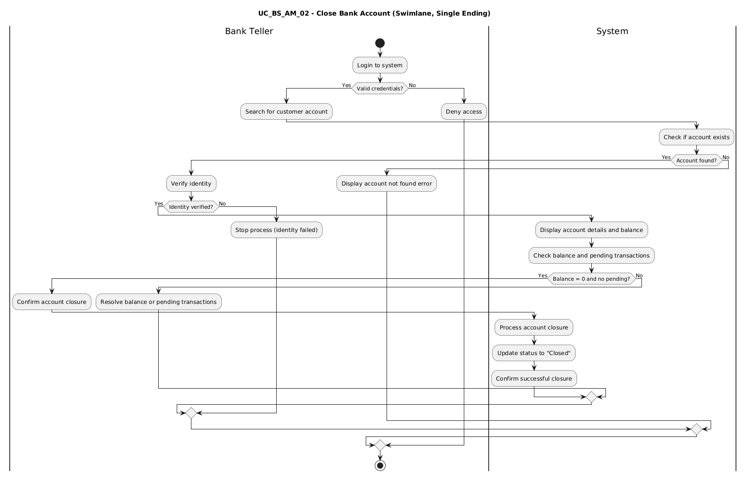

BS_AM_03
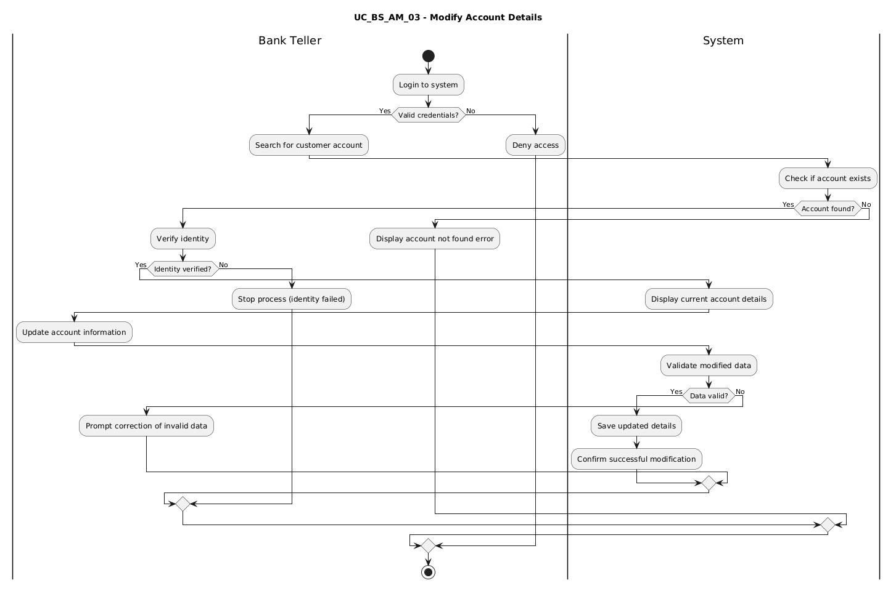

BS_AM_04
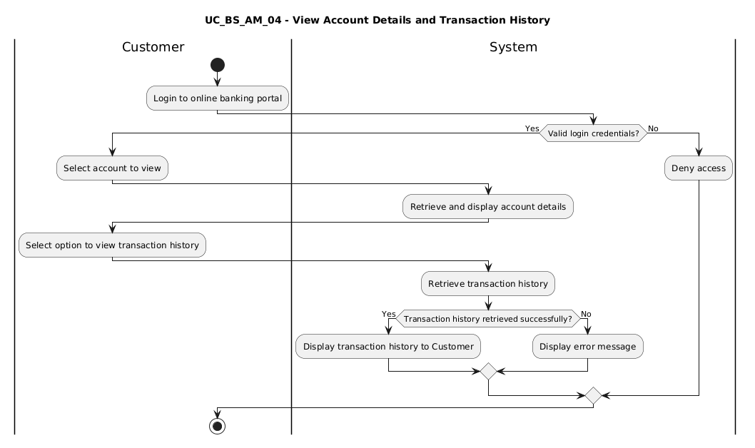

BS_AM_05
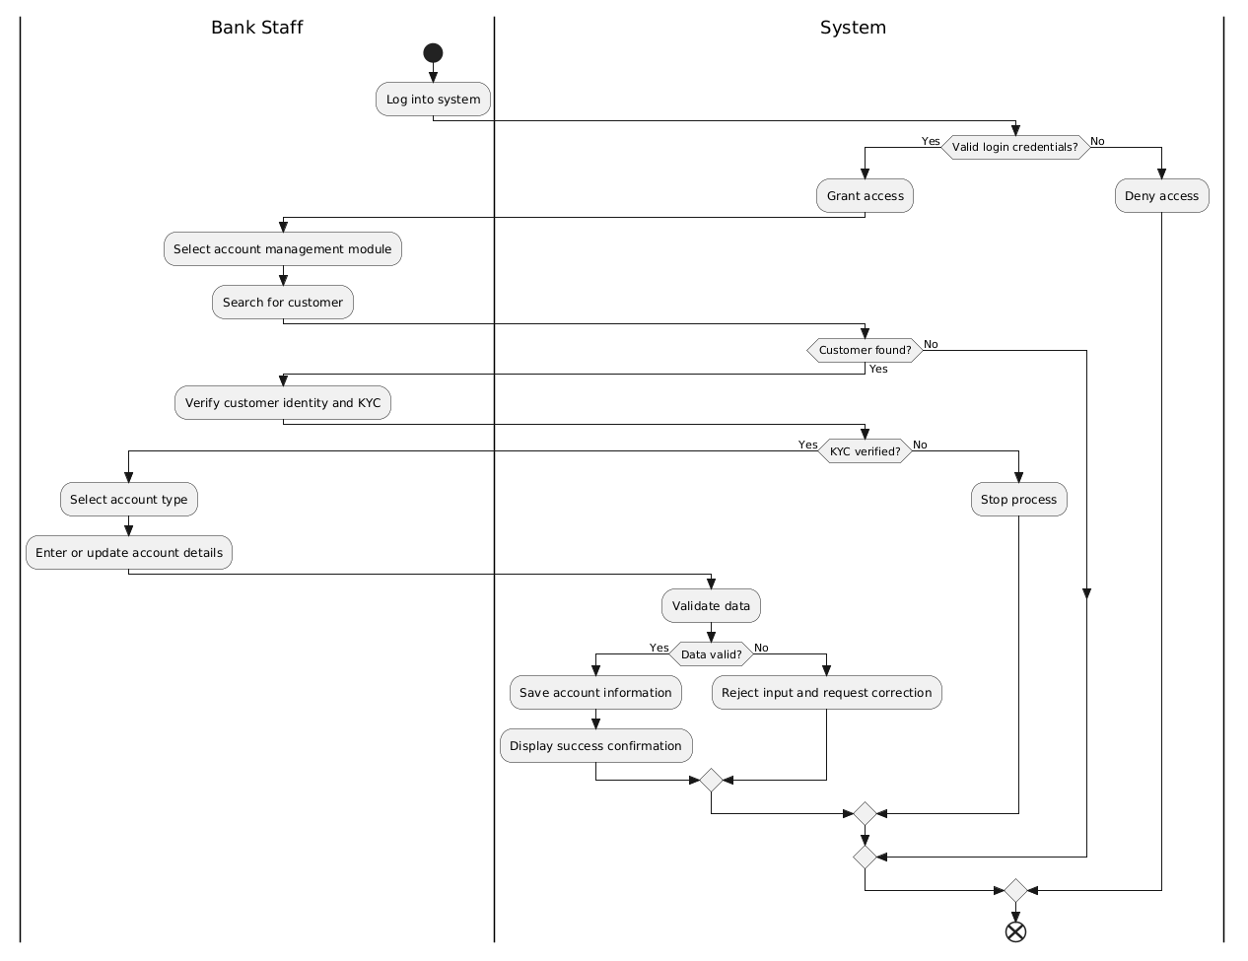

BS_AM_06
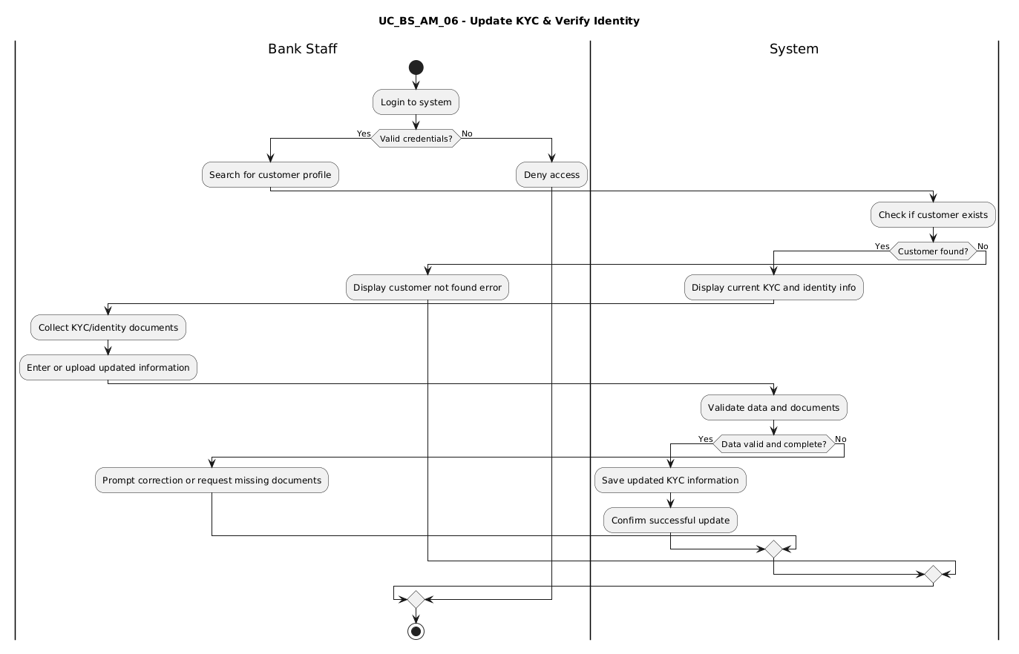

BS_AM_07
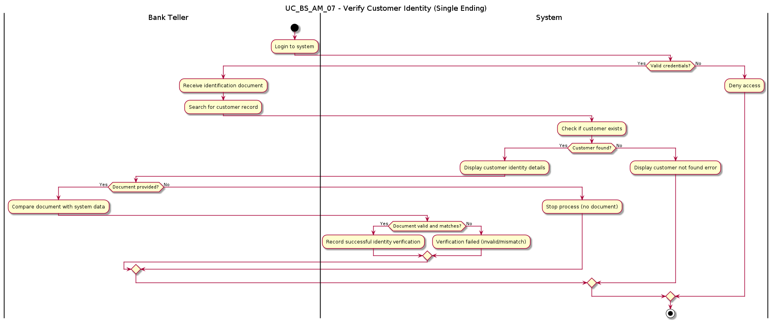

Andriano Demiri
BS_TM_01
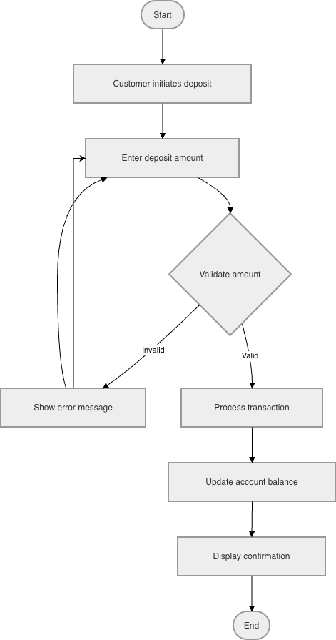

BS_TM_02
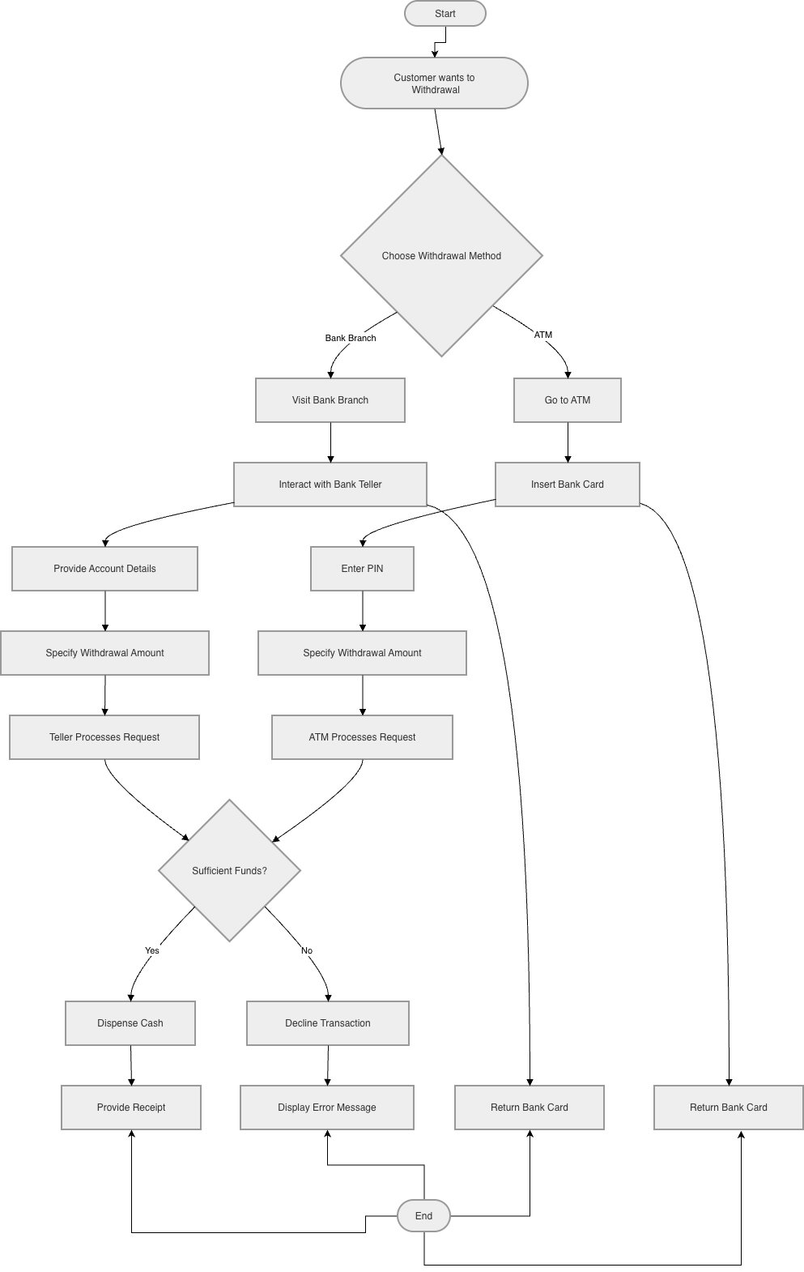

BS_TM_03
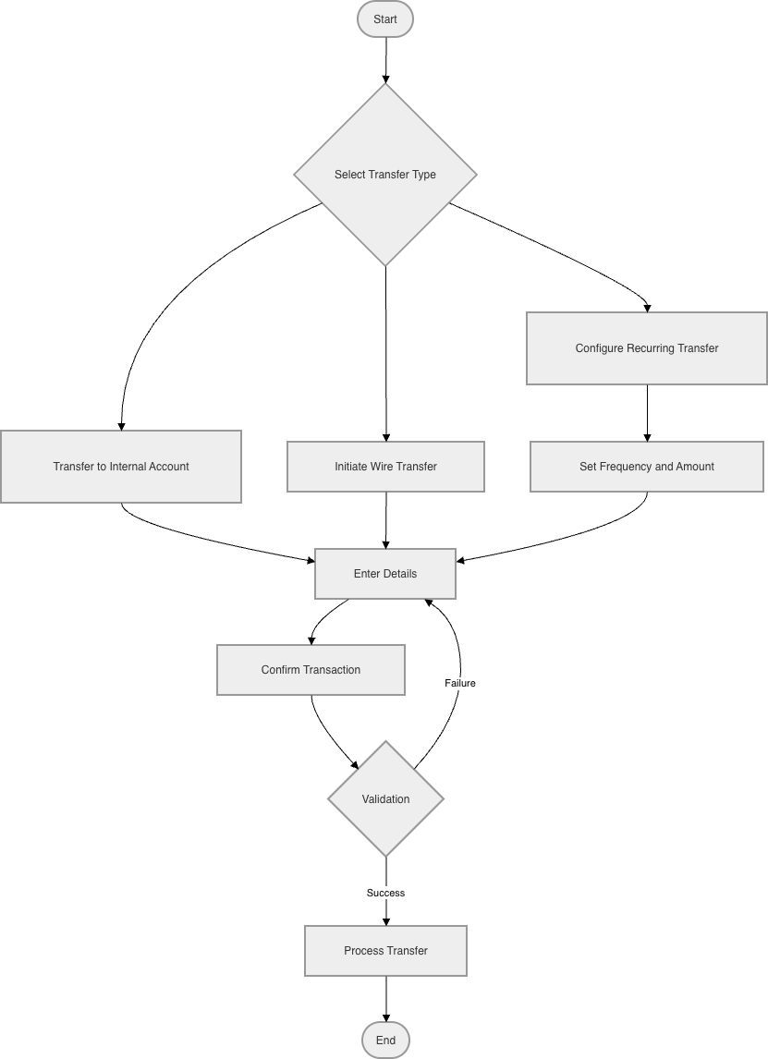

BS_TM_04
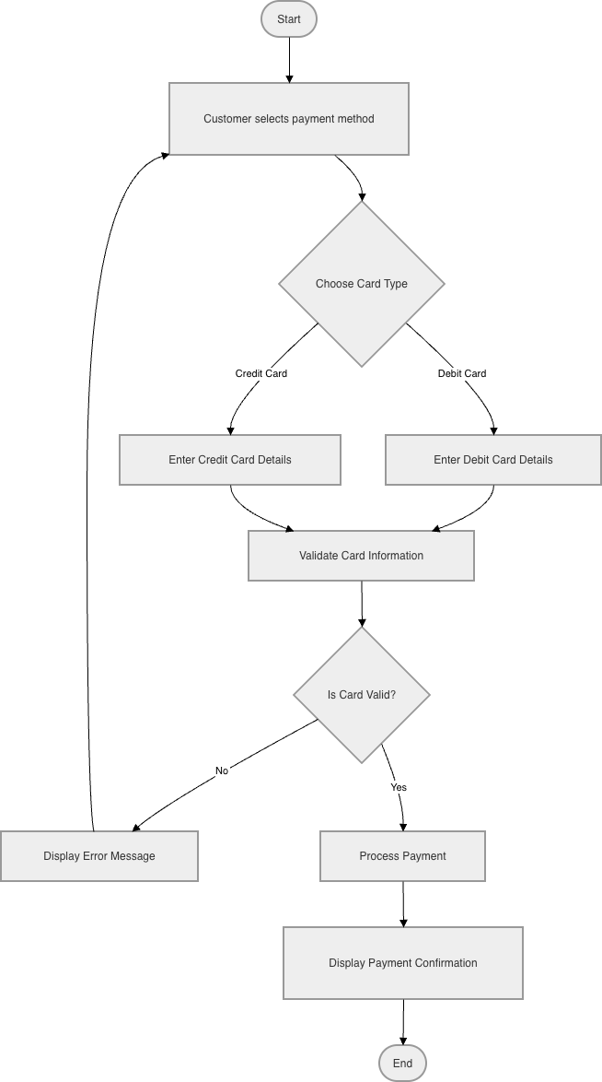
BS_TM_05
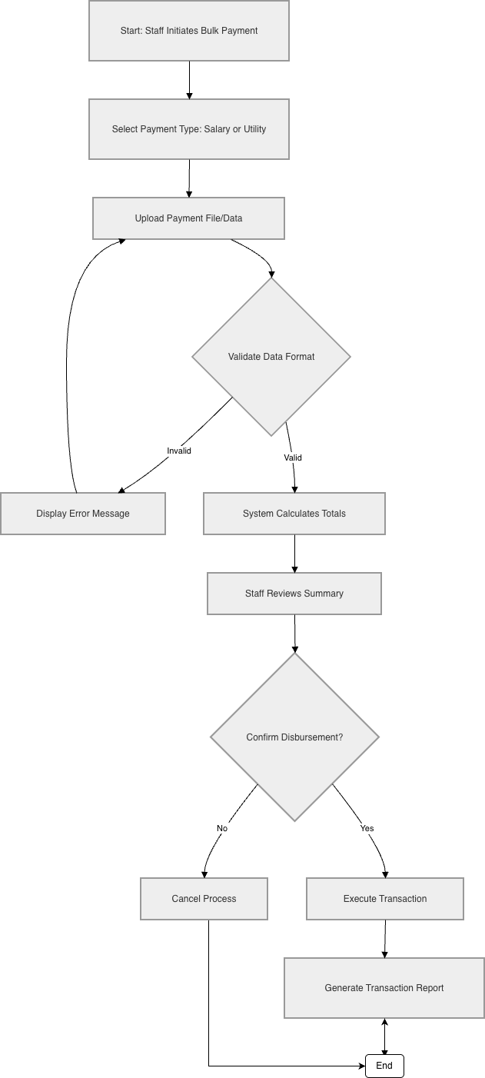

BS_TM_06
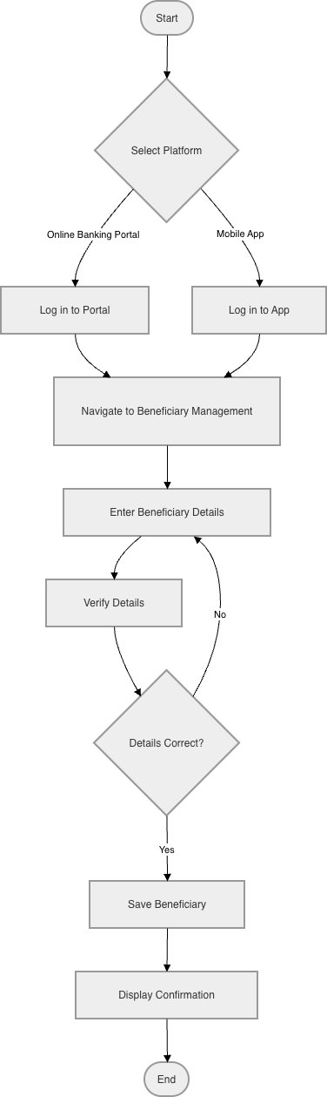
Emanuele Berbiu
BS_LM_01
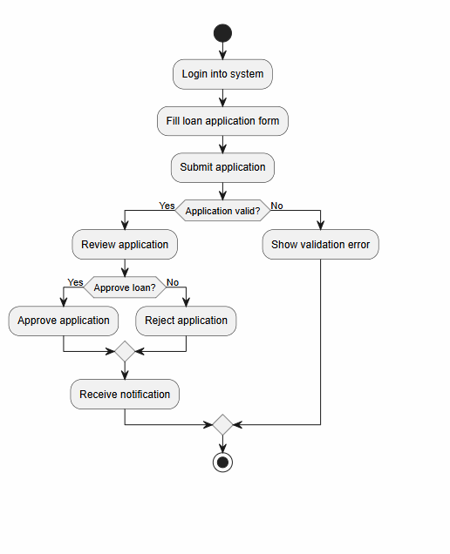

BS_LM_02
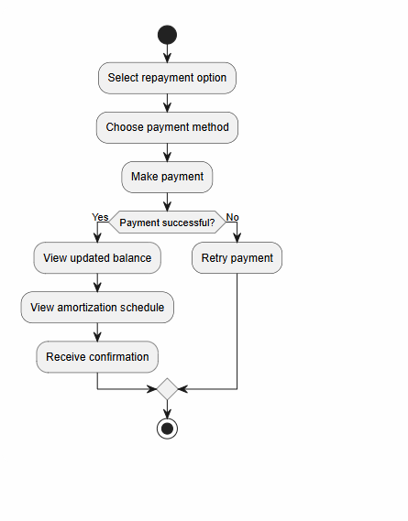

BS_LM_03
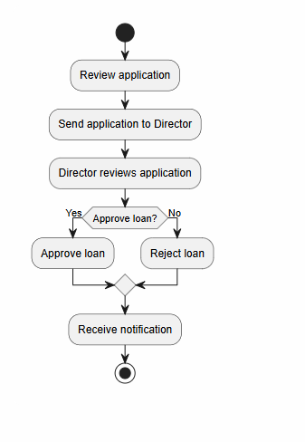

BS_LM_04
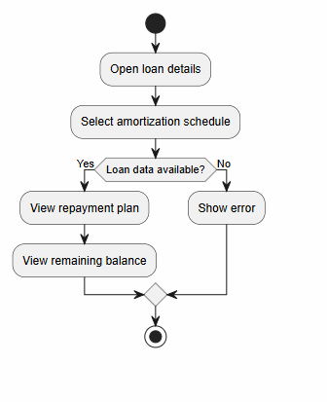

BS_CM_01
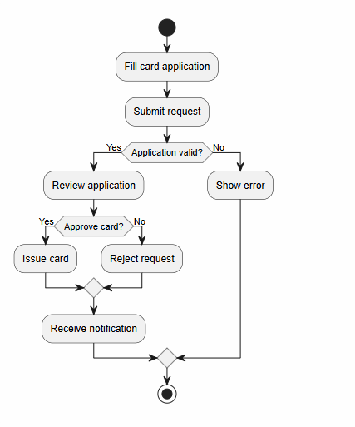

BS_CM_02
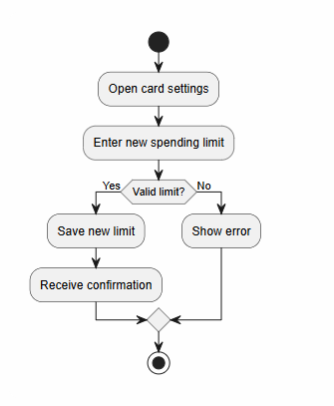

BS_CM_03
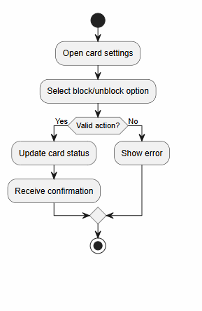

Joandri Domi
BS_FD_01
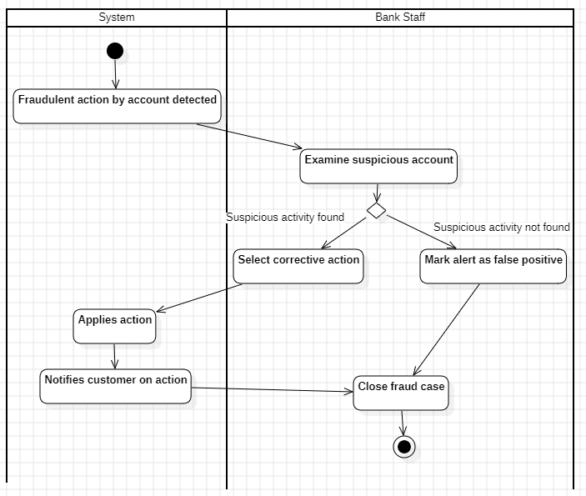

BS_FD_02
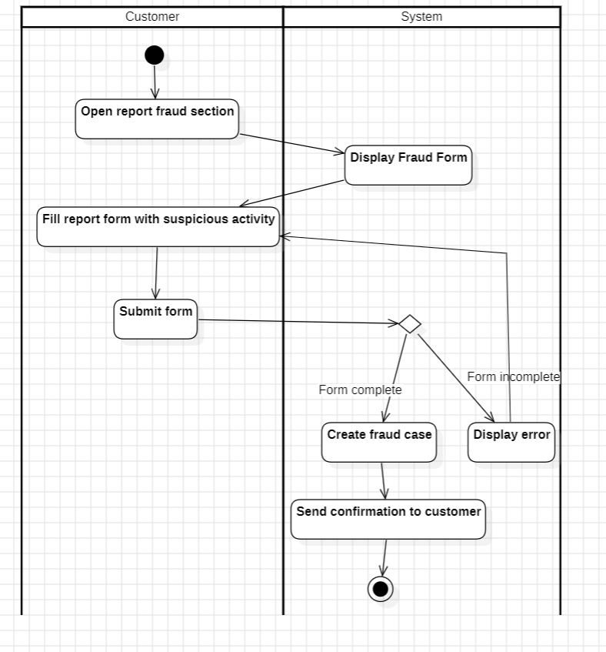

BS_FD_03
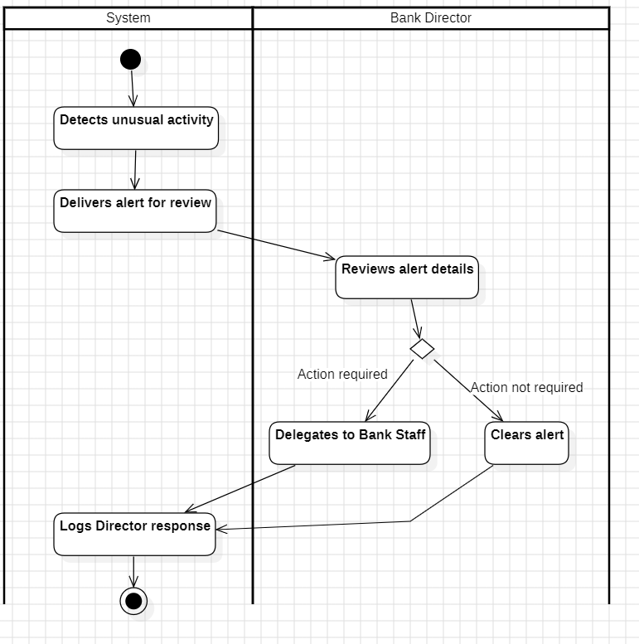

BS_FCM_01
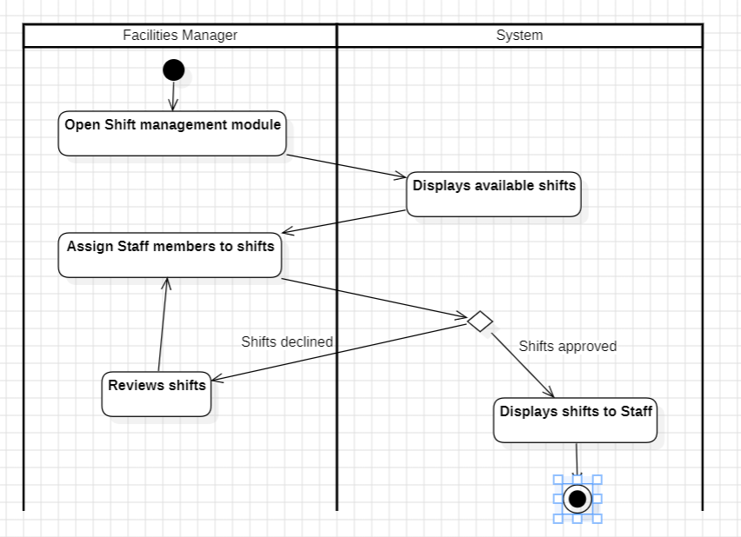

BS_FCM_02
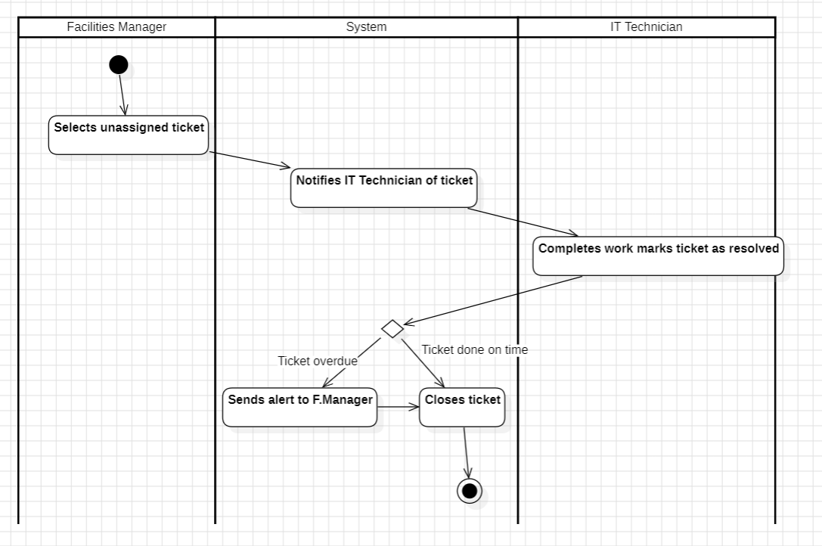

BS_FCM_03
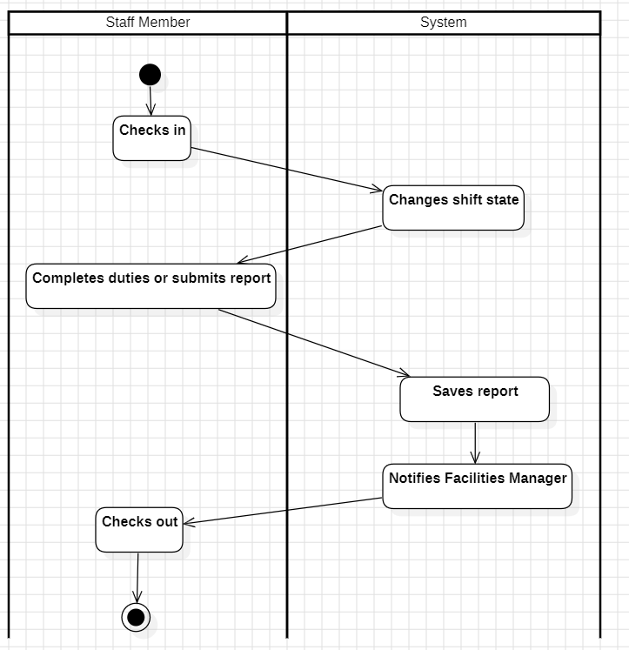

BS_FCM_04
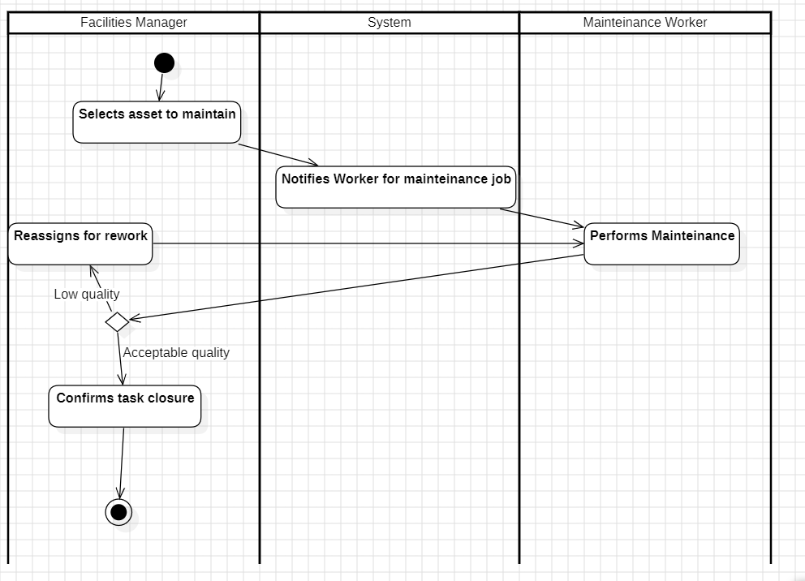

Kleo Miraka
BS_CS_01
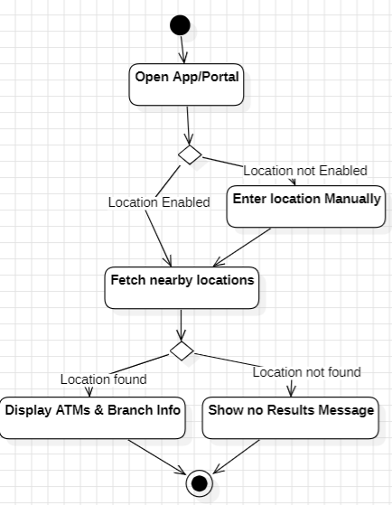

BS_CS_02
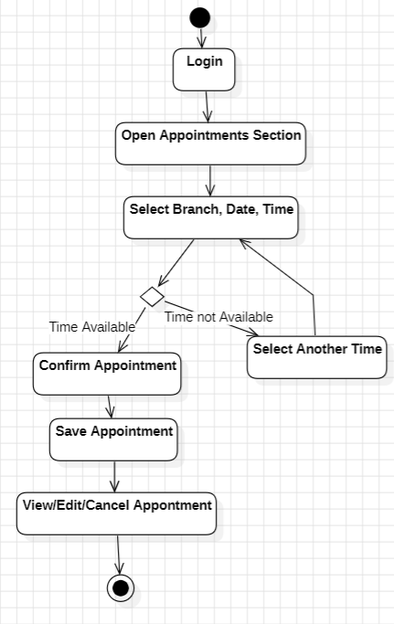

BS_CS_03
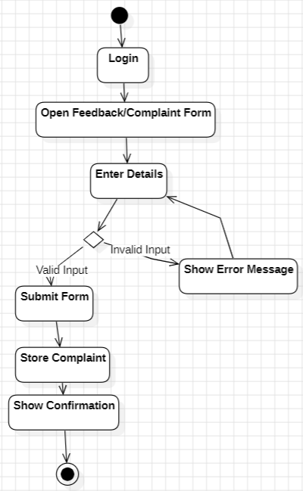

BS_CS_04
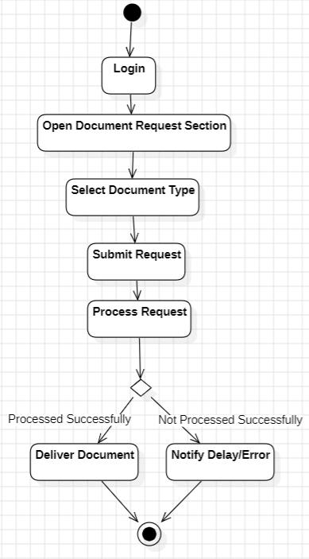

BS_CS_05
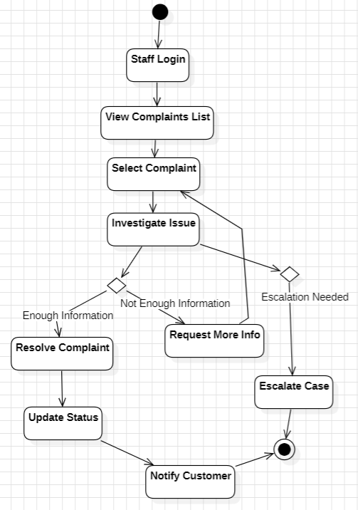

BS_CS_06
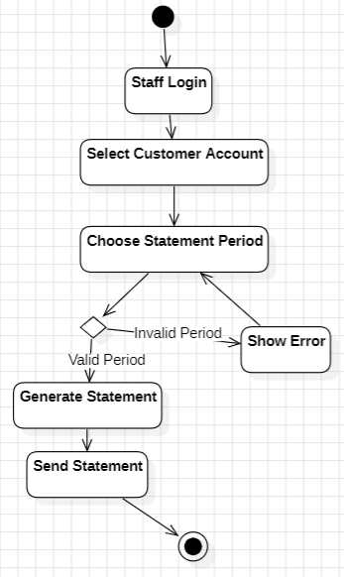

BS_CS_07
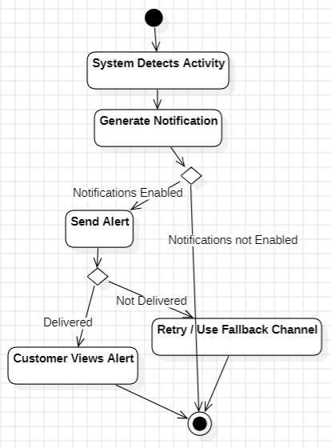

Erind Shabani
BS_AR_01
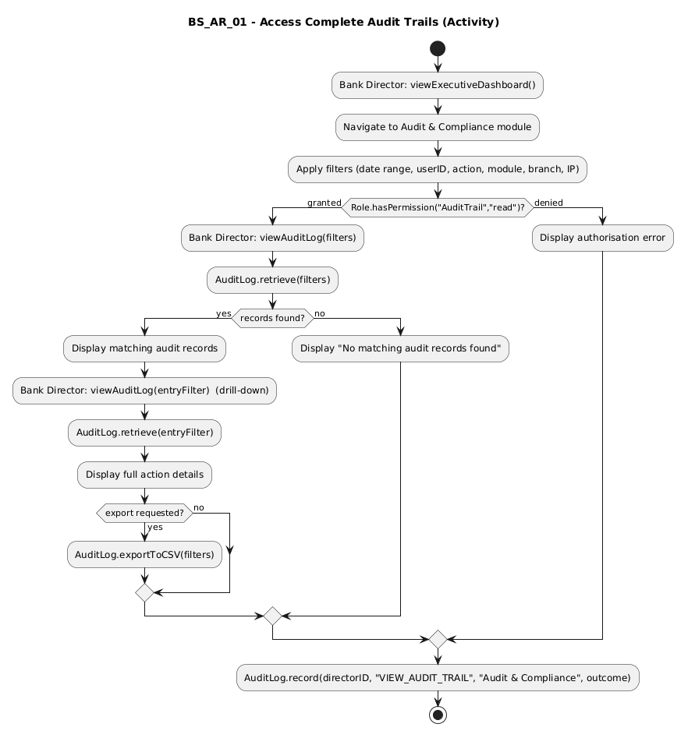

BS_AR_02
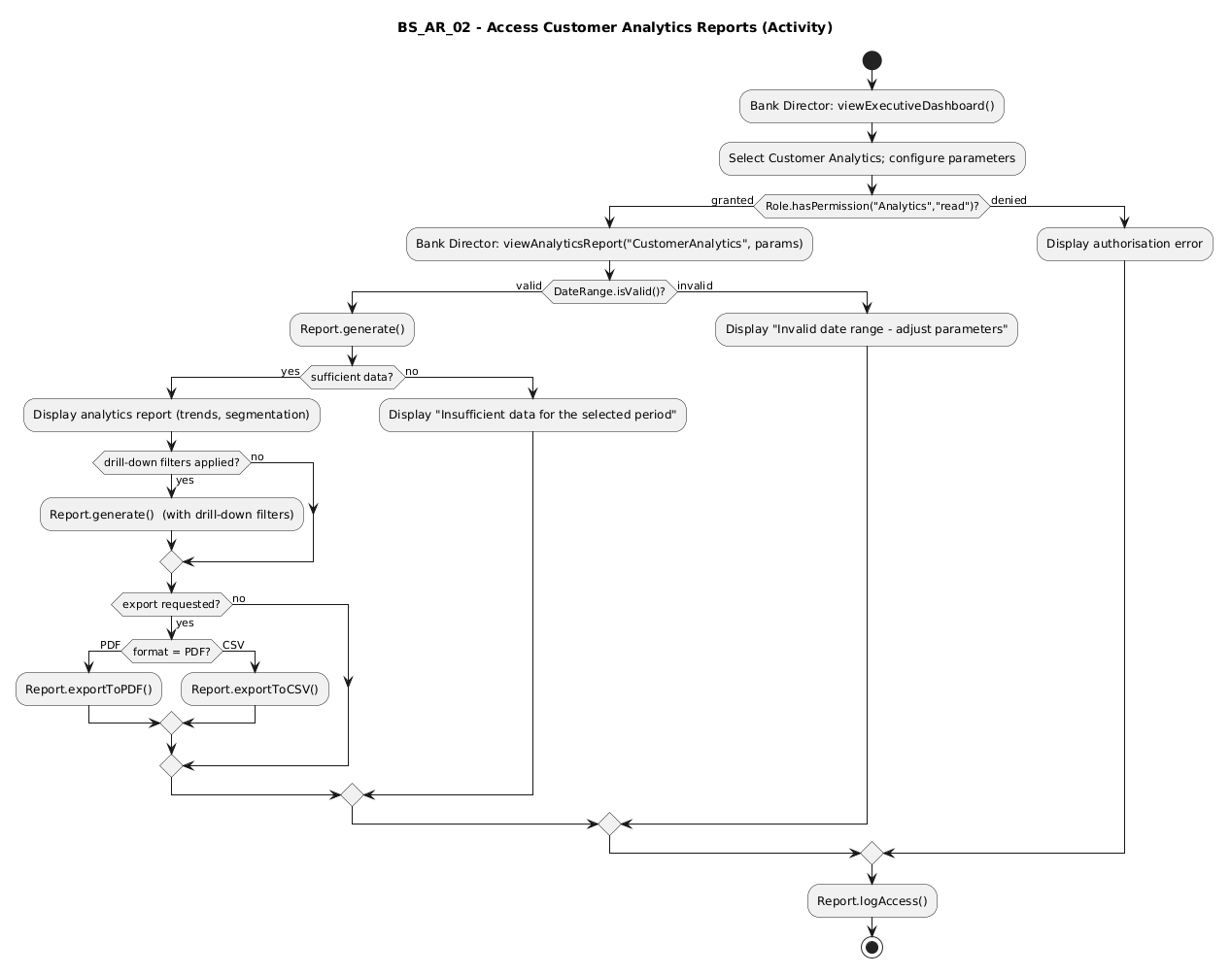

BS_AR_03
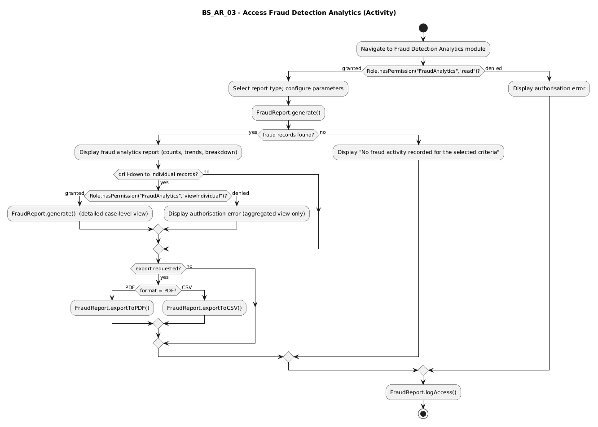

BS_AR_04
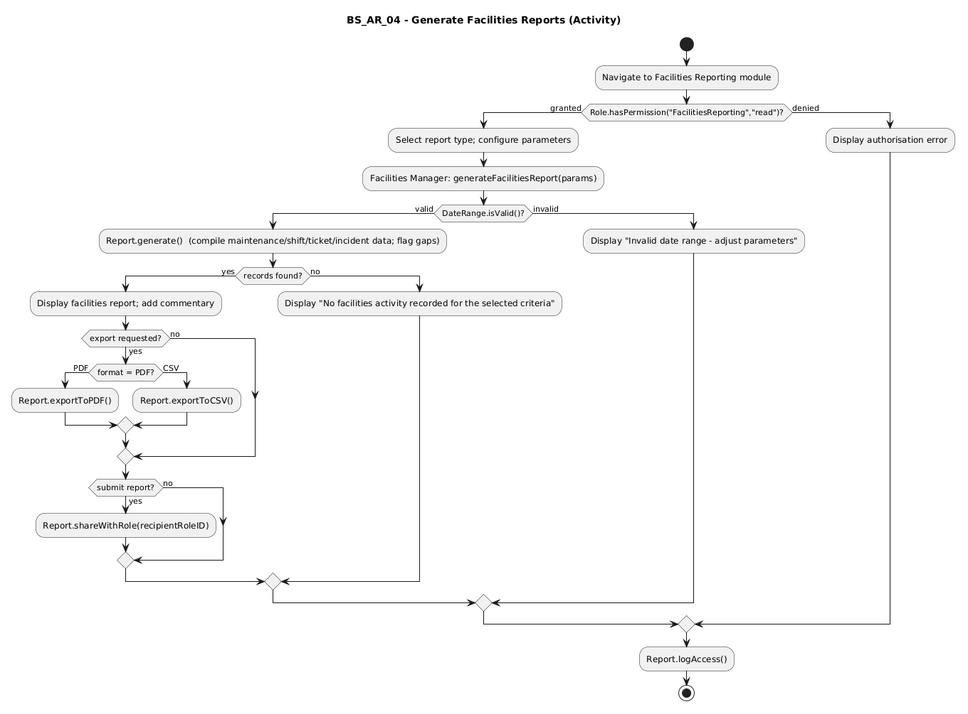

Sequence Diagrams
Andrea Ogreni
BS_UM_01
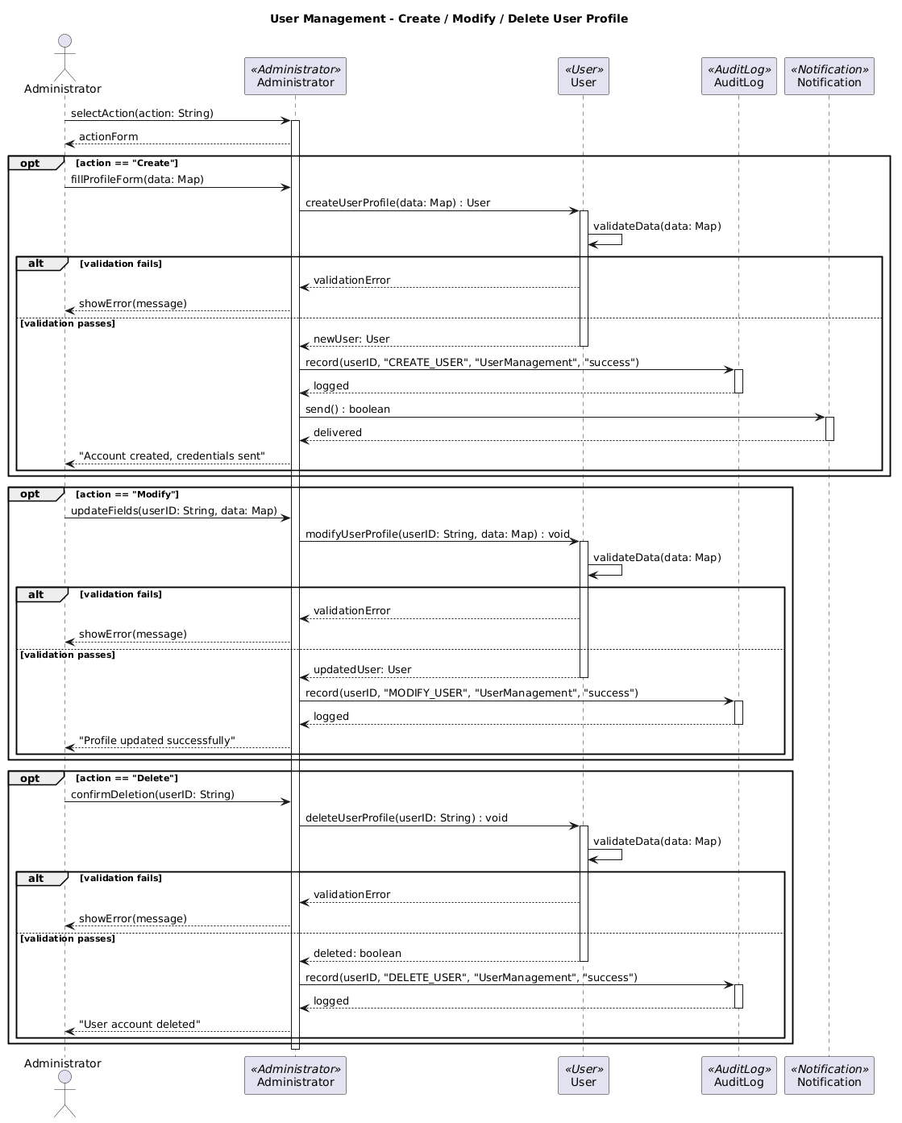

BS_UM_02
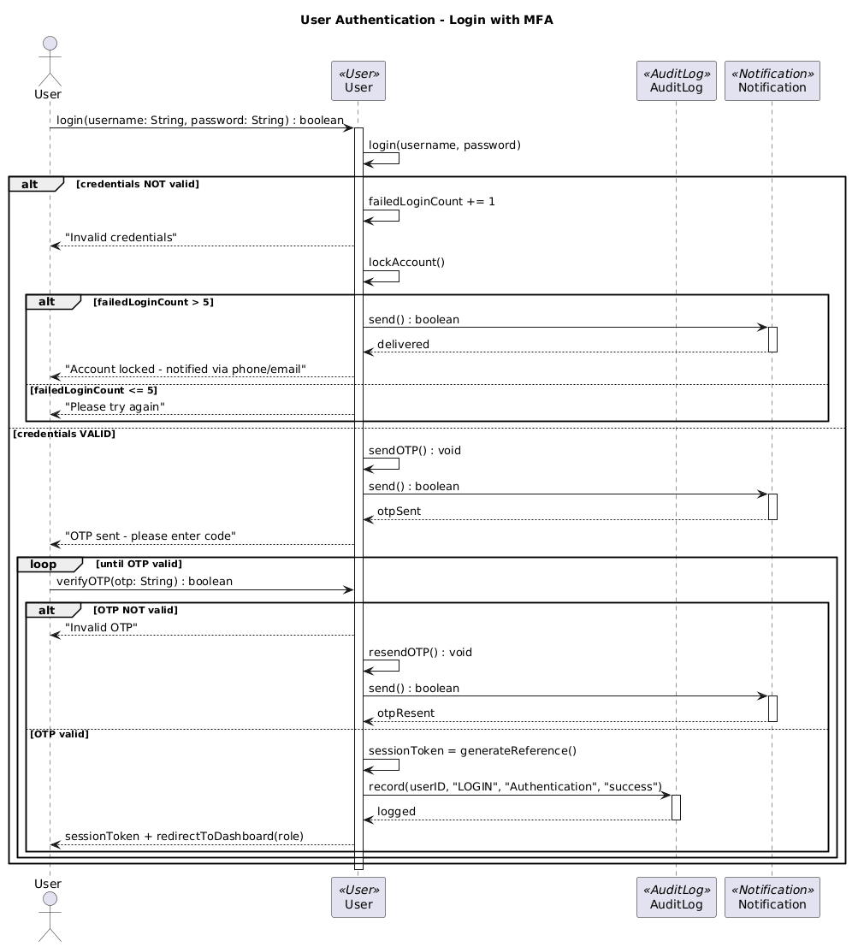

BS_UM_03
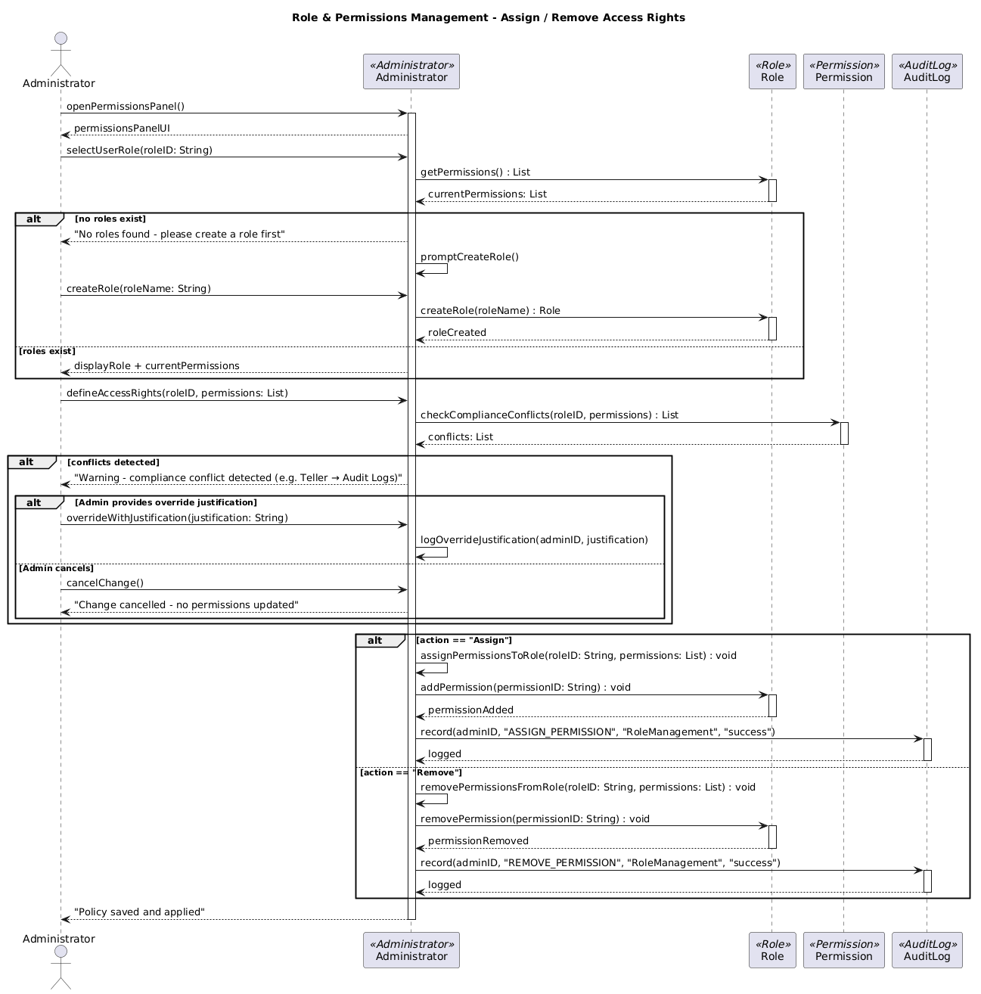

BS_UM_04
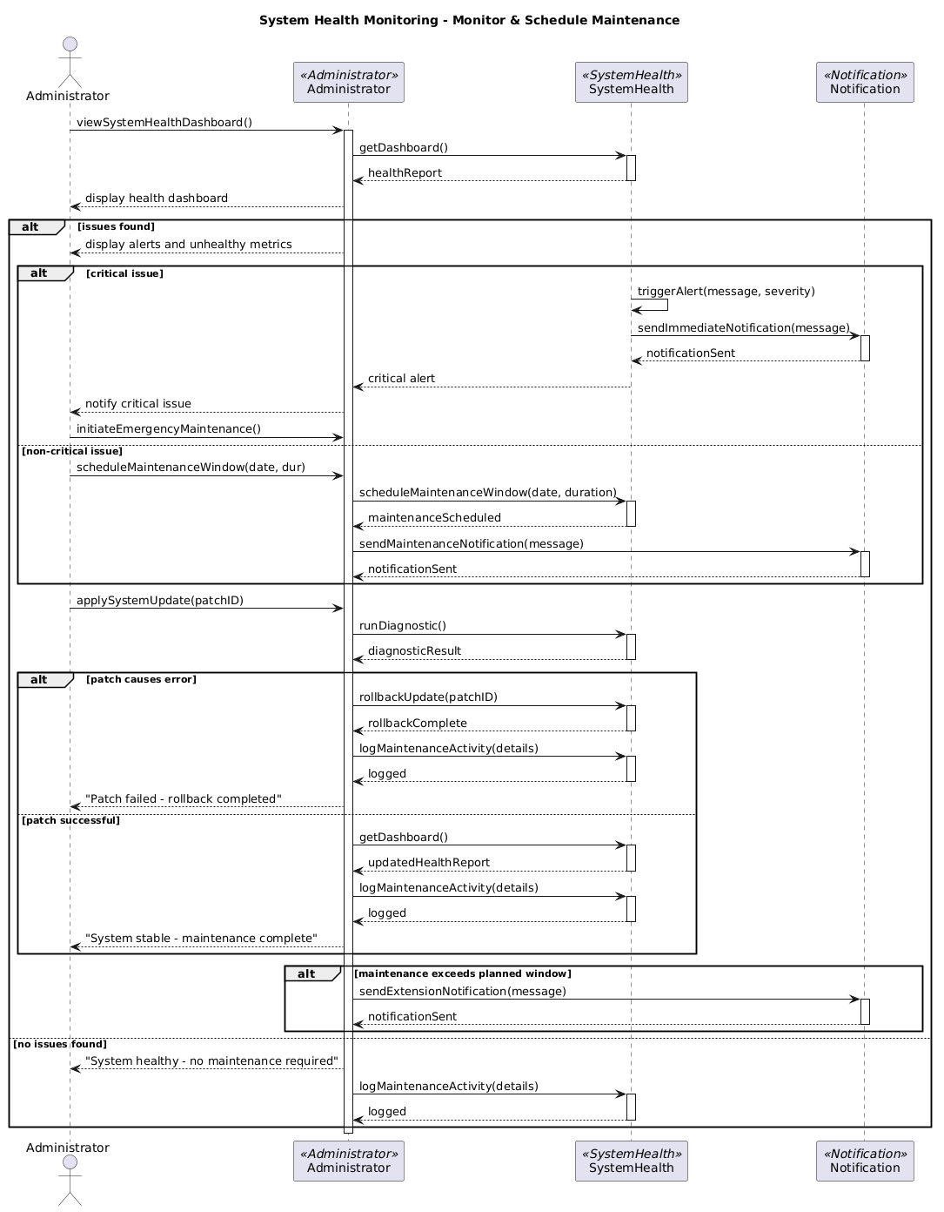
BS_FM_01
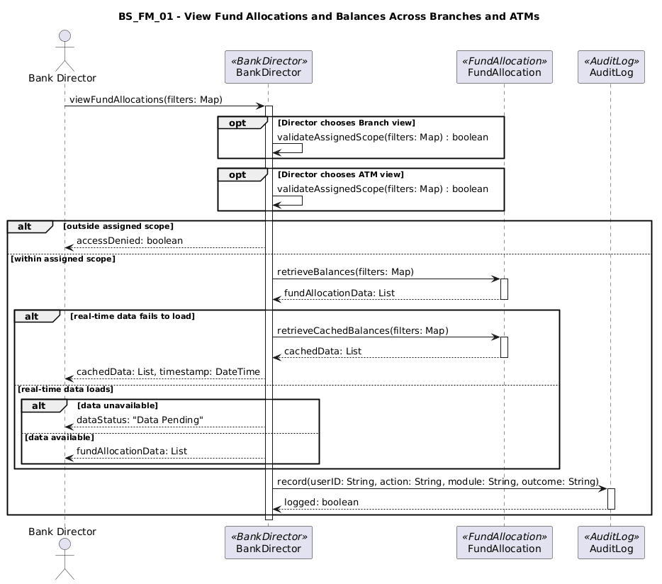

BS_FM_02
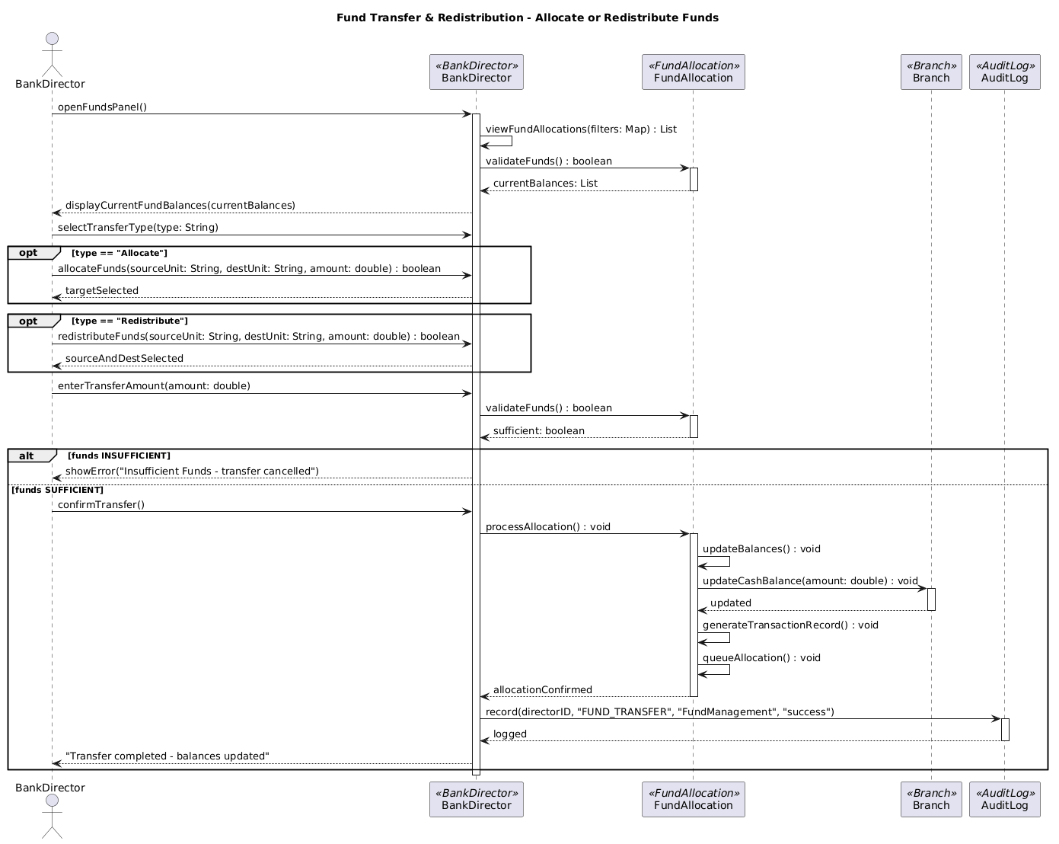

BS_FM_03
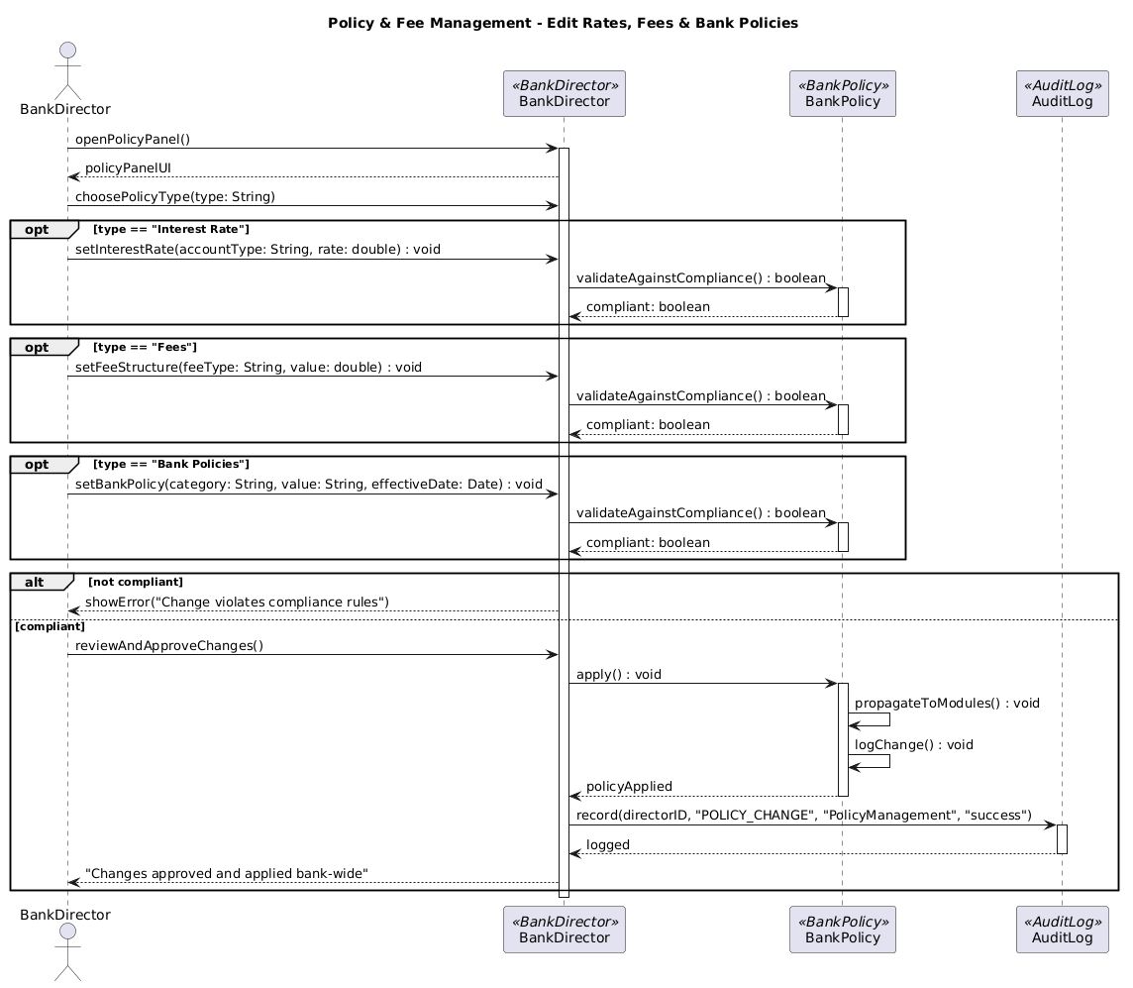

Joel Lluri
BS_AM_01
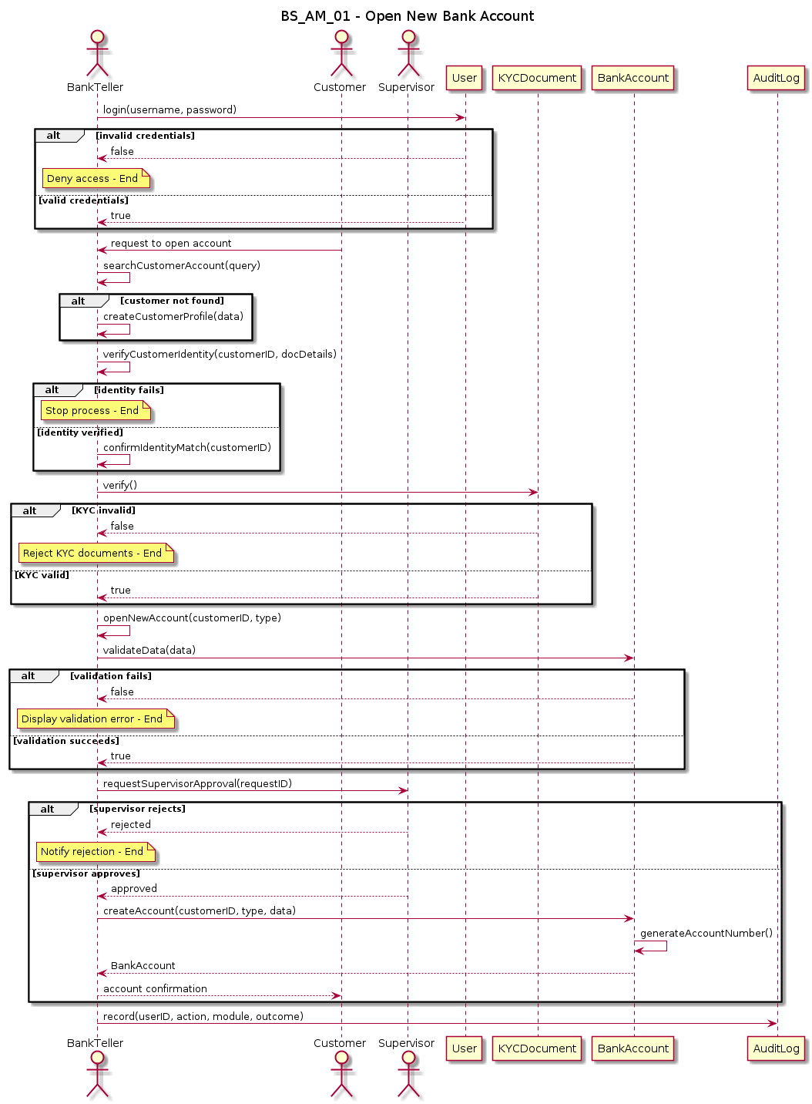

BS_AM_02
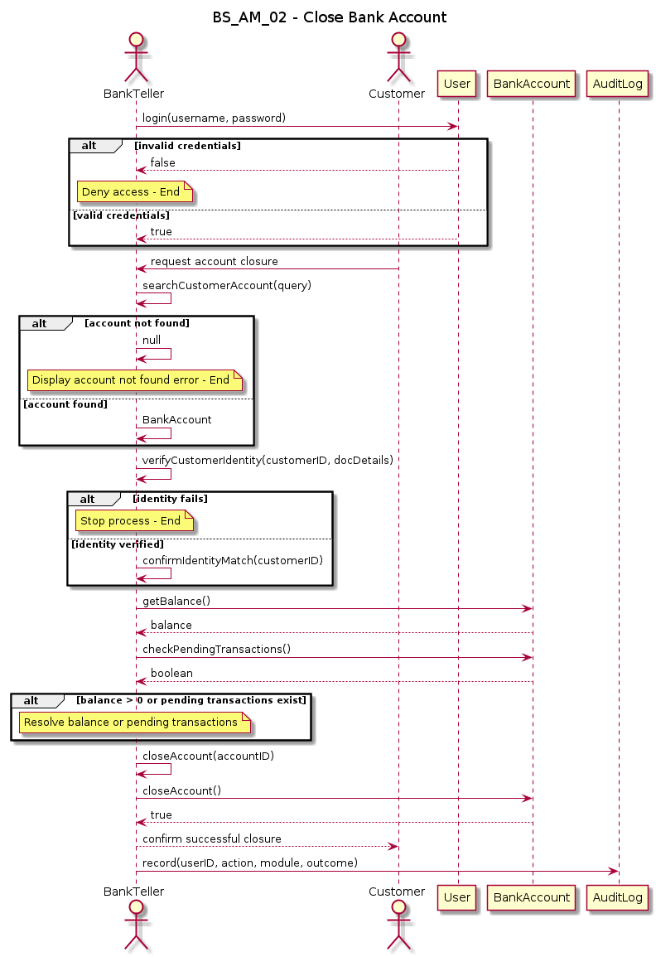
BS_AM_03
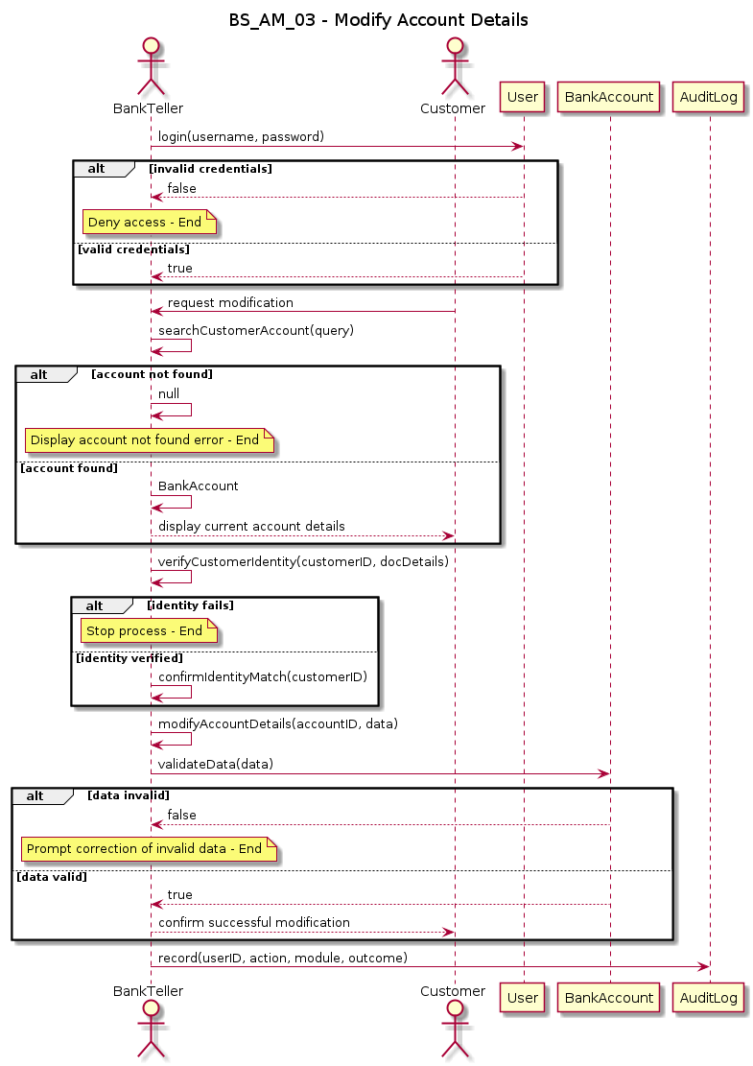

BS_AM_04
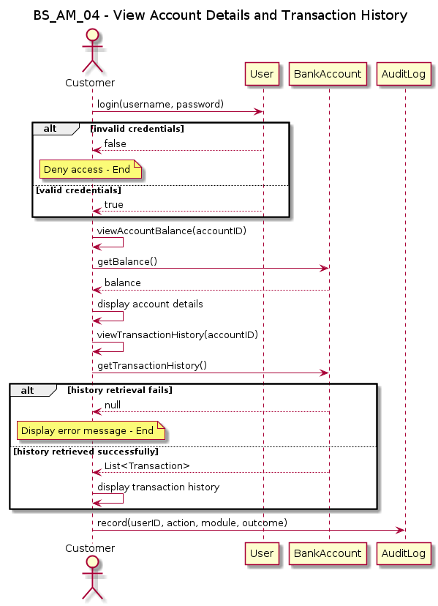
BS_AM_05
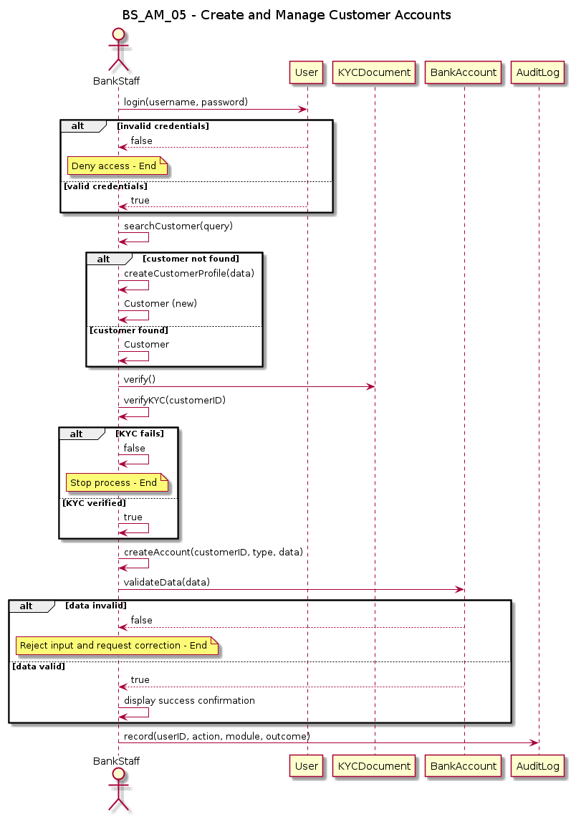

BS_AM_06
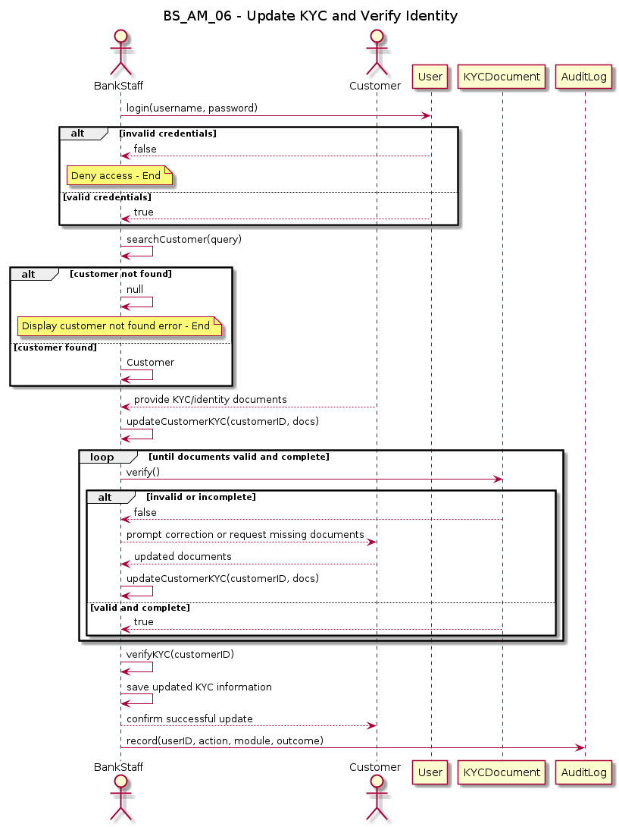

BS_AM_07
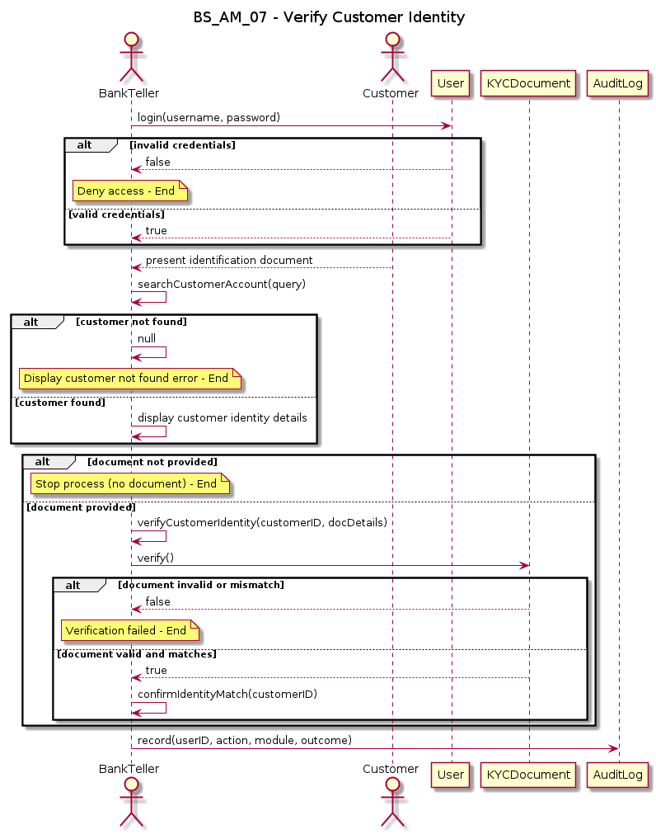

Adriano Demiri
BS_TM_01
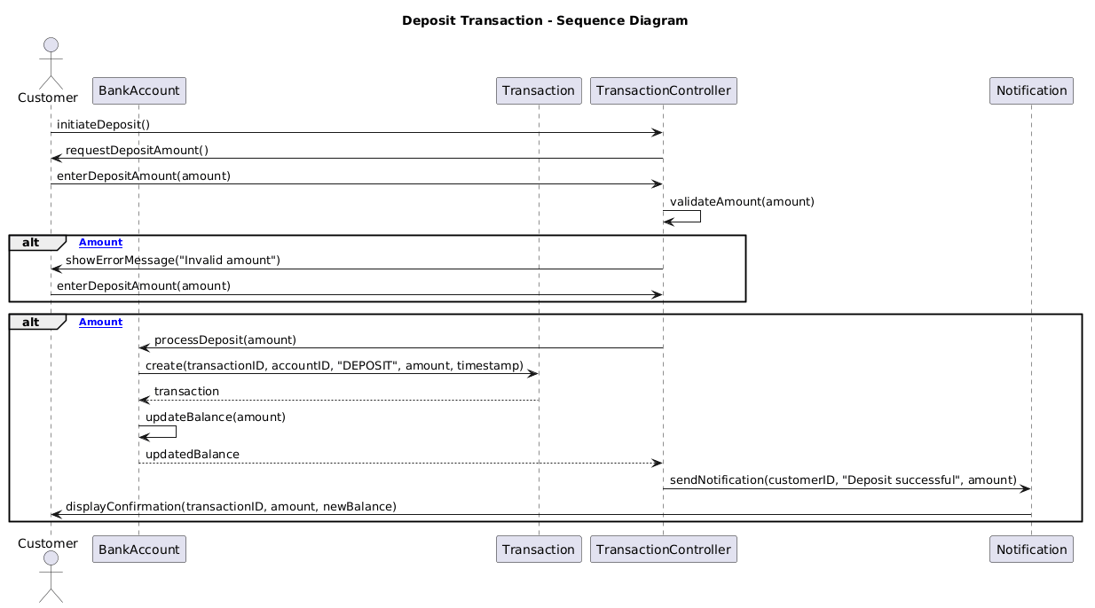

BS_TM_02
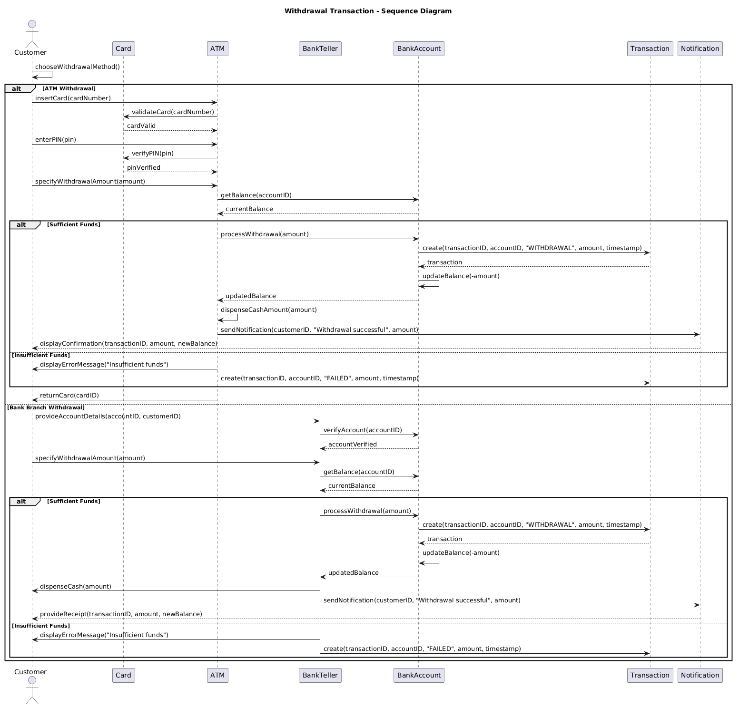

BS_TM_03
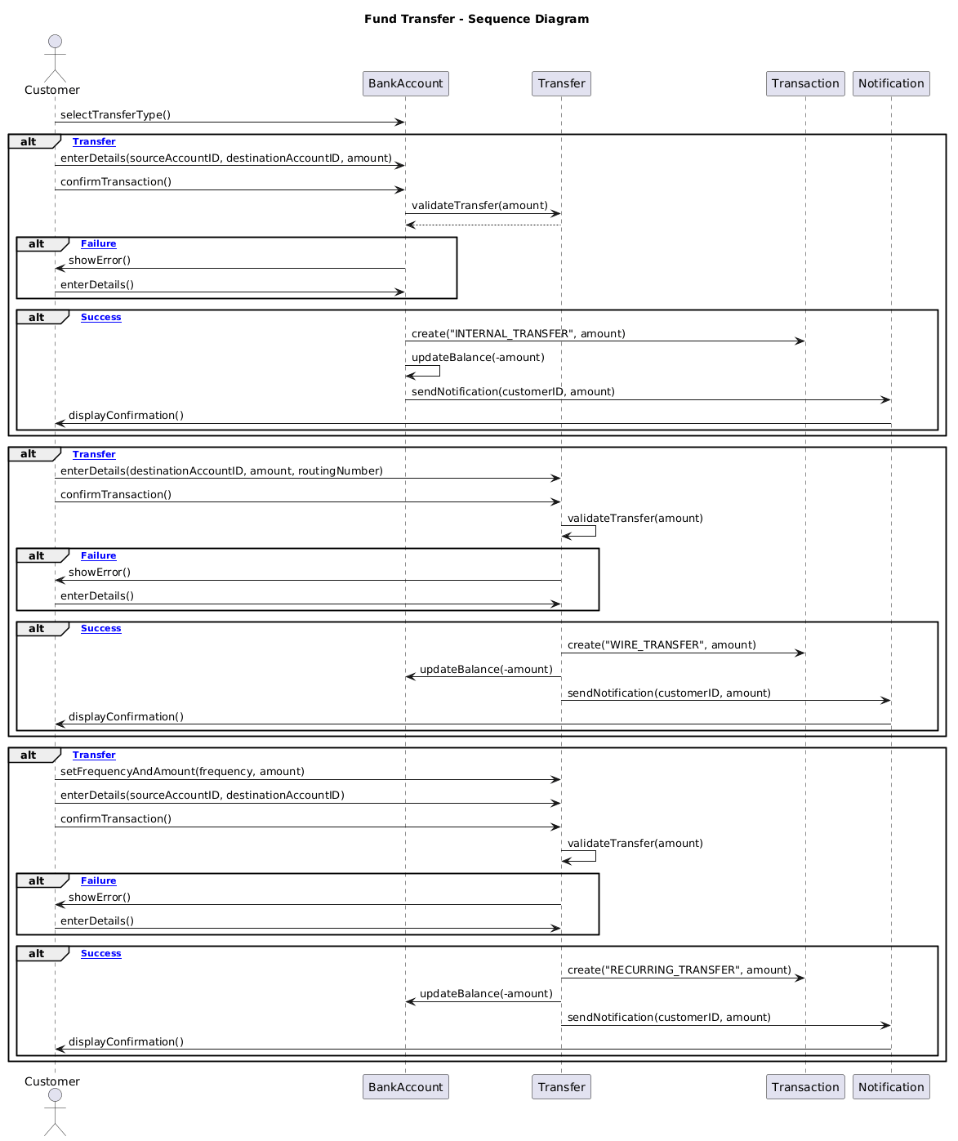

BS_TM_04
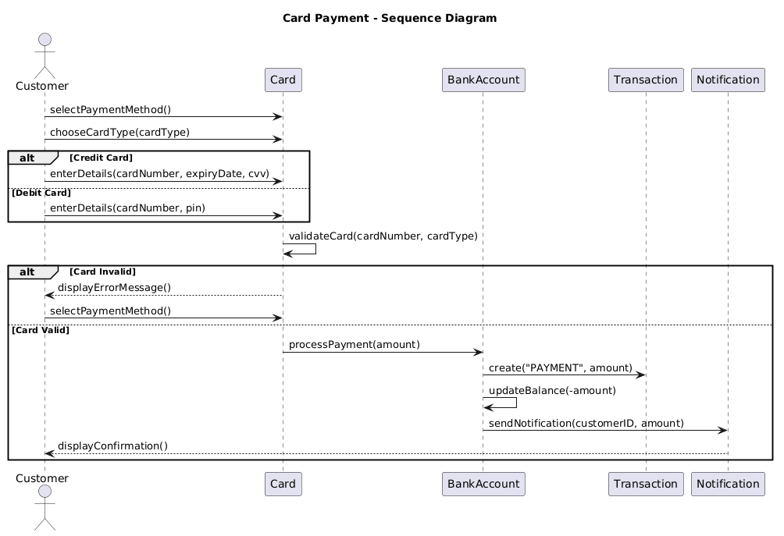

BS_TM_05


BS_TM_06
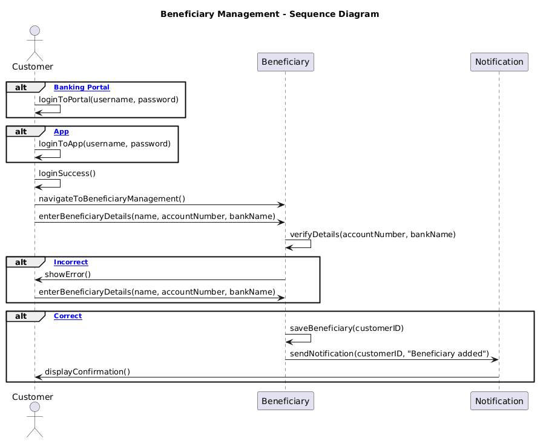

Emauele Berbiu
BS_LM_01
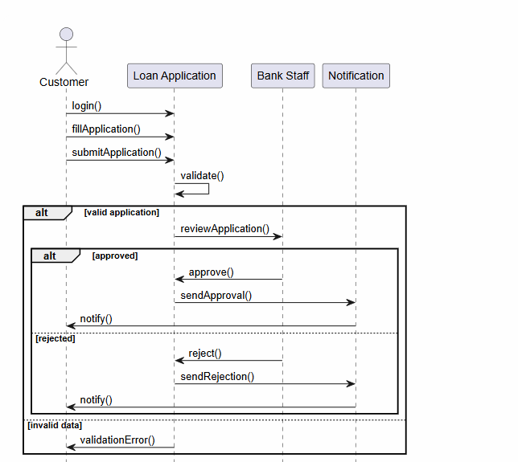

BS_LM_02
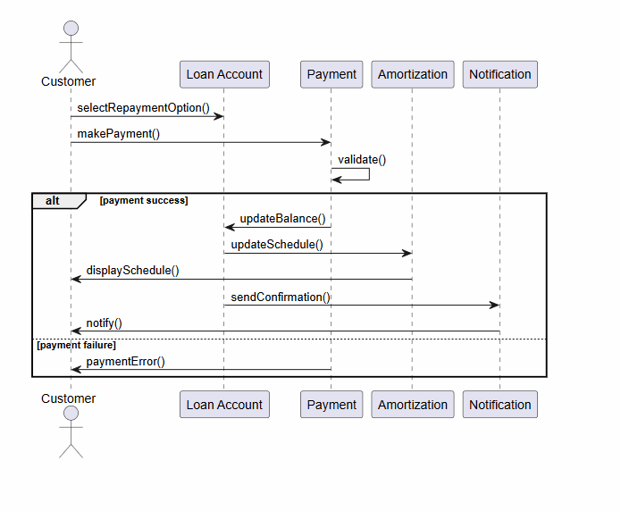

BS_LM_03
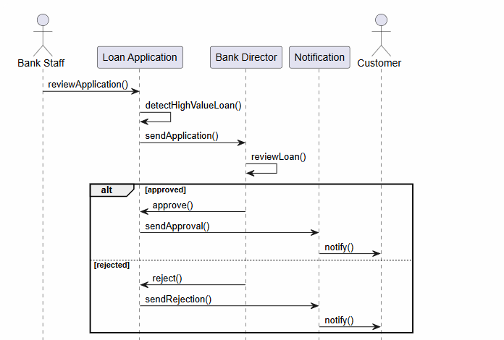

BS_LM_04
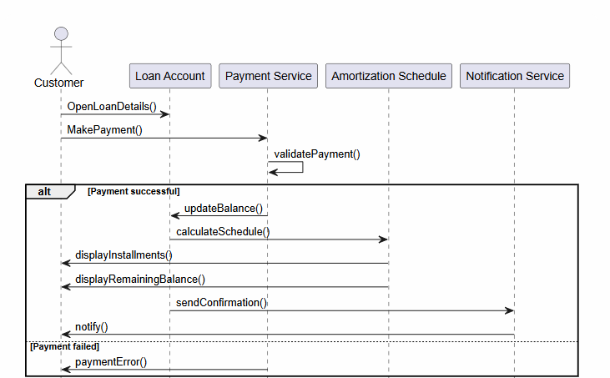

BS_CM_01
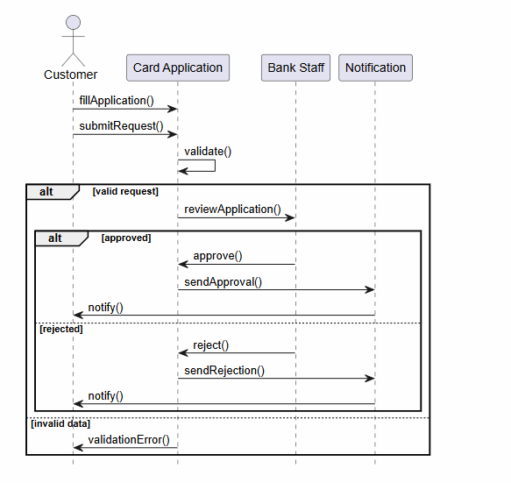

BS_CM_02
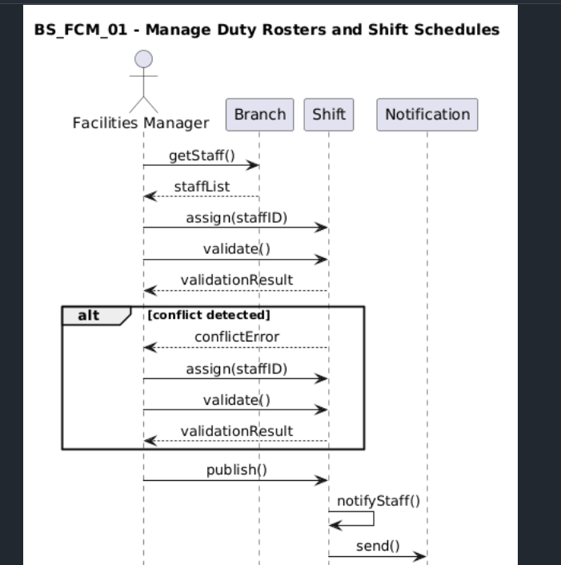

BS_CM_03
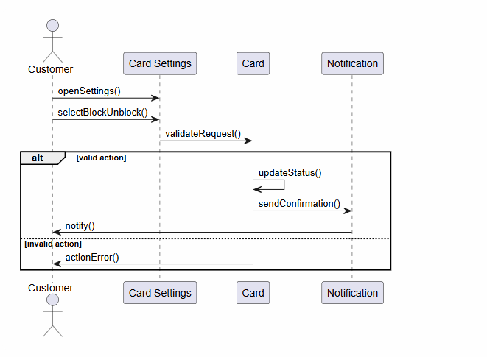

Joandri Domi
BS_FD_01
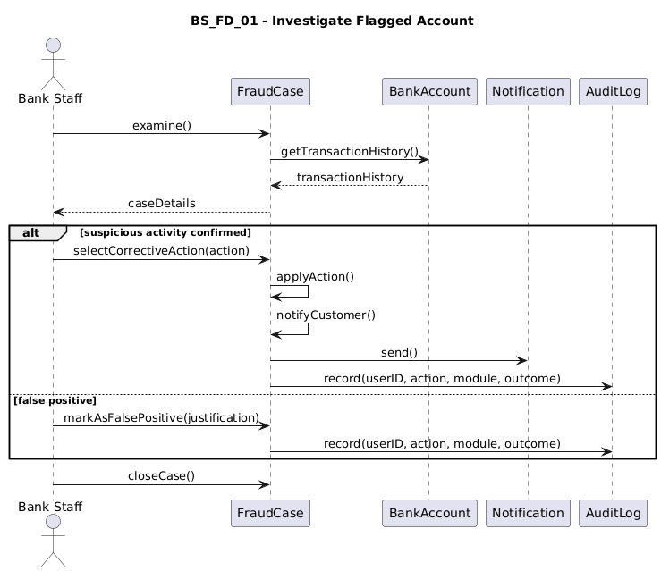

BS_FD_02
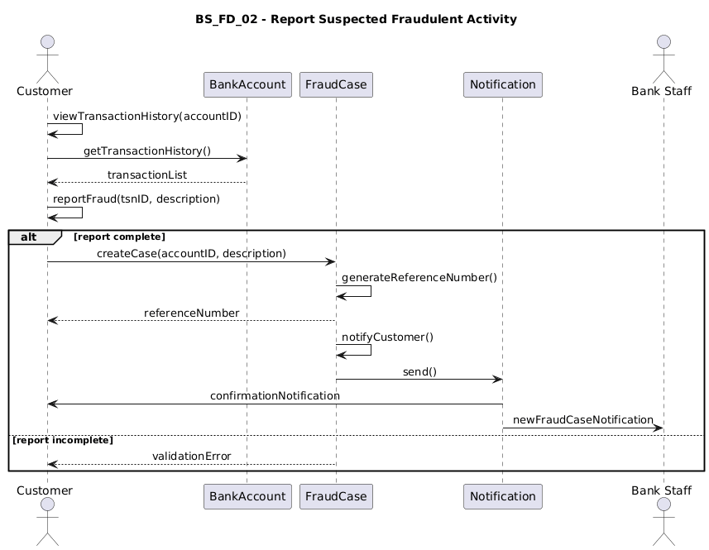

BS_FD_03
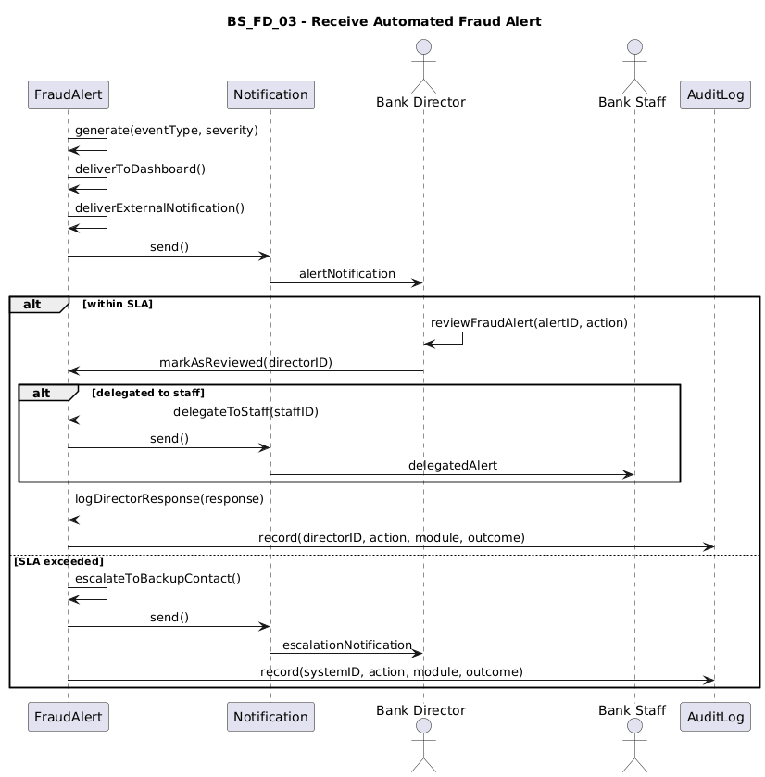

BS_FCM_01
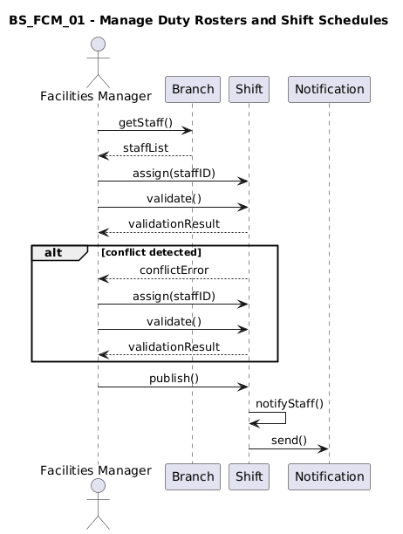

BS_FCM_02
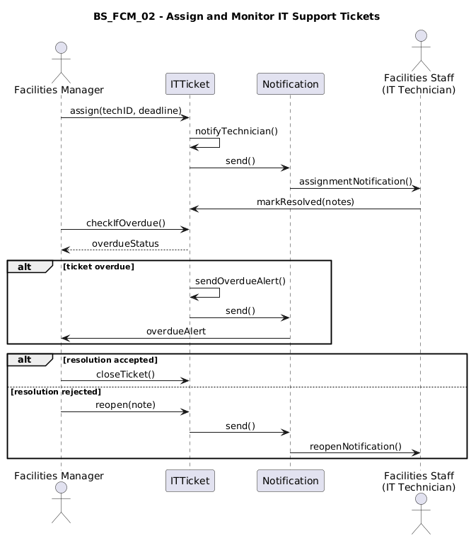

BS_FCM_03
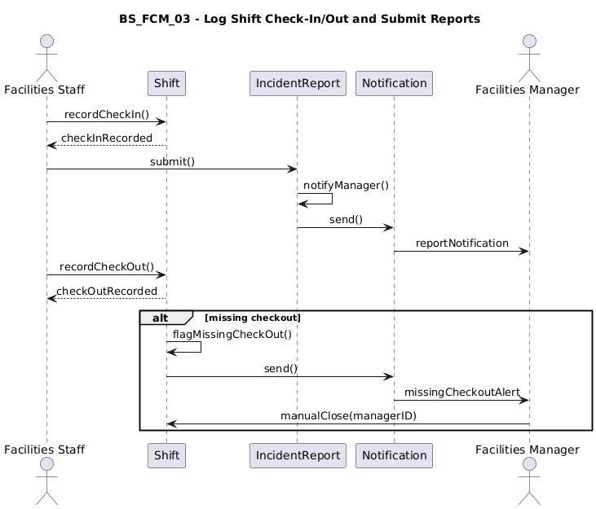

BS_FCM_04
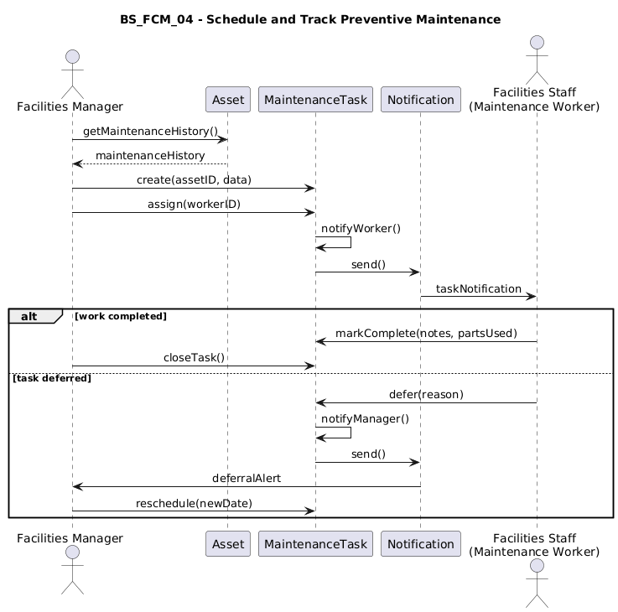

BS_CS_01
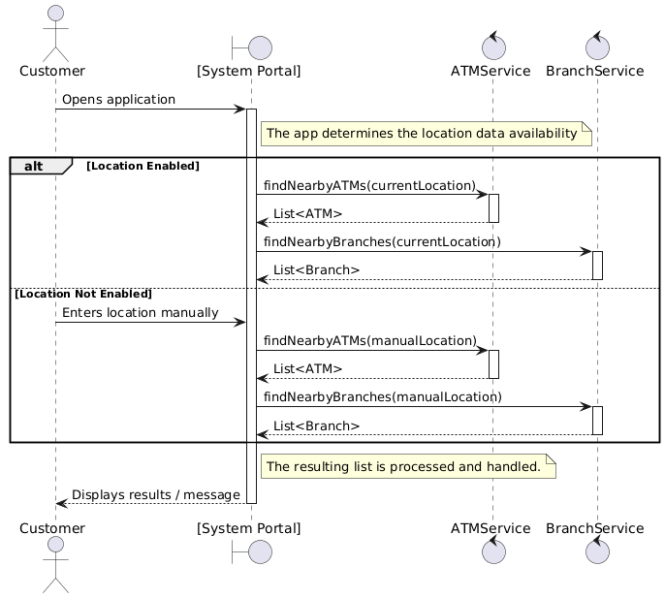

BS_CS_02
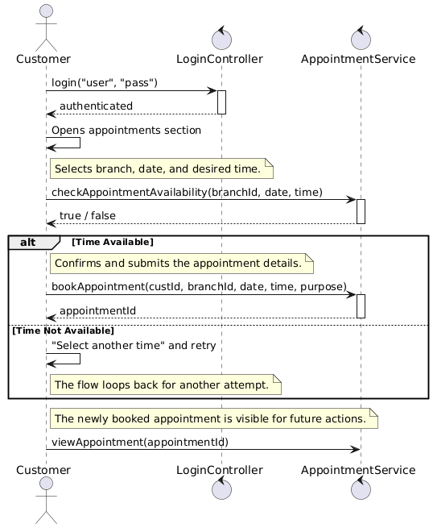

BS_CS_03
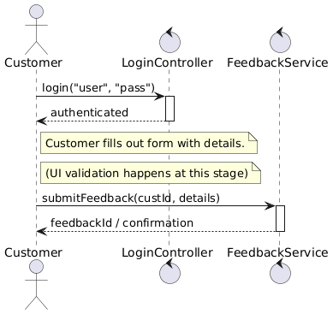

BS_CS_04
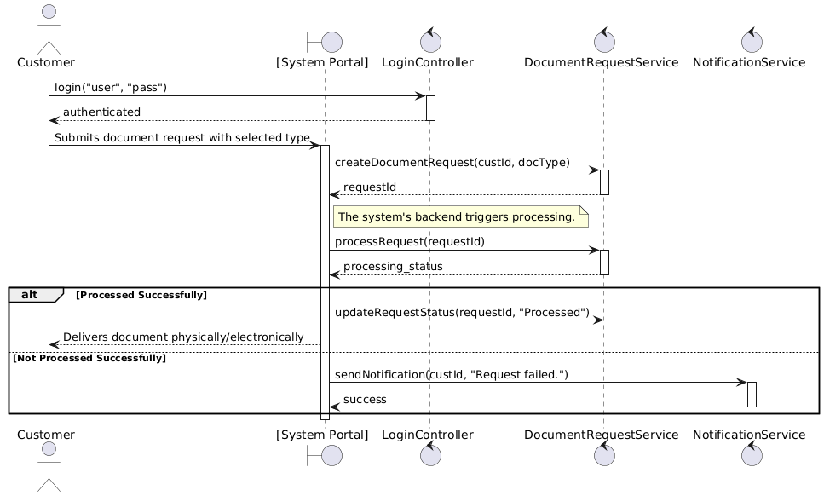

BS_CS_05
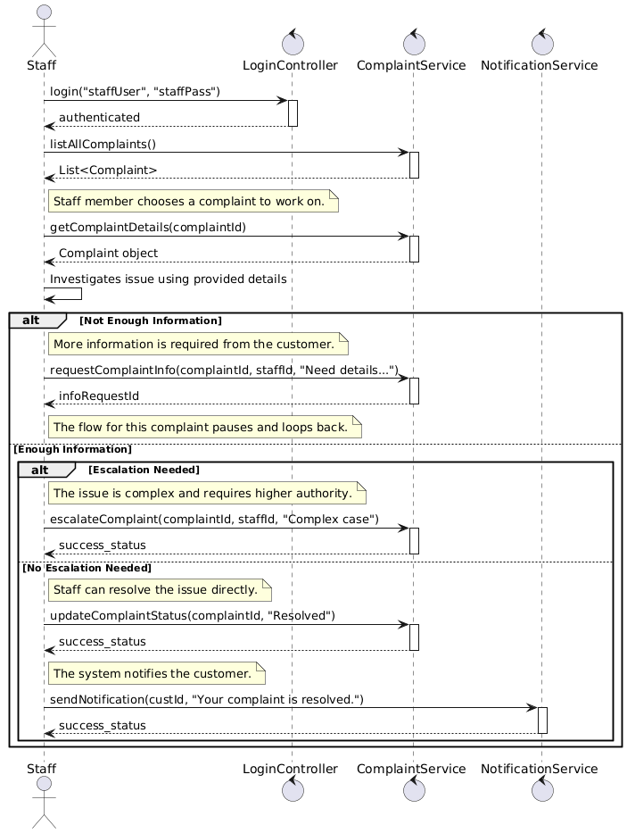
BS_CS_06
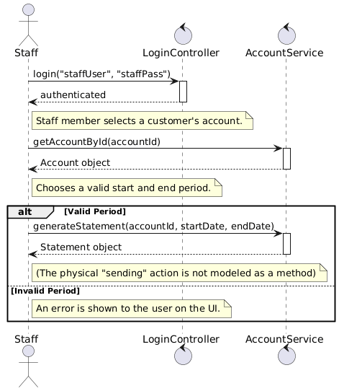

BS_CS_07
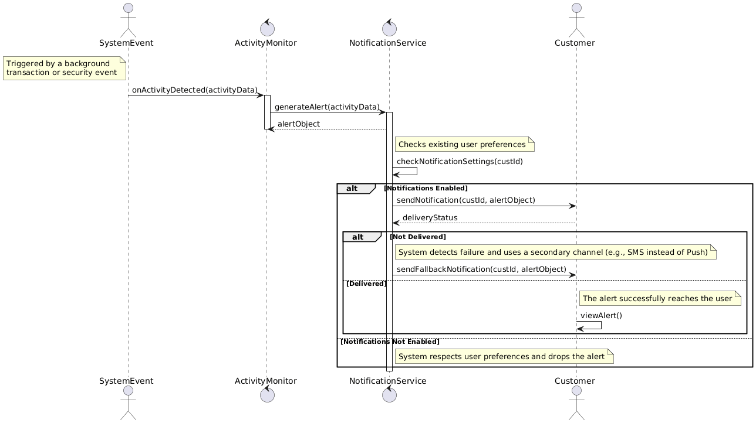

Erind Shabani
BS_AR_01
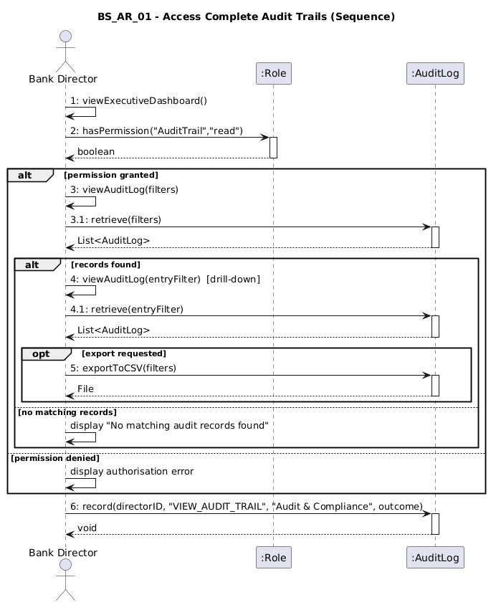
BS_AR_02
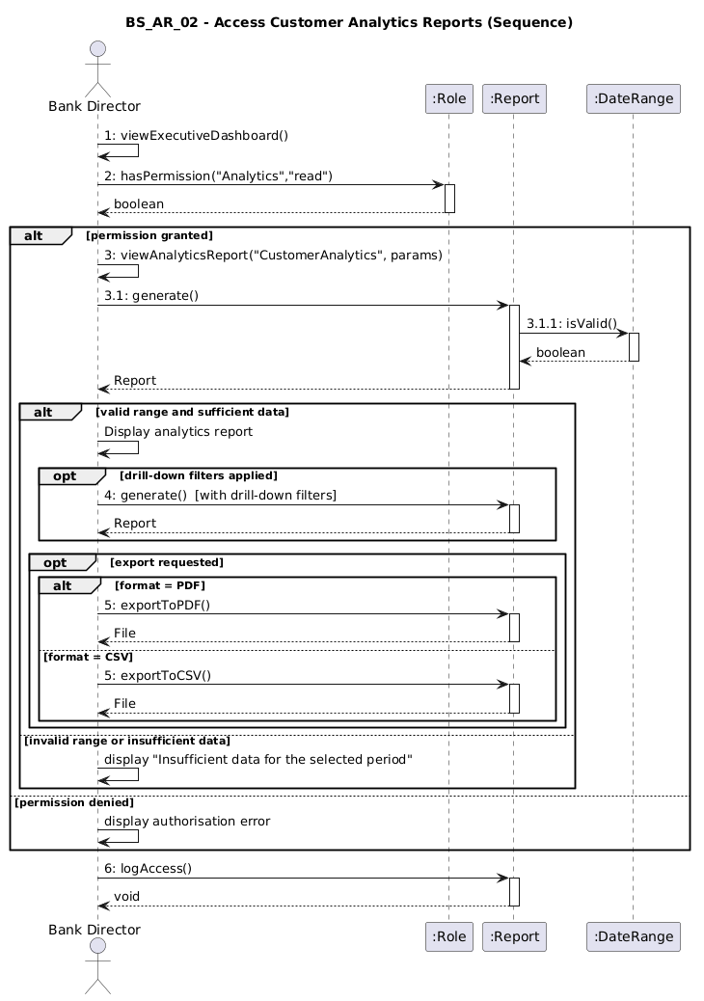
BS_AR_03
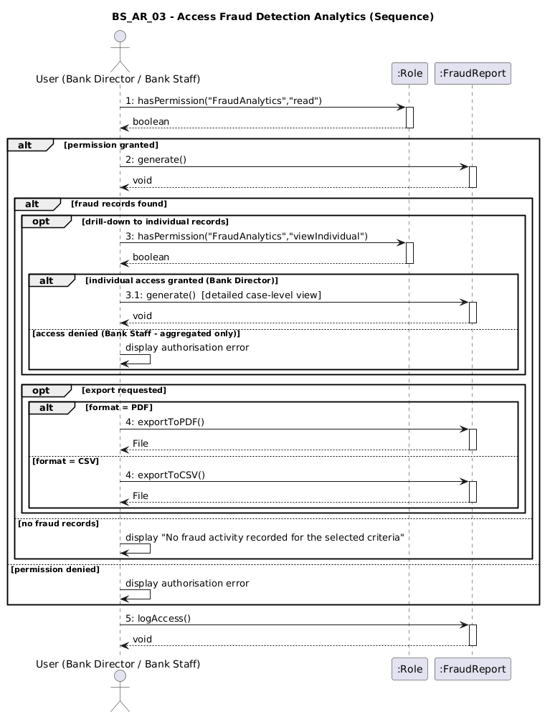
BS_AR_04
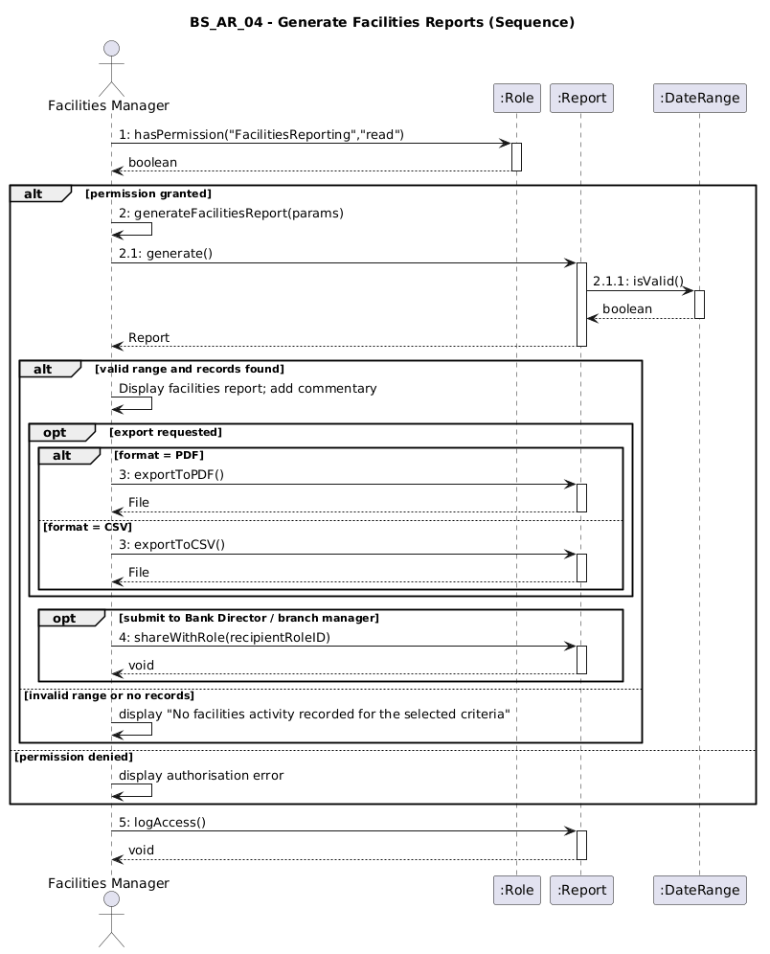

Collaboration Diagram
Andrea Ogreni
BS_UM_01
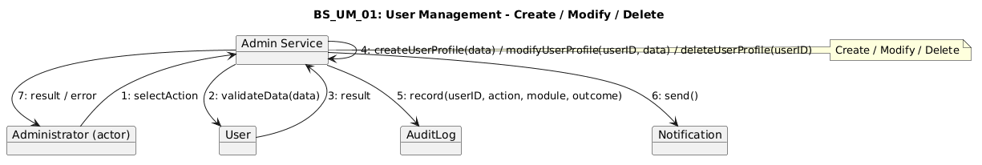

BS_UM_02
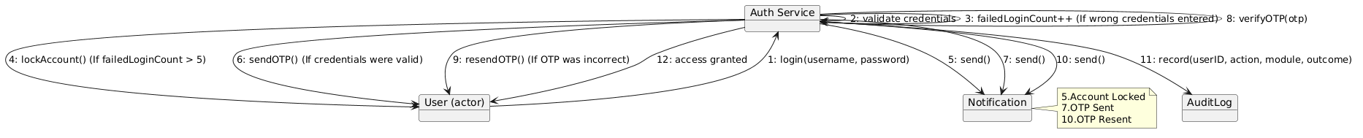

BS_UM_03
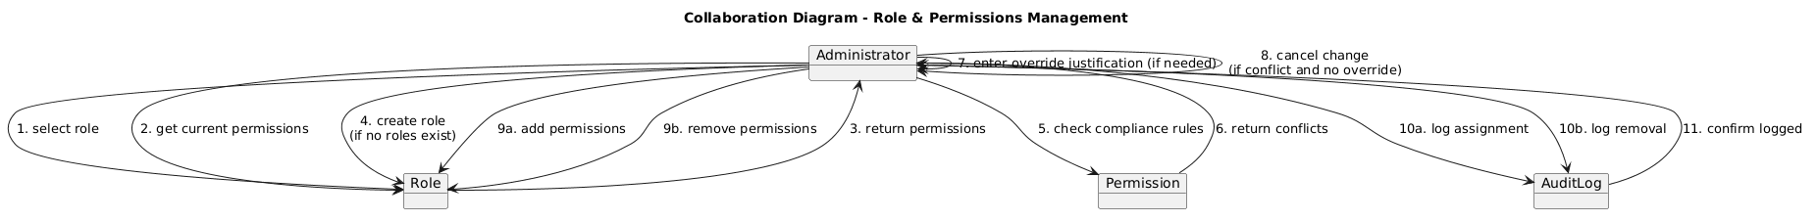

BS_UM_04
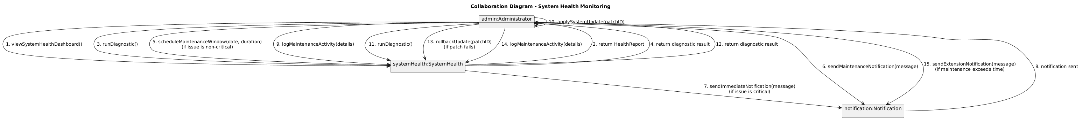

BS_FM_01
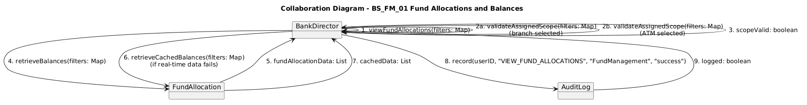

BS_FM_02
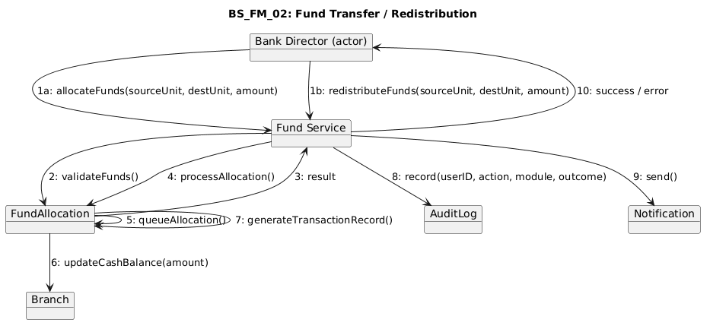

BS_FM_03
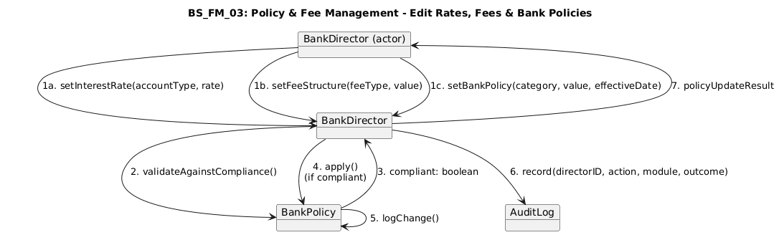

Joel Lluri
BS_AM_01

BS_AM_02
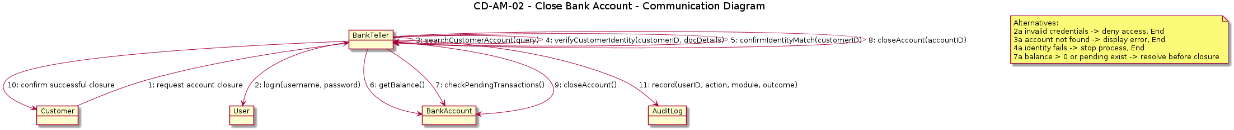

BS_AM_03
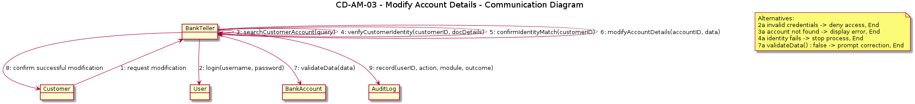

BS_AM_04
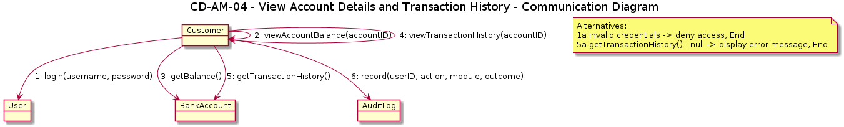

BS_AM_05
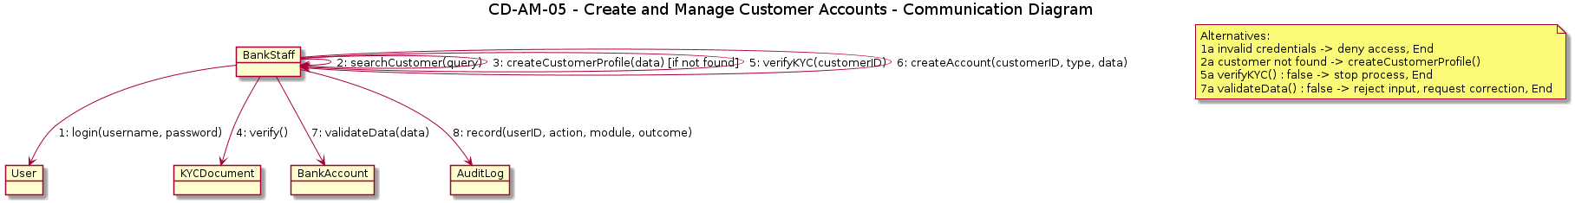

BS_AM_06
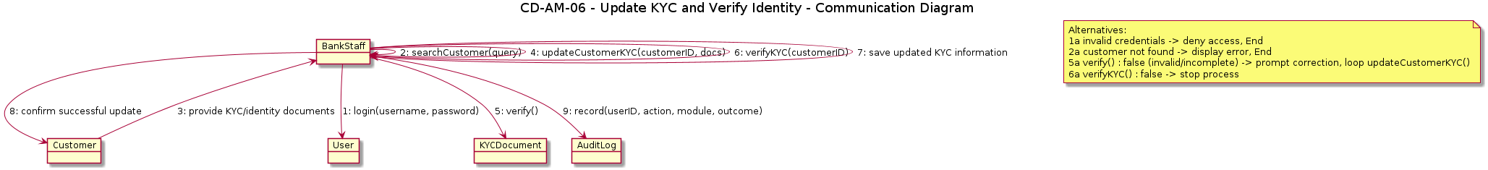

BS_ AM_07
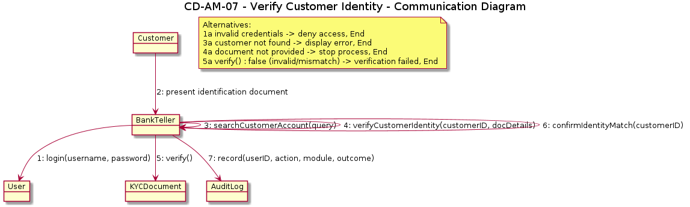

Adriano Demiri
AM_TM_01
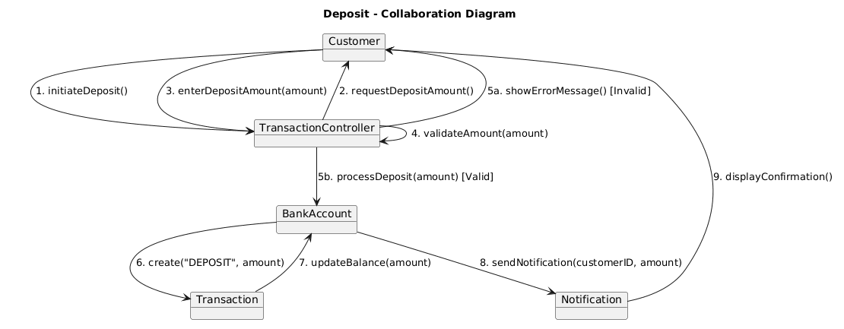

BS_TM_02
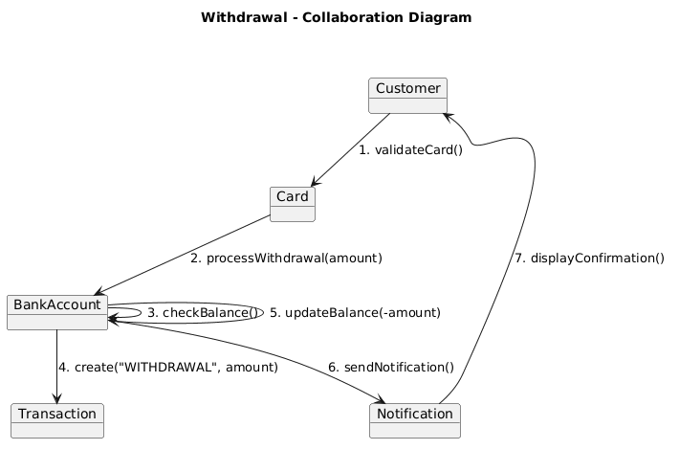

BS_TM_03
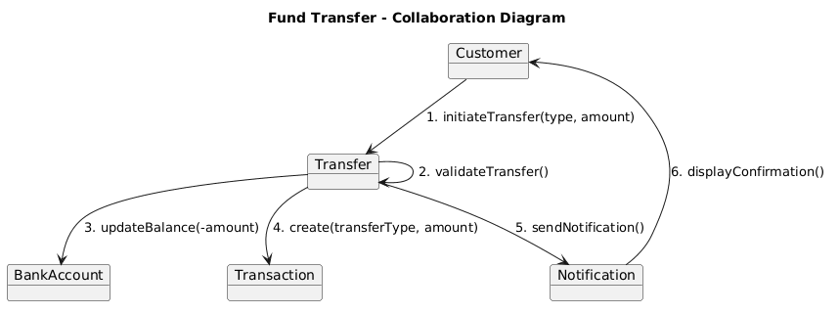

BS_TM_04
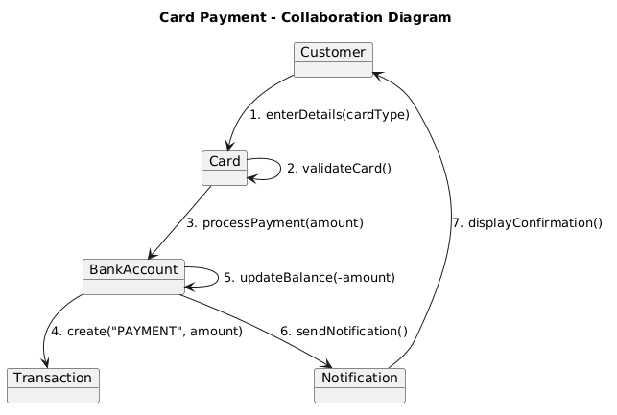

BS_TM_05
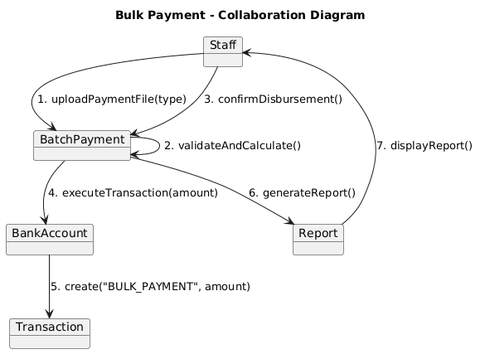

BS_TM_06
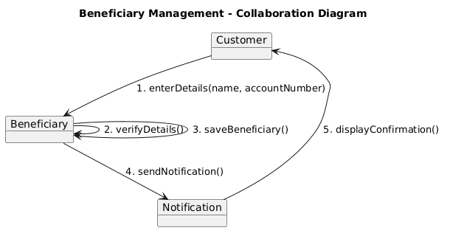
Emanuele Berbiu
BS_LM_01
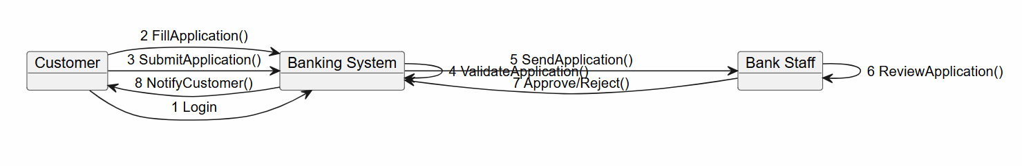

BS_LM_02
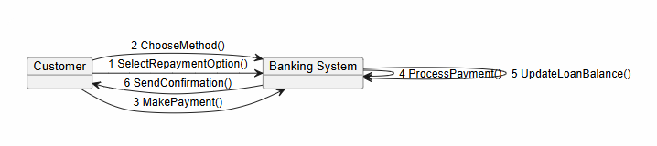

BS_LM_03
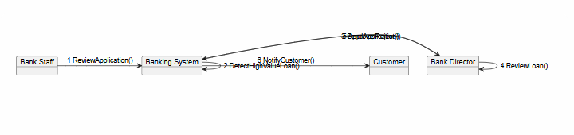

BS_LM_04
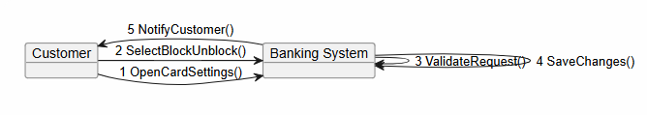

BS_CM_01
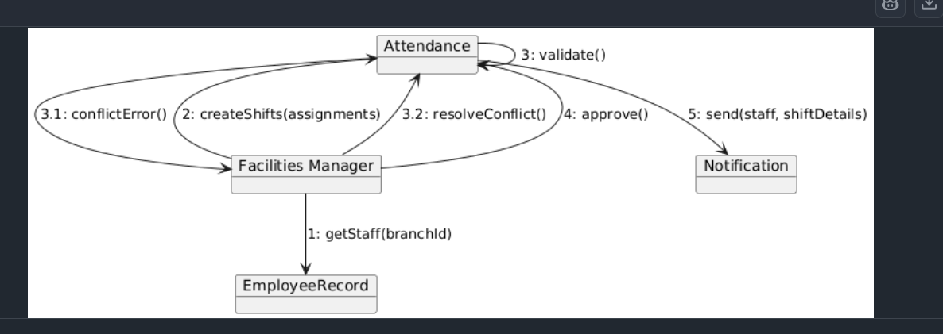
BS_CM_02
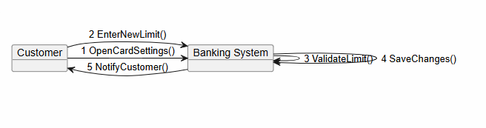

BS_CM_03
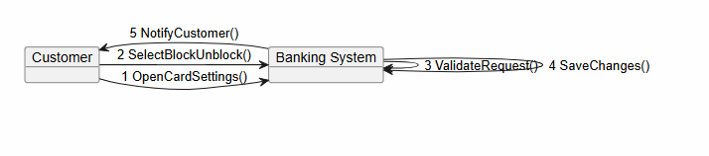

Joandri Domi
BS_FD_01
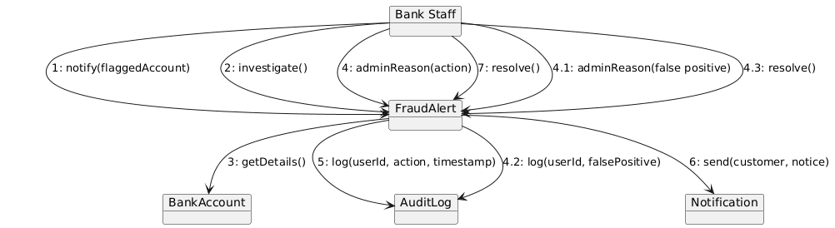

BS_FD_02
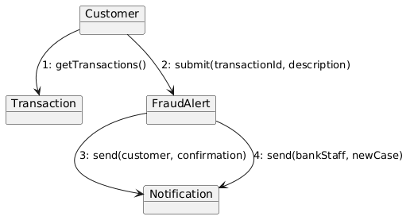

BS_FD_03
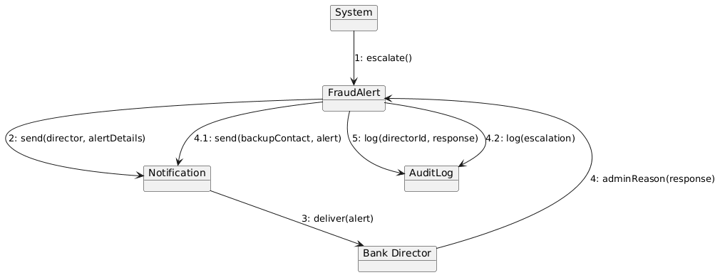

BS_FCM_01
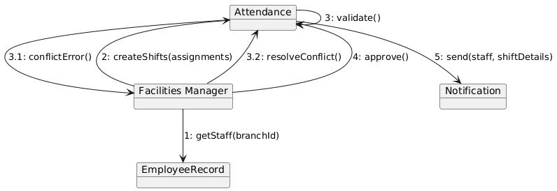

BS_FCM_02
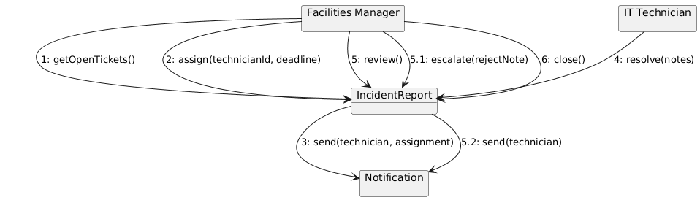
BS_FCM_03
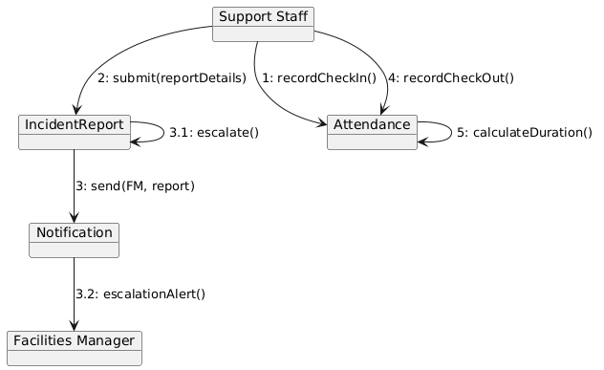

BS_FCM_04
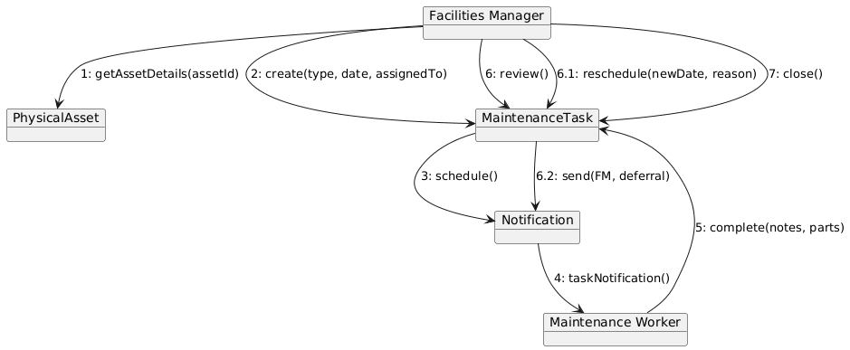

Kleo Miraka
BS_CS_01
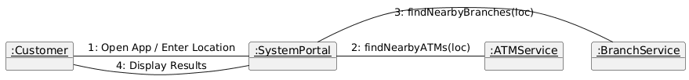

BS_CS_02
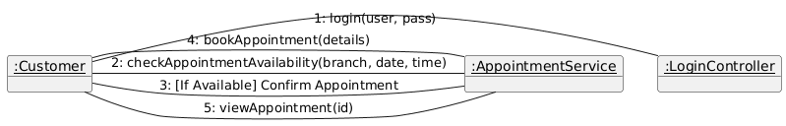

BS_CS_03
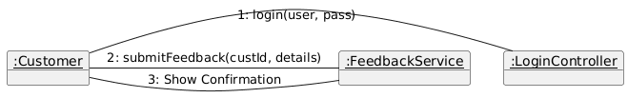

BS_CS_04

BS_CS_05
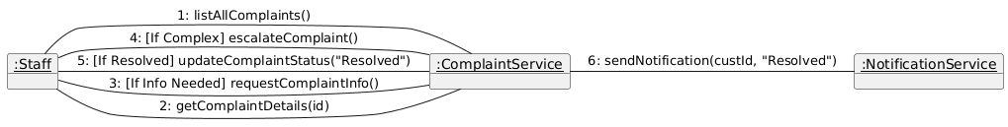

BS_CS_06
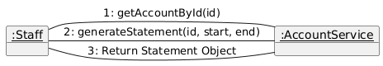

BS_CS_07

Erind Shabani
BS_AR_01
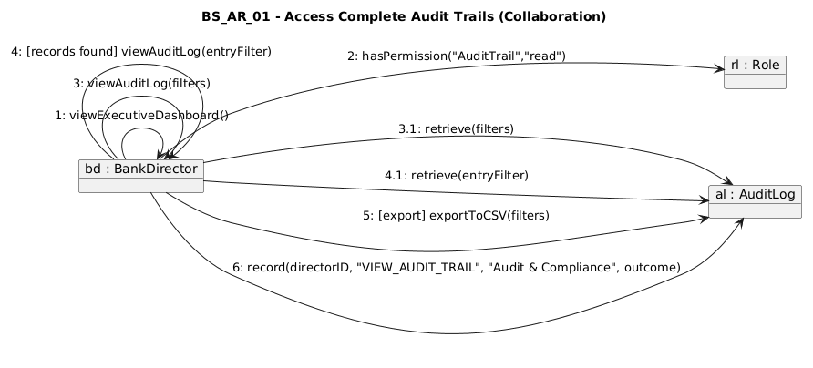

BS_AR_02
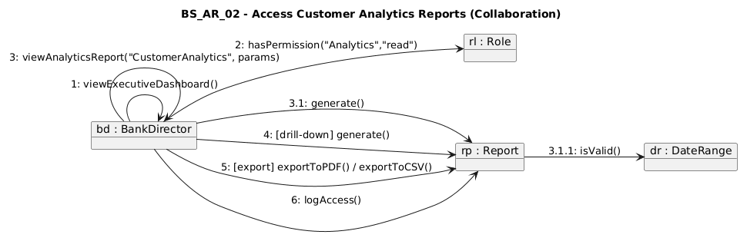

BS_AR_03
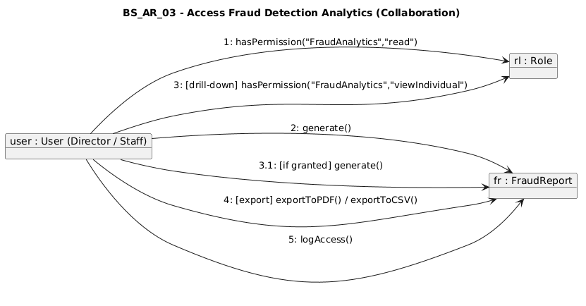

BS_AR_04
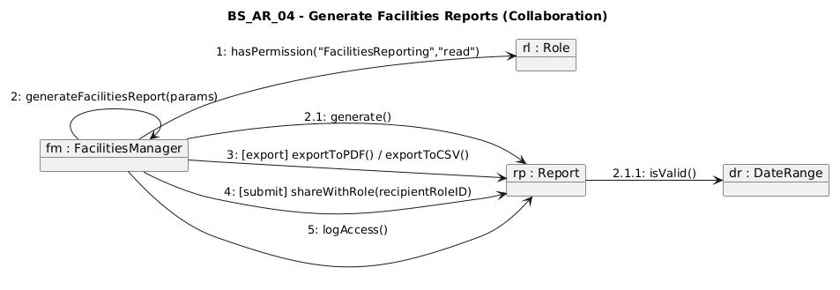

BPMN diagrams
Erind Kotobelli
bpmn1_account_oppening
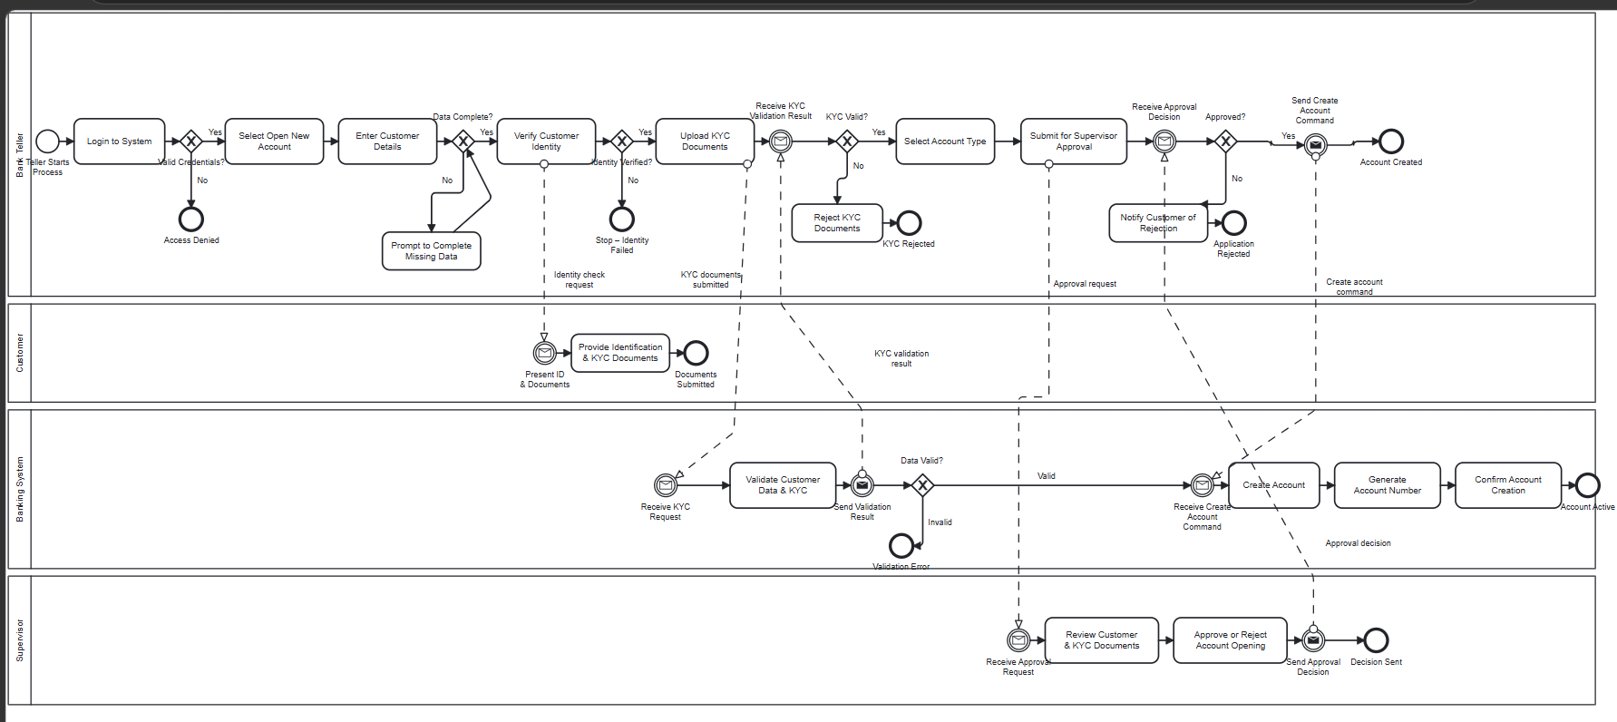

bpmn2_fund_allocation
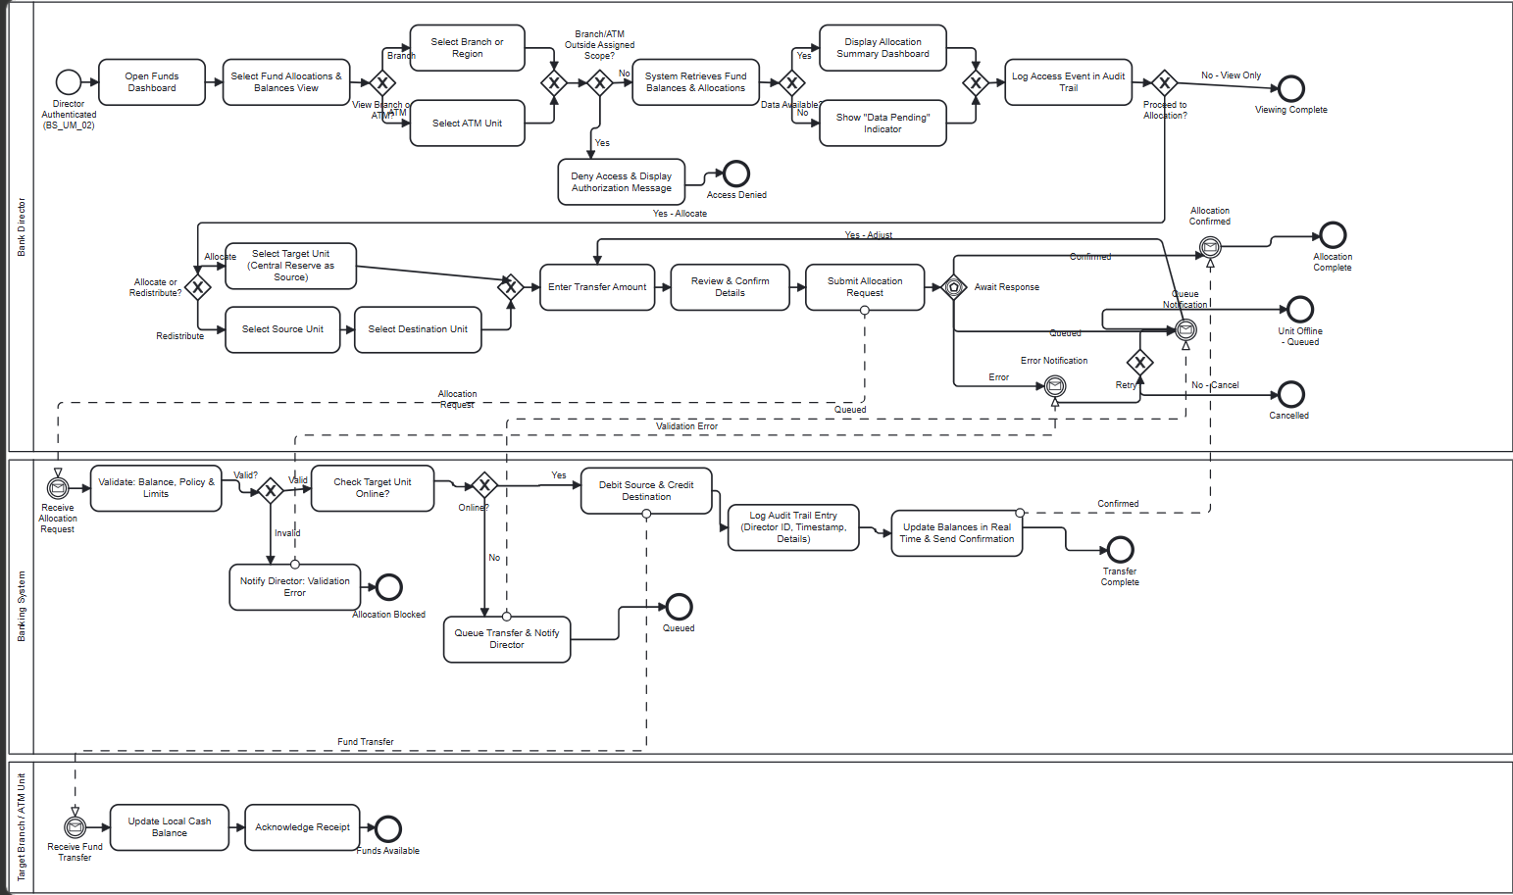
bpmn3_loan_application
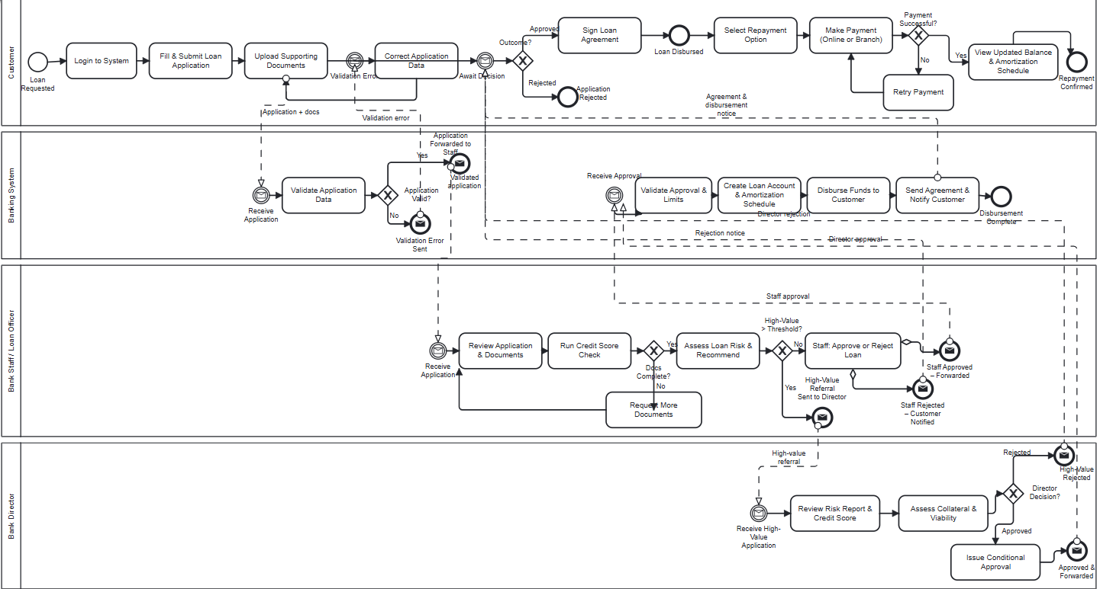

Interaction Overview Diagram
ALL Members
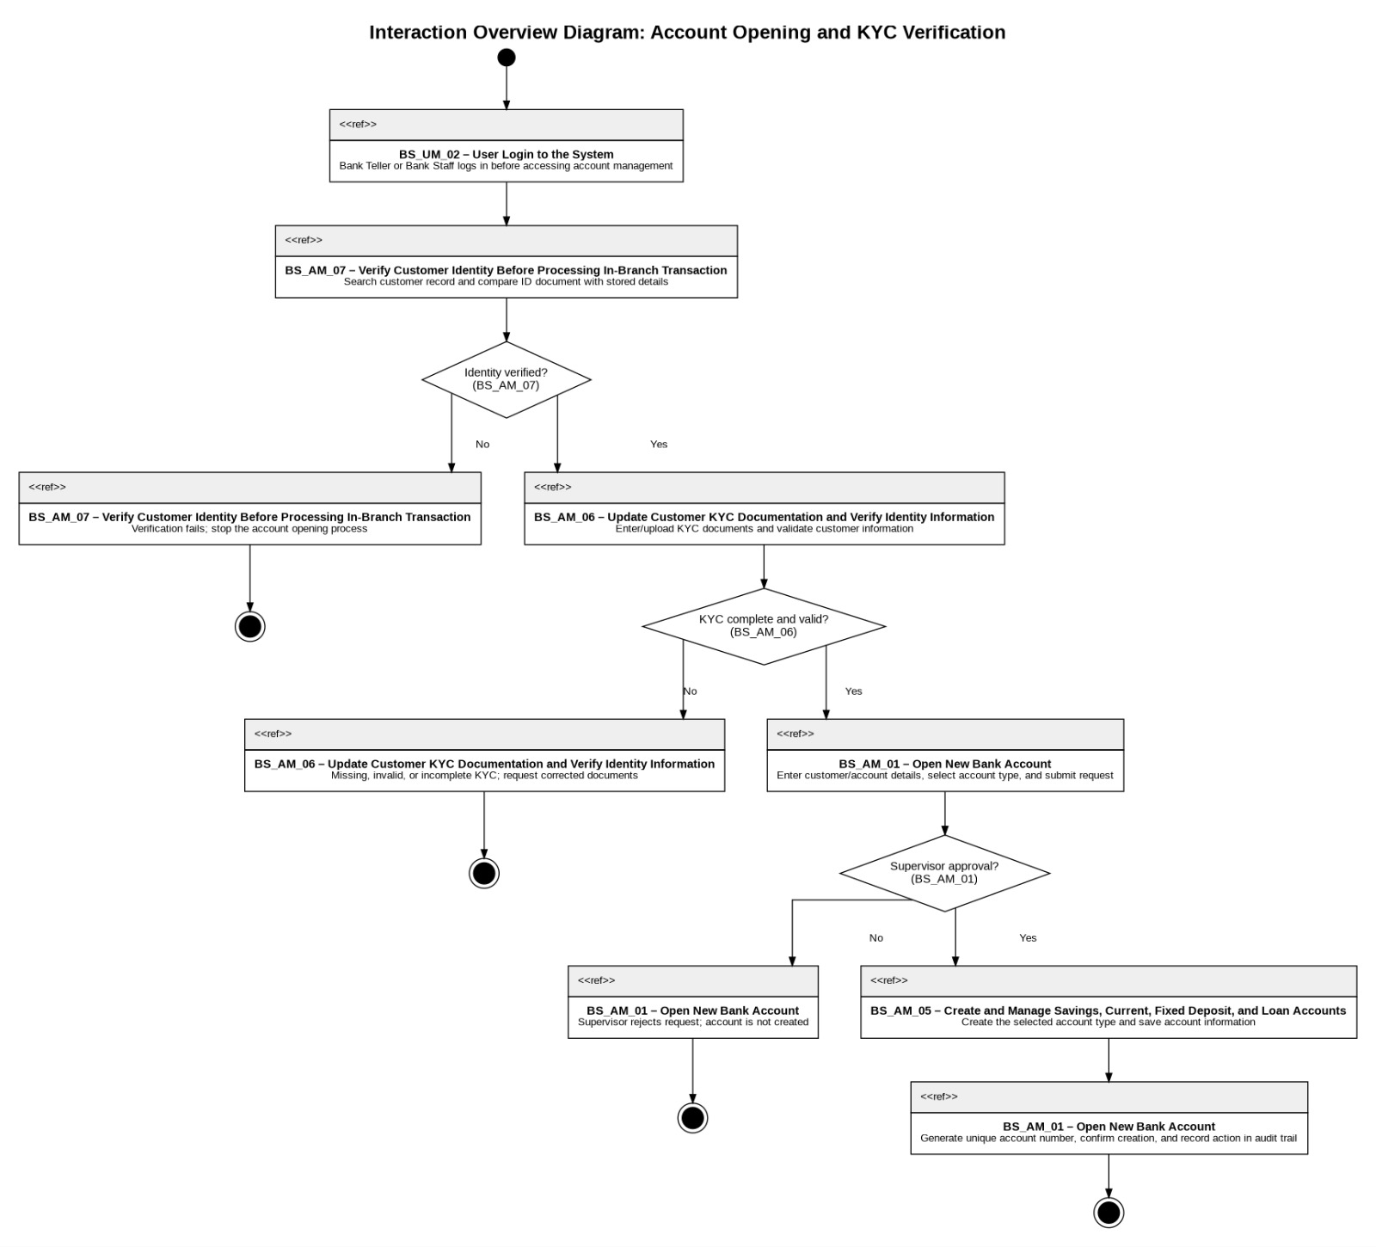

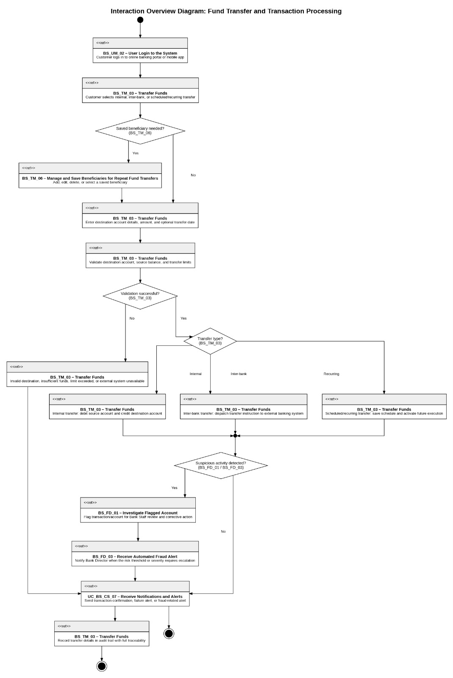
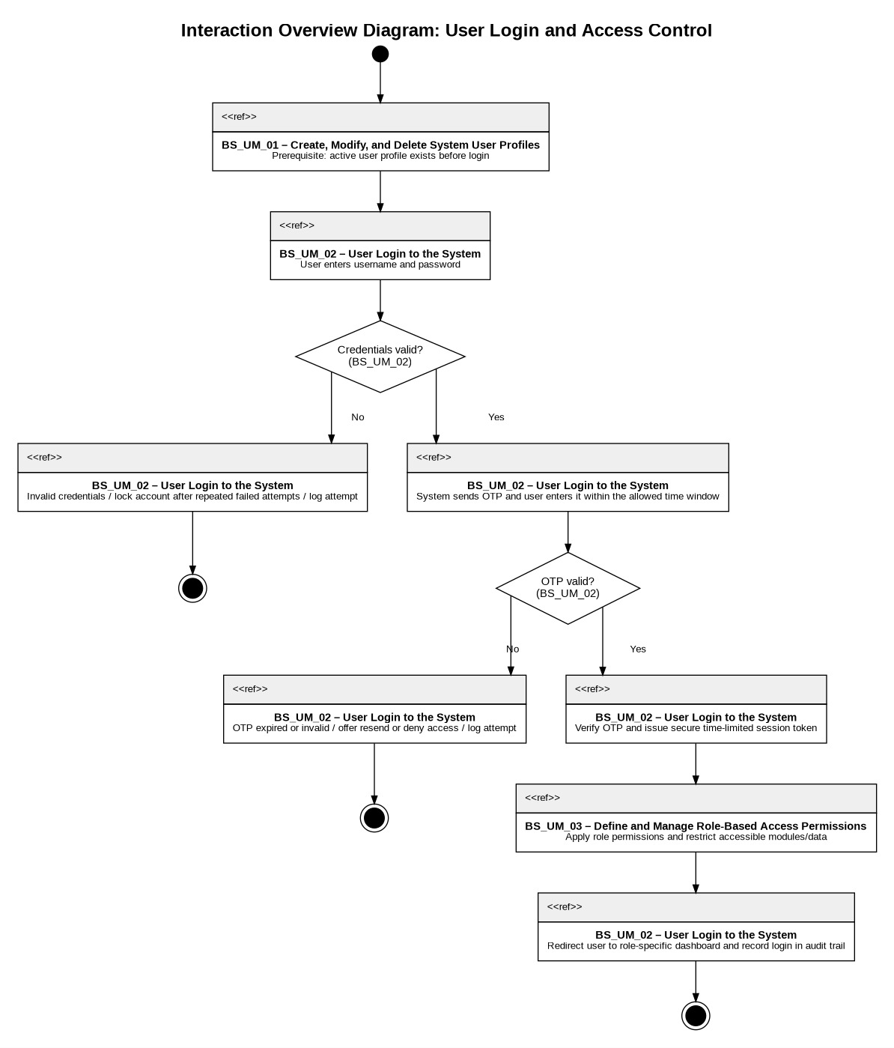

Design Patterns
All members
Command Pattern
The Command pattern was chosen for the Bank Management System because the system handles several transaction requests that must be processed consistently, including deposits, withdrawals, fund transfers, bulk payments, and recurring payment executions. The existing Transaction class already contains the shared command data and behavior through attributes such as amount, status, sourceAccountID, destinationAccountID, and methods such as process(), cancel(), and isReversible(), while Deposit, Withdrawal, FundTransfer, and BulkPayment specialize the transaction behavior. This pattern solves the problem of treating different banking operations as executable request objects, so they can be queued, processed, reversed when allowed, and recorded without forcing Customer, BankTeller, or BankStaff to know the internal logic of each transaction type. A new TransactionCommand interface and TransactionProcessor invoker are introduced only to formalize the pattern structure, while the real transaction classes from the system remain the concrete commands. This improves maintainability because transaction execution rules are kept inside transaction classes instead of being scattered across user-role classes. It also improves extensibility because new transaction types can be added later by extending Transaction and implementing the same command interface without modifying the existing invoker logic. The design supports the Single Responsibility Principle by separating request initiation from request execution, and it supports the Open/Closed Principle and Dependency Inversion Principle by allowing the processor to depend on the TransactionCommand abstraction rather than concrete transaction classes.

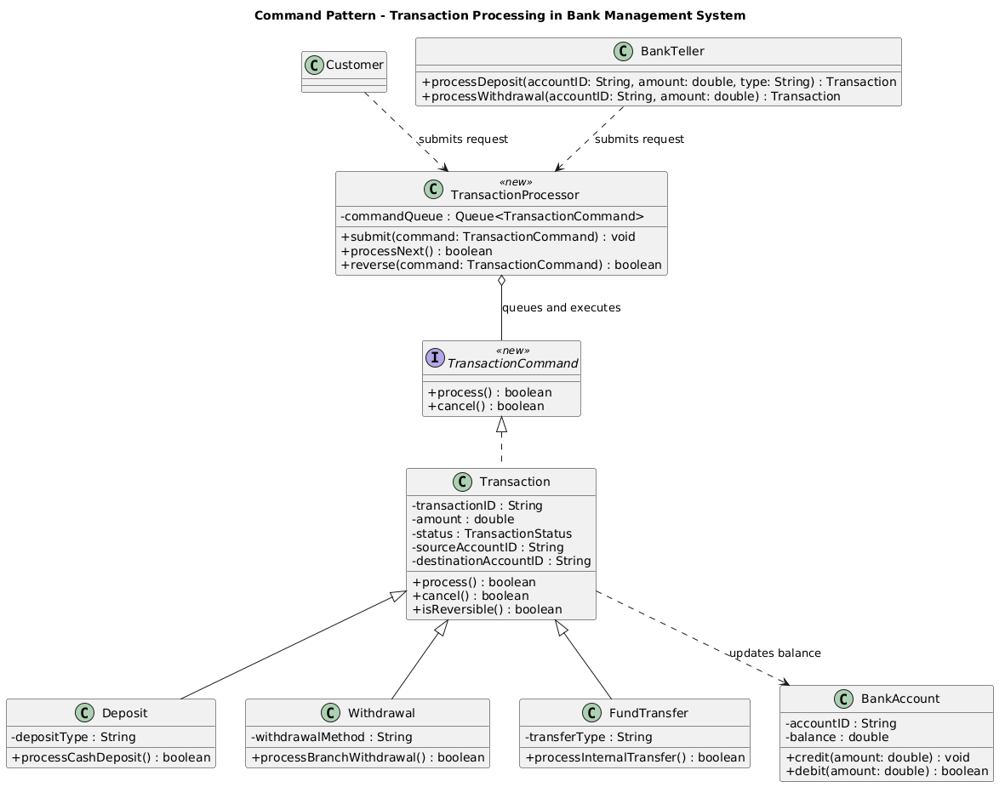

Singleton
The Singleton pattern was chosen for the Bank Management System because all sensitive data operations should pass through one controlled database access point instead of allowing multiple classes to create separate and unmanaged database connections. The system handles customer records, bank accounts, transactions, loans, audit logs, and financial reports, so uncontrolled database access could create security risks, inconsistent updates, duplicate connections, or incomplete transaction handling. By introducing DatabaseConnectionManager as a Singleton, classes such as BankAccount, Transaction, Customer, and AuditLog can use getInstance() to access the same database connection manager whenever they need to read or update persistent data. The pattern improves maintainability because connection setup, transaction control, rollback behavior, and connection closing are centralized in one class rather than duplicated across many banking classes. It also improves security because the database has one clear gateway, making it easier to enforce access rules, logging, and controlled connection usage. This design supports the Single Responsibility Principle by separating database connection management from business classes, the Open/Closed Principle because database access internals can change without modifying client classes, and the Dependency Inversion Principle because system classes depend on a controlled access point rather than directly managing low-level database details.
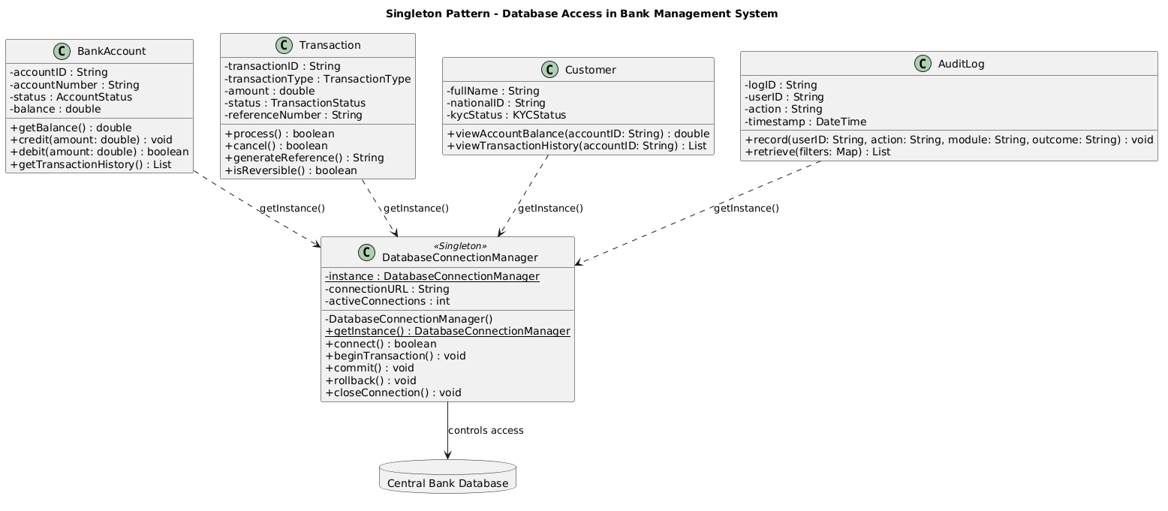

Factory
The Factory pattern was chosen for the Bank Management System because the system must create different account objects, such as SavingsAccount, CurrentAccount, FixedDepositAccount, and LoanAccount, while keeping account creation logic separate from user-role classes like BankStaff and BankTeller. In the existing system, BankStaff.createAccount(customerID, type, data) and BankTeller.openNewAccount(customerID, type) start the account-opening process, but these classes should not directly decide which concrete account subclass to instantiate. The common superclass BankAccount already defines shared account data and behavior through attributes such as accountID, accountNumber, accountType, status, balance, and currency, while each account subclass adds its own specialized behavior such as calculating interest, checking overdraft, calculating maturity amount, or processing repayment. The Factory pattern solves this by introducing an AccountFactory that centralizes account object creation and returns the result as a BankAccount, allowing the rest of the system to work with the common account abstraction. This improves maintainability because account creation rules are localized in one creation component instead of being scattered across teller and staff workflows. It also improves extensibility because new account types can be added later by creating a new BankAccount subclass and extending the factory creation logic without changing the client workflow. The design supports the Single Responsibility Principle by moving creation responsibility into the factory, the Open/Closed Principle by allowing account variations to be extended through new products, and the Dependency Inversion Principle because clients depend on the BankAccount abstraction rather than concrete account implementations.
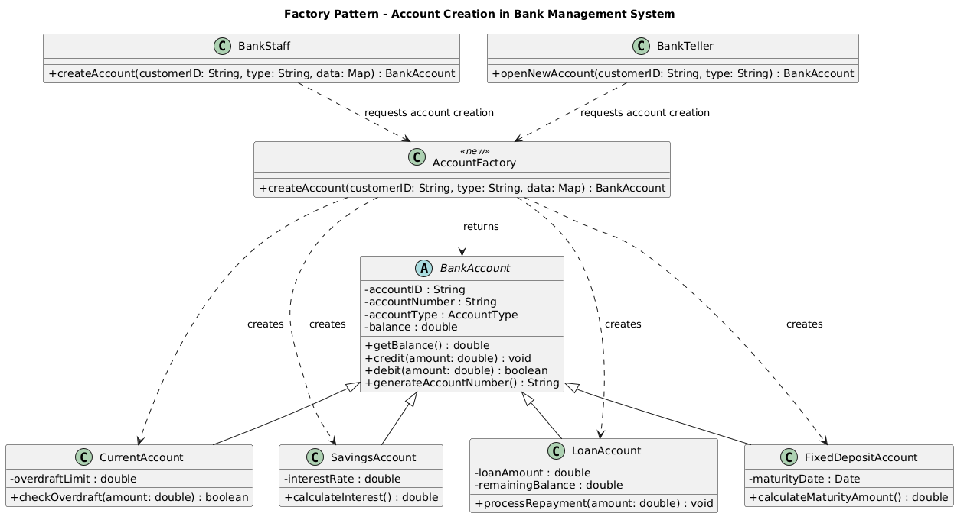

Proxy
The Proxy pattern was chosen for the Bank Management System because the riskiest operations occur when a user request enters the banking backend, especially for deposits, withdrawals, fund transfers, and bulk payments. Instead of letting Customer, BankTeller, or BankStaff send transaction requests directly to Transaction, the new SecureTransactionProxy filters the request first and only delegates to the real transaction object when the user session, role permissions, transaction limits, and duplicate-request checks are valid. This solves concrete banking problems such as accidental double submission of the same transfer, unauthorized access to transaction processing, repeated withdrawal attempts, and unlogged failed operations. The existing User, Role, and Permission classes are used to verify whether the current user may perform the requested operation, while AuditLog records both accepted and rejected requests. The existing Transaction hierarchy remains responsible for the real transaction behavior through process(), cancel(), and isReversible(), while the proxy adds protection without changing those transaction classes. This improves maintainability because security filtering is centralized at the backend entry point instead of being repeated inside every transaction type or user-role class. The design supports the Single Responsibility Principle by separating access filtering from transaction execution, the Open/Closed Principle because new transaction types can still be added under Transaction, and the Dependency Inversion Principle because clients depend on the TransactionAccess abstraction rather than directly on concrete transaction classes.
